

Programme: Master of Business Administration
Module: Strategic Management
Module code: LCMB7003
Tesco’s Strategic Expansion into the Vietnamese Retail Market
Student Name : Patel Nishit Jagdishbhai
Student I’d: 2433620
Lecturer name: Zulfiqar Khan
Words count: 5043
Submission date : 17 Nov 2025

Executive Summary
The Tesco international business strategy is a report on the analysis of business in a country, in this case Vietnam, with reference to its expansion and operations. It examines the implications of the strategic planning processes, the financial management processes and the performance control mechanisms of how these processes overall influence the success of this company in this emerging market in Southeast Asia. It explains the importance of evaluation and control with references to such models as the Balanced Scorecard and Total Quality Management (TQM) and the role whereby the models can help Tesco in its quest to achieve operational efficiency and customer satisfaction. The financial analysis assisted by the annual report Tesco 2025 and even the Statista data reveals a steady increase with the total group assets standing at 30.03 billion pounds and the total group net assets standing at 11.66 billion pounds being highly financial.
The effectiveness of the financial planning in the long term profitability and liquidity of Tesco is also prepared through the report as optimal cash flows of operations (2.9 billion) and net debt/ EBITDA ratio kept with control at 2.0. Moreover, the paper describes key opportunities that Tesco can assume to enhance its operations at Vietnam through digital transformation, alignment with the local market, and sustainable business operations. Tesco can leverage its operation into the global standards of environmental consideration and innovation to enhance its market position and ensure consistency with the global trends.
The report suggests that Tesco should work on enhancing localization strategies, capital utilization, the technology-based operations, and employee development. The measures will guarantee Tesco maintains profitability, creates loyalty to customers, and a long-term strategic success in the competitive retail economy of Vietnam.
Table of Contents
Executive Summary 2
1. Introduction 5
2. Selection of Organisation and Target Market 5
2.1 Identification of Organisation 5
Figure 1 5
Source 5
2.2 Proposed New International Market- Vietnam 6
2.3 Justification for Organisation and Market Selection 6
2.4 Current Situation of Tesco 7
2.5 Financial recap of Tesco 8
3. Comprehensive Strategic Analysis 8
3.1 External Audit 9
3.2 Internal Audit 11
4. Strategy Development and Formulation 14
4.1 Strategy Formulation 14
4.2 Strategy Implementation 16
5. Performance Evaluation Framework 18
5.1 Evaluation and Control Importance of Evaluation and Control 18
5.2 Evaluation, Monitoring, and Control Methods 18
5.3 Balanced Scorecard for Tesco in Vietnam 18
5.4 Financial Plan 19
6. Recommendation and Conclusion 20
Reference list 22
Appendix 26
Appendix 1: Income Statement 26
Appendix 2: Balance Sheet 26
Appendix 3: Cash Flow 28
Appendix 4: EBITA 28
Appendix 5: Key Performance Indicators (KPIs) and Success Metrics for Tesco in Vietnam 29

1. Introduction
The modern global business world dictates organisations in a dynamic market that is influenced by technologically innovative changes and globalisation and changes in consumer wants. To continue to grow and to be competitive, the multinational corporations have no choice but to forage new markets uncharted in terms of potential and being strategic. In this report, the manager of one of the leading retailing companies in the world, Tesco, is described and the way it wants to expand to Vietnam. With its experience in retail management, supply chain-efficiency, and digital-change, Tesco has forged a highly-developed global presence and can, therefore, penetrate the recently-emerging retail commerce market in Vietnam. Vietnam is an opportunity because it boasts of sound economic growth, rising middle class, deepening urbanisation, and favourable state policies towards FDI. The report will seek to prepare a detailed organisational expansion strategy of Tesco by using the major strategic frameworks to evaluate the market environment, develop an effective entry strategy, and a performance analysis framework to realise lasting success.

2. Selection of Organisation and Target Market
2.1 Identification of Organisation
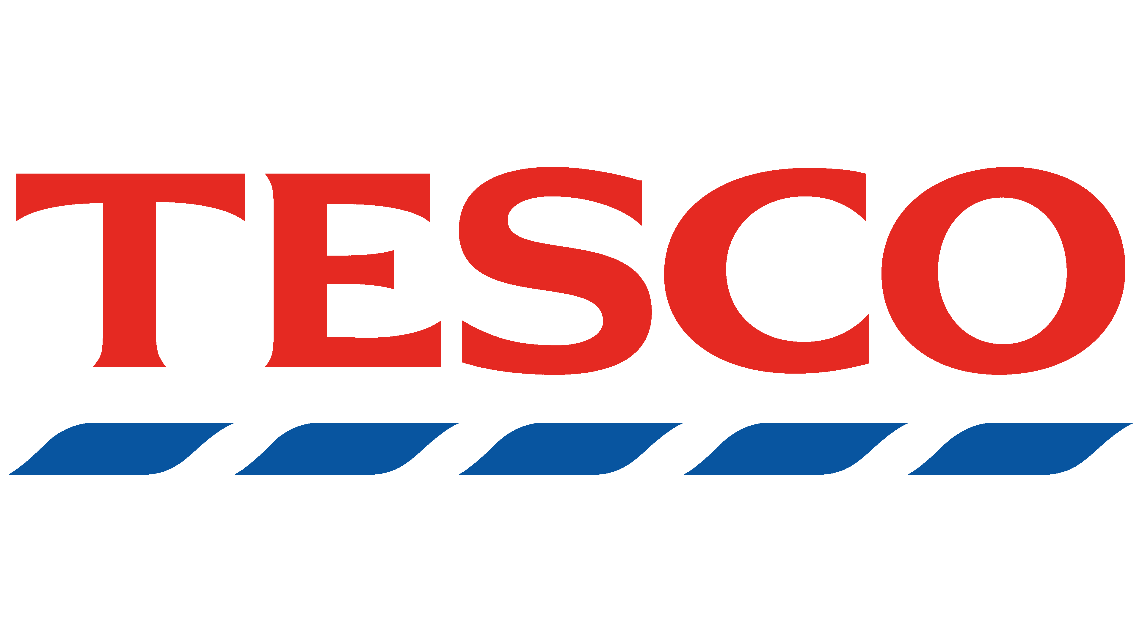
Figure 1: Tesco PLC
Source: (Tesco PLC, 2025)
Tesco PLC is a prominent and multinational retail company globally and it is based in Welwyn Garden City in the United Kingdom. Jack Cohen established Tesco way back in 1919 which started as a tiny grocery store but has transformed into a massive retail giant with operations in Europe and Asia (Tesco PLC, 2025). It ranks as the third largest worldwide based on revenue retailer, and it has centered its interests to avail low cost and quality products to millions of customers (Smith, 2023). In 2024, Tesco is still consolidating its presence in the UK and Central Europe, and has opportunities available to it in the growth of the emerging economies to support sustainable long-term development.
2.2 Proposed New International Market- Vietnam
Vietnam can safely be considered Tesco next target on the international expansion journey. It has shown stable growth in the economy with a steady GDP growth of 67 per cent annually over the last 10 years. By 2028, the Vietnamese retail market is projected to grow to above US 250 billion; driven by the growing size of the middle-income group, rising consumer purchasing power as well as urbanisation (PR Newswire, 2024). Vietnam has a population of more than 100 million people, with more than 70 percent of them below 35 years- a demographic which is highly technological and consumption based (Azan and Karimah, 2022). Moreover, its status as an entrant to the world trade such as EU-Vietnam Free Trade Agreement (EVFTA) and Regional Comprehensive Economic Partnership (RCEP), makes the country more appealing to foreign investors.
2.3 Justification for Organisation and Market Selection
Tesco has been chosen due to its successful involvement in the global market and flexibility to work across various markets. Although Asia has been a challenging country in the past like its retreat in China and South Korea, Tesco has learned some very important lessons in the areas of localisation, formation of partnerships and consumer adaptation. Vietnam is less saturated, high-growth, and much aligned with the strengths of Tesco in terms of digital retailing strategy, supply chain management, and use of own branding (Zainudin, Nor and Kamisan, 2023).
The government in the country works towards promoting foreign direct investment, particularly in modern retail, to serve the population which is having rapid urbanisation. Moreover, the increasing internet penetration (more than 75 percent) and the rapid development of e-commerce is also an opportunity that Tesco can consider implementing omnichannel retailing, physical stores and online delivery to customer services. Vietnam is a strategically viable country with respect to sustainable international expansion of Tesco.

2.4 Current Situation of Tesco
Vision and Mission: The vision of Tesco is to ensure that it is the most appraised business by customers, colleagues and communities. Its mission statement, to serve customers a bit better every day, demonstrates its focus on customer satisfaction and constant betterment (Fernández Vilas et al., 2018). These are the guiding principles that motivate the company to make strategic choices and operational excellence in the global markets.
Objectives: The main goals of Tesco are to increase customer loyalty, improve operational efficiency, and sustainability, as well as to constantly ensure steady financial growth. It is also a goal of the company to enhance its digital transformation and omnichannel retail strategy.
Ownership and Governance: Tesco PLC is a publicly traded company in London Stock Exchange and included in the FTSE 100 Index (Huffaker and Fearne, 2019). It has a sound governance structure that is overseen by an independent board of directors, which provides ethical, transparent, and accountable management standards.
Organisational Structure and Industry: Tesco is a decentralised in nature, each regional divisional structure is able to develop local market-based strategies. It is a retail sector company with specialization on food, groceries, clothing, electronics, and financial services.
Financial Position and Markets: Tesco conducts its business in more than 10 countries, with the UK and Europe being the main ones, developing an interest in the emerging markets (Abdelazim, 2024). It is financially stable, and in the year 2024, it recorded revenues of more than 65 billion, which shows that it is competitive globally.

2.5 Financial recap of Tesco
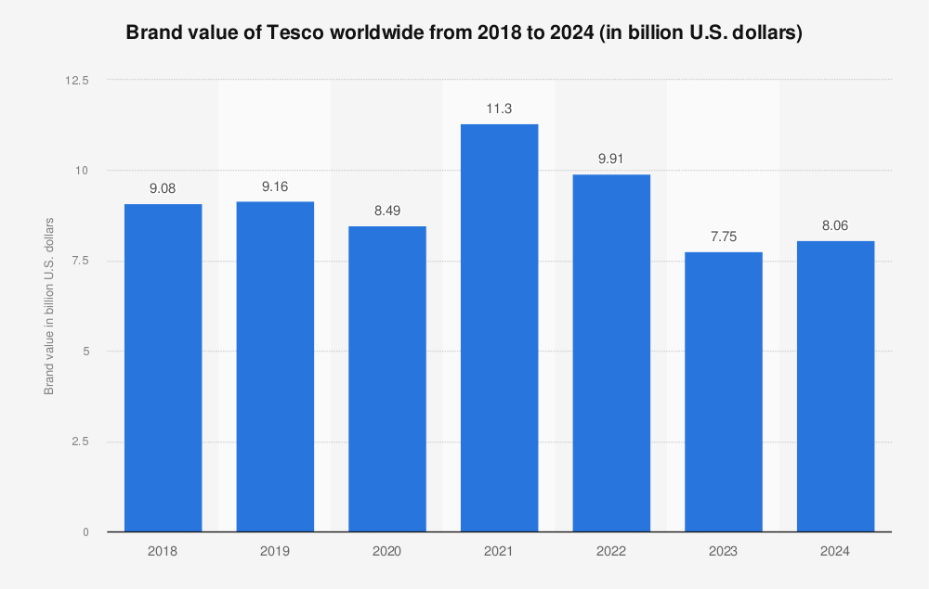
Figure 2: Worldwide Brand Value of Tesco from 2018 to 2024
Source: (Statista, 2025)
Moderate volatility of the global brand value of Tesco has been recorded in the last seven years. It began at 9.08 billion dollars in 2018 and rose marginally to 9.16 billion dollars in 2019, then it dropped by an average of 8.49 billion dollars in 2020 (Khanta and Srinuan, 2019). When compared to the year 2021, the value was highest at 11.3 billion which was seen in 2021, a year of strong performance in the pandemic, but subsequently dropped in the years to come to 9.91 billion in 2022, and of 8 billion in 2023 and 2024.

3. Comprehensive Strategic Analysis
When formulating international expansion strategy of Tesco into Vietnam, it is important that both external and internal environment that affect strategic decision-making are understood. The market moulds opportunities and threats regarding the external factors, whereas what is in control of the Tesco is its capacity to utilize its resources and capabilities depending on the internal factors (Sharma, Jain and Pajni, 2022). The next section critically analyses these dimensions in consideration of appropriate strategic frameworks.

3.1 External Audit
Defining the External Environment and Its Strategic Importance
External environment is all the factors that are outside an organisation but may influence operations, competitiveness, and strategic direction of an organisation. In the case of Tesco, these factors are economic trends, political policies, changes in technology and socio-cultural changes in Vietnam (Coyle and Gamberi, 2024). The knowledge of such forces will help Tesco to understand the market entry opportunities, predict difficulties and implement strategies that support local conditions. Such neglect of the external environment may result in strategic misfitting as witnessed when Tesco had a hard time in China and it is essential to ensure that an environmental scan continuously; successful internationalisation depends.
PESTEL Analysis: Vietnam’s Macro-Environmental Factors
Political: Vietnam has a stable political environment and the government has great support on foreign direct investment (FDI) (Lomoio et al., 2023). Tesco can enjoy cost benefits by increasing its trade relations and lowering cost through the EU-Vietnam Free Trade Agreement (EVFTA). To the short run, however, there may be bureaucracy and local ownership legislation.
Economic: Vietnam has one of the most rapidly developing economies in Southeast Asia, with GDP growth averaged at 67 percent per year. Disposable incomes are going up and there is a growing middle class which forms a strong demand of modern retail (Lomoio et al., 2020). Pricing strategies and cost structures of Tesco may be affected by major and unpredictable inflation and fluctuating currencies.
Social: Young population (70% less than 35 years) and rising urbanisation augurs well to the demand of new supermarkets. However, brand loyalty among the consumers in Vietnam is still immature with a lot of consumers favoring internal brands or the traditional markets. Tesco needs to work on brand localisation and customer relationship as a way of developing trust.
Technological: Heavy adoption rates of smartphones and the rapid development of the e-commerce segment provide Tesco with a chance to combine the digital retailing and online delivery patterns (Garnett, Mollan and Richards, 2024).
Environmental: Vietnam is exposed to increased environmental issues like waste disposal and carbon emission. Government efforts can be consistent with Tesco and its sustainability efforts such as the use of plastic reduction of packaging, which will improve the image of the brand.
Legal: Vietnamese retailing industry is becoming open, but the foreign retailers should adhere to the local labour regulations, taxation rates, and environmental regulations (Saadipour et al., 2019). There will be a need to have strong legal compliance in order to prevent operational delays.
3.3 Key Issues Emerging
PESTEL analysis indicates the positive macroeconomic and technological conditions that are favourable to Vietnam however it also indicates regulatory complexity and social cultural challenges. Tesco needs to change its operational model to align with the local market features without having to compromise on cost effectiveness and commitment to sustainability.
Porter’s Five Forces: Competitive Landscape Analysis:
Industry Rivalry: The competition in the Vietnamese retail market is stiff owing to the presence of well-established firms like AEON, Lotte Mart, and Big C that have been competing based on aggressive pricing, marketing tactics, and customer service presence (Iftikhar et al., 2022). Tesco will have to compete highly with incumbent players due to their active market rivalry which include superior product quality, digital convenience, and a positive localised brand experience.
Threat of New Entrants: The entry into Vietnam is challenged by the large capital investments needed, the complexities in its supply chains, and challenges in building the brands even though the retail market in Vietnam is growing.
Power of Suppliers: The power of the suppliers in Vietnam is also low to average because the local supply chain is fragmented. In the long-term competitiveness, Tesco should strategically build relationships with local producers and distributors to maintain quality products, control the cost, and streamline its products to meet the local tastes and cultures.
Bargaining Power of Buyers: The bargaining power of Vietnamese consumers is high since they are very price sensitive and receptive to discounts, promotions and loyalty schemes (Diem, 2022). To achieve and maintain effective and loyal customer relationships that build long-lasting consumer trust and satisfaction, Tesco is required to structure customer-focused pricing, high-quality standards plus launching of digital reward systems to ensure maintenance of the market share.
Threat of Substitutes: The medium level threat to Tesco entry into Vietnam market is represented by the presence of the traditional wet markets in Vietnam and the rapidly growing online grocery market (Suszynski, 2022). To address this, Tesco ought to have an omnichannel strategy that combines physical shops with the use of e-commerce services which includes conveniences, fresh products and reasonable prices to attract various consumer groups.
Key Issues Emerging: Vietnamese market is the one that is likely to develop, yet is characterized with a strong competition and buyer power. Brand differentiation, cost efficiency and strategic localisation will make Tesco successful.

3.2 Internal Audit
Defining the Internal Environment and Its Strategic Importance: Internal environment consists of resources, capabilities, structure and culture of an organisation that determine the strategic performance of an organisation. In the case of Tesco, it is important to assess its internal strengths and weaknesses to establish whether Tesco has resources needed to succeed in Vietnam or not (Lokanan, 2021). Internal analysis brings an alignment within the organisational capabilities and external opportunities making sure that there is strategic coherence and feasibility.
SWOT Analysis: Strengths: The effective presence in the retail market of Vietnam has good basis on the strong global brand of Tesco, well-developed supply chain network, and the latest digital infrastructure.
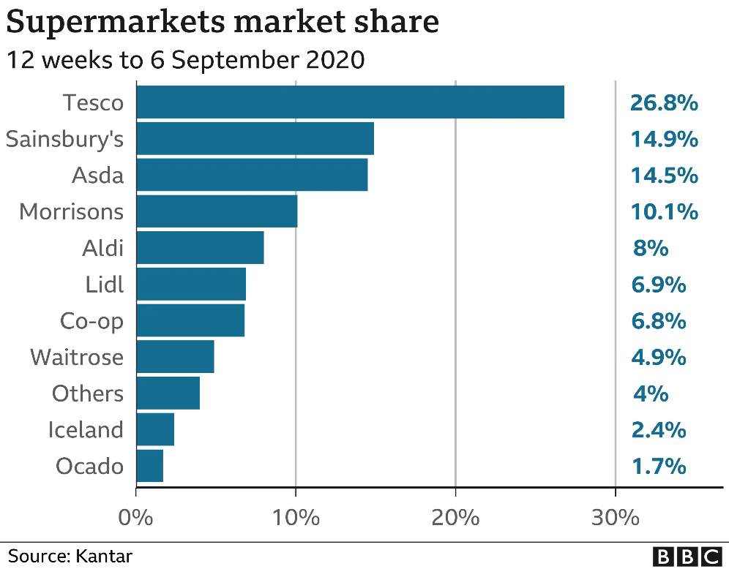
Figure 3: Supermarkets' Market Share
Source: (Simpson, 2020)
By the 12 weeks to September 6, 2020 Tesco is leading the UK supermarket industry with a large market share of 26.8%. The Sainsbury has adhered with 14.9, after being followed by Asda with 14.5. Morrisons took 10.1% and discounters Aldi and Lidl took 8 and 6.9 percent, respectively. Co-op had a 6.8 share, Waitrose had 4.9 shares, Iceland had 2.4 shares, Ocado had 1.7 shares and other retailers had a share of 4% of the market (Simpson, 2020).
Weaknesses: Tesco has had prior problems in Asian markets especially in China and South Korea that have led to the issue of cultural adaptation, localisation and highlighted the problem of understanding different consumer preferences.
Opportunities: The presence of a high growth middle class in Vietnam, rising urbanisation and government support towards foreign direct investment offers Tesco great opportunities in the growth of modern retail formats.
Threats: The competitive environment that includes existing regional competitors like AEON and “Big C” and the fact that the regulatory issues might be complicated might prevent new entrant and operational success by Tesco (Diem, 2022).
Value Chain Analysis for Tesco in Vietnam
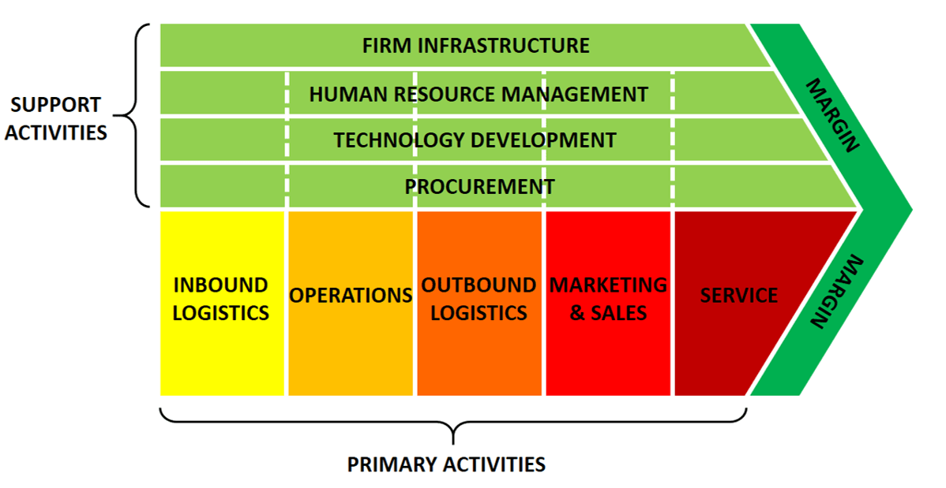
Figure 4: Value Chain Analysis
Source: (Bruin, 2019b)
Inbound Logistics: Tesco has well developed inbound logistics due to its global sourcing network and highly developed supply chain systems. The firm can also use local suppliers of fresh produce in Vietnam and regional distribution centres to minimize transportation expenses, and in order to replenish inventory faster.
Operations: The model of Tesco effective operations, store standardisation, automation, and digital inventory management can be successfully transferred to the urban retail business in Vietnam.
Outbound Logistics: Tesco can combine sophisticated distribution technologies and local delivery networks to enhance the efficiency of the last-mile as Vietnam is expanding a logistics infrastructure (Zhao, 2021). The proposal to invest in e-commerce fulfilment centres will enable Tesco to consolidate its online delivery activities and ensure that its customers are satisfied with its online delivery services.
Marketing and Sales: There are digital marketing, mobile applications and loyalty programs that Tesco may exploit to embrace tech savvy Vietnamese buyers. Promotions will be culturally modified, prices will be competitive and the expressive use of campaigns to amplify the wellbeing of the community will boost brand values and the loyalty of the customers.
Service: Tesco will be differentiated by high-quality customer service, hassle-free returns, and efficient after-sales support. The development of the customer-first culture at Tesco will involve training of the local staff so that they can maintain the customer-focused services at all stores in Vietnam (Sakata and Takanashi, 2022).
Key Issues: Tesco has a good brand presence in the market, efficiency and digital capabilities that can offer a strong foundation when entering the Vietnam market. Nevertheless, successful localisation, differentiating product lines based on the local behaviour, strategic local relationships, and database cultural sensitive marketing will result in sustainable success as well as consumer trust and loyalty.

4. Strategy Development and Formulation

4.1 Strategy Formulation
The term strategy formulation can be described as formulating long-term plans that define the direction of an organisation, its objectives, and the measures that need to be taken to attain the competitive advantage. It involves the combination of the internal strengths to the external opportunities, and the possible threats it faces. Strategy formulation in this case with Tesco in Vietnam will translate to planned entry and expansion plan that brokers the local market environment, consumer behaviour and competitive environment. It involves compromising between Tesco strengths from around the world and the thinking cultural and regulatory environment of Vietnam to be successful in the region.
Key Strategy Formulation Strategies for Tesco in Vietnam
Greenfield Investment: Tesco would be able to build its own stores and distribution outlets as well as online outlets. This gives complete freedom of operation, branding and customer experience. It involves immense financial risk, complex wave of regulatory procedures and deferment to profitability. This may not be the most efficient first approach at the Tesco in Vietnam where there is competition in the retail space.
Franchise Model: Franchising would enable Tesco to work with local business people running its brand. This will facilitate faster and capital-intensive growth. However, franchisees may not be able to maintain consistency and quality of services they give. In Tesco, the presence of strong management controls would be good to ensure that Tesco brand standards were maintained in the diverse retail environment in Vietnam.
Licensing: Brand and technology transfer of Tesco into a local retail chain could also provide access to the market fast and with little investment. However, this model plots less product quality, customer service, and efficiency of supply chain, which are the components that characterize the international image of Tesco.
Joint Venture: The collaborative venture with a top Vietnamese retail chain, like Saigon Co.op or VinCommerce, would diversify the trading experience of Tesco stores with the one of the domestic retail businesses. This approach enables cultural alignment, maneuvers through government regulation policies and helps in brand localization.
Recommended Strategy and Model Application: Joint Venture and VRIO Framework
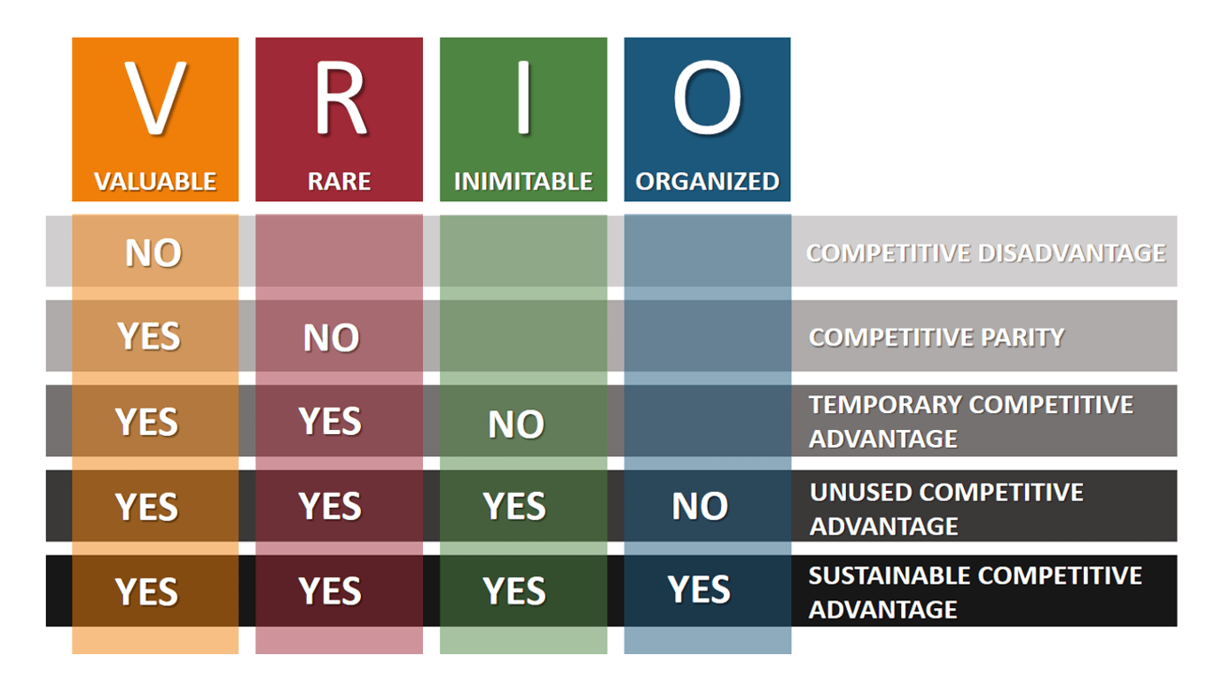
Figure 5: VRIO Framework
Source: (Bruin, 2019a)
Joint Venture Strategy: The Tesco can enter a joint venture with one of the existing Vietnamese retail firms like the Vina commerce or Saigon Co.op through this strategy, Tesco can bring in its expertise and experience in global retail, hi-tech technology and supply chain efficiency to the local partner with profound knowledge of market and cultural insight.
VRIO: Value The high-end supply chain systems, data-driven inventory management, and digital retail platforms offered by Tesco can bring a huge value to the fast-modernizing market of retail in Vietnam (Sakata and Takanashi, 2022).
Rarity: There are not many Vietnamese retailers of the same caliber with Tesco having both the global sourcing competence and online skills. This is the rarity that makes Tesco a company that can distinguish itself based on its excellent range of products and latest shopping experiences.
Imitability: Tesco has a complex integrated logistics network and data analytics, which is hard to imitate as it is complex and extensive (Zhao, 2021). This will develop a sustainable competitive advantage over domestic rivals.
Organization: Tesco has robust global governance with experience in managing cross-border business operations, which well places it to organize and access these resources optimally in the changing retail sector of Vietnam to achieve long-term strategic success.

4.2 Strategy Implementation
Defination of Strategy implementation
It is a process whereby strategic plans are converted into action plans by allocating resources, coordinating and implementing strategic plans. In the case of Tesco in Vietnam, it would entail setting up of local operations, developing supplier networks, training staff as well as a combination of technology systems to meet the needs of the market (Garnett, Mollan and Richards, 2024). The implementation of the strategic goals of Tesco is important in making sure that the strategic objective of the company is transformed into measurable and sustainable performance results.
Key Strategy Implementation Processes
The appropriate implementation of strategy with regard to Tesco in Vietnam needs to be in a programmed and well aligned manner. To begin with, the organizational alignment would guarantee that the structure, leadership, and culture of Tesco is geared towards expansion objectives. Second, there is resource allocation that is aimed at the efficient allocation of financial, technological, and human capital (Smith, 2023). Third, operational integration entails the efforts aimed at adjusting supply chains, IT to the market dynamics in Vietnam and likewise the retail format. change management and communicators are needed to involve employees and stakeholders, and create commitment to the long-term success of Tesco in the changing retail market in Vietnam.
Implementation of Strategies
Its venture into Vietnam will happen via a joint venture approach in which it will collaborate with a well-established local business, that is, Saigon Co.op to make use of its knowledge of the market and its systems of distribution. Such a strategy minimizes the risks associated with entry and augments the cultural flexibility. Marketwise, Tesco will first target key urban areas such as Ho Chi Minh City and Hanoi where consumer purchasing power and digital uptake remains strong (Suszynski, 2022). This will be followed by a gradual geographic expansion depending on the performance achievements and demand trends in the area.
The Tesco in relation to financial planning will invest capital strategically in areas of infrastructure, digitization of its supply chain and omnichannel retail platforms. This guarantees efficiency in operations and control of costs at the phase of the first expansion. On the inside, the talent cultivation and localization will be prioritized through the merger of the global management with the potential of working with Vietnamese personnel. The ongoing performance feedback based on KPIs like increase in market share, profitability, and customer satisfaction will help strategize the business so that it will succeed in the long run and remain in the Vietnam retail market.
Restructuring and Reengineering for Tesco’s Entry into Vietnam
Supply Chain and Logistics Optimization: Tesco has to rearrange their supply chain to the fragmentation distribution network in Vietnam (Enthoven and Van den Broeck, 2021). The collaboration with local sourcing and cold-chain logistic hotspots will contribute to the increased product freshness and decreased expenses.
Adaptation of Product Portfolio: The product mix of Tesco needs reengineering to suit the local food preferences of Vietnamese consumers, fresh foods and products, and low-cost household products. There will be increased relevance and profitability of the market by introducing their own brand products and partnering with local suppliers.
Human Resource and Training Systems: Tesco needs to re-design its HR model with local hiring and introduction of cross-cultural training interventions. The locality and the empowerment of local managers and inculcation of the global standards that can be applied in Tesco will prove effective in ensuring consistency in operations and congruency of culture.
Internal Strengths and Competitive Advantage for Tesco in Vietnam
Leveraging Digital Transformation: THR Tesco should be able to capitalize on the rising trend of online shopping in Vietnam by linking its online and physical system. In relation to the old retailers, data-driven omnichannel strategy will comprise of making Tesco more convenient, loyal and unique (Smith, 2023).
Local Partnerships: According to joint venture, retailers in Vietnam will easily be approached in terms of cultural information and regulation compliance came easy and this would be significant both in long term market entry as well as earning trust.
Supply Chain Localization: To localize the supply chain will lower down the costs, introduce freshness and bring the products of Tesco closer to the preferences of Vietnamese people. This plan helps to make operations flexible and customer satisfaction.

5. Performance Evaluation Framework

5.1 Evaluation and Control Importance of Evaluation and Control
Strategy management must contain evaluation and control; it is needed to be able to ensure that implementation is aligned to market realities and organizational goals. In the case of Tesco in Vietnam, the constant evaluation process helps determine the performance gaps, quantify the joint venture strategy performance, and acclimatize to the emerging retail business environment in Vietnam.

5.2 Evaluation, Monitoring, and Control Methods
Financial Performance Metrics: Strategic success can be measured using indicators like the growth of the revenues, the profit margins, and the ROI of Tesco (Zainudin, Nor and Kamisan, 2023). These indicators demonstrate financial soundness and inform investment in the competitive Vietnamese retail market.
Customer Satisfaction Analysis: Frequent surveys, reward schemes and online reviews assist Tesco to understand consumer attitudes and localization of services to meet local demands to maintain brand loyalty.
Operational Audits: The supply chain efficiency and store performance are audited periodically to determine any inefficiency with corrective measures taken in time.

5.3 Balanced Scorecard for Tesco in Vietnam
Financial Perspective: In its operations in the Vietnam retail sector, Tesco must target revenue development, cost efficiencies, and profitability along with profitability ratios in terms of retail outlets and small businesses in the long run which will guarantee long-term profitability and financial sustainability.
Customer Perspective: The loyalty programs, as well as the localised and digital convenience in increasing customer satisfaction will reinforce the brand to Tesco and lead to customer repeat business acquisition in the already competitive Vietnamese market (Enthoven and Van den Broeck, 2021).
Internal Process Perspective: The efficiency of supplying chain, store management, and inventory control with the help of digital systems will help cut waste, improve productivity, and facilitates the routine of delivering services to all Vietnamese shops.
Learning and Growth Perspective: Employee training, leadership, and digital investment will promote flexibility, allowing employees to ensure high service standards and stimulate constant evolution in the retail industry, which is constantly changing in Vietnam.

5.4 Financial Plan
Importance and Effect of Strategies on Financial Position: The financial plan should be well structured to sustain Tesco expansion in Vietnam and make it successful in the long run. Strategic choices, like joint ventures, home supply chain localization and investment in digital infrastructure directly affect the financial status of the company. At the beginning, capital expenditure will be high because of the infrastructure establishment, training, and integration of technologies, but they are necessary in creating competitive presence (Azan and Karimah, 2022). The profitability will be improved over time due to the economies of scale, sourcing at a low cost as well as the higher volume of sales.
Tesco Group Income Statement (2024–2025)
The Tesco Revenue increased to 69.9 billion in 2025 compared to 68.2 revenue in 2024. The financial performance was improved with a net profit which rose to the height of 1.63 billion (Smith, 2023). Earnings per share have been increased to 23.79p in comparison to 16.74p, making it to be seen that there is efficiency in its operations and a strong financial foundation to be conducted in global expansion plans which include Vietnam (Refer to Appendix 1).
Tesco Group Balance Sheet (2024–2025)
As of 22 February 2025, Tesco had the total assets amounting to 38.9 billion and the total equity amounted to 11.66 billion, which is stable compared to the year 2024 (Tesco PLC, 2025a). The amount of non-current assets was £30 billion as compared to the amount of current assets of 8.8 billion (Refer to Appendix 2).
Tesco Group Cash Flow Statement (2024-2025)
In 2025, Tesco net cash flow of operations activities was lower than in 2024, by 2.9-3.8 billion, and was contributed by increased tax and interest payment. There was an investment activity of £441 million and a financing activity of an outlay of 2.9 billion which is a share buyback and dividend payment. Ending cash stood at £1.4 billion (Refer to Appendix 3).
EBIT Reconciliation of Balance Sheet Measures
The Net debt ratio/EBITDA ratio of Tesco has also advanced to 2.0 in the year 2025 as compared to 2.2 in 2024 indicating higher efficiency in operations and great management of the debt with the increased EBITDA of 4.8 billion (Tesco Plc, 2025).

6. Recommendation and Conclusion
Strengthen Local Market Adaptation: To realize sustainable growth, Tesco should focus on local consumer preferences, and social-cultural trends in Vietnam. Despite enjoying its good international image, the company has to align its product portfolio, pricing, and marketing initiatives to the Vietnamese consumerism (Khanta and Srinuan, 2019). Localization must reach beyond language and cultural representation but should also affect the supply chain sourcing, relations with local farmers, and interactions with the community.
Enhance Financial Efficiency and Capital Utilization: Tesco reports to be having good liquidity position and steady assets in the financial review but yet businesses have problems on optimisation of working capital and management of long-term debt. The 2025 balance sheet reflects that the net assets are valued in 11.66 billion including stable non-current assets and middle liabilities (Tesco PLC, 2025a). However, according to the cash flow statement, the net cash of operations is low compared to that in 2014 that ought to emphasize that better financial control is needed. Tesco must also be more efficient by investing more capital in areas that can directly aid in growth within the market in Vietnam such as store digitalization and the automation of logistics (Huffaker and Fearne, 2019). Continuous monitoring with the assistance of the key metrics (net debt/EBITDA ratio 2.0 now) will allow sustaining a balanced financial structure.
Integrate Technology and Sustainability in Strategy Execution: Tesco will have to integrate digital transformation and sustainability into its strategy implementation processes to ensure that it remains relevant in the Vietnam retailing business landscape that is slowly transforming. Modern technologies can be used in order to encourage organizational efficiency and customer experience, such as artificial intelligence in demand forecasting, automated warehouse management, and electronic payment systems (Fernandez Vilas et al., 2018). Sustainability needs to be applied at all levels of implementation of the strategies: for example, the designs of the stores as energy efficient systems and supply chain management environmental friendly. For Tesco, the current thrust that Vietnam has on the space of environmental responsibility provides a window of opportunity to get positioned as a green store.
Improve Monitoring, Evaluation, and Human Capital Development: This is one of the core reasons for the success of Tesco because it can access and control the implementation of strategies (Abdelazim, 2024). Therefore, the firm needs to implement an improved performance management plan that relies on the Balanced Scorecard strategy which focuses on financial, customer, internal process, and learning aspects. The strategic objectives and the operations will be fulfilled by performing periodic analysis of the performance and through continuous feedback mechanisms.
Conclusion: The strategic process used by Tesco in Vietnam has demonstrated a tension between the use of competence from global headquarters and the realities of the local market. As noted in the analysis, the financial strength of the company, which is backed by effective capital management and efficiency enhancement gives the company good opportunity to grow in the long term. Nevertheless, Tesco should aim at the localization, technological innovation, integration of sustainability, and development of human capital to continue the momentum. The Balanced Scorecard and financial indicators like cash flow, performance of the income statement and net debt/EBITDA ratio give valuable information to continuously enhance.
With these recommendations in place, Tesco will be able to legitimize its role as a reliable retailer in Vietnam with profitability and resiliency in its operations. Finally, the company’s success will be based on how it can implement global policies to local levels and ensuring financial discipline and incorporating a culture of innovation and sustainability so that Tesco will not just expand but also succeed in the recent Vietnamese retail environment.

Reference list
Abdelazim, Z. (2024). Organization Behavior - TESCO Case. SSRN Electronic Journal.
Azan, M.E.M. and Karimah, W.N. (2022). The Relationship between Customer Loyalty Program and Customer Retention at Tesco. Research in Management of Technology and Business, 3(2), pp.174–184. doi:https://publisher.uthm.edu.my/periodicals/index.php/rmtb/article/view/9730.
Bruin, L. de (2019a). VRIO Framework EXPLAINED with EXAMPLES | B2U. [online] B2U - Business-to-you.com. Available at: https://www.business-to-you.com/vrio-from-firm-resources-to-competitive-advantage/.
Bruin, L. de (2019b). Value Chain Analysis EXPLAINED with EXAMPLES | B2U. [online] B2U - Business-to-you.com. Available at: https://www.business-to-you.com/value-chain/.
Coyle, D. and Gamberi, L. (2024). A real options approach to data valuation. Business Economics. doi:https://doi.org/10.1057/s11369-024-00374-2.
Diem (2022). Customer service culture at BigC retail chain in Vietnam.“. [online] Available at: https://www.researchgate.net/profile/Tony-Ng-29/publication/354522512_Customer_service_culture_at_BigC_retail_chain_in_Vietnam/links/613c55a64e1df271062ae966/Customer-service-culture-at-BigC-retail-chain-in-Vietnam.pdf.
Enthoven, L. and Van den Broeck, G. (2021). Promoting Food Safety in Local Value Chains: The Case of Vegetables in Vietnam. Sustainability, 13(12), p.6902. doi:https://doi.org/10.3390/su13126902.
Fernández Vilas, A., Díaz Redondo, R.P., Crockett, K., Owda, M. and Evans, L. (2018). Twitter permeability to financial events: an experiment towards a model for sensing irregularities. Multimedia Tools and Applications, [online] 78(7), pp.9217–9245. doi:https://doi.org/10.1007/s11042-018-6388-4.
Garnett, P., Mollan, S. and Richards, B. (2024). Counter-hostility as defensive strategy in a hostile takeover: The acquisition of Hillards supermarket chain by Tesco. Business History, pp.1–23. doi:https://doi.org/10.1080/00076791.2024.2321918.
Huffaker, R. and Fearne, A. (2019). Reconstructing systematic persistent impacts of promotional marketing with empirical nonlinear dynamics. PLOS ONE, 14(9), p.e0221167. doi:https://doi.org/10.1371/journal.pone.0221167.
Iftikhar, S., Raj, U., Tuli, S., Golec, M., Chowdhury, D., Gill, S.S. and Uhlig, S. (2022). TESCO: Multiple Simulations based AI-augmented Fog computing for QoS Optimization. IEEE Xplore. doi:https://doi.org/10.1109/SmartWorld-UIC-ATC-ScalCom-DigitalTwin-PriComp-Metaverse56740.2022.00302.
Khanta, F. and Srinuan, C. (2019). The relationships between marketing mix, brand equity, lifestyle and attitude on a consumer’s private product brand purchasing decision. African Journal of Hospitality, Tourism and Leisure, [online] 8(5). Available at: https://www.ajhtl.com/uploads/7/1/6/3/7163688/article_43_vol_8_5__2019_thailand.pdf.
Lokanan, M. (2021). Applying Four Quantitative Prediction Techniques to Detect Fraud in Financial Statements. Journal of Forensic and Investigative Accounting, [online] 13(2). Available at: http://web.nacva.com.s3.amazonaws.com/JFIA/Issues/JFIA-2021-No2-8.pdf.
Lomoio, S., Pandey, R.S., Rouleau, N., Menicacci, B., Kim, W., Cantley, W.L., Haydon, P.G., Bennett, D.A., Young-Pearse, T.L., Carter, G.W., Kaplan, D.L. and Tesco, G. (2023). 3D bioengineered neural tissue generated from patient-derived iPSCs mimics time-dependent phenotypes and transcriptional features of Alzheimer’s disease. Molecular Psychiatry, [online] pp.1–12. doi:https://doi.org/10.1038/s41380-023-02147-3.
Lomoio, S., Willen, R., Kim, W., Ho, K.Z., Robinson, E.K., Prokopenko, D., Kennedy, M.E., Tanzi, R.E. and Tesco, G. (2020). Gga3 deletion and a GGA3 rare variant associated with late onset Alzheimer’s disease trigger BACE1 accumulation in axonal swellings. Science Translational Medicine, 12(570). doi:https://doi.org/10.1126/scitranslmed.aba1871.
Peeroo, S. (2019). Customer-Initiated Conversations on Facebook Pages of Tesco and Walmart. Advances in Intelligent Systems and Computing, [online] pp.43–51. doi:https://doi.org/10.1007/978-981-13-3338-5_5.
PR Newswire (2024). Vietnam Retail Market to Expand by USD 226.4 Billion (2024-2028), Driven by Rising Demand for Convenience Foods, AI Driving Market Transformation - Technavio. [online] Yahoo Finance. Available at: https://finance.yahoo.com/news/vietnam-retail-market-expand-usd-191500988.html.
Saadipour, K., Tiberi, A., Lombardo, S., Grajales, E., Montroull, L., Mañucat-Tan, N.B., LaFrancois, J., Cammer, M., Mathews, P.M., Scharfman, H.E., Liao, F.-F., Friedman, W.J., Zhou, X.-F., Tesco, G. and Chao, M.V. (2019). Regulation of BACE1 expression after injury is linked to the p75 neurotrophin receptor. Molecular and Cellular Neuroscience, [online] 99, p.103395. doi:https://doi.org/10.1016/j.mcn.2019.103395.
Sakata, S. and Takanashi, F. (2022). Development of Inclusive Food Value Chain in the Mekong Region. [online] Available at: https://www.ide.go.jp/library/English/Publish/Reports/Brc/pdf/30_03.pdf.
Sharma, A., Jain, R. and Pajni, N.S. (2022). Risk Identification Techniques in Retail Industry: A case study of Tesco Plc. The Journal of Corporate Governance, Insurance, and Risk Management (JCGIRM), 9(1), pp.201–214.
Simpson, E. (2020). Tesco profits surge as online orders double. BBC News. [online] 7 Oct. Available at: https://www.bbc.com/news/business-54445399.
Smith, D. (2023). Logistics in Tesco: Past, Present and Future. Logistics And Retail Management insights Into Current Practice And Trends From Leading Experts, 1(2), pp.154–183. doi:https://www.taylorfrancis.com/chapters/edit/10.4324/9780429271144-8/logistics-tesco-past-present-future-david-smith.
Smith, D. (2023). Logistics in Tesco: Past, Present and Future. Logistics And Retail Management insights Into Current Practice And Trends From Leading Experts, 1(2), pp.154–183. doi:https://www.taylorfrancis.com/chapters/edit/10.4324/9780429271144-8/logistics-tesco-past-present-future-david-smith.
Statista (2025). Topic: Tesco PLC. [online] Statista. Available at: https://www.statista.com/topics/3807/tesco-plc/?srsltid=AfmBOorUhOLwYZMNIGqWoROgpi1QxKQFAeHDei3HC3oW8dHiMPVOdovS [Accessed 28 Oct. 2025].
Suszynski (2022). Cost optimization for R-logistics operations at foreign supermarkets in Vietnam. Case of AEON and Lotte. [online] Available at: https://www.researchgate.net/profile/Tony-Ng-29/publication/358022270_Cost_optimization_for_R-logistics_operations_at_foreign_supermarkets_in_Vietnam_Case_of_AEON_and_LOTTE/links/64e5d807434d3f628c423f97/Cost-optimization-for-R-logistics-operations-at-foreign-supermarkets-in-Vietnam-Case-of-AEON-and-LOTTE.pdf.
Tesco Plc (2025). Tesco PLC Annual Report and Financial Statements. [online] Available at: https://www.tescoplc.com/media/ky0bfwpo/tesco_ar25_interactive.pdf.
Tesco PLC (2025a). Annual Report 2025. [online] Tescoplc.com. Available at: https://www.tescoplc.com/investors/reports-results-and-presentations/annual-report-2025.
Tesco PLC (2025b). Tesco PLC. [online] Tesco Plc. Available at: https://www.tescoplc.com/.
Zainudin, C.N.B.M., Nor, M.E.B. and Kamisan, N.A.B.B. (2023). Non-trading days model for Tesco stock market forecasting. The 5TH ISM INTERNATIONAL STATISTICAL CONFERENCE 2021 (ISM-V): Statistics in the Spotlight: Navigating the New Norm. doi:https://doi.org/10.1063/5.0111062.
Zhao, C. (2021). Research on Cost Management of E-commerce Enterprises Based on Value Chain--Taking Suning Tesco as an Example. [online] doi:https://doi.org/10.25236/iemb.2021.026.

Appendix

Appendix 1: Income Statement
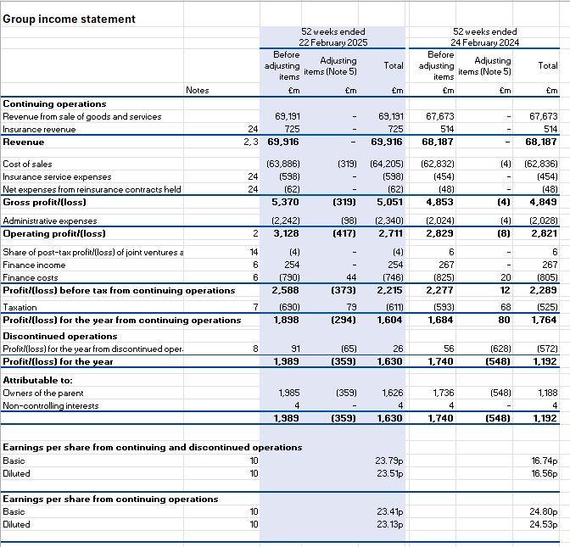

Appendix 2: Balance Sheet

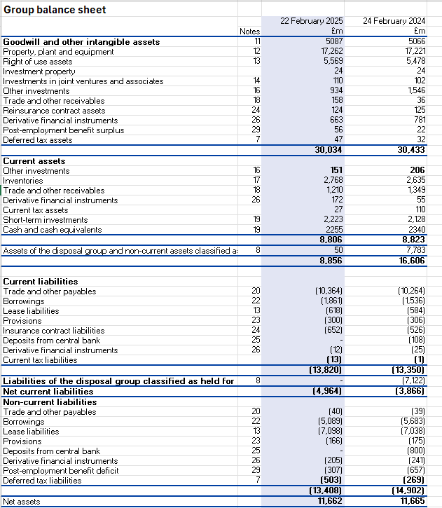
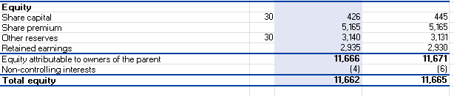

Appendix 3: Cash Flow
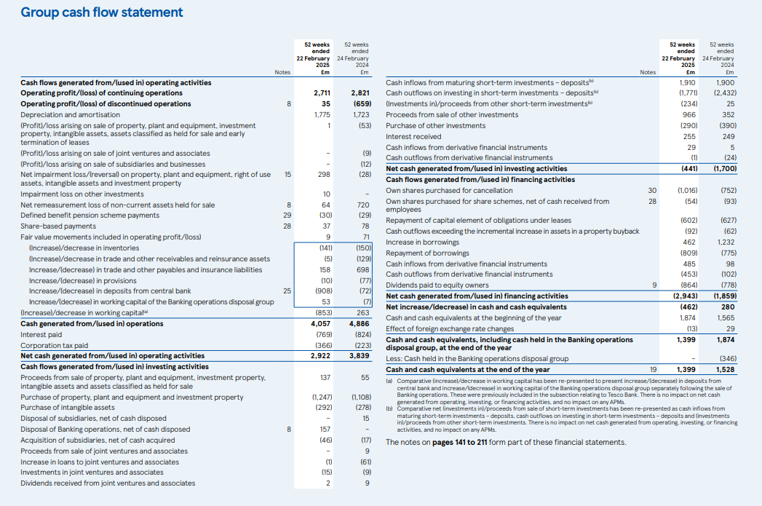

Appendix 4: EBITA
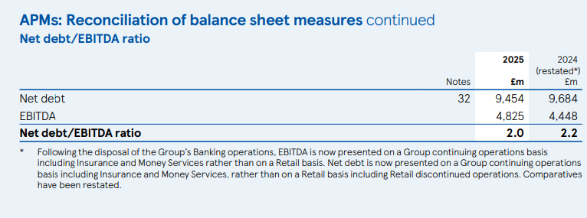

Appendix 5: Key Performance Indicators (KPIs) and Success Metrics for Tesco in Vietnam
Category | Key Performance Indicator (KPI) | Description | Success Metric / Target
Financial Performance | Revenue Growth Rate | Measures year-on-year increase in total sales revenue. | Achieve 10% annual revenue growth within the first three years.
Profitability | Net Profit Margin | Assesses efficiency in converting revenue into profit. | Maintain a net profit margin above 8% by year three.
Market Penetration | Market Share | Tracks Tesco’s share of the Vietnamese retail market. | Secure 5% national market share within five years.
Customer Engagement | Customer Satisfaction Index (CSI) | Gauges customer perception of service quality and shopping experience. | Maintain 85% or higher customer satisfaction rating.
Operational Efficiency | Inventory Turnover Ratio | Measures how efficiently inventory is managed and sold. | Achieve 8 inventory turns per year.
Supply Chain Management | On-Time Delivery Rate | Evaluates the percentage of deliveries made as scheduled. | Maintain 95% on-time delivery performance.
Employee Productivity | Sales per Employee | Determines staff efficiency in generating revenue. | Achieve annual sales of £150,000 per employee.
Sustainability and CSR | Carbon Emission Reduction | Tracks environmental performance across stores and logistics. | Reduce carbon emissions by 20% within five years.
Digital Transformation | Online Sales Contribution | Measures sales from e-commerce channels relative to total revenue. | Ensure 15% of total sales come from online platforms.
Brand Development | Brand Awareness Index | Monitors Tesco’s recognition and reputation in the local market. | Reach 70% brand awareness in target urban areas.

