Computer System Component Specification
Shamsa Kanwal
2229731
CertHE in Digital Skills B.Eng. in Electrical Engineering
Redhwan Al-amri
ACCA4028
11th Jan, 2024

Desktop PC specifications for an elderly relative.

A. CPU, Motherboard:

CPU: Intel Core i3-10100.
Motherboard: ASUS Prime H410M-A.
Justification:
The Intel Core i3-10100 processor is both inexpensive and energy-efficient, with plenty power to tackle tasks such as web browsing, video calls, and word processing. Its quad-core architecture offers smooth performance in regular applications. The ASUS Prime H410M-A motherboard was chosen due to its compatibility with the i3-10100, tiny form factor and consistent build quality. It provides the essential connectivity without adding extra features that increase the cost (Queiroz, Cruz and Simões, 2023, p.104848).
The Intel Core i3-10100 CPU and ASUS Prime H410M-A motherboard are at vital of this PC structure, suggesting a harmonious balance of presentation, cost-efficiency, and toughness. The Intel Core i3-10100 is a 10th generation quad-core processor with a base frequency of 3.6 GHz that can be enhanced to 4.3 GHz when needed. This CPU is capable of running common procedures like web browsing, video streaming, and light productivity tasks like word processing and email controlling. It additionally comes with Intel UHD Graphics 630, which can handle video playback and video calls without the need for a detached graphics card.

B. RAM:

RAM: 8GB DDR4 (2 x 4GB)
Justification:
8GB of RAM is adequate for the above-mentioned tasks, consenting for multitasking without overinvesting in excessive resources. The acquisition of two 4GB sticks facilitates dual-channel memory, which advances functioning. The decision to employ 8GB of DDR4 RAM, configured as two 4GB sticks, was made strategically to meet the needs and usage patterns of an elderly user who mostly performs everyday computing duties. This quantity of RAM provides the ideal balance between performance and cost, ensuring that the system functions smoothly without overspending on superfluous memory (Islam, Arafath and Hasan, 2014, December, pp. 148-151).
Furthermore, using two 4GB sticks rather than a single 8GB module enables the system to run in dual-channel mode. Dual-channel mode outperforms a single stick by increasing the throughput between the RAM and CPU. This implies that data may be processed more efficiently, resulting in slightly faster and more responsive system performance, which is visible in everyday use. RAM with DDR4 is preferred over DDR3 due to its superior energy efficiency and performance. DDR4 RAM runs at a lower voltage, consuming less power and producing less heat, and operates at a faster clock speed, allowing it to process more data more quickly. This is especially helpful in small systems where heat control is essential (Schmitz, 2015, pp.1-9).

C. Non-volatile Storage:

Storage: 256 GB SSD (SATA).
Justification:
SSDs are preferred over HDDs due to faster boot and load times. 256GB is more than enough for the operating system, vital programmes, and document and media storage. SATA SSDs provide a compromise between performance and affordability. A vital component of this system that focuses on both functionality and performance is the choice of a 256GB Solid-State Drive for non-volatile storage. There are several reasons why an SSD was selected as opposed to a conventional Hard Disc Drive. First of all, SSDs deliver faster boot speeds, quicker programme loading times and general quicker system functionality compared to HDDs. This speed lowers waiting periods and improves the user experience, making it especially useful for those who might not be as patient with technology (Alkorbi, 2015, pp. 23-34)
The capacity of 256GB is sufficient for the user's requirements. Given the usage scenario; word processing, email, web surfing, and occasional video chats — this amount of storage will easily support the operating system, vital software, and a fair collection of documents and multimedia files without running out of space. SSDs also feature no moving parts, making them more durable and reliable, which is especially crucial in a system that may not be upgraded frequently. They also work more silently and waste less electricity, which improves the system's efficiency. The choice of a SATA SSD strikes a balance between cost and performance, as NVMe SSDs, while quicker, would be overkill for this application.

D. Input/Output Features and Ports:

USB 3.0 and 2.0 ports.
HDMI and VGA for display connections.
Ethernet port
Audio jacks
Justification:
Multiple USB ports are required for accessories such as a keyboard, mouse, and potentially an external webcam. Most monitors can be connected via HDMI or VGA. An Ethernet port is supplied to ensure a stable internet connection, while audio jacks are typical for speakers or headphones. The input/output features and ports chosen for this desktop PC are designed to provide a wide range of connectivity possibilities, meeting the current and potential future needs of an elderly user. The provision of several USB 3.0 and USB 2.0 ports is critical. USB 3.0 ports enable greater data transfer speeds, making them perfect for connecting newer external devices such as USB drives or portable hard drives for backups, but USB 2.0 ports are compatible with a wide range of standard peripherals like as printers, scanners, and keyboards and the mouse.
An array of both HDMI and VGA ports guarantees flexibility when it comes to display connectivity. The former enables the user to connect to contemporary monitors or TVs for high-definition video output, which is essential for crisp video calls and enjoyable video streaming, while the latter is compatible with older monitors, meaning the PC can be seamlessly incorporated into pre-existing setups without requiring any additional upgrades. More dependable than wireless connections, an Ethernet connector is essential for a steady and secure wired internet connection—which is necessary for uninterrupted video chats and streaming. The usual audio jacks for speakers and headphones are also provided. These are necessary for clear audio during video conversations, watching content, and for privacy when desired. Together, these I/O features make the PC flexible and easy to use, supporting a variety of devices and use cases (Putman, 2014, October, pp. 1-10).

E. Graphics Cards:

Graphics: Integrated Intel UHD Graphics 630 (from CPU).
Justification:
The Intel UHD Graphics 630 built with the i3-10100 is sufficient for web browsing, video streaming, and video calls. There is no need for a specialised graphics card because gaming or intense graphic chores are not necessary. For this PC setup, we used the Intel UHD Graphics 630, an integrated graphics solution that ships with the Intel Core i3-10100 processor. This decision is influenced by the older user's individual needs and usage patterns, as they will not perform visual-intensive jobs such as gaming or professional graphic design.
The Intel UHD Graphics 630 is capable of handling most computer activities. It can handle web browsing, streaming high-definition video content from platforms such as YouTube, and conducting video conversations with Skype or comparable programmes. This level of graphical performance fully matches the user's needs for media consumption and communication. One key benefit of using integrated graphics is lower power consumption and system complexity. It eliminates the need for a separate graphics card, which helps to keep the system cost-effective, energy-efficient, and physically smaller - an important consideration given the tiny form factor desire. Integrated graphics also minimise the system's overall heat output, which is a key issue in small constructions. Furthermore, for an elderly user who may not be comfortable with regular hardware changes, an integrated solution provides simplicity and ease of use. There are no supplementary drivers or hardware to manage, making the system simpler and more accessible. In essence, the Intel UHD Graphics 630 strikes an arrangement between functioning and usableness, meeting the user's needs without the difficulties and expenses related with a dedicated graphics card (Gruzewski and Palkowski, 2021, pp. 473-482).

F. Case & Power Supply:

Case: Cooler Master Elite 130, Mini-ITX
Power Supply: Corsair CV450 (450W)
Justification:
The Cooler Master Elite 130 is tiny and meets the small form factor criterion. The Corsair CV450 power supply is reliable and more than suitable for this setup, guaranteeing steadiness and energy proficiency. The project uses the Cooler Master N200 Mini Tower case and the Corsair CV450 power supply, which strike a concession between size, functionality, and power efficiency. The Cooler Master N200 Mini Tower is a perfect choice because of its petite form factor, which meets the necessities for a small-sized PC. Despite its solid size, it offers adequate interior space for the vital components and effective circulation, guaranteeing that the system remains cool, which is fundamental given the user's shortage of technical familiarity. The case's clean, subtle design makes it well-matched for a diversity of locations, including the living room and the study. Furthermore, it offers quick access to USB and audio connectors on the front panel, which advances user convenience.
The Corsair CV450 power supply is chosen because of its dependability and efficiency. With 450 watts, it aso deliveries more than enough power to the system's constituents, confirming smooth operation. It is also 80 PLUS Bronze certified, demonstrating that it uses power resourcefully, which aids to reduce electricity expenses and heat production. The CV450's built-in protective devices for over-voltage, under-voltage, and short circuiting offer an additional layer of protection, which is critical for users who are unused with diagnosing hardware issues. This combination of a small, user-friendly case and a dependable, efficient power source creates the foundation of a system that is practical, long-lasting, and appropriate for the needs of an elderly user (Docter, Dulaney and Skandier, 2012, pp. 12-32).

G. Monitor:

Monitor: ASUS VA24EHE 23.8" Full HD
Justification:
A 23.8-inch monitor strikes an appropriate mix between size and desk space. Full HD resolution ensures that text and images are clear, which is excellent for those with vision issues. The ASUS VA24EHE 23.8-inch Full HD IPS monitor was chosen specifically to meet the visual comfort and requirements of an elderly user. The 23.8-inch screen size strikes the perfect combination between sufficient screen real estate and physical manageability. It is sizeable enough to clearly present content while decreasing eye strain, but not so huge that it becomes overwhelming on a desk or in a small area. The Full HD (1920 x 1080) display warrants the lucidity and prominence of text, images, and videos. For an elderly user, the aforementioned precision is critical because it creates reading text and viewing images simpler on the eyes. The IPS (In-Plane Switching) display is an essential feature of this monitor. Wide viewing angles and exceptional colour accuracy make IPS panels well-known for making consistent, brilliant colours from a diversity of viewing angles. This functionality is exceptionally useful for users who are not always in front of their screens (Zapf, et.al, 2015, p.036001).

H. Network connectivity:

Wi-Fi adapter: TP-Link TL-WN881ND, integrated with the motherboard (Ethernet).
Justification:
While the motherboard has Ethernet connectivity, it also has a Wi-Fi adaptor for wireless internet access. The TP-Link TL-WN881ND is a trustworthy and cheap alternative. This PC setup has Ethernet and Wi-Fi networking capabilities, providing flexible and dependable internet access. There is an Ethernet connector on the ASUS Prime H410M-A motherboard that supports wired connections. Because of its speed and stability, a wired Ethernet connection is advised. This is especially advantageous for activities like streaming and video conversations, where a steady connection is essential to prevent disruptions.
Additionally, a USB Wi-Fi adaptor is included to enable wireless communication. With this option, the user has more freedom to arrange the PC in places where it might not be feasible to run an Ethernet wire. In addition to being compatible with the majority of home networks and offering respectable wireless internet speeds for daily online activities, the Wi-Fi adaptor supports contemporary Wi-Fi standards. Whether for surfing, communication, or education, the user may always access the internet in the most convenient way thanks to this dual approach to network connectivity (Tramarin, Vitturi, Luvisotto and Zanella, 2015, pp.1877-1886).

Software

Windows 10 Home is the OS.
Virus protection: Bitdefender Antivirus Plus
Justification:
Learning about Microsoft Windows is not necessary if you use Windows 10 Home. The reason Bitdefender Antivirus Plus was designated is because of its high-class malware and virus fortification, which is principally important for less tech-savvy customers (Morris, Becker and Parkin, 2020, p.tyaa017).

Shopping List
Component | Product | Price | Retailer | Image
CPU | Intel Core i3-10100 | $120 | Amazon | 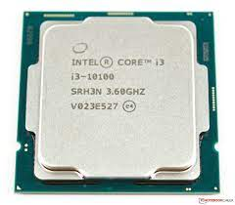
Motherboard | ASUS Prime H410M-A | $80 | Newegg | 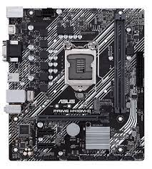
RAM | Corsair Vengeance 8GB DDR4 (2x4GB) | $45 | Best Buy | 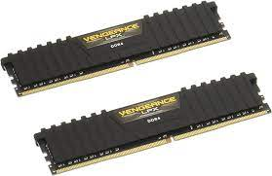
SSD | Samsung 860 EVO 256GB SATA | $50 | Amazon | 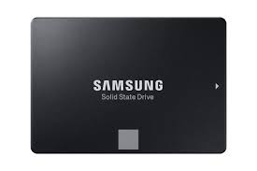
Case | Cooler Master Elite 130 - Mini-ITX | $60 | Newegg | 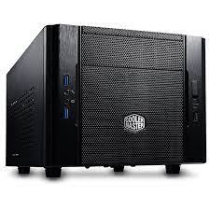
PSU | Corsair CV450, 450W | $45 | Amazon | 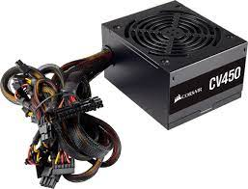
Monitor | ASUS VA24EHE 23.8-inch | $110 | Best Buy | 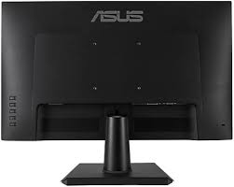
Wi-Fi Adapter | TP-Link TL-WN881ND | $20 | Amazon | 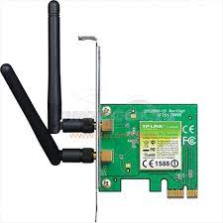
OS | Windows 10 Home | $100 | Microsoft | 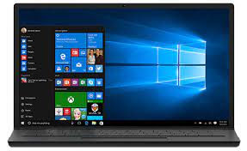
Antivirus | Bitdefender Antivirus Plus | $30 | Bitdefender | 

The entire cost is $660.

Note: Costs are an estimate and could change. Pictures are just for reference and might not show the exact model.

In conclusion, this construct prioritises value for money, dependability, and user-friendliness while taking an elderly user's needs into account. The selected parts guarantee a user-friendly experience and provide a balanced performance for jobs that are not gaming-related.

Bibliography
Queiroz, R., Cruz, T. and Simões, P., 2023. Testing the limits of general-purpose hypervisors for real-time control systems. Microprocessors and Microsystems, 99, p.104848.
Schmitz, T., 2015. The rise of serial memory and the future of DDR. White paper: UltraScale Devices, pp.1-9.
Alkorbi, M., 2015. Encryption, storage technology and security of data at rest (Master's thesis). pp. 23-34.
Gruzewski, M. and Palkowski, M., 2021. RNA folding codes optimization using the Intel SDK for OpenCL. In Artificial Intelligence and Soft Computing: 20th International Conference, ICAISC 2021, Virtual Event, June 21–23, 2021, Proceedings, Part II 20 (pp. 473-482). Springer International Publishing.
Docter, Q., Dulaney, E. and Skandier, T., 2012. CompTIA A+ Complete Deluxe Study Guide Recommended Courseware: Exams 220-801 and 220-802. John Wiley & Sons. pp. 12-32.
Zapf, M.P.H., Boon, M.Y., Matteucci, P.B., Lovell, N.H. and Suaning, G.J., 2015. Towards an assistive peripheral visual prosthesis for long-term treatment of retinitis pigmentosa: evaluating mobility performance in immersive simulations. Journal of neural engineering, 12(3), p.036001.
Tramarin, F., Vitturi, S., Luvisotto, M. and Zanella, A., 2015. On the use of IEEE 802.11 n for industrial communications. IEEE Transactions on Industrial Informatics, 12(5), pp.1877-1886.
Morris, J., Becker, I. and Parkin, S., 2020. An analysis of perceptions and support for Windows 10 Home Edition update features. Journal of Cybersecurity, 6(1), p.tyaa017.
Putman, P.H., 2014, October. Next-Generation Display Interfaces: Smaller, Faster & Denser. In SMPTE 2014 Annual Technical Conference & Exhibition (pp. 1-10). SMPTE.
Islam, M.A., Arafath, M.Y. and Hasan, M.J., 2014, December. Design of DDR4 SDRAM controller. In 8th International Conference on Electrical and Computer Engineering (pp. 148-151). IEEE.

