Name: Oana Catalina Georgescu
ID: 2027348
Module: Data Handling and Business Intelligence (LCBB5000)
Lecturer: Dr Eric Osei
Assignment Title: Coursework (Written Report)

Table of Contents
Part 1 3
Introduction 3
(a) Data visualisation dashboard 4
(b) Slicers and Filter connections 10
(i) Most profitable product line 10
(ii) Performance of Branches 10
(iii) Sales performance by gender 11
(c) Analysis of customer ratings 12
Part 2 14
a) Advantages and disadvantages of Excel 14
b) Meaning and importance of data mining 15
References 17

Part 1

Introduction
Businesses and organisations can evaluate and comprehend their data via data visualisation. Using PivotTables in Excel is a common method of data visualisation. Large volumes of data can be analysed and summarised with the aid of pivot tables, enabling organisations to base choices on their findings. In this report, the analyser examined the creation of a Pivot Table in Excel, the selection of fields, the analysis of data, and the development of charts for improved display. With the available data, it has also examined the profitability of product lines, the performance of various branches, and sales performance by gender.

(a) Data visualisation dashboard
To create the data visualisation dashboard PIVOT table will be used. Users of Microsoft Excel have access to a data analysis tool called a Pivot Table (Dierenfeld and Merceron, 2012). This tool enables users to summarise and reorganise vast volumes of data into a compact, flexible, and interactive table format. PivotTables are available in Microsoft Excel. Users can glean valuable insights from complicated and unstructured data with the assistance of this application. PivotTable is a very helpful tool for data analysis since it can be used in a variety of ways, such as summarising, filtering, and grouping data depending on a variety of criteria (Selwyn, 2020). PivotTable assists users in recognising patterns, trends, and insights hidden within their data by providing them with the ability to rapidly and simply change the layout of their data. PivotTable is a valuable tool for data analysis because it enables users to execute calculations on their data, such as adding up the totals, averaging the results, and calculating percentages.
Step 1: Create a new sheet
Creating a new sheet on which the pivot table will be built is the first step in generating a Pivot Table in Excel for supermarket data (Domino et al., 2021). As a result, the original data and the Pivot Table are kept apart. The procedures below should be followed to generate the new sheet using PivotTable for the Supermarket data.
- A spreadsheet with data from the supermarket should be opened (Miller, 2014).
- Within the data range you wish to use for the pivot table, click on any cell.
- Open the top menu and select the "Insert" tab.
- In the "Tables" section, select "PivotTable".
- Choose "New Worksheet" from the drop-down menu in the "Create PivotTable" dialogue box (Palocsay, Markham and Markham, 2010).
- On "OK," click.
The workbook will receive a new page that you may use to create your pivot table as a result. The following step involves choosing the data set the analyser wants to utilise for the pivot table and creating it by dragging and dropping fields into the "Rows," "Columns," and "Values" sections (Hai-Jew, 2019).
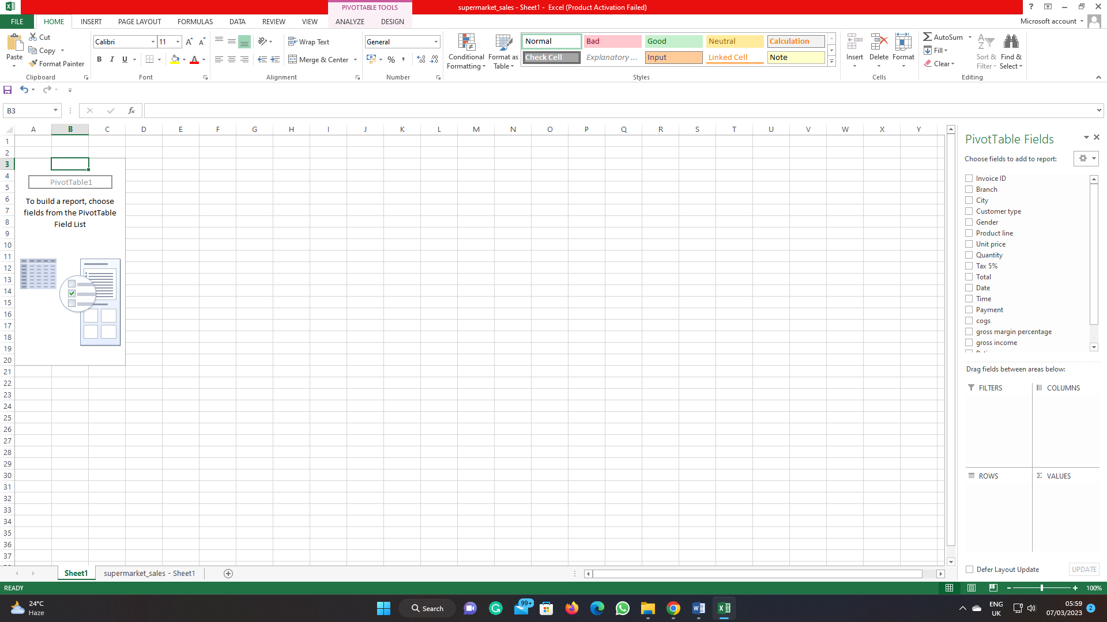
Step 2: Choosing fields
Selecting the fields you want to include in your PivotTable is the second stage in constructing a PivotTable in Excel for data from a supermarket (Cosma, 2019). The analyser will choose the fields for your pivot table in this phase, such as the invoice ID per sales, the gross margin percentage per product, the date per gross sales, the cost of goods sold (COGS) for each product line, and the product per customer ratings. To choose fields for the supermarket data using a pivot table, proceed as follows:
- Find the "PivotTable Fields" pane on the right side of the screen on the new sheet where the pivot table is located (Boschetti, Golfarelli and Graziani, 2019).
- Select the fields want to include in your PivotTable from the "Choose fields to add to report" section.
- Drag and drag the fields to the "Rows," "Columns," and "Values" sections of the "PivotTable Fields" pane as needed (Clark, 2020).
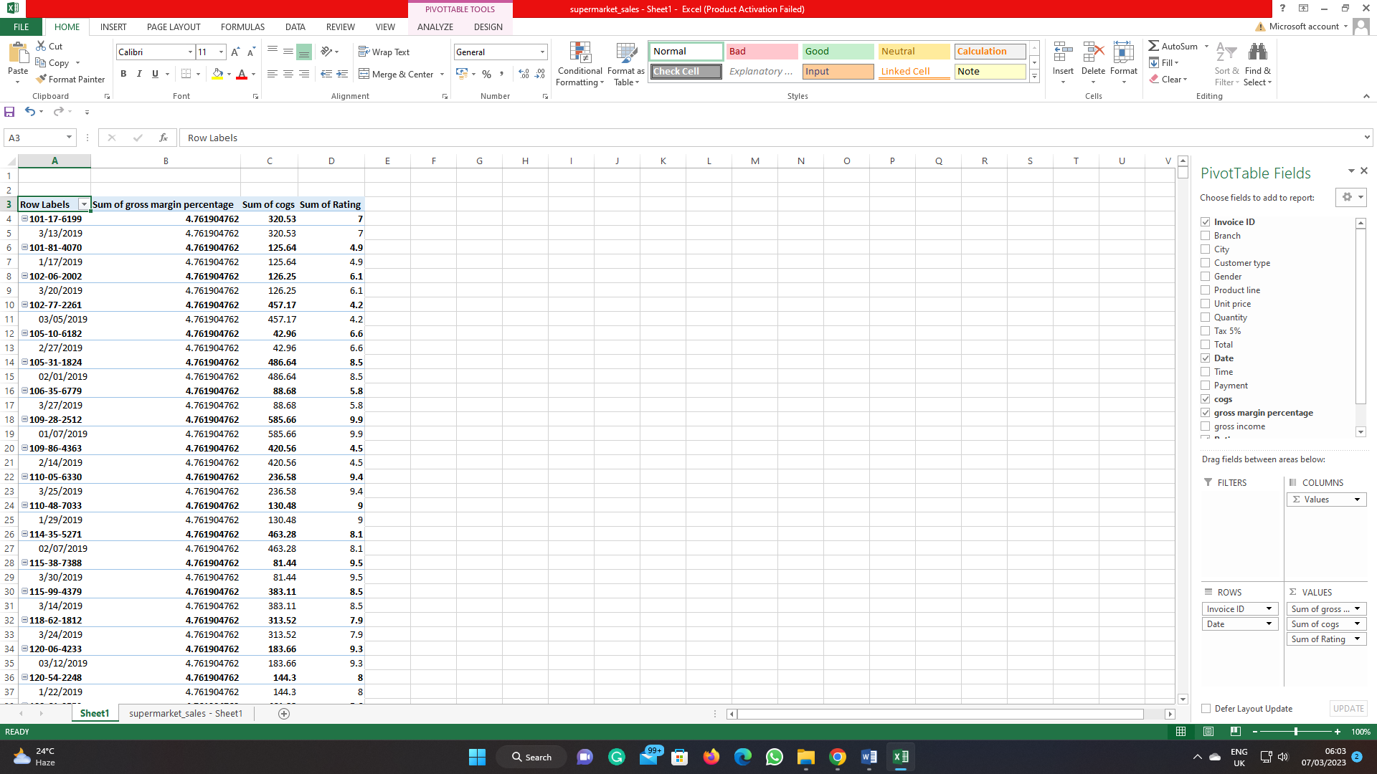
Step 3: Shorting data from largest to smallest
The final step in building a PivotTable for grocery store data in Excel is to sort the data according to the fields the analyser has chosen, from largest to smallest (Dobashi, 2018). The analyser will be better able to grasp the trends and patterns in your data and the highest and lowest numbers in it as a result. The following procedures should be followed to sort the supermarket data using PivotTable:
- Click on any PivotTable cell.
- Open the top menu and select the "Data" tab.
- Whether the analyser wishes to arrange data from largest to smallest or from largest to smallest, choose the appropriate option by clicking on it (Selwyn, 2020).
- Choose the desired field from the drop-down menu.
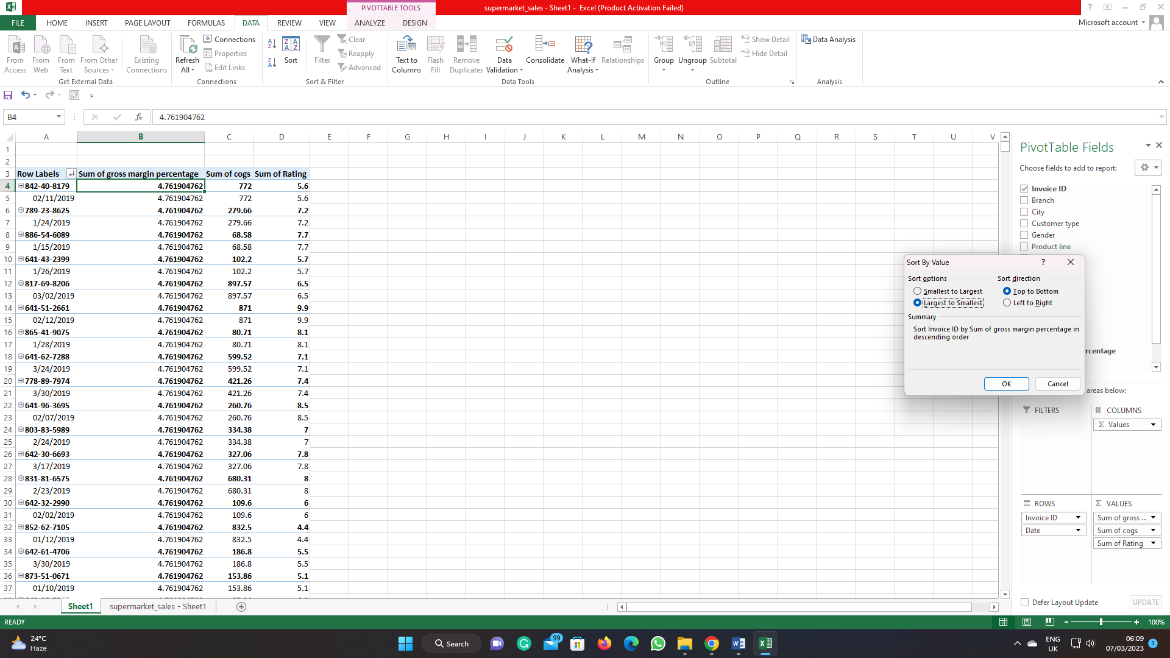
Step 4: Analyse
Analysing supermarket data using the fields the analyser choose is the fourth step in generating a Pivot Table in Excel (Palocsay, Markham and Markham, 2010). This stage uses PivotTable to produce summary statistics, make charts and graphs, and analyse data. PivotTable supermarket data analysis:
- Filter data by criteria in the "Filters" column. Drag the field to the "Filters" area of the "PivotTable Fields" pane.
- Use "Charts" to visualise data. Choose the chart type from the "Charts" section under the "Insert" tab in the top menu (Miller, 2014).
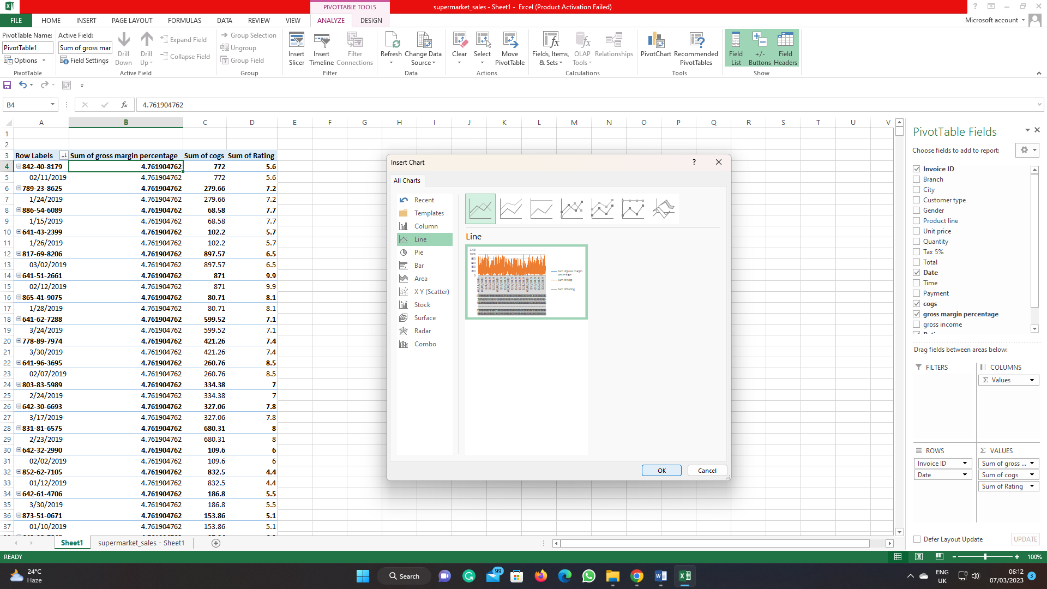
Step 5: Develop a chart for the gross profit using invoice ID and date
For supermarket data, use PivotTable to produce a gross profit chart using Invoice ID and Date:
- Choose the Pivot Table with the data in the chart.
- Excel's "Insert" tab (Hai-Jew, 2019).
- Under "Charts," select the chart type you want to create. Column, line, or bar charts are options.
- The worksheet will have a chart and "Chart Tools" on the ribbon.
- Click "Design" in "Chart Tools".
- "Choose Data" in the "Data" group (Domino et al., 2021).
- "Add" a new series in the "Choose Data Source" dialogue box.
- "Series name" in the "Edit Series" dialogue box.
- Choose the data range for the chart in the "Series values" column. PivotTable columns include Gross Profit.
- Choose the chart's X-axis data in the "Series X values" section. PivotTable columns include Date.
- Click "OK" to return to the chart.
- Use "Chart Tools" to format the chart.
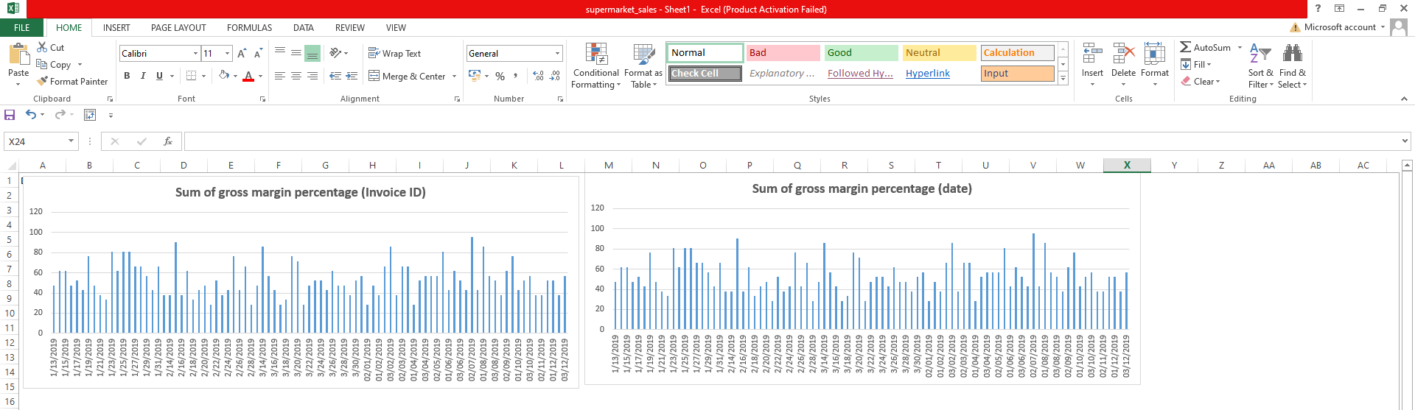
Step 6: Repeat the process for COGS (Cost of goods sold)
The same process as which has been mentioned above gross profit has been used here as well.
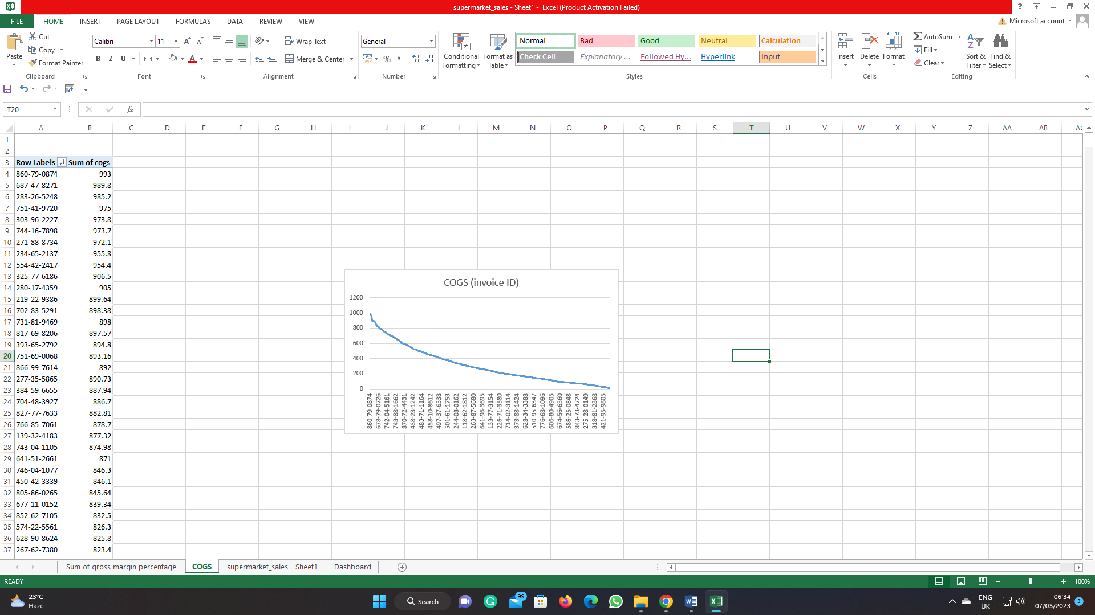
Step 7: Repeat the process for Product per customer ratings
Here too, the identical method that was utilised to calculate gross profit was applied.
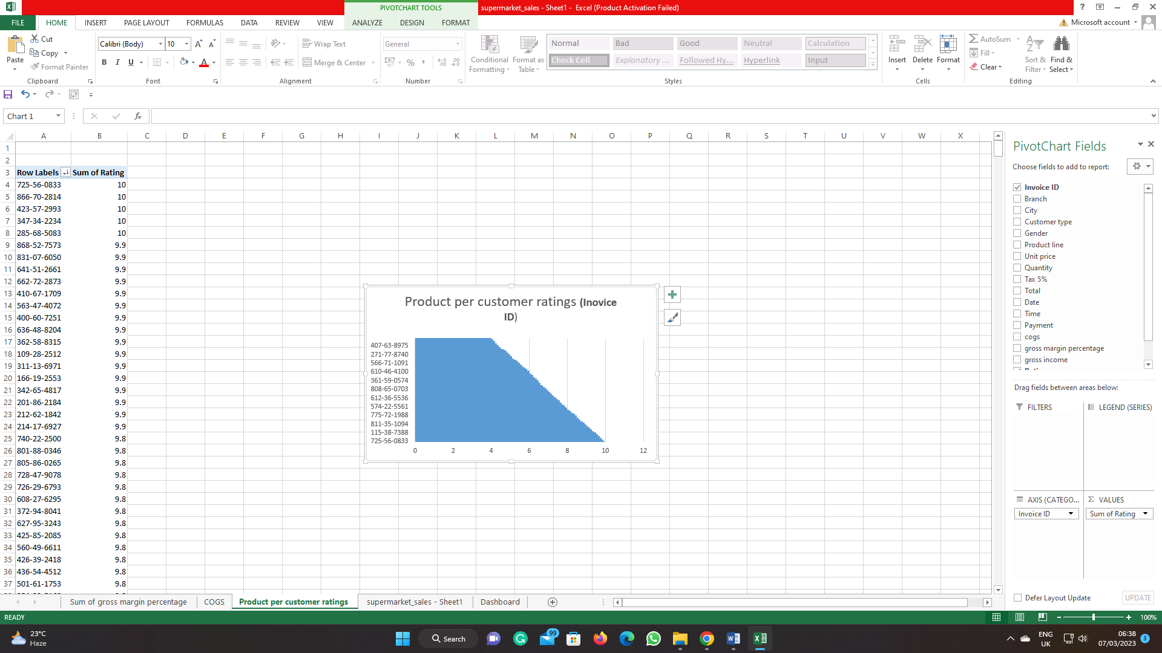
Step 8: Final Dashboard
Use PivotTable to generate the following final dashboard for the supermarket data:
- Put the Pivot Table, charts, and other worksheet components in a pleasing visual order (Dobashi, 2018).
- To add context and make it apparent what the viewer is looking at, give each element titles and labels.
- Make the dashboard readable and visually appealing by using formatting tools.
- Provide interactive components so the user can go deeper into the facts. Slicers, for instance, can be used to let the user filter the data based on particular standards like a date range or a product type (Dierenfeld and Merceron, 2012).
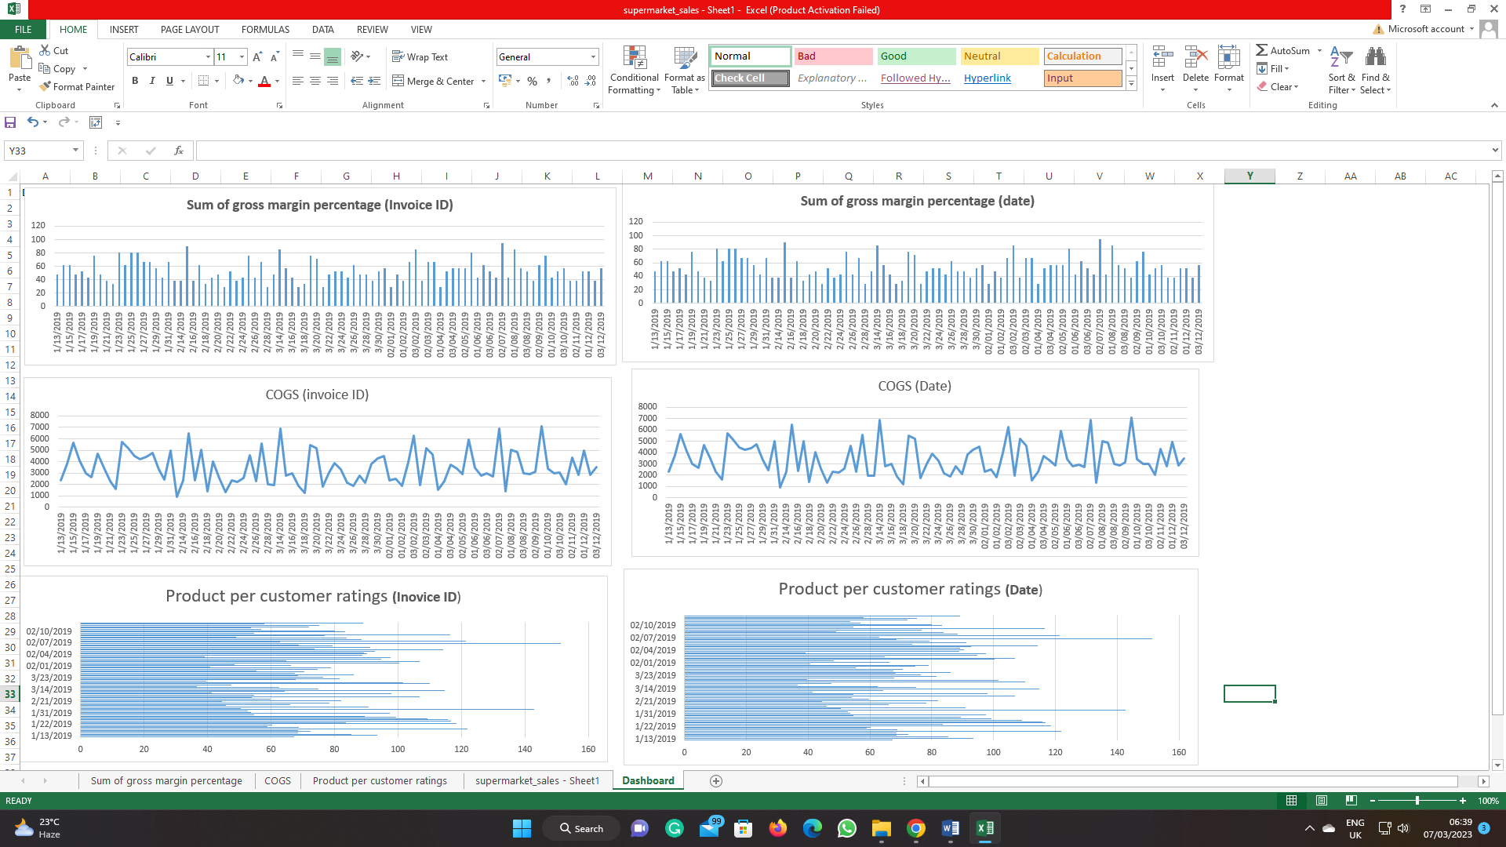

(b) Slicers and Filter connections

(i) Most profitable product line
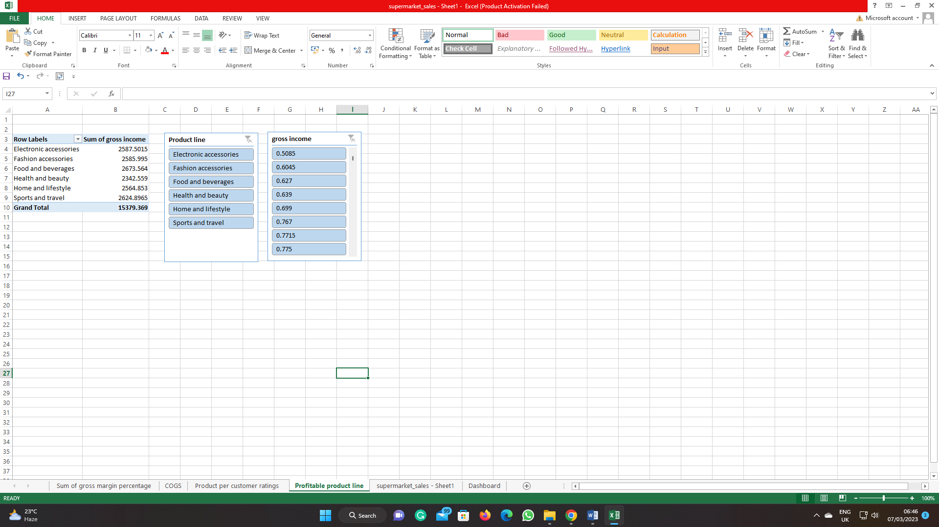
According to the information presented in the above figure, the product line "Food and beverages" generates the most gross income, with a total of 2,673,564 dollars. Following closely after "Electronic accessories" with a gross income of 2587.5015 is "Sports and travel," which has a gross income of 2624.8965. This product line is the second most profitable after "Electronic accessories." When compared to the top three product lines, the other product lines, including "Fashion accessories," "Home and lifestyle," and "Health and beauty," have lower gross revenues. According to the data, the product line that falls under the category of "Food and beverages" is the one that brings in the greatest revenue (Dobashi, 2018).

(ii) Performance of Branches
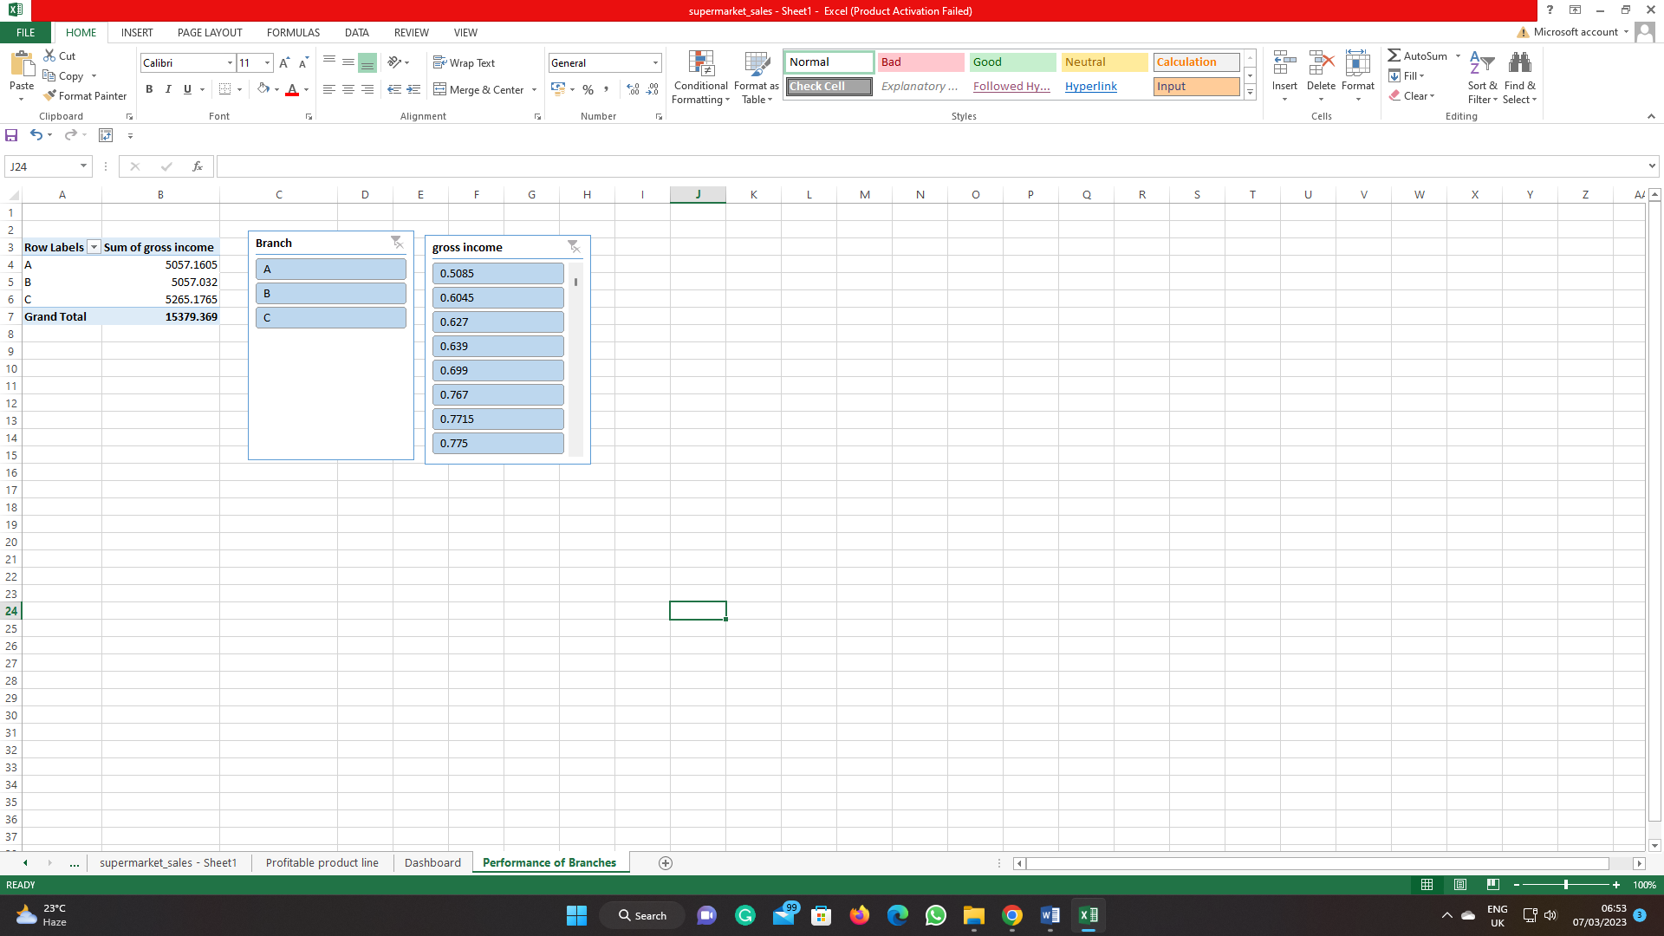
According to the information that has been presented, Branch C has the greatest gross income, which comes in at 5265.1765, followed by Branch A, which has a gross income of 5057.1605, and Branch B, which has a gross income of 5057.032. Although Branch A and Branch B have the same amount of sales, Branch A has a slightly greater gross income, which suggests that it either has a higher profit margin or offers more-priced products. Branch B has a slightly lower gross income.
On the other hand, to do a comprehensive analysis of the performance of the branches, we require additional data, such as the number of transactions, the average transaction value, and the operating expenses (Dierenfeld and Merceron, 2012). Based on the gross income alone, we are unable to arrive at any conclusions. In addition, the performance of the branches could also be affected by other factors, such as their location, their client base, and the level of competition they face. Thus, additional analysis is necessary to determine the performance of the branches in an exact manner.

(iii) Sales performance by gender
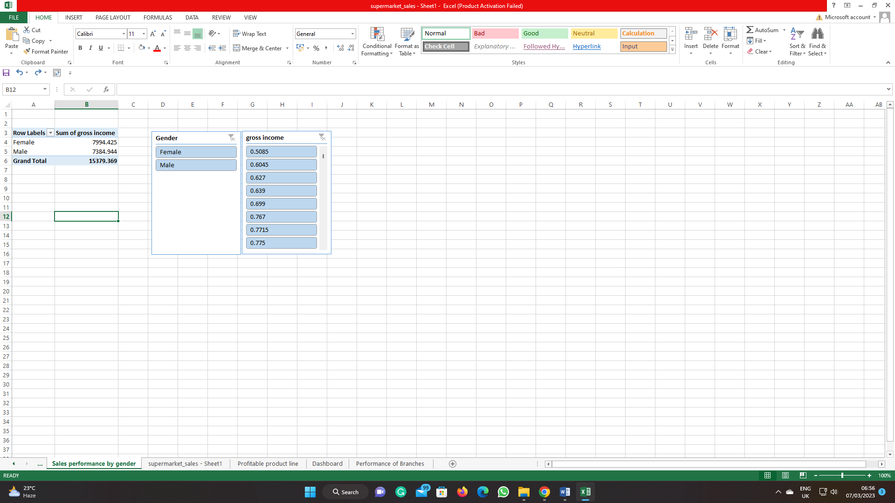
According to the information presented, the number of items sold to female clients is more than the number of items sold to male customers. When compared to the gross money created by male customers, which is 7384.944, the gross income generated by female consumers is significantly higher, coming in at 7994.425.
Yet, we need to carry out additional research to comprehend the reasons behind the disparate sales performance based on gender. For instance, we could wish to investigate the products that are more well-liked among female clients, as well as the shopping patterns of both sexes and the marketing tactics that are utilised to appeal to each of the genders.
In addition, this analysis does not take into consideration other aspects that may affect sales performance, such as a person's age, amount of income, or geographic region. As a result, we are unable to arrive at any definitive conclusions based solely on this fact (Clark, 2020). To get a deeper understanding of sales performance based on gender, additional research and perspectives are required.

(c) Analysis of customer ratings
Mean | 6.9727 | =AVERAGE(C2:C1001)
Median | 7 | =MEDIAN(C2:C1001)
Mode | 6 | =MODE(C2:C1001)
Range | 6 | =MAX(C2:C1001)-MIN(C2:C1001)
Standard Deviation | 1.717721 | =STDEV.P(C2:C1001)

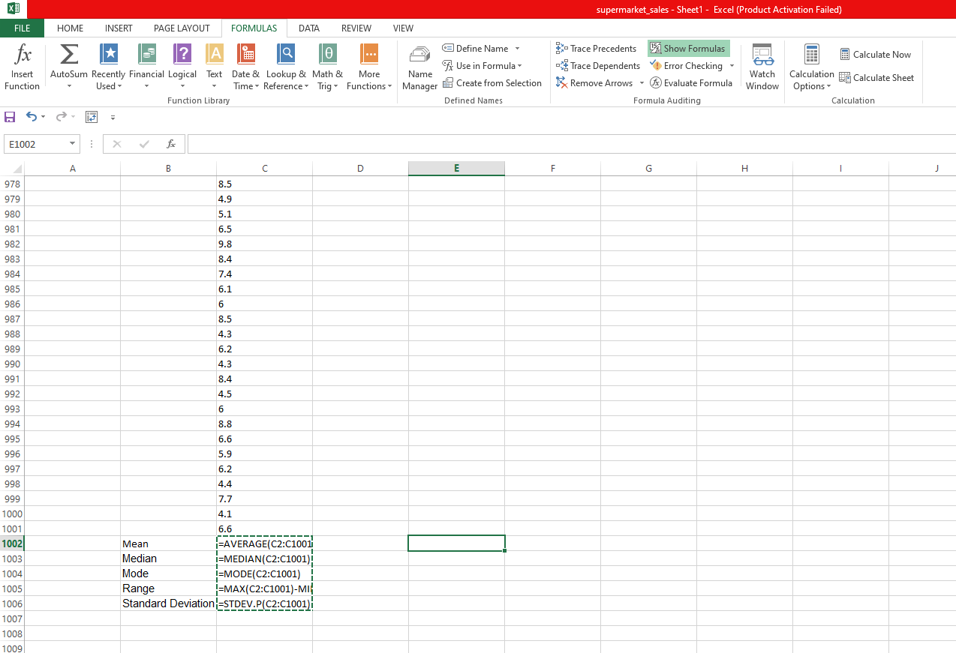
The supermarket received a positive review from its customers, as indicated by the supermarket's mean customer rating of 6.9727, which indicates that customers, on average, gave the supermarket a positive rating. The majority of consumers gave supermarket ratings between 6 and 7, which is consistent with the good trend suggested by the median score of 7, which is 7.
The fact that six is the mode suggests that six is the rating that was given by customers the most often (Boschetti, Golfarelli and Graziani, 2019). This leads one to believe that a sizeable percentage of customers have given the supermarket a rating of six, which indicates that there is room for development in this area.
The range of customer ratings is 6, which indicates that the lowest rating that a customer has given is 1, and the highest rating that a customer has given is 7. This indicates that there is a considerable disparity between the ratings provided by consumers, and the supermarket has to concentrate on enhancing the shopping experience provided to customers who provided poor ratings (Selwyn, 2020).
The customer ratings are fairly scattered around the mean rating of 6.9727, according to the standard deviation that was calculated, which was 1.717721. This indicates that some clients gave the supermarket a rating that was much higher than the mean, but other clients gave it a significantly lower rating.
The reviews received from consumers are positive on the whole; nonetheless, the supermarket should concentrate on enhancing the shopping experience for those customers who gave it low ratings, particularly those who rated it lower than the mean rating of 6.
Conclusion
Excel's pivot tables can be an effective tool for data analysis and visualisation. Businesses and organisations can use it to summarise and evaluate a lot of data so they can base their decisions on the results. Businesses can build powerful PivotTables that assist them in better understanding their data and making decisions based on their findings by using the procedures described in this article.

Part 2

a) Advantages and disadvantages of Excel
Excel is a tool that is utilised in a wide variety of fields for data analysis and visualisation. Users are afforded the ability to successfully manage and analyse data thanks to the intuitive design and robust capabilities offered by the software (Karolina, Alif and Sudharni, 2021). Excel, like any other programme, has both its benefits and its drawbacks, just like any other instrument. During this conversation, the benefits and drawbacks of using Excel will be assessed by analysing data from a supermarket that was used as an example in the previous question.
Advantages
User-friendly interface: Excel's user-friendly interface makes it possible for users to easily generate visualisations, conduct complex calculations, and analyse data (Cainas, Tietz and Miller-Nobles, 2020). Excel's user-friendly layout also allows users to easily perform complex computations. Users can also alter the UI to suit their preferences, making it a versatile tool for many sorts of users.
Flexibility: Excel's flexibility allows it to manage a wide variety of data formats, including numerical and text-based information, among others (Mcfedries, 2022). Additionally, it can manage enormous datasets and is capable of doing sophisticated calculations on these datasets.
Data Visualization: Excel's numerous built-in chart types and customization options make it simple to construct dynamic data visualisations that aid in the comprehension of complicated data sets (Albright, Winston and Zappe, 2010). For instance, the charts that were produced as part of the analysis of the data from the supermarket provide insights into the sales performance of various products, branches, and customer ratings.
Integration with other tools: Excel interfaces with other tools such as Power BI and Tableau, which enables users to import data from a variety of sources and produce more sophisticated data visualisations and reports.
Disadvantages
Limited data processing: Excel, despite its capacity to manage massive datasets, has several processing limitations when compared to other, more sophisticated tools such as R and Python (Selwyn, 2020). For instance, it is possible that it is not suited for doing advanced statistical analysis or managing large amounts of data.
Human error: Errors caused by humans Excel's heavy reliance on manual data entry and processing increases the risk of errors caused by humans (Palocsay, Markham and Markham, 2010). For instance, in the data analysis of the supermarket, if there were errors in the data entry, the estimated numbers and the visualisations would be wrong.
Security: Excel documents are susceptible to a variety of security flaws, including viruses and hackers, either of which can result in the deletion or alteration of data.
Version control: When dealing with numerous versions of an Excel file, it can be difficult to track changes and guarantee that everyone is working with the most recent version. This is where version control comes into play (Miller, 2014). Inconsistencies and inaccuracies in the data analysis process are possible outcomes of this situation.
Excel is a strong programme that provides users with the ability to handle and analyse data effectively. On the other hand, it does have some restrictions and potential drawbacks, such as the possibility of the error caused by humans and hazards to one's safety (Mcfedries, 2022). Because of this, it is essential to conduct a thorough evaluation of the benefits and drawbacks, as well as to investigate alternative strategies for the analysis and visualisation of data, taking into account the specific requirements of the user as well as the characteristics of the data that is being analysed.

b) Meaning and importance of data mining
The term "data mining cycle" refers to a sequence of activities that are carried out in the process of extracting meaningful patterns and insights from massive data sets. The phases of cleaning the data, integrating the data, selecting the data, transforming the data, mining the data, evaluating the patterns, and representing the knowledge are all included in the data mining cycle (Karolina, Alif and Sudharni, 2021). It is necessary to complete each stage of the process in its entirety to guarantee that the data mining process will produce accurate and helpful outcomes.
In the case of the data from the supermarkets, the data mining cycle was utilised in the process of developing the pivot table and, after that, the data visualisation dashboard (Hai-Jew, 2019). The step of cleaning the data consisted of eliminating duplicate entries, completing any gaps in information, and standardising the structure of the data. The data integration process entailed merging data from numerous sources into a single data collection.
In the process of data selection, we chose relevant variables to include in the study, such as Invoice ID, Sales, Gross Margin%, Date, COGS, Product, and Customer Ratings. We also considered whether or not to include Customer Ratings. The phase of "transforming data" consisted of changing the raw data into a format that is suitable for analysis, such as aggregating sales by product line or customer gender. This step was necessary before moving on to the next step.
The phase of data mining includes the application of various algorithms and statistical methods to the collected data to recognise patterns and derive insights from them (Domino et al., 2021). For instance, the most lucrative product line, sales performance based on gender, and the performance of various branches were all determined.
In the process known as "pattern evaluation," the researcher was tasked with determining whether or not the insights and patterns that were discovered in the "data mining" step were reliable and helpful. For instance, the standard deviation of customer ratings was used to establish the level of variability in the ratings and to identify potential outliers (Dobashi, 2018). This was done to determine whether or not there were any outliers.
In the final stage of the knowledge representation process, the results of the analysis were presented in a format that is simple to comprehend and convey to other people, such as through the data visualisation dashboard. This step was critical in ensuring that the knowledge was effectively represented.
The data mining cycle is an essential step in the process of deriving actionable insights and patterns from massive amounts of available data (Dierenfeld and Merceron, 2012). The cycle guarantees that the data is cleansed, integrated, processed, and evaluated in a methodical manner, which ultimately results in results that are accurate and helpful. The examination of the data from the supermarket provides concrete examples of the significance and significance of each stage of the data mining cycle.

References
Albright, Winston, W.L. and Zappe, C.J. (2010). Data analysis and decision making with Microsoft Excel. Mason, Ohio: South-Western ; Andover.
Boschetti, M.A., Golfarelli, M. and Graziani, S. (2019). An exact method for shrinking pivot tables. Omega, p.102044. doi:https://doi.org/10.1016/j.omega.2019.03.002.
Cainas, J.M., Tietz, W. and Miller-Nobles, T. (2020). KAT Insurance: Data Analytics Cases for Introductory Accounting Using Excel, Power BI and/or Tableau. Journal of Emerging Technologies in Accounting. doi:https://doi.org/10.2308/jeta-2020-039.
Clark, D. (2020). Data Analysis with Pivot Tables and Charts. Beginning Microsoft Power BI, pp.277–304. doi:https://doi.org/10.1007/978-1-4842-5620-6_11.
Cosma, E. (2019). Pivot Table: A Tool to Calculate, Summarize, and Analyze Data. [online] Available at: https://stec.univ-ovidius.ro/html/anale/RO/wp-content/uploads/2019/08/5-2.pdf.
Dierenfeld, H. and Merceron, A. (2012). CONFERENCE PROCEEDINGS Learning Analytics with Excel Pivot Tables. [online] Available at: https://research.moodle.org/56/1/15%20-%20Dierenfeld%20-%20Learning%20Analytics%20with%20Excel%20Pivot%20Tables.pdf.
Dobashi, K. (2018). Interactive Mining for Learning Analytics by Automated Generation of Pivot Table. Advances in Intelligent Systems and Computing, pp.66–77. doi:https://doi.org/10.1007/978-3-319-94229-2_7.
Domino, M.A., Schrag, D., Webinger, M. and Troy, C. (2021). Linking data analytics to real-world business issues: The power of the pivot table. Journal of Accounting Education, 57, p.100744. doi:https://doi.org/10.1016/j.jaccedu.2021.100744.
Hai-Jew, S. (2019). Creating a Simple PivotTable in Excel 2016. C2C Digital Magazine, [online] 1(10). Available at: https://scholarspace.jccc.edu/c2c_online/vol1/iss10/13/ [Accessed 7 Mar. 2023].
Karolina, V., Alif, M. and Sudharni, S. (2021). The Advantages and Disadvantages of Quantitative and Qualitative Approach for Investigating Washback in English Language Testing. EDUKATIF : JURNAL ILMU PENDIDIKAN, 3(5), pp.2299–2310. doi:https://doi.org/10.31004/edukatif.v3i5.530.
Mcfedries, P. (2022). Excel Data Analysis For Dummies. S.L.: John Wiley & Sons.
Miller, A. (2014). Application of Excel® Pivot Tables and Pivot Charts for Efficient Library Data Analysis and Illustration. Journal of Library Administration, 54(3), pp.169–186. doi:https://doi.org/10.1080/01930826.2014.915162.
Palocsay, S.W., Markham, I.S. and Markham, S.E. (2010). Utilizing and teaching data tools in Excel for exploratory analysis. Journal of Business Research, 63(2), pp.191–206. doi:https://doi.org/10.1016/j.jbusres.2009.03.008.
Selwyn, N. (2020). ‘Just playing around with Excel and pivot tables’ - the realities of data-driven schooling. Research Papers in Education, pp.1–20. doi:https://doi.org/10.1080/02671522.2020.1812107.

