Academic and Career Development Portfolio
Name of Student: Zain Hussain(2328252)
Name of Professor:masud siddiqi
Module code:ACCA4025

Overview of Basic Academic and Work Skills
Academic and employment skills are most sought after in the contemporary competitive labor market in order to guarantee not only academic achievements but also a successful professional development. This group of skills, commonly known as soft skills is vital in molding of students into professionals. Some of the most important are communication, critical thinking, time management, and adaptability, which play a prominent role in an individual being able to cope with the dynamics of both school and in the work environment [1].
Such is the case of communication, which does not just entail being able to communicate in a proper way, both verbally and in writing. It includes the verbal and non-verbal skill, and active listening. In the university context, a good communication enables the students to communicate their ideas in their papers and presentations and during the group discussions. This art is even more important when it comes to working in the job environment where there must be clarity in communication in order to achieve successful teamwork, negotiations and leadership. This is because misunderstanding or absence of good communication may bring inefficiencies that in the end impact the performance of the organization [7].
The other basic skill is critical thinking. It is a way of analyzing information based on facts without any personal opinion and finding patterns and making logical decisions. Critical thinking allows students to assess research, draw conclusions, and engage in scholarly discussions in the academic field. On the professional level, it is one of the major elements of problem-solving because they enable one to address difficult circumstances with thoroughly reconsidered solutions. Critical evaluation and synthesis of information is sometimes what distinguishes an average employee and a high performing employee.
Moreover, one should be flexible in time management. Academic work has tight deadlines and many assignments involved and time management skills make sure that learners can fulfill their responsibility without being overburdened. In a similar manner, where employees are at work place often they may be expected to handle a number of projects. Particularly, adaptability has become even more prominent within the frame of the constantly changing working environment [2]. Staff that is capable of maneuvering through changing priorities, emerging technologies and unforeseen hurdles would have a much greater chance to succeed in their professional lives. Finally, academic and employment competencies do not only entail attaining success in schools or getting a job; they constitute the foundation of an individual to sustain perpetual learning, development and making a significant contribution to the organizations they are employed in.

2. Collaborative Teamwork and Professional Academic Poster.
a) Team Activity
Co-operation is the key toward academic and professional success. This assignment involved collaborative effort by the team as a way of coming up with a mind-map containing the most significant thoughts of effective teamwork. The steps were to have the team members bring their individual point of views and skills to make the endeavor all-inclusive as to what defines successful teamwork. The concept of teamwork was enabled by utilizing an online mind-mapping tool, MindMeister, which enabled each member to contribute to the same and expand on the work of another team member.
Communication was one of the key areas we have factored in the mind-map. Without effective communication, it is impossible to have good teamwork. Confusion, miscommunication, and delays may occur as a result of a poor understanding of each other. There is also trust as another pillar of effective teamwork. Without trust, members of the team will have minimal chances of sharing ideas, offering feedback, and working together [3]. At workplace, these problems may cause morale lowness, low productivity, and eventual project failure.
One more important point that was mentioned in the mind-map was a conflict resolution. There is no need to insist that conflicts are bound to arise within any team but the way the conflict is handled would serve as a measure of whether the team will continue to operate. Resolution of conflict can be adopted through listening to everyone, finding a solution and respecting other opinions. It is a much-needed skill in the work environment, especially when the team is made up of a variety of individuals, and the various opinions are bound to arise [6].

b) Academic Professional Poster.
The professional poster developed showcased the need to work in a team by employing effective teamwork in the academic and professional world. The importance of communication, trust, and conflict resolution were some of the main areas highlighted in it, which could be concluded as vital issues demonstrated to develop a productive team environment. The design of the poster was in line with the traditions of creating academic posters, which made it simple, attractive and clear.
Another area that was also covered in this poster was the relationship between teamwork effectiveness and professional career success. Teamwork is an aspect in most organizations which helps in realizing organizational objectives. Teamwork permits the sharing of experience, different ideas, and joint problem-solving. Teammaking is a very important aspect that all employers want in employees since it brings more creativity, efficiency, and innovativeness. This is specifically true in areas like technology, healthcare and education where the possibility of a multi-disciplinary team work is always demanded [4].

3. Automatic referencing Tool
a) Unit 3 Topic Summary
In the case of this part, the topic selected was Virtual Collaboration. The option to collaborate with other individuals remotely on the basis of digital platforms is now one of the key elements of contemporary career and academic frameworks. With the widespread increase of the digital communication tools, including Zoom, Google Meet, Slack, and Trello, the teamwork between the teams spread out of the same areas has become easier.
Though virtual collaboration has incontrovertible benefits such as flexibility and cost-effectiveness, it has major difficulties. The inability to develop individual rapport and trust within the team of team members is one of the principal downsides. Insufficient virtual collaboration is characterized by face-to-face interaction which allows building relationships and engaging in non-verbal communication. Such physical inactivity may cause one to misunderstand each other, lose clarity, and reduce participation by the team members.
Nonetheless, the virtual collaboration has been on the increase due to the adoption of remote work by organizations and the move of students to online learning platforms. This is a critical aspect in the environment where communication should be made as straightforward as possible and each of the team members provided with resources and support they require. The solution to the mentioned challenges is to develop proper communication procedures and utilize relevant technology and primarily focus on team-building activities to overcome the lack of trust and involvement.

b) Use of RefWorks
RefWorks is a compelling referencing tool, it helps to manage and organize citations about academic work. It was applied in this assignment to construct correct citations and references to facilitate the summary of the topic on virtual collaboration. RefWorks offers an easy to use interface to add references that can easily be formatted to several different citation styles including IEEE. The major advantage of using RefWorks is that it makes it easier to have the process of referencing. With the option to add reference content, users can create citation in a very short time, eliminating the possibility of mistakes and inconsistencies. Besides, RefWorks provides flexibility in terms of the fact that it is possible to store different sources, such as books and journal articles, websites and reports to use it in writing academic and professional papers
.
4. E-Portfolio Production and Revisiting.
This assignment was done by the use of an online e-portfolio that is a digital compilation of the work done during the course. E-portfolio has been made easy to use and navigate to make sure that nothing remains buried in the box. The e-portfolio has dedicated pages to each of the tasks and this has presented the work done in a clear and well-organized manner.
The e-portfolio features detailed information on each page about the tasks including the written summaries, posters, mind maps, as well as the screenshots of the usage of the referencing tool such as RefWorks. The e-portfolio is a demonstration of the work of the student as well as a means through which the tutor can evaluate the assignments [5].
The e-portfolio home page provides a preview of the tasks, which contextualize and allow an easy access to each task-specific page. The e-portfolio has been developed in a way that all the content can be made available to the tutor and be readily perused by the tutor to mark them off.
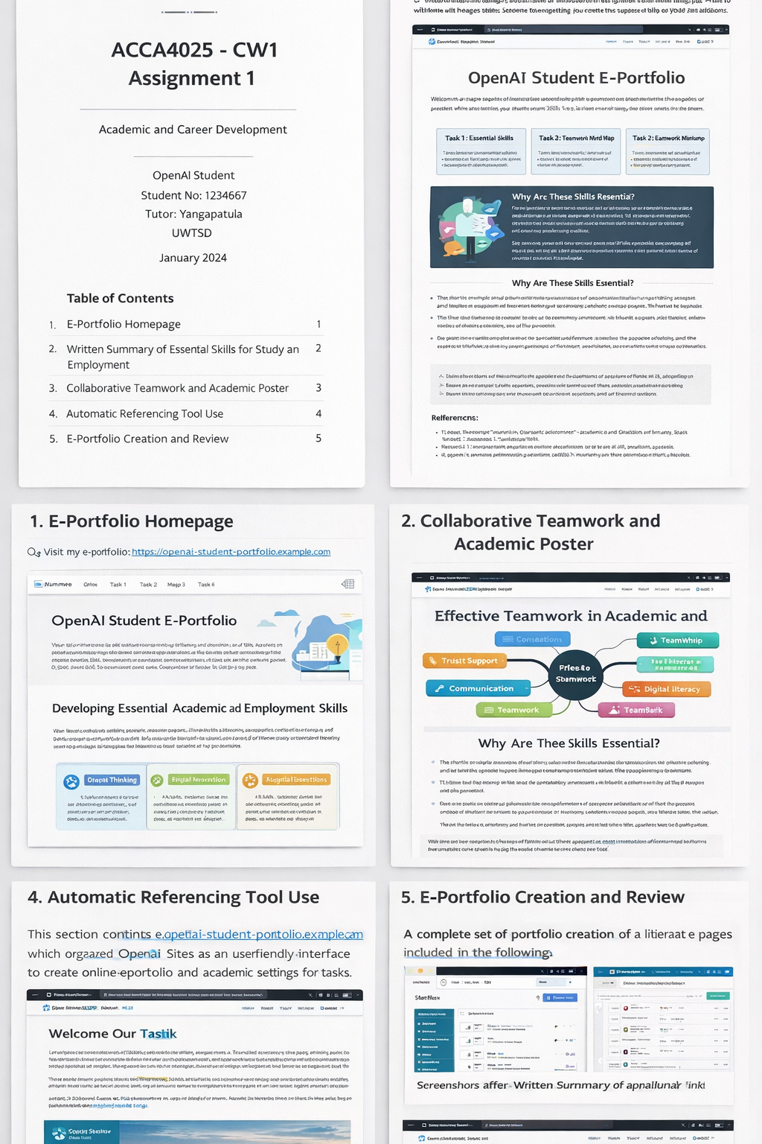
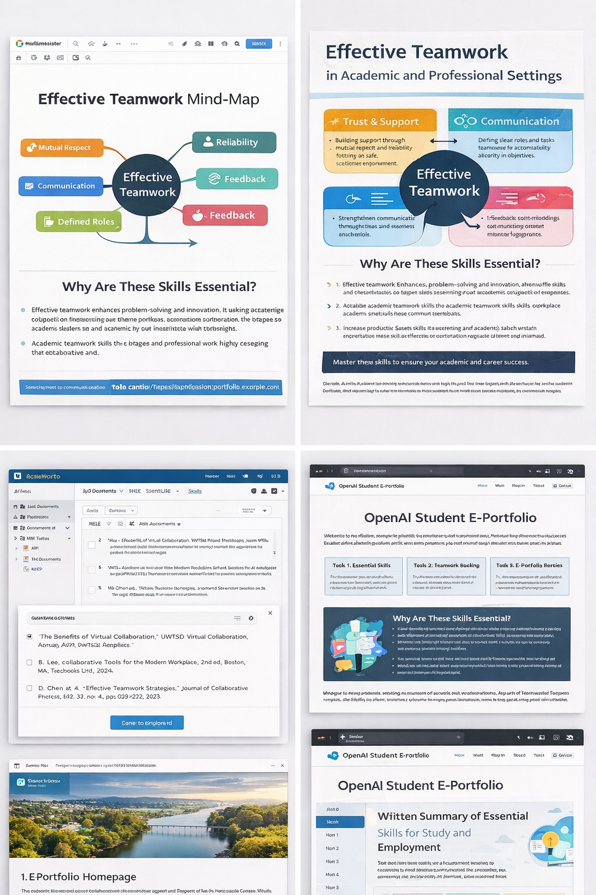
Conclusion
The given assignment teaches the significance of required academic and work abilities, teamwork, online cooperation and digital tools in learning and working environment. All the tasks are done reflectively on how these skills can be practiced in the long-term as regards to career success. The e-portfolio does not merely show the work as a digital record but also emphasizes the incorporation of a number of academic tools and technologies, which add efficiency and cooperativity.

References
[1] L. Faria, "Portfolio as a strategy to improve career adaptability resources," Education Applications and Developments VI: Advances in Education and Educational Trends Series, pp. 15-25, 2021.
[2] S. Stein Smith, "Building an academic portfolio," in Shifting from Accounting Practitioner to Academia: Tactics, Tips, and Strategies for the Transition, Cham: Springer International Publishing, pp. 189-230, 2021.
[3] E. Hartnell-Young, "Using a portfolio approach to navigate academia," in Women Thriving in Academia, pp. 147-165, Emerald Publishing Limited, 2021.
[4] F. Baldi and L. Trigeorgis, "Valuing human capital career development: a real options approach," Journal of Intellectual Capital, vol. 21, no. 5, pp. 781-807, 2020.
[5] P. Polly, K. Coleman, T. Fath, T. Thai, and J. L. Yang, "The learner-teacher portfolio journey: Developing self-efficacy and self-determination in the medical sciences," The WAC Clearinghouse; University Press of Colorado, vol. 125, pp. 145, 2020.
[6] S. Pandey, "Exploring design strategies for student career portfolios," Journal of Technical Writing and Communication, vol. 55, no. 4, pp. 385-415, 2025.
[7] J. Wright, "Developing your professional portfolio," in The Successful Occupational Therapy Fieldwork Student, pp. 167-171, Routledge, 2024.

