Parallelization in Image Processing: Implementation of Sobel in CUDA
Evan Smith (P146188)
University of Wales Trinity Saint David

Abstract— The Sobel Operator is one of the common edge detection algorithms used in the field of Computer Vision as well as Image Processing. Part of the first order derivative family, it is a Gaussian method. Implemented on the CPU, it achieves its objectives, however, it can also be implemented on the GPU, using NVidia’s CUDA. This paper presents a hypothesis, detailing that Sobel on the GPU achieves the result of processing high resolution images at a faster rate than the CPU.

Index Terms— Sobel, CUDA, CPU, Gaussian, Gradient, Kernel, Pythagoras Theorem, Race Conditions, Threads, Blocks, Grids.

INTRODUCTION
E
dge detection algorithms are an important factor in the field of image processing , which has increasingly grown since the 1950’s comprising algorithms such as those of Prewitt and Canny. One of the most common algorithms used in the field is the Sobel Operator which was first introduced at the Stanford artificial intelligence laboratory (SAIL) in 1968. Irvin sobel and Gary Feldman, both colleagues at the laboratory introduced the idea of using a gradient 3x3 mask in both vertical and horizontal directions, applying this to each region of the image. Calculating the image values, it creates a new image, replacing the values of the original with the new calculated values. This results in the image edges being shown upon a dark background. CUDA is a parallel computing language created by Nvidia specifically for the interest of high performance computing which utilizes the power of the graphics card, it is used to solve problems in general computing. The following paper examines the implementation process of the sobel operator in cuda.

Background Literature

Sobel Operator
The Sobel Operator requires the image to be loaded in order for the data to be used. Requiring the image data, the process calculates a new value for the new image and before the process begins, the image must be smoothed using the Gaussian filter. In General, filters work in the same way as using a mask that takes the original image and creates a new value, much like the edge and corner detection algorithms. The Gaussian filter is designed to remove any form of noise that is loaded into the application. The calculations perform a similar way to the calculations of gradient masks, however, the only detail to be aware of is the division of the sum of all the pixels in one region by 8. The result, is the right value for the blur and this is done as the result of the Sobel algorithm can be improved in terms of graphic quality.
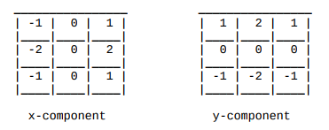

Figure 1 Gradient Masks
The gradient masks, representing both horizontal and vertical direction are used to determine the new values for the new image. The iteration process loops through the rows and the columns of the image and calculates all pixels in the region.
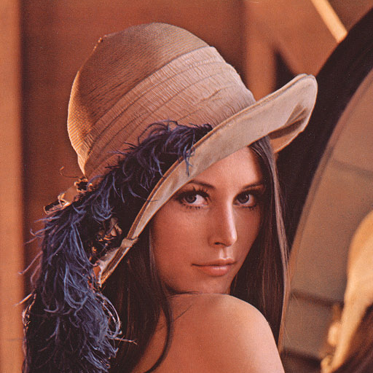

Figure 2 A Region in the Image

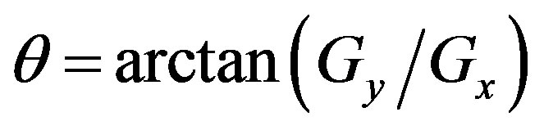
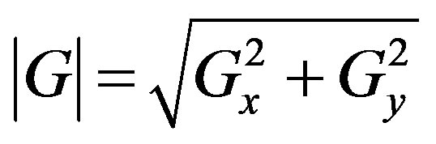
Calculating the new values for both x and y, the length of the edges can be found using the Pythagoras theory equation.
Figure 4 Gradient Direction Formula
Figure 3 Pythagoras Theorem
Once the length of the Gradient is found, the direction can be found using arctan, an inverse tangent method to determine the value of theta.

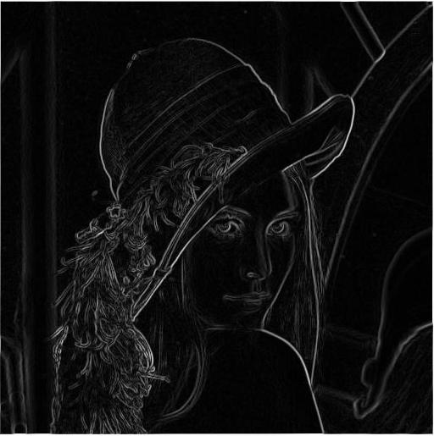
Figure 5 Sobel Filter
The current state of the literature is determined mostly by comparison projects and proposing models to achieve the aims. One project focuses on the comparison between the CPU and GPU in terms of applying Sobel to image resolution sizes. Freds et al [1] stated that the model they proposed was to “allows reducing time execution by comparing to the performance program code executed on a sequential processor (CPU).” The model mentions the use of OpenCV, a library designed for Image Processing. This is used only with displaying the image and the results. The findings of that project were that when the image size increases, the CPU execution speed increases to. However, the GPU’s execution speed does not.
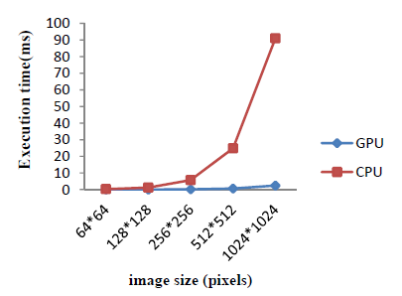
In terms of the time taken for the process, they occur during transferring data and outputting the results from both devices.

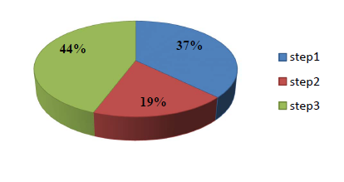

The project was a success, achieving high performance levels for executing Sobel in CUDA. The second project that is familiar was conducted Jain et al [2] and had similar aims which was to compare the “performance differences between program code that are run on a sequential processor (CPU) and a parallel processor (GPU)”. The difference is the usage of two machines, one with CUDA and one with Tesla. The results demonstrated that CUDA is faster than Tesla.

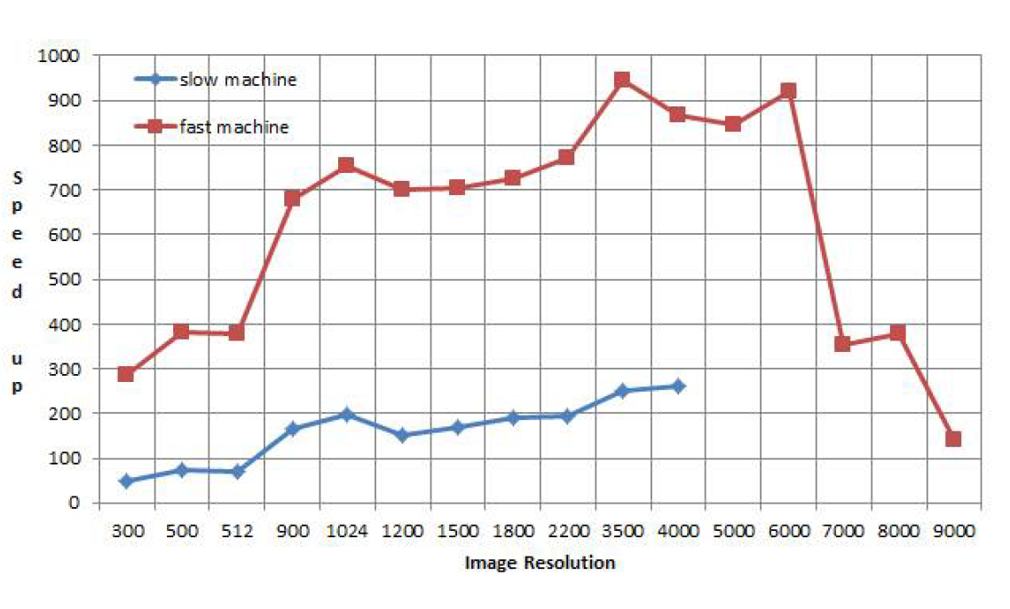
The literature on Sobel has been the subject of comparison frameworks designed to unlock the high performance of the graphics via CUDA. The literature review has shown that using CUDA to execute Sobel does provide faster results in comparison to the CPU version. With many models being proposed on how to achieve the best performance, the cycle is endless.

CUDA
Developed by Nvidia in 2007, CUDA is a programming language, utilizing several aspects of C, another programming language, to allow developers to access and utilize the properties and power of the graphics card. Originally used to solve graphics problems, the uses of the graphics card can also involve solving complicated problems in other areas such as performance in algorithms that can be computationally expensive for the CPU to execute. It can also be described as “Parallel Programming”, an ability that can allow multiple processors to execute tasks. This is primarily used for two main reasons, firstly, the CPU can only handle certain tasks and is not suitable for others and secondly, memory and performance are slow and do not execute algorithms faster. The main benefits of using Parallel programming in the form of CUDA is that algorithms executed on the Graphics Card can increase in speed as well as solving more problems that the CPU will find difficult to execute.

CUDA allows developers to perform the ability to multi-thread, utilizing all threads to perform a task. The problems that tend to be encountered while using multi-threading are known as “Race Conditions”. The term race conditions describe a problem where in that one thread is waiting for other thread to finish executing their task. The complication that this can cause is the delay in the speed of executing the algorithm and it is a barrier to achieve fast results. The solution to this would be thread synchronization, a method that prioritizes the tasks that the threads executing, removing the barrier to achieve fast results. Another solution would be to use the ability to share memory.

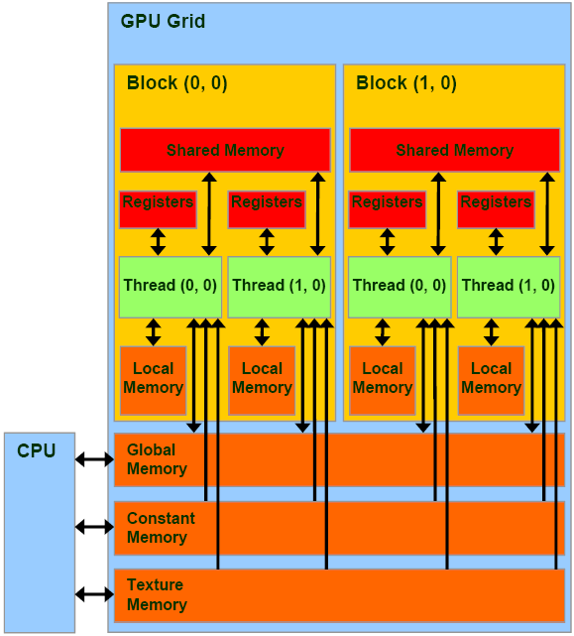
Figure 6 CUDA Sharing Memory Illustration

Sharing Memory in CUDA allows threads within a block to access the same memory, other threads in other blocks cannot access other blocks memory as their shared memory is created for every block. Young and Jargstorff [3] shared their view and imply that shared memory has the “Same Speed as Registers”. Harris [4] agrees stating that “shared memory is much faster than local and global memory”. Registers in the practice of CUDA, are described as another cache in the architecture that is used for single threads in a “Single Warp”, warps being another term for the length of threads in run time fashion.

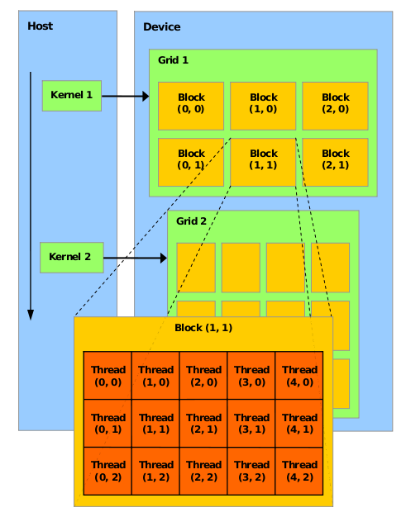
Figure 7 CUDA Architecture

CUDA’s Architecture is structured by three main components, Grids, Blocks and Threads. A grid contains multiple blocks which also contains multiple threads, each of which contains 1024MB of Memory. The methods in CUDA are represented as Kernels so that when executed, it can access the architecture of the Graphics Card. The details of how CUDA will be utilized for this project, is explored in the next section, entitled proposed algorithm.

Proposed Algorithm
As with the Sobel and CUDA discussed in the previous section, an algorithm proposed to prove the hypothesis is correct or incorrect is presented in this section. This involves discussing the algorithm that will be implemented as well as the equations that will be used for this paper.

Equations
There are a number of equations to implement in this paper. The first, the Gaussian blur equation (1). The equation can be found below:
(1)
$$G\left(x,y\right)=\frac{1}{2πσ^{2}}$$
(2)
$$\left|G\right|= \sqrt{Gx^{2}+Gy^{2}}$$
(3)
$$θ=arc\tan{(Gy/Gx)}$$

The second (2) and third (3) equations are part of the Sobel Algorithm. The third equation is used to determine the direction of the gradient.

Experiments
The Experiments that were conducted for this paper was designed to measure the speed of executing the Sobel Algorithm on both the CPU and the GPU. The performance will be timed using a function available in Visual Studio known as “Performance Profiler”, a method that allows developers to record the time taken to execute the algorithm without using a function from the time library. A report is then generated that records the time take and a graph of performance. This is beneficial as it is more reliable to present more accurate results which is crucial in the interest of the hypothesis. The speed will be measured in Milliseconds and will be displayed on the line graph which presents how fast the algorithm can be executed depending on the resolutions that will be tested. The results can be viewed in the next section.

Results
The results recorded during the experiments are for both the CPU and GPU versions of the algorithm. The table created contains two columns. The first, represents the resolution of the images that are used for each test. This is represented as the parameter “n”. The second represents the time taken to execute the algorithm, this is represented as the parameter “t”.

Conclusion

This paper presents the background literature for both Sobel Operator and CUDA in General as well as the test results. The test results was measured in milliseconds using the performance profiler feature for both the CPU and GPU version of the algorithm. In future, more work will be conducted into image processing and how it can be utilized in an Augmented Reality system as it is an iteration of a much bigger scoped project. Edge Detection algorithms have been used in Augmented Reality applications and curiosity grew as to how it is implemented and how it utilizes the camera of a webcam or a smartphone in order to process a simple marker. From that aspect, it will be an interesting aspect to explore as the image processing field itself, is in fascinating topic in Computer Vision.

References

[1] | M. L. A. A. C. S. Hana Ben Fredj, "Parallel implementation of Sobel filter using CUDA," in 2017 International Conference on Control, Automation and Diagnosis (ICCAD), Hammamet, Tunisia, 2017.
[2] | A. N. M. C. Adhir Jain, "Parallel edge detection by SOBEL algorithm using CUDA C," in 2016 IEEE Students' Conference on Electrical, Electronics and Computer Science (SCEECS), Bhopal, India, 2016.
[3] | F. J. Eric Young, "Image Processing & Video Algorithms with CUDA," 25 August 2008. [Online]. Available: http://www.nvidia.com/content/nvision2008/tech_presentations/Game_Developer_Track/NVISION08-Image_Processing_and_Video_with_CUDA.pdf. [Accessed 08 February 2018].
[4] | M. Harris, "Using Shared Memory in CUDA C/C++," Nvidia, 28 January 2013. [Online]. Available: https://devblogs.nvidia.com/using-shared-memory-cuda-cc/. [Accessed 08 February 2018].

Table of Figures
Figure 1 Gradient Masks 1
Figure 2 A Region in the Image 1
Figure 3 Pythagoras Theorem 2
Figure 4 Gradient Direction Formula 2
Figure 5 Sobel Filter 2
Figure 6 CUDA Sharing Memory Illustration 2
Figure 7 CUDA Architecture 3

