BSc Health and Social Care
Module: BMHP5023 – Introduction to Physiology
Component 1: Written Assignment (Case Study Report)
Understanding Type 2 Diabetes: A Guide for Patients
Student Name: | Zahida Parveen
Student Number: | 2511201
Module Code: | BMHP5023
Module Title: | Introduction to Physiology
Assignment Title: | Component 1: Written Assignment (Case Study Report)
Programme: | BSc Health and Social Care
Submission Date: | 26 October 2026
Lecturer: | Farah Islam

Introduction
Diabetes is a chronic metabolic disease that impacts millions of people across the UK and globally. Diabetes happens when the body cannot control the level of glucose in the blood. Glucose is one of the fuels our cells use but it cannot get into most of them by itself. This process depends on the hormone insulin, which is produced in the pancreas. If the body does not produce enough insulin the glucose accumulates in the blood instead of being used for energy. This is the cause of diabetes (World Health Organization, 2024).
Diabetes comes in two main types. Type 1 generally begins in childhood and occurs when your immune system attacks its own insulin producing cells. Type 2 is much more common and develops gradually over many years and about 90% of all people with diabetes have this type (International Diabetes Federation, 2025). Diabetes UK, 2026). There are around 4.6 million people in the UK who have been diagnosed with diabetes. Type 2 diabetes is where the body’s cells don’t respond properly to insulin. Initially the pancreas produces more insulin to compensate but eventually it cannot keep on (Chatterjee, Khunti and Davies, 2017).
Some people have a higher risk of developing Type 2 diabetes than others. Unchangeable factors such as getting older having a close family member with diabetes and being of South Asian, African-Caribbean or Middle Eastern origin. There are some risk factors that can be changed, such as being overweight, being physically inactive, eating too much sugary or fatty food, smoking and drinking too much alcohol (International Diabetes Federation, 2025).
As a practice nurse, I have written this report for patients who have Type 2 diabetes. It explains us how blood sugar is controlled in the body, how cells use glucose and oxygen make energy, why checking blood sugar regularly is important and how changes to daily habits can help people to manage their conditions.

How Blood Sugar Levels Are Kept Safe
Our bodies work hard to keep blood sugar in a healthy range it is called homeostasis. In people who do not have diabetes, fasting blood sugar is usually around 4 to 5.5 mmol/L (Guyton and Hall, 2021). For people with diabetes, a target of around 4 to 7 mmol/L before meals is recommended (American Diabetes Association, 2026). The pancreas, an organ that produces two hormones that do opposite jobs insulin and glucagon (Guyton and Hall, 2021).

Inside the pancreas are groups of cells which are called the islets of Langerhans. These contain beta cells, which make insulin and alpha cells, which make glucagon. Insulin lowers blood sugar, but glucagon raises it, so they work together to balanced (Table 1).
Table 1: Insulin and Glucagon Compared
Feature | Insulin | Glucagon
Made by | Beta cells | Alpha cells
Released when | Blood sugar is high | Blood sugar is low
Main target | Liver, muscle and fat cells | Liver
Effect on blood sugar | Lowers it | Raises it
Storage action | Stores glycogen | Breaks down glycogen
Source: adapted from Guyton and Hall (2021).
When we eat the carbs, they are broken down into glucose which enters the bloodstream and causes blood sugar to rise. The rise in blood glucose is sensed by the beta cells and insulin is secreted. Insulin circulates in the blood to liver, muscle and fat tissue and tells these cells to take up glucose. This is achieved by translocating glucose transporters to the cell membrane (GLUT4) of muscle and adipose cells. Glucose can be used immediately for energy or stored for later use. Glycogen is stored in the liver and muscle as a backup supply of glucose when needed (Guyton and Hall, 2021).
Alpha cells release glucagon when blood sugar drops. This tells the liver to convert the stored glycogen and release glucose back into the blood. The liver can also make new glucose by gluconeogenesis. This guaranties that the body, the brain is highly dependent on glucose, always has sufficient glucose (Guyton and Hall, 2021). Figure 1 illustrates how these two responses maintain blood sugar within a safe range (around 4-7 mmol/L when not eating).

Figure 1: How Blood Sugar Is Balanced
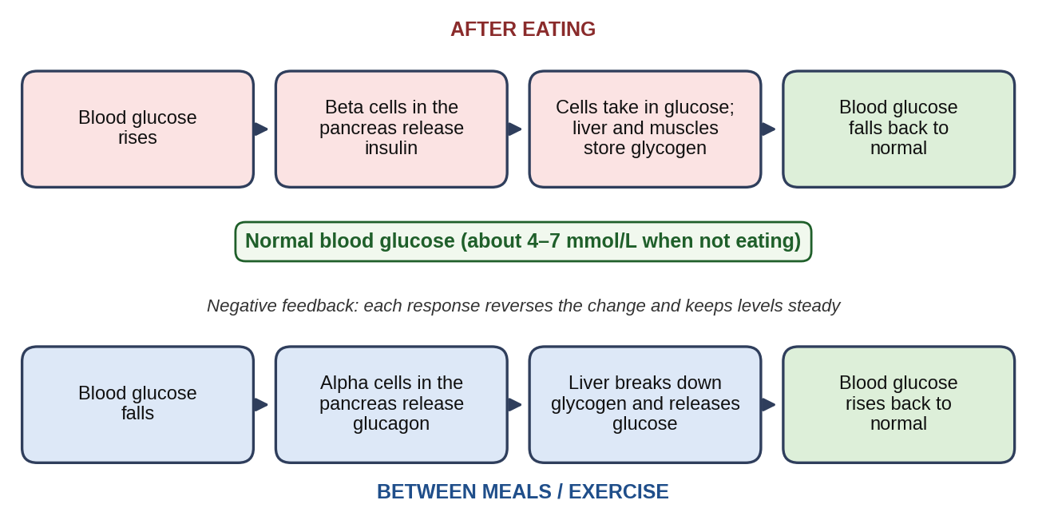
Source: adapted from Guyton and Hall (2021).
In Type 2 diabetes, this system does not work properly. The main problem is insulin resistance. This is when the body’s cells do not respond properly to the insulin. Even insulin is present, the cells partly ignore it, so glucose cannot get in easily. At first, the pancreas makes more insulin to overcome this. Over time the beta cells become worn out and cannot keep up, so glucose builds up in the blood (DeFronzo et al., 2015).

How Cells Use Glucose and Oxygen for Energy
The body’s cells require energy to be able to function. This energy is derived from a molecule called ATP. The process of making ATP from glucose is called cellular respiration. Glucose is dissolved in the blood to be able to get to the cells. Oxygen is taken in by the lungs and is taken around the body by haemoglobin in red blood cells. Cellular respiration needs oxygen to work efficiently (Guyton and Hall, 2021).
Cellular respiration consists of three stages, mentioned in Table 2. Glycolysis is the first step and takes place in the cytoplasm of the cell without oxygen. During glycolysis, one molecule of glucose is degraded into two molecules of pyruvate and a small quantity of ATP is generated (Chaudhry and Varacallo, 2023).
The second stage occurs in the mitochondria, which are called the powerhouses of the cell. Pyruvate is changed to acetyl CoA and then enters the Krebs cycle. This cycle makes some high energy electron carriers and a little more ATP. We breathe out carbon dioxide because it is a waste product that is given off. The cycle can only keep running when oxygen is available, because oxygen is needed at the final stage to recycle the electron carriers (Guyton and Hall, 2021).
The last stage is oxidative phosphorylation. It takes place on the inner membrane of the mitochondria. Electron carriers from the earlier stages pass their electrons to a chain of proteins. While the electrons move, they push protons across the membrane and that flow is what powers the production of a lot of ATPS. One glucose can give roughly 30 ATP molecules. Oxygen is essential because it accepts the final electrons. Without oxygen the whole process stops and the cell just can’t make enough energy (Guyton and Hall, 2021).
Table 2: Stages of Cellular Respiration
Stage | Where It Happens | Oxygen Needed? | ATP Made
Glycolysis | Cytoplasm | No | Small amount
Krebs cycle | Mitochondria | Indirectly | Small amount
Oxidative phosphorylation | Mitochondria | Yes | Large amount
Source: adapted from Guyton and Hall (2021).
In type 2 diabetes the insulin resistance prevents glucose from entering our cells. Even when there is plenty of glucose in the blood, many cells cannot use it, so they may not have enough glucose to make ATP. Instead, the body may attempt to burn fat for energy but this is less efficient and can lead to other problems. The unused glucose remains in the blood and causes damage to blood vessels and nerves (DeFronzo et al., 2015).

Why Tracking Blood Sugar Matters
For people with Type 2 diabetes, it’s important to check their blood sugar regularly. There are two main ways to monitor blood sugar self-monitoring at home and HbA1c testing carried out by a healthcare professional (Table 3).
Self-monitoring means using a small device called a glucose meter. You prick your finger and place a drop of blood on a test strip and the meter gives a reading. This shows your blood sugar changes through the day in response to food, exercise and medication (American Diabetes Association, 2026).
The HbA1c test is a blood test that shows average blood sugar of past months. It measures how much glucose has attached to haemoglobin the protein in red blood cells that transmits oxygen. Because red blood cells live for around three months, this test gives a longer term picture of blood sugar control (National Institute for Health and Care Excellence, 2022).
The treatment target for most adults with type 2 diabetes is an HbA1c of 48 mmol/mol or less but there may be individual circumstances that require a different target. Tracking HbA1c levels helps healthcare professionals determine whether a person’s treatment is working and if any changes are necessary (National Institute for Health and Care Excellence, 2022).
Table 3: Ways to Monitor Blood Sugar
Method | What It Shows | Who Does It | How Often
Finger-prick test | Current blood sugar level | Patient at home | As needed or advised
HbA1c test | Average blood sugar over 2–3 months | Healthcare professional | Every 3–6 months
Source: adapted from National Institute for Health and Care Excellence (2022).
If you might find that your blood sugar is always high after breakfast, but fine at other times, this can help you and your health care team make changes to your diet or medication. Also, records can show how lifestyle changes like exercising more or eating better are affecting your blood sugar, which can be very motivating (National Institute for Health and Care Excellence, 2022).
Monitoring does not suit everyone in the same way, it also have limits. The National Institute for Health and Care Excellence (2022) advises offering routine self-monitoring to people who take insulin, who take medicines that can cause hypoglycaemia, because for other people testing adds a little benefit. HbA1c targets should also be individual, as a strict target may not be safe for older or those at risk of hypoglycaemia. For this reason, how often to test and what to aim for should be agreed between each patient and their healthcare team.

Lifestyle Changes That Can Help
Making healthy lifestyle changes help to manage your type 2 diabetes. These changes can help to control blood sugar, reduce the need for medication and decrease the risk of serious problems. The main recommendations are summarized in Table 4.

Eating a Healthy Diet
Diet is a major factor in controlling Type 2 diabetes. Eating plenty of vegetables, whole grains and lean proteins and cutting back on sugary foods, saturated fats and refined carbohydrates. Cut down on alcohol, too (Evert et al., 2019).

Being More Active
One of the best things you can do for Type 2 diabetes is to exercise regularly. It lowers the blood sugar by making the cells more sensitive to insulin. Recommendations are 150 minutes of moderate exercise a week, such as brisk walking, swimming or cycling. It also suggests the training of two or more days a week, such as lifting weights or using resistance bands. It builds muscle, which uses more glucose and improves insulin sensitivity (Colberg et al., 2016)

Stopping Smoking
Smoking is damaging to those who have diabetes. It worsens the insulin resistance and damages blood vessels. People with diabetes who smoke are much more likely to have heart attacks, strokes and circulation problems. Stopping smoking is one of the most important things. (American Diabetes Association, 2026). There are lots of support available to help you quit, including nicotine replacement therapy, counselling and medication. (National Institute for Health and Care Excellence, 2022).

Managing Weight
Additional weight can make insulin resistance worse (DeFronzo et al., 2015). Overweight people who lose 5 to 10 percent of body weight by eating healthy and exercising regularly can improve blood sugar and reduce the need for medication. In some instances, weight loss has led to remission of Type 2 diabetes (Evert et al., 2019). If patients are unsure where to begin, they can be offered a referral to a structured education programme that teaches people how to manage diabetes on a day-to-day basis (National Institute for Health and Care Excellence, 2022).
Table 4: Lifestyle Recommendations at a Glance
Lifestyle Factor | What to Do | How It Helps
Diet | Eat more vegetables, whole grains and lean proteins; cut down on sugar and saturated fat; limit alcohol | Controls blood sugar and helps with weight loss
Exercise | 150 minutes of moderate activity per week plus resistance training | Lowers blood sugar and improves insulin sensitivity
Smoking | Stop completely | Reduces the risk of heart problems
Weight | Aim for 5–10% weight loss if overweight | Improves blood sugar control
Source: adapted from Evert et al. (2019) and Colberg et al. (2016).

Conclusion
By understanding how the body normally regulates blood sugar, patients can understand. Insulin and glucagon work together to keep blood sugar stable. In Type 2 diabetes the insulin resistance disrupts this balance. Learning about the cellular respiration explains how glucose and oxygen are used to make energy and why this process is affected in diabetes.
Eating better, doing some physical activity, stopping smoking and keeping weight under control can help with blood sugar levels and can also lower the chance of complications. The advice will not be the same for every person. Support can help patients understand why these changes are needed and make them easier to follow in everyday life.

Reference List
American Diabetes Association (2026) 'Standards of Care in Diabetes—2026', Diabetes Care, 49(Suppl 1). doi:10.2337/dc26-SINT.
Chatterjee, S., Khunti, K. and Davies, M.J. (2017) 'Type 2 diabetes', The Lancet, 389(10085), pp. 2239–2251.
Chaudhry, R. and Varacallo, M. (2023) Biochemistry, Glycolysis. Treasure Island: StatPearls Publishing.
Colberg, S.R., Sigal, R.J., Yardley, J.E., Riddell, M.C., Dunstan, D.W., Dempsey, P.C., Horton, E.S., Castorino, K. and Tate, D.F. (2016) 'Physical activity/exercise and diabetes: A position statement of the American Diabetes Association', Diabetes Care, 39(11), pp. 2065–2079.
DeFronzo, R.A., Ferrannini, E., Groop, L., Henry, R.R., Herman, W.H., Holst, J.J., Hu, F.B., Kahn, C.R., Raz, I., Shulman, G.I., Simonson, D.C., Testa, M.A. and Weiss, R. (2015) 'Type 2 diabetes mellitus', Nature Reviews Disease Primers, 1, p. 15019.
Diabetes UK (2026) Diabetes UK Strategy 2026–2030. Available at: https://www.diabetes.org.uk/sites/default/files/2026-01/DUK-Strategy-2026-2030-compressed.pdf (Accessed: 29 September 2026).
Evert, A.B., Dennison, M., Gardner, C.D., Garvey, W.T., Lau, K.H.K., MacLeod, J., Mitri, J., Pereira, R.F., Rawlings, K., Robinson, S., Saslow, L., Uelmen, S., Urbanski, P.B. and Yancy, W.S. (2019) 'Nutrition therapy for adults with diabetes or prediabetes: A consensus report', Diabetes Care, 42(5), pp. 731–754.
Guyton, A.C. and Hall, J.E. (2021) Textbook of Medical Physiology. 14th edn. Philadelphia: Elsevier.
International Diabetes Federation (2025) IDF Diabetes Atlas. 11th edn. Brussels: International Diabetes Federation.
National Institute for Health and Care Excellence (2022) Type 2 diabetes in adults: management (NG28). Available at: https://www.nice.org.uk/guidance/ng28 (Accessed: 20 September 2026).
World Health Organization (2024) Diabetes. Available at: https://www.who.int/news-room/fact-sheets/detail/diabetes (Accessed: 20 September 2026).

