

QUALITY ASSURANCE AND SERVICE IMPROVEMENT
Strengthening Escalation and Mortality Surveillance in Neonatal Care
A service-improvement report based on the Countess of Chester Hospital, Lucy Letby case
Student name: Josephine Osei Amoah
Student number: 2233505
Module code: LCHS7006
Lecturer: Christopher Mafuva

I confirm that I have not used any AI tools in the research and creation of this assignment. I confirm that I have not presented any AI-generated materials as my own work. I confirm I have copies of my drafts, notes, and other resources I used, which I may be asked to provide in evidence.
Content page
Introduction .................................................................................. 1
Analysis of the Quality Concern ................................................. 3
1.1 Rationale for the Analytical Approach ...................................... 3
1.2 Fishbone and 5 Whys Root-Cause Analysis ............................ 3
1.3 Donabedian Evaluation ............................................................. 5
1.4 SWOT Analysis ......................................................................... 6
1.5 Consequences for Quality, Efficiency and Equity ..................... 7
Recommendations and Implementation Strategy ..................... 9
2.1 Improvement Aim and Intervention Bundle .............................. 9
2.2 PDSA Implementation .............................................................. 11
Conclusion .................................................................................... 14
Reference List ............................................................................... 16

Introduction
This report examines a service-quality concern arising from neonatal care at the Countess of Chester Hospital NHS Foundation Trust: the failure to recognise, investigate and escalate an unusual pattern of infant deaths and collapses with sufficient speed and independence. The case entered public consciousness after the convictions of former neonatal nurse Lucy Letby. The Statutory Thirlwall Inquiry was established to examine the experiences of affected families, the conduct of hospital personnel and wider NHS arrangements for keeping babies safe (Department of Health and Social Care, 2023). Its final report had not been published by 14 August 2026; the Inquiry stated on 5 August that publication would not occur until after Parliament’s summer recess (Thirlwall Inquiry, 2026). Accordingly, this report does not present provisional evidence as settled inquiry findings. It analyses documented governance risks, published inspection material and national safety standards to formulate a proportionate improvement plan.
The concern is significant because neonatal patients have limited physiological reserve, deteriorations can be rapid, and families depend on clinical teams and organisations to detect patterns that are invisible at bedside. The 2016 Care Quality Commission (CQC) inspection rated services for children and young people as good, illustrating an important limitation of periodic assurance: acceptable aggregate ratings may coexist with weak signals that require different forms of surveillance (Care Quality Commission, 2016). Subsequent CQC work has continued to identify governance, risk-management and cultural concerns at trust level, although these later findings should not be treated as direct explanations of the 2015–2016 events (Care Quality Commission, 2024). Nationally, MBRRACE-UK data demonstrates why systematic review of perinatal deaths remains a public-health priority and why variation must prompt timely learning rather than reassurance by anecdote (Draper et al., 2023).
Countess of Chester is an acute NHS foundation trust serving a wide population through hospital and specialist services. Foundation-trust status gives the board responsibility for quality, finance and governance while retaining accountability to regulators, commissioners, governors and the public. This layered accountability is relevant: neonatal safety signals can move across ward, divisional, executive, board and external boundaries, creating several opportunities for challenge but also for diffusion of responsibility. A service-improvement response must therefore specify who acts, on what evidence and within what time, rather than assuming that another tier will intervene.
Quality is approached here as a property of systems, not merely the absence of individual error. Donabedian’s (1988) structure-process-outcome model links organisational capability to care delivery and consequences. Reason’s (2000) systems account similarly explains how harm can pass through several imperfect defences. These perspectives do not remove individual accountability; they prevent the narrower error of assuming that punishment alone repairs surveillance, escalation, or leadership. The report therefore applies a Fishbone analysis and 5 Whys to identify interacting causes, uses Donabedian to connect those causes to measurable quality, and employs SWOT to test strategic feasibility. Recommendations are implemented through the Model for Improvement and iterative PDSA cycles. The proposed service aim is to create reliable, independent, and psychologically safe escalation of unexplained neonatal deterioration and mortality, with transparent learning for staff and families.

(Harwood-Baynes, 2023)

1. Analysis of the quality concern

1.1 Rationale for the analytical approach
No single framework can explain a case involving clinical uncertainty, hierarchy, data interpretation and institutional reputation. Fishbone analysis is useful for widening attention beyond a presumed immediate cause, whereas the 5 Whys tests the chain connecting visible failure to deeper conditions. Both can oversimplify if treated as proof rather than prompts; complex healthcare events are rarely linear and ‘root cause’ language may imply a single removable origin (Card, 2017). Donabedian then provides an evaluative bridge from causes to quality measures, while SWOT considers whether proposed changes fit the organisation’s internal capability and external environment. Triangulation is preferable to relying on one diagram because each model answers a different question.

1.2 Fishbone and 5 Whys root-cause analysis
The effect at the head of the Fishbone is defined as delayed organisational recognition and external escalation of an abnormal pattern of neonatal deaths and collapses. Categories were adapted to the case rather than copied mechanically from manufacturing. The analysis below treats each branch as a hypothesis to be tested against records, staff accounts and independent review, not as an allegation about a named person.
Fishbone branch | Contributing conditions and service implications
Leadership and governance | Unclear ownership of the emerging risk; delayed board-level challenge; competing concerns about evidence, employment procedure and reputation; insufficient independent clinical scrutiny.
People and culture | Hierarchy between clinicians and executives; psychological insecurity; repeated concerns potentially reframed as interpersonal conflict; limited confidence that speaking up would trigger neutral review.
Methods and policy | Inconsistent aggregation of collapses and deaths; escalation routes dependent on local discretion; unclear trigger for external referral; incident processes oriented towards single events rather than patterns.
Measurement and information | Small-number variation is difficult to interpret; fragmented clinical, staffing and incident data; weak real-time visualisation; absence of explicit statistical or clinical trigger thresholds.
Environment and workload | High-acuity neonatal care, staffing pressures and multiple handovers can normalise instability and reduce time for reflective review.
External interfaces | Delayed or uncertain engagement with commissioners, regulators, specialist reviewers or police; accountability dispersed across organisational boundaries.
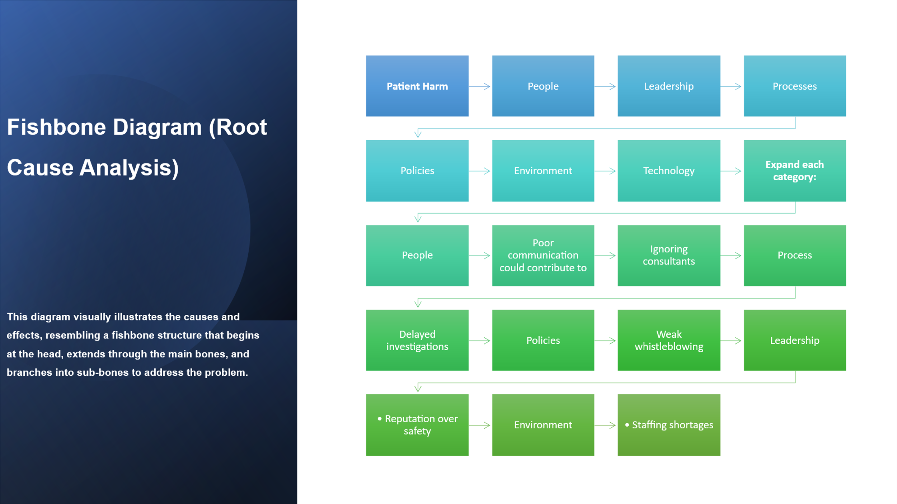

This causal picture is consistent with Reason’s (2000) observation that defences fail in combination. It is also supported by broader NHS evidence: cultures that discourage challenge weaken incident learning, even when policies formally permit reporting (Francis, 2013; Mannion and Davies, 2018). Psychological safety matters because staff must be able to express uncertainty and dissent without assuming that doing so threatens belonging or career progression (Edmondson, 1999; O’Donovan and McAuliffe, 2020). Yet a ‘just culture’ must not become an excuse for inaction. NHS England (2023a) distinguishes fair treatment from the need to examine conduct where evidence warrants it.
The 5 Whys sharpens one pathway. Why was escalation delayed? Because repeated events did not trigger a rapid, independent response. Why not? Concerns moved through local managerial processes that sought additional certainty and attempted internal resolution. Why was local handling insufficient? Mortality, incident, staffing and clinical-opinion data were not integrated into a predetermined trigger-and-response pathway. Why was integration weak? Governance arrangements relied heavily on professional relationships and discretionary escalation rather than observable reliability controls. Why did that persist? The organisation lacked a tested safety architecture that combined real-time surveillance, protected challenge, independent review and board accountability. The final answer is not ‘poor communication’; it is a design problem in how weak signals become decisive organisational action.

1.3 Donabedian evaluation
Donabedian’s model prevents improvement from being judged only by a favourable outcome after implementation. Structure concerns the resources and authority that make safe action possible; process concerns what teams actually do; outcomes include patient, workforce and trust consequences (Donabedian, 1988). Its limitation is that causal links between the three domains cannot be assumed. Better committees, for example, do not guarantee better escalation. Measures must therefore test both implementation and effect.

Domain | Case-related deficit | Improvement measure
Structure | Diffuse accountability; insufficient independent neonatal mortality oversight; fragmented dashboards; uncertain protected escalation. | Named executive and non-executive owners; independent neonatal review panel; integrated safety dashboard; resourced Freedom to Speak Up route.
Process | Variable incident coding; delayed multidisciplinary mortality review; concerns not consistently acknowledged, tracked or externally escalated. | Percentage of qualifying events reviewed within 72 hours; escalation acknowledgement within one working day; completion and closure of actions; family involvement.
Outcome | Potentially avoidable delay, family distress, workforce fear, regulatory exposure and loss of public trust. | Time from trigger to independent review; recurrence of unexplained clusters; staff speaking-up climate; family experience; evidence of learning sustained at 6 and 12 months.

The analysis aligns with NHS England’s PSIRF, which replaces a blame-focused search for a single cause with proportionate system-based learning and involvement of those affected (NHS England, 2022; 2024). It also complements national Learning from Deaths guidance and the medical examiner system, although neonatal deaths require specialist pathways and cannot simply be absorbed into adult mortality processes (NHS England, 2017; 2024). Clinical governance remains the organisational mechanism through which accountability, evidence, risk management and improvement are joined (Scally and Donaldson, 1998).

1.4 SWOT analysis
Strengths | Weaknesses
Established NHS patient-safety infrastructure; PSIRF; specialist neonatal networks; statutory duty of candour; national reporting systems; board governance and non-executive scrutiny. | Potential hierarchy and defensive behaviour; fragmented datasets; low event numbers complicating interpretation; improvement fatigue; reliance on policy compliance rather than behavioural reliability.
Opportunities | Threats
Digital surveillance; independent medical and neonatal review; renewed speaking-up arrangements; family escalation routes; manager regulation reforms; shared learning across neonatal networks. | Reputational pressure: punitive overreaction that suppresses reporting; false alarms and alert fatigue; workforce shortages; legal constraints; public mistrust; recommendations delayed while awaiting the Inquiry report.

SWOT shows that the Trust need not invent an entirely new safety system. The opportunity lies in connecting existing structures and testing their reliability. PSIRF already requires compassionate engagement, proportionate response and system-based learning (NHS England, 2022). Freedom to Speak Up guidance requires concerns to be heard and acted upon (NHS England, 2026a), while the statutory duty of candour requires openness after notifiable safety incidents (Department of Health and Social Care, 2014). Conversely, excessive surveillance or reflexive suspension could create fear, distort reporting and damage retention. Strong improvement therefore combines rapid protective action with fair, independent assessment. Evidence linking organisational culture with patient outcomes supports this balanced approach but also cautions that culture cannot be changed through slogans or training alone (Braithwaite et al., 2017; Dixon-Woods et al., 2014).

1.5 Consequences for quality, efficiency and equity
The quality impact extends across safety, effectiveness, experience and trust. Delayed recognition may expose babies to continuing risk and deprive clinicians of timely opportunities to change care. Families may receive fragmented explanations while an organisation remains uncertain about a pattern, conflicting with candour and compassionate involvement. Staff experience is also a quality outcome: when credible concerns appear unresolved, moral distress and disengagement can follow. Conversely, a purely punitive response may discourage incident reporting. The improvement challenge is therefore to increase responsiveness without equating every adverse outcome with misconduct.
Efficiency is affected because weak early review transfers cost downstream. Prolonged internal meetings, duplicate inquiries, sickness absence, litigation, external investigations, and regulatory interventions consume considerably more resources than a reliable initial response. Delay can also produce defensive documentation and repeated data collection without a clear decision owner. Lean thinking would describe these as forms of rework, waiting, and failure demand, although neonatal safety cannot be reduced to throughput alone. The relevant efficiency objective is faster access to trustworthy evidence and decisions, not fewer reviews. Independent triage should concentrate specialist investigation on credible signals while closing low-risk alerts transparently.
Equity concerns who is heard and who bears the consequences of organisational uncertainty. Junior staff, temporary workers, internationally educated professionals and employees from minoritised groups may experience hierarchy differently and may be less confident that speaking up is safe. Families likewise vary in health literacy, language, confidence and access to senior clinicians. An apparently universal escalation policy can therefore operate inequitably. Equality monitoring should examine who raises concerns, response times, whether feedback is provided and whether staff report retaliation. Interpretation must remain cautious: fewer reports from a group may indicate either fewer problems or reduced confidence in the route. Accessible information, independent advocacy, interpreter provision and several escalation channels are necessary to make voice a practical entitlement rather than a formal promise.

2. Recommendations and implementation strategy

2.1 Improvement aim and intervention bundle
The recommended aim is: within six months, 95% (NHS England, 2024; 2026).of defined neonatal safety triggers will receive documented senior clinical review within 24 hours and independent multidisciplinary review within 72 hours; within twelve months, 90% of resulting actions will be closed by their due date, without deterioration in staff-reported psychological safety. A bundle is required because dashboards without authority merely display risk and speaking-up routes without feedback reproduce silence.
First, the Trust should establish an independent Neonatal Safety Review Panel chaired outside the neonatal management line and including neonatal medicine and nursing, patient safety, data expertise, a neighbouring network representative, a Freedom to Speak Up representative and parent/public input. Predetermined triggers should include unexpected death, unexplained collapse, repeated deterioration, unusual clinical association and credible staff or family concern. The panel should have authority to recommend immediate protective measures and referral to external bodies. Independence reduces conflicts of interest, but membership and thresholds require evaluation to avoid delay through bureaucracy.
Second, an integrated neonatal safety dashboard should combine mortality, collapse, acuity, staffing, incident, infection and escalation data. Statistical-process-control methods may help distinguish ordinary from special-cause variation, but algorithms cannot determine malicious intent or clinical causation. Every alert therefore requires contextual clinical review. Monthly board reporting should show trigger frequency, review timeliness, unresolved actions and recurring themes rather than presenting crude mortality comparisons. Families should receive a named contact, timely explanation and routes to request review, consistent with compassionate involvement under PSIRF and the broader logic of Martha’s Rule.
Third, the Trust should create a closed-loop concern pathway. Any worker must be able to raise a concern through line management, patient safety, Freedom to Speak Up or an external route; receipt should be confirmed within one working day, a named owner assigned, and the reason for action or non-action documented. Aggregate themes should reach the board while identities remain protected. Leaders require training in receiving challenges, cognitive bias and fair accountability, but behaviour must be reinforced through appraisal, walk-round observation and consequences for obstructing escalation. Collective and compassionate leadership is associated with stronger engagement, yet leadership development works only when governance expectations are explicit (West et al., 2015). The NMC Code also requires nurses to preserve safety and raise concerns, so organisational arrangements must make professional compliance practicable (Nursing and Midwifery Council, 2018).

2.2 PDSA implementation
PDSA is selected over a one-off policy launch because the intervention must be learned into a complex clinical environment. The Model for Improvement asks what the team seeks to accomplish, how improvement will be recognised and which changes might produce it (Institute for Healthcare Improvement, 2026). However, PDSA is often reported poorly, with inadequate prediction, measurement, and repeated cycles (Taylor et al., 2014). The project will therefore document each cycle prospectively and use small tests before wider implementation.
Stage | Actions, ownership and evidence
Plan – weeks 1–4 | Executive sponsor and neonatal QI lead agree operational trigger definitions; map current escalation; establish baseline measures; complete data-protection and equality review; co-design dashboard and concern pathway with staff and parent representatives. Predict review workload and unintended effects.
Do – weeks 5–8 | Test the bundle on one neonatal shift team and through retrospective simulation of ten anonymised events. Run weekly review-panel huddles. Record delays, duplicate alerts, usability problems, staff experience and decisions made.
Study – weeks 9–10 | Compare time to acknowledgement and time to independent-review with baseline. Examine false-positive alerts, balancing measures, action closure and qualitative feedback. Review whether junior, temporary and internationally educated staff experience the pathway differently.
Act – weeks 11–12 | Adapt thresholds, roles and dashboard presentation. Abandon components that add burden without safety value. Standardise effective elements, then begin a second cycle across all neonatal shifts before network-level spread.

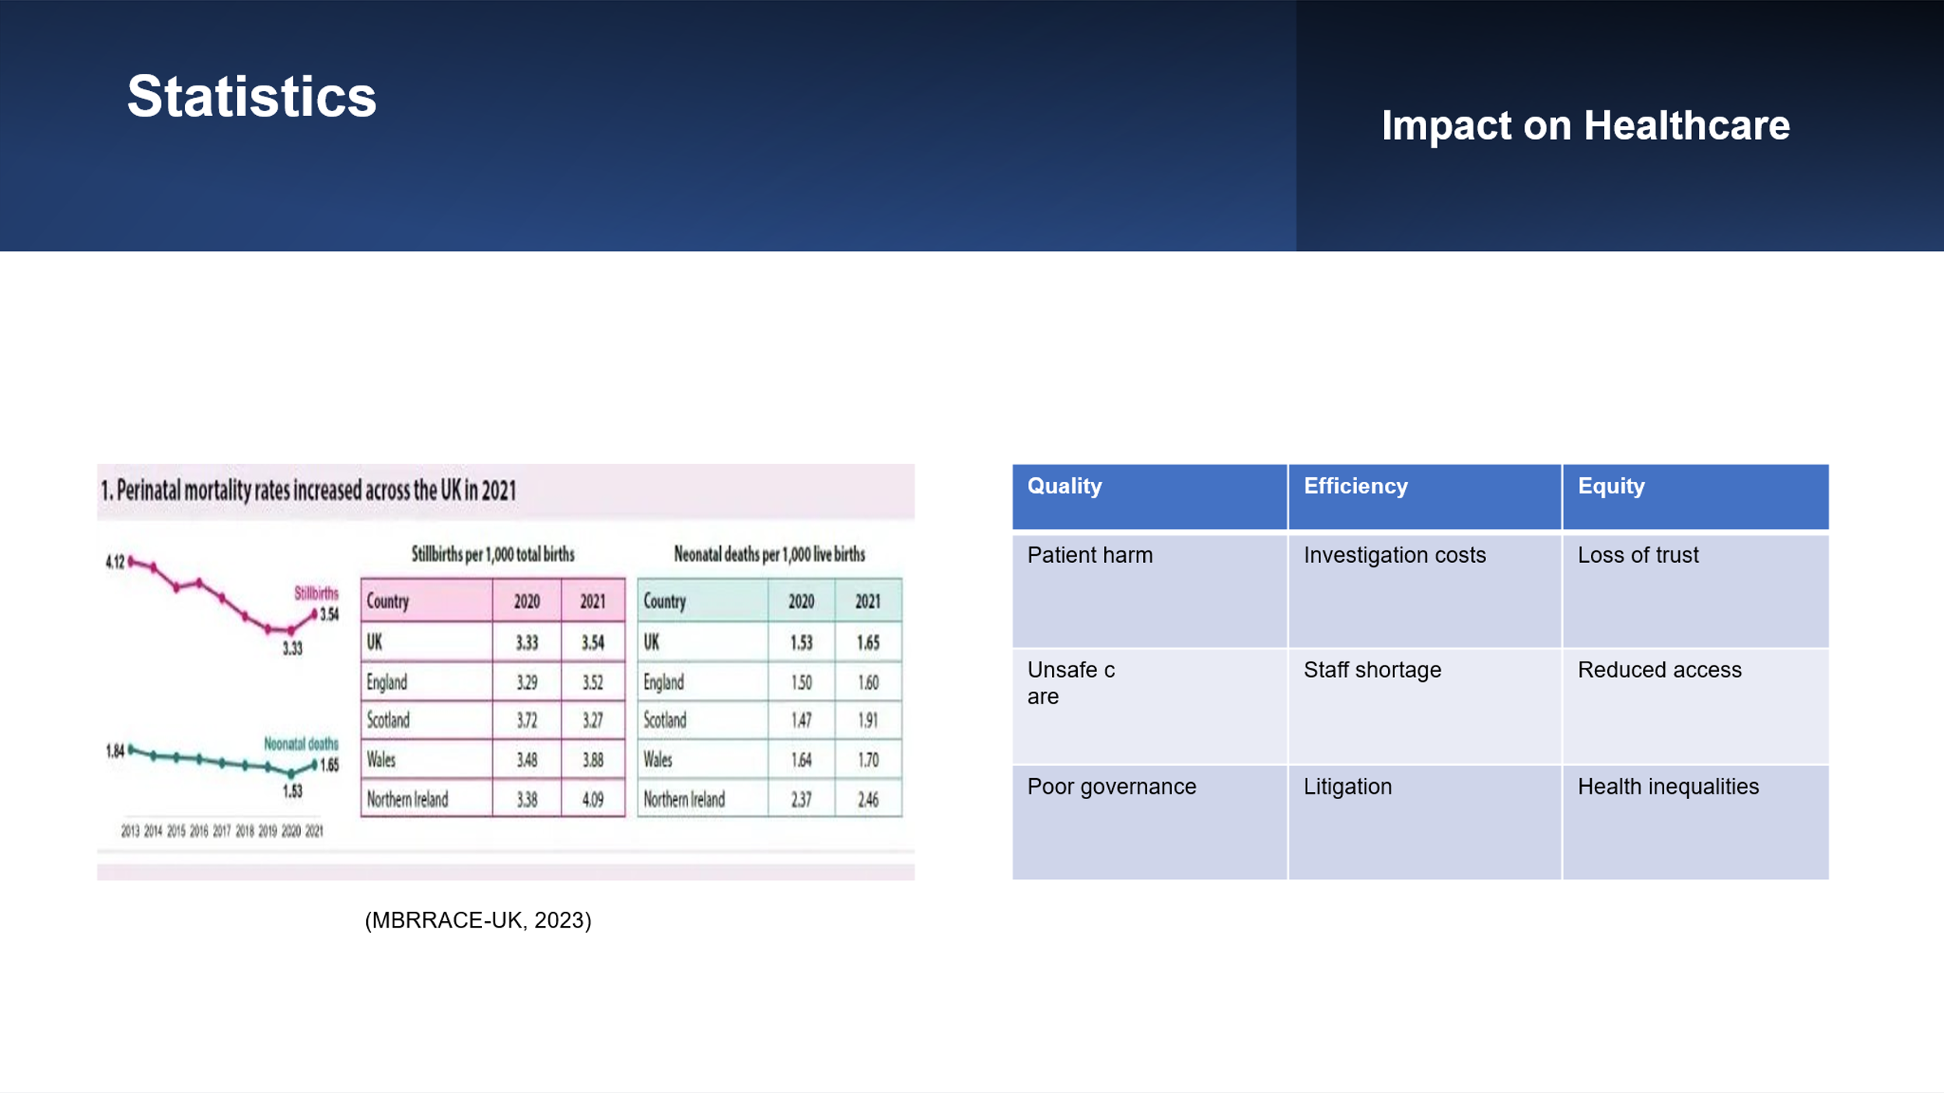
Measurement will use an outcome, process and balancing set. Outcome measures are median time from safety trigger to independent decision, repeated events before escalation, family experience and quarterly speaking-up climate. Process measures include the proportion of triggers acknowledged within one day, reviewed within 72 hours and actions closed on time. Balancing measures include alert volume per 100 admissions, review workload, staff sickness, vacancy and turnover, delayed care caused by review, and the proportion of alerts closed as non-actionable. Run charts will be reviewed fortnightly; special-cause signals will prompt examination rather than automatic claims of success. Measurement is essential because a completed policy or training attendance is not equivalent to safer care (Institute for Healthcare Improvement, 2026).
Sustainability requires the intervention to become part of governance rather than remain a temporary project. After two successful cycles, trigger definitions, panel terms and response standards should enter the Trust’s patient-safety incident response plan, induction and annual simulation. The quality committee should review performance quarterly and commission an external neonatal-network audit at six and twelve months. Results, lessons and overdue actions should be reported transparently to staff, governors and families. Board assurance should triangulate dashboard data with case-note audit, staff narratives and family feedback. This limits gaming and responds to Berwick’s (2013) warning that fear and excessive regulation can undermine learning. National reforms the medical examiner system, PSIRF and evolving arrangements for NHS speaking up and managerial accountability should be incorporated as they mature (NHS England, 2024b; Department of Health and Social Care, 2025). The Trust should not, however, postpone locally testable safeguards while awaiting the Thirlwall Inquiry’s final recommendations.

3. Conclusion
The Countess of Chester case exposes a service-improvement problem that is broader than the conduct of one practitioner: how a hospital detects a weak but potentially catastrophic safety signal, protects those who raise it, and moves from uncertainty to independent action. Because the Thirlwall Inquiry’s final report remains unpublished, conclusions about disputed events must remain provisional. Nevertheless, official inspection material, national guidance and the Component 1 analysis justify attention to mortality surveillance, escalation, clinical governance and organisational culture.
Fishbone analysis identified interacting weaknesses in leadership, culture, methods, measurement, working conditions and external interfaces. The 5 Whys showed that the central design failure was not simply communication but the absence of a reliable trigger-to-action pathway. Donabedian connected this gap to structures, processes and measurable outcomes, while SWOT demonstrated that improvement could build on existing NHS infrastructure but must manage alert fatigue, workforce pressure, fear and reputational defensiveness. Together, the frameworks support system interpretation without erasing personal accountability.
The recommended bundle combines an independent neonatal review panel, integrated real-time surveillance, protected closed-loop escalation, family involvement and visible board accountability. PDSA cycles allow the Trust to test the bundle safely, examine unintended effects and adapt it before full implementation. Success should be judged by timely independent review, completed actions, staff confidence and family experience, not by policy publication or training counts alone. The enduring lesson is practical: in high-risk care, uncertainty must trigger disciplined inquiry rather than organisational delay. A safety culture becomes credible only when concern leads predictably to listening, evidence, protection and action.
Implementation should begin before the final Inquiry report but remain adaptable to its recommendations. This preserves urgency without pretending that the present analysis is definitive. The board’s responsibility is to create a dependable pathway now, publish what is learned, and revise it when stronger evidence becomes available.

References
Berwick, D.M. (2013) A promise to learn – a commitment to act: Improving the safety of patients in England. London: Department of Health.
Braithwaite, J., Herkes, J., Ludlow, K., Testa, L. and Lamprell, G. (2017) ‘Association between organisational and workplace cultures, and patient outcomes: systematic review’, BMJ Open, 7, e017708. https://doi.org/10.1136/bmjopen-2017-017708.
Card, A.J. (2017) ‘The problem with “5 whys”’, BMJ Quality & Safety, 26(8), pp. 671–677. https://doi.org/10.1136/bmjqs-2016-005849.
Care Quality Commission (2016) The Countess of Chester Hospital: Quality report, 29 June 2016. Available at: https://www.cqc.org.uk/location/RJR05/reports (Accessed: 16 July 2026).
Care Quality Commission (2024) Countess of Chester Hospital NHS Foundation Trust: Inspection report, 14 February 2024. Available at: https://www.cqc.org.uk/provider/RJR/reports (Accessed: 14 July 2026).
Department of Health and Social Care (2014) Health and Social Care Act 2008 (Regulated Activities) Regulations 2014: Regulation 20, duty of candour. London: DHSC.
Department of Health and Social Care (2023) Thirlwall Inquiry: Terms of reference. Available at: https://www.gov.uk/government/publications/thirlwall-inquiry-terms-of-reference (Accessed: 10 July 2026).
Department of Health and Social Care (2025) Leading the NHS: Proposals to regulate NHS managers – consultation response. Available at: https://www.gov.uk/government/consultations/leading-the-nhs-proposals-to-regulate-nhs-managers/outcome/leading-the-nhs-proposals-to-regulate-nhs-managers-consultation-response (Accessed: 10 July 2026).
Dixon-Woods, M., Baker, R., Charles, K., Dawson, J., Jerzembek, G., Martin, G., McCarthy, I., McKee, L., Minion, J., Ozieranski, P., Willars, J., Wilkie, P. and West, M. (2014) ‘Culture and behaviour in the English National Health Service: overview of lessons from a large multimethod study’, BMJ Quality & Safety, 23(2), pp. 106–115. https://doi.org/10.1136/bmjqs-2013-001947.
Donabedian, A. (1988) ‘The quality of care: How can it be assessed?’, JAMA, 260(12), pp. 1743–1748. https://doi.org/10.1001/jama.1988.03410120089033.
Draper, E.S., Gallimore, I.D., Kurinczuk, J.J. and Smith, P.W. (eds.) (2023) MBRRACE-UK perinatal mortality surveillance report: UK perinatal deaths for births from January to December 2021. Leicester: University of Leicester.
Edmondson, A. (1999) ‘Psychological safety and learning behavior in work teams’, Administrative Science Quarterly, 44(2), pp. 350–383. https://doi.org/10.2307/2666999.
Francis, R. (2013) Report of the Mid Staffordshire NHS Foundation Trust Public Inquiry. London: The Stationery Office.
Institute for Healthcare Improvement (2026) Model for Improvement. Available at: https://www.ihi.org/library/model-for-improvement (Accessed: 02 August 2026).
Institute for Healthcare Improvement (2026) Model for Improvement: Establishing measures. Available at: https://www.ihi.org/library/model-for-improvement/establishing-measures (Accessed: 04 August 2026).
Mannion, R. and Davies, H. (2018) ‘Understanding organisational culture for healthcare quality improvement’, BMJ, 363, k4907. https://doi.org/10.1136/bmj.k4907.
NHS England (2017) National guidance on learning from deaths. Available at: https://www.england.nhs.uk/publication/national-guidance-on-learning-from-deaths/ (Accessed: 28 July 2026).
NHS England (2022) Patient Safety Incident Response Framework. London: NHS England.
NHS England (2023) Improving patient safety culture: A practical guide. Available at: https://www.england.nhs.uk/long-read/improving-patient-safety-culture-a-practical-guide/ (Accessed: 06 August 2026).
NHS England (2024) Patient Safety Incident Response Framework and supporting guidance. Available at: https://www.england.nhs.uk/publication/patient-safety-incident-response-framework-and-supporting-guidance/ (Accessed: 14 July 2026).
NHS England (2024) National Medical Examiner’s guidance for England and Wales. Available at: https://www.england.nhs.uk/long-read/national-medical-examiners-guidance-for-england-and-wales/ (Accessed: 24 July 2026).
NHS England (2026) Freedom to speak up. Available at: https://transform.england.nhs.uk/information-governance/guidance/freedom-to-speak-up/ (Accessed: 24 July 2026).
NHS England (2026) Martha’s Rule. Available at: https://www.england.nhs.uk/patient-safety/marthas-rule/ (Accessed: 14 July 2026).
Nursing and Midwifery Council (2018) The Code: Professional standards of practice and behaviour for nurses, midwives and nursing associates. London: NMC.
O’Donovan, R. and McAuliffe, E. (2020) ‘A systematic review of factors that enable psychological safety in healthcare teams’, International Journal for Quality in Health Care, 32(4), pp. 240–250. https://doi.org/10.1093/intqhc/mzaa025.
Reason, J. (2000) ‘Human error: models and management’, BMJ, 320(7237), pp. 768–770. https://doi.org/10.1136/bmj.320.7237.768.
Scally, G. and Donaldson, L.J. (1998) ‘Clinical governance and the drive for quality improvement in the new NHS in England’, BMJ, 317(7150), pp. 61–65. https://doi.org/10.1136/bmj.317.7150.61.
Taylor, M.J., McNicholas, C., Nicolay, C., Darzi, A., Bell, D. and Reed, J.E. (2014) ‘Systematic review of the application of the plan–do–study–act method to improve quality in healthcare’, BMJ Quality & Safety, 23(4), pp. 290–298. https://doi.org/10.1136/bmjqs-2013-001862.
Thirlwall Inquiry (2026) Update on final report, 5 August 2026. Available at: https://thirlwall.public-inquiry.uk/ (Accessed: 29 July 2026).
West, M., Eckert, R., Steward, K. and Pasmore, B. (2015) Developing collective leadership for healthcare. London: The King’s Fund.

