I confirm that I have not used any AI tools in the research and creation of this
confirm I have copies of my drafts, notes, and other resources I used, which I
may be asked to provide evidence.

Report

Abstract: It is often believed that today, sexism is not as prevalent as it once was in the previous decades. Despite that, feminism and feminist concepts such as beliefs surrounding gender roles are still a topic of debate in our contemporary society. This study investigates whether men and women have different attitudes towards gender roles using the Social Roles Questionnaire (SRQ). 36 valid responses were analyzed where 15 of them were female and 21 males. Our hypothesis was that female participants would have lower scores compared to male participants indicating more feminist attitudes. However, results showed no statistically significant difference in the overall results. The results are not conclusive, however, due to factors such as small sample size, individual differences, differences in age, educational background, and financial background where future studies should account for these factors.

- Introduction
Feminism has seen great improvements in the past century, with many rights restored and freedoms gained. It is often claimed, especially by men, that women have all the rights they have currently, suggesting that feminism as an issue of the past. However, while women’s rights and quality of life have undoubtedly improved, values with rigid standards concerning the social roles of men and women are rampant in our current world as feminist progress is not proceeding very quickly (Voznyuk et al., 2026; United Nations Women, 2025). Social roles affect various parts of women’s lives ranging from daily lives to their job opportunities, limiting their freedom and subjecting them to harsh judgements from their community when those social roles are challenged (Douglas et al., 2026). However, social roles may affect men as well. For example, if they wish to take on a hobby or job deemed as “feminine” this may invite criticism as well. Hence, this study aims to explore the attitudes of women and men towards social roles and feminism. Our hypothesis is that the scores of the female and male groups will be statistically significantly different.
1.2 Literature review
Feminism is an umbrella term which often refers to the movement aiming to liberate all women by gaining their full rights such as freedom of choice, equal ability to receive education, economic and political representation, and dissipation of discriminatory, unequal social/gender roles (Damanik et al., 2025). According to Malinowska (2020), feminism came in waves, the first being in the 1800s and the second in the late 1960s, lasting till the early 1980s, where the second wave questioned the gendered social roles. Social or gender roles affect people’s daily life in various ways such as their free time and parental responsibilities (Douglas et al., 2026). Furthermore, social roles are pillars of benevolent sexism, where it pertains viewing women who fit into traditional gender roles as the ideal, encouraging unequally divided domestic labor which encourages gender inequality, limiting career goals and progression of women, and restricting their ability to participate in to economic and political matters (Voznyuk et al., 2026; Bareket & Fiske, 2023; Barreto & Doyle, 2023; Zawisza et al., 2025).

2.0 Methods
This section discusses all the details and procedures of how the study was conducted and analyzed.
2.1 Participants
The participants consisted of 21 men and 15 women aged 18-30 years, who were recruited through random convenience sampling. In the female group, most participants were between the ages of 18-22, while in the male group, they were mostly aged 27-30. 36 participants were deemed as a suitable number due to difficulty in recruitment and ease of result analysis. The ages 18-30 were chosen as they represent the adults of generation Z according to McCrindle’s Generations. Ages older than 30 years and younger than 18 years were excluded to reduce the effect of age and generational differences on the attitudes towards feminism amongst men and women (McCrindle, 2021).

2.2 Design
This study used a between-groups design where the two independent groups of participants were men and women. Furthermore, the participants would only be tested once then compared. As for the variables, the independent variable is gender, while the dependent variable is attitude towards social roles and gender, measured using scores from the Social Roles Questionnaire (SRQ). To remain anonymous, the design chosen allows for statistical comparison between the groups without requiring repeated testing. These conditions were chosen as they were deemed suitable for an online survey.
2.2 Materials
The materials include the Social Roles Questionnaire (SRQ), a 13-item survey created by Baber and Tucker (2006) to investigate attitudes surrounding social roles for men and women within contemporary society. It assesses whether men and women believe roles are linked to gender or transcend gender, which refers to the belief that social roles should depend on personality instead of gender. This survey has 2 subscales, gender-transcendent and gender-linked. To analyze the results of the survey, the values of the items in the gender-transcendent scale were reversed so that the scores of both subscales indicate the same insights. To explain further, without reversing values, higher scores in gender-transcendent items indicate beliefs that the social role applies to everyone regardless of gender, suggesting more feminist views, while a higher score in gender-linked items would indicate a greater belief that the social role is relevant to a specific gender more than the other, suggesting fewer feminist attitudes.

2.4 Procedure & ethical considerations
This study was conducted through an online survey, hosted on the platform Qualtrics. Before any study-related questions were asked, the participants were presented with the information sheet. The participants were then asked whether they would consent to taking part in this study or not. They were also informed of their right to withdraw at any time during the study with no penalties, where withdrawal would not be possible once they submitted the survey as the data is anonymous. Once the participants’ consent was received, they were asked to fill in their demographic details such as age and gender, where no identifying details were collected for the participants’ identities to remain anonymous. Finally, the participants completed the 13-item Social Roles Questionnaire. Once the survey was completed, the participants were presented with the debrief form and thanked for their participation.

2.4 Analysis
The scores of every participant were grouped by gender, where the program JASP was used to display and analyze the results of each group on every item. The mean score and p-values of the female and male groups were then compared to determine if any statistically significant differences in attitudes were present. The comparison was carried out using an independent sample t-test including descriptives to ease understanding and provide more insights. Furthermore, the degrees of freedom were used to calculate the critical value of the independent t-test through an online t-distribution table calculator. The null hypothesis was that there are no statistically significant differences in attitude towards social roles while the study’s hypothesis predicts a significant difference.
3.0 Results
Table 1
Independent samples T-test: means, standard deviation, degrees of freedom, p-value
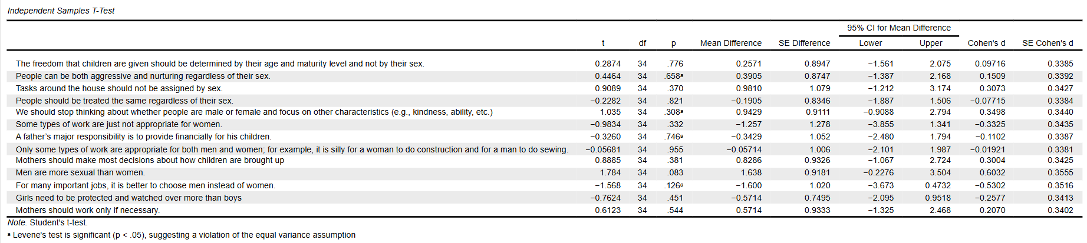
*p<0.05
The results of the independent t-test show that the degrees of freedom or df=34, which leads to a critical value=+-2.032 according to t-distribution tables. A confidence interval of 95% was also used to analyze the data. The t-values and p-values varied greatly throughout the table; however, the t-value is greater than the critical value, or CV(34)=+-2.032, across all the items. The p-value is also larger than 0.5 where the condition p<0.05 is not met across the items as well. The 95 % confidence interval or CI also crosses 0. Moreover, the Cohen’s d effect size was small for most items except the items “Men are more sexual than women” and “For many important jobs, it Is better to choose men instead of women”, where these 2 items had a medium-size effect. Considering these values, especially our result of p>0.05 and the mostly small effect size, the data in this table and survey shows homogeneity of variances.

Table 2
Descriptives: standard deviation, mean, median
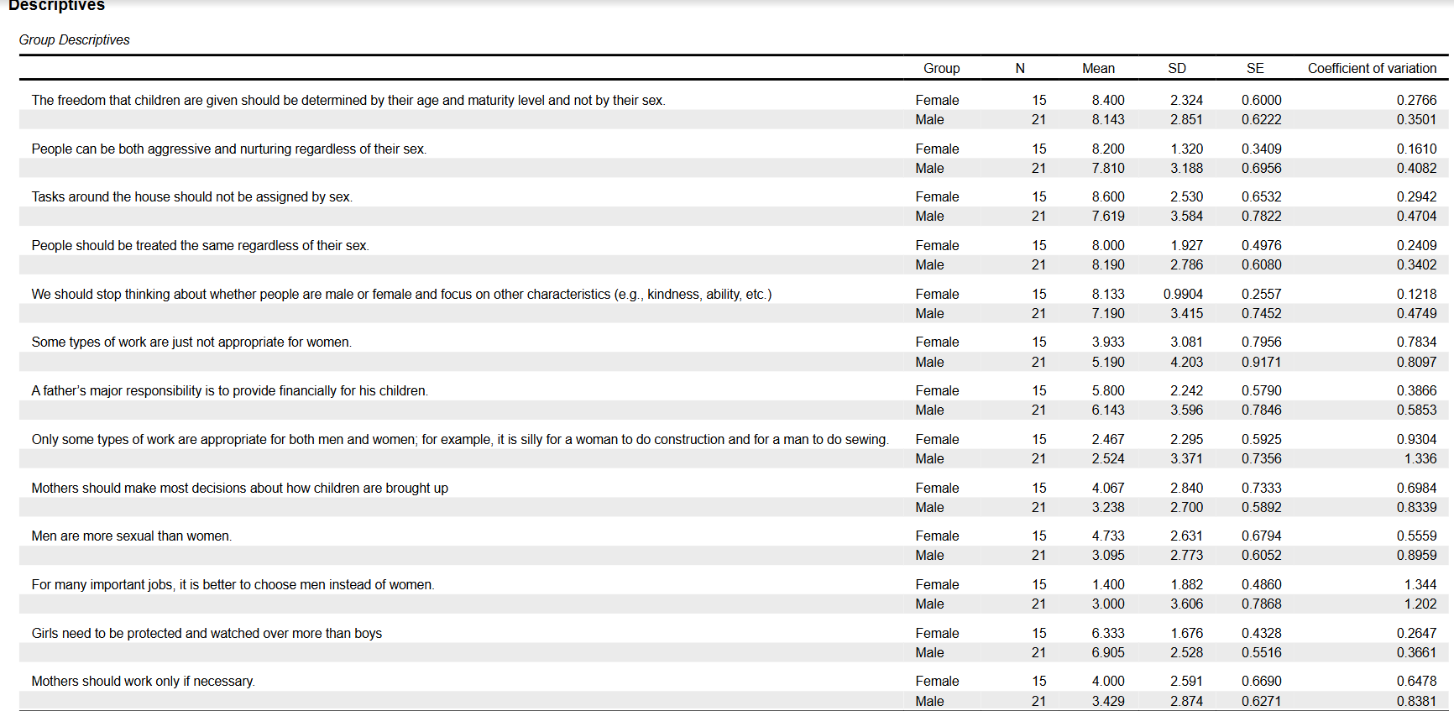
15 female participants and 21 male participants were convenience recruited where the median and means of their scores are quite similar in most items with some having relatively larger differences. This occurred in the items: “Some types of work are just not appropriate for women” where the results were M=3.933, SD=3.081 in the female group and M=5.190, SD= 4.203 in the male group, as well as “For many important jobs, it is better to choose men instead of women” where the results were M=1.400, SD=1.882 in the female group and M=3.000, SD=3.606 in the male group. In comparison, most results such as “people should be treated the same regardless of sex” had more similar results with M=4.000, SD=2.591 in the female group and M=3.429, SD=2.874, with a digit of difference in the means whereas the previous items had a 2-digit difference.

4.0 Discussion
The results showed no statistically significant differences between the group’s scores in this study. Therefore, the null hypothesis which states that there are no differences attitudes towards gender roles between the female and male groups, was not disproven, and the study’s hypothesis was rejected instead. The Cohen’s d effect size was mostly small, indicating a small difference, in addition the p-values larger than 0.05, small mean differences, and t-values which were all lower than the critical value indicated non-significant differences. However, this does not indicate that men and women have similar attitudes towards gender-linked and gender transcendent items, as the sample of this study is not generalizable to the whole population. Furthermore, the scores were not consistent across all items and even within the same gender group. While most items showed similar mean scores, some items showed a greater difference between the scores of male and female participants. This was mostly seen in items which asked about attitudes towards social roles which are related to jobs and finances, in relation to parenting roles at times as well, as seen in the descriptive statistics. Future studies may look further into the intersection of work, parenting and social roles.

4.1 Limitations
While this study had the strength of basing the survey on a researched, validated questionnaire (SRQ), it had many limitations. One of the limitations that may have affected the accuracy of the results is the size of the sample. It is too small to be able to make any generalized claims as 15 female participants and 21 male participants hardly represent their population, where it is also an unequal number of participants in each group. Furthermore, the participants were requited through convenience sampling, often by sending the survey in university WhatsApp groups chats or to friends from other universities. Hence, factors such as educational, racial, religious, and financial backgrounds may have led to greater individual differences amongst the participants. There were also often abnormal results where responses are either 0 or 10; however, it is unclear if the participants may have misunderstood the question, lacked interest in answering, or answered with what they think should be the “right” answer. Despite the survey being anonymous, some may still hesitate to answer truthfully in fear of being deemed as “backwards” or “old fashioned”. Furthermore, the mean scores shown in the analysis do not represent the sample accurately as there was significant variance in the individual results within the same gender group.
5.0 Conclusion
Feminism is certainly not a cause of the past and attitudes which are not in support of feminism are still common in today’s world. Many still believe in gendered social roles which limit women’s freedom and affect men as well. The study’s hypothesis that there would be a significant difference in the scores of the gender groups in the SRQ was disproven as no significant difference was found. This result might not be accurate due to differences in background, individual differences, small sample size, and age differences; hence, future studies should investigate with less extraneous variables.

References
Baber, K. M., & Tucker, C. J. (2006). The social roles questionnaire: A new approach to measuring attitudes toward gender. Sex Roles, 54(7–8), 459–467. https://doi.org/10.1007/s11199-006-9018-y
Damanik, F. H. S., Sukmana, O., & Susilo, R. K. D. (2025). Sociological perspectives on gender inequality in Indonesian sports: A systematic literature review. Retos: Nuevas Perspectivas de Educación Física, Deporte Y Recreación, (67), 607–623. https://doi.org/10.47197/retos.v67.114332
Douglas, S. B., Smith, C. T., & Webster, G. D. (2026). Breadmakers and breadwinners: Measuring prescriptive gender role beliefs for men and women separately and on a common metric. Sex Roles, 92(4), 49. https://doi.org/10.1007/s11199-026-01681-y
Malinowska, A. (2020). Waves of Feminism. The International Encyclopedia of Gender, Media, and Communication, 1, 1–7. https://doi.org/10.1002/9781119429128.iegmc096
McCrindle, M. (2021). The generations defined. In Mccrindle. https://mccrindle.com.au/article/topic/demographics/the-generations-defined/
Voznyuk, O. S., Overall, N. C., Hammond, M. D., Low, R. S. T., Henderson, A. M. E., Chang, V. T., & Christensen, M. (2026). Intergenerational links between parents’ and children’s hostile and benevolent sexism. Sex Roles, 92(4). https://doi.org/10.1007/s11199-026-01668-9

Appendix
Appendix A: raw JASP/SPSS data file (screenshot unavailable)

