Interim Report

Module: Project
Lecturer: Lintao Zhang

Student: Jairo David
DAV22868331

10th December 2025
Campus: Tycoch

Contents
Abstract 2
Introduction 3
Team Roles 4
Key Responsibilities: 4
Collaboration plan 4
Communication & Coordination: 4
Decision-Making & Accountability: 4
Planned Materials 5
BOM 6
Risk Assessment 7
Technical Risks 7
User Risks 7
Security Risks 7
Conclusion 8
References 9
References for Component Justifications 10

Abstract
This project describes the design and development of a low-cost smart cane intended for visually impaired individuals. The device integrates waterproof ultrasonic sensors to detect obstacles both at ground level and above the waist, a low-power Arduino Nano microcontroller, a haptic feedback system via vibration and a rechargeable power source. The design aims to maintain a manufacturing cost below £100. This is a significantly low cost considering the prices of current canes, which usually exceed £600. This report includes the selection of materials, the technical justification of the components, a Bill of Materials (BOM), a budget analysis, risk assessment, a market study and a development plan. This project will create an opportunity in the technology market as it will provide the chance for people with visual or hearing disabilities to access an affordable smart cane.

Introduction
We can say that independent mobility is one of the most important human faculties for the quality of life of people with visual impairments. However, traditional white canes have limitations as they only detect obstacles at ground level and do not warn of risks located above the waist. Many current smart canes offer detection, connectivity or advanced functions, but their high prices limit acquisition, especially among users with limited financial resources. The aim of this project is to design a functional yet highly affordable smart cane, with obstacle detection at various levels and clear feedback for the user, taking into account the importance of the economic factor for those who need it, while maintaining a production cost below £100. Our goal is to help people with disabilities without affecting their finances, providing them with the assurance and confidence that our materials will be appropriate and of the right quality.

Team Roles Oversees material selection, hardware research, and component procurement.

Key Responsibilities:
- Source materials that are strong, lightweight, and cost-effective.
- Research and purchase electronic components within project budget.
- Compare supplier prices to keep the cane under the £100 target.
- Test material durability and compatibility with electronic housing.

Collaboration plan
As the person in charge of the logistics for our meetings, we have always tried to maintain clear and organised communication with my colleagues, as this is the foundation and basis of our project. Likewise, decision making and the brainstorming method help us to create a theoretically stable project with great potential to develop tools for those in need that will assist them in their daily lives.
'The art of communication is the language of Leadership', phrase attributed to James C Humes (n.d.).

Communication & Coordination
- Weekly team meetings to review progress, set goals, and delegate new tasks.
- Group chat on Microsoft Teams for quick daily updates and problem-solving.
- Microsoft Teams used to store and share reports, files, and code.

Decision-Making & Accountability
- Major project decisions made jointly after discussion and vote.
- Each member maintains an individual project log for transparency.
- Shared responsibility for meeting deadlines and presentation quality.

Planned Materials
To achieve a safe and economical design, the following materials have been planned: • Aluminium
• ABS Plastic
• Anti-slip rubber
• Red reflective tape
• Low-gauge wires (AWG)
All materials to be used have been carefully selected, and their prices have been compared in the market to ensure they meet the requirements we need for durability and cost-effectiveness.
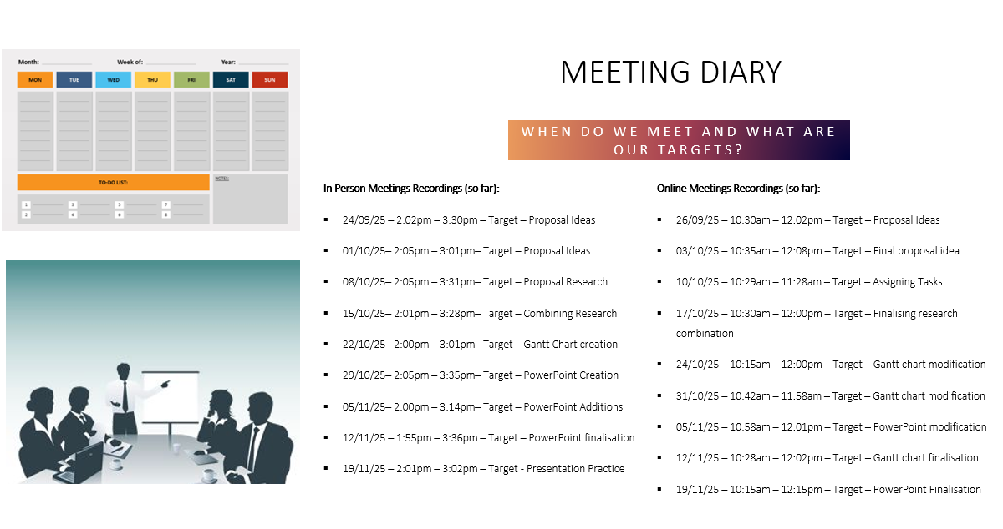

Item | Model / Specification | Function | Justification | Qty | Price  (Each) | Link
Arduino Nano | ATmega328P | Central controller | Small, low-power, and easy to program. | 1 | £14.32 | Amazon
Vibration Motors | 3V, 44000rpm | Spins rapidly to create vibrations | Small, compact, and cheap. | 1 | £9.32 | Amazon
Driver Board | DRV2605L | Controls speed and power of motors | Allows better distance detection via motors. | 1 | £6.99 | Amazon
Sensors | JSN-SR04T | Detects distances | Comes waterproofed, relatively cheap, and reliable. | 2 | £8.99 | Amazon
Battery | 10000mAh | Powers components/ devices | Rechargeable and stores large charge. | 1 | £12.49 | Amazon
Button | 4 Pin DC 5V SPDT | Allows/ stops flow of electricity. | Cheap, simple, allows power saving. | 1 | £7.49 | Amazon
Cane | Telescopic Blind Stick | Assists the blind with navigation | Provides a solid base to build off. | 1 | £17.19 | Amazon
Reflective Material | 1cm x 8000cm Red Reflective Tape | Reflects lights in a noticeable manner | Passive, cheap, easy to apply. | 1 | £1.49 | Amazon
 |  |  |  |  | £87.27

BOM

Risk Assessment

Technical Risks
Ultrasonic sensors could give erroneous readings with certain distances and surfaces.
Possible solutions would be parameter calibration, signal filtering and testing with different materials.
The battery may be damaged prematurely or may not offer sufficient charge duration.
A possible solution would be to optimise sleep modes and use reliable power banks.
Electronic components may be vulnerable to impacts or affected by humidity.
A possible solution would be to use reliable and rigid materials that provide real protection to our components and, at the same time, to use the best sealants that are resistant to moisture and impacts.

User Risks
The vibration may not be sufficiently perceptible as people walking might not identify the movement of the motors due to various factors.
The possible solution would be to carry out user testing, adjust the intensity and experiment with different patterns, and use motors that are strong enough to be perceptible even when people are in motion.
The additional weight of the system may make the cane uncomfortable, especially for elderly people or children.
A possible solution would be to use lightweight components and distribute the weight evenly.

Security Risks
Risk associated with the rechargeable battery.
Solution: use certified batteries, include overcharge protection.
Total dependence on the intelligent system by the user.

Solution: educate the user on its use, as they should not rely entirely on it since there is a factor of error which can be unforeseen because the components will be electronic and any failure could compromise the entire system or the battery might simply run out.

Due to these potential issues, it is always recommended to consider that our cane will also fulfil the needs of a traditional cane.

Conclusion
The proposed smart cane has the potential to revolutionise mobility for people with visual impairments by providing obstacle detection both at ground level and above the waist, haptic feedback, and a design with a dramatically lower cost than commercial alternatives, as the market value of one of the recognised brands is approximately £700. By keeping the manufacturing cost below £100, the device could be widely adopted by individual users, institutions and non-profit organisations, ensuring that this device is available to everyone who needs it without restrictions and, above all, at a low cost. Its development and deployment could significantly improve safety, independence and quality of life for many people, while democratising access to advanced assistive technologies.

References
Chandra, S., Sharma, U. & Khilnani, D. (2025) ‘A Computer Vision and Depth Sensor-Powered Smart Cane for Real-Time Obstacle Detection and Navigation Assistance for the Visually Impaired’, arXiv preprint, arXiv:2508.16698.
Ruan, L., Hamilton-Fletcher, G., Beheshti, M., Hudson, T.E. & Porfiri, M. (2024) ‘Multi-faceted sensory substitution for curb alerting: a pilot investigation in persons with blindness and low vision’, arXiv preprint, arXiv:2408.14578.
King Saud University Computer and Information Sciences (2025) ‘AI smart cane technology and assistive navigation for visually impaired users: an overview’, Journal of King Saud University – Computer and Information Sciences, 37, 226.
Lakshmi, S., Priya, P. & Kalpana, S. (2014) ‘Intelligent white cane to aid visually impaired’, International Journal of Advanced Research in Electronics, Communication & Instrumentation Engineering, 2(2), pp. 29–33.
Rohan, P., Ankush, G., Vaibhav, S., Mehra, D., Balakrishnan, M., Kolin, P. & Manocha, D. (2007) ‘“SMART” Cane for the Visually Impaired: Technological Solutions for Detecting Knee-Above Obstacles’, IIT Delhi.
Usability and Design Guidelines of Smart Canes for Users with Visual Impairments’ (2013) International Journal of Design, 7(3), pp. 43–59.
WeWALK UK Tech News (2022) ‘WeWALK raises £1.7m for “smart cane” to aid visually impaired’, UKTech.News. Disponible en: https://www.uktech.news/medtech/wewalk-ukri-20220704
Smart Technology (s. f.) ‘SmartCane from Smart Technology’: https://smart-technology.org.uk/our-technology-v1-srp-embedded-encryption-protocol/smartcane-from-smart-technology/
Humes, J.C. (n.d.) “ The art of communication is the language of leadership.” Attributes quotation.

References for Component Justifications
Arduino Nano
Arduino (2025) Arduino Nano technical specifications. https://store.arduino.cc/products/arduino-nano
Vibrating motor
Pololu (2024) Vibration Motors: Product Overview and Applications. https://www.pololu.com/category/60/vibration-motors
Driver DRV2605L
Texas Instruments (2024) DRV2605L Haptic Driver datasheet. https://www.ti.com/product/DRV2605L
Ultrasonic Sensor JSN-SR04T
Seeed Studio (2023) JSN-SR04T Waterproof Ultrasonic Sensor datasheet. https://www.seeedstudio.com/JSN-SR04T-Waterproof-Ultrasonic-Sensor-p-2645.html
Battery Power Bank 10,000 mAh
Anker (2024) PowerCore 10000 Portable Charger product page. https://www.anker.com/products/variant/powercore-10000/A1263011
Telescopic cane for visually impaired people
RNIB (2023) White Canes and Mobility Aids for Visually Impaired People. https://www.rnib.org.uk
Reflective tape
3M (2023) Scotchlite Reflective Material Product Datasheet. https://www.3m.com/3M/en_US/company-us/all-3m-products/~/All-3M-Products/Scotchlite-Reflective-Materials/
Interruptor SPDT 5 V
SparkFun (2024) SPDT Switches: Product Specifications. https://www.sparkfun.com/products/

