HTML & CSS Web Development

University of Wales Trinity St David

Module: Internet Technology and Security

Web Development

Shamuel Hashan

Kemi Ademoye

3 May 2018

1803153

Contents
- Introduction
- Requirements
- Implementation
- Validation
- Evaluation
- Referencing

Introduction

In this report I will be talking about the website I made for my Assignment. I will talk about various topics.
For example, during the requirements section, I will be talking about what the website required. I will talk about what the website is about. What the purpose of the website is, the target audience, what topics it covers and how relevant it is.
After that, I will talk move on to the implementation of the website. Here we will talk about the actual completed website using screenshots. I will also do the validation on my website’s html code and the CSS code. I will also show what the results of the code is. I am going to give description on what went right or what went wrong, if I was able to fix the issues or how I fixed the issues.
After the website gets validated, it will then be evaluated. That section will cover the various choices that was made on the websites design, what went wrong and what would do differently if this task was to be done again.

Requirements

In this section, I am going to be talking about the website’s requirements.
My website is on British cars. 3 of the main car companies I cover are Aston Martin, McLaren and Jaguar. I should have a homepage, a page on Aston Martin, McLaren and Jaguar as well as a contact page. Another thing that is required is a navigation bar to help the user navigate to different pages on the website. The contact page should Allow the user to enter their email. The homepage should include information on what this website will cover a fair bit on what the website is about.

The Aston martin page will cover what the history of Aston Martin is like while also giving a good amount of information on one of Aston Martins latest cars. The DBS Superleggera. The website should talk about the specs of the car. Another thing the website should include are images of the DBS and a video of the DBS.
The McLaren page will cover what the history of McLaren is like while also giving a good amount of information on one of their most recent cars. For example, the Senna. The website should include the specs of the Senna. It will also be a good idea to include an image of the car and a video of it.
The Jaguar page will cover the company’s history as well as giving a good amount of information on one of Jaguars latest cars. This would be the Jaguar XE SV Project 8. It is important that the Jaguar XE SV Project 8 specs is also included in this section as well as an image and video of the car.
The purpose of the website is to let people learn how well the British are doing with car engineering and how good some of the cars are. It should give the people an insight on the quality on some of the cars. The target audience are car enthusiasts or people that want to get into cars. This website is relevant since the three companies I cover are quite popular and the cars I talk about are quite new. I will need to have various images of stylish cars to get the users attention. It is important that the images used in the website have good quality otherwise the viewers might not come back. It is essential that the facts about the cars are right since the viewers will probably be looking at the website to learn more about website. Fact checking from reliable sources such as the car companies’ websites can ensure that the specs we use are correct.
The website should be easy to navigate, the colour contrast should be good. The user will need to be able to read it as well making sure that the colour scheme looks good. It is also important that the website functions well.

Implementation

  - The pages
Homepage
This is the homepage. It talks about what cars are owned by British companies and which ones are not. There is also a slideshow with three images of the cars from companies I am covering. It also includes a video showing what the British has done. I used a fade animation to transition between the images. It also contains links to the other pages, but the homepage link on the nav bar is highlighted. It should have a footer at the bottom.
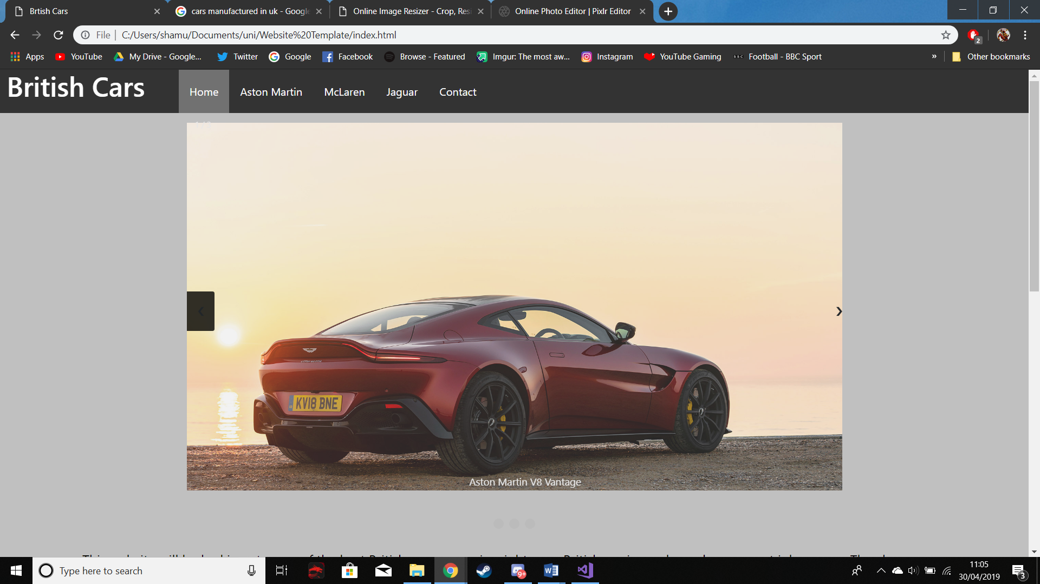
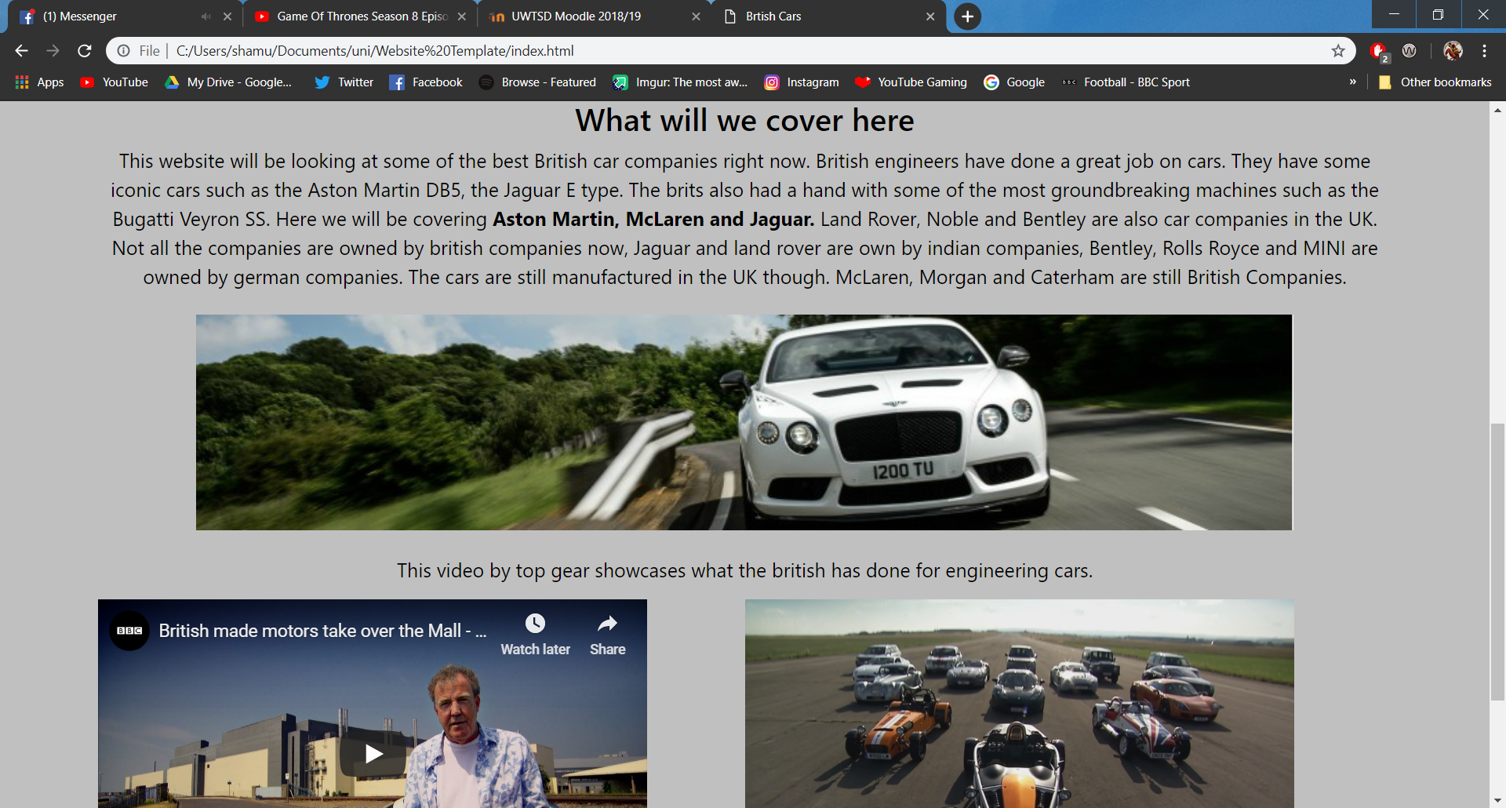

Aston Martin page
This page covers Aston Martins history and the DBS Superleggera. I used an image of a db11, db5 dbs superleggera and a video on the dbs superleggera. It also contains links to the other pages, but the Aston Martin link on the nav bar is highlighted. It should have a footer at the bottom.
.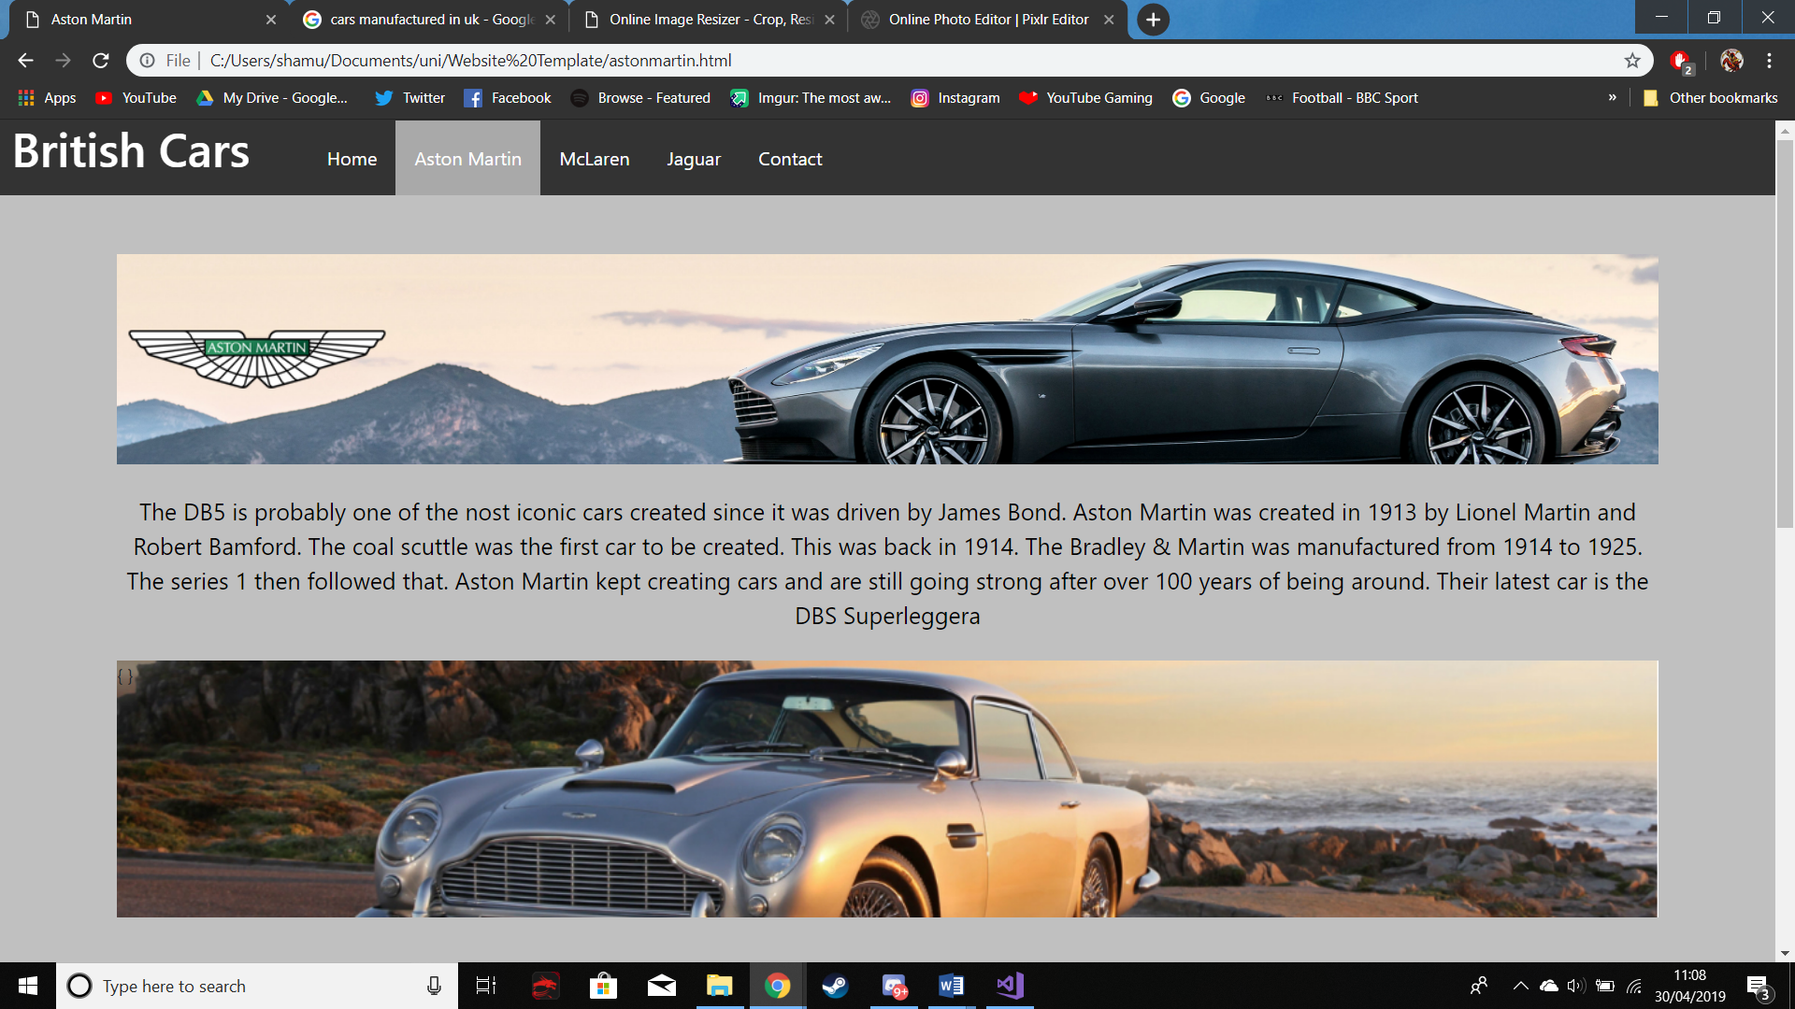
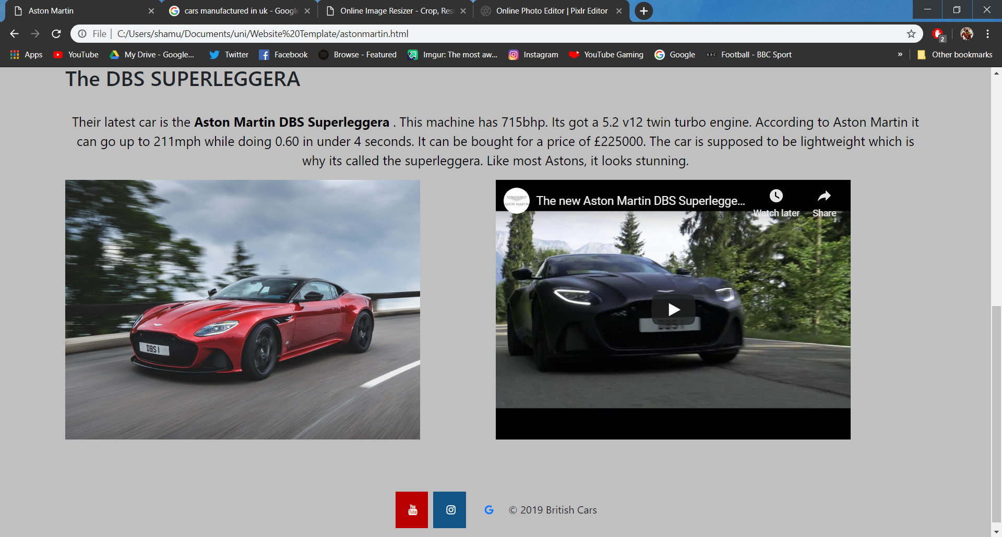

McLaren Page
This page covers McLarens history and the McLaren. I used an image of a p1, 650, senna and a video on the senna. It also contains links to the other pages, but the McLaren link on the nav bar is highlighted. It should have a footer at the bottom.
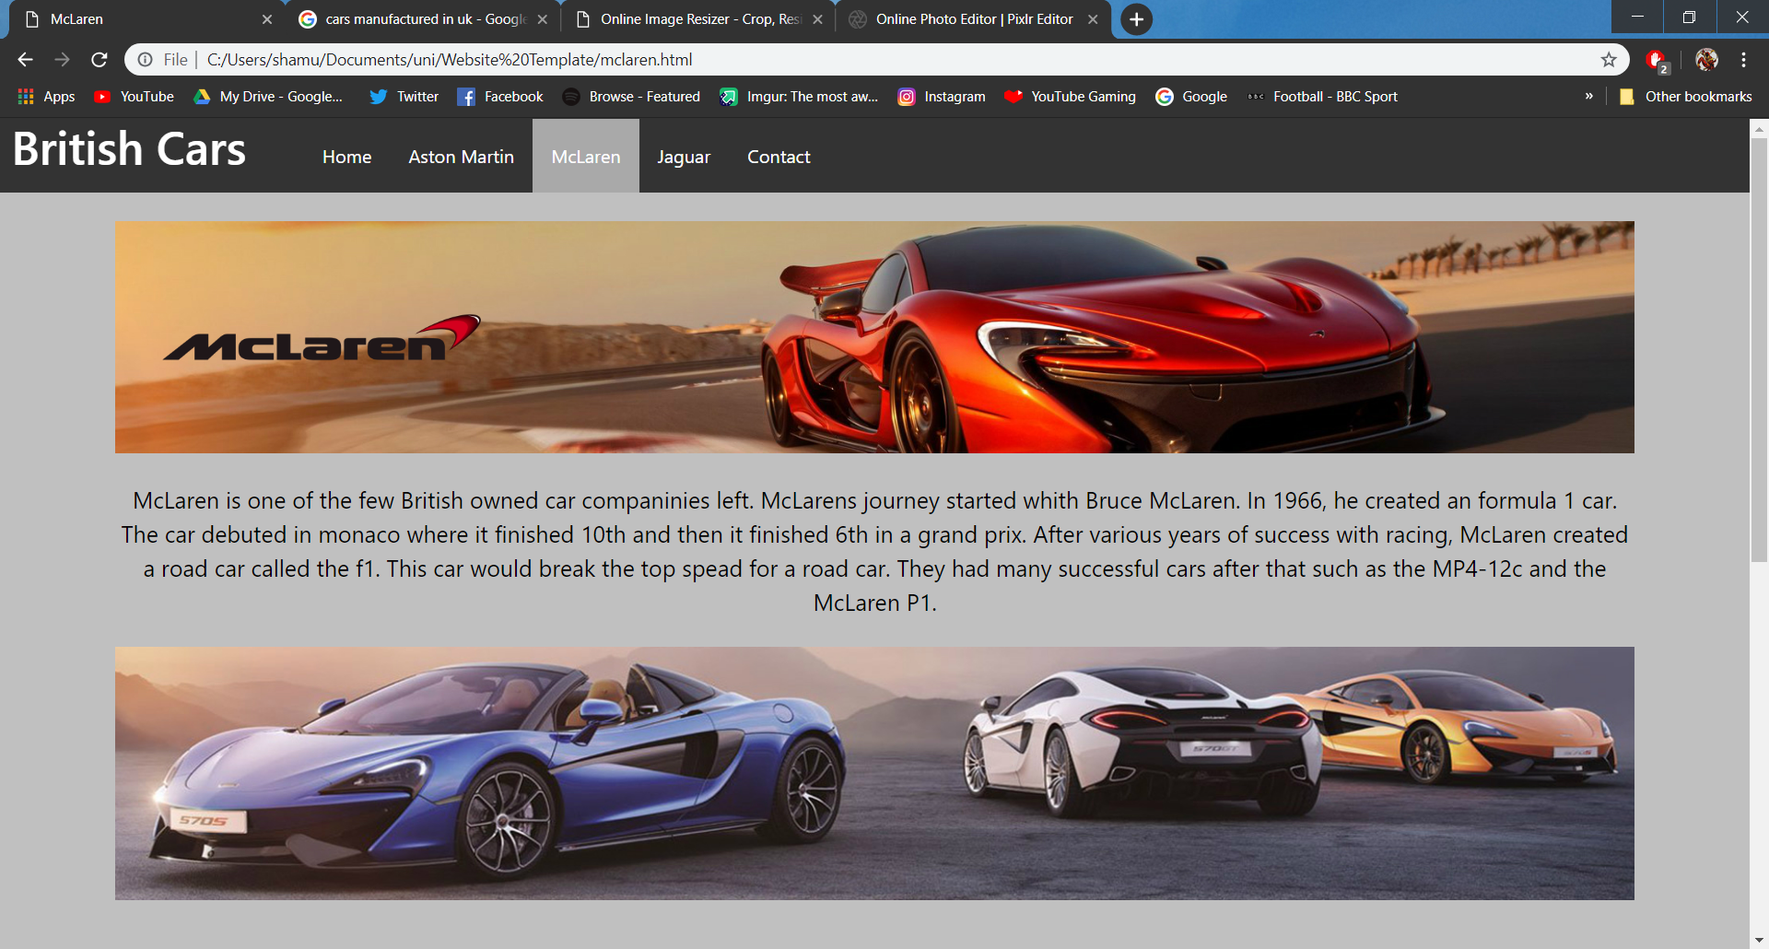
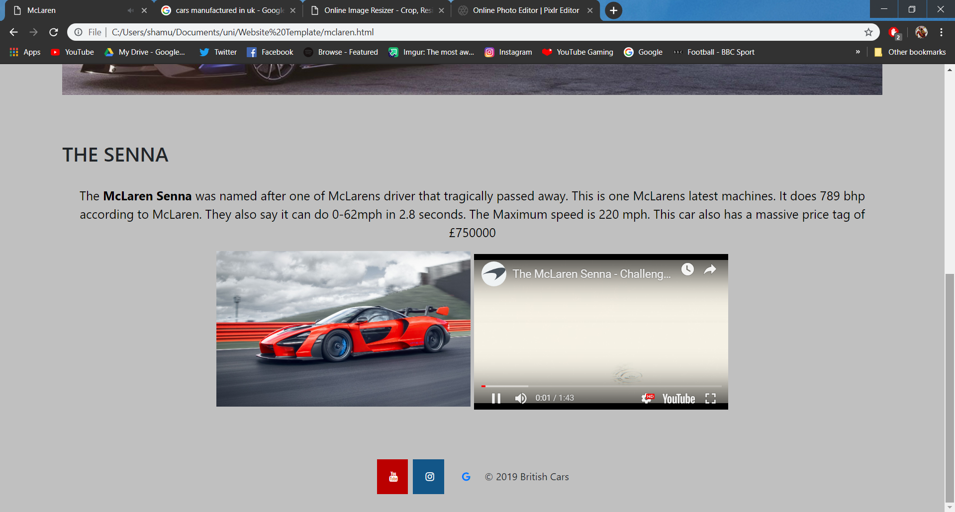
Jaguar page
This page covers Jaguars history and the McLaren. I used an image of an f-type, e-type, the XE SV Project 8 and a video on that car on a race. It also contains links to the other pages, but the Jaguar link on the nav bar is highlighted. It should have a footer at the bottom.
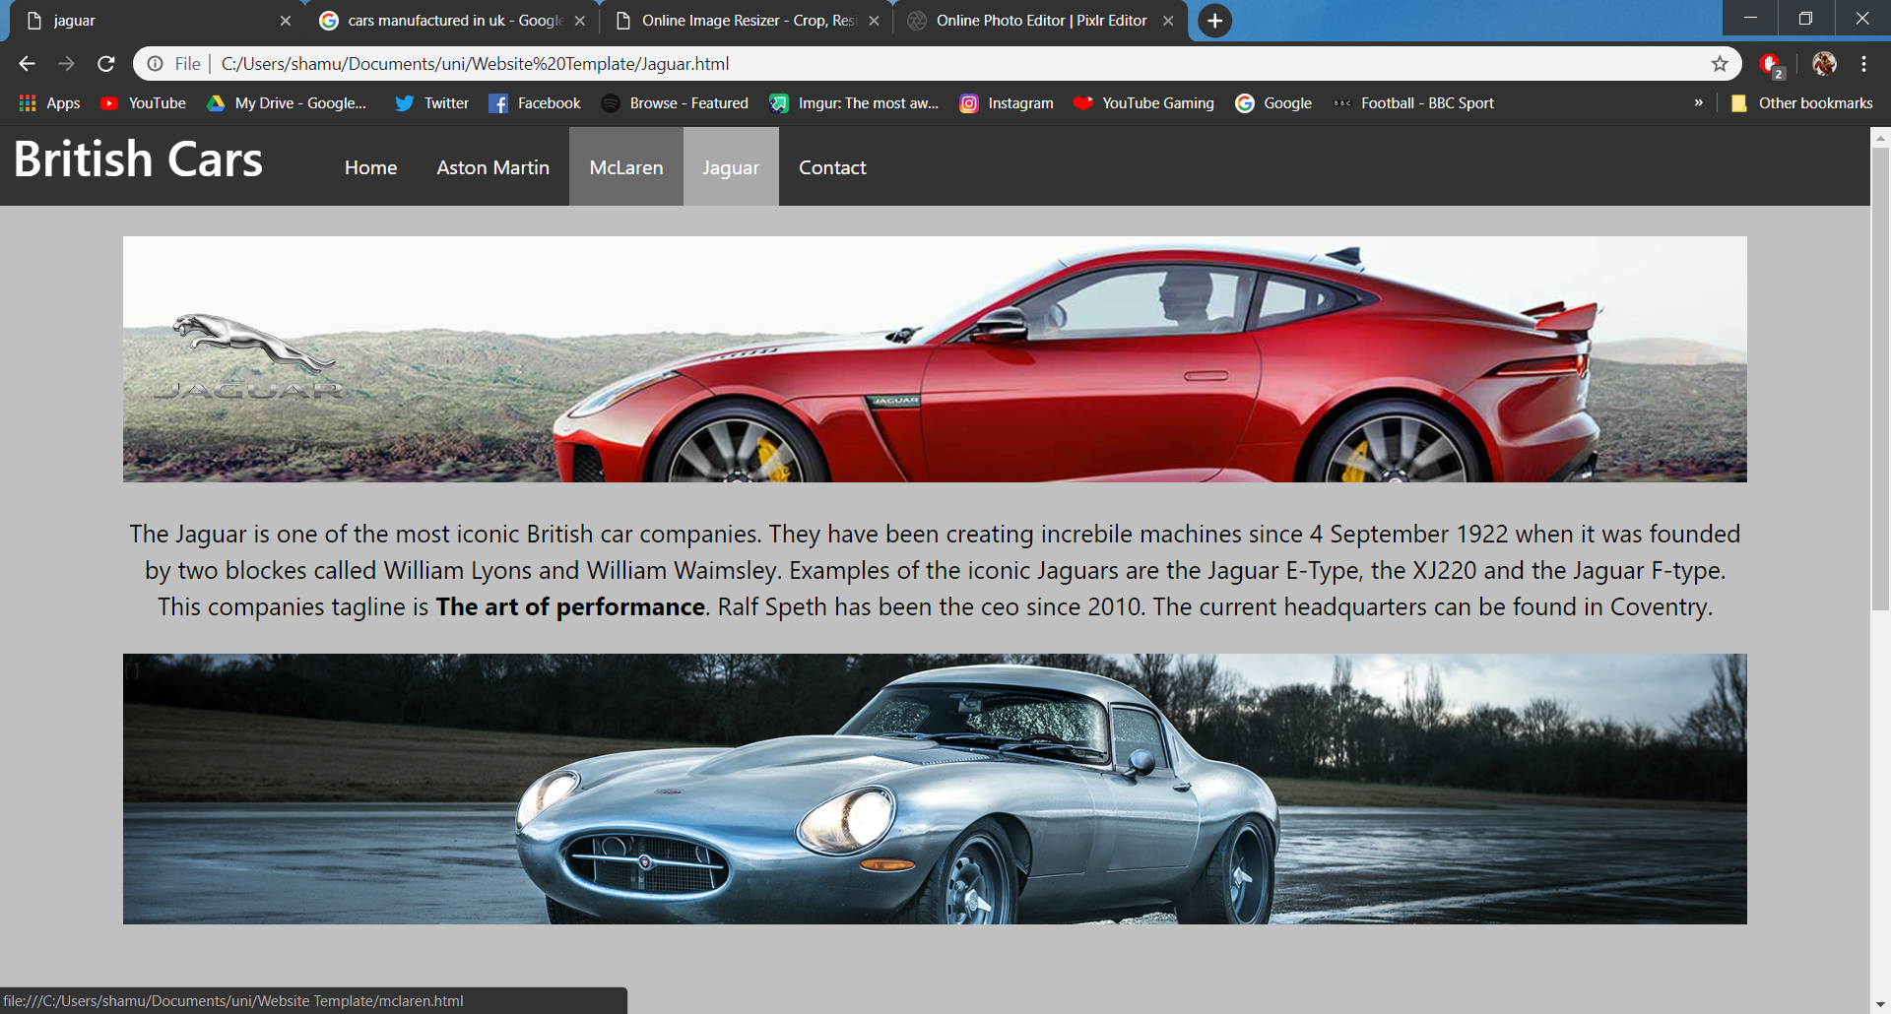
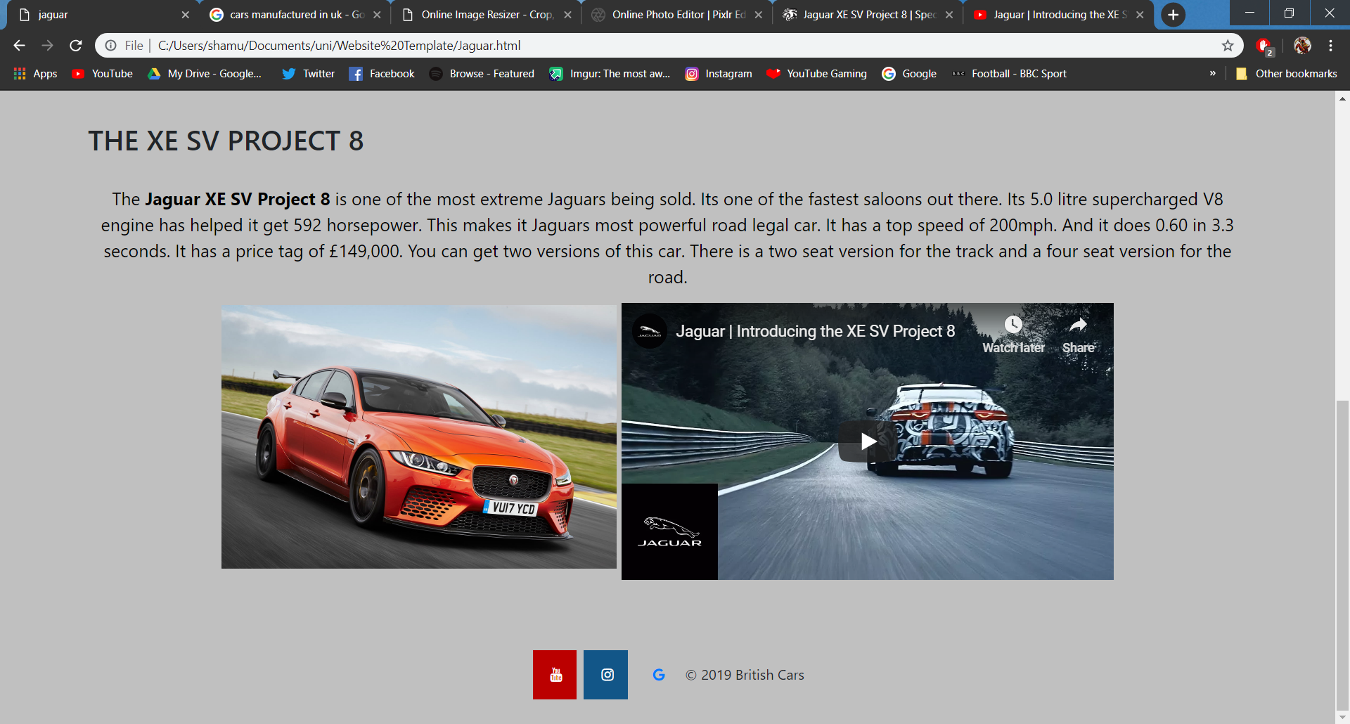

Contact page
This page is a form and should allow the user to enter their email and a message. It also contains links to the other pages, but the Contact link on the nav bar is highlighted. There should be a button to store it. This page should also have a footer at the bottom.
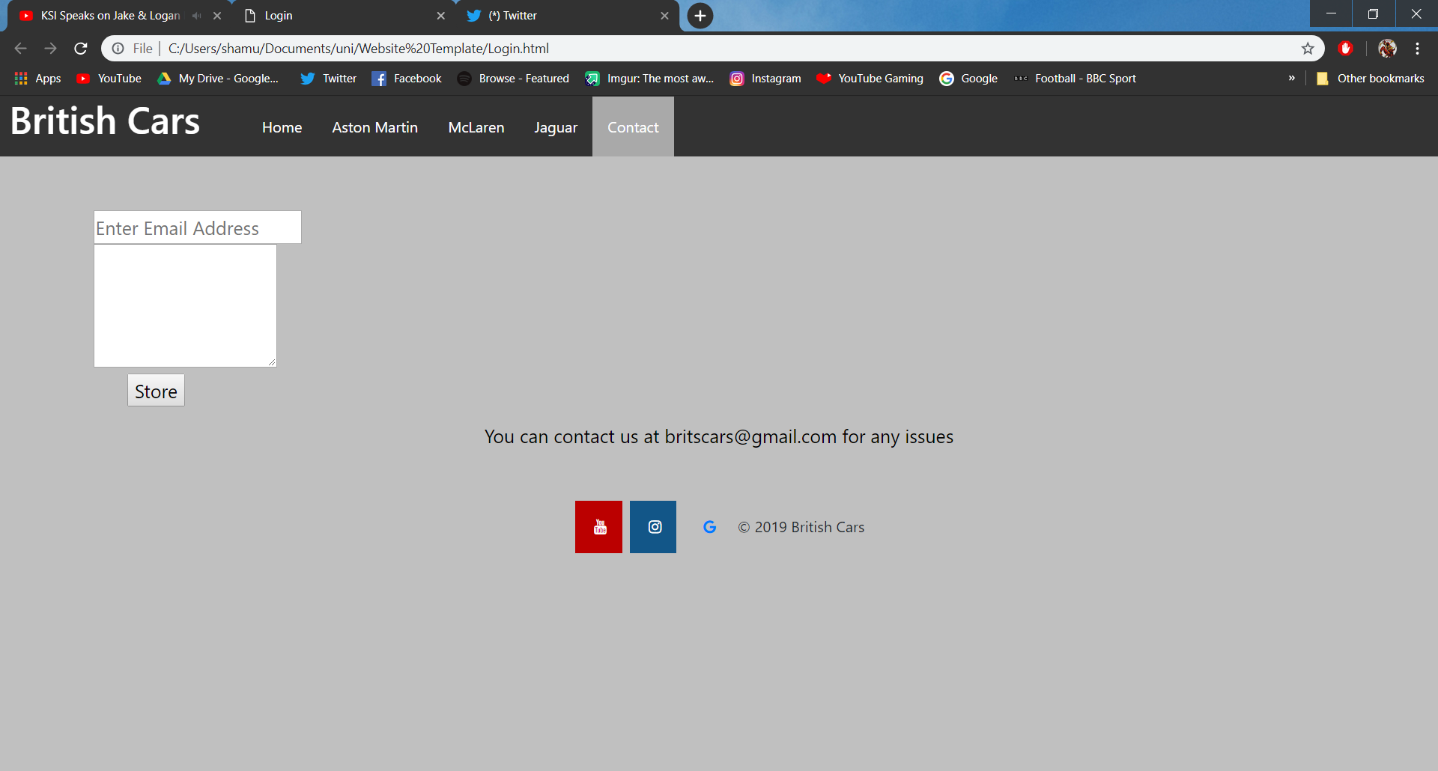

  - Validation
After validating my html pages, I found that I have a fair amount of errors. For example, I had an attribute value that wasn’t allowed. The code was <meta name="keywords" value="" /> so I changed it to <meta charset="UTF-8">.
I also had issues with the navigation bar. I had my heading on the wrong spot. Instead of having it before the navigation I put it on inside it.
A lot of the errors was that I had some pointless code that doesn’t really do anything. Such as the <img src="media/vantage.jpg" style="width:100%"> I just got rid of the style="width:100%
I also had this with two of the other images. I did the same thing as I did with the 1st image to fix it.

Another error found while validating the website code was the with the main element. The main element was put after the section element. For example, the code was
<section>
<main>
</main>
</section>

It should not be after the section element. To fix this issue, the main element was moved to before the section element instead of after element. The code should have looked like this.
<main>
<section>
</section>
</main>

I also and an error with the align attribute for an iframe and image I used. The align="left" code I used was a bit pointless. Instead, I used the stylesheet and made used
iframe
{
float:left;
}

Another error that was found while I was validating was that the section did not have a heading. To sort this out, a <h2> tag was added before that section. It looked like this.
<h2> What will we cover here? </h2> to make sure it had one.

While I did have a fair amount of errors on my HTML. I checked my CSS stylesheet. While I was validating, I found that I had no errors there.

Evaluation

Now that the website is completed, it is time to evaluate it.
To start off, I believe I did a few things well. I added a sufficient amount of information. I reckon the design of the website isn’t bad. It feels smooth. The website looks clean.
The colour scheme is fairly simple, its mostly grey, black and a bit of white. The colour contrast is not too bad. It does not make the text harder to read. I feel the colours I went for compliments each other well. Various different colours were used to try and find the right one such as blue and white, but it did not look as good. I went with this because since my website is about cars, I should go with car colours and most of the cars go well in these colours. Especially Aston Martin. It is also easy to read the text as well. At first, going with a red white and blue colour scheme was considered since that is the colours of the United Kingdom, but it could have been a bit flashy and harder to read. A contrast checker was used to test the contrast between the foreground and background. The colour’s that was used for the British Cars website ticked all the correct boxes. 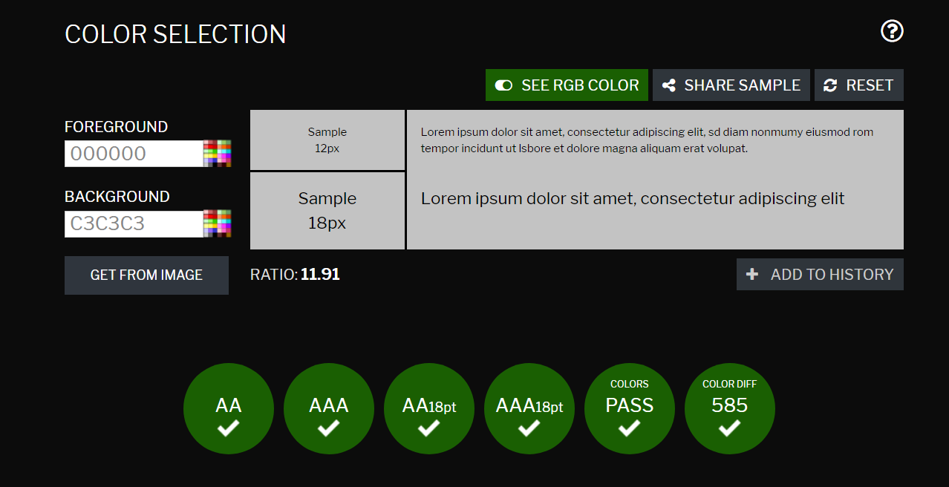 The text is also fairly big which also makes it easier to read. The website is also functional. It is easy for the user to navigate across. The user can easily see where each of the links to the other pages are.
If I was to do this website again, I might just use cars that are British owned. I might also make a better logo. I went with the one I went with because a lot of car websites have similar logos. I would probably add more cars to the pages. Maybe include classic cars. I might also use another animation.
To conclude, the website met the requirements. It was easy to navigate colour contrasted well and text was easy to read. It was also really easy to navigate. All of the functions worked as well.

Bibliography
Aston Martin. (2018, August 1). The new Aston Martin DBS Superleggera. Retrieved from Youtube: https://youtu.be/qpJroJm8x9g
ASTON MARTIN DB 5 HD WALLPAPERS. (n.d.). Retrieved from Easter Images: http://www.easterimagess.com/aston-martin-db-5-hd-wallpaper
Aston Martin. (n.d.). DBS superleggara. Retrieved from Aston Martin: https://www.astonmartin.com/en-gb/models/dbs-superleggera
BBC. (2013, August 20). British made motors take over the Mall - Top Gear: Series 20 Episode 6 - BBC Two. Retrieved from Youtube: https://www.youtube.com/watch?v=vmcmqTAu6b8
Dowsey, D. (2007). Aston Martin: Power, Beauty and Soul .
GALLAGHER, S. (2017, June 29). EWS JAGUAR XE SV PROJECT 8: FULL DETAILS. Retrieved from Evo: https://www.evo.co.uk/news/19419/592bhp-jaguar-xe-sv-project-8-pics-specs-and-149k-price-tag
Jaguar. (2017, May 25). Jaguar | Introducing the XE SV Project 8. Retrieved from Youtube: https://www.youtube.com/watch?v=P3t_DD1vzSg
Jaguar. (n.d.). JAGUAR XE SV PROJECT 8. Retrieved from Jaguar: https://www.jaguar.co.uk/about-jaguar/special-vehicle-operations/project-8.html
McLaren. (2018, March 6). The McLaren Senna - Challenge the Impossible. Retrieved from Youtube: https://www.youtube.com/watch?v=yvljnF_cU84
McLaren. (n.d.). About. Retrieved from McLaren: https://www.mclaren.com/group/about/
NEW CONTINENTAL GT. (n.d.). Retrieved from Bentley: https://www.bentleymotors.com/en/models/new-continental/new-continental-gt.html
Senna. (n.d.). Retrieved from Top Gear: https://www.topgear.com/car-reviews/mclaren/senna
Supporting UK manufacturing. (2017, December 27 ). Retrieved from AA: https://www.theaa.com/car-buying/cars-made-in-britain

