An Analysis of the Value of Corporate Social Responsibility Communication in the UK Gambling Industry: Ladbrokes & William Hill PLC



Author: Richard James Shaw
Course: (Mbus) Business and Management
P Number: 134923
Submission date:
Supervising tutor: Caroline Jawad

DECLARATION

This work has not previously been accepted in substance for any degree and is not being concurrently submitted in candidature for any degree

Signed……………………………………………

Date………………………………………………

STATEMENT 1

This dissertation is being submitted in partial fulfilment of the requirements for the degree of BA.

Signed…………………………………………….

Date………………………………………………

STATEMENT 2

This dissertation is the result of my own independent work/investigation, except where otherwise stated.

Other sources are acknowledged by footnotes giving explicit references. A bibliography is appended.

Signed……………………………………………

Date………………………………………………

STATEMENT 3

I hereby give consent for my dissertation, if accepted, to be available for photocopying and for interlibrary loan, and for the title and summary to be made available to outside organisations.

Signed………………………………………………

Date…………………………………………………

STATEMENT 4

I hereby give consent for my dissertation, if accepted, to be available on the university’s IT system to those who have consent to use the system.

Signed………………………………………………

Date…………………………………………………

Acknowledgement

I would like to express my deepest gratitude and thanks to my advisor, Caroline Jawad. Her guidance has been incremental to my research, she has provided me with support, encouragement and guidance.

Caroline, has provided me with an excellent learning environment. She is the one person who deserves my deepest thanks for her constant help and belief in my abilities over the past two years.

I am also grateful to all the other support I have received while undergoing this research project.

Abstract
The following dissertation aims to investigate the value of Corporate Social Responsibility communication in the UK gambling industry. Three objectives were used in order to successfully complete this dissertation:

Investigate the value and content of CSR communications in the UK gambling industry
Evaluate the value of CSR in the UK gambling industry
Produce recommendations for improved CSR communications
The researcher satisfied these objectives by exploring a wide range of academic authors such as Friedman, Freeman, Carroll, Griffiths, Reith and Kingma.

In addition to reviewing literature, a content analysis was conducted in order to obtain a better understanding of the values and commitment of CSR communication in regard to William Hill and Ladbrokes.

To conclude this dissertation, the objectives were successfully met within the content analysis.

Contents
Chapter 1: Introduction 1
1.1 Rationale 2
1.2 Background and Context 2
1.3 Difficulties with Gambling Research 5
1.3 Research Aims and Objectives 5
Chapter 2: Literature Review 7
2.1 Introduction 7
2.2 Exploring Online Gambling (OG) 7
2.3 History of Regulation 8
2.4 The Risk Society 10
2.5 Corporate Social Responsibility 11
2.6 General Theories of Ethics 13
2.6.1 Consequential Ethics 13
2.6.2 Deontological Ethics 14
2.6.3 Virtue Ethics 14
2.7 Theories of CSR 15
2.7.1 Instrumental Theory 15
2.7.2 Political Theories 16
2.7.2.3 Corporate Citizenship 17
2.7.3 Integrative Theory 18
2.7.4 Legitimacy Theory 25
2.8 The UK Gambling Industry 26
2.9 CSR Communication 27
2.10 Legal Issues and Pressure Groups 27
2.10 Corporate Communication 28
2.11 The Annual Report 29
2.12 The Corporate Website 29
2.13 Conclusion 30
Chapter 3: Research Methodology 31
3.1 Introduction 31
3.1 Introduction to Content Analysis 32
3.2 Practical Applications of Content Analysis 33
3.3 Conducting a Content Analysis 34
3.5 Triangulation 36
3.6 Methodology 37
3.6.1 Strategy 37
3.6.2 Data Collection 38
3.6.3 Reliability and Validity 38
3.6.4 Ethical Considerations 39
Chapter 4: Research Analysis 40
4.1 Introduction 40
4.2 Ladbrokes Coral PLC 41
4.3 Ladbrokes Annual Report: 46
4.4 William Hill PLC 60
4.5 William Hill PLC Annual Report 64
4.6 Content Analysis Finding’s 83
Chapter 5: Conclusion 86
5.1 Introduction 86
5.2 Main Findings 86
5.2.1 The Value and Content of CSR Communication in the UK Gambling Industry 86
5.2.2 The Value of CSR within the UK Gambling Industry 88
5.2.3 Recommendations for Improved CSR Communications in the Industry 88
5.3 Discussion of Main Findings 89
5.4 Recommendation for Future Research 90
5.5 Limitations 90
5.6 Conclusion of the Study 91
Bibliography 92

Chapter 1: Introduction

This dissertation seeks to analyse how the UK gambling industry communicates Corporate Social Responsibility (CSR). Hopkins (2003, p. 43) suggests CSR is “the continuing commitment by business to behaving ethically and contributing to economic development while improving the quality of life of the workforce and their families as well as the community and society at large”. Kraemer and Whiteman (2008) apply Goffman’s theory to CSR to the world petroleum industry and critically analyses the industry’s CSR display and are particularly interested in the front-stage and the darker, more realistic back-stage behaviours. Goffman (1959) suggests the use the use of cods of conducts, public statements and various CSR reports are just the front-stage. Simultaneously to these events there is a back-stage, what happens when the lights are off. This research project used the same argument as Kraemer and Whiteman, reviewing an industry with negative a negative image and how it uses CSR communication to its benefit. Communication has the sole purpose is the transmission of information and meaning from one individual to another (Guffey, et al., 2009). However, just as ‘CSR’ is difficult to define, this problem also follows ‘CSR Communication’. CSR communication is a sensitive subject due to the fact it involves the inherent problem of communicating sustainability issues (Brugger, 2014).

The aim of this dissertation is to aim of this dissertation is to analyse CSR communication within the UK gambling industry. Two operators have been selected William Hill, and Ladbrokes, based on their large presence in the UK.

This dissertation research is aware of the externalities which occur in the gambling industry. However, for the purpose of this research CSR communication will be analysed as a business model, and how CSR is used to offset PG.

1.1 Rationale

This study was chosen in order to further build on a successful undergraduate dissertation, this research aims to address and understand to what extent gambling operators communicate CSR, and how they communicate CSR. The general research question in this dissertation is to examine to what extent gambling operators, have embraced the idea of CSR. This dissertation will focus of the annual report, and the company website. All of these are in the public domain, and legitimate arguments for analysis. This dissertation takes the position that any hidden policies are there for irrelevant for this research. The communications selected target different stakeholders.

This research will focus on two gambling operators, Ladbrokes and William Hill. These operators have been chosen due to their market share and the local presence they hold in the UK. To offset negative publicity, gambling operators position themselves as responsible. Under the banner of CSR, operators advocate positions to offset the potential harm of their products. The gambling industry does this by donating percentages of their profits to “help gambling related research, education and treatment”. However, it is not in the gambling operators interest to encourage the gambler to walk away. In order to generate business operators must encourage addiction in some form (Byrd, et al., 2017).

1.2 Background and Context

Growth of the gambling industry has been primarily driven by the vast increase of technology and broadband penetration (Gainsbury & Blaszczynski, 2016). The accessibility that comes with online gambling (OG) has fundamentally changed the way the gambling industry does business. OG has evolved into a global marketplace that is accessible to a significant proportion of the world’s population (Banks, 2016). However, the increase in gambling is also due to the neoliberal economic change since the 1970s, the gambling industry has undergone a period of dramatic liberalization and deregulation. This began to happen with legal restrictions were loosened of promotion and expansion which resulted in the massive proliferation of commercial gambling as a global enterprise (Reith, 2007). Since gambling became legalized, there has been a great debate about the benefits and costs of legalized gambling. Whilst the gambling industry argues that its product is simply a form of entertainment. Many researchers argue that gambling is a different form of entertainment because it has very negative externalities (Walker, 1999). Rogers (2005) suggests that the large factor that suppresses the gambling industry is the negative externalities which are associated with gambling. Liberalised gambling reaps profit but bring a large amount of ‘Negative Externalities’.

Problem gambling (PG) is a major factor that is involved in the gambling industry. In the UK, the term “pathological” and “problem” gambling is used interchangeably. These terms describe gambling that compromises, disrupts, or damages family and personal lives (Meyer, et al., 2009). The British gambling prevalence survey indicated that there are around 450,000 pathological gamblers in the UK (Wardle , et al., 2010). This was the last gambling survey that was undertaken in regards to gambling in the UK, professor Hancock seen there was a 0.9% rise in pathological gamblers and stated this should be a wakeup call (Great Britain: Parliment: House of Commons: Culture, Media and Sport Committe., 2012). However, a more recent survey which was held in Wales In 2016, indicated that 1.1% of participants were identified as problem gamblers and 3.8% of participants were identified as moderate risk problem gamblers (Gambling Commission, 2016). PG costs the UK £1.2bn a year, but compared to the £2.6bn that the gambling industry contributes to exchequer yearly, the issue seems negated and leads to a lack of government interest (Davies, 2016).

CSR, is an issue that is tied to the gambling industry. The term CSR carries many alternative definitions which causes the subject to be a very unclear. Andrew Crane (2008, p. 3) states “CSR has experienced a journey that is almost unique in the pantheon of ideas in management literature”. If CSR is to be an effective influence of a corporation’s success, the efforts must be communicated accurately to key stakeholders (Moreno & Capriotti, 2009). The most common approach corporation’s use is the stakeholder theory, strategically by prioritizing important stakeholder group (Clarkson, 1995). These stakeholders most frequently include investors, customers, local communities, governments as well as non-profits. CSR can be looked at in two different perspectives’ which are explained by Friedman and Freeman. Economist Milton Friedman (1970, p. 1) looked at CSR with a business approach and stated, “there is only one social responsibility of business – the use its resources and engage in activities designed to increase its profits so long as it stays within the rules of the game, which is to say, engages in open and free competition without deception and fraud.”. On the other hand, Freeman (2008, p. 12) did not acknowledge Friedman’s stakeholder theory and suggested “The main goal of CSR is to create value for key stakeholders and fulfil our responsibilities to them”.

CSR communications pertains to communicate corporate identity, and plays a crucial role in the formation of ethical corporate perceptions, and social legitimacy (Balmer & Gray, 2007). Organisations are now concerned with communicating their CSR policies. CSR communications has become a vital issue in building and sustaining the legitimacy of the organisation in the eyes of stakeholders. Podnar (2008, p. 75) provides a clear definition:

“CSR communication is a process of anticipating stakeholders’ expectations, articulation of CSR policy and managing of different organisation communication tools designed to provide true and transparent information about a company’s or a brand’s integration of its business operations, social and environmental concerns, and interactions with stakeholders.”

In order for a company to achieve the above they utilize means such as advertisements, product labels, CSR reports, and websites (Kitchen & Uzunoglu, 2014). Christensen (2002) suggests the aim of corporate communication is “to organise an organisations communication activities as one coherent totality”. This suggests that any means of communication should represent a uniform image of the organisation.
Corporate ethical communication can be made up from several sources including the annual report, the company website, codes of ethics, values, advertising and others (Goodman, 2001). However, this dissertation will focus on:

- The Annual Report
- The Company Website

Both of these communications are offered in the public realm, and are therefore seen as legitimate targets for analysis. The communication methods target different stakeholders (Campbell, et al., 2003). The annual report targets shareholders whilst the website targets the public at large.

1.3 Difficulties with Gambling Research

Gambling studies are a narrow and uncritical homogenous field which suffers from unproductive repetition and rivalries. Large sectors of gambling research are influenced by the industry, regulators and governments who produce research which is seen as acceptable to all parties. Industry support given to high profile academics often attracts negative media attention and raises unresolved questions about the relationship between the researcher and operator (Nicholls, 2014). Growing research has shown that, poorly understood, financial relationships with the industry increase the likelihood of proindustry findings, biased interpretations and under representation of alternative interpretations (Babor & Miller, 2014). For gambling research to be conducted it is very important to understand and consider the ethical context in which this research will be conducted, this problem arises due the sensitivity of the research topic. Although, this research focuses on CSR communications, it will also focus on gambling. Gambling to many be a sensitive subject due to the issue of problem gambling (PG).

The UK gambling industry provides an important source of government revenue, in 2015, Gambling Commission revealed that the UK gambling industry is worth £7.1bn, which didn’t include the National Lottery (Pitt, 2015). The 1951, royal commission stated that moderate gambling causes no harm. However, Wardle (2013) reported 5.5% of moderate interest gamblers, and 13.3% of multi interest gamblers were problem gamblers. The UK gambling industry is primarily funded by the Responsibility in Gambling Trust (RiGT), which is an independent charitable trust funded by voluntary donations from gambling operators. Around £7m a year is spent on all gambling research, prevention, treatment and intervention, which is small change to a billion-pound gambling industry. The problem which arises with the industry funding research is the industry tends to have significant impact on what should be researched in the first place (Griffiths, 2009).

1.3 Research Aims and Objectives

The aim of this research is to evaluate and analyse the levels of CSR communication used by UK gambling operators. For aims to be met objectives have been set, Saunders (Saunders, 2009) states “objectives are more generally acceptable to the research community as evidence of the researcher’s clear sense of purpose and direction”.
The following objectives are summarised as SMART, and believed to be achievable:

- To investigate the value and content of CSR communications in the UK gambling industry
- To evaluate the value of CSR in the UK gambling industry
- Produce recommendations for improved CSR communications

This research is focusing on 2 UK Gambling Operators (Ladbrokes & William Hill). The conclusion of the dissertation will be to provide recommendations for the gambling operators to increase the value of their corporate ethical communications. This chapter of the dissertation sought to set out the background to the research area and the following chapter will focus on and analyse key literature.

Chapter 2: Literature Review

2.1 Introduction

This chapter seeks to examine OG and the changes that the industry has seen. This chapter will also seek to evaluate relevant CSR models applied to the industry. In order to understand how companies, communicate CSR current literature will be analysed. Literature acknowledges the benefits that can be reaped by communicating CSR, but it remains unclear exactly how and based on which measures a company should convey its CSR message (Morsing & Beckmann, 2006). According to Morsing and Schultz (2006) companies need to be cautious and very sensible when communicating their messages in order to prevent harmful backfire. Gambling providers are considered as entities that cannot be connected with socially responsible behaviour, due to the negative externalities that are connected with gambling (Tetrevova & Svedik, 2014). This research aims to understand how a harmful industry can portray an ethical standing, when communicating CSR.

2.2 Exploring Online Gambling (OG)

The influence of technology in the field of gambling has seen innovation at a phenomenal rate. The impact of gambling technology has been widespread, with apparent trends worldwide, for example gambling become asocial activity, wide-spread deregulation, and increased opportunities to gamble (Griffiths, 2003). Interactive gambling (computer, smartphone, wireless) is revolutionizing the delivery of gambling products. Internet usage and penetration has seen a significant increase, growing 480% worldwide since 2000 (Gainsbury & Blaszczynski, 2016). In recognition to the huge potential market this has created over 690 owners have created have established over 3504 OG sites worldwide (Casino City, 2017). However, the real figure of the number of OG sites is unknown, with some figures stating there are over 65,000 sites. Given the ease customers have to access such a widespread variety of different sites, has led to operators competing for customer loyalty (Gainsbury & Blaszczynski, 2016). Blaszczynski and Phillips (2010, p. 21) stated “accessibility is the most imperative factor for the growth of the OG industry with high quality and high speed internet access and associated technologies (computer, smartphones, iPads and webcams) are not only becoming more affordable but also accessible through computers located in educational institutes, cafes and public libraries”. Gay et al (2007) stated OG has been one of the most successful internet industries with its truly phenomenal growth. OG has been used as an economic tool, UK gambling operators are able to avoid the UKs high tax rate by moving to moving to offshore low tax markets such as Gibraltar. The Gambling Act 2005, stated extraterritorial operators do not need to hold a UK license, and can still take bets from UK customers as long licensed in jurisdiction which follows UK regulatory standards. UK operators such as William Hill, Coral, Betfair have relocated to Gibraltar where they only pay 1% tax capped at £425,000 (Banks, 2016)

A major factor which has aided the growth of the OG industry is that deregulation has been firmly imbedded within policies of many governments worldwide. The growth of technology innovation has aided deregulation. Technology has brought gambling into homes, work and into day to day life, and has opened a legislative minefield (Griffiths, 2003). Regulations primary intention is to prevent or to reduce harm to the public. Government has issued various ways the gambling industry can be harnessed to secure benefits for the public. Collins (2003) identified the main political principles in which regulatory objectives are grounded are; to secure conformity for behaviour that society deems to be immoral; to prevent people harming themselves; to prevent people harming others; to generate unpresented taxes.

2.3 History of Regulation

Neoliberalism is a dominant economic ideology which tends to advocate a free market approach to policymaking, which promotes measures such as privatisation, spending cuts and deregulation (Stone, 2016). Reith (2006) suggests that current trends in liberalization and proliferation, can be noticed within wider changes in Western economies; most particularly the era of change and the move towards political and fiscal policies of neo-liberalism and the rejection of broad principles of market regulation. Neoliberalism consists of three dimensions. Firstly, there is a normative dimension that approves the virtues of unregulated markets. Secondly, neoliberalism has an economic performance. Lastly, there is a regulatory dimension that consists economic consequential rules for action (Campbell & Pederson, 2001). This may be connected to Orford’s Gambling Restraint Erosion Theory (GRET), which is a framework for understanding the history of gambling regulation, the prevalence of an attitudes to gambling and ‘problem gambling’ in Britain (Jawad, 2016). GRET is also a framework that shows a gradual changing of partial prohibition to tolerance to widescale acceptance.

In the nineteenth century, gambling was still seen as largely illegal in the UK. However, commercial and quasi-commercial gambling had begun to expand. This growth continued over the 1920s and 1930s. By the 1950’s gambling was regarded typical for ordinary life in Britain. Anti-gambling legislation was controlled by the Home Office, which sought to balance police concern over resources for enforcement (Jawad, 2016). At the end of World War 2, an increase in gambling expenditures sharpened the government’s interest in possible revenues (Chenery, 1963). With gambling interests on the rise The Royal Gambling Commission further rejected the idea of moderate gambling being able to cause harm, and aimed to not impose on an individual’s leisure time (Miers, 2014). The Royal Gambling Commission (1951, pp. 185-6) stated;

“The object of gambling legislation should be to interfere as little as possible with individual liberty to take part in various forms of gambling but to impose such restrictions as are desirable and practicable to discourage or prevent excess”

In 1960, the Betting and Gaming Act was implemented, which attempted to tighten post-war gambling that had exploded. This new legislation created a single, regulated market with the principle of unstimulated demand. The act allowed gambling but under strict conditions, such as small members only clubs (Jawad, 2016). Towards the late 1960’s the Gaming Act 1968 was aimed to curb the exploitation of the 1960 act. Miers (2011) suggested the first notion of this act was that unregulated gambling creates significant social costs and regulation was necessary to control externalities, to correct information imbalance, and to safeguard the vulnerable, in particular children. Secondly, it was seen as necessary to allow gambling which would otherwise be conducted in an unregulated market (Miers, 2011).

The next three decades in the UK seen the requirement for gambling expansion to be limited started to weaken (Miers, 2011). In 1973 the Whitney Report, recommended that communities could benefit from lotteries, which was the precursor to the National Lottery (Jawad, 2016). The introduction of the National Lottery in 1993 was a marked departure from the original gaming policy and underpinned the structures introduced in 1960 to regulate the gaming market (Miers, 1996). Previous notions seen gambling as a socially endemic activity, which unregulated would create expensive social costs, also that it is not a function of the government to prevent individuals from gambling, neither is it a function to do more than facilitate them to do so (Miers, 2002). The national lottery transformed the principle of unstimulated demand, this was due to public interest encouraging gambling participation. The British gambling industry was reaping expansion, it demanded liberalisation and persuaded the government that the laws were over-regulated (Jawad, 2016).

The Gambling Act 2005 was the second chapter in the era of liberalisation of leisure legislation (Light, 2007). The legislation aimed to reform the UKs gambling laws, which considering technological and international trends were increasingly regarded as outdated and, since the National Lottery, regarded as unfair (Spapens, et al., 2008). The Act normalised and liberalised gambling in UK to an historic extent (Moodie & Reith, 2009). Legislation was necessary given the innovation of gambling technology had seen the 1968 act ineffective (Gordon & Moodie, 2008). However, Reith (2007) argued that the liberalization of the gambling markets in the UK, was primarily driven by the symbiotic association between government revenue and commercial profit of gambling. Light (2007, p. 644) also accused the government of being “driven by a commercial imperative masquerading as a desire to allow greater freedom for the sensible majority”.

2.4 The Risk Society

The issue of gambling and risk has seen significant interest to contemporary sociologists including Beck, Kingma, and Reith. Beck and Giddens wrote about the risk society in the 1980’s and referred to how societies manage their own risk and individuals are responsible for their own risk. The sociological aspect of gambling examines its impact on wider society and not just individuals and the risk society examines society’s response to risk. An increasing awareness off, the regulatory focus on, side effects of gambling such as PG and crime renders gambling part of the ‘risk society’ as defined by Beck (1992). Since OG can be characterized by the reduction of immediate controls and constraints on the consumption of gambling services, the significance of gambling risk increases (Williams, et al., 2012). The risk society creates a society which mass produces and consumes chance. Endeavour and aptitude are replaced by the fantasy of the big win (Young, 2010). Reith (2007) suggested that the ‘fantasy of the big win’ has ushered in a new consumption ethic promotes an age of chance. The once hostile middle class has embraced the risky consumptive practice of gambling to such an extent that it is seen to be increasingly normalised.

Beck’s model on risk, looks at how modern societies organise their response to risk. Arguably Beck builds on Weber’s rationalised society, whereby individuals are concerned about the ends and not means to the ends. The risk society can facilitate an understanding on gambling responsibility – risk has been transferred to the individual. The informed consumer has information that is provided by operators and then can calculate the risk involved. The problem is with problem gamblers or gambling at-risk – there is some point where self-control has been lost and therefore the question is whether they can assess the risk they are facing. Douglas (1970) suggested in this specific case liberalisation and addiction are considered social constructions, where in specific situations of ‘safe’ or ‘hazardous’ social activities are the outcomes of negotiations between diverging parties with linking definitions of what they feel is acceptable to their power relations. Risk assessment of gambling by the government is are influenced by the political and subjective appreciation of gambling (Kingma, 2004). Gambling in the risk society is seen as a risky consumption (Cosgrave, 2013). Gambling organisations such as lotteries, casinos, amusement arcades, betting shops, and bingo halls all offer risk for consumption, and also projects risks onto environments due to harms, dangers related to gambling addiction and crime (Kingma, 2008).

2.5 Corporate Social Responsibility

CSR is integrated into modern day businesses who seek to benefit themselves and society, however very few organisations fill the criteria. The term CSR carries no clear consensus of a definition for CSR (CSR). Sims (2003, p. 43) stated “the continuing commitment by business to behaving ethically and contributing to economic development while improving the quality of life of the workforce and their families as well as of the community and society at large” However, this definition is a very simplistic way to view CSR. Another definition from Kilcullen and Kooistra (1999, p. 158) looks at CSR as “the degree of moral obligation that may be ascribed to corporations beyond simple obedience to the laws of state” This statement gives a sense of direction to CSR, meaning the corporations that practice CSR. CSR can therefore be seen, as an agreement to an organisations stakeholder’s, where the organisation will take ethical responsibility into account for their actions. The overall picture of CSR is portrayed by Jawad (2016, p. 3) as “every organisation has a responsibility to act in a manner that is beneficial to society and not solely to the organisation”.

Gambling worldwide has received copious amounts of social acceptance. The global gambling industry in 2016, had a total revenue of $99.6bn (Dogtiev, 2017). In 2005, the Gambling Act was introduced in the United Kingdom in order to modernize gambling regulation, also to govern different forms of gambling, for example OG (Yani-de-Soriano et al, 2012). In 2007, the legislation was fully implemented, and with it came increased responsibilities and freedom to OG companies. With the act came also came the implementation of CSR policies as a condition for a license. However, it introduced a less regulated environment, which introduced a proliferation of gambling advertising (Gordon & Moodie, 2009). It is evident that the CSR policies which were introduced, acknowledged potential harm within gambling, and sought to protect public interest which allowed gambling operators to develop in the market place. Similar to Carrols CSR framework, Palazzo and Richter’s (2005) introduced a CSR framework which was used in the context of the tobacco industry. The first level of this CSR framework is known as the instrumental level, this refers to a corporation’s ability to deliver products/services to the level required by customer, at this level it is clear that the gambling industry offers a superior quality service (Griffiths, 2003). The second level is the transactional level which refers to an organisations integrity, for example the organisations ability to comply with legal and moral rules. The gambling industry is expected to comply with all legal and moral rules set by society in order to avoid harm, or taking responsibility for it if caused. However, problem gambling rises numerous amounts of moral or legal issues are caused by gambling operators. The transformational level is the final stage of this frame work, this covers the organisations benevolence. Benevolence is commonly shown by many UK gambling operators, for example Ladbrokes, William Hill, and Coral make yearly donations to Gamcare and other charities who focus on responsible gambling. The question that is unclear is how the gambling industry can attain a higher level of CSR. The instrumental level of this theory states the industry is expected to comply with legal and moral rules and behave with transparency and fairness, to avoid harm and take responsibility, but still problem gambling persists and moral issues are broke by gambling operators (Yani-de-Soriano et al, 2012). Gambling is seen as an easy target because more often than not gamblers are left with no tangible assets because of gambling spending.

2.6 General Theories of Ethics

There are three general theories of ethics:

- Consequential Ethics
- Deontological Ethics
- Virtue Ethics

2.6.1 Consequential Ethics

The consequential theory of ethics emphasizes that the morally right action is whatever act leads to maximum balance of good over evil. This theory revolves around the premises that the rightness or wrongness of an action depends on the consequences or effects of an action (Pozgar, 2014). Lantos (2002) defined consequential ethics as a consequence based on morality; behaviour is ethically right if its consequences are right, and wrong if the results are bad. The goal of a consequentialist is to achieve greatest good for the greatest number, it involves asking the following questions:

- What will be the effects of each course of action?
- Will they be positive or negative?
- Who will benefit?
- What will do the least harm? (Pozgar, 2012)

The underpinning problem that has seen modern ethicists reject this foundation of CSR, is that minorities can suffer harm so that majorities can benefit. Corporation that practice this theory are in danger of having negative pressure group problems if the minority position becomes known (Lantos, 2002). The right action for a teleologist is one that promotes the best consequences in which happiness is maximised, the decision to gamble or not depends on the likelihood of winning money or the risks of losing money, this form of ethics is the common belief of a gambler (Ddubisi et al, 2014).

2.6.2 Deontological Ethics

In contrast to consequential ethics, the deontological theory judges the morality of choices by criteria that is different from the state of affairs those choices bring. This theory gives great contrast to consequentialism, by identifying that some choices cannot be justified by their effects – no matter how morally good they consequences, some choices are morally forbidden (Moore & Alexander, 2007). Any action that violates a moral obligation is seen as immoral, however acting within moral obligations does not necessarily mean that the action is moral. Immanuel Kant argued that moral requirements are based on standard of rationality which he dubbed “Categorical Imperative” (CI). This states immorality involves a violation of the CI and is irrational (Johnson, 2004). This is consistent with the moral law, which is to treat other as you would be expected to treat yourself. Any action that is therefor, morally responsible if all stakeholders are treated with the same respect and dignity that would be expected from others (Lantos, 2002). The issue deontological ethics underpins is whether or not gambling is, in fact, bad for people. Gambling is seen an exploitive business (Sanchez, 2012). For the deontologist, the decision to gamble is all dependent on whether it is seen as contravening natural law or Gods commandment (Ddubisi et al, 2014.

2.6.3 Virtue Ethics

Virtue ethics look at a person character, an individual’s unique virtues that embrace elements of moral rightness, excellence, and goodness. A person who hold good character is a person of virtue, who upholds high moral values (Lantos, 2001). This theory of ethics can be helpful to organisations looking to make difficult choices where there are conflicting duties to various stakeholders. Virtue is not seen as being perfect, but seen as achieving balance. Aristotle identified virtue as the mean or an optimal balance between two extremes that one should seek. For example, too much truthfulness can be classed as boastfulness, however not enough can be deception or lying (Lantos, 2002). Moral virtues are there for developed from habit or custom, and are qualities that can be developed and influenced (Kaptein & Wempe, 1998). Organisations who follow the view of virtue ethics would seek to employ virtues people, who would always make the correct ethical choice. However, it would be impossible to make an informed decision if someone is virtuous or not. For a gambler to follow virtue ethics gambling decisions is dependent on whether an individual has a strong or weak moral character (Ddubisi et al, 2014).

2.7 Theories of CSR

There are 4 theories that underpin CSR

- Instrumental Theory
- Political Theory
- Integrative Theory
- Legitimacy Theory

2.7.1 Instrumental Theory

This group of theories of CSR, is seen only as a strategic tool to achieve economic objectives and, ultimately, wealth creation (Garriga & Melé, 2004). Organisations that adopt this theory deem that the only social responsibility that is necessary is to provide employment and pay taxes (Moir, 2001). This narrow and broad view of CSR was supported by Milton Friedman (1970, p. 1) who suggested that the sole responsibility of a business is “to use its resources and engage in activities designed to increase profits so long as it stays within the rules of the game, which is to say, engages in open and free competition without deception and fraud.” Friedman states how a business is just about making money. The problem that lies with Friedman’s theory is that it does not acknowledge stakeholders.

Friedman based this argument on three main principles:

- Only humans can have a moral responsibility for their actions.
- It is managers’ responsibility to act solely in the interest of shareholders.
- Social issues and problems are the province of the state rather than corporate managers (Crane & Matten, 2003)

The instrumental theory evolves around three groups, depending on the economic objective. The first group sees the objective as maximising shareholder value, measured by the share price. The second group focuses on the strategic goal of achieving competitive advantages, to achieve long term profits. The final group focuses very closely with the second, this group of theories looks at cause-related marketing (Garriga & Melé, 2004).

This theory is at most the basic concept of how gambling operators work. Gambling operators claim they are ethical providers. Operators commit to weak CSR practices which are aimed at preventing and minimising harm. Nevertheless, gambling operators gain their legitimacy on a basis of their CSR engagements at a transactional level, and so, by meeting their legal and ethical commitments and behaving with transparency and fairness, the integrity of the operator can be ensured. Gambling operators rely on the revenue produced by problem gamblers and controversial marketing activities (Yani-de-Soriano & Javed, 2012). This indicates that the industry stays within the guidelines set by government, however, the products offered by gambling operators can cause harm. Which leads to issue of consumers being responsible for their own actions.

2.7.2 Political Theories

The political theory of CSR focuses on interactions and connections between business and society with regard to the power and position of business and its inherent responsibility. Although there are a vast source of approaches, two major theories can be distinguished: Social Contract theory and Corporate Citizenship.

2.7.2.1 Corporate Social Contract Theory

Donaldson (1982) concluded that a business and its relationship to society was related to social contract tradition. Donaldson assumed that a sort of implicit social contract between society and a business existed. This social contract implied obligations of a business towards society. Corporate citizenship was seen to overcome some limitations of deontological and teleological theories. This theory was further extended by Donaldson and Dunfee (1994) who introduced the ‘integrative social contract theory’. These scholars assumed that there are two levels of consent. Firstly “a theoretical macrosocial contract appealing to all rational contactors, and secondly, a real microsocial contract between members of numerous localized communities”. The ‘corporate social contract’ distresses an organisations indirect societal obligations between citizens and governments. The corporate social theory has been advanced as a theoretical basis upon which to explain the practice of CSR by corporations, for them to receive a contractual foundation (Mullerat, 2010). This theory assumes “businesses are bound by the social contract in which they agree to perform various socially desired actions in return for approval of its objectives and other rewards, and this ultimately guarantee’s its continued existence” (Mullerat, 2010, p. 111). Mullerat discusses this theory as a contract between the corporation and the state, today this theory cannot be understood without the presence of the stakeholder. The ‘social contract’ is considered to represent the implicit agreement between the gambling operator and its society (Loh, et al., 2015). Gambling operators meet this by their engagement in CSR policies and initiatives. This grants a form of legitimacy for the operator, within society.

2.7.2.2 Corporate Constitutionalism

Davies (1960) was one of the first theorist to explore the role of power that businesses have in society and the social impact of this power. By doing this, Davies introduces business power as a new element in the debate of CSR. He understood that business is a social institution and it must use its power in a responsible manner. Furthermore, Davies stated that the causes that generate social power of the business are not solely internal of the firm but also external. The assumption was that the businesses locus is unstable and constantly shifting, from the economic to the social forum and from there to the political forum, vice versa. According, to Davies (1960) the equation of social power responsibility must be recognised and understood through the functional role of business and managers. However, in this respect Davies rejects the idea of total responsibility of business.

2.7.2.3 Corporate Citizenship

Corporate Citizenship (CC) has emerged as an obvious term in management literature dealing with the social role of business (Matten & Crane, 2003). However, this theory is not new, but certain factors have ensured further interest into the theory. (Garriga & Melé, 2004) state a major factor that has influenced the growth of this theory is that of the Globalization phenomenon. This, together with the deregulation process and lower costs with technology upgrades, have led to larger multination organisations having a greater economic and social power that some governments. The term “corporate citizenship’ cannot have the same meaning for everyone. Matten et al. (2003) defined three views of corporate citizenship: (1) a limited view, (2) a view equivalent to CSR, (3) an extended view of corporate citizenship. In a very limited view corporate citizenship can be, seen as the equivalent of corporate philanthropy. Carrol (1999) considers that corporate citizenship seems a new conceptualization of the role business in the society.

2.7.3 Integrative Theory

The integrative theories of CSR are focused on the integration of social demands, and include four approaches: issues management, stakeholder management, public responsibility, and corporate social performance (Kalkenberg, 2006). Garriga et al. (2004) suggests social demands are commonly considered to be the way in which society and business interact, and how it gives a business a certain legitimacy and prestige. Therefore, corporate management must consider the social demands, and integrate them in a way where the business operates in accordance with social values. To conclude, the integrative theories all related to the detection, scanning and response to social demands, to achieve social legitimacy, social acceptance and prestige.

2.7.3.1 Stakeholder Theory

This theory focus is on stakeholders rather than issues regarding social responsibility. Freeman (1988, p. 41) defines a ‘stakeholder’ as “groups of individuals who benefit from or are harmed by, and whose rights are violated or respected by corporate actions”. Stakeholder management attempts to integrate groups with a stake in the firm into managerial decisions.

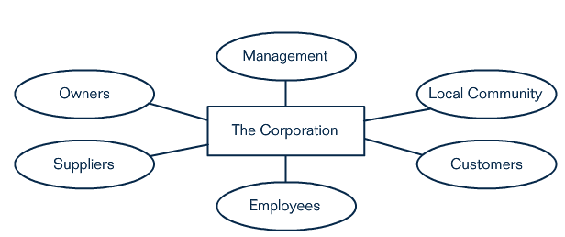

Figure 2: A Stakeholder Model of the Corporation (Freeman, 1988)

Figure 2 depicts the standard stakeholders in a large organisation. The stakes ok each reciprocal, due to each being able to affect the other in terms of harm and benefits. (1) Owners, hold a financial stake in the corporation in form of stocks or bonds. (2) Employees, typically have their jobs and livelihoods at stake. In return for an employee’s work, wages, security, benefits and meaningful work is expected. (3) Suppliers, in a stakeholder sense are vital to firm’s success. In turn the firm is a customer of the supplier and is therefore vital to its success and survival. (4) Customers, exchange resources for the organisations products in return to see benefits from the product. Customers form the lifeblood of an organisation in form of revenue. (5) Local Community, grants the organisation rights to build facilities and in turn benefits from tax, economic impact, and social contributions of the organisation. In return for the provision of local services, the organisation is expected to be a good citizen. (6) Management, plays a special role for it has both a stake in the organisation, and the employees (Freeman, 1988).

Freeman et al. (2006) identified four levels of commitment involved in the stakeholder management approach. Basic value proportion, at this basic level the business needs to understand how it can make the customer better off, and simultaneously offer value proposition to employees, communities, suppliers and financers. Sustained stakeholder cooperation, the competitive macroeconomic, regulatory and political environments are dynamic they require constant revision of the stakeholder arrangements. Managers of an organisation must understand the effect each trade-off has on its stakeholders and the amount of sacrifice a given stakeholder will accept, and how these sacrifices can be compensated. A manager must understand broad societal issues, for a manager to be effective they must be able to recognize and respond to the rising number of international issues. Finally, ethical leadership, recent studies points to a strong correlation between ethical values and positive organisational outcomes such as profitability and high innovation. This type of leadership is only possible if a deep understanding of the interests and concerns of the stakeholders are recognized.

Stakeholder theory prioritizes public into primary and secondary stakeholders rendering their ability to affect the firm, this suggests that CSR communications should primary stake holders first (Sweeney & Coughlan, 2008). Successful organisations thrive for their ability to balance obligations and communicate effectively with various stakeholders over the long term (Kimery & Rinehart, 1998). The stakeholder theory suggests that CSR decisions should be made with fairness to all stakeholders and should not prioritize primary stakeholders. If an organisation CSR actions are not properly communicated, stakeholder expectations for social responsibility may not be met (Meznar & Nigh, 1995). Community is perceived as a powerful stakeholder in the gambling industry, due to its power to influence government initiatives and decisions. With no community pressures, there would be no social responsibility initiatives established by gambling operators and governments, in view of the attractive gambling profits and tax revenues for organisations and governments. If gambling operators are able to meet or satisfy the powerful stakeholder, could then lead to no intervening from governments and no further regulations for gambling (Loh, et al., 2015). However, in reality it would be impossible for an organisation to satisfy all their stakeholders (Merson, 2010). Primary stakeholders must be prioritized these include shareholders, employees and customers, without continuing participation of these stakeholders and organisation cannot survive (Hage, 2007).

2.7.3.2 The Pyramid of CSR
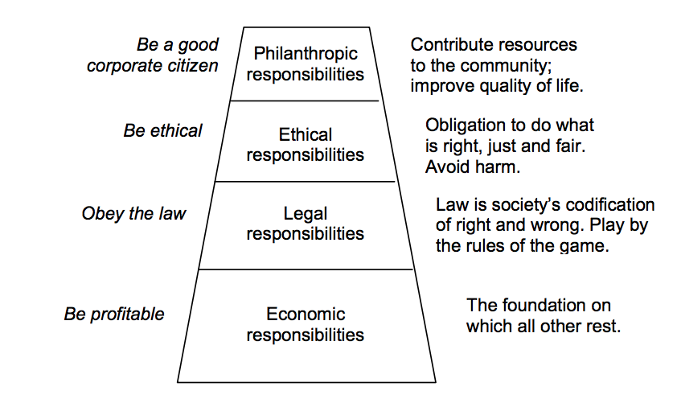
Figure 2.1: The Pyramid of CSR (Carroll, 1991)

Carroll (1991, p. 39) believed that “for CSR to be accepted by a conscientious business person, it should be framed in should a way that the entire range of business responsibilities are embraced”. Carroll created a framework the ‘Pyramid of CSR’ shown in Figure 1. Carroll suggests that there are four categories that are tied to CSR; economic, legal, ethical, and philanthropic (Carroll, 1991). Carroll also acknowledged how these categories are in constant tension with each other. Crane and Matten (2003) identified the four levels of social responsibility depicted in Carrols pyramid, starting from the sole goal of an organisation: (1) be profitable, (2) obey the law, (3) be ethical, and lastly (4) be good corporate citizens. Carroll’s further research into his framework, suggested that an organisation could only focus on either being profitable or being socially responsible, not both. Carroll (2000, p. 35) stated “businesses cannot be profitable and ethical, but they should fulfil these obligations simultaneously”.

Economic Responsibilities

First and foremost, economic responsibility is the most obvious and crucial focus of CSR (Visser, 2012). Dudovskiy (2012) identifies the economic responsibility of a business is to create goods and services in a profitable way. The motive for being profitable was established as the primary driver for businesses. For economic components of CSR, it is vital for a business:

- To perform in a manner consistent with maximising earnings per share
- To be committed to being as profitable as possible
- To maintain a strong competitive position
- To maintain a high level of operating efficiency

The gambling industry sees substantial profits. However, the problem which coincides with the gambling industry is that the industry relies on the repeat business from moderate and problem gamblers. It is not in the interest of the gambling operator to encourage the gambler to walk away. To succeed economically the operator must encourage addiction in some form (Byrd, et al., 2017)

Legal Responsibilities

The next level of Carroll’s CSR Pyramid focuses on the legal responsibilities of business. Friedman (1962) agreed that businesses should stay within the law, but if society felt strongly enough about an issue then a law should be passed, suggesting it should not be the responsibility of a business to act in the governments place. Ferral and Fraedrich (2012) suggest that laws are only passed because society believes businesses cannot be trusted to do the right thing. These views coincide that if the society believes strongly enough about an issue, a law will be passed through the power of the public.

The UK gambling industry must comply with three objectives which were set by the gambling commission in 2005;

- Preventing gambling from becoming a source of crime or disorder, being associated with crime or disorder, or being used to support crime.
- Ensuring that gambling is conducted in a fair and open way
- Protecting children and other vulnerable persons from being harmed or exploited.

Gambling operators must comply by these rules to maintain their operating licence (Gambling Commission, 2017)

Ethical Responsibilities

The ethical dimension of Carroll’s CSR pyramid refers to the behaviours and activities that are expected by society and stakeholders, even though they are not required by law (Fraedrich & Ferrell, 2012). Ferrell (1997) argue that the role of ethics within CSR in business, identifying that economic and legal responsibilities are of the upmost importance of performance. However, Hunger and Wheelan (2000) disputed that CSR doesn’t include economic and legal responsibilities, as these must be obeyed for the survival of the organisation, and stated that CSR will be made up of only ethical and philanthropic responsibilities.

Ethical responsibilities are met by the engagement of CSR in the gambling industry. CSR is used a tool to perceive the operator as an ethical business. CSR is engaged by all large-scale gambling operators, through the use of CSR communication strategies such as RG advertisements, online RG tools, and abiding by UK regulations and objectives.

Philanthropic Responsibilities

Philanthropic responsibilities are purely voluntarily obligations that organisations assume (Hunger & Wheelan, 2000). The variance between philanthropic and ethical responsibilities is that a scarce number of people expect organisations to fulfil philanthropic responsibilities. Philanthropic addresses a variety of issues including, charitable donations, support for local schools, sponsoring sports and arts etc. According to, Carroll philanthropic responsibilities are merely desired of corporations (Habisch et al. 2005)

Gambling operators use philanthropy as a strategy, to gain political and social support (Cohen, 2013). Gamble Aware is a charity which supports research and treatment of gambling harm. It is entirely funded by donations from gambling operators which is mandatory by the government, but the amount donated is not (MacInnes, 2017). The amounts which are donated are communicated heavily by operators, for example Ladbrokes donated £750,000, when this figure is compared to the £1.2bn revenue with they had in 2015, the donation is extremely small.

Carroll’s CSR Pyramid Applied

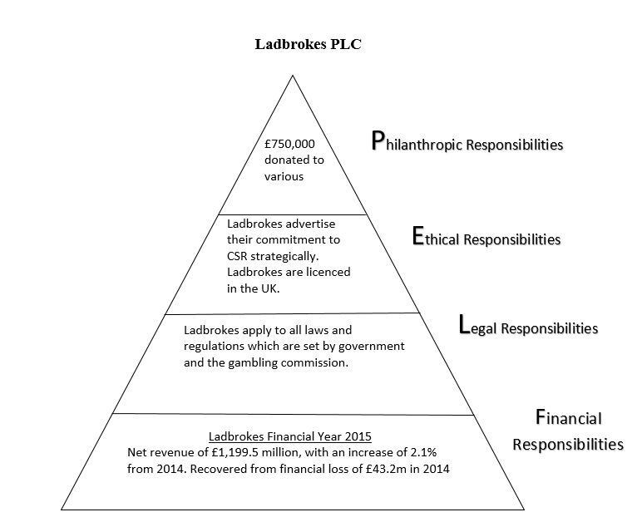
Figure 2.1: Ladbrokes CSR Pyramid

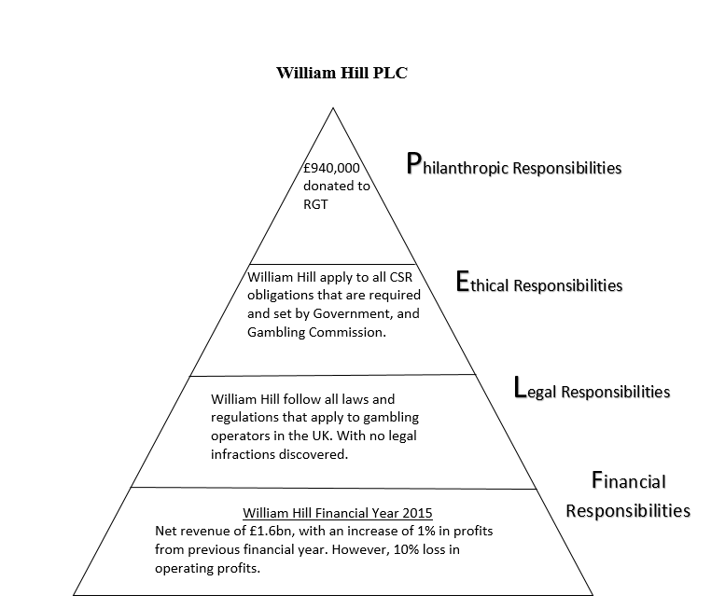
Figure 2.3: William Hills CSR Report

2.7.4 Legitimacy Theory

Legitimacy theory indicates that organisations may try to legitimise their activities by engaging in CSR, in order for their organisation to get approval from society (Belal, 2016). Grey et al. (1996) suggested that there are two variants of the legitimacy theory. The first variant, involved the legitimacy of the individual’s organisation, and the use of CSR reporting to close a ‘legitimacy gap’. The second variant, derived from the classical PET theory, raises questions about the legitimacy of the capitalist system. Lindbolm (1994) stated that organisations may employ legitimation strategies when the organisation is faced with different legitimation threats. She argued that a distinction needed to be made between legitimacy, which is either a status or a condition. Suchman (1995) identifies the key challenges of legitimacy management (gaining, maintaining, and fixing legitimacy). Suchman also points out that legitimacy management rest heavily on communication. Therefore, in order to examine legitimacy, forms of corporate communications much be examined. According to, Linbolm (1994), four strategies can be adopted in order to seek legitimation:

- Educate and inform the stakeholders about actual performance;
- Change stakeholder perceptions without changing actual behaviour;
- Distract attention away from the issue of concern;
- Change external expectations about performance;

Overall, showing organisations can use either of these strategies as ways of managing legitimacy through corporate communication channels, including annual reports or the company website.

2.8 The UK Gambling Industry

Palazzo and Ritcher’s (2005) suggested that controversial industries cannot conform to CSR as other industries to because their products are potentially harmful. However, the controversial industries should still engage at a transactional level of CSR. This level of CSR refers to the organisations integrity, i.e. it complies with legal and moral rules and behaves with fairness and transparency, avoiding harm or taking responsibility for it, if caused (Yani-de-Soriano & Javed, 2012). This narrow view of CSR is supported by Milton Friedman (1970, p. 1) who suggested that the sole responsibility of a business is “to use its resources and engage in activities designed to increase profits so long as it stays within the rules of the game, which is to say, engages in open and free competition without deception and fraud.”. The instrumental theory of CSR, indicates gambling operators gain their legitimacy on a basis of their CSR engagements at a transactional level. Gambling operators rely on the revenue produced by problem gamblers and controversial marketing activities (Yani-de-Soriano & Javed, 2012).

2.9 CSR Communication

It is widely recognised by responsible organisations that they should engage with stakeholders on CSR issues, and regularly communicate their CSR programmes, products, and impacts with concerned stakeholder (Du et al, 2010). This has involved communication on products and advertisements, in CSR reports, and throughout stakeholder engagement initiatives. CSR communication is viewed as crucial for everything from convincing consumers to reward responsible organisations (Bhattacharya & Sen, 2004). CSR has increasingly expanded due to heightened stakeholder expectations in a globalized economy (Scherer & Palazzo, 2007), the way organisations communicate CSR has become an area under scrutiny. CSR communications has seen change with new communication technology, diminishing traditional political influences, and globalisation challenges which has changed corporate-stakeholder interaction (Scherer & Palazzo, 2009). The traditional methods of one way CSR communication have been deemed unsatisfactory, due to the internet which offer symmetrical communication channels, which change the boundaries between the senders and receivers of CSR information and transform stakeholder interaction (Capriotti, 2011).

The concept that CSR communication is a form of stakeholder management is firmly rooted in CSR literature. Barnett suggests that the assumption is that communications are driven by the relative salience of stakeholder in achieving the firm’s goals (Barnett, 2007). Meaning, stakeholders are managed through the provision of information, dialogue and other methods of one and two way communications (Crane & Glozer, 2016). CSR communications can also be seen as a means to achieve specific goals. One in particular is image enhancement, which is commonly presented as the main purpose of CSR communication. For example, Du et al (2010) argues that effective communication in a necessity for CSR initiatives to build corporate/brand image.

2.10 Legal Issues and Pressure Groups

Once an organisation has implemented the use of CSR policy, then it must “play by the rules of the game” (Kitson & Campbell, 2008). CSR is a subject that has many ties to different areas of law. These laws include, international law, European law, mental law, and criminal law. These areas of law contribute to the development of CSR (Lambooy, 2014). One of the principle dividing lines of CSR is between the debate that the CSR agenda should be limited to the consideration of ‘voluntary’ activities ‘beyond compliance’ with legal baselines, and that of those who argue that the starting point should be remotely broader. This is based on the understanding of the impacts of business in society, or potential contributions of businesses in the societies in which they operate (Ward, 2003). The neo-classicalists believe that if a business practice was deemed important enough it should be passed as a law, and as of yet CSR is not a law. However, in the United Kingdom it is deemed important enough for a minister in the UK Labour Government to be appointed to oversight CSR across the UK (Henderson, 2001)

Both corporations and pressure groups will attempt to lobby governments to attain their aims. Lobbying is seen as the weakest form of private influence on government. However, both corporations and pressure groups employ professional lobbyists (Crane & Matten, 2004). Williams (1998, p. 224) identifies a pressure group as “a group of like-minded people who are organized with a view to influencing the formulation of government policy”. This is agreed upon by Crane and Matten (2004) who suggest pressure groups are people representing the interests of stakeholders, or the interest of non-human stakeholders. However, Crane and Matten (2004), identify that there is little to no evidence which proves that pressure groups have an actual influence to force organisations to change policy. The UK gambling industry has numerous pressure groups such as The Campaign for Fairer Gambling and the anti-FOBT campaign. The Campaign for Fairer Gambling has campaigned for the restriction on the number of Fixed Odds Betting Terminals (FOBTs) in each shop, as well as the reduction of the maximum stake. The group believes that the implementation of these regulations would place betting machines in accordance with the Gambling Act 2005. However, there is little evidence that these pressure groups have been the driver behind change in regulations (Abbott, 2016).

2.10 Corporate Communication

Corporate communications addresses society’s growing demand for high levels of corporate responsiveness and ethical standards. Corporate communication works to ensure relevant information is processed and supplied to the people who need it (Belasen, 2007). Christenesen (2002, p. 208) suggests the aim of corporate communications is “to organise an organisations communication activities as one coherent totality”. This suggests that any communication made by an organisation should represent the image of the organisation. There are numerous methods of corporate communication. However, despite the importance tied to corporate communication, is it still far from understood by many organisations (Cornelissen, 2014). Goodman (2001) identified some of the main forms of communication include the annual report, company website, strategy, advertising and public relation.

2.11 The Annual Report

The annual report is a fixed document that is published by an organisation on a yearly basis. The annual report is not subject to change in response to events. A company’s annual report, is essentially a financial and narrative document report concluding the previous 12 months. A significant component of an annual report is the company’s financial accounts, including profit and loss accounts, balance sheet, cash flow statement, and a statement of recognizable gains and losses. Most annual reports also produce an environmental, and community section specifying their environmental and social policies (Stittle, 2003). Grey et al (1995) examined the benefits of using the annual report, they concluded that it “represents what is probably the most important document in terms of the organisations construction of its own social imagery”.

However, Unerman (2000, p. 677) showed concern that “studies focusing exclusively on annual reports risk capturing an incomplete picture of the amount of CSR companies are engaging in” This suggests that the disclosed information included in an annual report, could represent a small image of the companies’ engagement of CSR. There are several reasons for using annual reports as a sampling unit; it has a higher degree of credibility, they also represent a method of communication and social construct (Wilmhurst & Frost, 2000). However, annual reports cannot provide a full picture of CSR policies and is recognized as a superficial disclosures of CSR information (Gray & Bebbington, 2005). Gray (2001) identifies other methods of CSR communication are often published in separate reports.

2.12 The Corporate Website

Corporate websites have seen a substantial change and have become increasingly ambitious in their functionality (Adams et al, 2003). Websites were subject to information that was little more than an electronic version of hard copy publications. An advance in technology has seen websites have an increase in sophistication and interactivity, allowing websites to now contain a high amount of information and also provide for a larger range of stakeholders (Campbell & Beck, 2004). The website offers a way for an organisation to immediately react to current issues and communicate to the public and stakeholders at large, the website also shows an organisations attitude towards issues. It is argued by Campbell et al, (2003) that it would be more efficient for an organisation to disclose their social and environmental information directly society by using media such as the internet, they justify this by identifying that the targeted stakeholders are less likely to read a company’s annual report.

However, an organisation may offer viable amount of quantity and disclosure. Christensen (2002) disputed that the sheer amounts of information that is given by an organisation does not automatically mean an increase in the legitimacy. He cautions that by having an increased amount of information it may cause distrust and produce alienation.

2.13 Conclusion

This chapter has discussed CSR theories in relation to the UK gambling industry, and evaluated CSR communications. This chapter has covered various aspects of OG and the growth of the industry. The key aspect of this chapter is the gambling industries link to the instrumental theory of CSR, where business is about making money and staying within laws and regulations. This chapter also discusses CSR communications and the methods in which CSR can be communicated. The current theme identified is that CSR communication is engaged by operators in order to gain legitimacy.

Chapter 3: Research Methodology

3.1 Introduction

In this primary research exercise, the main objective is to verify the existence of CSR Communications in the UK Gambling industry. The secondary goal of this research is to evaluate the value of CSR in the UK gambling industry, and to propose detailed recommendations for improved CSR communications. The general research aim is broken down into distinct objectives:

Objective 1: To investigate the value and content of CSR communications in the UK gambling industry
Objective 2: To evaluate the value of CSR in the UK gambling industry
Objective 3: Produce recommendations for improved CSR communications

The following section provides details and justifications of the research methods chosen for this research. This section fully reviews the techniques and approaches employed to fulfil the research objectives. The foundation of this chapter aims to answer the overall question of how the data has been collected, produced and the process used to analyse the data. To ensure the relevance of the research conducted, a clear classification of research is defined by Kerlinger (1973) “Systematic, controlled, empirical and critical investigation of hypothetical propositions about the presumed relations among natural phenomenon” Other theorists such as Khan (2011, p. 2) provide a more undeveloped definition of research “The manipulation of generalizing extending, correcting or verifying knowledge”

The emphasis of this research is on the UK gambling industry and how they communicate CSR. This dissertation seeks to comprehend the efforts are used by gambling organisation to communicate CSR. In this chapter, the researcher aims to satisfy the overall objective; to investigate the value and content of CSR communications in the UK gambling industry. This research section of the dissertation will justify and define the research methods that have been employed to achieve the chosen research objectives. To aims require the collection of primary data during the primary research of this dissertation to investigate the secondary research. Burns and Bush (2000) consider that secondary research will familiarise the researcher with the study and help identify concepts and terminology required in conducting primary research. However, they also make it evident that there are four possible disadvantages:

- Mismatches in units of measurement
- Diverse definitions of classifying data
- Relevance of data can differ
- A possible inability of verification of data integrity

For this research to minimise the risk of these advantages only the use of recognised academic journals and books have been chosen. Only reputable online casinos have been used. The secondary research of this dissertation has been identified in the literature review, which provides a comprehensive view of CSR communications and the gambling industry.

Methodology can be defined as “a way to systematically solve research problems” (Kumar, 2008, p. 5). Methodology also helps to establish how the chosen research is to be carried out, and provides terms for referencing for other researchers to follow.

3.1 Introduction to Content Analysis

Content analysis, is debatably one of the fastest growing methods in social research (Neuendorf, 2002). The term content analysis ages back around 60 years. Where it was originally defined by Webster (1961) as the “analysis of the manifest and latent content of a body of communicated material through classification, tabulation, and evaluation of its key symbols and themes in order to ascertain its meaning and probable effect”. Krippendorf (1980) also identified content analysis as a research technique for making replicable and valid boundaries from data to their context. Neuendorf (2002) protracted this definition by defining the definition as “the systematic, objective quantitative analysis of message characteristics”. Therefore, content analysis is an observational research method that can be used to systematically evaluate recorded forms of information (Ritchie et al, 2005). Fennel discussed that there are two key main styles of content analysis, which can be used combined or solely.

- Manifest content analysis includes the observable, surface content of a communication that can be simply counted.
- Latent content analysis implicates an analysis of the underlying means of a communication.

There are numerous advantages of content analysis, which describe why it is a popular method of research. Berger (2000) identifies that that due to the research method being unobtrusive makes the method crucial to some research. He suggests that because the researcher does not ‘intrude’ on what is being studied, it has no adverse effects on the outcome of the research. Silverman (1995) also suggested that this methodology pays attention to reliability, ensuring that different researchers can use the measures in the same way, and validity, through uses of word counts.

The problems that are involved with content analysis vary. Firstly, content analysis can only be a good as the documents that the research works. Scott (1990) recommends the researcher assessing documents in terms of; (1) authenticity, (2) credibility, (3) representativeness. Punch (1998) warns researchers that they must be aware of the underlying structure of the text, and that the social context of the text must also be studied. Meaning that the categories research must be clearly defined, together with a context.

In conclusion, this methodology corresponds with this dissertations research question and its aims. This method can also be used to investigate the content of CSR communications on UK gambling operator’s websites. The data will be made up from the CSR efforts from the annual report and website.

3.2 Practical Applications of Content Analysis

Jawad (2006) suggests content analysis is deemed a powerful tool for determining authorship. For instance, a technique for one to determine authorship is to make a list of possible authors, examine their previous work and correlate the frequency of function words in order to make a case of probability. Mosteller and Wallace (1964) used this technique based on word frequency to show that Madison had wrote the Federalist paper. Content analysis was also used by Foster (1996) who used this approach in order to determine the identity of an anonymous author of the 1992 book ‘Primary Colours’.

Content analysis can also be useful for examining patterns and trends in documents. For instance, Stemler and Bebell (1998) piloted a content analysis on a school mission statement, to make some inferences about what schools hold as the overall primary reason of existence. Therefore, content analysis can be used as a method for providing for monitoring changes in public opinion.

3.3 Conducting a Content Analysis

According to Krippendorff (1980) there are 6 questions that must be addressed in every content analysis:

- What data is analysed?
- How are they defined?
- What the population is from which they are drawn?
- What context is relative to which data is analysed?
- What are the boundaries of the analysis?
- What is the target of the inferences?

Content Analysis Chart Applied:

Operator: | What data will be analysed? | How are they defined? | What population is from which they are drawn? | What context is relative to which data is analysed? | What is the target of the inferences?
Ladbrokes | Company Website / CSR Report | - An electronic communication tool used to reach stakeholders directly  - The annual report is a fixed document that is published by an organisation on a yearly basis. The annual report is not subject to change in response to events | - Available globally through the internet. | - Ladbrokes website will only review RG features offered and RG information.  - CSR report will be analysed | To evaluate the values of CSR communication within the UK Gambling Industry.
William Hill | Company Website / CSR Section (Annual Report) | - An electronic communication tool used to reach stakeholders directly  - The annual report is a fixed document that is published by an organisation on a yearly basis. The annual report is not subject to change in response to events | - Available globally through the internet. | - William Hills website will review features related to RG and information provided.  - CSR section of William Hills annual report only carries relevance to this research | To evaluate the values of CSR communication within the UK Gambling Industry.
Source: Shaw (2017)

Krippendorff (1980) identifies the key advantages of a content analysis; it is unobtrusive, flexible, applicable to unstructured materials, context sensitive and it can be applied to a vast amount of data. All of these advantages apply to this research, as the internet will be used. However, at least three problems can occur when content analysis is being conducted. Firstly, if there are a substantial number of documents missing from the population, the analysis must be abandoned. Second, inappropriate documents, for example ones which do not match the context of the research, should be discarded, but a record should be kept. Finally, some documents may match the requirements for analysis, but may be uncodable sue to missing passages or ambiguous content (Stemler, 2001). McMillan (2000) highlights three difficulties that apply to content analysis through the internet these include, the definition of a website, the unit of analysis and the method of sampling.

As a result of these difficulties, McMillan (2000) implies five steps involved in conducting content analysis research to the internet. First, the research must present a question or hypothesis. The internet is vast and has opened doors to many research questions, whereas the challenge is not to present questions, but to narrow down those questions and find context. Second, the research must select a sample which must be based on a set of goals or aims for the research. Krippendorf (2012) further agreed on this by noting that a sample must be representative and this requirement of drawing a sample could be one of the most difficult aspects within internet content analysis. The third step in McMillan’s process is to define categories. Defining context can be very challenging on the internet. Ha and James (1998) suggest that a websites home page is an ideal unit of analysis due to it being the point in which a visitor will decide on whether or not they will proceed further on the website, this is on the basis of first impressions. They argue that for a whole website to be analysed the coding could be time consuming and introduce website bias. Fourth, McMillan (2000) states it is crucial for coder to be trained, and that the reliability of their coding is checked at every step. McMillan’s last step, indicated that the data collected during the coding is analysed and interpreted. However, the analysis will depend on the type of data that is collected and the researcher’s perspective. This research aimed to understand if the information provided through their websites and annual reports, is reliable or just an information vehicle. Orford (2010) suggested that an informed gambler can still become a problem gambler.

3.5 Triangulation

Triangulation in research refers to the use of multiple methods or techniques for gathering data within a singular study. Originally triangulation was aimed for seeking confirmation of apparent findings. There is now a secondary purpose, to try and fulfil completeness (Adami & Kiger, n.d.). In other words, triangulation uses several methods or techniques for gathering data in order for each technique to produce complementary data, such an approach adds rigour, richness, and depth to research (McMurray, 2004). Denzin (1978) identified four types of triangulation:

- Source triangulation, where a number of different data sources are used;
- Investigator triangulation, more than one researcher is used;
- Theory triangulation, in which more than one perspective is used to interpret the data;
- Methodological triangulation, in which several different data-gathering techniques are used.

The use of more than one method for collecting and analysing data in this research will allow the researcher to gain a deeper understanding.

3.6 Methodology

A content analysis is to be conducted in order to assess the standards 2 UK gambling operators communicate CSR, and to evaluate the perception of the UK gamblers. The sample consisted of the results of previous research with proved Ladbrokes and William Hill had embraced CSR. This research now seeks to determine to what extent these operators communicate CSR by conducting content analysis on the following annual reports:

- Ladbrokes Coral Group plc
- William Hill plc

These annual reports were accessed during the period of 7 days, from April 1st to April the 7th. Kim et al (1999) identifies that due to the ever-changing nature of the internet’s content it was important to analyse the data in a limited time frame.

For the purpose of this research, the term website is defined as a set of pages or documents hosted by a given server, on the internet (Lowe & Gaedke, 2005). The initial research aimed to limit the analysis to the two gambling operator’s homepages, however it was found that the homepages were very limited and would not provide the data to conduct a viable analysis. In order to gain the relevant data, the gambling operator’s annual report was to be used in order to gain the scope and breadth of the research.

3.6.1 Strategy

The chosen strategy for this research is that of a content analysis where the unit of analysis is an analysis of the extent UK gambling operators have embraced the idea of CSR. The characteristics and advantages of a content analysis fit with the chosen research question and will help achieve the specific aims. The first method employed in the research was to decide on the sample.

3.6.2 Data Collection
The data collection method used will be through content analysis. The data collection method used will be content analysis. The content analysis will allow the research to collect qualitative data that can be used for comparative purposes. A multi-method design will be used which incorporates two or more data collection techniques within one tradition (Tashakkori & Teddlie, 2003). Multi-method designs are a powerful approach to complex and nuanced research questions, and ensures trustworthiness in qualitative research. However, due to multi-method not combining more than one research tradition, as mixed-method designs do, competing philosophies and underlying assumptions do not appear an issue (Taylor, 2017). Multi-method research, due to the data collection and analysis considerations, has the potential disadvantages of time consumption, and the consumption of research funds (Roller & Lavrakas, 2015). This research used multi-method as two qualitative data collections methods are performed within the research collection.

3.6.3 Reliability and Validity

Reliability is seen as the extent to which the observable measures that represent a theoretical concept are accurate and stable when used in a study (Blesset al, 2006). Krippendorff (2012, p. 268) suggests “researchers need to demonstrate the trustworthiness of their data by measuring their reliability”. Webber (1990, p. 15) concerns regarding reliability frequently stem from “the ambiguity of word meaning, category definitions, or other coding rules”. In order to enhance the reliability of this research, guidelines have been put into place. Stemler (2001) explains a popular method of measuring reliability is to conduct a reliability test in order to measure the agreement in the coding. Krippendorff (1980) argued that data can be looked at from numerous perspectives. However, with the clear use of definitions of categories should help to prevent an introduction of errors due to the different perspectives of other researches following this method.

Validity was defined by Bechtoldt (1959, p. 654) as “the acceptance of a set of operations as an adequate definition of whatever is to be measured”. Although, there is no recognizable standard for intercoder reliability, Neuendorf’s (2002) report indicated that over 80% would be acceptable in most situations. In order to improve validity of the results, the definitions within the research have been reviewed and expanded to ensure that there was an extensive list of words for each sub-category where it was applicable. The use of a content analysis helps this research minimize the subjective biases of researchers interpreting qualitative texts, providing a more valid and reliable understanding of the patterns and themes within qualitative data (Heinmiller, 2016). This study will therefore be valid if it measures to what extent UK gambling operators communicate CSR as indicated in their annual report.

3.6.4 Ethical Considerations

For gambling research to be conducted it is very important to understand and consider the ethical context in which this research will be conducted, this problem arises due the sensitivity of the research topic. Although, this research focuses on CSR communications, it will also focus on gambling. Gambling to many can be seen as a sensitive subject due to the issue of problem gambling.

Content analysis will analyse information that is given by the organisations and will not sample any sensitive confidential information. By using content analysis, the research will be able to avoid any ethical issues, as the document being analysed is released by the organisation. An ethics form was proposed and completed, then evaluated and approved by the supervisor assigned to this dissertation. Also, concerns are less onerous because there was no research with participants and only used resources in the public domain. However, good standing of the University was ensured at all time, with a University ethics form being completed.

Chapter 4: Research Analysis

4.1 Introduction

Upon completion of data collection, all relevant information was organised and evaluated by the researcher. Data analysis consisted of objectively reviewing the accessed content of the websites and the CSR sections of the annual reports.

Data analysis will use both content analysis of the website and the company’s annual report. The annual report is the main subject of this analysis. However, the organisations website will also be evaluated in order to gain the relevant information needed. Solely focusing on only the annual report was subject to risk of not capturing a complete picture on the organisations CSR engagements (Unerman, 2000). The legitimacy of the information will be cross examined with current literature mention in chapter two of this research project.

In qualitative research, reliability is represented by the dependability of the findings. The researcher took steps in order to ensure that the research process was consistent. Logical and documented (Robson, 2002).

4.2 Ladbrokes Coral PLC

Summary of the organisation

Ladbrokes Coral PLC is one of the leading European and international betting and gaming groups, currently the leading British bookmaker with over 3500 shops in England, Wales and Scotland. Ladbrokes currently employ over 25,000. Group net revenue £1,195.5m (Ladbrokes PLC, 2015)

Vision

To build and ‘e’ enabled international betting and gaming business. This means using technology to distribute our products, service our customers and gain access to new territories and distribution channels. It also means leveraging the tremendous power of the Ladbrokes brand to drive us forward in a multi-channel marketplace (Ladbrokes PLC, 2015)

Analysis of Website

Ladbrokes PLCs website offers descriptive details of the organisations services. The researcher has chosen to examine and evaluate certain sections of Ladbrokes website which are relevant and objective. However, as Christensen (2002) suggested the sheer amounts of information that is given by the organisation does not automatically mean an increase in legitimacy, he also suggests that the increased amount of information available can cause distrust and produce alienation. This has allowed the researcher to be objective in the analysis conducted.

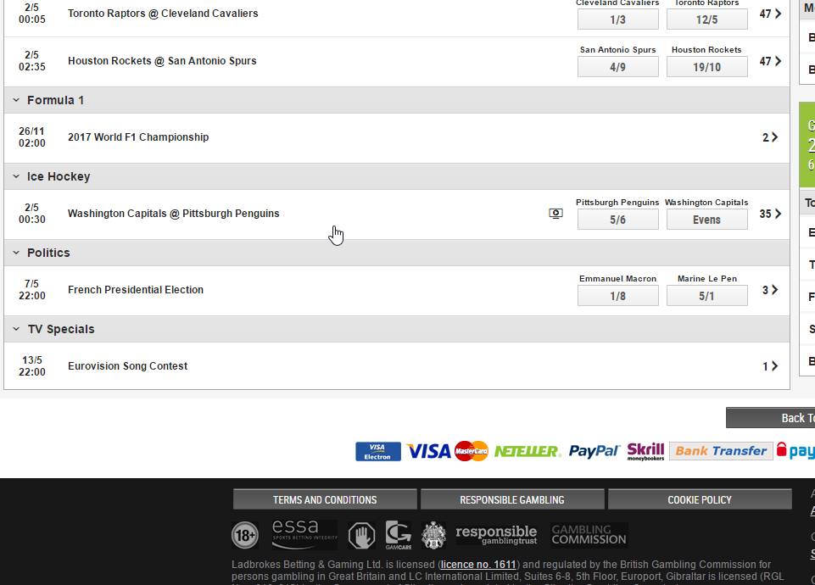
Ladbrokes Homepage

Figure 4.1: Screenshot 1: Ladbrokes Home Page

CSR is not evident on the upper part of Ladbrokes homepage; however, a small URL is seen at the bottom of the page as highlighted above. Ladbrokes show 2 different options Terms and Conditions, and Responsible Gambling.

Our Approach:
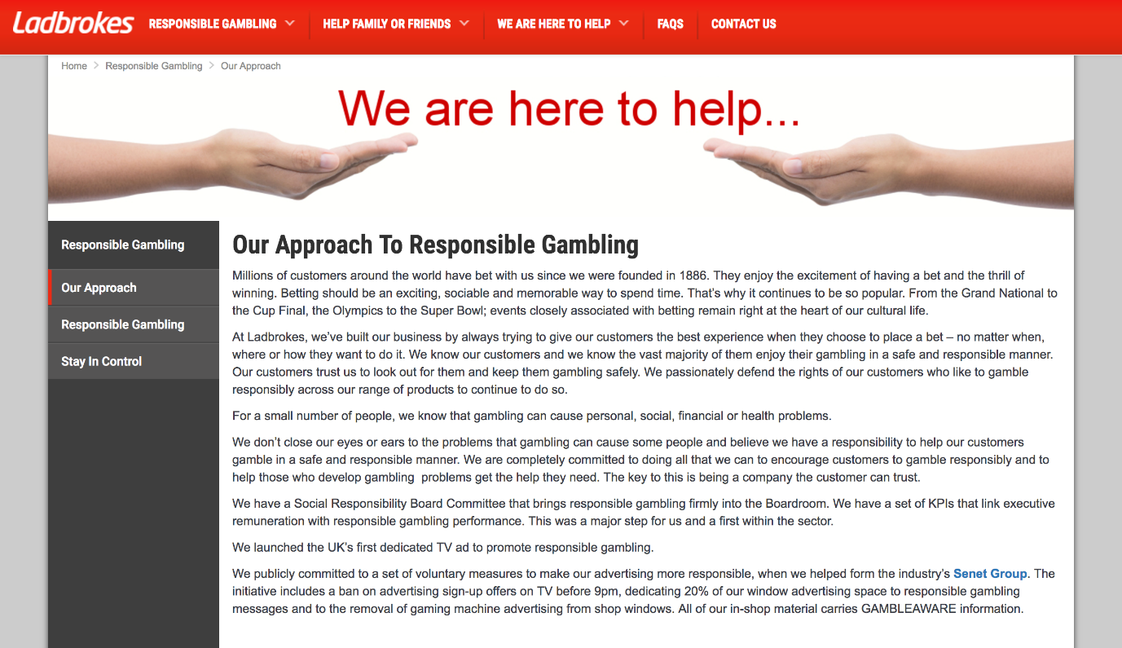

Figure 4.2: Screenshot 2: Our Approach

Upon following the URL from Ladbrokes homepage, the user is directed to Ladbrokes responsible gambling page, where three documents are available for display, Our Approach (As seen above), Responsible Gambling, and Stay in Control. Ladbrokes acknowledge here some of the potential harms caused by gambling such as, personal, social, financial and health problems. One aspect that differentiates Ladbrokes CSR efforts is that they created a Social Responsibility Board Committee in 2014, this board aimed to help Ladbrokes achieve their CSR objectives (Ladbrokes, 2014). Ladbrokes are known to be the first bookmaker to launch a dedicated Responsible Gambling TV advertisement. This page states Ladbrokes publicly committed to set voluntary measures to make adverting more responsible, when in 2014 they were one of the founders of the Senet Group, which was created in 2014 by the four largest bookmakers Ladbrokes, William Hill, Coral and Paddy Power, this happened due to the British concern regarding gambling and advertising (GC, 2017)
Responsible Gambling:
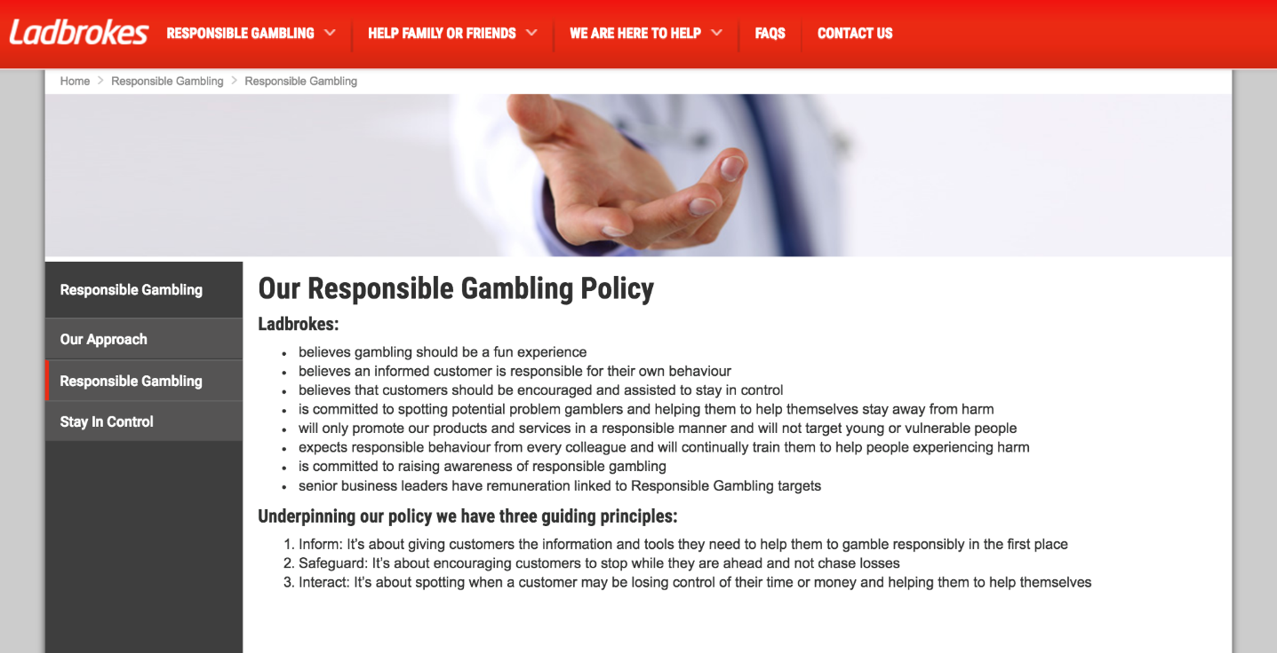
Figure 4.4: Screenshot 3: Responsible Gambling Homepage

Ladbrokes second page displays Ladbrokes Gambling Policy, the first section displays simple statements such as Gambling should be a fun experience, Customers should be encouraged and assisted to stay in control etc.

Secondly, Ladbrokes display their three guideline principles:
Inform: It’s about giving customers the information and tools they need to help them to gamble responsibly in the first place.
Safeguard: It’s about encouraging customers to stop while they are ahead and not to chase loses.
Interact: It’s about spotting when a customer may be losing control of their time or money and helping them help themselves.

Overview:

Ladbrokes covers a variety of CSR components on their Responsible Gambling homepage, however there is no in depth information, just broad descriptions of implemented safe guards to prevent problem gambling. The information which is communicated through their website seems to take a legitimacy approach, where information if provide seeks achieve legitimacy for Ladbrokes through the communication of RG tools available to consumers. Legitimacy theory indicates that organisations may try to legitimise their activities by engaging in CSR, in order for their organisation to get approval from society (Belal, 2016). As CSR is tied to the gambling industry operators must abide by the rules and engage in CSR activities in order to gain social acceptance Suchman (1995) suggested the key challenges of legitimacy management (gaining, maintaining, and fixing legitimacy). Ladbrokes gain their legitimacy through offering CSR information and offering RG tools. However, the information which is provided by Ladbrokes is very vague.

4.3 Ladbrokes Annual Report:

Ladbrokes annual report does not cover any information in regards to CSR, however they a separate document (Annual CSR Report) which can be found on their PLC website.
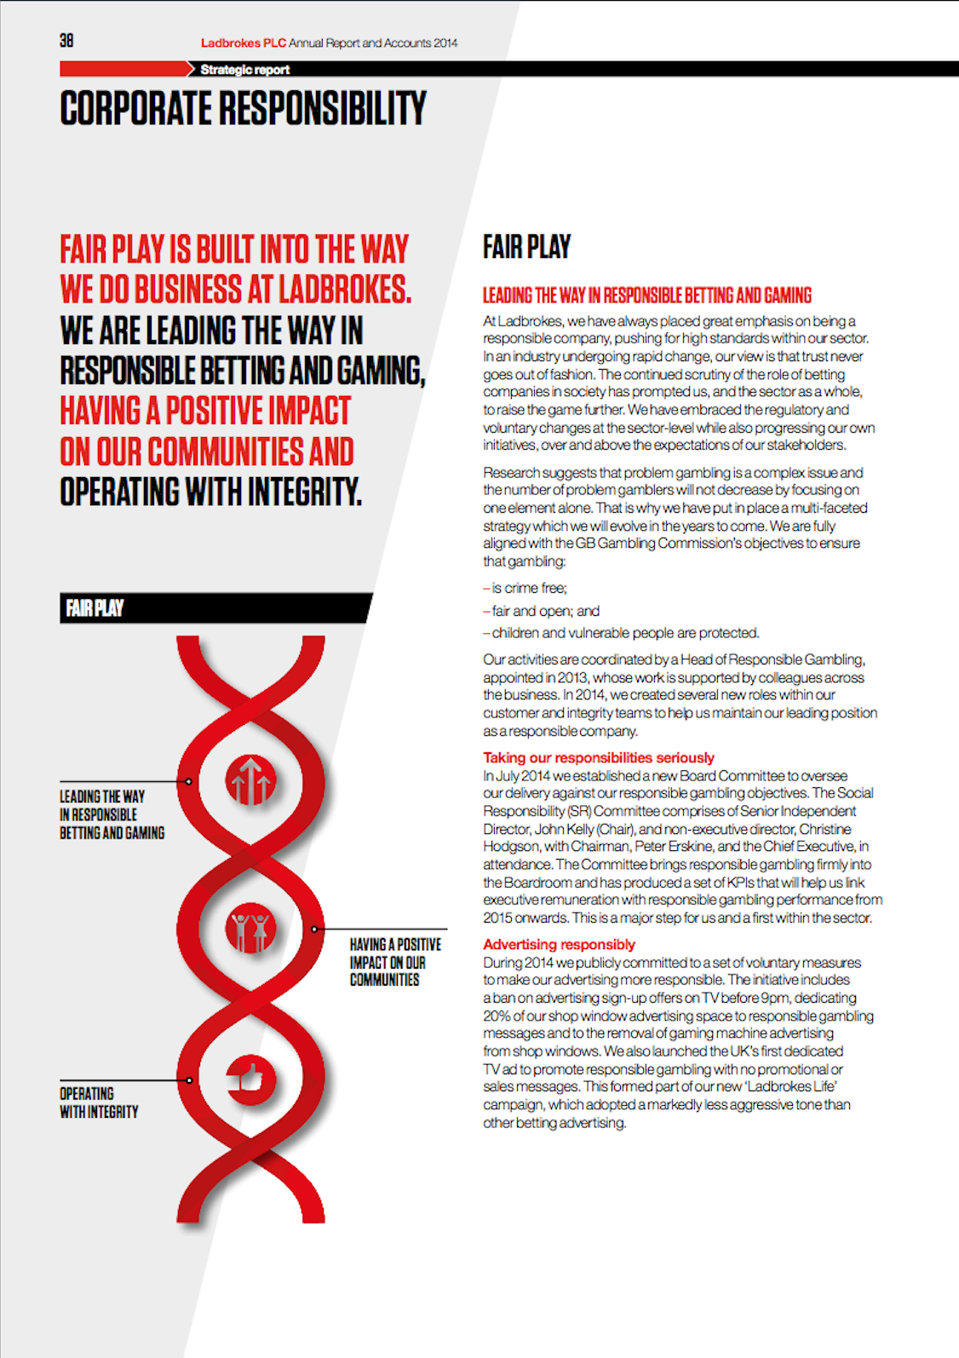
Ladbrokes Annual CSR Report: Page 1
4
2
1
5
3

Figure 2.5: Screenshot 4: Ladbrokes CSR Report Page 1
Section 1: Page 1: Opening Statement

Ladbrokes 1st page of their CSR report opens with Ladbrokes CSR statement:

“Fair play is built into the way we do business at Ladbrokes. We are leading the way in responsible betting and gaming, having a positive impact on our communities and operating with integrity” (Ladbrokes, 2014)

However, since this statement was made Ladbrokes has undergone a merger with the betting company Coral to create Ladbrokes Coral PLC. This merger has created the UK’s largest bookmaker, but the merger is causing over 359 betting shops in the UK to be closed in the UK (Farrell, 2016). This will have a very negative impact on smaller communities which are reliant on local jobs, Ladbrokes and Coral intend to lay off over 700 employees due to the merger (Walsh, 2016).

Section 2: Page 1: Leading the way in responsible betting and gaming

Section 2 of the CSR report covers the basis of Ladbrokes CSR initiative. Ladbrokes open by stating their great emphasis on being a responsible company, Ladbrokes state that in an industry going under change trust will never go out of fashion. Ladbrokes also follows the Gambling Commissions objectives which include:

Is crime free;
Fair and open; and
Children and vulnerable are protected.

Section 3: Page 1: Taking our responsibilities seriously

In July 2014 Ladbrokes established a new Board Committee to oversee their delivery of their responsible gambling objectives. The Social Responsibility committee sit three times a year and monitor and report to the Board in regards to the development of Responsible gambling policy across all areas of their business. The committee also assesses the performance of current key social responsibility targets. (Ladbrokes Coral PLC, 2014).

Ladbrokes Chairman Peter Erskine stated;

“it is clear that trust in bookmakers has been impacted by negative publicity and lobbying last year, and while we may believe that much of the concern is ill founded, we accept that is it only by our actions will be able to win it back. The Social Responsibility Committee, chaired by John Kelly with a wealth of experience and knowledge of the gambling industry, is a significant step in this process” (Erskine, 2014)

It is evident that Ladbrokes are committed to trying to appease their image by involving themselves in CSR commitments. However, the gambling industry offers harmful products, which force gambling operators to follow CSR guidelines for social acceptance. Carroll (2000, p. 35) suggested that “business cannot be profitable and ethical, but they should fulfil these obligations simultaneously”. Ladbrokes have proven their commitment to indulging CSR, this is proven as in 2015 Ladbrokes reported their first financial loss in the past decade, Ladbrokes reported a pre-tax loss of £43.2m. Ladbrokes states this was due to an increase of £50m in gambling taxes. Ladbrokes are currently one of the few gambling companies which operate out of the United Kingdom and abide by their tax laws (Bury, 2016).

Section 4: Page 1: Advertising Responsibly

The fourth section of Ladbrokes CSR report, covers their efforts for responsible advertising within the industry. Gambling advertisements have become a growing concern in previous years, with over half a billion pounds being spent on gambling TV advertising since 2012. Gambling TV advertising has seen a 46% annual rise in spending. Derek Webb, of the Campaign for Fairer Gambling stated that the sheer volume of gambling advertising is fuelling gambling addiction, he also states that the majority of gambling companies operate offshore which allows them to spend more on advertising due to the savings they accumulate from paying lower amounts of tax (Davies, 2016).

In 2014 Ladbrokes committed to setting a voluntary measure to make gambling advertising more responsible. This initiative included a ban on advertising sign-up offers on TV before 9pm, also dedicating 20% of shop window advertising space to responsible gambling messages and the removal of gaming machine advertising. Ladbroke’s also emphasis they are the first betting operator to have a dedicated TV advert to responsible gambling with no gambling or sales messages.

Section 4 is continued on page 2 section 4.1. Ladbrokes was one of the three founding members of the Senet Group, which is a self-regulatory body which is dedicated to the promotion of responsible gambling standards and to ensure the marketing of gambling is socially responsible. Members of the Senet Group commit to the following;

A voluntary TV advertising ban on sign-up offers before 9pm
Refrain from gaming machine advertisements
Dedicate 20% of shop windows to responsible gambling messages (Senet Group, 2016)

Section 5: Page 1: Fair Play

Section 5 is a short picture message where they inform they lead the way in responsible betting and gaming, and their positive impact on communities and how they operate with integrity.

Ladbrokes CSR Report: Page 2
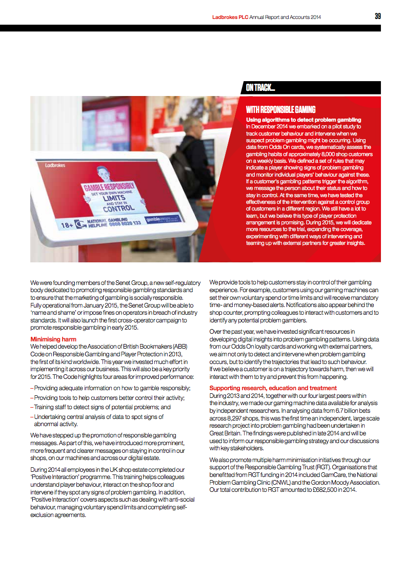
4.1
1
3
2
Figure 2.5: Screenshot 5: Ladbrokes CSR Report Page 2

Section 1: Page 2: With Responsible Gambling

In December 2014, Ladbrokes began using an algorithm to detect problem gambling. This algorithm sought to track gambling behaviours and allow Ladbrokes to intervene when suspected gambling problem might be occurring. Ladbrokes stated that more resources would be used to further progress this feature to prevent problem gambling, however after initial research the researcher was unable to find newer relevant information that could support this. Although, it is evident that this algorithm has been ineffective, as recent studies in Wales which showed 1.1% of participants were indicated as problem gamblers and 3.8% of participants were seen as moderate risk problem gamblers (Gambling Commission, 2016). This figure prove that current regimes used by gambling operators are ineffective.

Section 2: Page 2: Minimising Harm

Section 2 includes information about Ladbrokes efforts to minimise harm in the Gambling industry. Ladbrokes state they were involved in creating the Association of British Bookmakers (ABB) Code on Responsible Gambling and Player Protection in 2013, the first of its kind worldwide. This code highlights four areas for improved performance:

Providing adequate information on how to gamble responsibly;
Providing tools to help customers better control their activities;
Training staff to detect signs of potential problems; and
Undertaking central analysis of data to spot signs of abnormal activity.

Ladbrokes have stepped up the promotion of responsible gambling messages. As part of this more frequent and prominent messages on staying in control are issues in shop and on gaming machines. Gaming machines were fitted with message reminders in Ladbrokes which offer the player, deposit limits, time limits, and frequent warning on time played and money spent. Ladbrokes also has online features such as self-exclusion, time-outs, deposit limits, time limits etc. Current views on advertising are very polarized and tend to be very critical or supportive. The negative views on advertising suggest they cause trickery to consumers and inevitably cause disaster to society (Binde, 2014).

In 2014, employees across Ladbrokes where given an ‘Positive Interaction’ programme. This training was implemented to help employees understand player behaviour, and how to interact on the shop floor and intervene if necessary. This training also, covered aspects in regards to anti-social behaviour, managing voluntary spending limits and how to complete self-exclusion agreements.

Section 3: Page 2: Supporting research. Education and treatment

Ladbrokes along with Coral, William Hill and Paddy Power made their gaming machine data available for analysis by independent researchers. The data included 6.7million bets across 8,297 shops. In 2014, these finding were published were used in regards to Ladbrokes responsible gambling strategy. Ladbrokes also emphasize their support to the Responsible Gambling Trust (RGT), Gamcare, and the National Problem Gambling Clinic (CNWL) and the Gordon Moody Association. Ladbrokes total commitment in 2014 amounted to £682,500 (Ladbrokes, 2014).

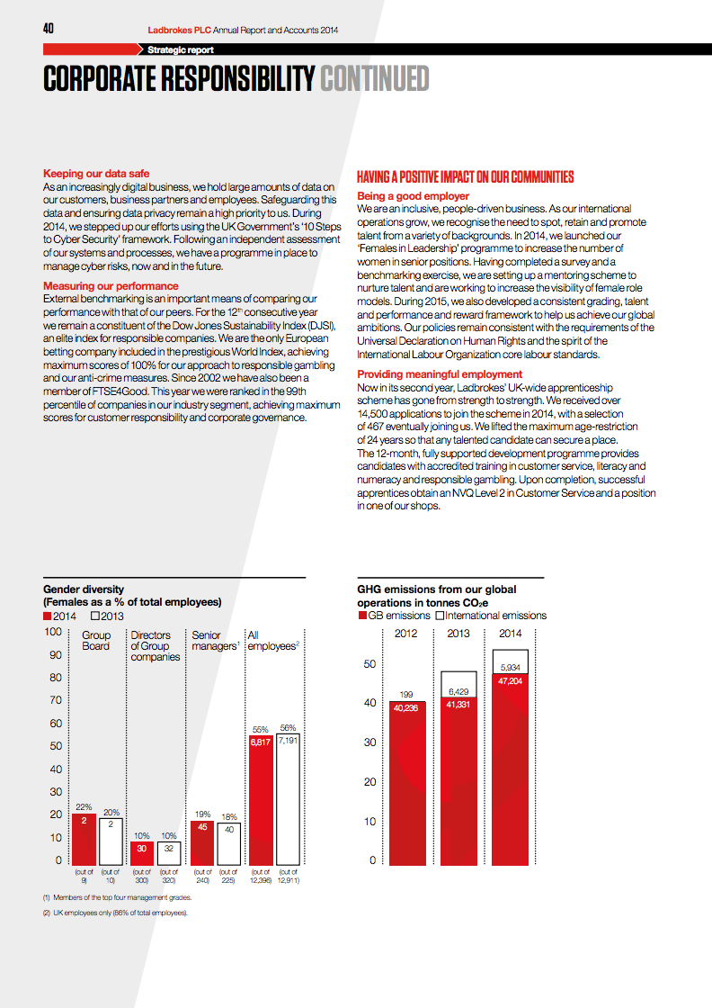
Ladbrokes CSR Report: Page 3
2
5
4
3
1

Figure 2.6: Screenshot 5: Ladbrokes CSR Report Page 3
Section 1: Page 3: Keeping our data safe

Section 1 entails Ladbrokes commitment to keeping data safe. With the gambling industry moving heavily into digital business, large amounts of data on customers, business partners and employees are stored. In 2014 Ladbrokes committed to stepping up and using the UK Governments 10 steps to Cyber Security framework. Ladbrokes were first introduced to this problem in 2010 when they had a major data leek. A UK employee of Ladbrokes breached their database and gave The Mail 10,000 Ladbrokes customers person information, and offered to sell the data of 4.5 million UK customers. However, this offence did not go further (Lewis, 2010)

Section 2: Page 3: Measuring our performance

This section of Ladbrokes CSR report, concludes of information about Ladbrokes involvement in the Dow Jones Sustainability Index (DJSI) and being a member of the FTSEGood.

The Dow Jones Sustainability Index was founded in 1999, and is the first global indices tracking the financial performance of the leading sustainability-driven companies worldwide (Hák & Moldan, 2012). Ladbrokes has been a member for 12 consecutive years, and are the only European betting company included in this world index. And have achieved maximum scores of 100% for their approach to responsible gambling and their anti-crime measures.

In 2002 Ladbrokes joined the FTSEGood. Being ranked in the 99th percentile of companies in the gambling industry to achieve maximum scores for customer responsibility and corporate governance.

Section 3: Page 3: Being a good employer

Section 3 covers Ladbrokes efforts of being a good employer, Ladbrokes state they are an ‘inclusive, people-driven business’. In 2014 Ladbrokes launched a programme called ‘Females in Leadership’ this programme aimed to increase the number of women in leadership positions. Section 5 shows the figures of female staff, red shows figures in 2014 and white 2013, this graph shows that since the programme has started, the Group Board has received 2% more female staff, Directors have remained the same, Senior managers with an increase of 1% and overall employees has dropped by 1%. Ladbrokes have also set up a mentoring in order to nurture talent and to increase the visibility of female role models. Ladbrokes follow by stating they remain consistent with the requirements of the Universal Declaration on Human Rights and the spirit of the international labour Organisation core labour standards.

Section 4: Page 3: Providing meaningful employment

Ladbrokes launched an apprenticeship scheme in 2013, in 2014 Ladbrokes received 14,500 applications to join the scheme, with 467 receiving the role. The role entails of a 12-month training and development programme, which provides candidates with accredited training in customer service, literacy, numeracy and responsible gambling. Upon completion of the scheme candidates receive an NVQ Level 2 in Customer Service and a position in one of their shops.

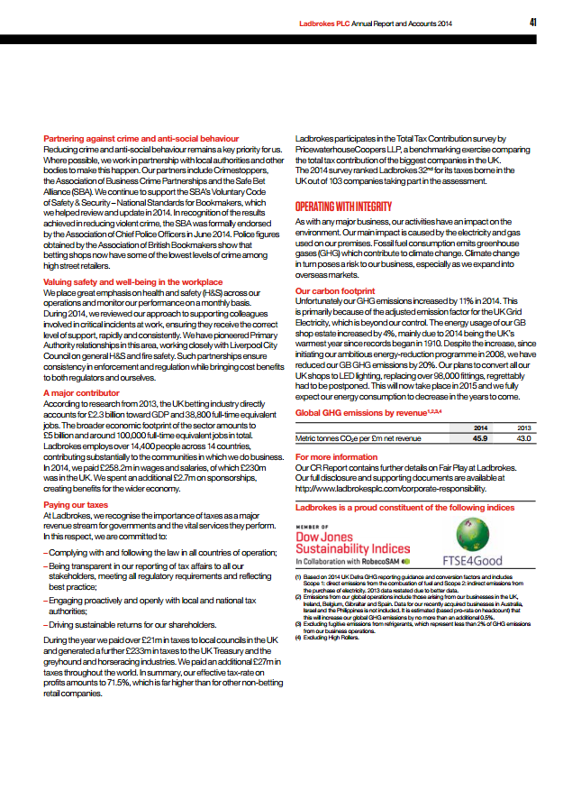
Ladbrokes CSR Report: Page 4
7
6
5
4
3
2
1

Figure 4.7: Screenshot 6: Ladbrokes CSR Report Page 4

Section 1: Page 4: Partnering against crime and anti-social behaviour

Section 1 covers Ladbrokes partnerships with local authorities and bodies such as, Crime stoppers, the Association of Business Crime Partnership and the Safe Bet Alliance (SBA). The SBA was launched in 201, with a key role of making UK betting shops safer for staff and customers. In 2014, the SBA was endorsed by the association of Chief Police Officers saying:

“The Safe Bet Alliance has proved to be not only an effective tool for reducing violent crime, but also a clear example of best practice for partnership working. The collaboration of police, bookmakers and other key stakeholders has led to an initiative that has stood the test of time" (Association of British Bookmakers, 2016)

Section 2: Page 4: Valuing safety and well-being in the workplace

Section 4 briefly states on Ladbrokes commitment to Health and Safety procedures, and their commitment in Liverpool, where Ladbrokes work closely with Liverpool City Council on general Health and Safety. Stating such partnerships ensure consistency in enforcement and regulation, while bringing cost benefits to both regulators and themselves.

Section 3: Page 4: A major contributor

In 2013, the UK gambling industry accounted to £2.3 billion towards GDP and provided 38,000 full-time jobs. Ladbrokes provide 14,400 jobs across 14 countries, contributing substantially to local communities. Ladbrokes state in 2014 they paid £258.2m in wages and salaries with £230m being in the UK, with £2.7m spent on sponsorships.

Section 4: Page 4: Paying our taxes

Section 4 clearly states that Ladbrokes, recognise the importance of taxes as a major revenue stream for governments, and state they ate committed to:
Complying with and following law in all countries of operation;
Being transparent in our reporting of tax affairs to all our stakeholders, meeting all regulatory requirements and reflecting best practice;
Engaging proactively and openly with local and national authorities;
Driving sustainable returns for our stakeholder.

Ladbrokes also make it evident that amounts of taxes they have paid in taxes. Once clear issue with gambling operators is the avoidance of UK taxes by operating offshore in Gibraltar. Ladbrokes were recently lost an appeal over a tax avoidance case, this appeal led to the company having to pay £71 million in tax charges. In 2008 Ladbrokes and its auditor Deloitte violated a tax loophole that consisted of loans between third parties and corporations with the intention to minimise their tax bill (Houlder, 2017).

Section 5: Page 4: Operating with integrity

Section 5 is a brief section on issues such a Global Emissions. Ladbrokes provide a section on their carbon footprint, where in 2014 they had seen an increase by 11%, and state that it is primarily linked to adjustments in the UK Grid Electricity, which is beyond their control. However, it is stated that since their Ambitious Energy-Reduction programme in 2008, they have been able to reduce their GB GHG emissions by 20%, by replacing UK shops to LED lights.

Summary of Ladbrokes

Through the content analysis of their website (Ladbrokes CSR Report 2014), it has been made clear that Ladbrokes follow the guidelines of CSR such as staying within the law and attempting to prevent problem gambling. However, issues arise where statements made by Ladbrokes have been contradicted, such as their commitment to paying UK taxes, although they are one of the few betting companies who operate out of the UK rather than offshore, they have recently been fined for tax avoidance. The same issues arise with their commitments to communities, Ladbrokes have offered no solution to the issues that have arisen with their merger with Coral such as the job losses.

4.4 William Hill PLC

Summary of the organisation

William Hill was founded in 1934, employing over 16,000 people in nine different countries currently in the UK and Australia retail market, with their online headquarters in Gibraltar, its marketing and customer service functions in Israel, Bulgaria and the Philippines. With a net revenue of £1.6bn in 2016 (William Hill PLC, 2017)

Vision

Our approach to responsibility is core to how we operate as a business and focuses on three key area: our customers, our colleagues and our community contribution (William Hill PLC, 2017)

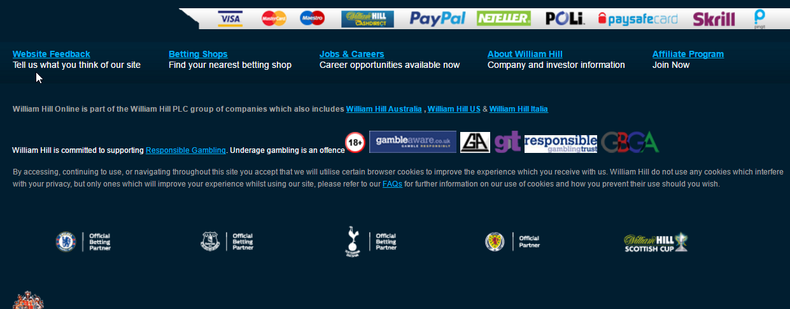
William Hill Website

Figure 4.8: Screenshot 7: William Hill Home Page

William Hills homepage includes a small Responsible Gambling URL displayed at the bottom of their homepage. Following this link, a small pop up screen is displayed on screen.

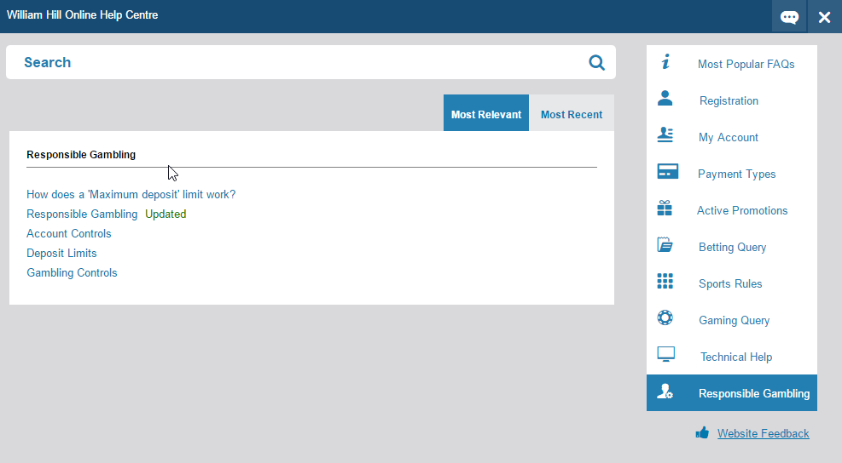
William Hill Responsible Gambling
Figure 4.9: Screenshot 8: William Hill RG Page

William Hill offer 5 different links within the page in regards to responsible gambling, these include Deposit limits, Responsible Gambling, Account Controls, and Gambling Controls.

Responsible Gambling Page


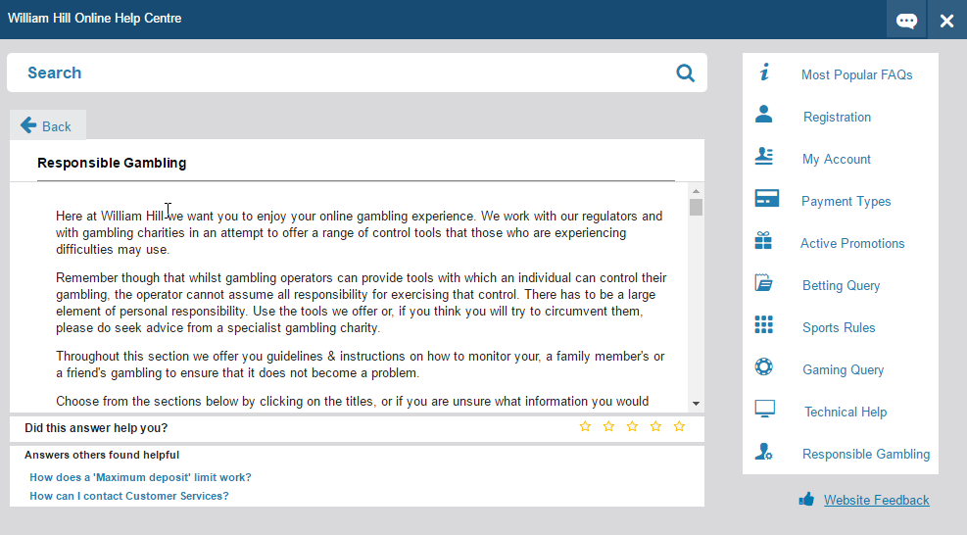
Figure 4.10: Screenshot 9: RG Page

William Hill opens their Responsible Gambling section by stating “Here at William Hill we want you to enjoy your OG experience. We work with our regulators and with gambling charities in an attempt to offer a range of control tools that those who are experiencing difficulties may use” (William Hill PLC, 2017). However, this is soon followed up by the following statement “Remember though that whilst gambling operators can provide tools with which an individual can control their gambling, the operator cannot assume all responsibility for exercising that control. There has to be a large element of personal responsibility.”

Website Overview

William Hill, make it evident here that responsibility is not solely of the operator but requires personal responsibility. William Hills views on CSR are similar to Friedman’s (1970) views who suggests that the sole responsibility of a business is to use its resources in order to increase profits so long as they stay within the rules and do not engage in deception or fraud. Friedman’s views suggested that “only humans can have a moral responsibility for their actions”.

This conception of CSR, is found to be closely linked to harmful industries. William Hill stay within the rules of the game and operate under legislation that is related to gambling. The use of CSR strategies is very diluted in the gambling industry, as without gamblers the industry would not be profitable.

4.5 William Hill PLC Annual Report

William Hill publicly release a 160-page annual report. Within the annual report two sections will be analysed first William Hills Corporate Responsibility section. This is the only sections within the 160-page document which mention CSR, leaving it the only subject to analysis. There are a number of reasons for using annual reports as a sampling unit; it has a higher degree of credibility, they also represent a method of communication and social construct (Wilmhurst & Frost, 2000). However, annual reports cannot provide a full picture of CSR policies and is recognized as a superficial disclosures of CSR information (Gray & Bebbington, 2005). Gray (2001) identifies other methods of CSR communication are often published in separate reports. William Hill did not publish any other methods of CSR communication, only their annual report.

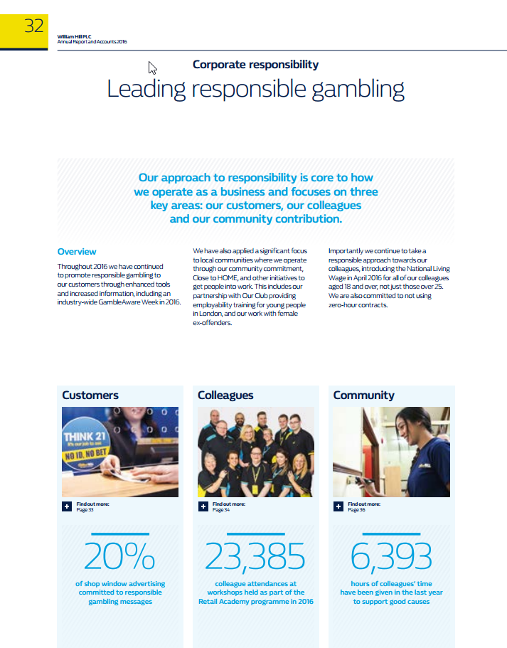
Leading Responsible Gambling
2
3
1
Figure 4.11: Screenshot 10: Leading RG

Section 1: Opening Statement

William Hills first section within their corporate responsibility section opens with the following statement:

“our approach to responsibility is core to how we operate as a business and focuses of three key areas: our customers, our colleagues and out community contribution.” (William Hill PLC, 2016).

However, back in 2008 William Hill were sued for breaking their self-exclusion policy and allowing someone to gamble. Calvert ages 28 self-excluded online (6 months) and in shop, because he found his gambling was becoming excessive, but 2 months later William Hill allowed him to create a new online account and continue gambling leading to a loss of £2 million for Calvert (Britten, 2008).

Section 2: Overview

Section 2 displays a brief overview on William Hills RG commitments in 2016, this section states how William Hill took part in an industry wide Gamble Aware week, and how they have applied a significant focus to local communities where they operate. William Hill also mention their use of Our Club which provide employability for young people in London and their efforts with female ex-offenders. William Hill also introduced the national living wage to all staff in 2016, providing employees under 25 better wages.

Section 3: Overview

Section 3 is just a brief overview of the following 3 pages which will be analysed.

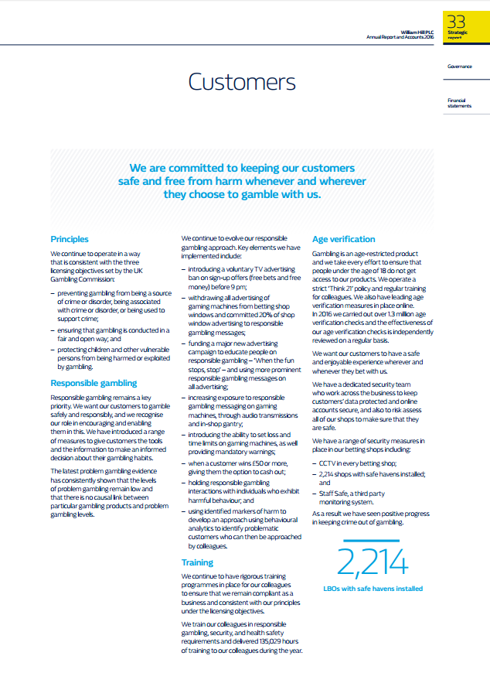
William Hill: Customers Page

1

2
5

3

4

Figure 4.12: Screenshot 11: Customers

Section 1: Opening Statement

William Hill open their customer page with the following statement:

“We are committed to keeping our customers safe and free from harm whenever and wherever they choose to gamble with us” (William Hill PLC, 2016, p. 33).

Section 2: Principles

Section 2 is a summary of the way William Hill operate and their current licensing objectives:

Preventing gambling from being a source of crime or disorder, being associated with crime or disorder, or being used to support crime;
Ensuring that gambling is conducted in a fair and open way; and
Protecting children and other vulnerable persons from being harmed or exploited by gambling.

Section 3: Responsible Gambling

Section 3 is a more detailed version of the Responsible Gambling page located on their website, which was previously mentioned. William Hill state that responsible gambling remains their key priority, explaining they want customers to gamble safely and responsibly, and show they understand their role in encouraging and enabling gambling.

William Hill state that the latest problem gambling evidence shows that levels of problem gambling remain low. However, the last British gambling prevalence survey was held in 2010. In 2010, the gambling prevalence survey indicated there was 450,000 pathological gamblers in the country, around 0.9% of the country. The charity Gamcare stated it has seen a rise of 18% in phone calls and 39% rise in clients being treated at their clinics (Gentleman, 2016). These figures indicate there is a rise in problem gambling, however, due to the gambling prevalence survey ending in 2010, the most recent gambling survey was taken in Wales in 2016, which indicated that 1.1% of participants were identified as problem gamblers and 3.8% of participants were identified as moderate risk problem gamblers (Gambling Commission, 2016).

The next section of this information William Hill describes the key elements they have implemented to help responsible gambling;
- Introduction of voluntary TV advertising ban on sign-up offers before 9pm.
- Withdrawing all advertising of gaming machines from windows and committing 20% to responsible gambling.
- Funding the new advertising campaign to educate people on responsible gambling “when the fun stops, stop”.
- Increase in exposure to responsible gambling messages.
- Introduction to the ability to set time and deposit limits, and providing mandatory warning messages.
- When a customer wins £50 or more, option to withdraw.
- Holding responsible gambling interaction with individuals displaying signs of harmful behaviour.
- Using identified markers of harm to develop an approach using behavioural customers who can then be approached by colleagues.

The above approaches are boasted by William Hill; however, these approaches are used by mostly every high-street bookmaker, and has not shown to decrease the risk of problem gambling.

Section 4: Training

William Hill mention the rigorous training programmes that they have in place for their colleagues to ensure compliance as a business, and to allow employees to remain consistent under their licensing objectives. William Hill state that their employees are trained in responsible gambling, security and health and safety requirements and that 135,029 hours of training during the year.

Section 5: Age Verification

The closing section of this page covers age verification. Gambling being an age restricted product William Hill state they use every effort to prevent underage gambling. William Hill operate a think 21 policy meaning any customer who looks under the age of 21 requires age verification. William Hill also state they have leading age verification measures in place on their online website, however, the user was able to create an online account without any age verification being required. It is stated that over 1.3 million age checks were carried out in 2016.

William Hill have a dedicated security team who ensure customers date is kept protected and online accounts are secure, and also risk assess shops to ensure safety. William Hill shops are fitted with the following security measures;

CCTV
2,214 shops fitted with safe havens
Staff Safe, a third-party monitoring system.

Previous research conducted by the researcher showed that William Hill’s age verification lacked reliability and was very inconsistent (Shaw, 2016).

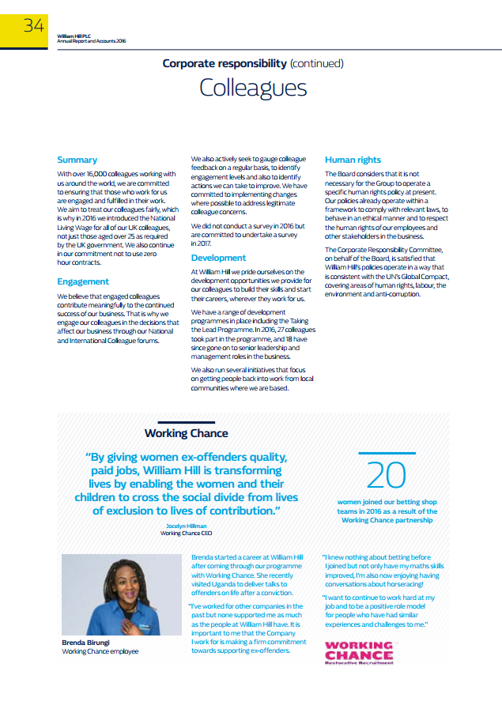
William Hill: Colleagues
4
3
2
1
Figure 4.13: Screenshot 12: Colleagues

Section 1: Summary
Section 1 is a summary of William Hill as an organisation. William Hill currently has 16,000 colleagues around the world, and state they are committed to ensuring employees are engaged and fulfilled in their work. In efforts to treat all employees fairly they introduced the national living wage to all employees and committed to supplying no zero hour contracts.

Section 2: Engagement
William Hill use a yearly survey in order to address employee concerns, although one was not carried out in 2016 it is stated that they are committed to undertake one in 2017. This survey is also a means to understand their employee engagement, as they state engaged employees contribute to continued success at William Hill.

Section 3: Development

Section 3 is information about the development opportunities that William Hill provide. In 2016 William Hill started a programme called taking the Lead Programme. This programme aims to recruit management from within the company, in 2016 27 colleagues took part and 18 have since gone on to senior management roles within William Hill. William Hill also stated using ‘Our Club’ which is a private organisation that aims to turn long-term unemployed people into positive, productive employees (WDR, 2017).

Section 4: Human Rights

Section 4 states that;

“The board has considered it not necessary to operate a specific human rights policy. Our policies already operate within a framework to comply with relevant laws, to behave in an ethical manner and to respect human rights of our employees and other stakeholders in the business” (William Hill PLC, 2016, p. 36)
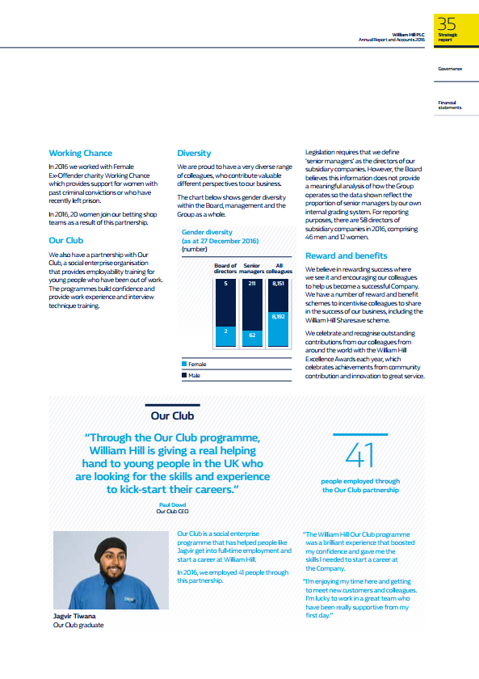
William Hill: Colleagues Continued
8
7
6
5
Figure 4.14: Screenshot 13: Colleagues continued

Section 5: Working Chance

In 2016 William Hill worked with a Female Ex-Offender charity called Working Chance, this charity aims to provide women support with past convictions. William Hill state that in 2016, 20 women joined betting shop teams through this partnership.

Section 6: Our Club

Section 6 details Williams Hill’s partnership with Our Club which was previously mentioned in (Section 3: Development)

Section 7: Diversity
William Hill state they are proud to have a diverse range of colleagues. However, by viewing the graph displayed it seems clear that the diversity in lower management jobs diverse, but within higher management there is a very noticeable difference between male and female employees.

Section 8: Reward and Benefit

Section 8 Includes information about William Hills reward schemes that are in place for employees. The first scheme is William Hill Share save scheme which allows employees to contribute a percentage of their wages annually to purchasing shares which can be sold at a later date. William Hill Excellence awards are also given yearly to performing shops and to employees who have contributed to the community and innovation.

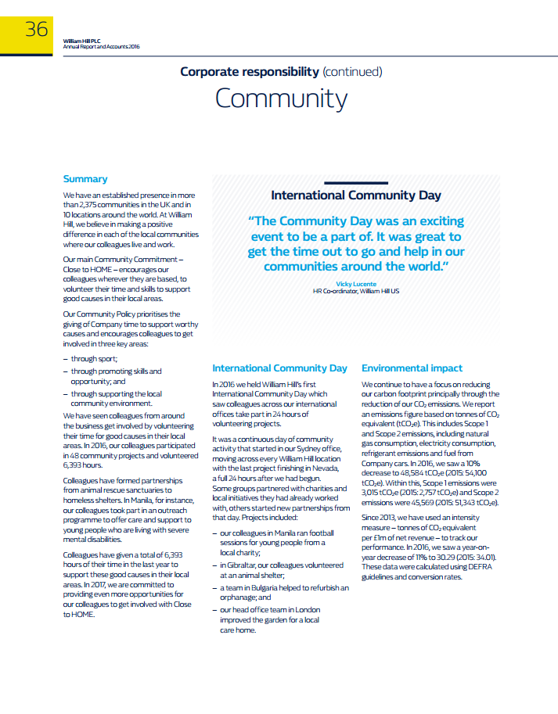
William Hill: Community
3
2
1
Figure 4.15: Screenshot 14: Community

Section 1: Summary

William Hill display their commitment to supporting communities in the UK and around the world. William Hill’s community commitment is called ‘Close to HOME’ and it encourages employees to volunteer their time and skills to support good causes in local communities. The policy prioritises the giving of company time to support worthy causes through three key areas:

Through sport;
Through promoting skills and opportunities; and
Through supporting the local community environment.

In 2016, William Hill employees participated in 48 community projects and volunteered 6,393 hours. William Hill has formed partnerships from animal rescues to homeless shelters.

Section 2: International Community Day

In 2016 William Hill held an International Community Day, which saw colleagues across all William Hills offices taking part in 24 hours of volunteering projects. Some examples follow;

Colleagues in Manila ran football sessions for young people from a local charity;
In Gibraltar, colleagues volunteered at an animal shelter;
A Bulgarian team helped refurbish an orphanage; and
Head office London team improved the garden of a local care home.

Section 3: Environmental Impact

Section 3 entails a section on the William Hills efforts to decrease their carbon footprint, through the reduction of CO2 emissions. In 2016, William Hill state the company saw a 10% reduction in the amount of emissions produced.

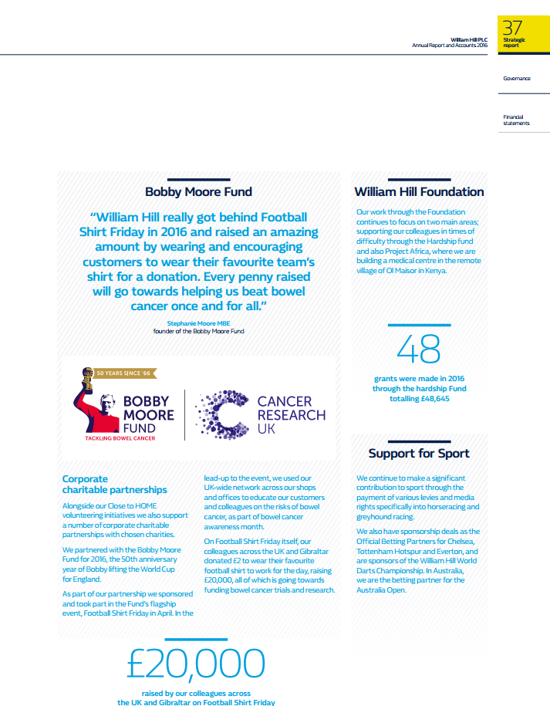
William Hill: Community Continued
2
1

Figure 4.16: Screenshot 15: Community Continued

Section 1: Bobby Moore Fund

William Hill joined the Bobby Moore Fund in 2016, a cause set up by Stephanie Moore (Cancer Research UK, 2017). This section includes a statement made by Stephanie Moore;

“William Hill really got behind Football Shirt Friday in 2016 and raised an amazing amount by wearing and encouraging customers to wear their favourite team’s shirt for a donation. Every penny raised will go towards helping us beat bowel cancer once and for all.” (Moore, 2016).

William Hill’s involvement with the charity raised £20,000.

Section 2: William Hill Foundation

William Hill offer a foundation to help employees who are times of difficulty, in 2016, £48,645 in grants were made through the hardship fund.

William Hill: Performance
2
1
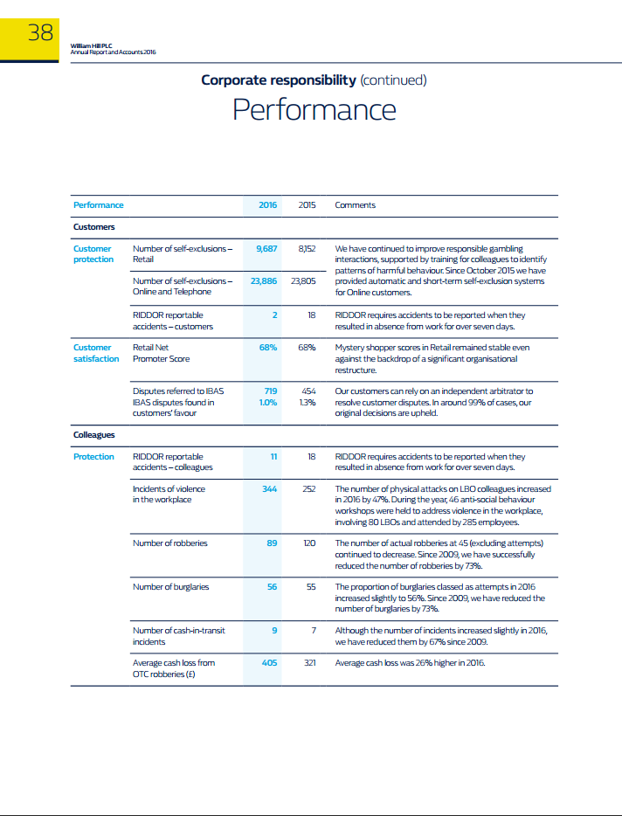
Figure 4.17: Screenshot 16: Performance
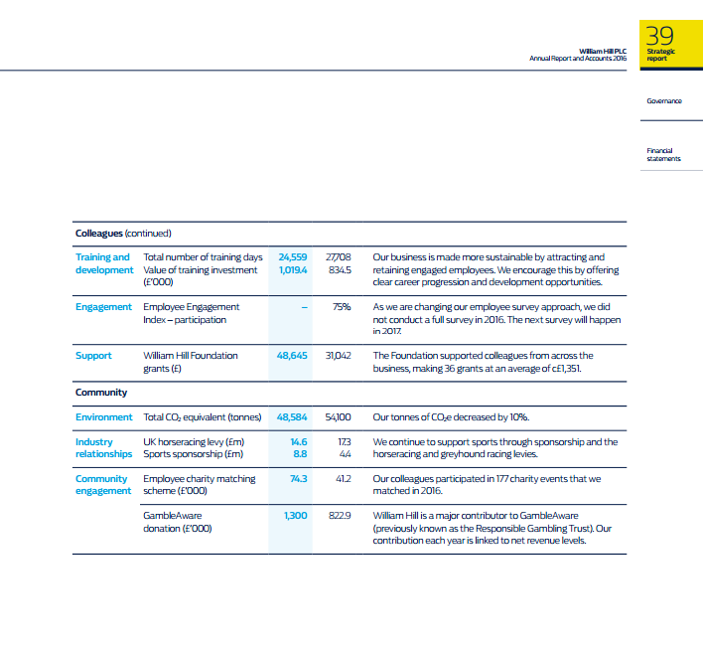
Figure 4.18: Screenshot 17: Performance Continued
4
3

Section 1: Customers
Customer Protection:
This section displays the number of self-exclusion between the years 2015 and 2016. There is a clear rise in the amount of self-exclusions between the years 2015 having 8,152 and 2016 9,687. William hill state they have continued to improve responsible gambling interactions, supported by staff to help them identify patterns of harmful behaviour. It is not clear if this is the reason behind the increase of self-exclusions. Gambling Commission figures indicated that the number of people using the self-exclusion had risen by 45% between 2009 and 2011. However, this tool has been seen as very ineffective at preventing problem gamblers from gambling. In 2010, many gamblers found that they were able to bet again without any challenges in betting shops, 2010 seen 10,468 breaches of self-exclusions (Ross, 2012).

Customer Satisfaction

This section shows William Hills net promoter score which is indicated by their yearly mystery shopper scores. William Hill have not improved since 2015 still will with an overall score of 68%

Section 2: Colleagues

Protection
Section 2 covers employee accident to robberies and average cash loss. There has been improvement over the past year in a few different areas such as robberies which has seen a successful decrees of 76% since 2008. However, the number of incidents in regards to violence has increased by a dramatic 46%.

Training and Development
William Hill state their business has been made more sustainable by attracting and retaining engaged employees. This has been done by offering clear careers progression and development opportunities. 2016 has seen a significant increase in the value of their training investment.

Engagement
Not applicable as the 2016 employee survey was not conducted.

Support
This section covers the William Hill foundation which was previously mentioned and displays the amount given in grants.

Section 3: Community

Environment
Co2 emissions have seen a 10% decrees since 2015.
Industry Relationships
William Hill have committed a further £4 million in sports sponsorships since 2015.
Community Engagement
This section is a more statistical view to the previous section on community engagement. It shows that William Hill have increased their Gamble Aware donation by £500,000 since 2015. It also shows the large increase in their charity matching scheme.

Summary of William Hill
Throughout the content analysis of William Hills website followed by a case study of part of William Hills annual report 2016. It is evident that William Hill apply the regulations and guidelines set by the gambling commissions. However, through their website the user found it very difficult to find the appropriate information needed for certain aspects of their responsible gambling tools, such as their self-exclusion where William Hill state they have leading technology for the tool. William Hill also state g

4.6 Content Analysis Finding’s

Betting Operator: | Correct Age 18 | Age Verification | RG Links | RG Information | License | Self-Exclusion Option | Warning on RG | Deposit Limits | Account Closure | CSR Report | GC Objectives | Overall Rating
Ladbrokes |  | High | High | Moderate | UK | Moderate |  |  |  |  |  | 17
William Hill PLC |  | Low | High | High | Offshore | High |  |  |  |  |  | 15

Figure: 4.19: Table of ratings for operators

The content analysis within this research was processed through ratings. Both Ladbrokes and William Hill’s website and annual report/CSR report have been analysed. The findings will be discussed in more depth. The ratings were made through a pointing system of 1 point per tick. Then ranging from 1 point for Low, 2 Moderate, 3 High, with a maximum overall rating of 20.

Ladbrokes:
Ladbrokes displayed a clear age logo throughout their website. The researcher attempted to create an online account and was asked to provide ID proof to verify account. Ladbrokes homepage also displayed a link to RG on their homepage and offered separate links to different sections of their RG page. Ladbrokes RG page consisted of numerous links and lacked in depth information on RG, however, Ladbrokes achieved a High rating through their in-depth information which was provided within their CSR report. Ladbrokes state their commitment to paying UK taxes which was further researched and found they hold a UK operating license. Ladbrokes website lacked information relating to self-exclusion options. The researcher was not able to find any RG warning on either their website or CSR report. However, Ladbrokes did provide clear information on deposit limits, and account closure, with guidelines on using these tools.
Ladbrokes offered a separate document from the annual report, a dedicated report to CSR, this was subject to Ladbrokes commitment to CSR engagement. Both their website and CSR report clearly showed they abide by the objectives set by the Gambling Commission.
The content analysis scored Ladbrokes 17/20. The research felt as their commitment to CSR was made clear within their CSR communication strategies. However, felt as the information given lacked reliability, and was just used as a method for gaining legitimacy, and social acceptance (Belal, 2016).

William Hill:
William Hill also displayed a clear age logo on their website. The researcher tested their age verification, by creating an account with a random age, and was able to make the account with no restrictions or any implication what proof of age needed to be provided. William Hill provided a clear link to their RG page, although it was displayed at the bottom of the page. William Hill was rated high for their RG communication, throughout their website and the CSR section within the annual report, in depth information regarding RG was evident. Unlike Ladbrokes, William Hill do not license from the UK, but do so from Gibraltar which research showed a maximum of 1% tax is paid capped at £425,000 (Banks, 2016).

William Hill offered clear information on self-exclusion options available for customer and provided information within the annual report showing yearly self-exclusion, and stated they are rising due to better self-exclusion technology and employee engagement. William Hill state “Here at William Hill we want you to enjoy your OG experience. We work with our regulators and with gambling charities in an attempt to offer a range of control tools that those who are experiencing difficulties may use” (William Hill PLC, 2017). Then follow up this statement with “Remember though that whilst gambling operators can provide tools with which an individual can control their gambling, the operator cannot assume all responsibility for exercising that control. There has to be a large element of personal responsibility.”. This statement relates Friedman’s (1970) theory which suggests that the sole responsibility of a business is to use its resources in order to increase profits so long as they stay within the rules and do not engage in deception or fraud. Friedman’s views suggested that “only humans can have a moral responsibility for their actions”. This was found to relate to the instrumental theory of CSR. Palazzo and Richer (2005) also agreed that controversial industries should engage at a transactional level of CSR. This level of CSR refers to the organisations integrity, i.e. it complies with legal and moral rules and behaves with fairness and transparency, avoiding harm or taking responsibility for it, if caused (Yani-de-Soriano & Javed, 2012). William Hill offered deposit limits, but there were no instructions on account closure.

Overall, William Hill scored 15/20 due to their age verification, and not using a CSR report for communication.

Chapter 5: Conclusion

5.1 Introduction
This concluding chapter seeks to discuss the main findings as collected in this study. Limitations of the dissertation – this chapter will provide recommendations – lack of dialogue with operators and problem gamblers. The value and content of CSR communications within the UK gambling industry has been investigated within the Results chapter. However, it is important to link the results together with the finding from the literature review. Although the ethical stance of the operators has been analysed, it is difficult to truly understand what the underlying moral creed is without being able to interview the Directors of the organisation in detail.

5.2 Main Findings

The aim of this dissertation sought to understand how UK gambling operators value CSR and how they communicate CSR. The aim of the research was to critically analyse the communication of CSR values in the UK gambling industry with special reference to Ladbrokes and William Hill which was achieved. Three objectives were set out in this research in order to obtain reliable and substantial results:

- To investigate the value and content of CSR communications in the UK gambling industry
- To evaluate the value of CSR in the UK gambling industry
- Produce recommendations for improved CSR communications

5.2.1 The Value and Content of CSR Communication in the UK Gambling Industry

This research project aimed to, investigate the value and content of CSR communication, within two UK gambling operators, and examine the perceptions of CSR communications provides by (Ladbrokes & William Hill).

The literature review indicated that gambling operators in the UK are highly pressured by CSR obligations. The result of this high pressure has led to regulations and licensing objectives being set by the Gambling Commission. It is evident through current literature that the liberalization of gambling in the UK has had impact on problem gambling.
The last gambling prevalence survey indicated that 0.9% of gamblers are effected by problem gambling (Orford & Griffiths, 2012). BGPS abandoned due to lack of funding – highlights a lack of seriousness about gambling-harms. In replacement of the BGPS, questions about gambling have been added on to general surveys about health in England and Scotland. However, no UK gambling prevalence survey has been conducted since, only a study in Wales 2016, which indicated that 1.1% of participants were effected by problem gambling, and 3.8% were seen as moderate risk problem gamblers (Gambling Commission, 2016). This shows clearly that problem gambling is on the rise. However, the revenues the gambling industry bring builds relationships with government. Figures estimates problem gambling costs the government £1.2b compared to £2.6b the gambling industry contributes to the government annually (Davies, 2016). Figures like these enable stakeholders to pressure governments to add regulations. The research chapter of this dissertation, examined RG information, and tools on their website and their annual report. It was made clear that Ladbrokes and William Hill both use CSR strategies in order to gain legitimacy. Legitimacy theory specifies that organisations try to legitimise their activities by engaging in CSR, in order for their organisation to get approval from society (Belal, 2016). The value of CSR was much more apparent with Ladbrokes who proved to engage more with CSR. Ladbrokes are currently one of the few gambling organisations who operate in the UK and not offshores. William Hill, did not offer a CSR report like Ladbrokes, but dedicated a section of their annual report to CSR. Both operators engage in watered down CSR, because it is the only method to gain legitimacy.

The underlying question which this research attempted to understand was how an industry which produces harms to consumers can be socially responsible. This question is very difficult to answer, as the industry stays within the law and engages in CSR. The problems which this industry relate to Friedman (1970) who suggests that only humans have a moral responsibility for their actions, and business overall objectives are to increase profits, and social issues and problems are the responsibility of governments not of an organisation (Crane & Matten, 2004).

5.2.2 The Value of CSR within the UK Gambling Industry

The gambling industry has mushroomed over the past decade, in terms of technological advancements and liberalization. The industry is massive and extremely profitable; it has current links to political and economic institutions of state (Reith, 2007). It is evident that CSR policies are in place, which acknowledge the potential harm of gambling however they are very weak. Both Ladbrokes and William Hill all claim to be integrating CSR into the core of their business. Ladbrokes emphasize their financial success is “rigorously underpinned by a solid foundation of long term responsible thinking” (Ladbrokes, 2014). However, research found that Ladbrokes had their first financial loss due to CSR issues such as paying UK tax. William Hill on the other hand state “they are committed to improving continuously its practices in the area of corporate social responsibility” (William Hill PLC, 2016). Both UK gambling operators report on how they are looking to encourage socially responsible gambling. This has raised several issues which merit discussion. The broad questions which arise about industries whose good and services can have potentially harmful effects on society such as gambling are heavily demonized. It is clear that CSR is used as a strategic tool in the gambling industry to minimize any potential negative impacts for the organisation (Jones, et al., 2009).

5.2.3 Recommendations for Improved CSR Communications in the Industry

The last objective of this research aimed to produce solid recommendations for improved CSR communications within the UK gambling industry. The following recommendations were built through the content analysis and the evaluation of current CSR communication literature conducted within this dissertation:

- Increased efforts to increase legitimacy: Throughout this dissertation is was evident that CSR is only engaged by gambling operators in order to achieve legitimacy and social acceptance. Gambling operators achieve this by offering RG tools, to help prevent problem gambling, and involve themselves in CSR initiatives. The researcher understands that gaining true legitimacy is impossible within a harmful industry. However, to achieve a greater social acceptance, operators could offer PG sessions with customers who are beginning to show signs of PG. If operators are able to communicate personally with customers rather than directing them to other PG charities, legitimacy could be gained through social and community acceptance. However, this is unlikely due to gamblers and PG are the lifeblood of the casino.

- Embed CSR into the organisations marketing communications: Literature has made it evident that it is paramount to embed CSR into an organisations marketing approach. Ladbrokes, and William Hill both provide short RG messages within their advertisements. However, these are seen as very weak and do not offer any help to customers. Gambling operators need to dedicate adverts to CSR initiatives and not solely focus of profits but the harm caused by gambling.

- Establish a CSR culture within the organisation: CSR communication needs to start with an internal communication within the organisation. If employees of William Hill, and Ladbrokes are truly aware of CSR, employees will be able to understand CSR values and will be able to adjust their behaviours in daily business, internally and externally.

5.3 Discussion of Main Findings

The research in the literature review showed there was no clear consensus of the term CSR. The term CSR is made of a vast amount of definitions, with no clear or distinctive definition. CSR is engaged different by organisations. The purpose of this research was to attempt to understand the value and content of CSR communications in the UK gambling industry. The research chapter made it clear that the chosen operators involve themselves with CSR and make customers aware of their CSR commitments. However, as Orford (2010) suggested an informed gambler can still become a problem gambler. The information which is given by the operators, is weak. It was evident that William Hill engage in CSR as a strategic objective, but when it comes to real concerns of problem gambling (PG) only offer a gateway to other charities. Ladbrokes have attempted to integrate CSR into their core, by advertising their commitment to CSR, and operating within the UK rather than off shores. Overall, it was clear both operators used CSR strategically in order to gain legitimacy, as legitimacy theory indicates organisations try to legitimise their activities by engaging in CSR, in order for their organisation to get approval from society (Belal, 2016).

5.4 Recommendation for Future Research

This dissertation was successful in achieving the objectives of this project. However, the research suggests this area is subject to further research. Concerns which arise within this research area are subject to the lack of research in this area, and the sensitivity of the subject. For more superior research to be conducted the researcher must:

- Attempt to contact the chosen organisations researched. Communication with the operators will allow the researcher to gain further insight into the depths of the operators CSR communications values.
- Conduct content analysis with a wider sample of UK gambling operators, this will gain a more comprehensive view.
- Produce interviews, or a questionnaire to include the opinions of gamblers and ex-gamblers in order to cross reference operator’s statements with the views of gamblers.

It is important to mention that gambling and OG research is less than a generation old. This produces a lack of relevant literature for the researcher to use.

5.5 Limitations

One of the largest limitations which occurred within this research, was that the research was only able to critically analyse information which resided on the operator’s websites and annual reports. It was not possible to gain further insight on deeper values of CSR communications which operators pursue. Although this research was focused on CSR communications, it was also focused on gambling which is a sensitive research topic due to the problems which it can cause.

Lack of resources was a substantial issue with this research. The research conducted was carried out over the space of 2 weeks. Jawad (2016) argues that to ensure that data is reliable and valid, that all research should be conducted at the same time, on the same day. However, this was impossible for the researcher due to commitments to others academic modules. Financial issues also occurred in this research, which led to the researcher not being able to access certain journals, software’s, etc.

Lack of time, was a very limiting factor in this research, due to this study being allocated to a set time. The researcher suggests that more time could potentially lead to deeper and more relevant information.

5.6 Conclusion of the Study

This section will identify the most apparent theme which was discovered through this research.

The overall theme which was evident through this research, was the issue that falls to legitimacy. The researcher believes that CSR is only engaged within the industry due to laws and regulations which pressures operators into engaging in CSR. The use of CSR communication in both operators aimed to gain legitimacy for the operators. As Suchman (1995) identified the key challenges of maintaining and gaining legitimacy rest heavily on the operator’s communication. Both Ladbrokes and William Hill offered information on their CSR engagements on their websites and within their annual report. The content analysis aimed to understand the value of CSR communication for these two operators. The research proved that although both operators engage in CSR, they do not offer in-depth or any personal help for PG’s. As previously mentioned gambling operators engage in a weak form of CSR, in order to gain legitimacy and social acceptance to help prevent further regulations. To conclude this dissertation the researcher understands that CSR is engaged by gambling operators to a certain extent, this form of CSR which is engaged by gambling operators is weak and lacks any results. CSR is used as a strategic tool, to gain legitimacy and social acceptance. The problem with CSR in the gambling industry will always relate back to the question that surrounds CSR research, can an industry which provides harmful products be seen as ethical.

Bibliography
Abbott, N., 2016. Campaign for Fairer Gambling “relieved” over upcoming gambling review. [Online]
Available at: https://www.gamblinginsider.com/news/2541/campaign-for-fairer-gambling-relieved-over-upcoming-gambling-review
[Accessed 15 04 2017].
Adami, M. F. & Kiger, A., n.d. The use of triangulation for completeness purposes. Nurse Researcher, 12(4), pp. 19-29.
Association of British Bookmakers, 2016. Safe Bet Alliance (SBA), s.l.: s.n.
Babor, T. & Miller, P., 2014. Conflict of interest and Addiction’s new transparency declaration procedures. Addiction.
Bailey, K., 2008. Methods of Social Research, 4th Edition. s.l.: Simon and Schuster.
Balmer, J. & Gray, E., 2007. The nature and management of ethical corporate identity. Journal of Business Ethics, pp. 7-15.
Banks, J., 2016. Online Gambling and Crime: Causes, Controls and Controversies. s.l. Routledge.
Barnett, M. L., 2007. Stakeholder influence capacity and the variability of financial returns to corporate social responsibility. Academy of Management Review, pp. 794-816.
Bechtoldt, H. P., 1959. Construct Validity: A Critique. American Psychologist, 14(10), pp. 619-629.
Beck, U., 1992. Risk Society Towards a New Modernity. s.l. SAGE.
Belal, A., 2016. Corporate Social Responsibility Reporting in Developing Countries: s.l.: Routledge.
Belasen, A. T., 2007. The Theory and Practice of Corporate Communication: A Competing Values Perspective. s.l. SAGE.
Berger, A. A., 2000. Media and Communication Research: An Introduction to Qualitative and Quantitative Approaches. s.l. SAGE.
Bhattacharya, C. & Sen, S., 2004. Doing better at doing good: When, why and how consumers respond to corporate social initiatives. California Management Review, pp. 9-24.
Binde, P., 2014. Gambling advertising: A Critical Research Review, s.l.: Responsible Gambling Trust.
Britten, N., 2008. Gambler sues William Hill for letting him bet. [Online]
Available at: http://www.telegraph.co.uk/news/uknews/1578629/Gambler-sues-William-Hill-for-letting-him-bet.html
Brugger, M., 2014. Communicating Corporate Social Responsibility. s.l.: Emerald Group Publishing.
Burns, A. & Bush, R., 2000. Marketing Research: Volume 1. s.l. Prentice Hall.
Bury, R., 2016. Ladbrokes reports its first loss in a decade. [Online]
Available at: http://www.telegraph.co.uk/business/2016/02/23/ladbrokes-reports-its-first-loss-in-a-decade/
[Accessed 13 04 2017].
Byrd, J., Hickman, K., Baker, C. & Cohanier, B., 2017. Corporate Social Responsibility Reporting in Controversial Industries, s.l.: SSRN.
Campbell, D. & Beck, A., 2004. Answering allegations: the use of corporate website for restorative ethical and social disclosure. business Ethics: A European Review, 13(2), pp. 100-116.
Campbell, D., Craven, B. & Shrives, P., 2003. Voluntary social reporting in three FTSE sectors: a comment on perception and legitimacy. Accounting, Auditing and Accountability Journal, 16(3), pp. 558-581.
Campbell, J. L. & Pederson, O. K., 2001. The Rise of Neoliberalism and Institutional Analysis. s.l. Princeton University Press.
Cancer Research UK, 2017. Bobby Moore Fund. [Online]
Available at: http://www.cancerresearchuk.org/support-us/become-a-partner/our-charity-partners/bobby-moore-fund
Capriotti, P., 2011. Communicating corporate social responsibility through the internet and social media. The Handbook of Communication and Corporate Social Responsibility.
Carroll, A. B., 1991. The Pyramid of Corporate Social Responsibility: Toward the Moral Management of Organisational Stakeholder. Business Horizons, 34(4), pp. 39-48.
Carroll, A., 1999. Corporate Social Responsibility: Evolution of Definitional Construct. Business and Society, pp. 268-295.
Carroll, A. B., 2000. Ethical Challenges for Business in the new Millennium. Business Ethics, 10(1), pp. 33-42.
Carter, R. & Lubinsk, J., 2015. Rehabilitation Research: Principles and Applications. s.l.: Elsevier Health Sciences.
Casino City, 2017. Casino City. [Online]
Available at: http://online.casinocity.com/
[Accessed 17 January 2017].
Chenery, B. H., 1963. The use of interindustry analysis in development programming.
Christensen, L. T., 2002. New tensions and challenges in integrated communications. Corporate Communications: An International Journal, 14(2), pp. 207-219.
Clarkson, M., 1995. A Stakeholder Framework for Analysing and Evaluating Corporate Social Performance. Academy of Management Review, 20(1), pp. 92-117.
Cohen, R., 2013. It’s a Gamble: Casinos Offering Charitable Donations to Woo Voter Support. [Online]
Available at: https://nonprofitquarterly.org/2013/10/24/it-s-a-gamble-casinos-offering-charitable-donations-to-woo-voter-support/
[Accessed 18 04 2017].
Collins, P., 2003. Gambling and Public Interest. s.l. Greenwood Publishing Group.
Collis, J. & Hussey, R., 2009. Business Research: A Practical Guide for Undergraduate and Postgraduate Students. s.l. Palgrave Macmillan.
Cornelissen, J., 2014. Corporate Communication: A Guide to Theory and Practice. s.l. SAGE.
Cosgrave, J., 2013. The Sociology of Risk and Gambling Reader. s.l. Routledge.
Crane, A., 2008. The Oxford Handbook of Corporate Social Responsibility. s.l.: OUP Oxford.
Crane, A. & Glozer, S., 2016. Researching Corporate Social Responsibility Communication: Themes, Opportunities and Challenges. Journal of Management Studies, pp. 1223-1252.
Crane, A. & Matten, D., 2003. Business Ethics. s.l. Oxford University Press.
Crane, A. & Matten, D., 2004. Questioning the Domain of Business Ethics Curriculum: Where Laws ends or Where It Starts? International Centre of Corporate Social Responsibility.
Creswell, J. W. & Clark, V., 2011. Designing and Conducting Mixed Methods Research. s.l. SAGE.
Davies, K., 1960. Can Business Afford to Ignore Corporate Social Responsibilities? California Management Review.
Davies, R., 2016. Betting firms spent half a billion pounds on TV adverts since 2012. [Online]
Available at: https://www.theguardian.com/society/2016/jul/15/betting-firms-spent-half-a-billion-pounds-on-tv-adverts-since-2012
Davies, R., 2016. Problem gambling costs UK up to £1.2bn a year, says report. [Online]
Available at: https://www.theguardian.com/society/2016/dec/13/problem-gambling-gambleaware-ippr
Denzin, N. K., 1978. Sociological Methods. New York: McGraw-Hill.
Dogtiev, A., 2017. 2016 Global Gaming & Gambling Markets Overview. [Online]
Available at: http://www.mobyaffiliates.com/blog/2016-global-gaming-gambling-markets-overview/
[Accessed 22 04 2017].
Donaldson, T., 1982. Corporations and Morality.
Donaldson, T. & Dunfee, T., 1994. Toward a Unified Conception of Business Ethics: Integrative Social Contracts Theory. The Academy of Management Review, pp. 252-284.
Douglas, J. D., 1970. Deviance and Respectability. The Social Construct of Moral Meanings. s.l. S.n.
Dudovskiy, J., 2012. Carroll’s CSR Pyramid and its applications to small and medium sized businesses.
Duff, P., 2012. Case Study Research in Applied Linguistics. s.l. Routledge.
Du, S., Bhattacharya, C. & Sen, S., 2010. Maximizing business returns to corporate social responsibility: the role of CSR communication. International Journal of Management, pp. 8-19.
Easterby-Smith, M., Thorpe, R. & Lowe, A., 2002. Management Research: An Introduction. s.l. SAGE.
Erskine, P., 2014. Ladbrokes Archive. [Online]
Available at: https://www.ladbrokescoralplc.com/media/press-releases/ladbrokes-archive/2014/2014-07-04
Farrell, S., 2016. Ladbrokes and Coral. [Online]
Available at: https://www.theguardian.com/business/2016/oct/17/ladbrokes-coral-sell-betting-shops-betfred-stan-james-merger
Ferrell, O., 1997. Business Ethics: Ethical Decision Making and Cases. s.l. Houghton Mifflin Company.
Foster, D., 1996. Primary Culprit. 26 February. 50-57.
Fowler, F. J., 2013. Survey Research Methods. s.l. Sage Publications.
Fraedrich, J. & Ferrell, O., 2012. Business Ethics: Ethical Decision Making & Cases. s.l. S.n.
Freeman, E., 1988. Stakeholder Theory of the Modern Corporation. General Issues in Business Ethics, pp. 38-48.
Freeman, E., 2008. A New Approach to CSR: Company Stakeholder Responsibility. Business Roundtable Institute for Corporate Ethics.
Freeman, E., Velamuri, R. & Moriarty, B., 2006. Company Stakeholder Responsibility: A New Approach to CSR. Business Roundtable: Institute for Corporate Ethics.
Friedman, M., 1962. Capitalism and freedom. University of Chicago Press.
Friedman, M., 1970. The Social Responsibility of Business is to Increase its Profits. The New York Times Magazine.
Gainsbury, S. & Blaszczynski, A., 2016. Exploring Internet Gambling: Policy, Prevention and Treatment. s.l. Routledge.
Gambling Commission, 2017. The 2005 Gambling Act, s.l.: s.n.
Gambling Commission, 2016. New survey data highlights gambling participation and problem gambling rates in Wales. [Online]
Available at: http://www.gamblingcommission.gov.uk/news-action-and-statistics/news/2016/New-survey-data-highlights-gambling-participation-and-problem-gambling-rates-in-Wales.aspx
Garriga, E. & Melé, D., 2004. Corporate Social Responsibility. Journal of Business Ethics, pp. 51-71.
Gay, R., Charlesworth, A. & Esen, R., 2007. Online Marketing: A Customer-Led Approach. s.l. S.n.
GC, 2017. What is the Senet Group? [Online]
Available at: https://www.gambling.com/laws/senet-group
Gentleman, A., 2016. Inside the NHS's only specialist gambling clinic. [Online]
Available at: https://www.theguardian.com/society/2016/jun/06/gambling-secret-addiction-ruins-lives
Goffman, E., 1959. The presentation of self in everyday life. s.l. S.n.
Goodman, M. B., 2001. Current Trends in Corporate Communication. Corporate Communications: An International Journal, pp. 117-123.
Gordon, R. & Moodie, C., 2009. Dead cert or long shot: the utility of social marketing in tackling problem gambling in the UK? International Journal of Non-profit and Voluntary Sector Marketing, pp. 243-253.
Gratton, C. & Jones, I., 2004. Research Methods for Sport Studies. s.l. Psychology Press.
Gray, R. & Bebbington, J., 2005. CORPORATE SUSTAINABILITY: Accountability and the Pursuit of the Impossible Dream. Social and Environmental Accounting Research.
Gray, R., Mohammed, J., Power, D. & Sinclair, D., 2001. Social and Environmental Disclosure and Corporate Characteristics: A Research Note and Extension. Journal of Business Finance & Accounting.
Great Britain: Parliament: House of Commons: Culture, Media and Sport Committee., 2012. The Gambling Act 2005: a bet worth taking, s.l.: The Stationery Office.
Greener, S., 2008. Business Research Methods. s.l. S.n.
Grey, R., Owen, D. & Adams, C., 1996. Accounting and Accountability: Change and Challenges in Corporate Social and Environmental Reporting. s.l. Practice Hall.
Grey, R., Kouhy, R. & Lavers, S., 1995. Corporate Social and Environmental Reporting: a review of the literature and longitudinal study of UK disclosure. Accounting, Auditing & Accountability Journal, 8(2), pp. 47-77.
Griffiths, M., 2003. Internet Gambling: Issues, Concerns, and Recommendations. Cyber Psychology & Behaviour, pp. 557-568.
Griffiths, M., 2009. Gambling research and the search for a sustainable funding infrastructure. Gambling Research, Volume 21, pp. 28-32.
Guffey, M. E., Rogin, P. & Rhodes, K., 2009. Business Communication: Process and Product. s.l. Cengage Learning.
Hage, M., 2007. A stakeholder’s concern towards an economic theory on stakeholder governance. s.l. S.n.
Hák, T. & Moldan, B., 2012. Sustainability Indicators: A Scientific Assessment. s.l. Island Press.
Ha, L. & James, E. L., 1998. Interactivity re-examined: A baseline analysis of early business web site. Journal of Broadcasting and Electronic Media.
Heinmiller, T., 2016. Water Policy Reform in Southern Alberta: An Advocacy Coalition Approach. s.l. S.n.
Henderson, D., 2001. Misguided Virtue: False Notions of Corporate Social Responsibility. Institute of Economic Affairs.
Houlder, V., 2017. Ladbrokes loses appeal over £71m tax avoidance case. [Online]
Available at: https://www.ft.com/content/8de8f866-fb73-11e6-96f8-3700c5664d30
Huhn, T. S., 1970. The Structure of Scientific Revolutions. s.l. S.n.
Hunger, D. & Wheelan, T., 2000. Strategic Management. s.l. Prentice Hall.
Jankowicz, A. D., 2004. Business research projects. s.l. S.n.
Jawad, C., 2006. An Analysis of Responsible Internet Gambling Websites. s.l. S.n.
Jawad, C., 2016. A critical analysis of responsible gambling, s.l.: s.n.
Jawad, C., 2016. The Business Case for CSR and Sustainability: Are Virtuous Firms Built to Last? s.l.: s.n.
Johnson, R., 2004. Kant's Moral Philosophy. Stanford Encyclopaedia of Philosophy.
Jones, P., Hillier, D. & Comfort, D., 2009. Corporate social responsibility in the UK gambling industry. Corporate Governance: The international journal of business in society, pp. 189-201.
Kalkenberg, J., 2006. The Value of Corporate Social Responsibility Looking Beyond the Bottom Line. Norwegian School of Economics and Business Administration.
Kaptein, M. & Wempe, J., 1998. A Means of Sharing Responsibility. The Ethics Report, 7(3), pp. 131-139.
Katsirikou, A. & Skiadas, C., 2010. Qualitative and Quantitative Methods in Libraries. s.l. World Scientific.
Kerlinger, F., 1973. Foundations of Behavioural Research. Behavioural Research.
Khan, J. A., 2011. Research Methodology. slap Publishing.
Kilcullen, M. & Kooistra, J., 1999. At least do no harm: sources of the changing role of business and corporate social responsibility. Volume 27, pp. 158-178.
Kimery, K. & Rinehart, S., 1998. Markets and Constituencies: An alternative view of the marketing concept. Journal of Business Research, pp. 117-124.
Kim, P., Eng, R., Deering, J. & Maxfield, A., 1999. Published criteria for evaluating health related web sites: review. British Medical Journal.
Kingma, S., 2004. Gambling and the risk society: the liberalisation and legitimation crisis of gambling in the Netherlands. International Gambling Studies.
Kingma, S., 2008. Global Gambling: Cultural Perspectives on Gambling Organisations. s.l. Routledge.
Kitchen, P. & Uzunoglu, E., 2014. Integrated Communications in the Postmodern Era. s.l. Springer.
Kitson, A. & Campbell, R., 2008. Ethical Organisations. s.l. Palgrave Macmillan.
Kraemer, R. & Whiteman, G., 2008. REPORT FROM THE FRONT-STAGE – AN ETHNOGRAPHIC ACCOUNT OF THE 19TH WORLD. s.l. S.n.
Krippendorf, K., 1980. Validity in Content Analysis. s.l. S.n.
Krippendorff, K., 2012. Content Analysis: An Introduction to its Methodology. s.l. SAGE.
Kumar, R., 2008. Research Methodology. s.l.:APH.
Ladbrokes, 2014. Corporate Responsibility, s.l.: Ladbrokes.
Ladbrokes Coral PLC, 2014. Ladbrokes establishes Social Responsibility Committee, s.l.: Ladbrokes.
Ladbrokes PLC, 2015. Building a Better Ladbrokes, s.l.: Ladbrokes PLC.
Ladbrokes, 2014. CSR Report, s.l.: Ladbrokes.
Lambooy, T., 2014. Legal Aspects of Corporate Social Responsibility. Journal of European Law, 30(70).
Lantos, G., 2001. The Ethicality of Altruistic.
Lantos, G., 2002. The ethicality of altruistic corporate social responsibility. Journal of Consumer Marketing, 19(3), pp. 205-232.
Lewis, J., 2010. For sale: Personal details of millions of Ladbrokes gamblers, offered to the MoS by a mysterious Australian. [Online]
Available at: http://www.dailymail.co.uk/news/article-1245622/For-sale-Personal-details-millions-Ladbrokes-gamblers.html
Light, R., 2007. The Gambling Act 2005: Regulatory Containment and Market Control. The Modern Law Review, pp. 626-653.
Lindbolm, C. K., 1994. The implications of organisational legitimacy for corporate social performance and disclosure. Critical Perspectives on Accounting Conference.
Loh, C., Deegan, C. & Inglis, R., 2015. The changing trends of corporate social and environmental disclosure within the Australian gambling industry. Accounting and Finance, pp. 783-823.
Lowe, D. & Gaedke, M., 2005. Web Engineering. s.l. Springer Science & Business Media.
MacInnes, P., 2017. Experts warn of £12.6bn scale of UK gambling problem. [Online]
Available at: https://www.theguardian.com/sport/2017/apr/27/12-billion-pounds-scale-uk-gambling-problem-experts-warn
[Accessed 20 04 2017].
Mason, E. J. & Wong, N. C., 1998. Observation of two distinct phase states in a self-phase-locked type II phase-matched optical parametric oscillator. Optics Letters, 23(22), pp. 1733-1735.
Matten, D. & Crane, A., 2003. Corporate Citizenship: Towards an extended theoretical conceptualization. International Centre for Corporate Social Responsibility.
McGivern, Y., 2009. The Practice of Market Research: An Introduction. s.l. Pearson Education.
McMillan, S., 2000. The Challenge of Applying Content Analysis to the World Wide Web. SAGE Journal.
McMurray, A., 2004. Research: A Common-sense Approach. s.l. Cengage Learning.
Merson, R., 2010. Rules Are Not Enough: The art of governance in the real world. s.l. S.n.
Meyer, G., Hayer, T. & Griffiths, M., 2009. Problem Gambling in Europe: Challenges, Preventions, and Interventions. s.l. Springer Science & Business.
Meznar, M. & Nigh, D., 1995. Buffer or Bridge? Environmental and Organisational Determinants of Public Affairs Activities in American Firms. Academy of Management Journal.
Miers, D., 1996. Regulation and the Public Interest: Commercial Gambling and the National Lottery. The Modern Law Review.
Miers, D., 2002. OFGAM? OFBET? The Regulation of. Entertainment Law, pp. 20-51.
Miers, D., 2011. From Constraint to Competition: 50 Years of Change in British Gambling Policy. Gaming law Review and Economics, pp. 93-103.
Miers, D., 2014. The Gambling Market in Great Britain. Problem Gambling.
Moir, L., 2001. What do we mean by corporate social responsibility? Corporate Governance: The International Journal of Business in Society, 1(2), pp. 19-22.
Moodie, C. & Reith, G., 2009. Responsible gambling signage on electronic gaming machines, International Gambling Studies, pp. 5-17.
Moore, M. & Alexander, L., 2007. Deontological Ethics. s.l. S.n.
Moore, S., 2016. William Hill PLC Annual Report, s.l.: s.n.
Moreno, A. & Capriotti, P., 2009. Communicating CSR, citizenship and sustainability on the web. Journal of Communication Management, pp. 157-175.
Morsing, M. & Beckmann, S., 2006. Strategic CSR Communication. s.l.: DJOF Publishing.
Morsing, M. & Schultz, M., 2006. Corporate social responsibility communication: stakeholder information, response and involvement strategies. Business Ethics a European Review.
Mosteller, F. & Wallace, L. D., 1964. Inference and Disputed Authorship: The Federalist. s.l. S.n.
Mullerat, R., 2010. international Corporate Social Responsibility: The Role of Corporations in the Economic Order of the 21st Century. s.l. Kluwer Law International.
Mustafa, A., 2008. Case Study Method Theory And Practice, Research And Management Approaches. s.l. Atlantic Publishers.
Neuendorf, K., 2002. The Content Analysis Guidebook. s.l. SAGE.
Nicholls, S., 2014. Clubs bet $1.2m on gambling research, Xenophon claims 'stalling tactic'. [Online]
Available at: http://www.smh.com.au/nsw/clubs-bet-12m-on-gambling-research-xenophon-claims-stalling-tactic-20140530-399ud.html
Oppenheim, A. N., 2000. Questionnaire Design, Interviewing and Attitude Measurement. s.l. Bloomsbury Publishing.
Orford, J., 2010. The role of social factors in gambling: evidence from the 2007 British Gambling Prevalence Survey. Gambling and Social Responsibility, pp. 257-271.
Orford, J. & Griffiths, M., 2012. What proportion of gambling is problem.
Palazzo, G. & Richter, U., 2005. CSR Business as usual? the case of the tobacco industry. Journal of Business Ethics, pp. 387-401.
Phillips, J. & Blaszczynski, A., 2010. Gambling and the impact of new and emerging technologies and associated products. Gambling Research Australia.
Pitt, M., 2015. British Gambling Industry Generates £7.1bn Revenues. [Online]
Available at: https://uk.pokernews.com/news/2015/07/british-gambling-industry-generates-7-1bn-revenues-18333.htm
[Accessed 22 04 2017].
Podnar, K., 2008. Communicating Corporate Social Responsibility. Journal of Marketing Communications, pp. 75-81.
Pozgar, G., 2012. Legal and Ethical Issues for Health Professionals. s.l. Jones & Bartlett.
Pozgar, G., 2014. Legal and Ethical Issues for Health Professionals. s.l. Jones & Bartlett.
Punch, K., 1998. Introduction to Social Research: Quantitative and Qualitative Approaches. s.l. SAGE.
Reith, G., 2006. Gambling and the Contradictions of Consumption: A Genealogy of the. American Behavioural Scientist.
Reith, G., 2007. Gambling and the Contradictions of Consumption. American Behavioural Scientist, pp. 33-55.
Reith, G., 2007. Gambling and the Contradictions of Consumption a Genealogy of the “Pathological” Subject. American Behavioural Scientist.
Robson, C., 2002. Real World Research: A Resource for Social Scientists and Practitioner-Researchers. s.l. Wiley.
Rogers, R. M., 2005. Gambling: Don’t Bet on it.
Roller, M. & Lavrakas, P., 2015. Applied Qualitative Research Design: A Total Quality Framework Approach. s.l. Guilford Publications.
Ross, A., 2012. Why self-exclusion is not an answer to problem gambling. [Online]
Available at: https://www.thebureauinvestigates.com/stories/2012-07-24/why-self-exclusion-is-not-an-answer-to-problem-gambling
[Accessed 12 04 2017].
Sanchez, C., 2012. The Sin of Gambling: Part 4 - The Case Against the Permissibility of Gambling. The Case Against the Permissibility of Gambling.
Saunders, M., 2009. Research Methods for Business Students. s.l. S.n.
Scherer, A. & Palazzo, G., 2007. Toward a political conception of corporate responsibility: Business and society seen from a Habermasian perspective. Academy of Management Review.
Scherer, A. & Palazzo, G., 2009. Globalization and corporate social responsibility. The Oxford Handbook of Social Responsibility.
Scheuren, F., 2004. What is a survey? Washington: American Statistical Association.
Scott, J., 1990. A Matter of Record: Documentary Sources in Social Research. s.l. S.n.
Senet Group, 2016. About Us. [Online]
Available at: http://senetgroup.org.uk/about-us/
Shaw, R., 2016. Critical Analysis of Corporate Social Responsibility within the UK Gambling Industry, s.l.: s.n.
Silverman, D., 1995. The Quality of Qualitative Data: Two Strategies for Analysing Medical Interviews. Qualitative Inquiry.
Sims, R. R., 2003. Ethics and Corporate Social Responsibility: Why Giants Fall. s.l. Greenwood Publishing Group.
Spapens, T., Littler, A. & Fijnaut, C., 2008. Crime, Addiction and the Regulation of Gambling. s.l.: BRILL.
Stake, R. E., 2005. Qualitative case studies. s.l. SAGE.
Stemler, S. & Bebell, D., 1998. An Empirical Approach to Understanding and Analysing the Mission Statements of Selected Educational Institutions.
Stemler, S., 2001. Practical Assessment, Research and Evaluation. 7(17).
Stittle, J., 2003. Annual Reports: Delivering Your Corporate Message to Stakeholders. s.l. Gower Publishing.
Stone, J., 2016. Neoliberalism is increasing inequality and stunting economic growth. [Online]
Available at: http://www.independent.co.uk/news/uk/politics/neoliberalism-is-increasing-inequality-and-stunting-economic-growth-the-imf-says-a7052416.html
Suchman, M., 1995. Managing Legitimacy: Strategic and Institutional Approaches. The Academy of Management Review, pp. 571-610.
Swanson, R. & Holton, E., 2005. Research in Organisations: Foundations and Methods in Inquiry. s.l. Berrett-Koehler Publishers.
Sweeney, L. & Coughlan, J., 2008. Do Different Industries Report Corporate Social? s.l.: s.n.
Tashakkori, A. & Teddlie, C., 2003. Handbook of Mixed Methods in Social & Behavioural Research. s.l. Sage.
Taylor, R., 2017. Kielhofner's Research in Occupational Therapy. s.l. S.n.
Tetrevova, L. & Svedik, J., 2014. Corporate Social Responsibility in Gambling, s.l.: s.n.
The Royal Gambling Commission, 1951. s.l.: s.n.
Unerman, J., 2000. Reflections on quantification in corporate social reporting content analysis. Accounting, Auditing & Accountability Journal, 13(5), pp. 667-680.
Visser, W., 2012. Corporate Sustainability & Responsibility: An Introductory Text on CSR Theory & Practice - Past, Present & Future. s.l. Business and Economics.
Walker, D. M., 1999. The Social Costs of Gambling: An Economic Perspective. Journal of Gambling Studies.
Walsh, D., 2016. Bookmakers to lay of 700 as part of merger. [Online]
Available at: http://www.thetimes.co.uk/article/bookmakers-to-lay-off-700-as-part-of-merger-90xbfz3cd
Ward, H., 2003. Legal Issues in Corporate Citizenship. Global Ansvar.
Wardle, H. et al., 2010. British Gambling Prevalence Survey, s.l.: Nat Cen.
Wardle, H., 2013. Gambling Behaviour, s.l.: s.n.
WDR, 2017. Our Club. [Online]
Available at: http://www.wdr.co.uk/our-club
Webber, R. P., 1990. Basic Content Analysis. s.l. Sage Publications.
Webster, N., 1961. Webster’s Third New International Dictionary. s.l. S.n.
William Hill PLC, 2016. William Hill PLC Annual Accounts and Reports, s.l.: s.n.
William Hill PLC, 2017. William Hill Today. [Online]
Available at: https://www.williamhillplc.com/about/william-hill-today/
William, A., 1998. UK Government & Politics. s.l. Heinemann.
Williams, R., Wood, R. & Parke, J., 2012. Routledge International Handbook of Internet Gambling. s.l. Routledge.
Wilmhurst, T. & Frost, G., 2000. Corporate environmental reporting: A test of legitimacy theory. Accounting, Auditing & Accountability Journal, Issue 10-26.
Yani-de-Soriano, M. & Javed, U., 2012. Can an Industry be Socially Responsible if its Products Harm Consumers? The Case of Online Gambling. Journal of Business Ethics.
Yin, R. K., 1994. Case study research: design and methods. s.l. SAGE.
Young, M., 2010. Gambling, capitalism and the state: towards a new dialectic of the risk society. Journal of Consumer Culture, pp. 254-273.
Zikmund, W. & Babin, B., 2006. Exploring Marketing Research. s.l. Cengage Learning.

