Assignment 1- 75%

Student Name : Parminder kaur

Student ID : 2124229

Module Code : LCMB7001

Lecturer name: Tushara Balendran

MBA MARKETING MANAGEMENT
IKEA
Table of Contents
Introduction 3
Brief background of the company 4
Communication and its model 4
New promotional strategies Ikea can use to raise awareness of the brand 6
Branding and brand equity 7
Customer journey and customer touchpoints for IKEA 10
Conclusion: 14
References: 15

Introduction
A brand can gain a dominant position in the market with the help of its innovative marketing strategies. To survive in the market, it is necessary for a company to raise awareness regarding its products and operations. Ikea is one of the leading furniture retailers in the world and has a strong brand presence due to its unique stores and great offers. The company uses diverse touchpoints for connecting with the customers and understanding their thoughts. As the competition is rising it is important for the company to develop new strategies which will help in staying relevant in the market.
The project helps in knowing about the different models of communication which can be used by the brands to grow in the market. There is a brief description regarding integrated marketing communication along with the brand equity model of Keller. The problems faced by Ikea in the market for promotions are described in the project along with recommendations for future developments. If the company follows recommended strategies for raising brand awareness it will be able to capture a strong segment in the market.

Brief background of the company
Ikea is a Swedish multinational conglomerate company that deals in ready-to-assemble furniture. The company is focused on the customers and has been one of the best companies for furniture. Ikea works in the retail sector and was founded in 1943 by Ingvar Kamprad. At the initial stage, the company was just a mail-order business operating on a smaller scale and it slowly started selling furniture after 5 years of operations. In the year 1958, the first store of the company was started in Almhult Smaland. The company has headquarters in the Netherlands and operates in around 445 locations (Ikea, 2020). In the year 2021 the company had revenue of €41.9 billion which is higher compared to all its competitors. This shows that the company has a strong, hold over the market and connects with the customers in a better way.
The vision statement of Ikea is to create a better everyday life for all the customers. The mission of Ikea is to provide a wide range of functional and well-designed furnishing products at affordable prices. This would allow all the people to afford the products. The company has been growing with the help of its core values. All these values such as togetherness, caring for people, simplicity, renewal, innovation, leading by example and cost-consciousness. The company has been paying great attention to innovating new products which have been helpful in connecting with more customers. The key reason behind providing ready-to-assemble furniture was to provide a unique purchasing experience to the customers (Ikea, 2020). This also helped the company in saving packaging and supplying costs. This strategy helped the company in standing apart from the competition and providing great customer connections. The work culture of Ikea has also helped the company to grow.

Communication and its model
Communication is one of the most important parts of a company to grow in the market. It is necessary for all the companies to communicate with their customers so that they can operate in an effective way. In terms of business, communication can be defined as a procedure of sharing data between people in and outside the company. Through proper communication, the company is able to interact with the customers and work towards its goals. A company needs effective approaches for growing in the market and communicating with the employees and customers is the most important part. Ikea communicates with its customers through print and media advertising (Elf, et al., 2021).
The brand has focused a lot on advertisement which has helped in providing great results. Ikea has also collaborated with plenty of magazines and journals for their advertisements. The company is also active on diverse social media platforms which makes it important for the company to communicate. Ikea has been using diverse methods of communication for connecting with the customers and promoting all their products. through constant communication, the company has been able to understand the demands of the customers (Tóth, et al., 2020). The company constantly listens to the needs and dreams of people which helps in providing value to the customers.
The value chain of the company starts with listening to the needs of customers and working as per the demands. It is necessary for the company to communicate its messages through its vision and mission. Ikea has been able to make people understand how they are committed to providing great products through its social media communication. There are different models of communication which can be used by Ikea to communicate with the customers and employees (Ikea, 2020). Among all the models the Westley and Maclean Model is considered to be the most effective. As per the model, communication does not begin when a single person starts speaking but it happens when a person responds to all the physical surroundings.
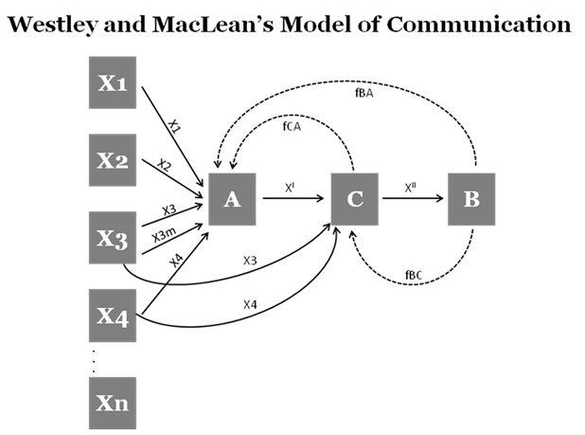
(Figure 3: Westley and MacLean’s model of communication)
(Source: Kawani, 2013)
The figure above shows the Westley and Maclean Model of communication. Based on the model communication starts when a person gets messages from the surroundings. This method accounts for feedback. For example, when Ikea launches a specific advertisement then it alone can’t be accounted as communication. The communication will start when the customers provide feedback or start responding to that advertisement. This model is effective for interpersonal as well as mass communication. The model can be great for Ikea as it provides direct communication to customers on a narrow path sending only the message which is necessary for the customers (Adair, et al., 2016). It can be observed that Ikea communicates with customers in an effective way but lacks in understanding the feedback. The company needs to work on promotions and respond better to feedback. The customers can post a review or even share a picture of their purchased products but there is very little response made by the company on reviews of their customers. This makes the process of communication poor and can impact the growth and operations of Ikea (Ikea, 2020).

New promotional strategies Ikea can use to raise awareness of the brand
Ikea has used plenty of promotional strategies for its growth and to capture the market. It can be observed that by using more methods the company can gain dominance in the market. There are many companies that are giving tough competition to Ikea. If the company uses new ideas it will be able to get better opportunities in the market to grow its brand. Social media promotions are the most effective methods of promoting the products and making sure the company reaches the customers. Due to the pandemic, many companies lost communication with their customers and so did Ikea. It was not easy for the company to exchange their ideas and thoughts with the customers in such situations (Tiwari, 2015).
Using social media is a great way to interact with customers and understand their needs. For engaging with loyal customers, the company has already developed a loyalty program but needs ideas to grow the idea. As people are recovering from the sufferings of covid-19, Ikea can develop new strategies that will develop better opportunities in the market. The company can develop better branded promotional gifts and product giveaways for its loyal customers. The company can also provide health kits to customers where they could pass on a message that they care about their health. The company can also start investing more in public relations. It can use new ideas to develop more customer touchpoints in the store and on the app (Roy, 2020).
For raising awareness Ikea can use the Integrated Marketing Communications approach. It is a method where messages are promoted by using various strategies that could work together. Ikea has already promoted its logo, tagline and packaging. It can work more on such concepts to make sure that the customers get more connected with the brand. Currently, the concept of influencer marketing is getting boosted in the market. Ikea can use influencers in describing how people use their products to completely change their house looks. This will help in increasing sales by raising the awareness of the company. As influencers and bloggers will provide a high number of video content it will help in reaching the customers sitting at home. As the covid-19 restrictions are being uplifted the company should also focus on offline campaigns.
Online methods are good but offline factors will be much more helpful in reaching the customers. The company can make public displays of what a house decorated with Ikea furniture looks like. Having multiple displays at various locations will help in boosting the company’s reputation (Abrahamian, 2013). Ikea has already developed a strong brand identity but in the current market, customers are easily influenced. To keep the customers connected it is important for the company to keep on updating its methods of promotions. When it comes to the marketing funnel, brand awareness is the initial stage. This can help in developing a better connection with the customers in the market. Ikea needs to do marketing by thinking of the long-term perspectives where they can connect with more customers. The company can start working on more online and offline competitions where if the customers share the videos of a room decorated using all Ikea furniture they will get registered for the competition (Konuk, 2017).
The customers who win the competition will get rewards and can even get a chance of getting free furniture for their kitchen or other parts of the house. This will help the company in getting customers more excited and interested in their products. As most of the customers are loyal to Ikea it will make it easier for the company to get more people for the competition. All such competitions are likely to increase the engagement of customers in the company (Garvey, 2018). This will be building a better marketing opportunity for the company to understand the thoughts of their customers. The company can also use more innovative marketing strategies where use content marketing, referral programs and other methods to connect with the customers (Ikea, 2020). This will help the company in getting engaged with the customers for the long term. Using all such methods will help the company in raising brand awareness and enhance its market presence (Kim, 2018).

Branding and brand equity
Brand equity is said to be the value that is gained by a company through its reputation when compared to the generic equivalent. There are three key basic components of brand equity such as negative or positive effects, consumer perception and resulting value. On the other hand, branding is said to be a procedure for developing a strong and positive perception of a company (Theurer, et al., 2018). Ikea has a strong brand image in the mind of customers which makes the company efficient in terms of market growth. The brand presence and the touchpoints in the stores, as well as the website, make the company effective in terms of branding. The unique products and in-store experiences are the identities of the brand. Brand equity is done by Ikea by gaining the loyalty of customers (Hunt, 2019). It is done on the basis of the price and distance at which the customers visit the stores. The customers can choose other brands if they have a higher budget or other brands offer a lower price.
In terms of Ikea the company has developed its model in such a way that customers are easily attracted to its offerings (Chang, et al., 2015). After loyalty, the second factor of brand equity at Ikea is perceived quality and leadership measures. The idea of branding has made the company adopt serious leadership measures. The company is known by customers for their flat-pack products. the company does brand with the help of increasing brand awareness. The customers can easily recognise the brand with its logo, advertising campaign, tagline and even the packaging (Jain, 2017).
For a better understanding of the concept, Keller’s Brand Equity Model can also be utilised. Based on the model for developing a strong brand it is necessary to shape it in a way that customers think about the product. The experiences developed by the brand should relate to the customers. All of this would be helping in developing a strong perception of the brand in the market (Pinar, et al., 2014).
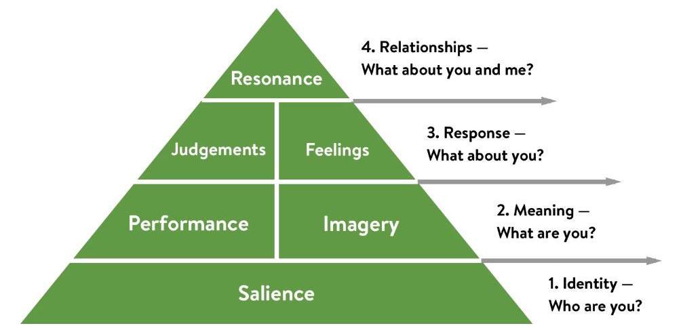
(Figure 4: Keller’s brand equity model)
(Source: Hawker, 2019)
The image above shows the brand equity model of Keller. The pyramid shows the different factors which lead to the strong brand equity of a brand. In terms of salience, the company is a furniture retailer providing the most unique and low-price furniture to the customers. The imagers for the brand are price-conscious people, families, and innovative customers. The performance of the company in the market is as per furniture leaders who offer low prices and diverse designs of products (Hawker, 2019). The feelings gained while entering an Ikea store are of socially accepted, friendly environment and welcoming layout. The judgment segment is of a good deal, durable and good customer service.
Keller’s Brand equity model has certain advantages and disadvantages. The model provides sustainable customer loyalty and even the costs of retention are lower. If the model is applied better profit margins can be gained by Ikea. The lifetime value of customers is also higher when the model is applied. Ikea can also face certain disadvantages of using the model such as needing a highly talented team for managing all the processes and also need of having high industry knowledge for operations.
Based on Resonance the brand provides rapid purchases, strong engagement, an online fan community and also loyalty in terms of price and distance. There are certain advantages as well as disadvantages of the brand equity concept (Williams and Omar, 2014). Based on the advantages brand equity helps in developing sustainable customer loyalty, lesser cost on customer retention and better profit margins. Brand equity can be seen as a great factor for the growth of a brand in a competitive market. In terms of disadvantages, it becomes harder to resonate with the customers in a market that is overloaded with data. For maintaining brand equity there is a need for a highly talented team which is a difficult task. When compared the advantages of brand equity are higher than the disadvantages. This makes sure that adopting Keller’s brand equity model is a positive scenario for brands like Ikea.

Customer journey and customer touchpoints for IKEA
The unique customer journey of IKEA is helpful for the customers to connect with the products. it is a visual tour for the people to go through the IKEA store. It can be stated that in the retail business the customers tend to purchase more products when they are connected through the touchpoints. The company has made its store and products a spectacle for the viewers. In the customer journey of IKEA, the key point is branding. At the initial stage while reaching the warehouse of IKEA the customers feel like entering a massive stadium or an airport terminal. Most of the space in the store is used as a space where the products are laid in 400 square foot compact dioramas (Metsai, et al., 2022). The five stages of the customer journey which are followed by the customers of Ikea are awareness, consideration, retention, decision and advocacy. Each stage helps in knowing better about the customers and provides a better experience for the customers. In the awareness stage, the customer gets to know about the products, in the consideration stage, the customers view all the aspects of products and substitutes to consider the right one. In the decision stage, the customers get all the information about the product and make decisions depending upon the information. At the retention stage, the factors have developed that help in bringing back the customers and at the end, advocacy stage helps in providing a great experience to the customers.
The products are displayed as a touchpoint for customers which helps in promoting the products. The company easily displays the products and shows the customers how the products will look in their homes. The key touchpoint of Ikea here is that the customers don’t just see the products but also experience how they would look at their home. In terms of the customer journey, the floorplan of Ikea is laid in such a manner that it brings the customer journey to life. All the phases of the rooms are displayed in a way that they help in engaging the customers (Ikea, 2020).
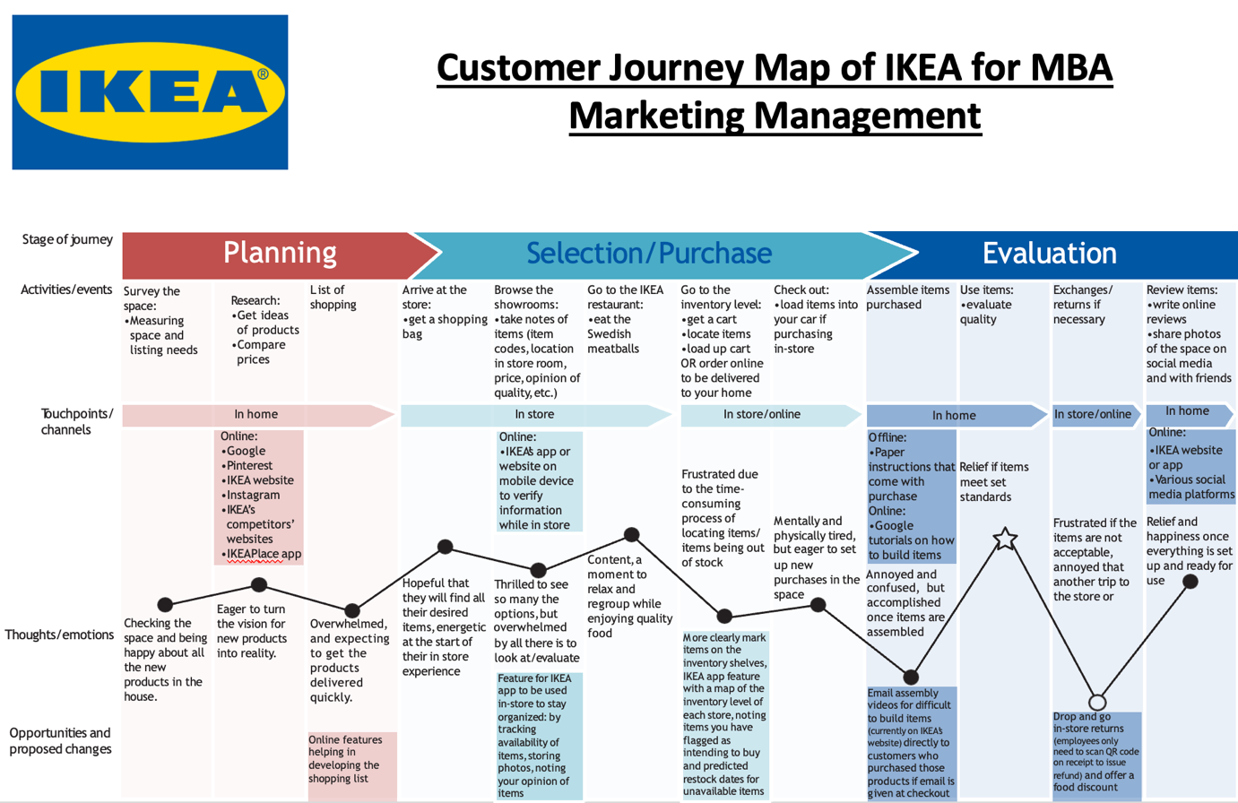
(Figure 1: Customer journey map of Ikea)
The above customer journey map has been prepared to show all the touchpoints which are experienced by a customer while purchasing certain products from IKEA. The customer journey map has been divided into three parts namely planning, selection and evaluation. In the pre-purchase stage, the touchpoints for customers are of checking space, online checking of products and developing a list of shopping. The purchase points for customers include arriving at the store, viewing the products, checking prices, comparing with other products, and viewing the store experience.
The post-purchase factors incorporate service, after-sales product performance and other factors. Based on the above diagram it can be stated that at the initial stage the customer completes a survey of the space. Here the customer identifies the needs of products and gets ideas about the products which are to be needed by him. At this stage, the customer is highly excited, and the touchpoints are his/her emotions (Moon, et al., 2016). The customer ahead is excited regarding the possibilities of the new spaces. The customers also make a list of all the products which they want to purchase. There are also certain online features that can help the customers in preparing a list of all the products.
Once the customer arrives at the store the first thing, they see is the massive parking space. The customers are energetic at this point in time, and they expect that they get their desired product at the store. After getting inside the store the customers are super excited to see all the products (Ikea, 2020). The customers can also use the Ikea app inside the store so that they can keep track of their activities and manage their purchases. Ikea store always has a reputed restaurant connected to their store (Ai, et al., 2020). The customers can spend some time at the restaurant and enjoy the dishes. This would help the customers in relaxing and concentrating more on purchasing their products. after relaxing the customers can reach the inventory level, get their cart, locate all the items they need or even order online after viewing things in the store. The process of locating all the items can be frustrating and time-consuming but most people enjoy it due to the visual tour they get of different products. At the end of the purchase, most of the customers are tired and want to rest. At this touchpoint, the thoughts of customers can be mixed depending on their product availability (Koniorczyk, 2015).
If the customers get their desired products, they are happy but if they are not able to find suitable products, they feel low. Further, the customers reach home and assemble their purchased products. after reaching home the customer opens their products and read all the instructions related to the assembly of the products. If the purchased products meet the expectations of their customers, they feel relief (Canfield and Basso, 2017). At the next step, the customers exchange their products or return them depending upon their satisfaction. If the customers are satisfied with the final products and they get all their desired items they write an online review. The customers can write a positive or negative review depending upon the product quality and even share pictures of completed products (Ikea, 2020).
The strengths of Ikea customer journey map are the wide range of products which are available to the customers, better services, multiple price ranges, sample displays and store experience. The weaknesses of Ikea customer journey map incorporate of large time needed for checkout, unavailability of home delivery and mentally and physically tiring situation after the purchase is completed.
The Total engagement model can also be considered while understanding the customer segment of Ikea. The total engagement model focuses on aligning the key elements of customer value proposition, customer experience and brand advertising. The model is effective for organisations in creating better customer engagement (Grover and Kar, 2020).
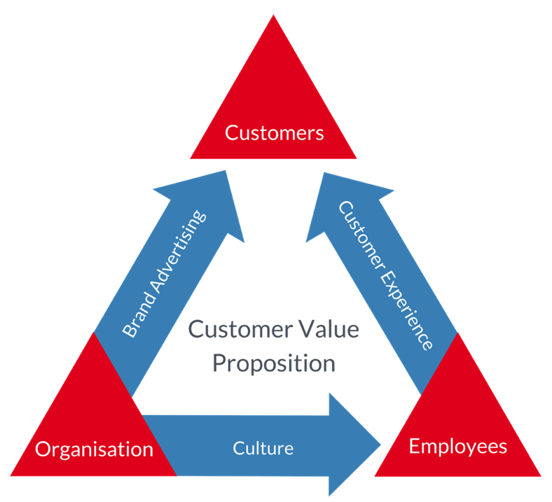
(Figure 2: Total Engagement Model)
(Source: Engaged strategy, 2022)
The total engagement model is an effective method to engage the customers of a business. The value proposition of Ikea is unique which makes it effective for the brand to attract customers. The three key factors which help in connecting with the customers are customer experience, brand advertising and culture (Batidzirai, et al., 2021). All these factors are helpful in building a brand in terms of customers, organisation, and employees. Ikea uses different channels of advertising which are useful for the company to promote its new products and policies. It can be observed that the company has developed great ideas for building customer experience. The culture of the company is also suitable for diverse factors related to the work environment. The employees, as well as customers, are happy with the culture of Ikea. All these factors make sure that all the customers are engaged totally (Graffigna, et al., 2017).
Further, the following recommendations can be followed by Ikea for improving its touchpoints. It can be recommended that Ikea can start taking feedback from customers at the end of their purchase journey regarding the issues they have faced. The company can analyse all the issues and start working on solutions. It can also work on adopting better marketing strategies for developing better online reviews. Ikea can provide free delivery to customers on longer routes depending upon their bill amount. The company can also enhance its after-sales services so that customers can easily trust the company and purchase its products.

Conclusion:
In a nutshell, it can be stated that Ikea is one of the most customer-centric companies in the world. The company has been able to connect with diverse segments of customers through its unique touchpoints. At each stage, the customers can connect with the company and its products. When it comes to long term growth it is necessary for the company to build a much better portfolio so that it can stand in front of the competition. Currently, the company has various touchpoints which can be observed with the help of a customer journey map. The customers can easily connect with the products of the company with its unique experience which starts right from the parking area.
The sample setups done by the company in their store and the massive store size have helped the company in gaining huge recognition among the customers. The total engagement model shows that the company has been able to engage with the customers through customer experience brand advertisements and culture. Al the factors show that the company is great in terms of operations and can easily connect with the customers. For better communication, the company can use Westley and Maclean Model of communication. In the end, a few recommendations have been provided such as promotional campaigns, social media, content marketing and others that can be used by Ikea for attracting customers.

References:
Abrahamian, K., 2013. Global Marketing through Local Cultural Strategies: A Case Study of IKEA.
Adair, W.L., Buchan, N.R., Chen, X.P. and Liu, D., 2016. A model of communication context and measure of context dependence. Academy of Management Discoveries, 2(2), pp.198-217.
Ai, X., Jiang, Z., Hu, K., Chandrasekaran, S. and Wang, Y., 2020. Integrating a Cross-Reference List and Customer Journey Map to Improve Industrial Design Teaching and Learning in “Project-Oriented Design Based Learning”. Sustainability, 12(11), p.4672.
Batidzirai, B., Trotter, P.A., Brophy, A., Stritzke, S., Moyo, A., Twesigye, P., Puranasamriddhi, A. and Madhlopa, A., 2021. Towards people-private-public partnerships: An integrated community engagement model for capturing energy access needs. Energy Research & Social Science, 74, p.101975.
Canfield, D.D.S. and Basso, K., 2017. Integrating satisfaction and cultural background in the customer journey: A method development and test. Journal of International Consumer Marketing, 29(2), pp.104-117.
Chang, A., Chiang, H.H. and Han, T.S., 2015. Investigating the dual-route effects of corporate branding on brand equity. Asia Pacific Management Review, 20(3), pp.120-129.
Elf, P., Isham, A. and Gatersleben, B., 2021. Above and beyond? How businesses can drive sustainable development by promoting lasting pro‐environmental behaviour change: An examination of the IKEA Live Lagom project. Business Strategy and the Environment, 30(2), pp.1037-1050.
Engaged strategy., 2022. Total engagement model round. [Online]. Available at: https://www.engagedstrategy.com.au/home/total-engagement-model-round/. [Accessed on: 15/04/22].
Garvey, P., 2018. Consuming IKEA and Inspiration as Material Form. Design Anthropology: Object Cultures in Transition, p.101.
Graffigna, G., Barello, S. and Bonanomi, A., 2017. The role of patient health engagement model (PHE-model) in affecting patient activation and medication adherence: a structural equation model. PloS one, 12(6), p.e0179865.
Grover, P. and Kar, A.K., 2020. User engagement for mobile payment service providers–introducing the social media engagement model. Journal of Retailing and Consumer Services, 53, p.101718.
Hawker, K., 2019. Keller’s Brand Equity Model — What It Is & How to Use It. [Online]. Available at: https://medium.com/@keatonhawker/kellers-brand-equity-model-what-it-is-how-to-use-it-84e42d562299. [Accessed on: 15/04/22].
Hunt, S.D., 2019. The ethics of branding, customer-brand relationships, brand-equity strategy, and branding as a societal institution. Journal of Business Research, 95, pp.408-416.
Ikea., 2020. Annual summary and sustainability report FY20. [Online]. Available at: https://www.ingka.com/wp-content/uploads/2021/01/Ingka-Group-Annual-Summary-Sustainability-Report-FY20.pdf. [Accessed on: 15/04/22].
Jain, R., 2017. Basic branding concepts: brand identity, brand image and brand equity. International Journal of Sales & Marketing Management Research and Development (IJSMMRD) Vol, 7, pp.1-8.
Kawani, M., 2013. Westley and MacLean’s model of communication. Communication theory. [Online]. Available at: https://www.communicationtheory.org/westley-and-macleans-model-of-communication/. [Accessed on: 15/04/22].
Kim, B.G., 2018. An exploratory analysis on strategic changes of furniture retailer: Focusing on IKEA and Hanssem in Korea. Journal of Distribution Science, 16(12), pp.33-45.
Koniorczyk, G., 2015. Customer knowledge in (co) creation of product. A case study of IKEA. Journal of Economics & Management, (22), pp.107-120.
Konuk, F.A., 2017. Competitive Strategies in Retailing in Emerging Economies: Evidence from Turkey. In Promotional Strategies and New Service Opportunities in Emerging Economies (pp. 66-89). IGI Global.
Metsai, A.I., Tabakis, I.M., Karamitsios, K., Kotrotsios, K., Chatzimisios, P., Stalidis, G. and Goulianas, K., 2022. Customer Journey: Applications of AI and Machine Learning in E-Commerce. In Interactive Mobile Communication, Technologies and Learning (pp. 123-132). Springer, Cham.
Moon, H., Han, S.H., Chun, J. and Hong, S.W., 2016. A design process for a customer journey map: a case study on mobile services. Human Factors and Ergonomics in Manufacturing & Service Industries, 26(4), pp.501-514.
Pinar, M., Trapp, P., Girard, T. and Boyt, T.E., 2014. University brand equity: an empirical investigation of its dimensions. International Journal of Educational Management.
Roy, D., 2020. Impact of Consumer Market Preferences on Expansion Strategies: Strategies Used by IKEA in the International Market.
Theurer, C.P., Tumasjan, A., Welpe, I.M. and Lievens, F., 2018. Employer branding: a brand equity‐based literature review and research agenda. International Journal of Management Reviews, 20(1), pp.155-179.
Tiwari, S., 2015. Standardized marketing strategies: a solution to the global competition? A case study of IKEA in Norway, Sweden, France and China (Master's thesis, Universitetet i Nordland).
Tóth, B., Sachidanandan, S. and Jørgensen, E.S., 2020, September. Balancing Relevance and Discovery to Inspire Customers in the IKEA App. In Fourteenth ACM Conference on Recommender Systems (pp. 563-563).
Williams Jr, R.L. and Omar, M., 2014. How branding process activities impact brand equity within Higher Education Institutions. Journal of Marketing for Higher Education, 24(1), pp.1-10.

