

Managing Enterprise in the 21st Century

Tejas Pankajkumar Mehta (2437947)

Business Plan

MOBIFIX LTD

Submission Date:30/03/2026
Lecturer: Dr Tola Odugbesan

Table of Contents
Executive Summary 4
Business Concept 4
Business Description 5
Product Description 5
Business Objectives (SMART Objectives) 5
Short-Term Objectives (less than a year) 5
Long-Term Objectives (More than a year) 5
Market Analysis and Marketing Plan 6
Market Analysis (Competitors, Customers, Target Groups) 6
Competitors 6
Customers 6
Target Groups 7
PESTEL Analysis 7
Political 7
Economic 8
Social 8
Technological 8
Environmental 8
Legal 8
SWOT Analysis 8
Strengths 8
Weaknesses 9
Opportunities 9
Threats 9
Marketing Mix (4Ps) 9
Management Team 10
Management Team and Their Background 10
Organisational Chart 11
Key Milestones 11
Financial Plan (One Year) 12
Sources of Finance 13
Cash Flow Forecast 14
Sales Forecast 14
Cost of Production Forecast 15
Break Even Analysis 15
Operations and Management Plan 16
Production of Good and Service 16
Technology Plan 17
Human Resource Plan 17
Expansion Plan 17
Reference List 18

Executive Summary
MobiFix Limited is a start-up mobile phone repair business based in London, United Kingdom, offering fast, affordable, and reliable repair services for smartphones and small electronic devices. The increasing dependence on mobile phones for communication, work, and entertainment has led to a growing demand for efficient repair services, as consumers seek cost-effective alternatives to replacing expensive devices.
The business will operate as a Private Limited Company (Ltd), which limits the owner’s personal liability and supports future growth and investment (Companies House, 2023). MobiFix will specialise in common smartphone repairs, including screen replacement, battery replacement, charging port repairs, and software troubleshooting.
Market analysis indicates strong demand driven by rising smartphone usage and high replacement costs. The business will differentiate itself through same-day service, competitive pricing, and high-quality parts.
The start-up requires approximately £23,000 in funding, sourced from personal savings and a bank loan. Financial projections show that the business will reach break-even within four months and achieve profitability thereafter.

Business Concept
MobiFix Limited is a service-based business focused on providing convenient and high-quality repair solutions for mobile devices. A business concept defines how value is created and delivered to customers (Burns, 2018). MobiFix aims to reduce the cost burden on customers by offering repairs instead of device replacement.
.

Business Description
The business will operate from a high footfall location near a university or shopping centre, targeting students and working professionals. Its legal structure as a Private Limited Company enhances credibility and allows for future expansion.

Product Description
MobiFix will provide the following services and products:
Services:
- Smartphone screen replacement
- Battery replacement
- Charging port repair
- Water damage repair
- Phone cases
- Screen protectors
- Charging cables
- Phone chargers

Business Objectives (SMART Objectives)

Short-Term Objectives (less than a year)
- Successfully launch the MobiFix repair shop within the first 3 months.
- Achieve Break-even within Four Months
- Acquire at Least 300 Customers within Six Months.

Long-Term Objectives (More than a year)
- Expand into tablet and laptop repairs within two years
- Open a second branch within 3–5 years
- Develop online booking and delivery services

Market Analysis and Marketing Plan
Market analysis involves examining customers, competitors, and market trends to identify opportunities (Kotler and keller ,2016).

Market Analysis (Competitors, Customers, Target Groups)

Competitors
- Manufacturer-authorised repair centres (Apple, Samsung, etc.)
- Independent phone repair shops
However, MobiFix will differentiate itself by offering faster service, competitive prices, and personalised customer support.
Customers
The main customers include:
- Students
- Young professionals
- Local residents
- Small business owners

Target Group
The primary target market is 16 – 65+ old smartphone users who need quick and affordable phone repair services.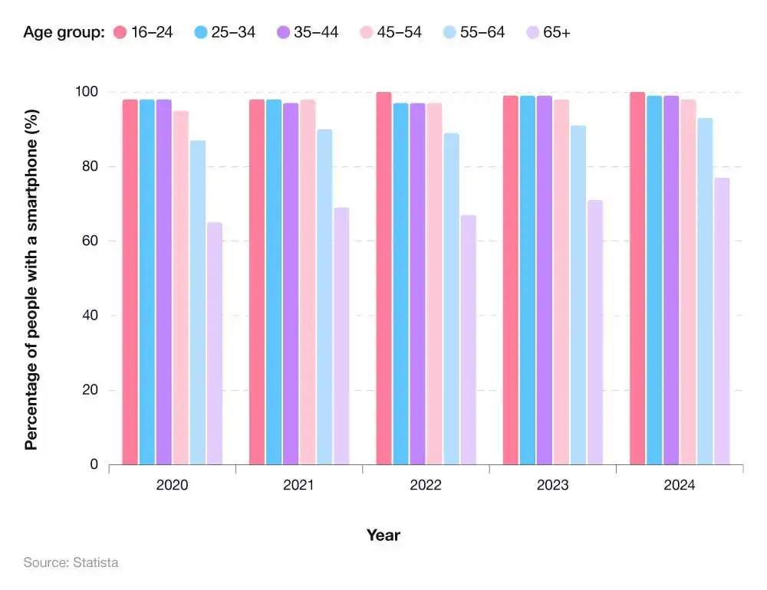
(Statista, 2024)

PESTEL Analysis

A PESTEL analysis is a tool used to analyse the external macro-environmental factors affecting a business (Johnson et al., 2017). A PESTEL analysis is necessary because it helps a business like MobiFix understand the external environment that can influence its success.

Political
Government support for grants, business training for small businesses and entrepreneurship encourages new businesses.

Economic
Smartphones are becoming expensive because of influence due to which so many consumers prefer repairing their devices rather than buying new ones.

Social
Mobile phones are essential for communication, social media, work, and entertainment, increasing the demand for repair services.

Technological
Continuous innovation in smartphone technology creates a steady demand for skilled repair services.

Environmental
Repairs reduce electronic waste

Legal
Compliance with consumer rights laws, warranties, data protection regulations, and health & safety standards is critical to avoid legal issue.

SWOT Analysis
SWOT analysis is employed to evaluate internal strengths and weaknesses alongside external opportunities and threats (Gürel and Tat, 2017).
The use of SWOT analysis in this plan provides insight into how MobiFix can leverage its strengths while addressing potential challenges.

Strengths
- Skilled technicians expertise
- Affordable repair services
- Convenient location
- Fast same-day service

Weaknesses
- New business with limited brand awareness
- Dependence on spare part suppliers

Opportunities
- Growing smartphone usage
- Increasing demand for repair services
- Opportunity to expand to other electronic devices

Threats
- Rapid technological changes
- Price competition

Marketing Mix (4Ps)
The marketing mix, commonly referred to as the 4Ps (Product, Price, Place, and Promotion), is a strategic framework used by businesses to develop effective marketing strategies and satisfy customer needs (Kotler and Keller, 2016).

Marketing Mix

Product
- Core Product: Mobile phone repair services like screen replacements, battery fixes, water damage repair, and software updates.
- Augmented Product: Quick service (same-day or express), doorstep repairs, a user-friendly app for booking, warranty on repairs, and high-quality parts.

Price
- Competitive Pricing: Affordable pricing matching or undercutting competitors.
- Bundling: Offer combo deals (e.g., screen + battery repair).

Place
- Physical Locations:

Promotion
- Advertising: Digital ads on Google, Facebook, and Instagram, plus local promotions through flyers and ads.
- Public Relations: community involvement.

Management Team
MobiFix will operate with a small team consisting of an Owner/Manager, Repair Technician, and Customer Assistant.

Management Team and Their Background

Owner/ Manager : The Owner/Manager will lead the business and be responsible for strategic planning, financial management, and overall operations

Technician: The Repair Technician will be responsible for diagnosing and repairing mobile devices. The technician is expected to have relevant training or certification in mobile phone repair, as well as the ability to keep up to date with technological advancements.
Sales Assistant: The Customer Service Assistant will manage customer interactions and support day-to-day operations. This role requires strong communication and interpersonal skills, as well as the ability to handle customer enquiries and resolve issues effectively. Responsibilities include managing bookings, processing payments, promoting accessories, and maintaining customer relationships.

Organisational Chart
Owner
Tejas Mehta

Manager
Tejas Mehta

Sales Assistant
Smit Shah
Technician
Jatin Patel

Key Milestones

Milestone
Business Registration and Funding
Location and Setup
Recruitment and Training
Business Launch
Customer Acquisition
Performance Evaluation

Financial Plan (One Year)

Milestone Stage | Financial Impact
Business Registration | Legal fees and initial setup costs
Shop Setup | Equipment, rent, and inventory expenses
Recruitment | Staff wages
Launch | Marketing and operational expenses
Growth Phase | Increasing revenue and ongoing costs

The financial plan outlines the expected financial performance of MobiFix Limited over its first year of operation.

Startup Costs
Expense | Cost
Business registration | £500
Equipment and tools | £4,000
Initial inventory | £5,000
Shop rent (deposit + first month) | £3,000
Marketing and promotion | £1500
Miscellaneous | £1,000

Startup cost: £15000

Fixed Cost | Per Month
Rent | £1500
Employee salary | £6000
Accountant | £100
Insurance | £50
POS | £150
Marketing | £250
Total Cost | £8050

Variable cost | Jan | Feb | March | Apr | May | June
Utility | £400 | £450 | £500 | £600 | £600 | £650
Material | £2000 | £2200 | £3000 | £4000 | £4500 | £4750
Transaction charge | £30 | £45 | £50 | £55 | £60 | £70
TOTAL | £2430 | £2695 | £3850 | £4655 | £5155 | £5470

Sources of Finance

Source | Amount | Purpose
Personal Savings | £8,000 | Initial setup and registration
Bank Loan | £15,000 | Equipment, rent, and inventory

Total Funding: £23,000

Cash Flow Forecast

Month | Fixed | Variable | TotalCost | Revenue | Profit/loss
Jan | £8,050 | £2,430 | £10,480 | £7000 | £-3480
Feb | £8,050 | £2,695 | £10,745 | £8250 | £-2495
March | £8,050 | £3,850 | £11,900 | £10800 | £-1100
Apr | £8,050 | £4,655 | £12,705 | £13000 | £295
May | £8,050 | £5,155 | £13,205 | £14050 | £845
June | £8,050 | £5,470 | £13,520 | £15500 | £1980

Sales Forecast

Month | Estimated Repairs (Units) | Average Price | Total Revenue
Jan | 175 | £40 | £7,000
Feb | 206 | £40 | £8,250
March | 270 | £40 | £10,800
Apr | 325 | £40 | £13,000
May | 351 | £40 | £14,050
June | 388 | £40 | £15,500

Sales are expected to grow gradually as customer awareness increases during the growth phase.

Now combine:
- Startup Cost = £15,000
- Operating Loss (until break-even) = £7,075
Funding Required £23000

Cost of Per unit Forecast
Month | Total Variable Cost | Repairs (Units) | Cost per Unit
Jan | £2,430 | 175 | £13.89
Feb | £2,695 | 206 | £13.08
March | £3,850 | 270 | £14.26
Apr | £4,655 | 325 | £14.32
May | £5,155 | 351 | £14.69
June | £5,470 | 388 | £14.10

Spare parts represent the largest cost due to the nature of repair services.

Break Even Analysis

Break-even point (units) = Fixed Costs ÷ Contribution per Unit
Where:
Contribution per unit = Selling price – Variable cost per unit

Calculation
- Selling price per repair = £40
- Average variable cost per repair = £14
- Contribution per unit = £40 – £14 = £26
- Fixed costs per month = £8,050

Break-even (units):
= 8,050 ÷ 26
= 310 repairs (approximately)

Break-Even (Revenue)
Break-even revenue = 310 × £40
= £12,400

Units (Repairs) | Revenue | Total Cost | Profit/Loss
250 | £10,000 | £11,550 | £-1,550
300 | £12,000 | £12,250 | £-250
310 | £12,400 | £12,400 | 0 (Break-even)
350 | £14,000 | £13,950 | £50
388 | £15,500 | £13,520 | £1,980

Operations and Management Plan

For a service-based business such as MobiFix, operational efficiency and customer satisfaction are critical success factors.

Production of Good and Service

Customer arrives with device
↓
Device diagnosis by technician
↓
Repair cost and time estimation
↓
Customer approval
↓
Repair process
↓
Quality check
↓
Device returned to customer

Technology Plan

- Professional repair tools (e.g. screen separators, soldering tools)
- Diagnostic software for identifying device issues
- Point of Sale (POS) system for transactions
- Inventory management system to track spare parts
- Online booking system (future development)

Human Resource Plan

Role |  | Key Responsibilities
Owner/Manager |  | Strategy, finance, operations
Repair Technician |  | Device repairs and diagnostics
Customer Assistant |  | Customer service and sales

Expansion Plan

Short-Term
- Introduce repair services for tablets and laptops
- Expand product range (accessories)
- Develop online booking system

Long-Term Expansion
- Open additional branches in nearby cities
- Introduce collection and delivery services
- Build a strong brand presence

Reference List

- Barrow, Barrow, P., & Brown, R. (2012). The business plan workbook (7th ed.). Kogan Page.
- Barringer, B.R. and Ireland, R.D., 2019. Entrepreneurship: Successfully Launching New Ventures. 6th ed. Global Edition. Harlow: Pearson.

- Baker, N. (2025) UK mobile phone statistics. Available at: https://www.uswitch.com/mobiles/studies/mobile-statistics/ (Accessed: 30 March 2026).

- Burns, P. (2011) Entrepreneurship and Small Business Start Up, Growth and Maturity, London, Palgrave Macmillan

- Kotler, P. and Keller, K.L. (2016) Marketing Management. Marketing Management 15th edn. Harlow/Boston: Pearson

- Mariotti, S., & Glackin, C., (2017). Entrepreneurship: Starting and Operating A Small Business, 4th Edition, Pearson.

