Simulation of Real World Scenarios
Alec Davies
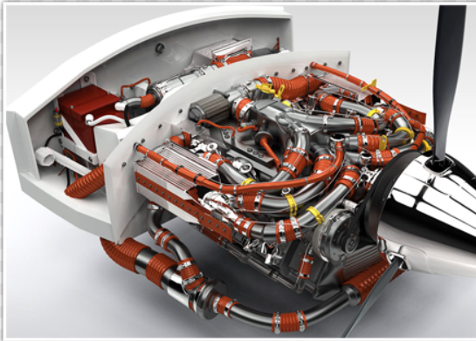

Table of Contents

Task 1 – pages 3-11

Task 2 – pages 12-19

Task 3 – pages 20-27

Task 4 – pages 28-30

Task 1
Basketball Hoop

“Visualise Michael Jordan scoring a Slam dunk during a game of basketball. You are to simulate the forces that would be applied to the Basketball Hoop during the action of his resultant scoring motion and analyse the deformation characteristics, bracket strength and modify the predefined model to improve its performance characteristics. Technical data: Hoop material – Steel; Michael Jordan weighs 98kg.”

This first task requires me to simulate the forces on a basketball hoop during a thorough dunking from a 98kg person. The basketball hoop is comprised of steel and should be able to withstand high forces acting down on it. The basketball hoop will undergo not only the force of the player, but his weight hanging on the hoop for a small period of time. Therefor it will have to be strong enough to endure at least 3 times his weight to pass this simulation.
After opening the hoop on the CAD package ‘Solidworks 2017’ and inserting the material data (Steel) the software has calculated several notable information points, such as mass, volume, density, weight and more. This data is found in a table below;
Object | Mass (kg) | Volume (mꜛ3) | Density (kg/mꜛ3) | Weight (N) | Yield strength (N/Mꜛ) | Tensile strength (N/Mꜛ)
Basketball Hoop | 4.3 | 0.0006 | 7700 | 42 | / | /

Through using Solidworks Simulation Xpress, I was able to choose fixtures, direction of force and force quantity and then place these onto the hoop to simulate a 98kg force (998N) downwards. The results obtained are below.

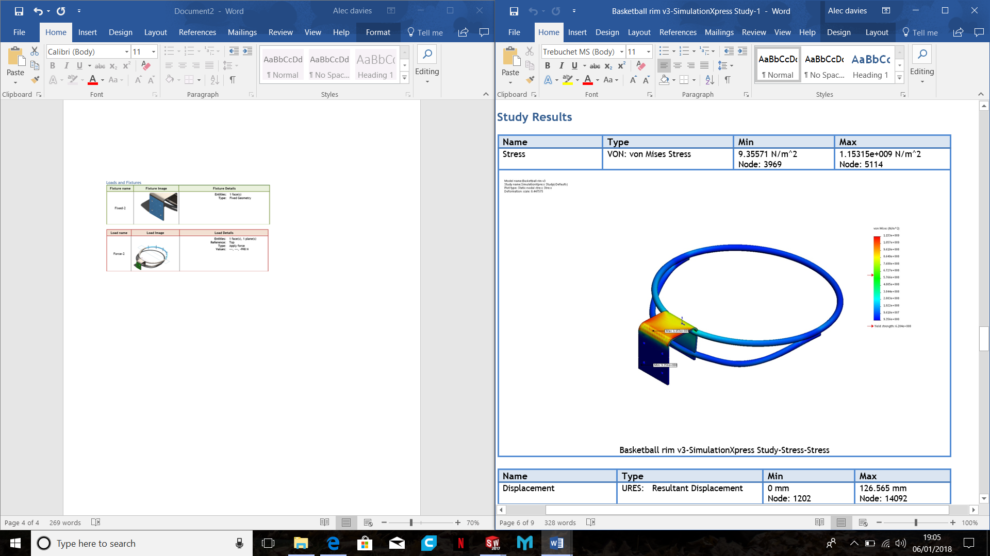
This simulation displays a ‘Von Mises Stress’ simulation. This method of testing product strength is widely used by designers whether it will withstand a given load condition. Using this information, we can see if this design will fail, if the maximum value of Von Mises stress induced in the material is more than strength of the material.
Force
fixture
In this case, the maximum value of Von Mises Stress is greater than the yield strength of the hoop, therefor it fails under 998N of force.

Below is an image of displacement in mm that shows deformation of the hoop whilst baring the load.
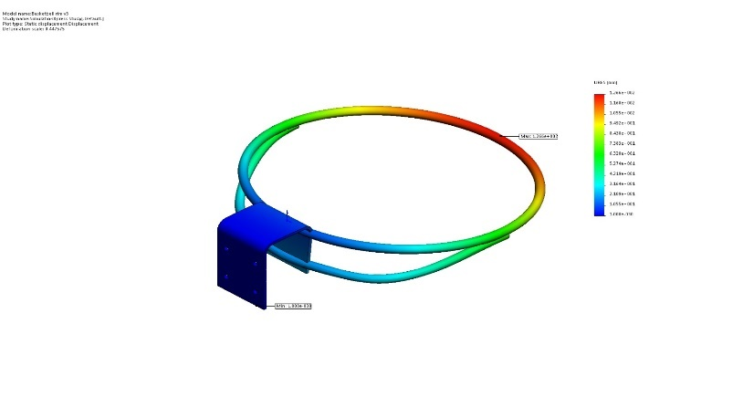

Under the next simulation, I decided to modify the basketball hoop to hopefully increase it’s strength so it would be able to withstand the forces of micheal Jordan.

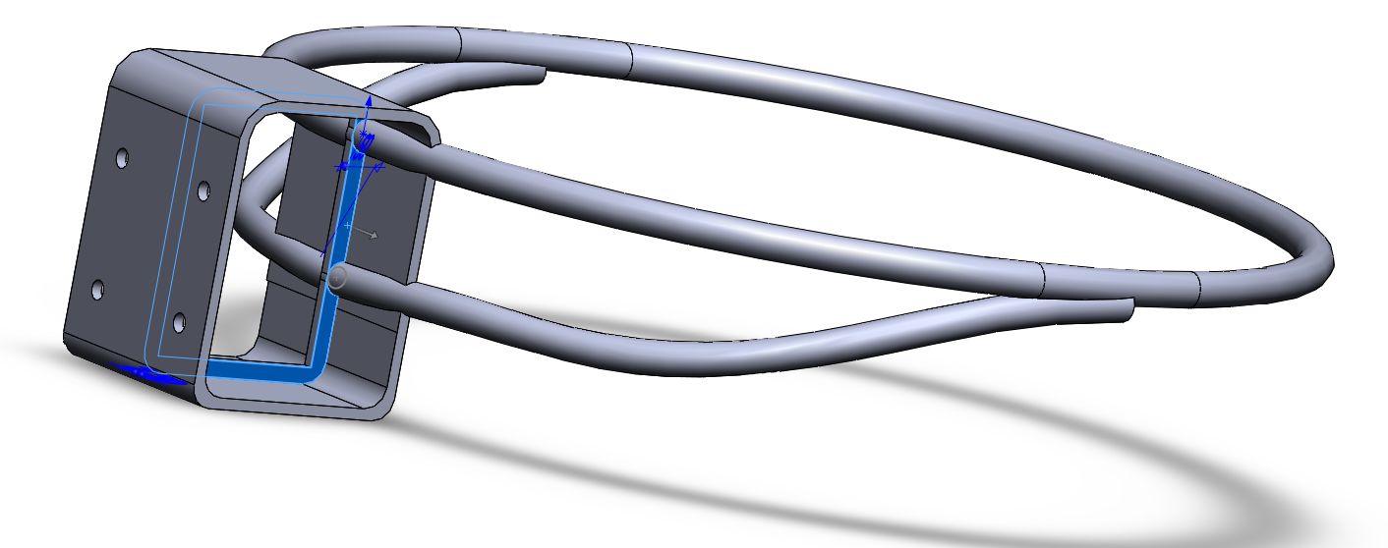

This new design adds a bridge between to two sides of the fixtures and a strengthening rib along the inside, spreading out the load throughout the fixture. This design will also reduce flexing in the hoop as it provides support from underneath.

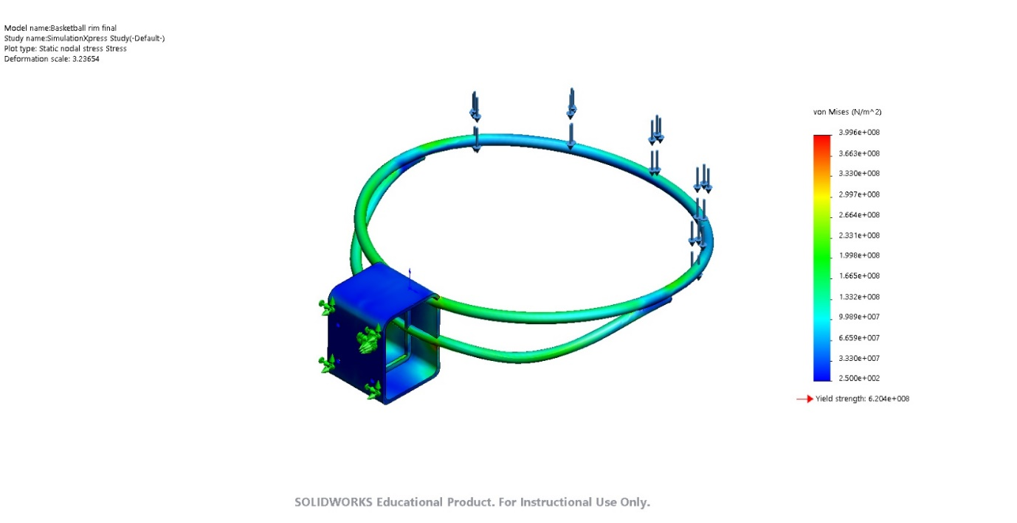
In the next simulation all factors will be the same except the load on the hoop is increased to 2500N, to simulate Michael Jordan hanging from the hoop.
With this new design upgrade, the basketball hoop has been vastly strengthened. It can now withstand up to 2500N on the outer rim, allowing Michael Jordan to successfully perform a ‘slam dunk’.
With the maximum Von Misses Stress being 3.9x10ꜛ8N/mꜛ2, the basketball hoop just excedes it’s strength with 6.24 x10ꜛ8 psi.
The outcome of this study has shown that re-analysing and designing parts can create a stronger product. FINISH

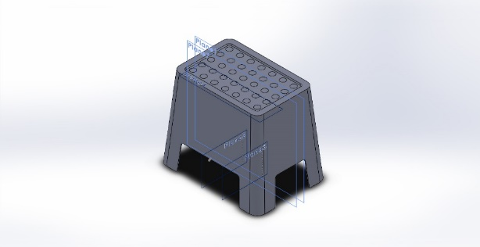
Task 1 – Bolmen Stool

‘Analyse the Bolmen stool (material Polypropylene) from IKEA with a loading of 100kg. You are to optimise the performance characteristics by adding strengthening ribs to stool to ensure a Safety Factor of 3 is achieved.’
This last segment of the task requires optimisation of a plastic stool with a 100kg load to achieve a safety factor of 3. “Factor of Safety” is a term that describes how much stronger a system usually needs to be for an intended load. Below is data for the stool, which is made from Polypropylene.

Object | Mass (kg) | Volume (mꜛ3) | Density (kg/mꜛ3) | Weight (N) | Yield strength (N/Mꜛ) | Tensile strength (N/Mꜛ)
Bolman stool | 1.17 | 0.00126 | 933 | 11 | 3.2e+007 N/m^2 | /3.3e+007 N/m^2

Before analysing and adding ribs to ensure a safety factor of 3, we must first study how to stool performs under a weight of 100kg (980N).
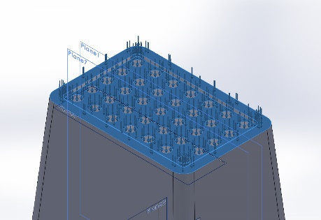
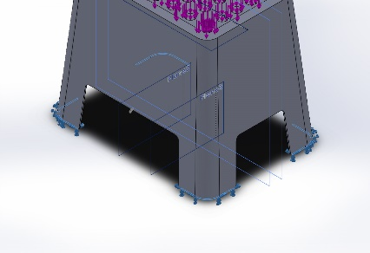The 980N of force are evenly distributed onto the flat surface area of the top of the stool, and the 4 fixtures are between the stool legs and the ground. The surface area between the stool legs and the ground is relatively small, so I expect some flexing in the plastic body as force is applied.
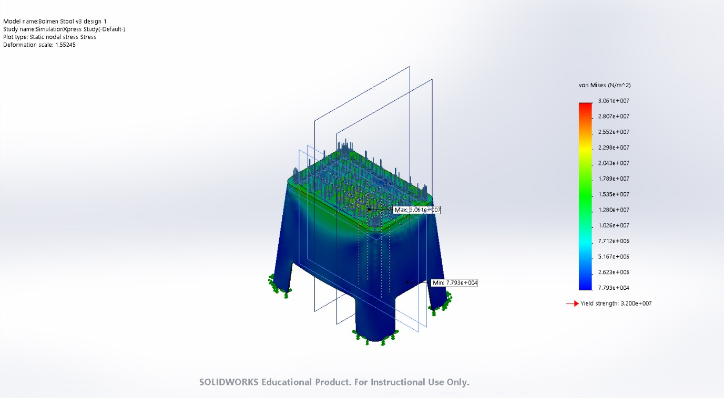
After conducting the simulation, the results show that the Polypropylene stool is strong enough to withstand 100kg’s of force, as the yield strength of the stool is 3.2e+007N/mꜛ2 which is higher than the max Von Mises Stress of 3.06e+007N/mꜛ2.
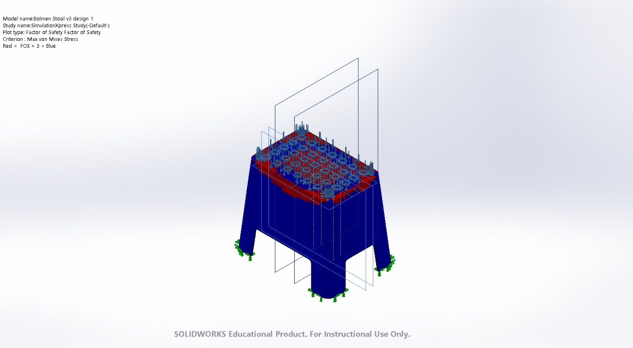

As you can see by this image, the stool has failed the FOS test, achieving just a factor rating of 1. This design will need updating to achieve a FOS rating of 3 or more.

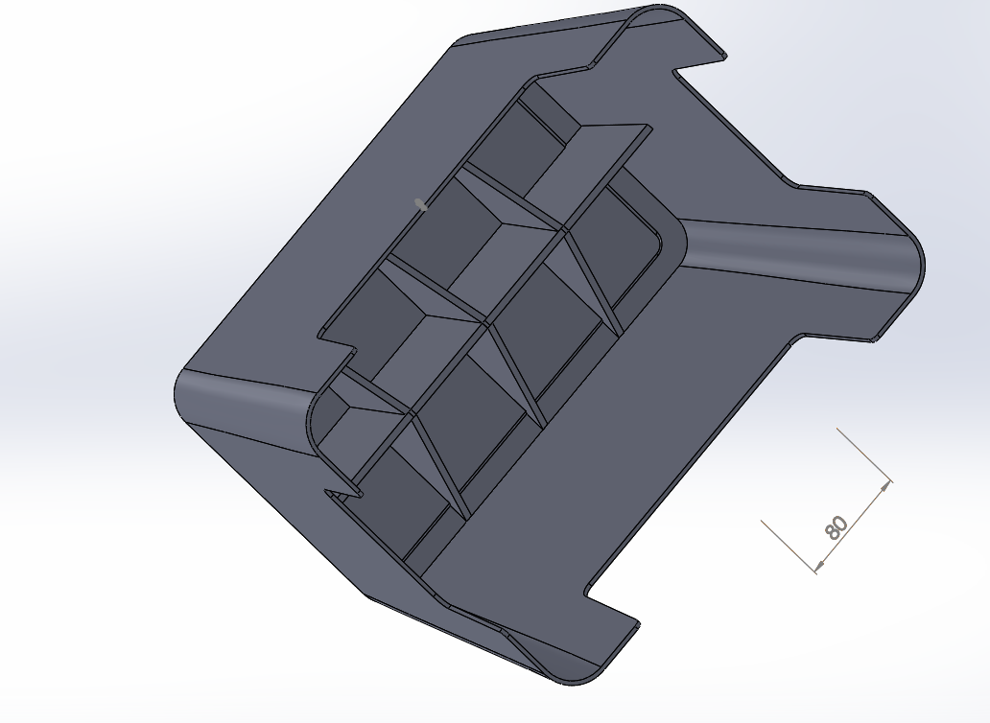

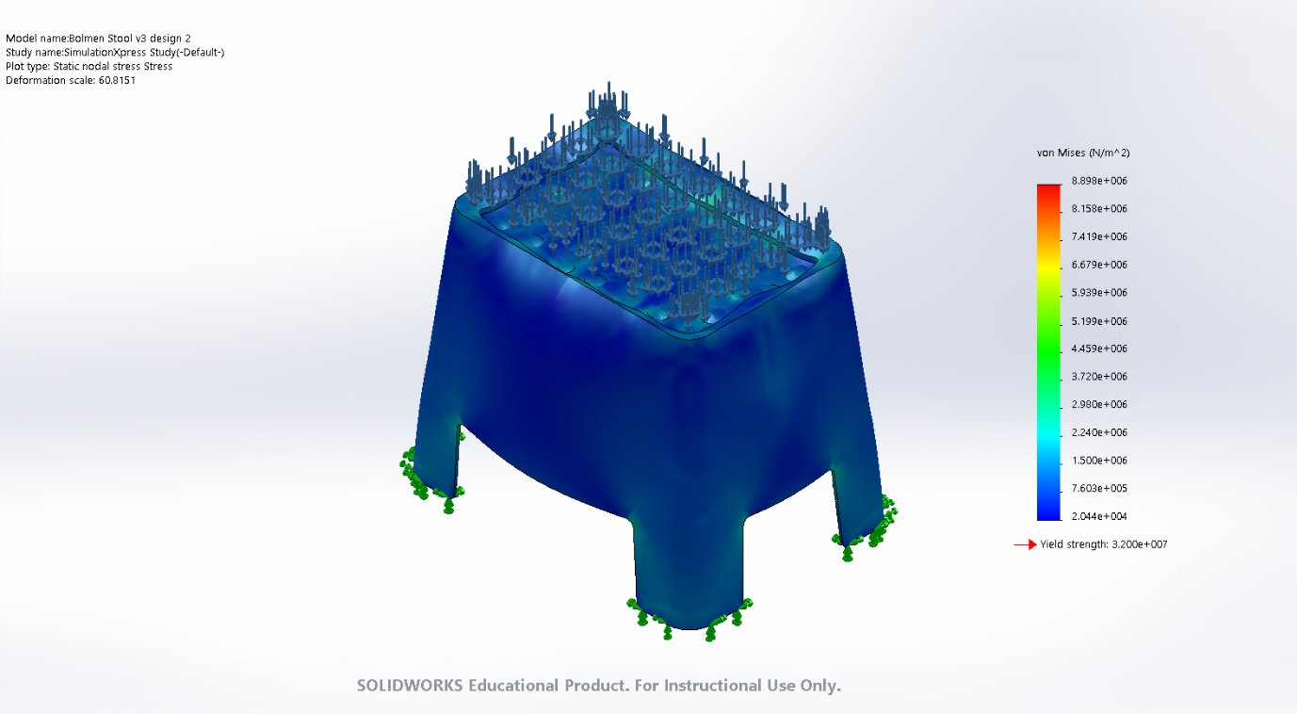
To achieve a FOS rating of 3, I have added strengthening ribs to the underside of the stool. These ribs will add strength to the stool, increasing its strength and hopefully increasing it’s FOS rating in the next simulation.

After completing the simulation, the stool passed the Von Misses Stress simulation well, with the yield strength of the stool (3.2 e+007N/mꜛ2) exceeding the Von Misses Stress of 8.9 e+006N/mꜛ2. This data shows that the stool is more than capable of withstanding the 100kg load, although there is distortion and flexing around the rim of the stool.

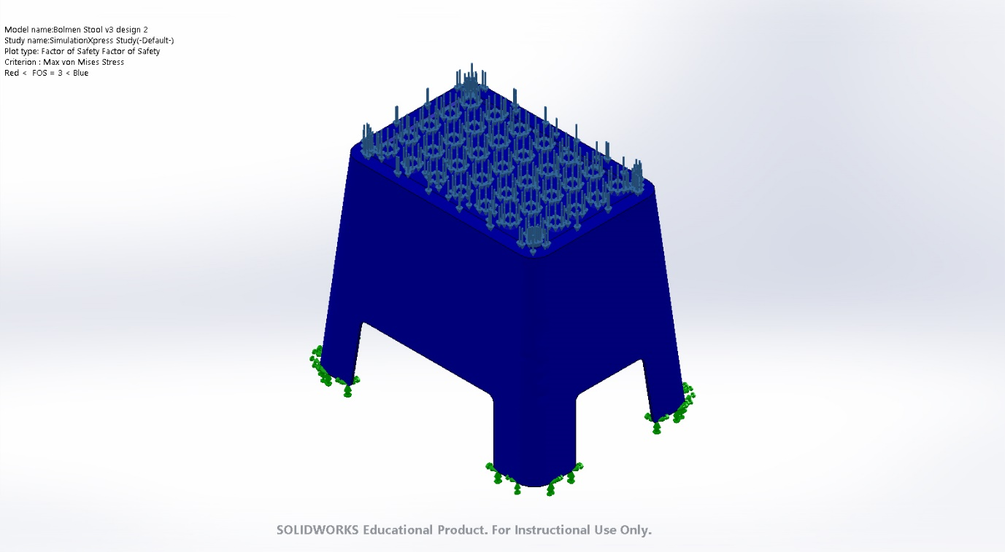
This new stool design also achieves an FOS rating of 3, as the image above shows. In fact, it reached a total FOS rating of 3.6, which shows the design hasn’t been over-engineered as it has been designed to reach the FOS rating of 3.

Task 2 – Car Flow Analysis
“You are to simulate each of the predefined vehicles travelling at 30mph and 100mph, analysing the velocity and flow trajectories for each vehicle with regard to their design characteristics. FlowXpress may be used for this investigation.”
This second task requires that a velocity and flow simulation to be conducted on 2 vehicles, a sports car and an F1 car, at 30mph and 100mph. This task will compare the designs of the two cars, studying them both under the same conditions to see which has better aerodynamics.
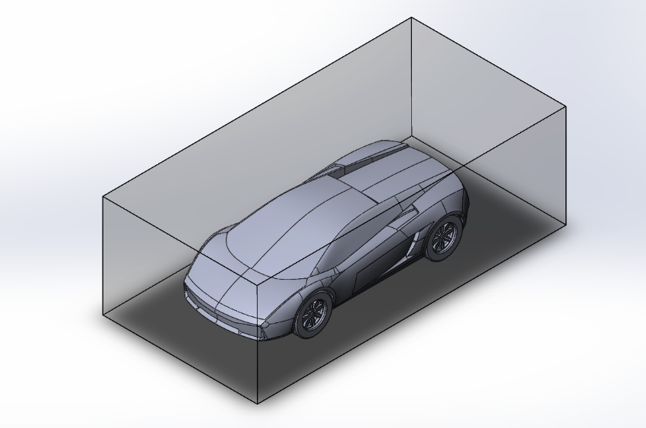
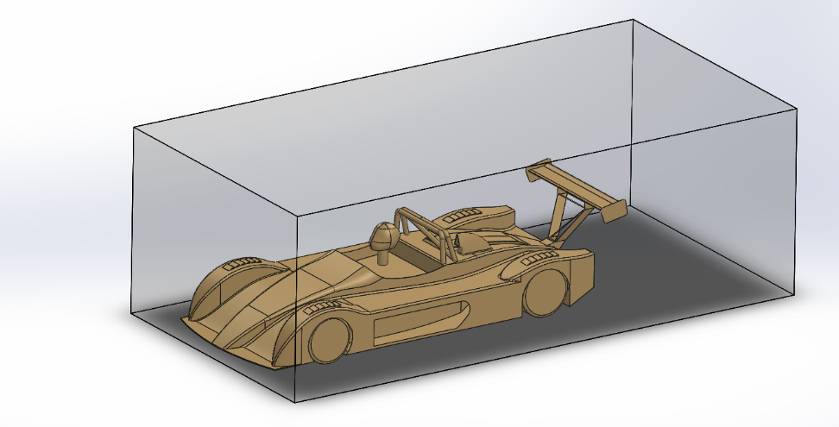

Each car has been placed inside a box, to limit the airflow to around the vehicles. On the FloXpress, volume flow rate was set to 80.6 m^3/s and temperature was set to 293.20 k. The environmental pressure of inside the box was 101325.00 Pa.
As the airflow surrounds the car, air resistance will form as the air becomes turbulent. At higher speeds air resistance should increase. Drag will also be higher as the speed rises, but instead of increasing linearly with speed, it squares to the speed.
As the car accelerates, negative air pressure will form behind the car, creating drag.

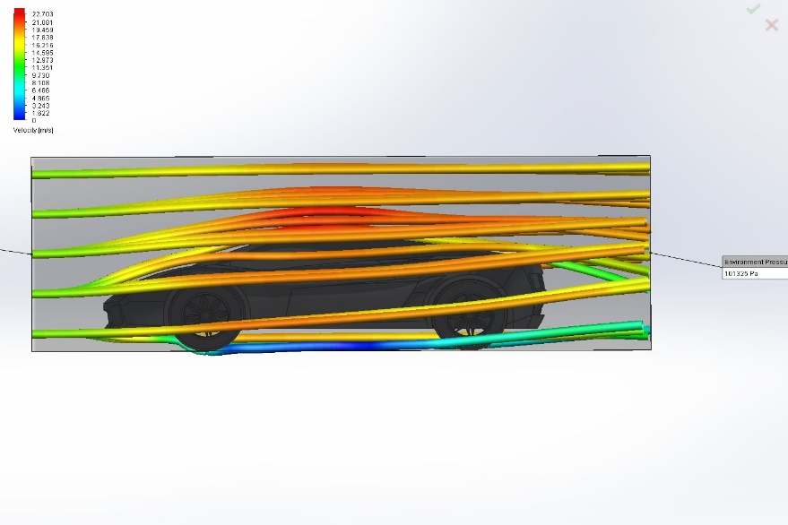
At 30mph: Inlet
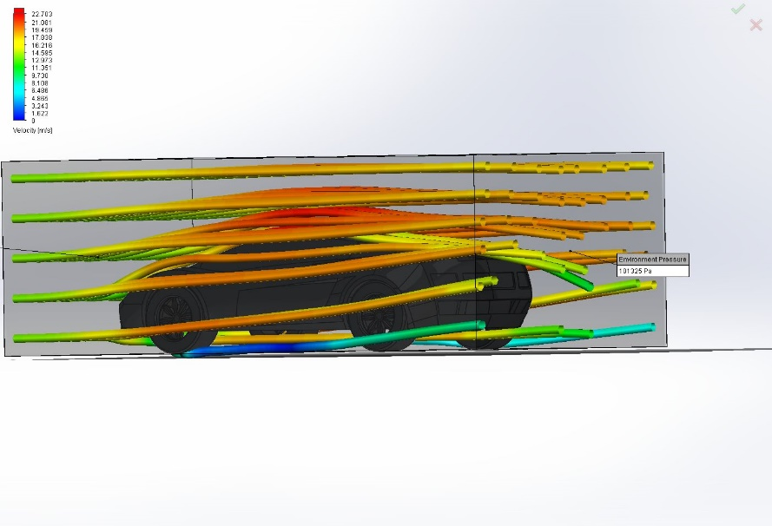

At 30 mph, the car experiences air velocities of up to 22.7m/s, and the flow trajectory flows smoothly around the vehicle. As the air passes onto the wheels, the resultant velocity behind them decreases and increase linearly. Directly behind the car there is no air flow as the airflow follows the shape of the car and does not affect the back.

At 30mph : Outlet
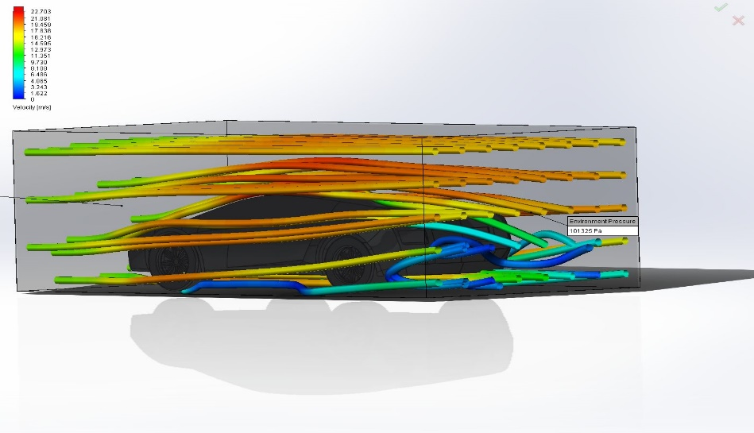

As low pressure forms behind the car, the velocity of the inlet airflow remains the same at 22.7m/s, but as the air reaches the back of the car it flows downwards and decelerates as it reaches the low pressure area. The outlet air flow remains slow in velocity, not exceeding over 4m/s, as the rear of the car deflects this as it flows back with the main air stream.

At 100mph :Inlet
At 100mph the volume flow rate has to increase to 267 m^3/s but the temperature remains the same at 293k.
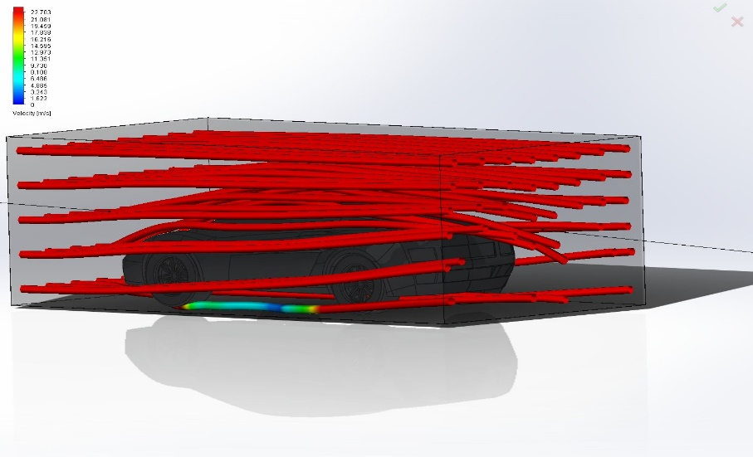
At 100mph, the airflow flowing around the car has increased to 22.7m/s. As you can see the air flow travels straighter than at 30mph, and doesn’t follow the linear shape of the car as tightly as before.
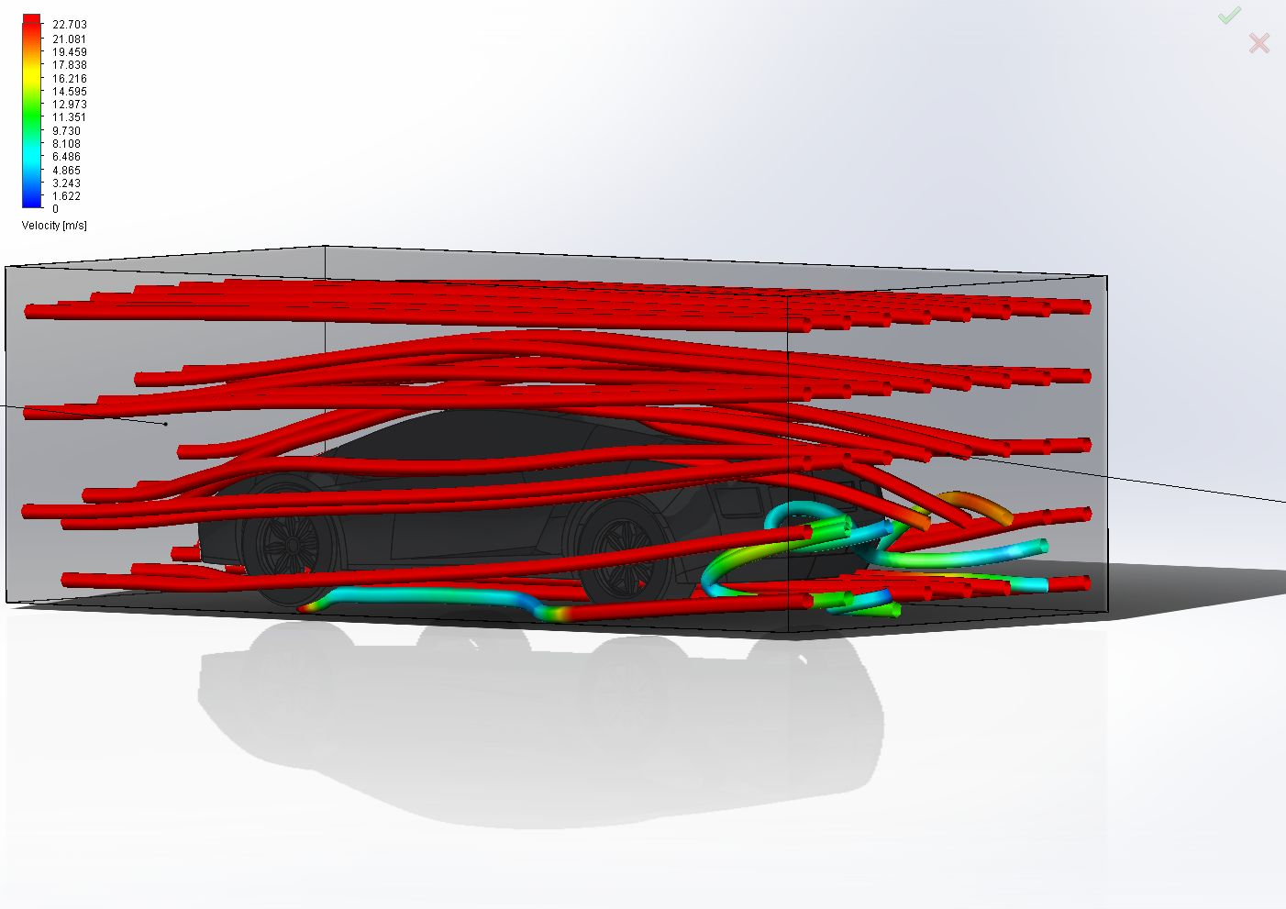
At 100mph : Outlet

As you can see, the outlet air flow has increased in speed compared to 30mph. Although the speed has increased by 70mph, drag does not increase linearly to speed but increases by square, so drag / air resistance behind the car will be considerably higher at 100mph.

Task 2 part 2 – F1 Car
This second part of the task requires me to simulate airflow around an F1 car in the same conditions as the last. One difference between the two simulations is the F1 Car possess a rear wing and the sports car does not. I expect to see less drag / air resistance behind the vehicle as rear wings reduce drag by allowing the air to flow over the rear of the car.

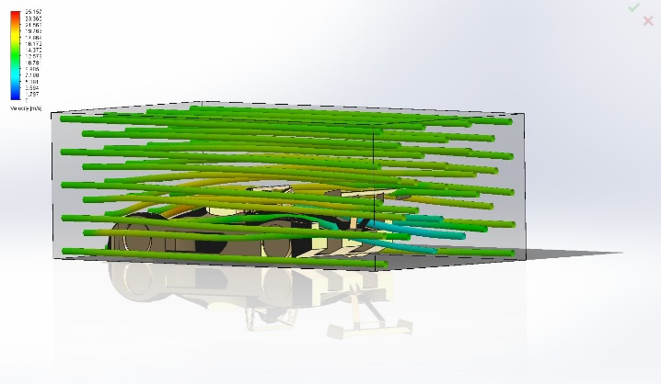
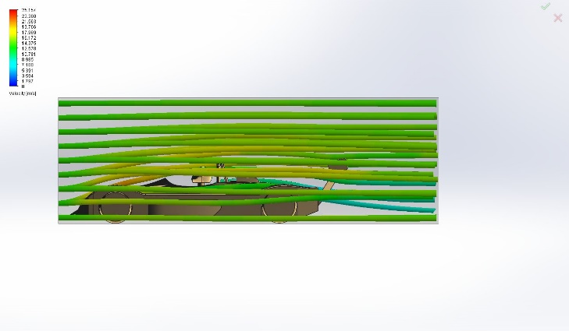
inlet @30mph

At 30 mph, the airflow at the front of the vehicle follows the curves of the car body smoothly as it heads towards the rear of the vehicle. As the car has been designed with minimal drag in mind, the airflow over the vehicle should be slower, as to reduce drag. The airflow speed over the vehicle is around 14m/s which shows the car is more aerodynamic.

Outlet at 30mph
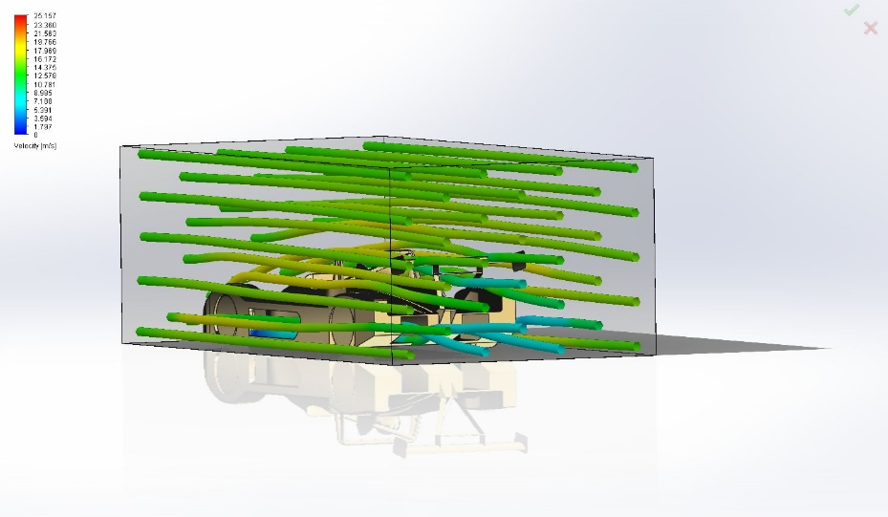

As you can see, with the rear wing the vehicle causes little drag at 30mph. With airflow speed behind the vehicle low, around 7m/s, the air pressure compared to the sports car is comparably low.

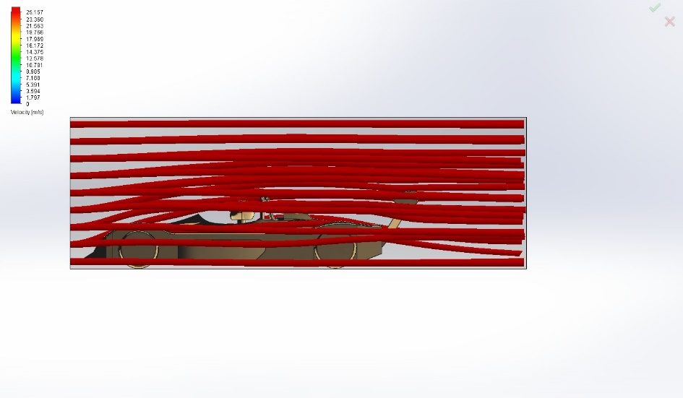
Inlet at 100mph.
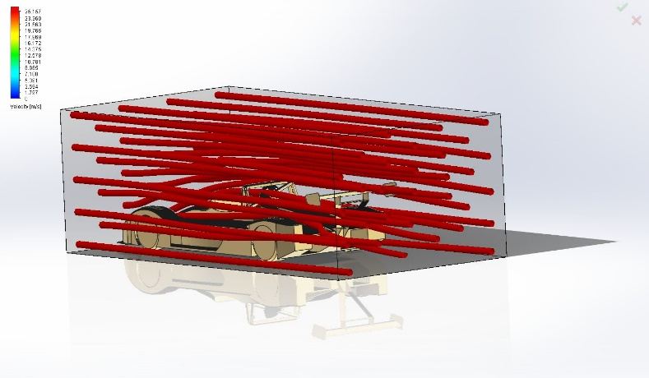

At 100mph we see that the flow velocity has increased to 25m/s, and the air flow is linear to the car body. The aerodynamics of the car are allowing the air to pass over smoothly causing minimal drag.

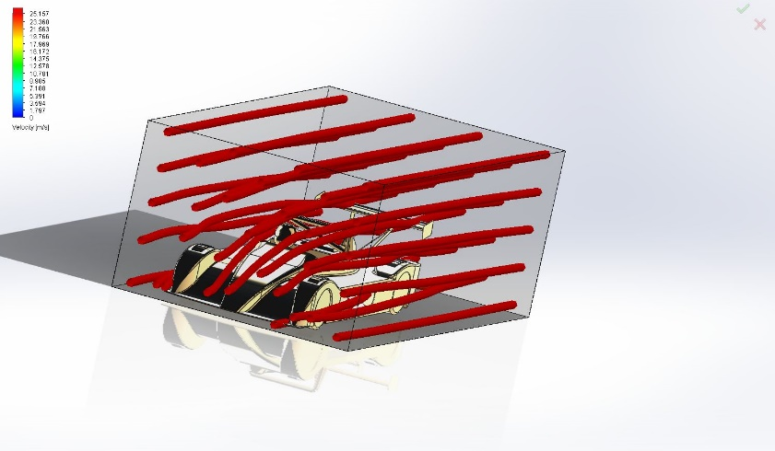
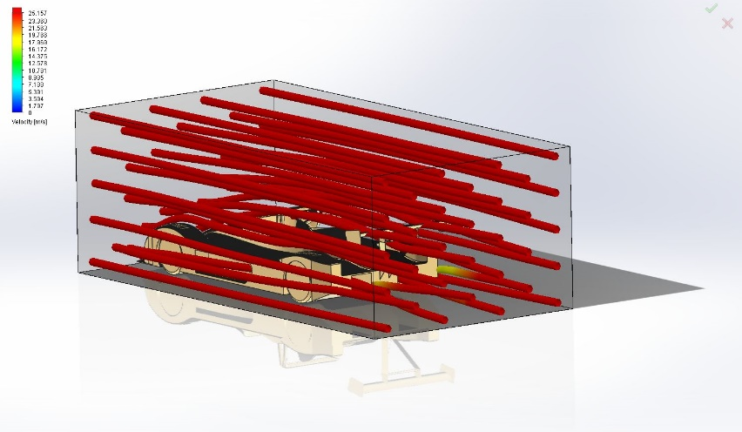
Outlet at 100mph

At 100mph, the air flow flowing over the rear of the car flows straight and doesn’t stray downwards. Drag at the back of this vehicle would be much less compared with the sports car, as there is very little airflow at the rear of the vehicle due to its aerodynamic properties.

Conclusion
After completing this task, the data collected has shown the importance of good aerodynamic design on reducing drag and therefor increasing speed and efficiency. Efficient design has been demonstrated in the F1 Car, as the airflow is efficiently distributed over the vehicle compared to the sports car which has increased drag and lift due to lesser aerodynamic properties. The rear wing on the F1 car helps vastly in decreasing drag and lift and is a modification that would have benefited the aerodynamic property of the sports car.

Task 3 – Funnel and Drill

“You are to simulate the injection moulding of the predefined parts by adding the appropriate gate location(s) that would theoretically ensure that they could be successfully moulded. You are to investigate and analyse the output results with regard to the following criteria: Fill Time, Ease of Fill, Gate Filling Contribution, Cooling Time, Sink Marks, Weld Lines, and Air Entrapment in relation to the gate position(s)”

This third task requires an analysis of injection mouldings on 2 predefined parts, a drill body and a funnel. This analysis will examine how the positioning of filling gates on the predefined part effect Fill time, ease of fill and several other criteria.

Funnel
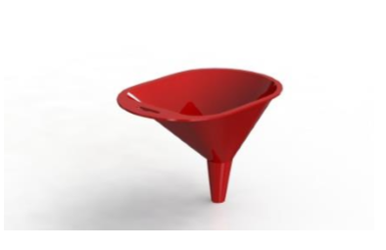
“Gate positions” refer to the position(s) where melted plastic is injected into the mould, creating the product. Choosing these locations are crucial, the fill time of the mould, ease of fill and several other factors depend on it.

For the first injection simulation, 1 gate filling position was chosen. This was on the lip on the funnel to allow easy filling into the mould.
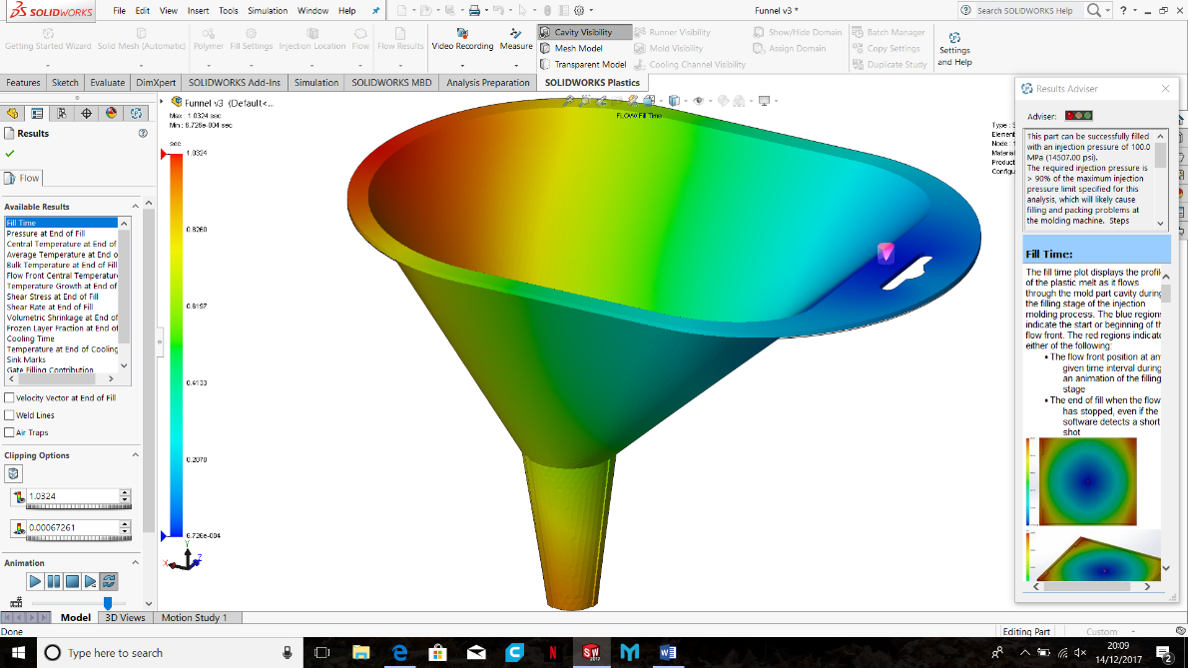
Filling Gate

Plastic is injected at this gate location. The image above shows the time taken to fill the part, blue is almost instantly and red the maximum time taken to fill. At this location, the part took only 1.032s to fill.

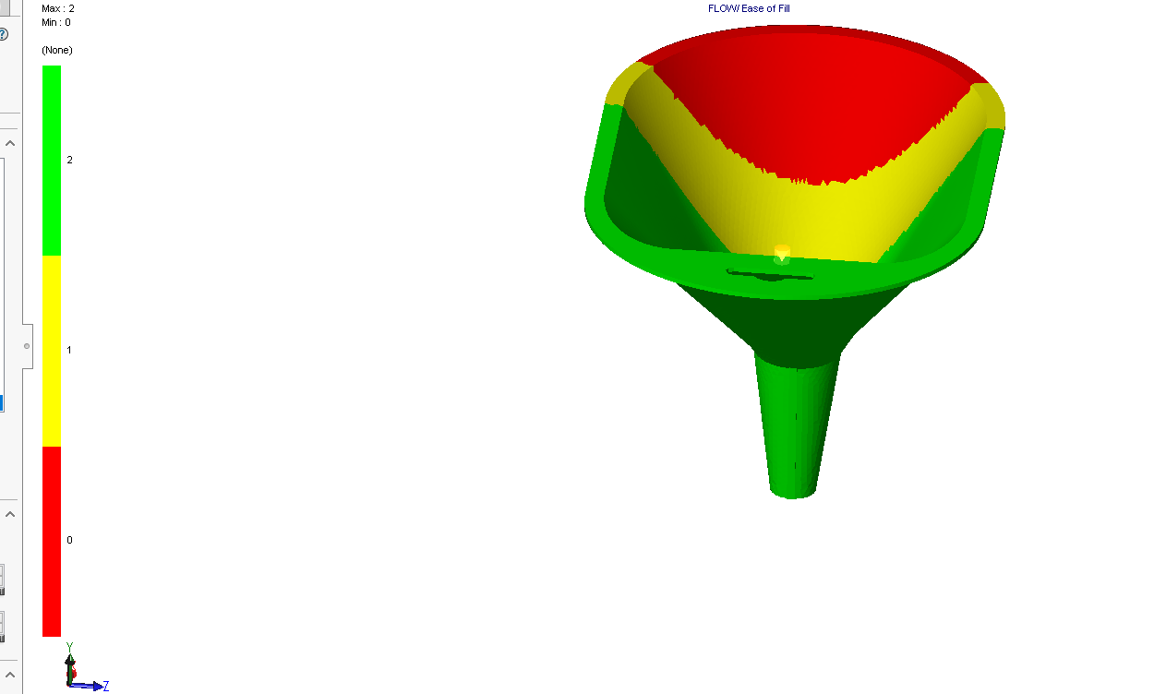

This image shows the ease-of-fill. The area in green filled easily, filling under normal fill-pressures. The yellow section took 70% of the machines maximum filling pressure to fill and the red section indicates the pressure to fill would exceed 85% of the machines injection pressure.

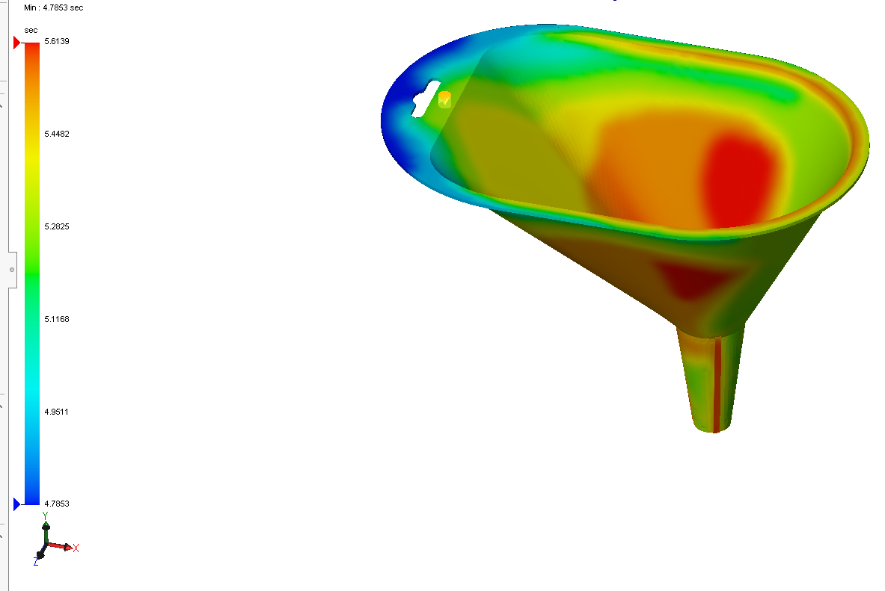

The image above shows cooling time of the part in the mould. The part took 5.61s to completely cool inside the mould. The time taken to cool this part is relatively long compares to parts with 2 or more gate locations, as the plastic flowing from one area may take longer to reach areas of the part.

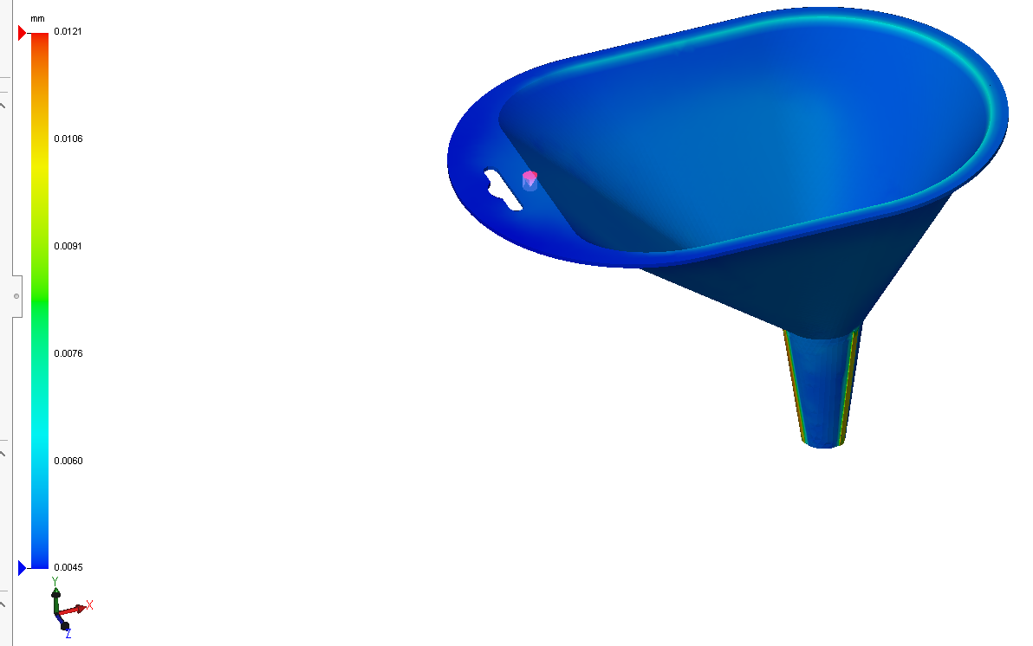
Sink marks occur when thicker sections of the part take longer to cool the other areas, resulting in shrink marks. This funnel has 4 shrink marks at nozzle at the bottom of the part. These shrink marks can be avoided by designing the part with uniform wall thickness or placing injection locations at thicker sections of the part.

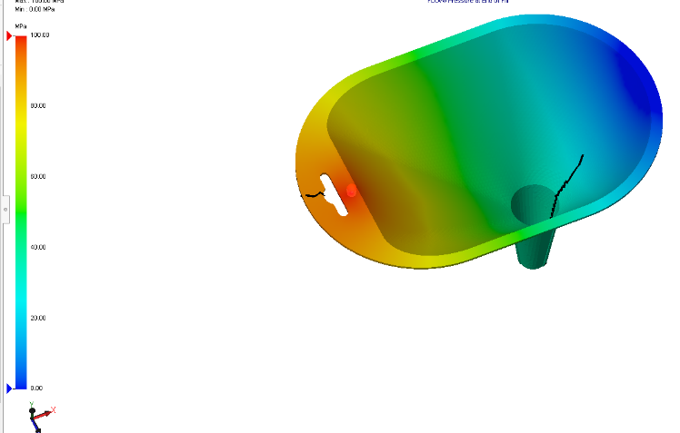

Weld lines
Weld lines occur when two flow front of plastic meet as the part is being injected with plastic. These fronts have an inability to “weld” together during the moulding process. These lines can occur around around obstructions or holes, cause weaknesses and visible deformation in surrounding areas. These deformations in the funnel are not problematic because this product is unlikely to undergo much stress.
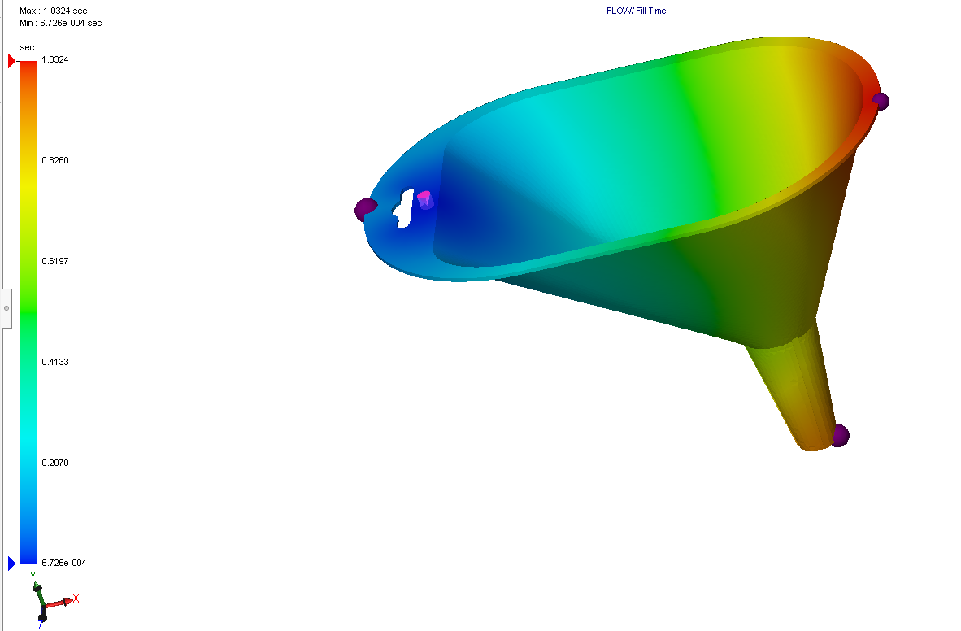

Air traps
The image above shows “air traps”. Air traps occur when trapped air inside the mould cavity cannot escape into the atmosphere during injection moulding process. This trapped air can prevent material from filling the mould properly, resulting in incomplete filling of the part and even a hole in the cooled product which will cause a cosmetic deformity. To avoid this, two or more gate locations will fill the mould evenly and force out of the mould and into the atmosphere.

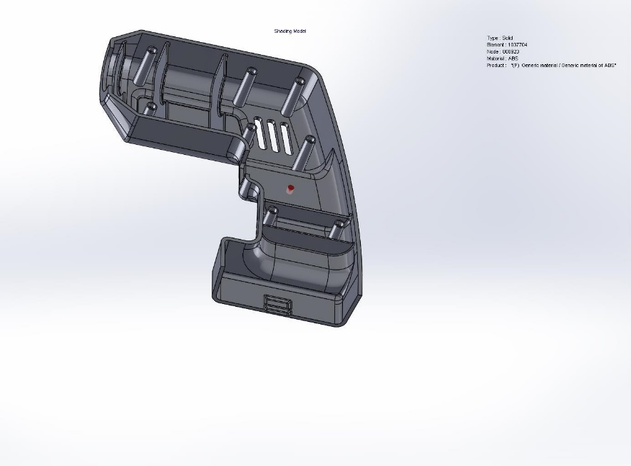
Drill Body

For this drill body, one gate location has been used to simulate the injection moulding process, so comparisons can be made with the injection process of the previous funnel.
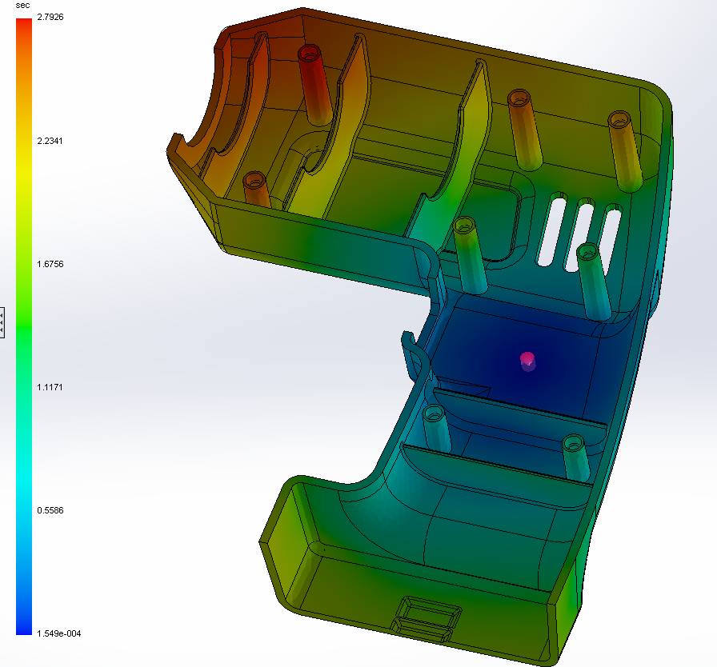

Fill time
The gate location where plastic is injected in has been placed in the centre of the part, which is an easy location for the injector to reach and an even location on the part so plastic would spread evenly. The part took 2.79s to fill, and evenly cooled throughout the part.

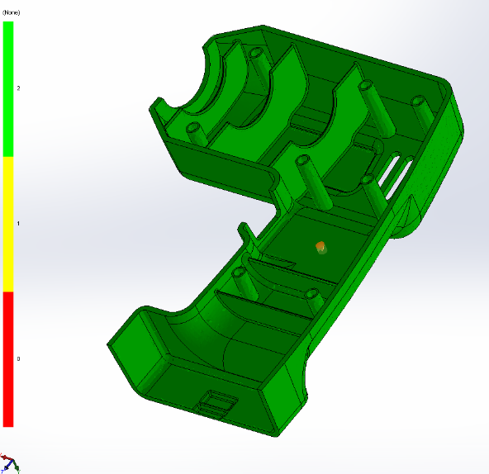

Ease of Fill
Ease of fill indicates if the injection machine can fill the appropriate cavities without overloading pressure. The drill body successfully filled with an injection pressure of 27.6mPa (3998psi). Yellow on the part shows that the machine was able to inject the part without exceeding 70% its maximum pressure output, with 66% of the injection pressure actually used. This shows good placement of the gate.
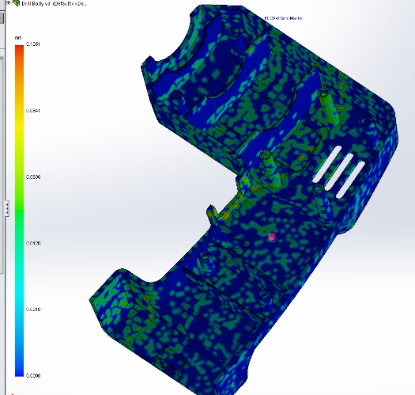

Sink Marks
Sink marks, caused by thicker sections of polymer cooling at slower rates, are visible throughout the drill body. These can cause depressions in the surface and compromise the integrity of the part. Designing the part with uniform thickness and placing the injection location at thicker parts as to increase pressure can all reduce sink marks forming.

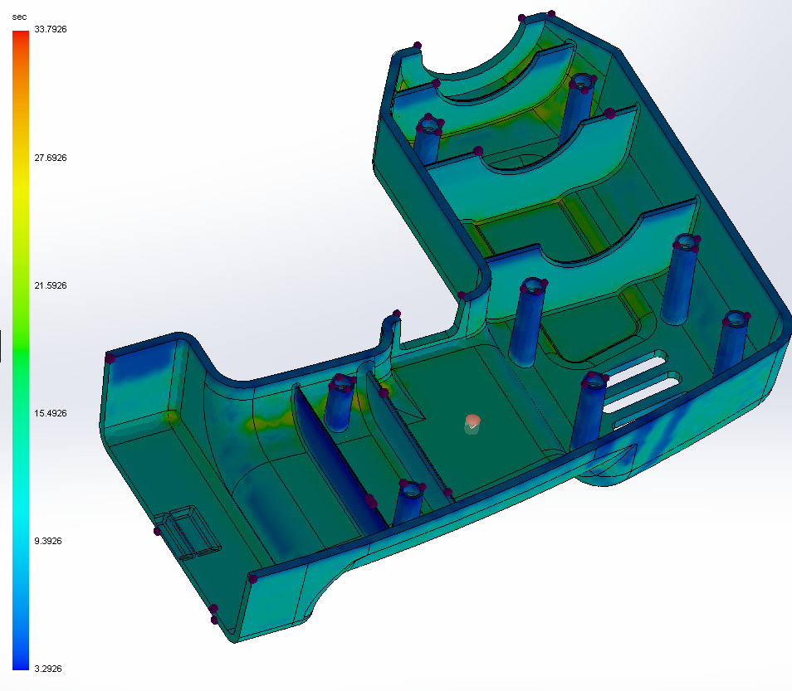

Air traps
After injecting the drill body, 40 air traps developed after cooling, where air trapped in the mould could not escape outwards. These air traps could seriously damage the integrity of the product by creating weak area and even bubbles void of plastic. This is also a visual deformation and can be seen on the product after removing from mould. Inserting ejector pins or fitting more gate locations can overcome this issue.
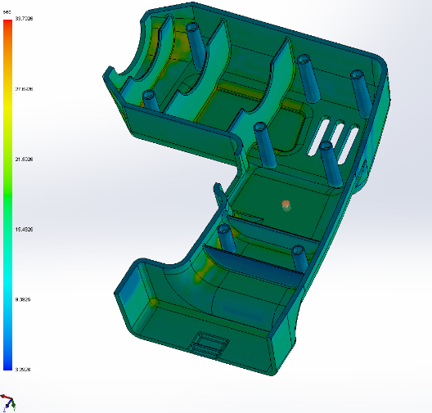

Cooling time
In total this part cooled completely in 33.8s, which is relatively long. Adding more gate locations spread around the part would increase so plastic would flow quicker would increase cooling time. Compared to the funnel, this part is much more complex so increased cooling time is expected with only 1 gate location.

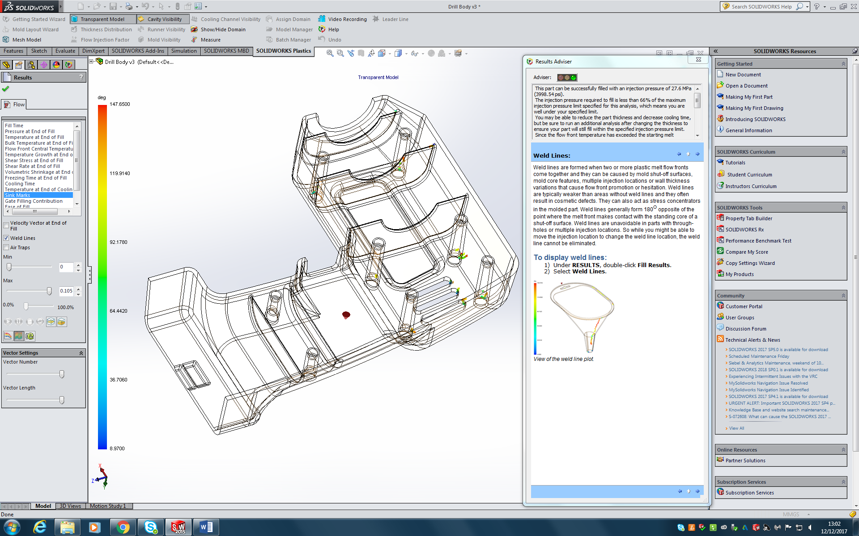
Assembly guide

Weld lines
There are several weld lines that have occurred due to multiple flow fronts meeting during the injection process. These lines re typically weaker than areas without and can cause cosmetic deformities. In this case, they have formed particularly around assembly guides and screw points as they are thicker and flow ca be disrupted as it travels up the assembly point.

Conclusion
In conclusion, I believe 1 gate location can be more beneficial for certain aspect of injection moulding. For example, fill time and ease of fill produced good results with one gate location with the funnel, as it is a relatively simple part. The drill body also benefited from one gate location, as the fill time was completed quickly and was filled easily with even distribution as time progressed. The funnel had little sink marks, which could easily be rectified with re positioning of the gate location. The drill body’s more complex design possibly required another gate location to reduce its sink marks. Air traps on the funnel were limited to three, and again could be avoided with another placement of a gate, but for a simple part like the funnel adding another would increase tooling cost unnecessarily. Air traps were an issue with the drill, this shows gate location/number of gates could be changed. Cooling time in both parts are vastly different. As the funnel cooled quickly and efficiently, the drill didn’t and would have benefited from another gate location to evenly distribute plastic across the part to decrease cooling time.
Task 4
“You are to analyse the predefined part with regard to undercut and draft criteria, then modify for manufacturability.”
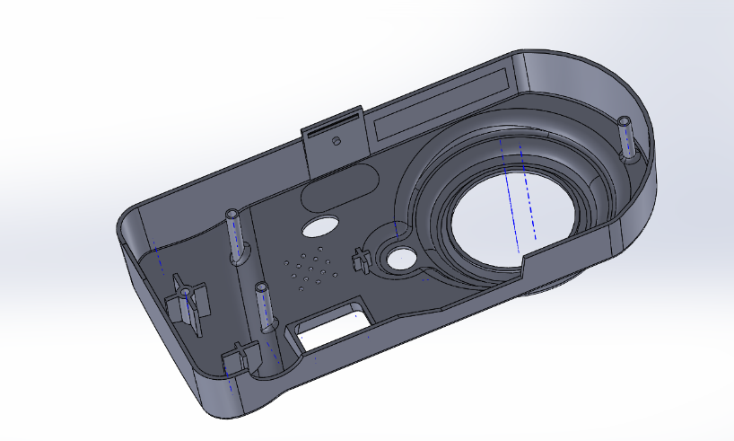

This last task requires a draft and undercut analysis on a pre-defined camera body. The draft analysis will allow inspection of any sections of the camera body that will require a draft so when moulding, the tool can free itself after cooling. The undercut analysis study if any parts of the camera body won’t allow the mould to be removed.

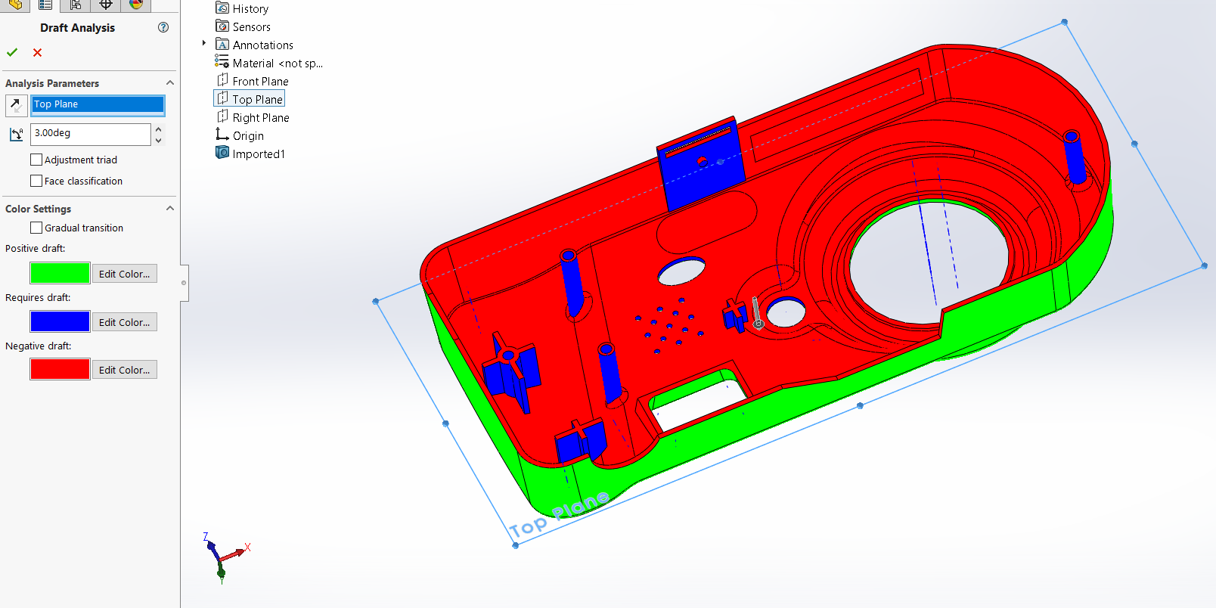
Here is the draft analysis of the part. Red and yellow colours of the part show negative and positive drafts that can be removed easily from the mould. The purple sections are the parts that require a draft.

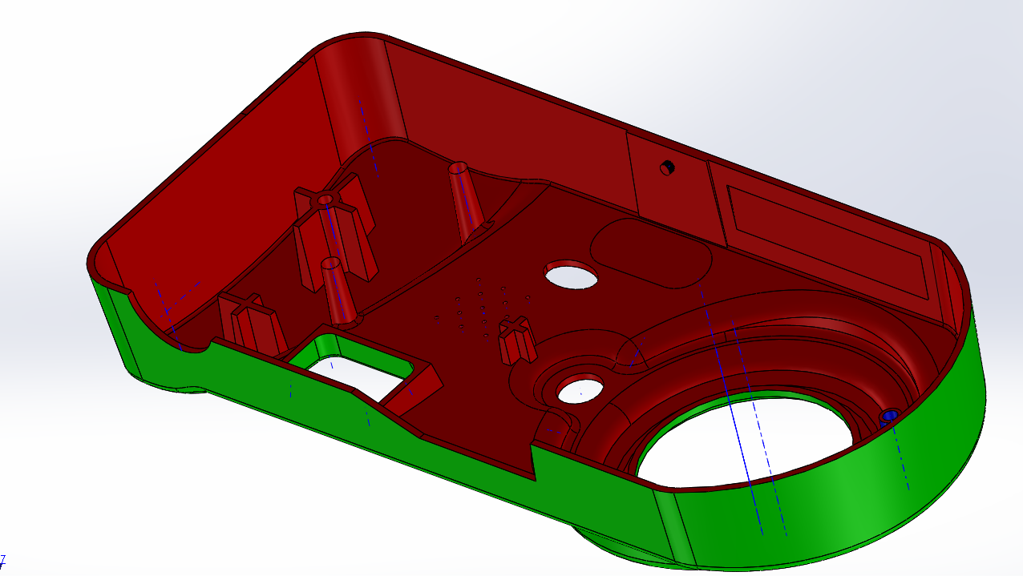
Here is the camera body after completing the required drafts. A 3mm draft was added to the required parts. As you can see, the once required drafts are now negative drafts, meaning then can be removed from the mould successfully without damaging the mould.

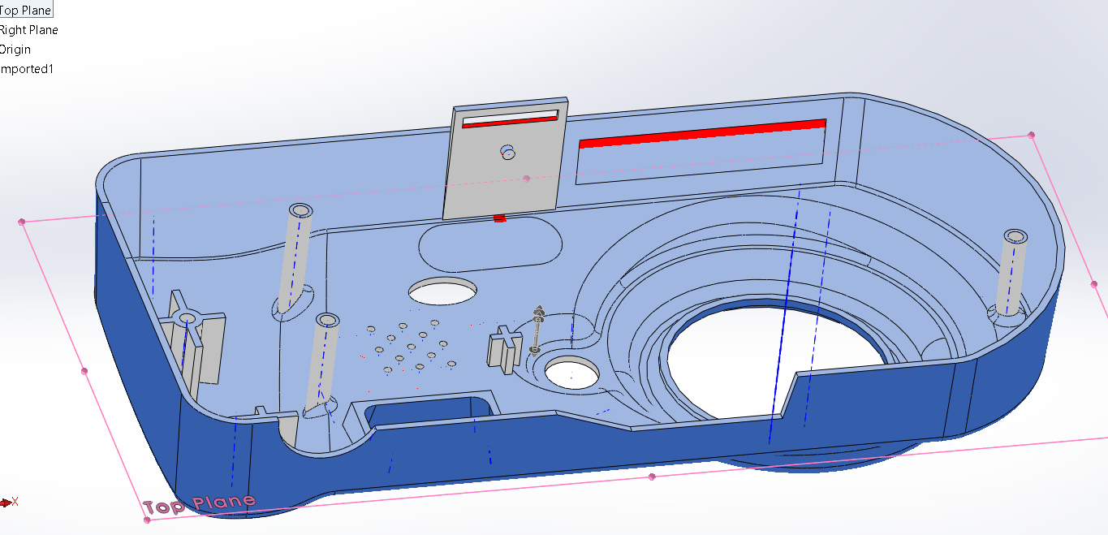
On this undercut analysis, there are several undercuts that could prevent a mould from being removed without causing damage. These undercuts could be removed to allow ease of mould removal, but it would compromise the design. For instance, the far clip has an undercut but removing could compromise the use of the clip and therefor rendering the design pointless. In this instance, a sliding core would allow the mould to be removed freely without damaging the part and without removing any unnecessary design features.

