

Research On Market Entry Strategy for Blue Bottle

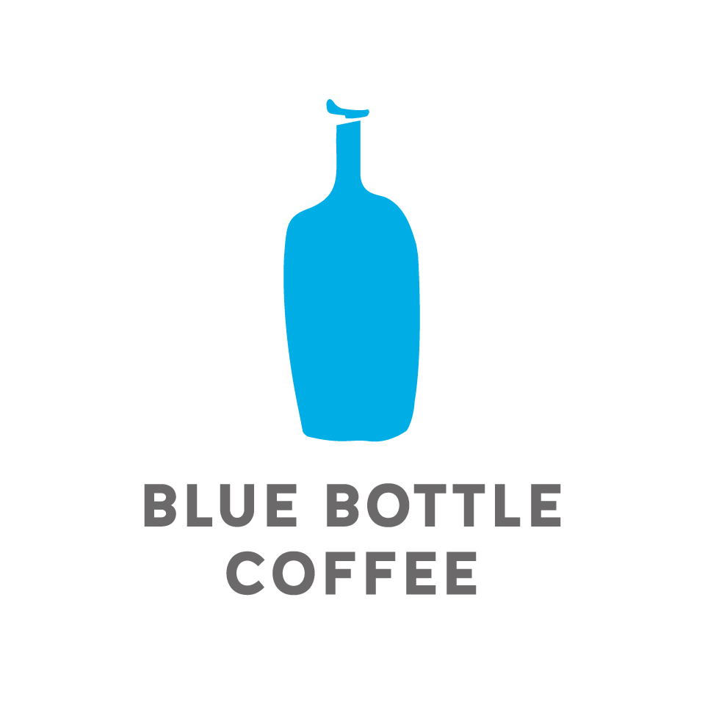
MODULE NAME: Global Marketing Strategy (M3X9086)
Name: Jiankai Gao
Student Number: 1904304

13th/Mar/2020

Contents
Executive Summary 1
1 Introduction 2
1.1 Background 2
1.2 Blue Bottle 2
1.3 China Coffee Market 2
2 Macro Environment Analysis 3
2.1 Legal-Political Factor 3
2.2 Economic Factor 3
2.3 Social Factor 3
2.4 Technologic Factor 3
2.5 Environmental Factor 4
3 Micro Environment Analysis 4
3.1 The Bargaining Power of Suppliers 4
3.2 The Bargaining Power of Customers 4
3.3 Current Competitive Rivalry 5
3.4 Threat of New Entrants 5
3.5 Threat of Substitute Products 6
4 Market Entry Options 6
5 Conclusion 7
Bibliography 8

Executive Summary
In the fast-evolving market, the market-entry timing and option would have long-term impacts on corporates' future operation. Therefore, thorough and insightful assessment is essential before making strategic action. The report will firstly consider the macro environment in China through PESTLE framework. Afterwards, a microenvironment analysis under Porter's Five Forces will be conducted to gain information about Chinese coffee industry. Based on the previous discussion, the reporter will conclude an appropriate market entry strategy for Blue Bottle.
Keywords: Blue Bottle, Chinese coffee market, market entry

1 Introduction

1.1 Background
Considering the exploding coffee market in China (GMA, 2018), the report will discuss possibilities of entering into the main Chinese market. Initially, the report will assess influential macro factors of the region through a PESTEL analysis (macro environment analysis). Afterwards, there will be a microenvironment analysis through the Porter Five Forces framework, exploring industrial conditions of the local market. Additionally, suggestion for market entry options, considering practical issues, will be given after sufficient discussions.

1.2 Blue Bottle
Beginning from a single coffee shop to a booming industry pioneer, Blue Bottle Coffee utilises eCommerce business as its growth engine during the process of expanding to global markets (Hollis, 2018). Blue Bottle insists on running its business on a specific focus – fresh-roasted coffee which is crafted by baristas – the brand hardly run social media campaigns as it considers the product as the only significance. (Taylor, 2017).

1.3 China Coffee Market
Young generation in China is embracing and trying every new stuff. Despite the late start, the Chinese coffee market is booming on a dramatic rate. Statista (2019) indicates that the market size of coffee shop industry in China would triple by 2023 (See Figure 1) – the market size will reach 47.9 billion RMB (around 6.8 billion USD).
Figure 1. Market Size of Coffee Shop Industry in China 2013-2023
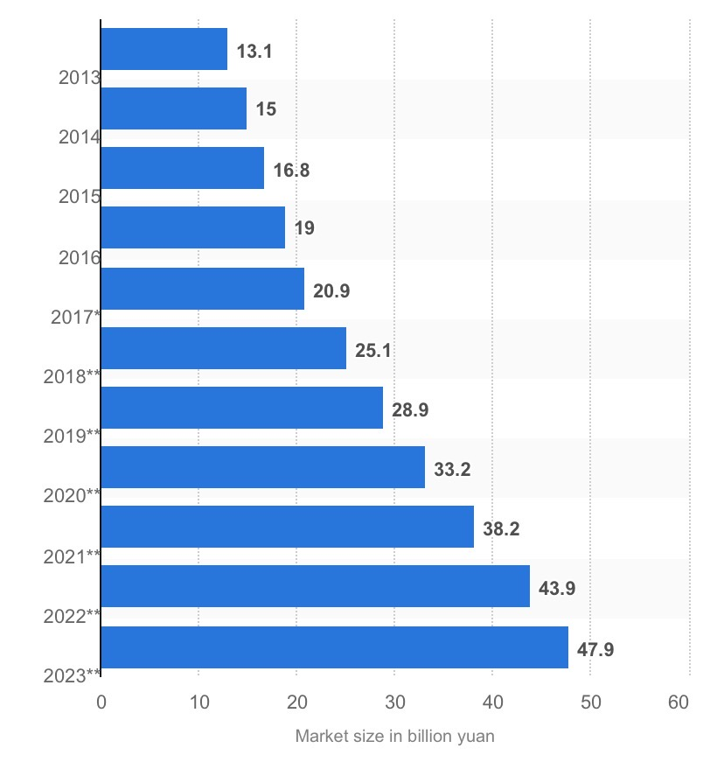
Source: Statista, 2019.

2 Macro Environment Analysis

2.1 Legal-Political Factor
In general, China is proposing new foreign investment law, placing equal treatment for domestic and foreign business. Positively, the draft proposes a five-year transition period for Chinese-foreign joint ventures and wholly foreign-owned business. (Healey & Wang, 2019).
Although the majority of coffee consumed in China is imported globally, there is also some locally grown beans (Duggan, 2015). In agricultural provinces such as Yunnan, which shares a border with Vietnam – a major coffee producer, local governments utilise its influences in determining in supporting certain industries. Yunnan government made a reform in 1988, embarking on a UN Development Program with Nestlé and the World Bank, regarding coffee production. With capabilities and resources supported by the local government, Yunnan is now producing 99% of China's coffee. (Ma, 2018).

2.2 Economic Factor
Due to Coronavirus precautions, China's economic growth for the first quarter could shrink for the first time in decades, would be far below the estimated 4%, in comparison of 6% in the fourth quarter. (He, 2020). Meanwhile, customers and travellers are kept home, leading to a growing number of private companies to struggle from loss. As a result, many private businesses feel unable to cover the previous labour costs, and they have to cut wages or delay payment to survive. Relatively, for new entrant players, the employment level will drop shortly, causing the decline of the recruitment cost. (Chen & Hong, 2020). Additionally, because of the trade-war between China-the United States, tariffs of products import to China has risen, causing domestic inflation. (Bloomberg, 2018).

2.3 Social Factor
Referring to drink trends, coffee is increasingly taking the place of caffeine choice for young Chinese population, particularly Millennials who has been exposed to Western influences. (CBSNews, 2018). Furthermore, in China, though instant coffee mixes once thrived, with growing concerns about health and wellness, an increasing number of consumers started to consider daily sugar intake and tried to avoid human-made additive. (Euromonitor, 2019). Such trends encourages the booming of coffee shop culture. It is also noteworthy that Chinese food and drink customers are increasingly receiving online services. Thanks to convenient delivery services, consumers could enjoy hot, freshly brewed coffee delivered within half an hour. (Xu, 2019).

2.4 Technologic Factor
Technology is in the essence of Chinese daily consumption. Third-party food delivery platforms such as Ele.me and Meituan are providing convenient services. Thanks to well-developed positioning technology, with such delivery service, various kinds of stuff, including files, medicines, clothes . could be delivered door-to-door. Users can observe the real-time position of the courier of their orders. In 2018, above 355 million food orders are made through these channels. (Xu, 2019). In 2020, revenue in the online food delivery segment is supposed to reach US$45,909 million, among which platform-to-consumer delivery (e.g. Ele.me and Meituan) still accounts for the largest market share (with an amount of US$33,361 million). (Statista, 2020).

2.5 Environmental Factor
China has been charging for plastic bags for over ten years, and the campaign seems to be very successful. However, online shopping and food delivery service is undoing the previous efforts. The majority of the package would only be used during the delivery, and could hardly be recycled. Furthermore, consumers usually have only a few options when they make orders. (Zhang, 2019). On the other side, the newly developing industry brings trends of cultivation, which may cause adverse impacts on local climate. Some local governments have already noticed the problem. For instance, Yunnan, the biggest coffee bean production area in China, has been suffering water scarcity in recent years. Nevertheless, coffee cultivation is a water-intensive process, especially when the majority of coffee beans grown in Yunnan is sun-grown than shade-grown; the booming demand for coffee crops is intensifying the sustainability issues of local development. To improve environmental, Chinese authority asks foreign companies to ensure their investments and production are socially responsible and comply with sustainability standards. (Duggan, 2015).

3 Micro Environment Analysis

3.1 The Bargaining Power of Suppliers
The bargaining power of suppliers is relatively low. Coffee shop suppliers usually involve coffee bean suppliers, coffee machine suppliers, and human resources (including barista and delivery couriers). For chain brands such as Starbucks and Costa, the supply chain is systematically established, qualified suppliers are supporting their global business with materials in standards (Starbucks, 2020). However, for local boutique coffee shops, specially selected coffee beans and professional barista may be key resources of their competitive advantages. Within the context, a small number of suppliers with competitive capabilities or resources (such as unique coffee beans, and well-trained barista) might have stronger bargaining power over small coffee shop players.

3.2 The Bargaining Power of Customers
The bargaining power of customers is relatively low. Though the general economic environment of China slows down, giving more price pressure to business operators, there is little possibility for price competition in the coffee shop industry. John Zolidis, an equity analyst, states that coffee is not economically sensitive. With initiatives such as delivery, coupons, and subsidiaries, consumers would keep partially loyal. Besides, Chinese consumers are quite diverse. There are highly globalised segment, including Hong Kong, Shanghai, and Beijing, where consumers share similar tastes and preferences with those who in the western market. There are also extremely localised segment, where consumers have their preferences and tastes. (Mourdoukoutas, 2019). Therefore, defining customer segments is quite significant for market players.

3.3 Current Competitive Rivalry
The real competition in China's coffee shop industry is relatively intense. Though the market volume climbed each year rapidly – coffee consumption in China will grow at a rate of 20% and reach 300 billion RMB by 2020 (Wang, 2018), the current positions of leading brand Starbucks and start-ups such as Luckin Coffee are quite stable. (Mourdoukoutas, 2019).
As the most significant foreign player in China, Starbucks has aggressively opened 3600 stores on 150 cities in the past two decades. (Xu, 2019). With such an enormous number of branches, China has become the second biggest market for the coffee giant. Meanwhile, the brand is also facing the problem of market-saturation. (Mourdoukoutas, 2019).
Luckin is taking a different strategy, and the new local start-up brand operates mainly through pickup and delivery models – while Starbucks just started its delivery service in September 2019. The new player insists on implementing its app, rather than joining in third-party platforms. It utilises aggressive coupons to attract office people with products selling 20% cheaper than which of Starbucks (Mourdoukoutas, 2019), and locate customers' position with their technique. By collecting user data, Luckin can understand its consumers better and make reactions in accordance. In result, Luckin Coffee gained considerable success in the China market in just two years after establishment, aiming at opening 4500 stores in China over Starbucks's 3600 stores. (Xu, 2019).

3.4 Threat of New Entrants
The threat of new entrants is moderate. Considering the abundant investments required to establish a chain store, the entry barrier is high for professional branches. Mainly, considering the following difficulties and financial investment during the business operation, only a few new entrants would be likely to participate. However, in terms of small, medium coffee shops, including private owned boutique brands and speciality coffee cafe, the initial investment is relatively low. These brands usually start from a corner shop, having a definite competitive advantage in product design, and develop a loyal group of customers through online and offline interactions. (Gu, 2018).

3.5 Threat of Substitute Products
Threat of substitute products is relatively high. The most localised mode of drink store is tea shop. At present, there are several chain brands such as Hey Tea, and Nayuki Tea (a.k.a Naixue), owning 390 and 230 stores, respectively, expanding their products portfolio into coffee drinks. (Mulia, 2020; Bloomberg, 2020). Though tea drink shops currently have accounted for a small share of the drink market and could never entirely replace coffee drink shops, the unique recipe of cheese tea is still leading a new trend. Particularly, Hey Tea, the market leader, understands its customer segment well. Tea beverage shares the same target segment (young generation) as the coffee shop market. As the young generation becoming the main driving force of China's beverage consumption, demands towards innovation and creativity appear. Tea drink brands usually have pretty localised menu and frequently provide seasonal items to attract consumers. It is also noteworthy; Hey Tea has innovated its order program and membership system, which assists the brand in understanding the consumer better. (Mulia, 2020). Such a threat will be strengthened, particularly when consumption-ability shrinks due to economic influence.

4 Market Entry Options
There are diverse options of market entry strategies, including exporting (indirect and direct exporting), and foreign direct investment. Different degrees of FDI indicate various levels of engagement foreign investors have in business operations. It usually involves contract manufacture, licensing, strategic alliances, joint ventures, acquisitions and mergers, assembly plants, and wholly-owned subsidiary. The selection of an entry strategy also involves dealing with the relationship between ownership and control. Besides, the market entry strategy may frequently change during business operation and expansion, which requires flexible adjustment. (Dev et al., 2007).
Considering the previous discussion around macro and microenvironment of China's coffee shop industry, Blue Bottle is now facing a "Now-or-Never" challenge. Chinese coffee shop market is rising while competitors have clear competitive advantage (Starbucks owns well brand reputation, Luckin has powerful technology and knows the local market well), the brand is losing its competitive advantage during the process of waiting. The target consumer segment is still enthusiastic to new elements – the evident characteristics of Blue Bottle brand will successfully attempt new customers in the beginning. However, innovative local start-ups will soon attract their attention with a frequently evolving menu and convenient technological services. (Xu, 2019). Besides, delivery services and online ordering system are becoming increasingly unavoidable in China, which means competitors have to follow the trend or losing their customers. In essence, even Starbucks started to launch delivery services through cooperation with third-party platforms and to adapt its pricing strategy via online coupons and promotions. (Mourdoukoutas, 2019).
Therefore, in order to get well developed logistic chain and delivery system, Blue Bottle would be better to start from establishing a joint venture with local corporate – particularly when taking the fact that Chinese government is adapting its foreign-investment law into a more friendly version (Healey & Wang, 2019). Such a strategy could strengthen the impacts of brand equity and avoid operational risks of dealing with legal issues and social problems. Being compared to local coffee shops, the joint-venture will be renowned for the brand. In essence, Blue Bottle has been enjoying the market's recognition in terms of its professionality and obsession on the best quality. (Morell, 2014). The new joint-venture will be able to bring a right combination of chain coffee shops yet featured in boutique shop's craftsmanship spirit.

5 Conclusion
In conclusion, China's coffee shop industry is thriving. Though the declining economy might influence the consumption ability shortly, the rapidly growing market is still the best destination to entry for innovative brand. Considering the financial investment barrier and legal risks, Blue Bottle could start from a joint venture with local corporations which have abundant capabilities and resources in logistics and delivery services. Afterwards, Blue Bottle could consider to scale-up its business and adjust the operation mode in the future.

Bibliography

Bloomberg (2018) Tariff Deadline Nears as China Scraps Trade Talk with US. Economic Times [online]. Available from: https://m.economictimes.com/markets/stocks/news/tariff-deadline-nears-as-china-scraps-trade-talks-with-us/articleshow/65920077.cms [Accessed 09/03/2020].

Bloomberg (2020) China's Nayuki Tea 'Seeks US$400m US IPO'. China Daily [online]. Available from: https://www.chinadailyhk.com/article/122344 [Accessed 09/03/2020].

CBS News (2018) China Embraces Coffee Culture Craze, Thanks to Millennials. CBS This Morning [online]. Available from: https://www.cbsnews.com/news/china-coffee-craze-millennials-embracing-culture/ [Accessed 08/03/2020].

Chen, L. Y. & Hong, J. (2020) Chinese Companies Say They Cannot Afford to Pay Workers Now. Bloomberg [online]. Available from: https://www.bloomberg.com/news/articles/2020-02-19/chinese-companies-say-they-can-t-afford-to-pay-workers-right-now [Accessed 08/03/2020].

Dev, C. S., Brown, J., & Zhou, K. Z. (2007). Global Brand Expansion: How to Select a Market Entry Strategy. Cornell Hospitality Quarterly. 48(1), p.13-27.

Duggan, J. (2015) Spilling the Beans on China's Booming Coffee Culture. The Guardian [online]. Available from: https://amp.theguardian.com/sustainable-business/2015/may/18/spilling-the-beans-chinas-growing-coffee-culture [Accessed 07/03/2020].

Euromonitor (2019) Coffee in China. Euromonitor International [online]. Available from: https://www.euromonitor.com/coffee-in-china/report [Accessed 08/03/2020].

GMA (2018) The Coffee Market Explodes in China. Marketing To China [online]. Available from: https://www.marketingtochina.com/coffee-market-explodes-china/ [Accessed 08/03/2020].

Gu, L. (2018). The Rise of Specialty Coffee Cafes in China. Ecns.cn – Society [online]. Available from: http://www.ecns.cn/news/society/2018-07-06/detail-ifyvvuhv1810877.shtml [Accessed 09/03/2020].

Healey, D. & Wang, L. (2019). China's Proposed Law on Foreign Investment. Asia & The Pacific Policy Society [online]. Available from: https://www.policyforum.net/chinas-proposed-law-on-foreign-investment/ [Accessed 08/03/2020].

He, L. (2020) China's Economy Could Shrink for the First Time in Decades Because of the Coronavirus. CNN Business [online]. Available from: https://www.google.com.hk/amp/s/amp.cnn.com/cnn/2020/03/04/economy/china-services-employment-coronavirus/index.html [Accessed 08/03/2020].

Hollis, S. (2018) How Blue Bottle Coffee Turned One Coffee Shop into a $700 Million eCommerce Business. JILT [online]. Available from: https://jilt.com/blog/blue-bottle-coffee-content-marketing/ [Accessed 08/03/2020].

Ma (2018) Slow Brew: China's Coffee Revival and Globalization. Macro Polo [online]. Available from: https://macropolo.org/analysis/slow-brew-chinas-coffee-revival-and-globalization/ [Accessed 08/03/2020].

Morell, K. (2014) James Freeman of Blue Bottle Coffee: A Pioneer in the Slow Coffee Movement. American Express [online]. Available from: https://www.americanexpress.com/en-us/business/trends-and-insights/articles/building-empire-james-freeman-blue-bottle/ [Accessed 10/03/2020].

Mourdoukoutas, P. (2019) Starbucks Worst Nightmare in China is Coming True. Forbes [online]. Available from: https://www.forbes.com/sites/panosmourdoukoutas/2019/01/21/starbucks-worst-nightmare-in-china-is-coming-true/amp/ [Accessed 08/03/2020].

Mulia, E. (2020) 'Hold My Tea': HeyTea to Double Stores in 2020? Equal Ocean [online]. Available from: https://equalocean.com/retail/20200115-hold-my-tea-heytea-to-double-stores-in-2020 [Accessed 09/03/2020].

Starbucks (2020) Doing Business with Starbucks. Starbucks [online]. Available from: https://www.starbucks.com/business/suppliers [Accessed 09/03/2020].

Statista (2019) Specialist Coffee Shop Market Share Based on Sales in China in 2017, by Sales. Statista [online]. Available from: https://www.statista.com/statistics/880921/china-coffee-shop-market-share/ [Accessed 08/03/2020].

Statista (2020) Online Food Delivery. Statista [online]. Available from: https://www.statista.com/outlook/374/117/online-food-delivery/china [Accessed 09/03/2020].

Taylor, K. (2017) Blue Bottle Customers Are Scared The Chain Will Lose Its "Hipster" Spirit After The Nestlé Acquisition – Here is Why The CEO Says They Do Not Need to Worry. Yahoo! Finance [online]. Available from: https://finance.yahoo.com/news/nestl-acquisition-blue-bottle-could-215939305.html [Accessed 11/03/2020].

Wang, E. (2018) Analysis of the China Coffee Market 2017. Marketing China [online]. Available from: https://www.marketingchina.agency/analysis-china-coffee-market-2017/ [Accessed 08/03/2020].

Xu, Y. (2019) China's Luckin Coffee Tries to Conquer A Nation of Tea Drinkers. NPR [online]. Available from: https://www.npr.org/sections/goatsandsoda/2019/05/17/723193259/what-does-chinas-luckin-coffee-have-that-starbucks-doesnt [Accessed 07/03/2020].

Zhang, Y. (2019) Online Shopping and Food Delivery Succeed in China at Great Cost to the Environment. Break Free from Plastic [online]. Available from: https://www.breakfreefromplastic.org/2019/01/14/online-shopping-food-delivery-succeeds-china-great-cost-environment/ [Accessed 09/03/2020].

