  - MODULE CODE/ COD Y MODIWL: BMSW5104

MANAGING PROJECTS IN THE ORGANISATION

Student Name: Tracy Asantewaa

Student ID:1713700

Lecturer’s Name: Dr Kenny Tang

Date of Submission: 11th May 2020

Contents
Introduction 4
Produce a project plan using an appropriate project planning technique (PID) 4
Project Title 4
Project Background 4
Purpose 4
Objectives 4
Deliverables 5
Constrains 5
Project Sponsors 6
Project Stakeholders 6
Project Scope 6
Tools and Techniques of project management 6
Project communication methods 8
Benefits of project management 8
Characteristics of project managers 9
Organizational structure to support projects 9
Types of projects 10
The project life cycle 11
PRINCE2 13
Risk Management techniques 15
Appreciation of soft skills 15
Stakeholder analysis 16
A Green Agenda 16
Present Critique 16
Reflection of the project manager 17
SWOT 17
Strength: 17
Weaknesses 17
PPD Plan 17
Conclusion 18
Reference 19
Appendix 1: Gantt chart of the project 20

Introduction
Project management is the process of monitoring and looking after all aspects of the project to complete within the time frame, cost, and resources (Roberts, 2011). The hospitality industry in the UK has been steadily growing and needs to adapt and renovate to stay competitive and attractive to tourists. This report will explore my endeavor as a project manager and discuss in details about the execution and other factors for The Landmark Hotel in London. And also, the report concludes with my own personal plan and SWOT analysis to be developing my ability as a project manager.

Produce a project plan using an appropriate project planning technique (PID)

Project Title
Installing new LED light fixtures and reducing the overall electricity consumption

Project Background
The building that the Landmark Hotel in London is situated was opened in 1899 and was acquired by the Landmark group in 1995. Although the hotel is a five-star rating, the style remained eccentric with historic touches of the architectures in the rooms and other areas of the hotel. The light fixtures of the hotel use halogen light bulbs are not sufficient enough to emit a good light source, and electricity consumption is high compared to new LED lights. The hotel has 300 rooms and suites that will be the main focus of this project.

Purpose
The purpose of initiating this project is to make the hotel more attractive to the customers and reduce the consumption of electricity and save operating costs for hotel management.

Objectives
- Reduce the operating cost of the hotel by changing light fixtures to the new LED's.
Will be measured with the electricity consumption per month
- Increase the attractiveness of the hotel to the customers
Will be measured by the number of check-in from the records.

Deliverables
The progress report of the Landmark Hotel project will be presented monthly to the following:
- Mr. Raj Rahil , Vice President of Operations
- Mr. Eric Ayala , Director of Facilities
- Hardik Barot, Development & Acquisitions Manager
Also, the project will have other deliverables that will help to manage the tasks of installing new LED light fixtures into the hotel rooms for reducing the operational costs and increasing the attractiveness to the customers of the Landmark Hotel. Some necessary deliverables of this project are:
- Tools and Techniques of project management
- Stakeholder analysis
- Gantt chart for maintaining the deadline of the project
- A personal reflection on SWOT and Personal Development Plan

Constrains
The limitations or restriction on the deliverables of the project is known as constrains and has to be clearly stated before starting the project to minimize or workaround (Maylor, 2010). The completion of the project is dependent on the vacancy of the room on which the project objectives will be executed. With the help of the hotel management, a coordinated effort will take place to minimize every constrain of this project.

Project Sponsors
The project was sponsored by the management team of the Landmark hotel, and financial accounts will be directly monitored and controlled by the Director of Revenue Management, Ms. Sumeeta Saxena, along with her team of accountants to maintain the bookkeeping duties.

Project Stakeholders
Stakeholders are all parties involved with the project's outcomes and have the ability to exert a positive or negative influence on the progress of the project deliverables (Heerkens, 2015). The stakeholders of this project are the shareholders of the hotel, management, the guests, and employees of The Landmark Hotel, London.

Project Scope
The project scope entitles to how the project will be delivered and plans to accomplish the tasks with the resources within the fixed time period (Heagney, 2012). This project will take on ambition as a part of the gradual renovation program of the Landmark Hotel without closing the operations of the hotel, and it is the first phase of the program. The project will include a group of 20 highly trained technicians working in pairs for conducting the tasks of changing the light fixtures by following fixed schedules agreed by the hotel management. The project will be completed in just 3 months, and work will continue based on the vacancy of the rooms.

Exclusion from Scope
The work of the project will not include the lobby, corridor, restaurants, and outside areas and shall not create any disturbance on the regular activities of the hotel staff and its guests.

Tools and Techniques of project management
Project management is the actions taken by the project manager to effectively lead the team to complete the project on time and report the progress to the responsible authorities and keep track of the resources are being used efficiently to meet the project objectives within the time period (Buttrick, 2009). The success of the project depends on the ideal choice of tools and techniques for project management. For this complex project, the classic technique will be used for project management of the Landmark Hotel's first phase of renovating the light fixtures. This is ideal because the work will be conducted by small teams consisting of two technicians for each room to finish the task efficiently on time. The aspects of the project management for the Landmark Hotel have been discussed below:

Schedule (Gantt chart)
A Gantt chart is an instrumental tool for scheduling the various activities of the project designed according to the importance of completion to go for moving forward on the different phases of the project in a timely manner (Berkun, 2008). The Landmark Hotel project will require three months to install new LED light fixtures in all 300 rooms of the hotel. After the completion of the project, the effectiveness of the project will be further monitored in terms of electricity consumption and operational costs.
A Gantt chart listing all the tasks of the project has been provided in Appendix 1.

Human Resource Requirements: Project Team
The project will require a team of 20 technicians and 5 supervisions to work directly in the execution process for the Project at Landmark Hotel London.

Support Staff
The support staff for this project will consist of 10 teams of technicians working in pairs for installing the new LED light fixtures in every room of the hotel. Each floor will contain 1 supervisor to monitor the progress and report back to the project manager.

Additional Staff
There will be 30 supporting crew whose job is to carry the tools and other objects such as ladders to aid in the work of supporting staff.
Project Control
The importance of controlling all aspects of the project is essential to avoid any issues and troubleshooting constraints that can lead to delays in the completion time (Wysocki et al., 2000 ). There will be monthly progress report presented to the meeting with the management teams and the project manager for discussing and adapting to the changes in any circumstances to ensure the Landmark Hotel is up and running for accommodating the guests without creating any nuisance.

Quality Control
To ensure each product that goes to the final installation matches the highest quality, the technicians will perform second testing and inspection to verify the checklist for reporting to the supervisors. Although the suppliers have been strictly instructed to ensure the quality, a second inspection will minimize the risk of a bad fixture being installed.

Project communication methods
The success of the project to execute according to the plan within the timeframe requires communications in all levels of the Landmark Hotel. After the project plan is presented and approved by the management of the hotel, the employees and supporting staff will be notified about the course of actions, including their roles and contributions for the execution process of the project. Each week the project manager will collect the progress reports and check up with the supporting staff to investigate and advise on any issues that might hinder the progress of the project. Also, the project manager has to work with the hotel's front desk to plan ahead on the project by taking into account the reservation and vacancies for the rooms that will need the light fixtures to be installed. With compiling the proper reports of the project, the findings and results will be presented to the management of the hotel to keep them updated and get feedback.

Benefits of project management
The benefits of project management depend on the complexity and deliverables of the outcomes of the project, and it provides straight forward guidance for accomplishing the task, staying within the budget, and foreseeing any issues before starting to execute the project plan (Reiss, 2015). The Project at Landmark Hotel London requires to be very preciously executed so that it does not attract the attention of the guests and disrupt the environment of the hotel. So with project management, it will increase the possibility to executing the process according to the schedule, complete the tasks by prioritizing on the availability of the rooms, improve the productivity of the technicians by setting targets, minimize the risks associated with the project and maintain a good relationship with the management of the Landmark Hotel for acquiring future projects. Also, it will enhance the experience of the project manager to be active and efficient for monitoring and leading the team, maintain consistent communication with the stakeholders and maintain the project scope through the completion of the project.

Characteristics of project managers
A project manager is an essential individual who is responsible for bringing out the desired outcomes for the project to complete within the given resources and time and has to possess distinct characteristics to sustain the project management responsibilities (Roberts, 2011). The Project at Landmark Hotel London is complicated in terms of scope and risks associated with project management, which requires the project managers' innate ability to demonstrate leadership skills to manage the team and provide governance for completing the tasks on due time. Also, the project manager has to have strategic decision-making skills to plan and identify potential risks before it has the chance to hinder the progress of the project. Having to work with the management of the hotel, the project manager has to be very diplomatic with everyone involved to avoid any kind of conflict and build rapport to gain support and provide motivation to the staff and hotel employees to ensure the progress of the project. Moreover, the essential characteristics of a project manager are the ability for time management because, with proper time management, the manager can set examples to their team members to be sincere and maintain the working time schedule. With all the mentioned characteristics, the project manager of the Landmark Hotel will be able to act as a successful delegate between the hotel management and project staff members and ensure the objectives are being accomplished and resources are being used efficiently for the project to progress smoothly without falling behind of the project timeline.

Organizational structure to support projects
The organizational structure of a project shows the link of the supports that are responsible for executing the project in a timely manner (Linman, 2011). The Landmark Hotel's Project has the project sponsor, who is the hotel management team at the top hierarchy, who is responsible for approving the project management plan for the manager to progress forward with the teams of technicians and support staff. Here it is important to note that the project manager has a role in communicating with all the stakeholders, including the project sponsor and the stakeholders of the hotel, and provide governance to the project teams.
The organizational structure of the Landmark Hotel project has been provided below:
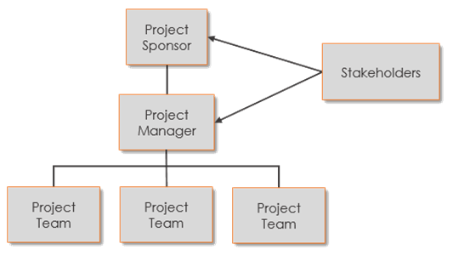

Types of projects
There are typically three types of projects according to the project size, capacity, structure, and functions that are distinct and require a varied level of expertise for the project management to be handled by the project manager (Haughey, 2011). The discussion of the types of projects has been discussed below:
- Civil engineering projects: These types of projects are conducted at the industrial scale, where many expertise comes together to solve mathematical and scientific problems that arise within the project to be efficiently and effectively completed. The project is conducted on-site with exposure to the natural elements and requires large capital investments for providing resources such as machinery and equipment along with the workforce. This type of project requires complicated communication between the different types of professionals and contractors to act together to achieve the objectives of the project. Examples of civil engineering projects are the construction of buildings, mining, and quarrying, etc.
- Manufacturing projects: These types of projects usually take place inside a confined environment to control and monitor each aspect of the project precisely to maintain a standard, and on the spot, management is conducted to maintain the integrity of the manufacturing process. The project manager is responsible for overlooking and ensuring a smooth manufacturing process and handling the human resources and identifies flaws in the project to make it more efficient and minimize the cost of production effectively. Examples of manufacturing projects are manufacturing machinery and equipment, ships, cars, aircraft, and other hardware that are key components to make products.
- Management Project: The Project at the Landmark Hotel in London falls under this category. As every organization has to undertake certain projects from increasing capacity, introduce new technology into the system, relocate the office premises into another location, launching new marketing campaigns or undertake renovation projects that help the company to achieve a final goal. The project's outcome might not be visible or tangible to be noticed externally but can make a path for the success of the organization (Heerkens, 2015). The project manager is usually responsible for acting as a delegate between the management and the project's team members. The project management at Landmark Hotel is not vast in terms of the other two types of projects and can tolerate a modern level of project management effectiveness because the work has to be done discretely.

The project life cycle
For any project, it has to go through certain phases following a specific sequence or cycle for the successful outcomes of the project deliverables. It gives structure and guidance while following the project life cycle for accomplishing the objectives and the desired outcome for conducting the project. It helps to create plans for each phase of the project and ensures the flexibility and adaptability in each phase for the effectiveness of the project manager (Pinto, 2016).
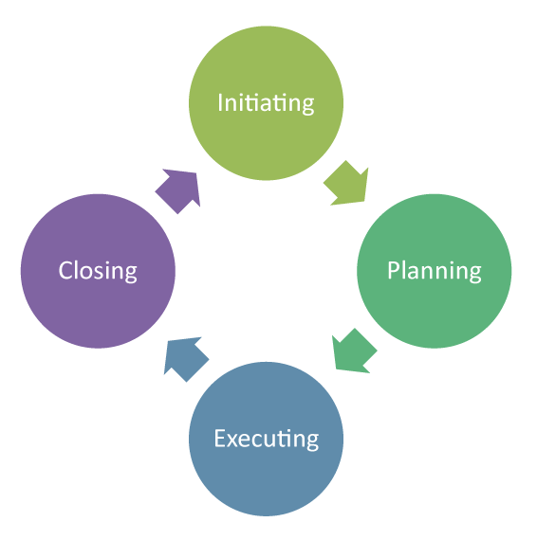
(Source: Pinto, 2016)
For the Project at The Landmark Hotel in London, there are four phases in the project life cycle. The initiation process started when the management felt the need to start renovating the hotel rooms incorporating the latest technological innovations without closing down the hotel's regular activity. Then the project was handed over to our firm for creating plans and making strategic approaches that will fulfill the objectives set by the hotel's management along with the budget and resources necessary to execute the project deliverables. After the approval of the project plans, the execution process can begin where technicians and supporting staff, along with the project manager's direct involvement, start executing the complex tasks of installing the new LED light fixtures in a discrete manner following the exact path that was decided in the planning stage. Finally the closing phase will begin for terminating the project by ensuring all the work has matched the standard and every light fixture are performing at their optimal level. The closing phase also includes the hotel's management to approve the successful devilry of the deliverables according to the plan and issue the finance department to issue the payment order for the project.

PRINCE2
This is another name for projects in a controlled environment and has been used by the government and private sectors for managing projects in the United Kingdom (Booker, 2009). The PINCE2 contains several aspects of the project, including the cost, time, resources, and other factors that each phase of the project will require for accomplishing the success of the deliverables. There are five stages of PRINCE2, which have been discussed for the project at the Landmark Hotel in London.
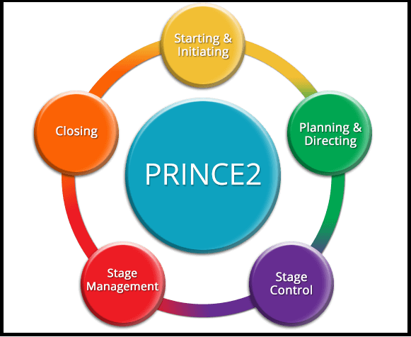
(Source: Booker, 2009)

Starting & Initiating
The start of the project initiated when the management of the Landmark Hotel decided that it is viable for the company to renovate the light fixtures into modern, cost-efficient LED fixtures. They have formally initiated the start of the next stage of the project by issuing a project brief to our firm containing the business case or the trigger.

Planning & Directing
The planning process includes listing down all the variables of the deliverables and ways for executing the project efficiently. Also, creating the budget quote by calculating the costs associated with the project and confirming the prices of the fixtures from the suppliers. The planning process also includes defining the project scope and project deliverables, associated risks, constraints, stakeholder analysis, and initial project plan. After getting the plans approved, the project can be directed into the next stage of the PRINCE2 stage.

Stage Control
The role of the project manager is most important in this phase of the project. Landmark Hotel will not shut down for the project to be executed, which is why the project manager has to constantly communicate with the front office of the hotel to figure out the best possible time for each room to conduct the installation process without letting the guests being noticed. The support staff has to be monitored and given authorizations to execute the project deliverables by the direction of a project manager from communicating with the management.

Stage Management
The project manager has to continuously monitor and gather the progress report from each project team and provide leadership whenever there arises any issue. The main aim of the stage manager for this particular Project at Landmark Hotel is to ensure the safety and progress of the project to be completed in due time with minimal risk to the existing infrastructure. Also, the coordination of the project teams to follow the project plans have to be strictly monitored and guided, and progress reports to be presented to the management of the hotel and ensure the project will end in due time.

Closing
The termination process will begin by checking all the rooms contain everything intact, and all the light fixtures and electronic devices are working perfectly. Also, ensure the project has ended on the given timeline of three months to complete the project deliverables. When everything has been checked by the project manager, the discharge of the project duties will be handed over by handing the planned closure document to the management of the hotel and request the issuance of the project payment order for closing the project to an end.

Risk Management techniques
Every project has some risk factors and constraints that need to be identified and managed to avoid any drawbacks or negative influence on the project to end in due time (Roberts, 2011). The aim of risk management is to ensure the protection of the interests of the stakeholders and the wellbeing of the project's team members. There are few techniques that can be instrumental for ensuring the success of the project deliverables. For the Landmark Hotel's Project, the risk management process began by a qualitative risk analysis for identifying the probable risk facts and formulating the risk management plan. The plan included a details step by step guide for handling high-risk situations such as accidental electrocution and falling off the ladders while executing the project deliverables for the team members. The solutions for controlling the risk such risks were providing appropriate safety gear and harnessed to minimize the risk. Also, risk management for the project included a response plan in case of any unavoidable circumstances that require medical attention. And finally, the entire risk management plan has complied as a document for being reviewed by the management of the hotel for approval and evaluating the effectiveness of the strategies taken to minimize the risks associated with the project.

Appreciation of soft skills
The role of a project manager is equally distributed into all aspects of project management (Leach, 2004). Apart from being a good leader, the project at the Landmark Hotel in London requires the manager to have a good understanding of team building and team dynamics so that they can be cooperative and supportive against each other for actively participating in the execution of the project deliverables. Good communication and active listening skills of the manager are a kind of superpower to delegate between the management and the team members to make positive progress and be the key person to make justified decisions regarding the project matters. Negotiating the conflicts that may arise and have sound cultural awareness for working with a diverse workforce in the project is also an advantage for this project.

Stakeholder analysis
The stakeholders for this project are the shareholders of the hotel, management, the guests and employees of the Landmark Hotel and the government of the United Kingdom. The aim of the stakeholder analysis is to ensure that all their needs are being met and communications are effectively transmitted to the stakeholders regarding the project (Brugha, 2000). As this project has the ambition to reduce the consumption of electricity, reduce the operational costs, and minimize the environmental impact from the hotel's operation that will benefit all the stakeholders in some way.

A Green Agenda
The shift towards environmentally friendly and incorporating a green business model is known as a green agenda. The Landmark Hotel has been emphasizing the transformation of a green agenda since the customer's trends and government regulations have been shifting towards lowering the environmental impact from business actives. Moreover, a green agenda is equally beneficial for the customers and profitable for the hotel to incorporate into its business practices.

Present Critique
The main criticism of the green agenda for the Landmark Hotel is that it will require a large financial expenditure to fully incorporate into the business. This project is just a part of the green agenda; additional projects need to be planned and implemented, such as the installation of solar panels on the roof of the building, changing the heating and cooling systems into environmentally-friendly equipment and technology.

Evaluation
Although the green agenda is good for the business reputation and image; it can hurt the hotel's financial security and might need the shareholders to invest additional funds into the business just to fulfill the green agenda into the business. However, the recent economic condition in the United Kingdom has posed a threat to the hospitality industry, and this investment into the business might be risky for the shareholders in the long run.

Reflection of the project manager
This project has been the largest project in my career as a project manager. There has been a certain challenging situation that I tried to cope as best I could. However, getting involved in this project has presented some interesting aspects of myself that I was not aware of. This has sparked a need to list down my strengths and weaknesses and create a personal development plan for performing even better on future projects.

SWOT

Strength:
- Effective at communication at all levels of the project management
- Ability to predict risky situations and taking charge to initiate the risk management procedure
- Ability to influence and motivate others for accomplishing the objectives
- Good diplomatic skills

Weaknesses
- Lack of negotiating skills
- Lacking the qualities of an effective leader
- Not being proactive on the job
- Trouble at managing conflicts in the project

PPD Plan
What are my development  Objectives? | Priority | What activities do I need to undertake to achieve my objectives? | What support/resources do I need to achieve my objectives | Target date for achieving my objectives | Actual date of achieving my objectives
Develop the characteristics of an effective leader | High | Active observation and seeking advice from my superiors | Being coached by my superiors and attending leadership workshops for the corporates | September 2020 | January 2021
Develop negotiation skills | Moderate | Take part in the marketing courses that helps to build good marketing skills | Read lots of books on negotiation and take notes on the techniques | June 2020 | December 2021
Improve at managing conflicts in the project | Low | Be more involved with the team members and get to know them better | Gain their trust and make them follow my actions | October 2020 | March 2021

Conclusion
The Landmark Hotel in London has been a prestigious five-star hotel with rich historical significance and reputation. The project is a part of the first phase in the gradual renovations of the hotel to incorporate modern technological advancement to stay competitive and reduce operational costs with environmentally sustainable solutions. The project management was required to handle complexity and decisiveness to maintain the hotel's integrity and reputation while the work for the process was conducted in the background. The management of the hotel has been very satisfied due to the excellent management as a project manager and has assured me of appointing on future projects. The reflection, along with the personal development plan, will help to improve and develop to handle more phenomenal projects that will match the career goals and success.

Reference
Berkun, S (2008) Making Things Happen: Mastering Project Management (Theory in Practice) O'Reilly
Booker, J., (2009). Managing Successful Projects Prince2. London: Stationery Office, The.
Brugha, R., (2000). Stakeholder analysis: a review. Health Policy and Planning, 15(3), pp.239-246.
Buttrick, R. (2009). The Project Workout: The Ultimate Handbook of Project and Programme Management. 4th ed. Harlow, England: Financial Times/Prentice Hall.
Haughey, D., (2011). Understanding The Project Management Triple Constraint. [online]
Heagney, J. (2012). Fundamentals of project management. (Online) New York: American Management Association.
Heerkens, G. (2015). Project management (A briefcase book). New York: McGraw-Hill
Leach, L. (2004). Critical chain project management [ebook] (2nd ed., Artech House effective project management series). Boston, Mass. ; London: Artech House.
Linman, D., (2011). Project Governance Structure: The Steering Committee. [online]
Maylor, H. (2010). Project Management. 4th ed. Harlow : Financial Times Prentice Hall.
Pinto, J., (2016). Project Management. New York: McGraw-Hill
Reiss, G. (2015). Project management demystified London: Routledge
Roberts, P. (2011). Effective project management. London, UK Philadelphia, PA: Kogan Page.
Wysocki, R. K. et al. (2000). Effective Project Management 2nd ed. New York: Wiley.

Appendix 1: Gantt chart of the project
Time | Month 1 |  |  |  | Month 2 |  |  |  | Month 3
Project Initiation
Project Planning
Cost/benefit analysis
Risk analysis
Sourcing the LED light fixtures
Starting the installation process
Producing monitoring plan
Reflection over Project
Reflection for own professional development needs

