APPLE COMPANY

Apple Company
Background of the Company
Apple is a multinational company that was founded in 1976, where it started by selling personal computers named Apple 1. The firm has inscribed a narrative of outstanding innovation in the technology landscape since its inception (Podolny and Hansen, 2020). Ronald Wayne, Steve Wozniak, and Steve Jobs are the three founders of the company. It designs and manufactures consumer electronics and is a digital distributor of media content. Apple’s product lines include iPhone smartphone, iPad, and Macintosh personal computer. It sells its products online and also has retail stores that it calls Apple Stores. The company's mission is to “design the best products on earth and leave the world a better place than it found it” (Kim et al., 2021, p.140). It has been demonstrating much commitment to fulfilling all the market demands and redefining these demands in a groundbreaking innovation. The initial company products, Apple I and Apple II, set the enterprise's pace, which enabled it to get to the point it is today. The firm has navigated through various challenges since the departure of the founding members, but this did not cause the closure of the firm. Its success milestones are a story of reinvention, resilience, and commitment to pushing the boundaries of what seems impossible (Kim et al., 2021). Currently, Apple is a trillion-dollar valuation company, making it a testament to the power of innovations and the enduring influence of the company's mission.
Segmentation, Targeting, and Positioning Strategies
Segmentation
Company segmentation includes the dividing of the population into groups according to given characteristics. Kotler and Armstrong (2016) stipulate that clients may be segmented based on the place where they live, behavioural traits, and demographics, among other variables. In the complex structure of Apple's segmentation, demographic factors have particular importance, which makes the Apple brand resonate with different consumer groups. Even though the company is known for surpassing traditional marketing boundaries, it incorporates demographic considerations to customise its products in a way that will make them appealing to a wider range of users (Lu, 2022). In terms of age, Apple acknowledges different technological needs depend on the age of customers (Kumar, Ramachandran, and Kumar, 2021). For example, it has designed the iPhone to have a user-friendly interface with various applications that provide a seamless experience to a wide range of age demographics, from professionals to teenagers who are tech-savvy. It also has products like the MacBook Pro, which are more convenient for older customers and align with the professional needs of a more mature audience. The company acknowledges the importance of technology in education and, thus, designs products like MacBook Air to be good companions for students. Sometimes, it also offers discounts to facilitate learning, especially among students with disabilities (Chelkowski, Yan, and Asaro-Saddler, 2019). The company also understands that different professional roles require different technological capabilities. As such, it customs its products to ensure they meet the various occupational needs.
Apple also pays attention to psychographic segmentation, which brings in the aspect of consumer psychology in matters of customers' values, aspirations, lifestyles, and values (Kotler and Armstrong, 2016). A large part of its success comes from its ability to tap into the aspirations and dreams of its target consumers. The organisation engages in detailed market research to identify ambitions and desires that please its audience. For example, the sleek design of its products, such as the MacBook, iPhone, and Apple Watch, creates an aesthetic appeal, that resonates with the aspirations for stylish technological devices (Xi and Zheheng, 2021). This segmentation also includes understanding and obliging the diverse lifestyles of its customers. In addition, it has seamless integration across all its products to cater to individuals’ changing lifestyles. Its ecosystem is designed to allow its customers to easily transition between entertainment, work, and personal pursuits, providing a cohesive technological experience and multifaceted lifestyle. Furthermore, the emphasis on design and innovations differentiates the company’s products in the market as the products become appealing to customers that value innovation.
Targeting
Targeting entails identifying the segments that are most attractive to business. These are groups that a company identifies after selling products to them. Apple’s targeting strategies entail the selection of segments that were in the previous segmentation process (Kotler and Armstrong, 2016). It focuses on consumers who prioritise performance quality and design with no focus on the price. Firstly, the firm positions itself as the premium provider in the consumer electronics industry. It aims to establish an image that communicates innovation and exclusivity, hence signifying to a specific group of consumers (Schlegelmilch, 2022). Moreover, it targets customers who have discerned high-quality products and are willing and ready to invest in technological devices that go beyond utility to offer cutting-edge features and superior performance. The strategy also focuses on well-off individuals who have the financial capacity to invest in premium technology (Weinstein, 2020). This is a demographic sector where the users have disposable incomes and are willing to spend on high-quality products. The major advantage is enhancing profitability since its focus on the premium market makes it command a higher price for its products, raising the profit margins. However, the same premium focus limits its market reach as it excludes the consumers who consider affordability over premium features.
Positioning Strategies
Apple’s positioning strategy is an attestation of its ability to go beyond the basic functionality of consumer electronics and construct a different identity in the minds of its users (Kotler and Armstrong, 2016). The firm positions itself as an innovation leader as it always introduces novel products that redefine all products in the industry. Additionally, it positions itself as the indicator of technological advancement, differentiating it from the competitors (Podolny and Hansen, 2020). It also carefully fosters an ambitious brand image, positioning the company's products as a symbol of lifestyle and prestige. The products have been effectively designed and made using premium materials, contributing to the aspirational nature of its products. The major advantage of these positioning strategies is that they foster the brand loyalty of the company. The positioning strategy is unique, giving the firm a competitive differentiation, making it a leader and not a follower in the industry. However, it has been found to create perceived exclusivity and limit the cost-conscious customers.
Marketing Mix
Marketing mix entails tactical marketing tools that a company blends to produce the response it wants in the target market. The mix entails everything the firm can do to increase the demand for its products. Kotler and Armstrong (2016) call them the 4Ps of marketing: product, price, place, and promotion.
Product
It means the products the company provides to its target market. Apple has a wide range of products that it produces based on consumer needs and preferences. Some of these products are iPhone, iPad, Apple Watch, MacBooks, and Airpods, as shown in Figure 1. Each product has a distinct purpose in meeting the demands of the consumer segments. In terms of quality, Apple products are known to have premium quality, which arises from the design and the type of material used to manufacture these products, which reinforces the company's reputation of excellence (Razak et al., 2020). In all its product offerings, innovation is the hallmark. Each new replication brings features that bring a new look at the industry standards as a way of elevating the users’ experience (Appio et al., 2021). The company has created features that extend beyond mere functionality, such as face ID for seamless authentication and the continuous upgrading of its iOS software. The company's packaging design is an essential part of the company’s identity. Its packaging style is a reflection of elegance, simplicity, and environmental consciousness. It used recyclable materials that resonate with the company's commitment to sustainability, making it attractive to environmentally conscious customers (Orth, Rose, and Merchant, 2019). Overall, Apple’s conscious balance of variety, quality, and iconic packaging makes it a good competitor.
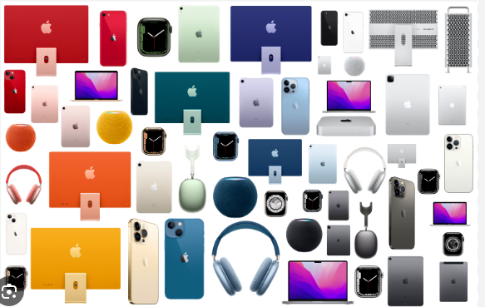
Figure 1: Major Apple Products
Price
It refers to the amount of money customers must pay to attain a given company product. Apple has a pricing strategy that makes it balance between maintaining its premium brand image and the perceived value of its products. The company has premium pricing compared to those of its competitors, connecting it to the high quality of the material it uses and the cutting–edge technology. This premium pricing strategy positions its products as luxury and high-end items for a specific demographic in the market (Budiono, Purba, and Adirinekso, 2021). However, it also has a tiered pricing approach, where there are different prices for different modes of a product. For example, there are different prices for the different models of iPhone (Figure 2 shows prices for different products). In addition, Apple also gives occasional promotions and discounts, especially when there are product launches. It is a tactic that enhances demand, attracts a large customer base, and is always on the lookout for the launch of a new product. It is worth noting that Apple is a business-to-consumer company that does not offer credit terms or payment periods to customers as it has a direct retail model, where customers must pay the full price of the product they want at the time of purchase.
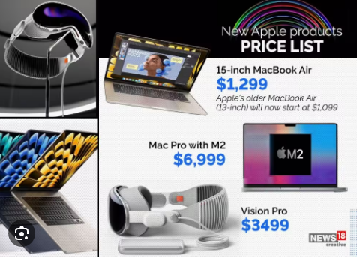
Figure 2: Apple product prices
Place
It is a marketing mix component that defines the activities that a company engages in to make the product available to its target customers. Apple has an Omni-channel distribution channel where it has retail stores in different nations, authorised resellers, and online platforms to ensure its products are available to its customers. It has over 527 retail stores in 26 countries worldwide, with the Wenzhou retail store in China as the newest store (Sellers, 2023). The stores are designed where, besides making purchases, the customers can receive technical support and personalised assistance on how to operate the devices. Furthermore, in the today’s digital era, Apple has online stores where interested customers can make online purchases via http://www.apple.com/, which is the official platform of the company. It also has authorised resellers, such as electronic resellers, to make its products more available to customers. The organisation also has distribution partnerships with telecom carriers. For example, it has a good collaboration with AT&T, which assists the distribution of iPads and iPhones. A combination of these strategies ensures Apple products are available to its customers.
Promotion
The elements entail activities that a company uses to persuade target consumers to purchase products. Apple combines public relations, sales promotions, advertising, personal selling, direct marketing, and social media marketing to convince its target consumers. In advertising, it makes visually compelling television commercials, showcasing the unique features of the products. Though printing advertising is less prevalent in the current digital era, Apple occasionally uses it in magazines to showcase its products. It also has sales promotions, such as back-to-school promotions, especially on devices used by educators and students, such as personal computers. Apple Company occasionally has product launch events, which form part of public relations (Tien, Dat, and Chi, 2019). These events assist in generating public interest and give significant media coverage. The company also has email marketing, where it shares promotion opportunities and product updates directly with its customers. Apple makes its email marketing unique by only communicating something important and not the monthly newsletter, which makes its customers always look forward to getting an email from Apple.
It also uses social media marketing, where it collaborates with various celebrities and social media influencers to promote its products. It is a promotional strategy that assists it to tap into an existing and large fan base. Additionally, Apple has a massive social media following, which helps it reach a wide audience. It has opened social media pages for almost all its products. For example, Apple TV has a Facebook account. It uses these platforms to announce the production of new products or make important announcements, such as in Figure 3. For integrated marketing communication, the company has consistent brand messaging across all its promotional channels. Overall, Apple uses both digital and traditional promotional methods.
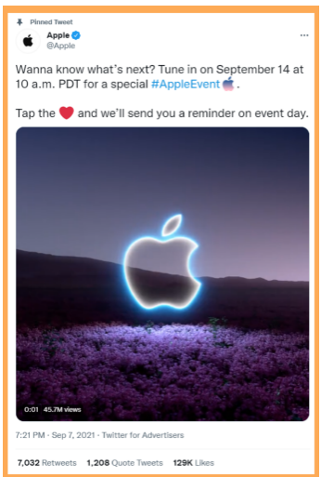
Figure 3: Twitter Advert (https://twitter.com/Apple/status/1435307157944078336)
References
Appio, F.P., Frattini, F., Petruzzelli, A.M. and Neirotti, P., 2021. Digital transformation and innovation management: a synthesis of existing research and an agenda for future studies. Journal of Product Innovation Management, 38(1), pp.4-20.
Budiono, S., Purba, J.T. and Adirinekso, G.P., 2021. Strategic business analysis by using determinants of buying decision on products: lessons from an international company in Indonesia. [Online] Available at: http://www.ieomsociety.org/brazil2020/papers/555.pdf [Accessed 14 November 2023].
Chelkowski, L., Yan, Z. and Asaro-Saddler, K., 2019. The use of mobile devices with students with disabilities: a literature review. Preventing School Failure: Alternative Education for Children and Youth, 63(3), pp.277-295.
Kotler, P. and Armstrong, G., 2016. Principles of marketing sixteenth edition. Addis Ababa: Harambee University.
Kumar, V., Ramachandran, D. and Kumar, B., 2021. Influence of new-age technologies on marketing: a research agenda. Journal of Business Research, 125, pp.864-877.
Kim, J., Jeong, B., Kim, D., Kim, J., Jeong, B. and Kim, D., 2021. Who drives innovation? Apple. Patent analytics: transforming IP strategy into intelligence. Singapore: Springer Verlag, pp.139-148.
Lu, B., 2022. The market strategies of Apple in China. In 2022 7th International Conference on Financial Innovation and Economic Development (ICFIED 2022). Paris: Atlantis Press, pp. 1129-1132.
Podolny, J.M. and Hansen, M.T., 2020. How Apple is organized for innovation. Harvard Business Review, 98(6), pp.86-95.
Orth, U.R., Rose, G.M. and Merchant, A., 2019. Preservation, rejuvenation, or confusion? Changing package designs for heritage brands. Psychology & Marketing, 36(9), pp.831-843.
Razak, M., Hidayat, M., Launtu, A., Kusuma Putra, A.H.P.A. and Bahasoan, S., 2020. Antecedents and consequence of brand management: empirical study of Apple’s brand product. Journal of Asia Business Studies, 14(3), pp.307-322.
Schlegelmilch, B.B., 2022. Segmenting targeting and positioning in global markets. In Global marketing strategy: an executive digest. Cham: Springer International Publishing, pp. 129-159.
Sellers, D., 2023. Apple is to open a new retail store in Wenzhou, China, on November 4. Apple World Today. [Online] Available at: https://appleworld.today/apple-to-open-new-retail-store-in-wenzhou-china-on-november-4/ [Accessed 14 November 2023].
Tien, N.H., Dat, N. and Chi, D.T.P., 2019. Product policy in international marketing comparative analysis between Samsung and Apple. Int. J. Res. Mark. Manag. Sales, 1, pp.129-133.
Weinstein, A., 2020. Creating superior customer value in the new economy. Journal of Creating Value, 6(1), pp.20-33.
Xi, Z. and Zheheng, E., 2021. Interpreting Dieter Rams's design concept from Apple Products. In 2021 2nd International Conference on Education, Knowledge and Information Management (ICEKIM) (pp. 529-532). Piscataway, NJ: IEEE.

