

Student name: Erkan Paca
Student ID: 2010132

Module name: Introduction to Physiology
Module code: BMHP-5003
Lecturer name: Leyla Surani

Assessment: Written report assignment 2

Contents
1. Introduction 2
2. Anatomy and Physiology 3
3. Health and Lifestyle routine measures 5
4. Health and Social Care practice 7
5. Recommendations 10
6. Conclusion 11
References 13

Topic: Tuberculosis

Introduction

Tuberculosis (TB) is caused by bacteria that infect the lungs and other major body parts such as the kidney, spine, or brain. This report will aim to explore the health condition of Tuberculosis in the UK.
A robust immune system is vital in defending against TB; individuals with a solid and resistant structure can battle with TB, and smoking and drug misuse can trigger coughing. This cough can be confusing with smoking or drug connected, but it may be TB in your pulmonary system. (The truth about TB, N, D)
The prevalence of TB in the UK is more significant than compared in western countries (GOV UK, 2013)
In 2020, the rate of tuberculosis cases was informed % at 7.3 per 100.000 incidents in the communities, that is 4.125 individuals. (GOV UK, 2015 updated 2022).
TB is a contagious ailment and has a gradual progression if not treated properly. Although nearly all forms of the disease are curable, the detection side of the process can be tricky. Thus, screening for TB is a significant matter in the UK. WHO’s the estimation in 2016 ratio is 10.4 million new people had the disease.

TB is a lifestyle-related condition because appropriate protein-rich foods support the immune system. Any alterations in the lifestyle which has a negative outcome should be eluded. According to all doctors, any unhealthy eating consumption that individuals follow in their diets, such as purchased foods, can hurt their health.TB is an endemical illness that directly connects with your immunity level; once that goes down, you start having a latent version of TB infectiveness. Especially in deprived areas where individuals are financially restricted. The susceptibility to catching TB in smokers is significantly high, along with non-healthy food intake and anxiety. (Business Standart, 2014).
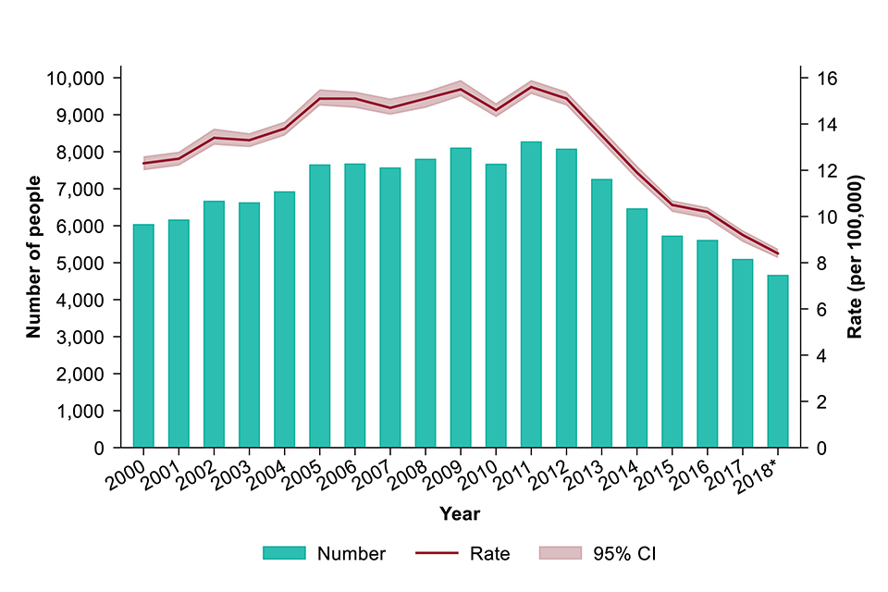
(Gov UK, 2019, image)

Anatomy and Physiology

Whilst infective components outstretch to alveoli (tiny saclike structures in the air spaces in the lungs), another lymphocytes cell sweep over the TB bacteria. Then the bacteria are transported to the lymphatic mechanism and bloodstream, and other organs occur.
The bacteria further multiply in organs with high oxygen pressures, such as the upper lobes of the lungs, the kidneys, bone marrow, and meninges -- the tissue layer that overlays the cerebral or spinal cord. (Project in Human Anatomy & Physiology, 2013)
Tuberculosis has often damaged the lungs and is also recognised as the pulmonary as the human body’s respiratory system. Other organs can be damaged, for example, the inner layer of the lungs (pleural TB), the nervous system that is the central nervous system (TB meningitis), osseous tissue is, also called ‘bone’ and joints (musculoskeletal system) to lymph nodes and abdominal section which connected with liver, spleen and the bowels (abdominal TB), kidney and bladder(orogenital TB) and blood as (circulatory system). (The Conversation, 2019).

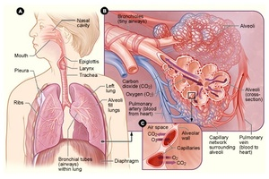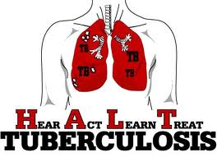
Tuberculosis is transported in the air in fragments called nuclei of 1-5 micrometre, and it is infective. The process starts when an individual breathes the droplets nuclei that contain M. tuberculosis, which travels either via the mouth or nasal canal, upper respiratory region, and bronchi to arrive at the lungs’ alveoli. (NHS, 2019) How to identify TB;
TB is frequently identified with the dermatological examination. The test procedure is by dropping a tiny drop of test substance onto your skin. If a particular size of lumps progresses within a few days, this can indicate possible TB infections. Other means of testing include x-ray, phlegm tests or blood testing procedures. (John Hopkins Medicine, 2022)

Health and Lifestyle routine measures

Many of you may have contracted TB bacteria but not progressed the illness because the immunity given by the immunisation cannot keep you lifelong protected.
People with weakened immunity are a substantial threat of getting infected. Thus, keeping a healthy lifestyle is vital to preventing TB. Including fresh fruits and vegetables, take a proper meal that contains carbohydrates, proteins and fats.
Cease smoking and stop consuming alcohol, exercise consistently and keep active. (The (Health Site, 2015)

The healing process can take around 12 months in active TB. Therefore, enhancing the immune system is vital to battle with good nutritional support. Individuals who are weak and not adequately supported with proper nutrition are considered at risk of having TB even after when they heal. Food s that contains essential vitamins, minerals, and nutritional supplements can fortify your body to fight TB. Physical activity;
If an individual with TB is capable of doing any bodily exercises, then this can turn fat into muscles fortifying the body and supporting your enthusiasm to eat more. (TB Facts, 2022)
Food advice and avoidances are described below explained;
- Sufficient iron and vitamin B complex also food that contains darker leaf greens, spinach and kale.
- Any whole grains, wheat pasta, bread and cereals.
- Colourful vegetables with rich antioxidants, carrots, pepper, fruits, tomatoes, berries and cherries.
- Olive oil, unsaturated fats, no butter. (Rodriguez, 2009)

- Avoid smoking and alcohol consumption.

- Limited coffee and refined products such as white sugar, bread or rice.

- Instead of red meat, protein-based foods include pulses, beans, chicken, tofu and fish.
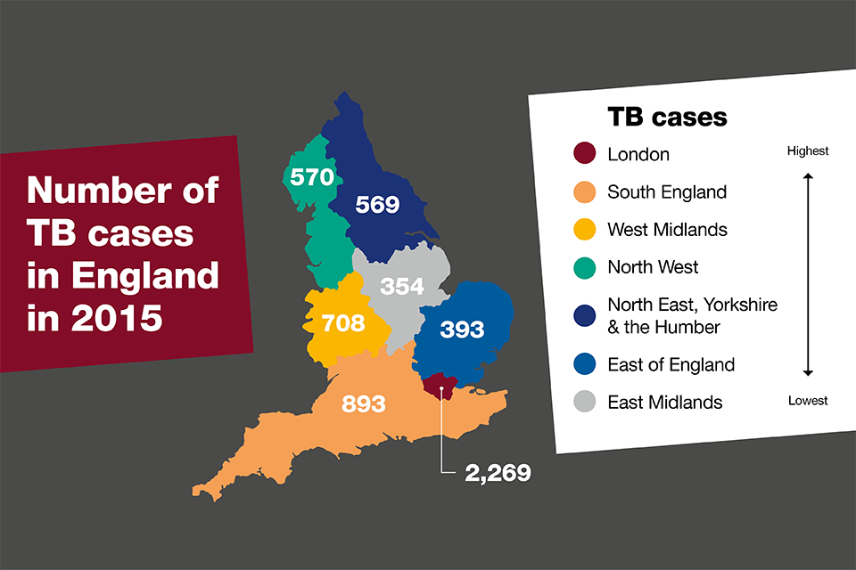
(GOV UK, 2016)

Health and Social Care practice

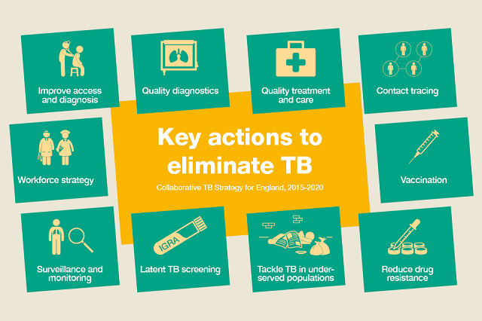

The National for Health and Care Excellence (NICE) involvement provides a screening programme in the UK, especially for people who have maximised risk of TB.
It is crucial to implement consciousness of TB within communities and from the medical workers’ point of view. ‘The Tuberculosis (TB) Action Plan for England, 2021-2026’. Acknowledges that the filtering for active or inactive types of TB and promoting consciousness programmes will support minimising the prevalence of TB in England. (Public Health England, 2014).
The master plan utilised to surface the active cases is Discovering those who typically do not pursue efficient medical attention. (Golub et al., 2005) This system called (ACF) generally targets and filters individuals with pulmonary TB by utilising radiograms or symptomatic requests. If the results are not typical, they will be collected via phlegm test for further examination.
A timely approach to discovering TB enhances the therapy results and stops the prevalence of the illness.
Countries with a lower majority of cases utilised this system approach called ACF (‘active case finding’) with people with significant risk. (Zenner et al., 2013); (Pareek et al., 2016). In the United Kingdom, ACF operates on;
- Medical workers who carry the risk
- Patients who have very close contact
- Homeless individuals
- Individuals with alcohol and substance problems
- Convicts
- Refugees’ involvement where TB prevalence is high.
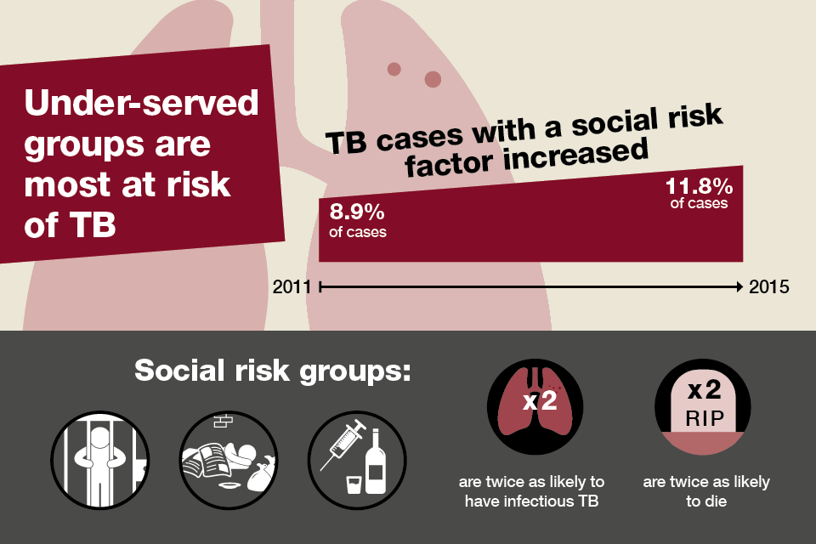
(GOV UK, 2016)

5. Recommendations

“Tuberculosis (TB): a collaborative strategy for England.”
Currently, the direction that the TB in England is heading toward and intensely concentrated, with fewer quantities of significant prevalence by region.
Despite some complicated issues occurring with multidrug-resistant (MDR) people with this illness, which can be anywhere or any place in the country. Several regions obtained significant attainment fortifying TB services, and dedicated services given to those who need the support have made a positive impact. Regardless of that dedication provided by leadership, the total figure of the ailment had not displayed a persistent decrease currently. (PHE, 2018).
The current scenario for the UK indicates that if prevention is ignored to identify and sufficiently cure, the TB prevalence can cause significant damage in the communities, such as the TB pandemic. Accomplished TB management applications were provided from similar countries such as the US, Germany, and the Netherlands had minimised the level of TB cases by controlling the prevalence of the disease. As for the UK, we need to learn and implement the same approach to reduce the current system of well-managed implementation.
Public Health England and NHS joined to manage Tuberculosis prospectively. This co-operated plan for 2015-2020.
1. Progress accession to services and promote timely diagnosis
2. Supply entry to adequate quality testing
3. Develop better therapy and medical care
4. Detailed contact tracing
5. Develop and promote BCG immunisation comprehension
6. Minimise medicine-resistance of TB
7. Better intervention for TB in under-served populations.
8. Carry out a consistent TB filtration for newcomers (latent)
9. Better observation and better follow-up
10. Ensure an appropriate workforce to deliver TB control.
It is a societal issue, particularly in underprivileged areas in the UK, causing unemployment, unhealthy lifestyle and alcohol misuse.

The United Kingdom Health Security Agency is dedicated to reaching WHO’s eradication objectives of TB before 2035, which defines an action scheme called “TB action plan for England 2021-2026”, which is the yearly reduction of achievement programme on TB prevalence in the UK. (GOV UK, 2015).
Timely detection and increased consciousness are significant amongst communities with community centre approach to therapy that is medical protection with complying the significance of the treatment.
In the UK, the therapy for Tuberculosis is available without no charge to anyone who suffers from this health condition.
The multiagency approach within the community, especially for people who possess a high risk of Tuberculosis and the staff who deal with patients, should be supported and educated by a multi-disciplining team. (NICE, 2016)
More significantly, TB is curable, and there is no fee for NHS treatment. A timely reaction is essential, especially for asylum seekers and refugees who are more susceptible to TB. Consequently, their registry to GP should be made available as soon as possible with screening and control of the TB prevalence.
The information should also be made available and accessible to all people who carry the risk of TB to prevent further transmission. (PHE,2018).

6. Conclusion

The prevalence of TB in the last decade has gradually risen in the UK, particularly among people who come to the UK from countries where incidence rates are higher than in the UK. Therefore, early screening and therapy are significant to stopping the prevalence of TB. Furthermore, local agencies should work collaboratively and strategically to encourage individuals to come forward if they suspect any symptoms of TB with a holistic approach.
The below measures were concluded and advised by (PHE, 2016)
- Printable data, letters, calls, texts and mobile apps using a relevant language.
- medical information, guidance and individual-centred approach
- Individual-based medical guidance, information from a reliable authority.
- home visits
- societal assistance
- monitoring

TB can be deadly if therapy is lacking, and therefore, it can cause serious medical issues and infection. Moreover, excellent therapy care is inevitable to deal with TB and ensure the ratio is well managed. (Department of Health, 2007)

Local authorities’ objectives on TB are significant to stop the TB incidence in the UK. They should mainly concentrate on people who are more susceptible to TB ailment, which is more frequent. A holistic attitude is needed to involve everyone in a multi-agency and robust management approach to battle and control the prevalence of TB.

References

Business Standard (2014) TB is a new life style disease: [online] Available at: https://wap.business-standard.com/article-amp/specials/tb-is-the-new-lifestyle-disease-11421200664-1.html (Accessed:19/04/2022)
Department of Health (2013) Public Health Outcomes Framework [online] London: department of health,2013. Available at: https://www.gov.uk/government/publications/healthy-lives-healthy-people-improving-outcomes-and-supporting-transparency. (Accessed:16/04/2022)
GOV UK, (2013) Tuberculosis rates remain among highest in western Europe: [online] PHE. Available at: https://www.gov.uk/government/news/tuberculosis-rates-remain-among-highest-in-western-eorope. (Accessed: 17/04/2022)
GOV UK, (2015) Tuberculosis in England: Annual report{online] UKHSA. Available at: https://www.gov.uk/government/publications/tuberculosis-in-england-annual-report. (Accessed: 18/04/2022)
Golub, J.E et al. (2005) Patients and health care system delays in pulmonary tuberculosis diagnosis in a low-incidence state: Impact of empiric antibiotics and the chest radiograph on delays in the diagnosis of tuberculosis [online] Int J Tuberg lung Dis 2005; p 392-397 Available at: https://local.gov.uk/sites/default/files/documents/22.22%20tackling%20tuberculosis_05pdf. (Accessed:19/04/2022)
GOV UK, (2016) Health matters: [online images] Available at: https://www.gov.uk/government/publications/health-matters-reducing-the-burden-of-tuberculosis/health-matters-reducing-the-burden-of-tuberculosis. (Accessed: 18/04/2022).
National Institute for Health and Care Excellence (2016) Tuberculosis: Guidance. [online] NICE, 2016. Available at: https://www.nice.org.uk/guidance/ng33. (Accessed: 19/04/2022)
NHS (2019) Tuberculosis: Overview [online] NHS. Available at: https://www.nhs.uk/conditions/tuberculosis-tb/. (Accessed: 18/04/2022)
Pareek, M, et al. (2016) The impact of migration on tuberculosis epidemiology and control in high-income countries: a review [online] Springer link, 2016. Available at: https://link.springer.com/article/10.1186/s12916-016-0595-5 (Accessed: 18/04/2022)
Public Health England (2014) Tuberculosis in the UK: 2014 report. [online]. London. Public Health England;2014. Available at: https:// UK. (Accessed:18/04/2022)
Public Health England (2018) Tackling tuberculosis: Local government’s public health role. [online] Local government association/pdf. Available at: https://www.local.gov.uk/sites/default/files/documents/22.22%20tackling%20tuberculaosis_05.pdf. (Accessed: 17/04/2022)
Public Health England (2021) Collaborative TB Strategy for England, 2015-2020: End of programme report. PHE [online] Available at: https://assets.publishing.service.gov.uk/government/uplooads/attachement-data/file/971925/collaborative-TB-Strategy-for-England-2015-2020-End-of-Programme-Report.pdf (Accessed: 20/04/2022)
Rodriguez, D. (2009) The proper diet to beat tuberculosis [online] Available at: https://www.everydayhealth.com/tuberculosis/the-right-diet-to-beat-tuberculosis.aspx.(Accessed: 05/04/2022)
TB Facts. Org (2022) Food & TB [online] Available at: https://tbfacts.org/food-tb/. (Accessed: 15/04/2022).
The Conversation (2019) TB doesn’t only attack the lungs: other organs are also vulnerable: National Disease for Communicable Disease [online] Available at: theconversation.com/tb-doesn’t-only-attack-the-lungs-other-organs-are-also-vulnerable-113791 (Accessed: 19/04/2022)
The Health Site (2015) Five ways to prevent tuberculosis:[online] Available at: https://healthsite.com/diseases-conditions/5-ways-to-prevent-tuberculosis-183633/ (Accessed:20/04/2022)
The Truth About TB, (N.D) Health & Immunity: The truth about TB [online] Available at: https://www.thetruthabouttb.org/am-i-at-risk/health-immunity/text. (Accessed: 19/04/2022)
Zenner D, et al. (2013) Active case finding for tuberculosis among high-risk groups in low-incidence countries. [online] Tuberc Lung Dis. 2013; 17:573-582. Available at://pubmed.ncbi.nlm.nih.gov/23575321/ (Accessed: 18/04/2022)

