enGINE CONTROL SYSTEMS Techincal Report
Electronic Ignition and Fuel Ignition Systems

Callum Evans 1702660
BSc/HND Motorsport and Automotive Engineering

Abstract
This technical report conveys information regarding electronic ignition and fuel ignition systems. Systematic testing on a LH2 Jetronic engine and a Motronic systems has taken place and results have been obtained and. The two systems have been discussed and compared and any improvements to the systems have been included.

Contents
1. Abstract 1
2. Introduction 3
3. Research 4
1.1 Motronic systems 4
1.2 Wasted Spark systems 5
1.3 Direct Injection system 5
4. Methodology 6
4.1 Equipment 6
4.2 Motronic engine process 7
5. Results 9
5.1 Motronic system results 9
5.2 Jetronic System results 12
6. Analysis 14
6.1 Motronic analysis 14
6.2 Jetronic system 16
7. Engine Electronic Advancements Suggestions 18
8. Conclusion 19
9. References 19
10. Appendices 19

Introduction

This report will involve the investigation and analysation of different types of Electronic Ignition and Electronic Fuel injection systems using digital testing equipment.
The report will include results obtained from a testing session held in a test lab on 2 different engines. The first engine was a 2 litre Motronic system and the other was a 1.5 litre LH2 Jetronic system. Digital testing equipment was used to record all the necessary voltage waveforms such as injection on time. Also, ohms and voltage readings have been obtained from the use of a digital multi meter to measure voltage and resistance of electronic components on the engine such as the throttle switch and a throttle potentiometer. These results have been compared to the engine system manual and any imperfections or differences such as high ohms readings have been discussed.
The test results have been used to create graphs as it is easier to compare the data. Improvements have been suggested to the tested systems to make them more up to date with the current technology. More efficient systems like wasted spark systems have been explained in the technical report and why they are used.

Research
Electronic ignition system is the type of ignition system that uses electronic circuit, usually by transistors controlled by sensors to produce electric pulses which in turn generate better spark that can even burn the lean mixture and provide better economy and lower emissions (Mishra, 2017)
There are 3 types of basic automotive ignition systems. Distributor based, distributor-less and coil-on-plug. Early ignition systems used fully mechanical distributors to deliver the spark at the right time. The new generation of ignition involves more reliable distributors equipped with solid state switches and ignition control modules. (Mishra, 2017)

Motronic systems
Motronic systems is the name given to Bosch systems for the open and closed loop control of spark ignition engines. The Motronic system compromises all sensors for detecting ongoing operating data from the engine and all the actuators that perform the required adjustments to the spark injection engine. The ECU is reading information off all the sensors every few milliseconds to meet the systems real time requirements. (Dietsche, Electricle system overview, 2018) M-Motronic combines all the electronic systems for engine control in a single ECU.
Engine mounted sensors gather the required information and signals which relay the readings to input circuits for:
- Ignition (on/off)
- Camshaft position
- Vehicle speed
- Gear selection
- Transmission control
- Air conditioner
Monitored analog data includes:
- Battery voltage
- Engine temperature
- Intake-air temperature
- Air quantity
- Throttle-valve angle
- Lambda oxygen sensor
- Knock sensor
- Engine speed.
The ECU uses this signal inputs and relays them as outputs to elements such as, injectors, spark plugs. (Barho, 2000)
To follow modern legal legislation in terms of new emission rules. M-Motronic functions make it possible to monitor all the components associated with the exhaust gasses. These include:
- Idle-speed control
- Lambda oxygen control
- Control of the evaporative emissions control system
- Knock control
- Exhaust-gas recirculation (EGR) for reducing NOX (Barho, 2000)
With the single ECU controlling all these components it is possible to re map the ECU to make way for modified inlet manifolds and turbo charges to create more power and improve efficiency.

1.2 Wasted Spark systems
Wasted spark ignition systems use one coil for every two cylinders. The coil provides the spark for one of the paired cylinders on the compression stroke and to the other on the exhaust stroke. Because the coil fires the spark plug on the exhaust stroke as well, it is appropriately named 'wasted spark ignition'. In effect, the spark plugs fire simultaneously and twice as often. (NGK, NA)

Direct Injection system
DIS use one ignition coil per cylinder and sit directly on top of the spark plug therefore no HT leads are needed. An ignition coil primary circuit is required for each ignition coil, (ECU controlled). The switching is carried out by the ignition amplifier. The amplifier is usually found built into the body of the ignition coil. The ECU supplies the amplifier with a low voltage (around 5 volts) switching signal, this signal can then be seen by the amplifier and with it controls the primary circuit to provide the spark to the plug. (Hiller, 2004)
The ECU provides an ignition control timing signal which is different depending on the firing order of the engine. A 4 cylinder would be 1-3-4-2. To provide this information the ECU needs to know other information about the engine including Engine speed and crankshaft position. The ECU needs to know when the no1 cylinder is nearing TDC. (Hiller, 2004)

Methodology

Equipment
- Digital Fluke Multimeter. This was used over an analog multi meter because of its accuracy and reliability compared to the analog versions. Digital multimeter are more resistant to drops and shock failures. This is because they do not have moving parts like the needle in an analog meter, they can be easily knocked of their reading. Digital meters have an auto polarity function, this prevents connecting the probes to the wrong polarity of a circuit. Digital meters cause less loading effect on circuits and can prevent damaging the ECU. An analog meter is usually more accurate at checking things like a diode. (Morris, 2012) However, the lab testing only consisted of measuring resistance in ohms and Voltage in volts.
- Digital Oscilloscope. A Digital oscilloscope allows the user to have access to a variety of functions such as Zoom levels and comparison functions. Digital scopes are more suited to higher frequency signals. An analog scope can only save an image instead of the signal on the tube. The digital makes it easier to look at the details of our primary waveform at different engine speeds (Hickman, 2000)
- Lab Coats. These must be worn to cover flammable items of clothing underneath, also covers up any lose clothing
- Extractor fans. The extractor pipes must be placed over the exhaust of the engine to filter out carbon monoxide and carbon dioxide. Doors must be cracked open to also filter out any harmful gasses.
- Rotating part engine guards. Wherever there is a rotating part on the engine like the flywheel or the auxiliary belt.
- Safety measures. Only 1 person should be measuring a component on a running engine at any time. This is to reduce contact with the engine.
- Safety measures. Clear communication from the person who turns on the ignition and cranks the engine to their fellow partners.

4.2 Motronic engine process
Static Testing
- Put on all necessary PPE and set up extraction fans and open doors for ventilation.
- Allocate roles within the group. Data recording, component reading, ignition on/cranking.
- Turn Fluke multimeter to Volts (direct current) and measure all the ECU pins with the ignition off
- Repeat process with ignition on
- Record all voltages found
- Turn the Fluke multimeter to Ohms to measure resistance
- Unplug and measure resistance of the primary and secondary winding of the Kettering coil using the 2 probes of the multimeter. It does not matter which way you put the leads when measuring resistance.
- Unplug and measure resistance of the rotary idle valve
Unplug and measure resistance of the 4 Injectors stating at number 1 which is nearest to the cam belt
- Unplug the leads from the distributor cap and twist and pull them off the spark plugs
- Measure resistance of the leads one at a time and record any differences
- Unplug and measure resistance of the throttle potentiometer
- Unplug and measure resistance of the air flow sensor
- Unplug and measure resistance of the coolant temperature

Operating Testing
- Set up Bosch digital oscilloscope
- Remove old dipstick and match the length to the temperature probe attachment
- Place the probe into the dipstick, do not push it down too far to prevent the probe getting wrapped around the crankshaft
- connect the scope to a good earth/ground somewhere on the vehicle or battery.
- Connect channel 1 to a HT lead
- Check the oil temperature and use this as a starting temperature
- Run the engine letting the temperature go up in increments of 10 degrees until 80 degrees is reached.
- At each increment of 10 complete the steps below
- Use the scope to record the primary waveform and measure the injection on time in milliseconds by freeing the scope reading.
- Using a multi meter measure the voltage of NTC2 by measuring across pins 2 and 45 and record the reading in volts
- Remove the plug off NTC2 (temperature sensor) and measure the resistance across it using a multi meter on the 2 pins. Record the reading in ohms.
- Using pin 4 measure the reading from the rotary idle valve and convert to a percentage
- Using pin 5 Measure the reading from the charcoal canister too see when this is in operation
- Using pin 28 measure when lambda begins to read and record what temperature a change occurs
- Repeat the above readings every 10 degrees until 80 is reached

The testing procedure will be the same for the Jetronic engine apart from there are different engine components to test such as the auxiliary air valve.
Also, during the operational testing, lambda and the charcoal canister are not part of the Jetronic system. So only NTC2 and Injection on time will need to be recorded.

Results

5.1 Motronic system results
(Figure 1)
(Figure 2)
(Figure 3)
 | Rotary Idle valve | Charcoal Canister | Lambda
Temperature | Pin 4 (%) | Pin 5 | Pin 28
20 | 41 | off | off
30 | 43 | off | off
40 | 42 | off | on 40-46°
50 | 44 | off | on
60 | 44 | on 52-61° | on
70 | 48 | on | on
80 | 43 | on | on

(Figure 4)
Figure 1,2,3 and 4 are all results obtained from the operation testing of the Motronic system. All the results have been gathered with the use of a digital multi meter and a digital oscilloscope. Findings and analysis will be discussed in the next chapter
Static testing with ignition off
PIN | Voltage | Function
16 | 12.45 | Injectors
36 | 12.31 | ECU Power

(Figure 5)
The above table shows the main findings of the static testing with the ignition off. The permanent lives are discussed in the next chapter.
Cold Cranking @ | 17.8°C
Injection on time | 20ms

(figure 6)
Figure 6 above shows the results from the injection on time at cold start up.

Voltage and resistance measurements were taken of electronic engine components. These reading were then compared with the manual of the engine to see if there were any problems with the components. The components were:
Lead 1 (KOhms) | 19.84
Lead 2 (KOhms) | 18.1
Lead3 (KOhms) | 15.44
Lead 4 (KOhms) | 25.1
- Throttle potentiometer
- Air flow sensor
- Coolant temperature sensor
- Air temperature sensor
- Kettering coil (primary and secondary winding)
- Injector resistance
- Rotary idle valve resistance. (Figure 7)
- All 4 HT leads

5.2 Jetronic System results
(Figure 8)
(Figure 9)
(Figure 10)

Temperature | NTC2 Pin 8 ohms | NTC2 pin 8 Voltage | Injection on time (ms)
19 | 2770 | 2 | 4.4
30 | 1080 | 1.2 | 3.2
40 | 770 | 0.9 | 2.6
50 | 520 | 0.7 | 2.6
60 | 400 | 0.5 | 2.6
64.2 | 570 | 0.7 | 2.8

(figure 11)
Cold Cranking @ | 19°C | 13.2 Ms

(figure 12)

Components that were tested against voltage and resistance on the Jetronic engine:
- Throttle switch
- Coolant temperature sensor
- Auxiliary air valve
- Injectors
- Kettering coil, primary and secondary windings
- King lead to the distributor
- All 4 HT leads
HTLead 1 | 8640
HT Lead 2 | 8830
HT Lead 3 | 7650
HT Lead 4 | 5580

(Figure 13)

This table shows the ohms readings obtained from the HT leads after being disconnected from the spark plugs and the distributor. Any differences are discussed in chapter 6 part 6.2

Analysis

6.1 Motronic analysis

A. NTC2 Coolant Temperature sensor
Figure 1 and 2 shows data collected from the NTC2 coolant temperature sensor, figure 1 shows the voltage reading and figure 2 shows the resistance readings. Looking at figure 2 it is obvious to see the colder the temperature, the higher the resistance in the NCT2 sensor. The voltage going through the sensor (figure 1) has a very similar shape to the graph figure 2. This is because the ECU uses a 5-volt circuit that passes through NTC2 to understand what the sensor is reading. The higher the resistance the higher the voltage. When the sensor is reading at 20 degrees the resistance is as high as 1470 ohms. The ECU will know the resistance is high because of the 3volts running through the sensor. With this information the ECU knows that the engine is cold, and it will have to take measures to make sure the engine warms up.

B. Injection on time
When the ECU knows that the engine is cold because of the feedback from NTC2 we can see from figure 3 that the injection on time increases. During the warmup phase from 20-40 degrees the injection on time is on for as long as 3.5 milliseconds. When the engine gets to operating temperature and NTC2 is reading 1v then the injection on time decreases to 2.7 milliseconds.
The ECU increases injection on time to warm up the combustion chamber faster. This is because fuel vapor condenses on the cold surfaces within the cylinder and less of it burns. So, injection on time is increased to compensate. (This statement can be backed up by this source) (Garrett, 2001)

C. Rotary idle valve
In figure 4 the Rotary Idle Valve can be seen operating to bypass the throttle body at 70 degrees where the valve is 48 percent open. This is because the fan kicked in and was trying to cool the engine, therefore the Valve opened to keep the idle stable and compensate for the extra electrical load. During cold cranking, the rotary idle valve would off been approximately 45% open, however the engine was not idling smoothly because on an inherent issue with number 4 HT lead. Also it would have been hard to see the rotary valve in operation at the cold start because there is no gearbox attached and therefore no extra load to overcome therefore there was no need for the idle valve to work. (why and when the Rotary valve works can be backed up by this source) (Hatch, 2020)

D. Charcoal canister
It can be seen from figure 4 that the charcoal canister starts to be used. Vapour from the cars fuel tank get let into the intake to be burnt. This occurs within the range of 52 to 61 degrees. This is because the engine is getting close to operating temperatures. This means the combustion chamber temperatures are not too cold to start condensing the vapor. If the canister was always working, then at cold start up the fuel and air mixture would be improper causing knock and a rough idle. (information about the charcoal canister can be backed up by this article) (Azuma, 2020)

E. Lambda
It is clear from figure 4 that the lambda is not involved until the engine reached 40-46 degrees. Lambda sensors are situated in the exhaust and measures the oxygen content of the gages leaving the combustion chamber. The lambda sensor can detect how clean the vehicle is running and can tell the ECU to alter the air and fuel mixture by changing the injection rate to produce either a leaner or richer mix. When lambda measures less than 1 this indicates air deficiency and therefore a rich mixture. Enriching the air/fuel mixture may be necessary to protect components against thermal overload (information can be backed up by this source) (Dietsche, Lambda , 2018) which could lead to pre destination which can lead to knock, which can also lead to knock sensors retarding ignition. Therefore figure 4 shows the lambda not reading at cold temperatures because the ECU is running a rich fuel mixture to warm up the engine during cold phases.

F. High readings with problematic components
All the readings resistance and voltage readings obtained with the digital Fluke multimeter were as expected and there were no problems with any components apart from Number 4 HT lead. As seen from figure 7 the resistance in lead 4 was much higher than the others. It would be expected to see a slight variation in ohms reading as the leads are all different lengths. However, this lead was an aftermarket component and is not meant for the vehicle. This meant that a slight mis fire can be seen on the oscilloscope.

G Cold cranking
Figure 6 shows more results supporting the fact that the ECU increases injection on time significantly doing cold start up. The results show at 17.8 degrees the injection on time was 20ms compared to 3.5ms at cold idle and 2.7ms and warm idle. (This statement can be backed up by this source) (Garrett, 2001)

6.2 Jetronic system

A1. Injection on time
The main findings from the graphs (figure 8, 9 and 10) are very similar to the Motronic systems in terms of what the ECU is telling the injectors to do with the information gathered from the temperature sensor.
From figure 10 we can see that the injection on time at 17 degrees was 4.4ms compared to the Motronic engine which had an injection on time of 3.2ms at 20 degrees. Therefore, it is apparent that the Jetronic engine was injecting more fuel into the cylinder during cold phases. (refer to 6.1-part B for information on why this happens) The reason for the longer injection time could have been due to the 3 degrees difference when the engines were first run. The Jetronic system seems to get to normal injection on time readings quicker compared to the Motronic system. Looking at figure 10 at 40 degrees the ignition on time is already as low as 2.6ms. Figure 3 Shows the ignition on time to only get as low as 2.7ms at 80 degrees, double the temperature of the Jetronic. This can be down to the engines having different displacement sizes therefore the Motronic engine is using more fuel to warm up its bigger displacement.

B1. Other components
The Jetronic system does not have the same electronic components as the Motronic engine system. It does not have a rotary idle valve, lambda sensors or a charcoal canister. Therefore, the Motronic engine will be much more efficient because it knows more parameters about itself and can adjust accordingly.

C1. Auxiliary air valve
To replace the rotary idle valve on the Motronic engine the Jetronic system has an Auxiliary air valve. This is used by providing additional air to the cylinder so that together with the additional injection on time the engine can overcome greater friction during the cold phases. The hotter the engine gets the less additional air is provided.(this can be backed up by information from this source. (Bosch, unknown )

D1. High readings with problematic components
Slightly higher resistance readings where found with the auxiliary air valve. The recorded value was 46.3 ohms and the manual said it should have been 40 ohms. This difference was caused by the component being aftermarket and therefore it may have different tolerances. The resistance was measured in the HT leads when disconnected from the plug and the distributor. The Ohms readings were all slightly different because of the varying length in the cables. The shorter the lead the less resistance it should measure. It can be seen in figure 13 that the HT lead 1 is furthest away from the distributor and number 4 is the closest.

E1. Cold cranking
Figure 12 shows cold cranking results at 20degrees. The injection on time is 13.2 Ms. This increase is due to the engine using triple injection to help it start. However, compared to the injection on time of the Motronic engine its 7ms shorter, this can again be because of the larger displacement of the Motronic engine.

Engine Electronic Advancements Suggestions

The two engines that were tested are not quite up to date with the current emissions regulations therefore some improvements/ changes could be made to make they electronic systems on the engine more reliable and help improve engine efficiency.
The engines could be introduced to distributor less ignition systems like a coil on plug this can eliminate the Kettering coil and the mechanical distributor. Some advantages of this system would be: (information backed up by this book) (Erjavec, 2004)
- No moving parts and therefore requires less maintenance
- The spark plugs have a longer service life because they run cooler as they are not needed to fire as often.
- Flexibility on mountain locations, newer engines are very compact and small
- No mechanical load on the system in order to work
- More energy efficient
Double Ended coil/Wasted Spark Systems could also be introduced where one ignition coil can be used for two spark plugs. This means that 2 spark plugs are ignited at the same time. Advantages of this are the coils have a longer saturation time and do not get too hot which can increase component life. Also, the engine can run on less cylinders in slow moving traffic to increase efficiency. (more information about wasted spark in research section)
The Jetronic engine can look at the Motronic engine to look for improvements. The use on a lambda sensor would improve emissions as the fuel and air mixture could be varied using the ECU to change the injection on time accordingly. Also, to improve emissions the use of a charcoal canister could be considered to emit less harmful gasses into the atmosphere. These two improvements could help the engine pass Euro emission regulations. (More into of Lambda and Charcoal canister in chapter 6-part D)

Conclusion
Throughout this report it become apparent that the two engines that were tested were not very efficient and did have inherent problems. However, the testing helped gain a greater understanding of how the Motronic and Jetronic behave differently throughout the warmup phases. It was interesting to see how the injection on time is different between the two systems and why this would be. A greater knowledge of the components fitted to the engines and how they operate was gained. It was interesting to see how the rotary idle valve is used on one engine and the auxiliary air valve used on the Jetronic engine. Finding out when lambda and the charcoal canister was turned on and how they affected the Motronic engine was also useful information. Experience was gained with using a digital multimeter and a digital oscilloscope. Using a multimeter to measure resistance can be used in the future to test if a valve or sensor is damaged. The testing has also helped one understand how the systems could be improved and how a wasted spark system could be introduced and what benefits it can bring. It has also been discussed how the distributor is unreliable and less accurate because it is a mechanical component. Therefore, the importance of ECU controlled components is favoured on newer vehicles because if their reliability and efficiency.

Improvements to Testing
Improvements could have been made to the testing. Different testing labs could have been used where the conditions could have been changed and then the engines tested again. A good service of the engines could have been taken place and the testing run again to see any improvements. Introducing a gearbox to the engine to see if the extra load influenced the ignition and injection at cold idle. Results from other groups could have been obtained and an average could have been calculated. This would give more accurate results.

References

Bibliography
Azuma, T. (2020, march 09). Charcoal canister . Retrieved from Car from japan .com: https://carfromjapan.com/article/car-maintenance/bad-charcoal-canister-symptoms/
Barho, H. (2000). M-Motronic System overview . In R. bosch, M-Motronic Engine managment (p. 21). stuttgart.
Bosch. (unknown , na na). Auxillary air device . Retrieved from bosch classic. com : http://www.bosch-classic.com/en/internet/bosch_classic/produkte/motor_1/zusatzluftschieber__elektrisch/zusatzluftschieber_bimetall___mit_teaser_1.html#
Dietsche, K.-H. (2018). Electricle system overview. In K.-h. dietsche, Bosch automotive handbook (p. 617). Germany: Robert Bosch.
Dietsche, K.-H. (2018). Lambda . In K.-H. Dietsche, Bosch automotive handbook (p. 655 and 695). germany : Robert Bosch.
Erjavec, J. (2004). electronic igntion system operation . In J. Erjavec, Automotive Technology: A Systems Approach (p. 615).
Garrett, T. (2001). Adjustment for various opeating conditions . In K.newtown, Motor vehicle (p. 445). oxford .
Hatch, S. V. (2020). Fuel managment system . In S. V. Hatch, Computerized Engine Controls (p. 414).
Hickman, I. (2000). Digat storage ocsillocsopes . In I. hickman, Digat storage ocsillocsopes (p. 7). oxford: Reed Elsevier Group .
Hiller, V. (2004). Engine Managment-Ignition system . In P. c. Hillier, Hillier's Fundamentals of Motor Vehicle Technology, Book 1 (p. 191). Cheltenham: Nelson Thornes .
Mishra, P. (2017, November 17). How electronic ignition system works . Retrieved from Mechanical booster.com: https://www.mechanicalbooster.com/2017/11/electronic-ignition-system.html
Morris, A. s. (2012, NA NA). Advantages of Digital Multi meters. Retrieved from Bright Hub Engineering : https://www.brighthubengineering.com/consumer-appliances-electronics/113975-pros-and-cons-of-digital-multimeters/
NGK. (NA, NA NA). Wasted Spark Ignition Systems. Retrieved from NGK.com: https://www.ngk.com/learning-center/article/815/wasted-spark-ignition-systems

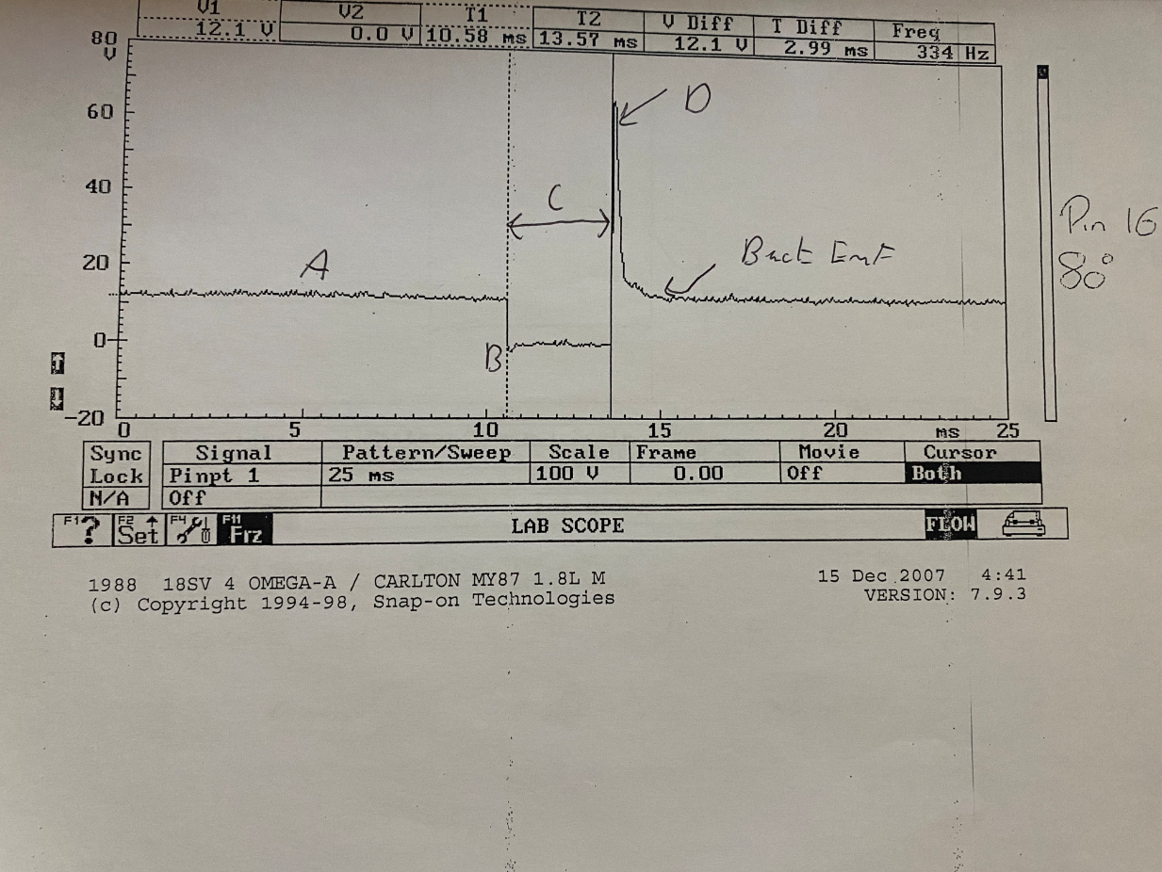
Appendices
appendix 1 Motronic system 80 degrees
Injector idle waveform. The first initial line is the dwell time (A). This the injector being charged. Where the line drops to 0 volts this is the injector going to ground (B). The whole time the line is at 0 volts the injector is turned on. This is injection on time (C). The steep line after it is the injector voltage spike ad it regains voltage(D). Then the line goes back to battery voltage which is back emf

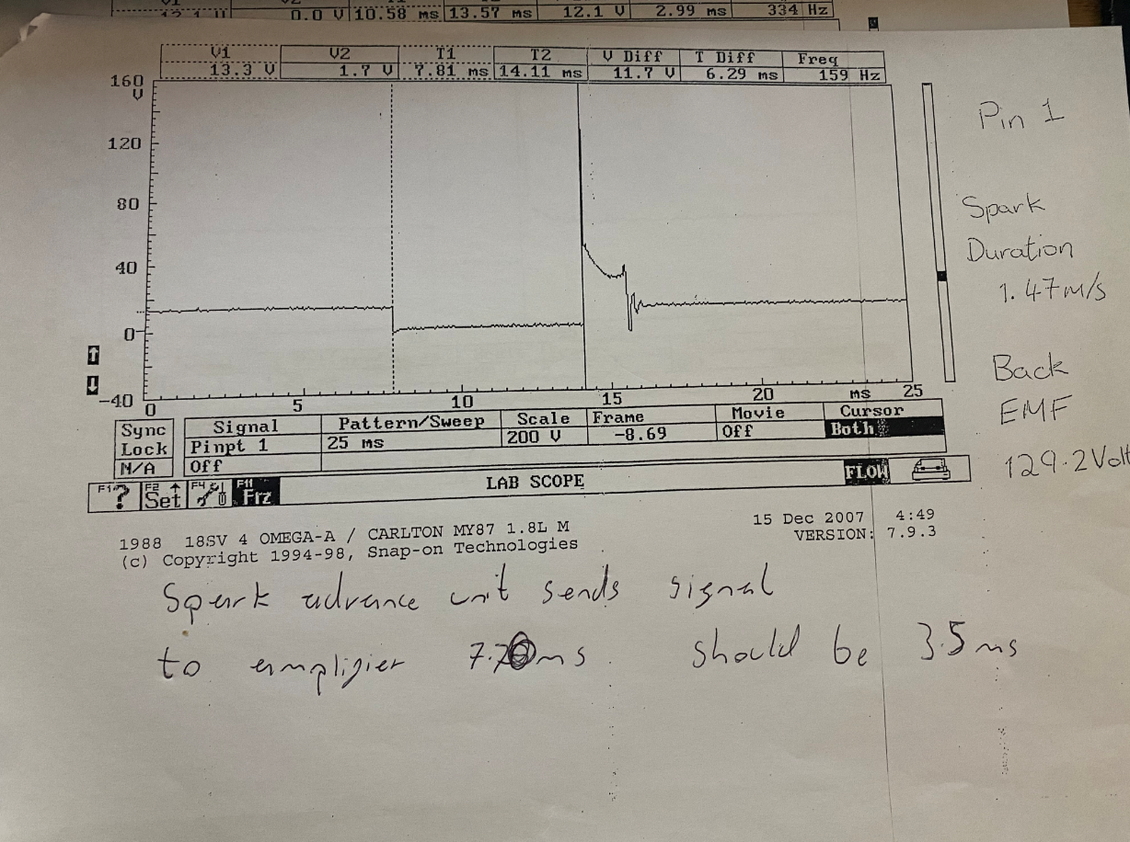
appendix 2 (information handwritten)

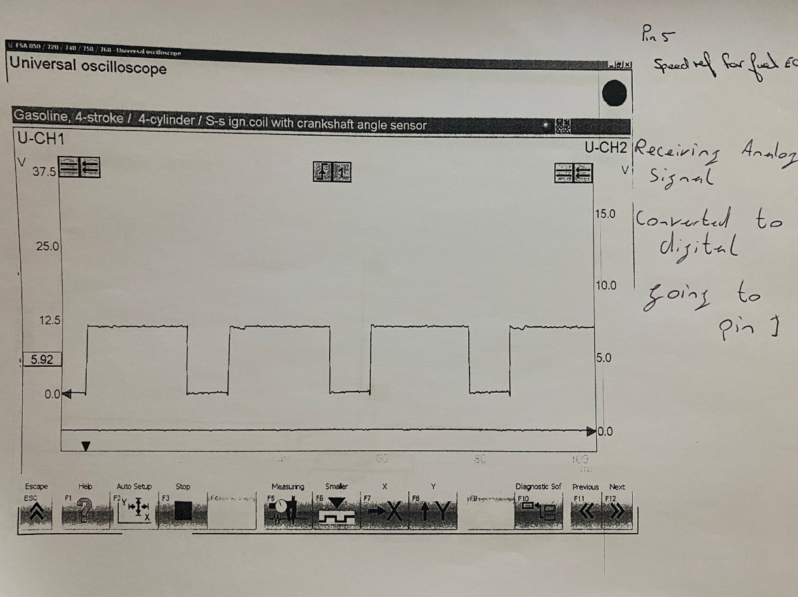
Appendix 3 (information handwritten)

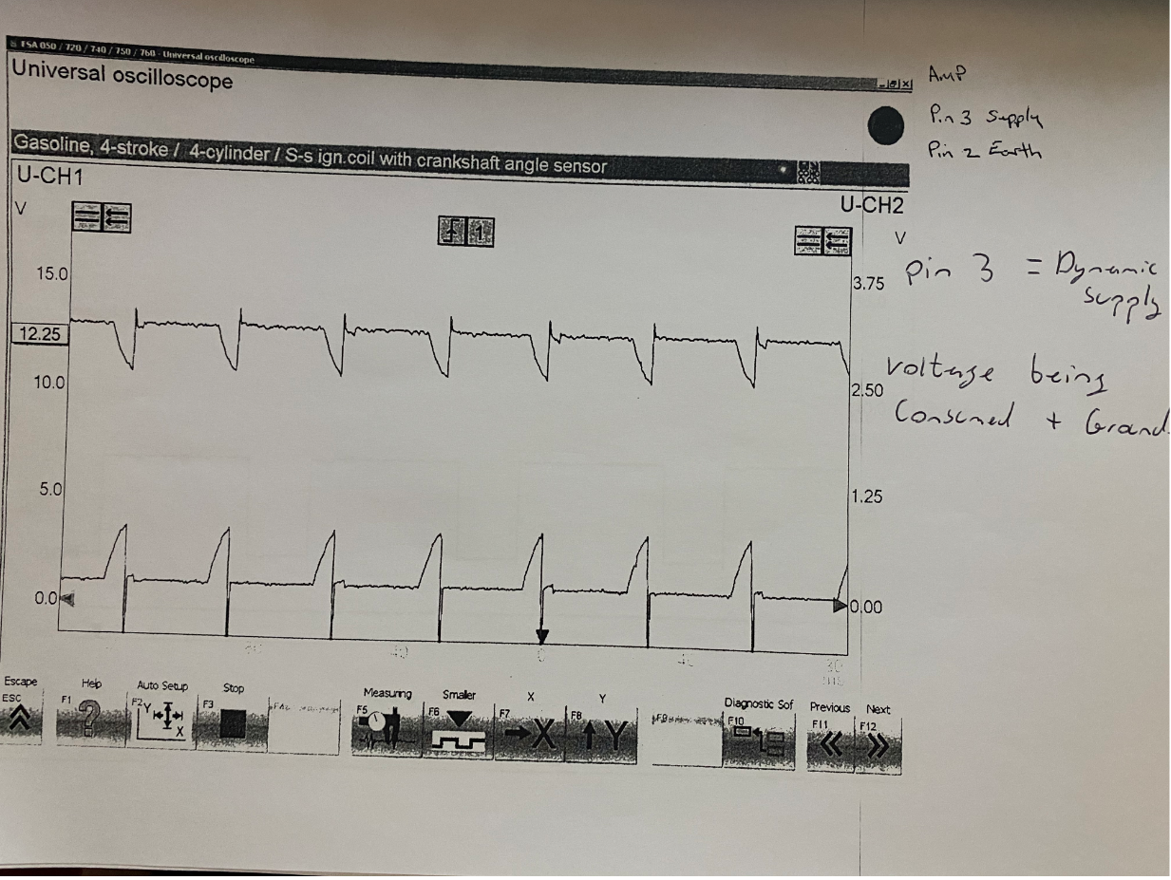
Appendix 4 (information handwritten)

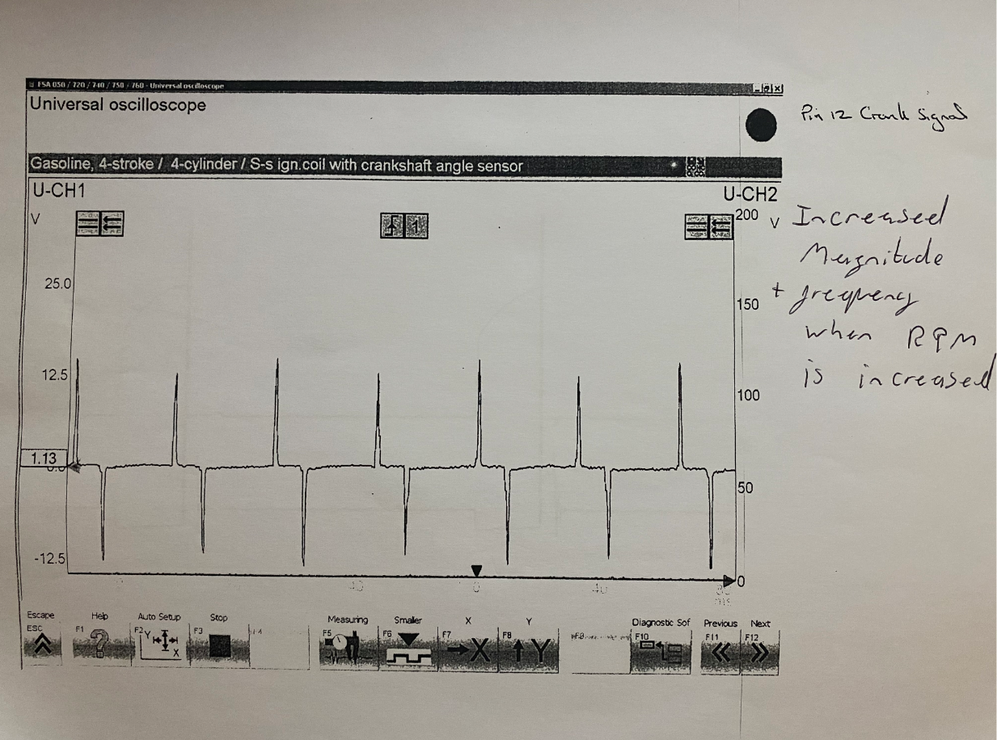
Appendix 5 (information handwritten)

