

MODULE:- LCMB7000: Human Resource Management
LECTURER:- Gladius David kulothungan
Student Name:- RAJPUT SAMVEER
Student Id:- 2132184
COURSE:- Master in Business Administration
TITLE:- Human assessment 2
SUBMISSION DATE:- 14/09/22

Executive Summary
The assessment examines the demographics of the labour market in the UK which is diverse and indiscriminative. It considers the employability; gender pay gap and the unemployment rates between men and women in the UK. The assessment further considers the shift in the working culture as remote working is becoming a norm and resignations happening all over the country. It provides details about the challenges faced by the market in the UK after the covid-19 pandemic and Brexit. The external factors that affect the HRM strategies such as competition, technology and government policies that shape the future of BT are being discussed. The HRM and cost leadership techniques help the company to maximise the efficiency of the workers and it uses specialised jobs to conduct the strategies. HRM and differentiation techniques maximise the distinction between the product in the customer’s mind. The assessment further analyses the shaping behaviour of the HRM which requires positive and negative reinforcement. The removal of benefits to decrease unwanted behaviour shapes the overall strategies. Finally, the assessment recommends various strategies such as aligning the business with the economic changes and reducing the expectation of high returns and allocating the resources accordingly. BT needs to acquire talent and motivate them to stay ahead of the competitors and make use of the available opportunities. The company can use digital tools to monitor the performance of the workforce and their involvement in the change process. The well-planned HRM strategy will help BT to overcome the challenges faced due to Covid-19 and Brexit.

Table of Contents
Executive Summary 1
1. Introduction 3
2. Current state of Labour Market of the UK post-Brexit and Covid-19 3
3. Emerging changes in Human Resourcing Strategies in the post-Covid, post-Brexit external environment 4
3.1 External Environment 5
3.2 Internal Environment 7
3.3 HRM challenges faced by BT 8
3.4 Suggestive recommendations 8
4. Conclusion 10

1. Introduction
The assessment discusses the current labour market in the UK and the labour demographics of the country. It analyses the current trends in HRM and the challenges faced in the UK due to the recent Covid-19 and Brexit. The emerging changes in the HRM such as remote working, online interviews and training are discussed in full length (Liang et al., 2022). The aim of the assessment is to examine the internal and external environment of British Telecom that is changing the HRM strategies after the pandemic. The usage of strategic differentiation will have a positive impact on the performance of the employee as key performance indicators such as net promoters score will be considered while selecting employees for specific job roles. Finally, it recommends the policies and processes adopted by the company to mitigate the problems faced in the current market fulfilling the scope for the future implementation of such measures.

2. Current state of Labour Market of the UK post-Brexit and Covid-19
The labour market in the UK is currently healing from the unemployment stress caused due to Covid-19 pandemic. As opined by Li and Heath (2020), the employment level increased to 75.6% which is still behind the pre-pandemic levels. The economic inactivity has decreased by 0.1% and the job vacancies have sprung up to 13,00,000 (Hick and Murphy, 2021). The UK’s exit from the EU has forced the country to adopt many new governance agreements which led to the implementation of high-quality standards to compete and increase the credibility of the new statistical systems in the UK. The self-employed and part-time workers have decreased with the vacancies in the full-time jobs and the average weekly working hours have returned to the pre-pandemic levels.
The overall employment has risen in the past 12 months and the economic activity has grown immensely. Employment rates of men in the UK are higher than those of women with 75.5% and 62.3% respectively (Sologon et al., 2021). The rates of inactivity are higher in women than men and the gender pay gap can be attributed to the hours worked. According to Deng et al. (2022), the base and compositional effects have affected the strong growth rates in the starting months of 2022. The increase in inactivity is also attributed to the increasing population aged between 50 to 64 years. The latest data in the labour market of the UK shows that there is a high demand for jobs and the unemployment rates are reducing but to reach the pre-pandemic levels. The labour market is tight and inflation is getting higher due to Brexit and restrictions on the labour movement. Brexit has impacted employers and leaving the EU had adversely affected the UK labour force.
The atmosphere of the labour market in the UK has created business confidence especially due to the fall in unemployment rates. However, the recovery of the market has seen multiple employees changing their companies or shifting their professions which are termed great resignations (Sull et al., 2022). It has turned into a great concern for HRM in the UK as the loss of experienced and efficient workers has created a void in the companies. The enormous resignations happened due to the lack of sense of belonging at work, company culture and the lack of flexibility. Brexit has created a labour shortage in the UK that failed the supply chains in large proportions.
The HRM of the UK has changed the approach to recruitment and retention to decrease the effects of the great resignation and Brexit. As opined by Mayhew and Anand (2020), the companies have shifted to a skills-based approach which helped them to enrol the right talent and engage in efficient work structures. The hybrid model of the work has proved to be a challenge for the companies as the HRM strategies had to be reinvented to support the new systems. The Brexit has created shortages of skilled labour in the UK and the HRM has shifted its focus to

3. Emerging changes in Human Resourcing Strategies in the post-Covid, post-Brexit external environment
British Telecommunication, the prominent telecom and intranet provider in the UK has been at the forefront of experiencing the changes in the Human Resource strategies post Covid-19 pandemic and Brexit. BT is facing difficulties in access to the numerous multi-million pounds contract in European Union. As per the report published by Guardian (2022), since the UK was no longer a part of the European Union, the £49m contract with the European Parliament and £24m contract with the European Commission including cloud security service us facing slow jeopardization. As result, BT may risk putting excessive levels the performance criteria on the employees to keep up good track despite the political turmoil. On the other hand, the Covid-19 pandemic has created havoc in terms of the work process in BT with management and operation works shifting mostly to the remote facility (Lazarova et al., 2023). However, the suddenness of the outbreak and declaration of the lockdown has called for drastic changes in the employee management and Human Resourcing strategies in all the business organisations in the UK including British Telecommunication.

3.1 External Environment
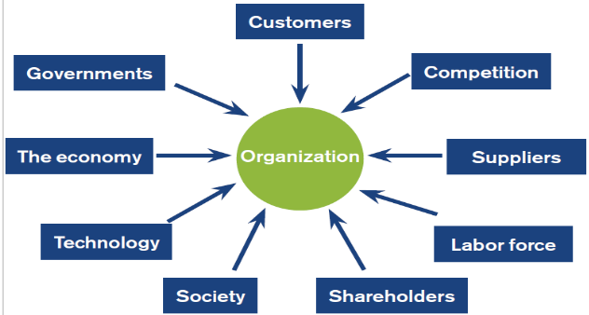
Figure 1: External Environment
(Learning Material)
Customers: Customers of BT has spanned over 180 countries including a significant number of customers belonging to the UK and the European Union. The outbreak of the Covid-19 pandemic has increased the demands among the customers regarding internet and the Wi-Fi connection. For instance, according to Race et al. (2022), the average screen time of the customers of BT has increased by 65% during the lockdown for both internet browning and internet-related activities or entertainment and work. Therefore, during the lockdown, the HRM of BT group witnessed increased engagement of the customer support employees who themselves are working from a remote facility. Despite providing adequate equipment handling too much customer pressure became pressuring for the employees in terms of motivation.
Competition: The rising competition in the telecom segment in the EU in terms of the technology and the workforce will rise exponentially with Brexit. European nations are prepared to subsidise their own home companies of telecom which will enable them to improve their HRM infrastructure through employee development and training making BT face tough competition.
Suppliers: The primary suppliers of BT- Nokia Seimens networks, Ericsson and Alcatel are mostly based in European countries and other foreign (Liboni et al., 2019). The successive occurrence of Brexit and the Covid-19 pandemic has caused havoc in the supply chain management with BT facing a dearth of properly skilled supply chain managers.
Labour Force: The labour force is currently facing extreme issues in the UK within BT management due to the misalignment of structure, technology, and culture. The labour market is tight and inflation is getting higher due to Brexit and restrictions on the labour movement (Atkinson et al., 2021). Brexit has impacted employers and leaving the EU had adversely affected the UK labour force.
Shareholders: According to Tadesse et al. (2020), Shareholders are influenced by the adverse issue within the Brexit and Covid-19 pandemic throughout the meticulous implementation of the measures that can improvise the HRM infrastructure, any of the shareholders of BT are demanding a great productivity level for the increase in the share value which is becoming impossible at some point of time due to the remote working.
Society: UK is experiencing a rise in the younger population and by the year 2035, the whole population of the UK will stand at 75 million (Lazarova et al., 2023). Youths of the UK who want to start a career in telecom often prefer BT as their natural destination for trying their career. With the looming economic regression and the reduced requirement of manual labour, has become difficult for BT to utilise numerous young talents who are, otherwise, not skilled for the new world of automation.
Technology: HRM technology has gone through a drastic change with the introduction of Artificial Intelligence, Machine Learning and Blockchain technology which must be incorporated into the organisation like BT to optimise the day-to-day functions smoothly (Khan et al., 2022).
Economy: Economic recession post-Covid-19 pandemic has been drastic due to the year-long lockdown from 2020 till the second half of 2021. As a result, necessities, and the raw materials for developing the telephonic and intranet structure are drastically increasing forcing BT to opt for tacos-cutting measures creating dissatisfaction among the employees (Younis and Adel, 2020).
Governments: The intervention of the Government in terms of HRM is not strong. However, the consistent urge of the government and advocating the legalisation of fair pay and equal treatment in the workplace has an impact on the wage revision and the HRM policies of organisations like BT (Younis and Adel, 2020).

3.2 Internal Environment
Strategy: According to Cai (2022), the strategy of BT is to enhance the experience of the customers by unveiling new technology and providing uninterrupted service. This has been possible through the implementation of the rigours training and careful onboarding process of the employee who is equipped with the adequate skills to handle the demands of 10 million customers worldwide
Culture: BT enjoys transactional organisational culture where the managers are responsible for the training and development of the employees to enhance their productivity. Cai (2022) stated that HRM policy of BT inspires them to become collaborative in their approach to handling the multiple telecommunication services to the customers and maintain stability in terms of the productivity.
Structure: According to Race et al. (2022), current organisational structure is the matrix structure through the six lines of the business comprising Consumer, Business and Public Sector, Wholesale and ventures, EE, Openreach and Global Services. Therefore, despite the Brexit and Covid-19 pandemic, BT is focusing on diversifying its service which will enable a high number of hiring and many existing employees to get new job roles and responsibilities.
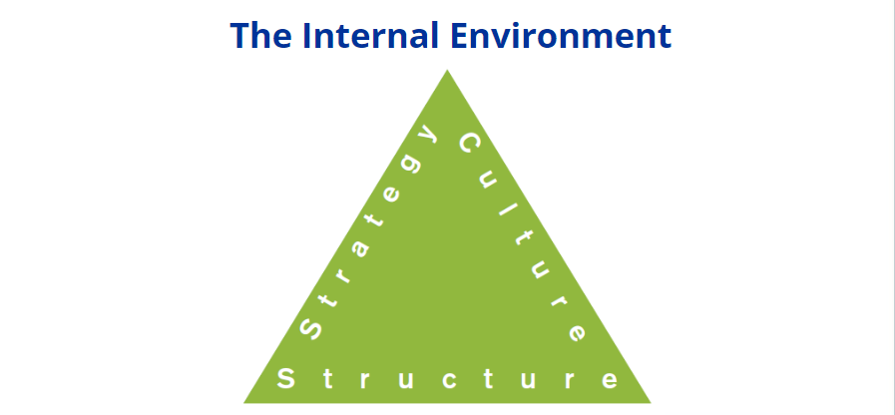
Figure 2: Internal Environment
(Learning material)

3.3 HRM challenges faced by BT
The critical understanding related to the HRM challenges in BT is considered for focusing on the implementation of the critical outcomes for the call begs faced by BT in terms of HRM management.
- The remote working facility that BT has given to its employees has been beneficial in increasing the work-life balance and curbing the outbreak of the virus among the employee. However, while the situations are normalising and many employees are asked to come back on-site, BT employee is losing their motivation as there were no certain tracking tools and performance management metrics while working from home which they felt hampered their progress in the career (AL-Husan et al., 2021). As a result, when BT is planning to start a hybrid mode of working, many employees are feeling disillusioned.
- The lack of a leadership development program from the year 2020 to 2022, while employees were remote working, may be detrimental to developing the next generation of organisational elders who are ready to take the helm of newly structured BT into six divisions (Khan et al., 2022). As a result, through the new structure discussed above has lots of potentials, it may experience slow growth due to a lack of proper leadership.

3.4 Suggestive recommendations
HRM and Cost Leadership Technique
The strategic management of the HRM is required for focusing on gaining the competitive advantage while improvising the productivity of BT through a cost differentiation strategy. To deliver the product at a lower cost, BT needs to raise its bar of productivity and increase the skill sets of each employee through individual training, specifically on Artificial Intelligence and Blockchain (Mahmoud, 2021). The Low-cost provider strategy could be united by creating strict timelines and targets for the employee through the proper on-job training plan that will help them to train in the new processes and the leadership of taking charge of various departments that BT has newly created to become truly globalised telecom brand post-Brexit and Covid-19 pandemic.
HRM and differentiation strategy
BT must practice an HRM differentiation strategy to manage the individual employee or the team working to create a value-based approach and assign them for the work-based approaches. Using the HRM differentiation strategy is important for easing the gaps that are discussed in both the internal and external analyses of BT’s HRM selecting the HRM practices including the benefit options that best suit the requirements the interest of the employees as well as the vision and mission of the organisation (Kyzym, et al., 2019). The usage of strategic differentiation will have a positive impact on the performance of the employee as key performance indicators such as net promoters score will be considered while selecting employees for specific job roles.
Shaping Behaviours
As part of the strategic HRM overhaul, BT must thrive to implement the Shaping Behaviours model to apply the increasing targeted behaviour for better performance and motivation and decrease the targeted behaviour of gaps such as not meeting the targets, and gaps in the training and conflicting culture (Aryatama, 2020). Positive reinforcement must be given by BT to provide weekly rewards for the employee through the integrated performance management system. This will help the company to recognise the constructive action of the productive employee periodically which will increase their level of motivation. As part of the negative reinforcement, BT must withdraw any sort of discriminatory practice among the employee that may hamper the multi-cultural and inclusive workplace ethos of BT. Strict action of termination and suspension must be taken against the employee who is practising the discriminatory practices as a form of punishment. According to Falola et al. (2021), implementation of the rewarding system will alienate the sense of apathy and non-involvement among the employees as they will feel that their talent is being recognised by the company. Taking strict action or punishments against discriminatory practices will implement a positive and coordinating work culture. This will avoid reinforcement of undesirable behaviour.
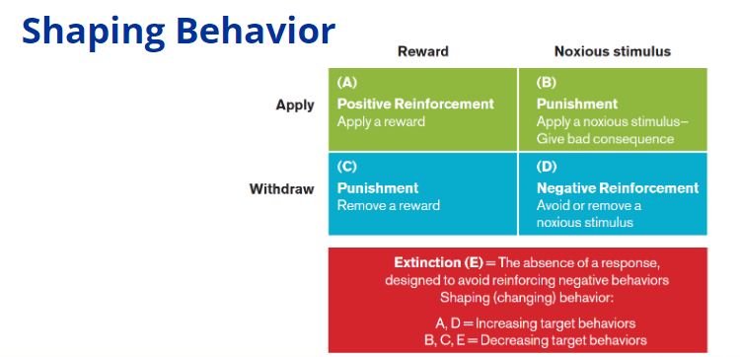
Figure 3: Shaping Behavior
(Learning Material)

4. Conclusion
The strategic choice of the organisation is to focus specifically on the current strategies and analyse the external and internal options to create the best options for the solutions. The assessment concludes that the remote working structure of the current HRM has proven to be a challenge for BT. It discussed the external and internal environment of the company such as competitors, suppliers, labour, technology, organisation culture and structure that cause hindrances to the HRM strategies. Finally, it recommended that the cost leadership techniques, differentiation strategy and shaping behaviour strategies would help to overcome the issues of HRM. BT must employ specialised measures to carry out the strategies, and HRM and cost leadership tactics aid in maximising worker productivity. Techniques for differentiation and HRM help customers distinguish products more clearly in their minds. By using the integrated performance management system, BT must deliver weekly prizes for the employee as positive reinforcement. This will enable the business to periodically recognise the productive employee's positive actions, which will raise their level of motivation. Implementing a rewards system will make employees feel like their talent is being recognised by the organisation, which will drive away feelings of apathy and non-engagement.
References
AL-Husan, F.B., Amaugo, A.N. and Idiko, B., 2021. Emerging Multi-National Enterprise (EMNE)'s Approaches and Challenges for the Management of Human Resources in BRICs Countries. International HRM and Development in Emerging Market Multinationals, pp.314-329.
Aryatama, H., 2020. The effect of pandemic COVID-19 in the outsourcing industry sector and the role of human resourcing in dynamic organizations. Available at SSRN 3591137.
Atkinson, C., Beck, V., Brewis, J., Davies, A. and Duberley, J., 2021. Menopause and the workplace: New directions in HRM research and HR practice. Human Resource Management Journal, 31(1), pp.49-64.
Cai, W., 2022. HRM Risk Early Warning Based on a Hybrid Solution of Decision Tree and Support Vector Machine. Wireless Communications and Mobile Computing, 2022, pp.23-90.
Deng, Z., Arim, R., Henseke, G., Schoon, I., Dietrich, H., Murray, A., Smyth, E. and Dupéré, V., 2022. Youth unemployment in Canada, Germany, Ireland, and the United Kingdom in times of COVID-19. Economic and Social Reports, 2(3), pp.1-5.
Falola, H.O., Oludayo, O.A., Olokundun, M.A., Salau, O.P., Ibidunni, A.S. and Igbinoba, E., 2018. Employee resourcing strategies and universities’ corporate image: a survey dataset. Data in brief, 18, pp.1378-1382.
Guardian, 2022. BT could lose millions of pounds of EU contracts after Brexit. [online] the Guardian. Available at: <https://www.theguardian.com/business/2019/jan/08/bt-could-lose-eu-contracts-after-brexit>.
Hick, R. and Murphy, M.P., 2021. Common shock, different paths? Comparing social policy responses to COVID‐19 in the UK and Ireland. Social Policy & Administration, 55(2), pp.312-325.
Khan, S.A., Mubarik, M.S., Kusi‐Sarpong, S., Gupta, H., Zaman, S.I. and Mubarik, M., 2022. Blockchain technologies as enablers of supply chain mapping for sustainable supply chains. Business Strategy and the Environment.
Kyzym, M., Khaustova, V., Reshetnуak, O., Timohova, G. and Sakhnenko, O., 2019. Research Study of the Problems of Human Resourcing of the Scientific and Innovation Entrepreneurship. International Journal of Recent Technology and Engineering, 8(3C), pp.213-218.
Lazarova, M., Caligiuri, P., Collings, D.G. and De Cieri, H., 2023. Global work in a rapidly changing world: Implications for MNEs and individuals. Journal of World Business, 58(1), p.101365.
Li, Y. and Heath, A., 2020. Persisting disadvantages: a study of labour market dynamics of ethnic unemployment and earnings in the UK (2009–2015). Journal of Ethnic and Migration Studies, 46(5), pp.857-878.
Liang, X., Zhang, X., Paulet, R. and Zheng, L.J., 2022. A literature review of the COVID-19 pandemic’s effect on sustainable HRM. Sustainability, 14(5), p.2579.
Liboni, L.B., Cezarino, L.O., Jabbour, C.J.C., Oliveira, B.G. and Stefanelli, N.O., 2019. Smart industry and the pathways to HRM 4.0: implications for SCM. Supply Chain Management: An International Journal, pp.1-10.
Mahmoud, A.B., 2021. Like a cog in a machine: the effectiveness of AI-powered human resourcing. Advances in intelligent, flexible, and lean management and engineering, pp.1-20.
Mayhew, K. and Anand, P., 2020. COVID-19 and the UK labour market. Oxford Review of Economic Policy, 36(Supplement_1), pp.S215-S224.
Race, N., Eckley, I., Parlikad, A., Rotsos, C., Wang, N., Piechocki, R., Stiles, P., Parekh, A., Burbridge, T., Willis, P. and Cassidy, S., 2022. Industry-Academia Research toward Future Network Intelligence: The NG-CDI Prosperity Partnership. IEEE Network, 36(1), pp.18-24.
Sologon, D.M., Van Kerm, P., Li, J. and O’Donoghue, C., 2021. Accounting for differences in income inequality across countries: tax-benefit policy, labour market structure, returns and demographics. The Journal of Economic Inequality, 19(1), pp.13-43.
Sull, D., Sull, C. and Zweig, B., 2022. Toxic culture is driving the great resignation. MIT Sloan Management Review, 63(2), pp.1-9.
Tadesse, W.M. and Jembere, M.W., 2020. Strategic HRM Principles Implementation & Organizational Performance: The Case of Ethio Telecom. Indian Journal of Industrial Relations, 55(4).
Younis, R.A.A. and Adel, H.M., 2020, September. Artificial intelligence strategy, creativity-oriented HRM and knowledge-sharing quality: empirical analysis of individual and organisational performance of AI-powered businesses. In Proceedings of The British Academy of Management (BAM) 2020 Annual International Conference: Innovating for a Sustainable Future, London, United Kingdom.

