

Cover Page
Student Name: Naela Aslam
Student Number: 2223215
Lecturers Name: Zarah Ahmed
Assignment Title: Personal Brand Online Portfolio of set Exercises

Task 1 – Personal Brand
The foundation of my personal brand is a caring, trusting and growing ealth and social care practitioner with previous experience as a Support Worker and high self-learning drive. My career objective is to pursue a sustainable career as a Mental Health Support Worker. Consequently, the following qualities must be communicated through my professional identity: empathy, communication, teamwork, respect and willingness to learn. These qualities align with those demanded in the health and social care environment where there is requirement to treat people with dignity, cooperate and improve quality of care. Teamwork, Problem-solving, learning, and development are useful employability skills of social care workers, according to Skills for Care (Skills for Care, 2022).
LinkedIn, professional networking events and proper use of social media can help me to build my personal brand. My LinkedIn account must visibly highlight my experience as Support Worker, Care Certificate, Level 4 Health and Social Care details and my present Level 5 coursework. I can also connect with health and social care professionals and follow NHS and social care organisations to develop sector knowledge. My brand should be more natural, rather than advertising. I can offer relevant articles, professional concepts and research on mental health and person-centred care. Career growth as the concept highlighted by Skills for Care is a necessity to learn and be able to identify individual strengths in the care workforce (Skills for Care, 2019). Through consistent demonstration of my skills, values and career growth I can achieve an recognisable professional identity that will help me achieve my long-term employment objectives.

Task 2 - Network Map and Rationale

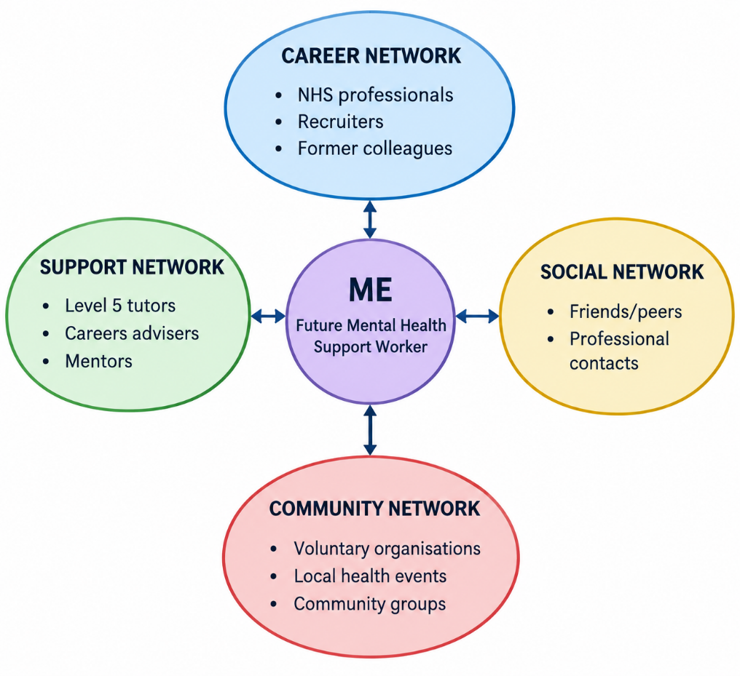
Figure 1 Network Map
Source (Author)
My network contains career, support, social and community dimensions, which provide different forms of assistance. My career network includes NHS staff, recruiters and former of Support Workers. These contacts can offer information about vacancies, expectations and career development in the workplace. The Level 5 tutors, careers advisers, and possible mentors are viewed as my support network and will assist me in receiving advice on academic issues, looking over applications, and professional development guidance. My social network consists of friends and peer that can assist me to provide support and can also introduce me to valuable professional networking. The community dimensions include the voluntary organisations, health and social care activities and community groups. The networks could help me to be an experienced person who understands what different communities required.
Networking is not merely an employment seeking tool. It may also aid learning, self-confidence and career growth. Networking within social care extends to career and leadership development, identified by Skills as Care (Skills for Care, 2026; Carpenter et al., 2022). However, my network is now less inclined toward direct mental health work than to past care experience and education. Thus, I will have to intentionally widen my network by relating with mental health practitioners, NHS recruitment teams and other organisations. This would stabilise my network and make it more my career goal.

Task 3- Blog
Developing Future Adult Social Care Workforce Skills
Target audience: Students and people preparing to enter Health and Social Care
Why Skills Matter in Social Care
Working in Health and Social Care has much more than getting things done. Employees need to communicate, work together, find solutions, acquire computer knowledge and the ability to provide person-centred services. These capacities are gaining growing importance as the services address the needs of emerging and emerging with altered needs and working methods. The Adult Social Care Workforce Skills Survey by the Department of Health and Social Care was carried out on 3,058 adult social care providers in England. Nearly half of the respondents (46) noted that they have found it hard to hire individuals with skills needed in the last 12 months (GOV.UK, 2025). In direct care positions, 84.7% of those who had recruitment challenges noted that finding people with the right skills was somewhat or very challenging. Communication is especially significant. The same survey discovered that interpersonal and communication skills were some of the most identified recruitment and development requirements, with 63.2% of the survey indicating that they struggled to recruit direct care workers with interpersonal and communication skills (GOV.UK, 2025). The crucial areas to focus on development were also found to include person-centred care and inclusion.
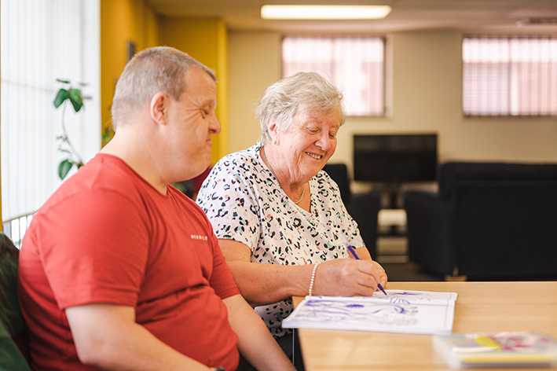
Figure 2 Adult Social Care Survey
Source (Gloucestershire County Council, 2026)
The Digital Skills are also becoming significant.
The use of technology in care delivery is on the rise. Electronic records, communication systems, online training and other technologies involved in the workplace might require digital skills. According to the 2025 survey, 81.9% of participants who anticipate their organisation to alter its skills within the coming five years recognised digital and technological expertise as one of their future needs.

Figure 3 Digital Technologies in Healthcare
Source (Marsh, 2022)
What Can Future Care Workers Do?
This should be prepared by acquisition of both the technical and transferable skills by the students and new employees. Options to train communication and teamwork are available here through volunteering, placements, training and part-time care. The advantages of reflection are also that it allows learners to identify the areas where they can work to reinforce their strengths.
According to Skills for Care, Social Care workers require core skills such as English, digital skills, teamwork and problem-solving, and the employer can help the workers improve their skills through training and on-the-job learning (Skills for Care, 2024). To the future care workers, the message is simple enough; qualifications matter, yet the skills, values, adaptability and continuous learning are also significant in establishing a sustainable career.

Task 4- NHS Equality, Diversity and Inclusion Quiz
- What is the primary goal of the NHS Equality, Diversity, and Inclusion Improvement Plan?
The key goal of the NHS Equality, Diversity, and Inclusion Improvement Plan is to address both direct and indirect prejudice, discrimination, and health disparities among the NHS workforce (NHS, 2023).
- How does the NHS EDI Improvement Plan propose to tackle the gender pay gap?
The NHS Equality, Diversity, and Inclusion (EDI) Improvement Plan addresses the issue of the gender pay gap with High Impact Action 3 as the main strategy to eradicate the total pay gap by gender, race, and disability (NHS Employers, 2023)
- What is meant by the term ‘intersectionality’ as used in the NHS EDI Improvement Plan?
Intersectionality acknowledges that people may possess multiple identities or characteristics and they can be subject to more than one source of inequality. So, weaknesses cannot necessarily be perceived through studying one attribute in isolation.
- Why is it important for the NHS to create a psychologically safe work environment?
Creating a psychologically safe work environment is vital for the NHS because it allows staff to report errors, discuss concerns, and share new ideas without the fear of blame or punishment.
- How does the NHS EDI Improvement Plan suggest improving the experience of internationally recruited staff?
High Impact Action 5, as outlined in NHS EDI Improvement Plan, includes having the trusts initiating an extensive induction, onboarding, and development programme targeted at staff recruited internationally (Wright, 2023)
- What role does leadership play in advancing EDI objectives according to the NHS Improvement Plan?
Leadership is important in culture change, shaping organisation culture, and responsibility. The plan underscores that EDI practices must be strategically located within the top-down set up that translates aspirational goals to measurable outcomes.
- Identify one way the NHS EDI Improvement Plan aims to reduce health inequalities within the workforce.
Under the High Impact Action 4, the Plan intends to decrease workforce health inequalities by providing targeted health and wellbeing support based on the unique needs of staff who face health disparities (NHS, 2023).
- Why does the NHS EDI Improvement Plan emphasise the importance of collecting and analysing data on protected characteristics?
The NHS EDI Improvement Plan focuses on gathering and examining data on characteristics under protection to shift to passive statements about diversity towards data-based accountability and targeted action.
- Explain how flexible working policies can contribute to equality and inclusion in the NHSworkforce
Flexible working policies promote the EDI as it removes structural barriers that facilitate diverse staff as well as providing equal opportunities and an inclusive workforce in the NHS where employees can enjoy flexibility at the point of employment.
- What is one strategy mentioned in the NHS EDI Improvement Plan to combat bullying and harassment in the workplace?
Establishing the environment where bullying, discrimination, harassment, and physical violence in the workplace cannot take place, and providing psychological safety is one of the strategies listed in the NHS EDI Plan (NHS, 2023).

Task 5- A Letter to Yourself

Dear Younger Me,

I know that sometimes you may feel unsure about yourself, your decisions, and your future. You might focus more on what has not worked out instead of thinking about what you can learn from the experience. Looking back, I want you to understand that facing difficulties does not mean you are failing. These experiences can help you grow, understand yourself better, and develop emotional intelligence and resilience.

Emotional intelligence would have helped you understand your feelings and manage them better. Instead of reacting straight away when you felt worried, disappointed or overwhelmed, you could have taken a moment to understand what you were feeling and why. This would have helped you make better decisions, communicate with others, and understand their feelings too.

Resilience would have reminded you that failure is not the end and that things do not always improve straight away. You do not need to have everything figured out at once. Sometimes, you just need to focus on what you can control, learn from your mistakes, and keep moving forward.

You also need to be more open to asking for support. Speaking to teachers, people you trust or others who can offer guidance may help you see things in a different light (Siegel, 2023). Remember that asking for help does not make you feel weak. It shows that you are willing to learn and improve yourself.

As you continue your journey in Health and Social care, emotional intelligence and resilience will be important when working with others. You will need to be patient, understanding, and able to manage challenging situations calmly. Looking after yourself is just as important as supporting others.

Finally, do not be afraid of making mistakes or facing changes. Give yourself time to learn, believe in your abilities, and continue developing your skills. Every experience can teach you something valuable and help you become more confident in the future.

From,

Your Future Self

Task 6- GANTT Chart
Five-Year Employment Development Plan
Table 1 Gantt Chart
Source (Author)
Activity | 0–6 Months | 6–12 Months | Year 1–2 | Year 2–3 | Year 3–4 | Year 4–5
Complete Level 5 studies
Refresh Care Certificate knowledge
Mental health awareness training
Improve challenging-behaviour skills
Apply for suitable care roles
Mental health work/volunteering
PMVA/employer-required training
Have professional portfolio
Maintain LinkedIn profile
Build professional network
Obtain supervisor feedback
Explore further qualifications
Review career progress
This Gantt chart offers a systematic guide through completion of education and refresh of existing skills up to an experience of mental health and advancing professionally. According to Skills for Care, career development entails recognition of strengths, building skills and gaining learning opportunities that are right in the role of a worker and future advancement (Skills for Care, 2026a).

Task 7- Making Changes- Report
Report: Introducing Digital Person-Centred Care Records
To: Care Home Manager
From: Care Home Manager – Change Proposal
Subject: Introduction of Digital Care Records
Introduction
This report suggests the implementation of digital person-centered care records in the care home. The purpose is to improve the accessibility, consistency, and recording of residents' care information while maintaining confidentiality and appropriate information governance. Person-centered care requires services to understand residents' individual needs, preferences, independence, and quality of life (Lorber et al., 2025).
Implementation
The NHS Change Model offers an appropriate framework since the model considers the shared purpose, leaders, motivation, measurement, project management, improvement tools and spread of successful change (NHS England, 2018). To begin with, employees ought to be contacted regarding the issues of the existing recording system and the benefits they are anticipating of digital records. The purpose should be formed by a small implementation team that includes care workers, senior workers, management, and were proper, residents or representatives.
Second, the home must identify a good digital system and a training programme. Staff will need to be training digitally, communicating, and working as a team, problem-solving and confidentiality awareness. The training process should include demonstration and practice. The CQC (2022) guidance predicts that the care providers decide what staff should be trained to deliver safe, effective and person-centered care. The change should initially be piloted on one unit or with a small group of residents. Before the system can be expanded, staff feedback, recording accuracy and user experience can be considered. NHS England recommends establishing baseline measures, testing changes and continually measuring whether improvement has occurred.

Barriers and Solutions
Potential obstacles are the resistance of the staff, a lack of digital confidence, and training time, the financial costs and doubts related to confidentiality. This can be dealt with by consultation, proper training, proper procedure, technical support and step-by-step implementation (Alzghaibi, 2025). These should include the inclusion of staff not only telling them to adopt the new system but also helping them to owe the change.
Evaluation
Measures of success include record-completion rates, documentation errors, staff feedback, training completion and resident-care outcomes. Findings should be verified after some period and necessary corrections made. In case the results of the pilot are favorable, the approach can be introduced to the entire care home gradually (Johannessen et al., 2019). Hence, the change must be conducted slowly and in partnership. By integrating the NHS Change Model with the staff education, measurement and person-centered can make digital record keeping a lasting value instead of a mere technology system.

Reference List
Alzghaibi, H. (2025) ‘Examining healthcare practitioners’ perceptions of virtual physicians, mHealth applications, and barriers to adoption: insights for improving patient care and digital health integration’, International Journal of General Medicine, pp.1865-1885.
Carpenter, J., Spencer, B., Moreira da Souza, T., Cho, Y. and Brett, J. (2022) ‘Exploring lessons from Covid‐19 for the role of the voluntary sector in integrated care systems’, Health & social care in the community, 30(6), pp.e6689-e6698.
CQC (2022). Staff training and support - care quality commission. [online] www.cqc.org.uk. Available at: https://www.cqc.org.uk/publications/themed-work/dnacpr-training [Accessed 29 Sept. 2026].
Gloucestershire County Council (2026). Adult Social Care Survey 2025-26 - helping to shape future services | Gloucestershire County Council. [online] Gloucestershire.gov.uk. Available at: https://www.gloucestershire.gov.uk/gcc-news/news-january-2026/adult-social-care-survey-2025-26-helping-to-shape-future-services/ [Accessed 29 Sept. 2026].
GOV.UK (2025). Adult social care workforce skills survey: September 2025 report. [online] GOV.UK. Available at: https://www.gov.uk/government/statistics/adult-social-care-workforce-skills-survey-september-2025/adult-social-care-workforce-skills-survey-september-2025-report [Accessed 29 Sept. 2026].
Johannessen, T., Ree, E., Strømme, T., Aase, I., Bal, R. and Wiig, S. (2019) ‘Designing and pilot testing of a leadership intervention to improve quality and safety in nursing homes and home care’, (the SAFE-LEAD intervention). BMJ open, 9(6), p.e027790.
Lorber, M., Mlinar Reljić, N., McCormack, B. and Kmetec, S. (2025) ‘June. Person-centred care in association with psychological well-being of older adults’, In Healthcare (Vol. 13, No. 12, p. 1379). MDPI.
Marsh, A. (2022). Rethinking health care delivery through home-health technology advancements. [online] Physicianspractice.com. Available at: https://www.physicianspractice.com/view/rethinking-health-care-delivery-through-home-health-technology-advancements [Accessed 29 Sept. 2026].
NHS (2023). NHS equality, diversity, and inclusion improvement plan. [online] Available at: https://www.england.nhs.uk/wp-content/uploads/2023/06/B2044_NHS_EDI_Workforce_Plan.pdf [Accessed 29 Sept. 2026].
NHS Employers (2023). NHS Equality, diversity and inclusion (EDI) improvement plan | NHS employers. [online] www.nhsemployers.org. Available at: https://www.nhsemployers.org/articles/nhs-equality-diversity-and-inclusion-edi-improvement-plan [Accessed 29 Sept. 2026].
NHS England (2018). The change model guide. [online] NHS England. Available at: https://www.england.nhs.uk/wp-content/uploads/2018/04/change-model-guide-v5.pdf [Accessed 29 Sept. 2026].
Siegel-Stechler, K. (2023) “Conversation is everything”: How teachers and students create environments where open discussion can thrive’, Theory & Research in Social Education, 51(4), pp.626-660.
Skills for Care (2019). Skills for Care and Development – Just another WordPress site. [online] Skillsforcareanddevelopment.org.uk. Available at: https://skillsforcareanddevelopment.org.uk/ [Accessed 29 Sept. 2026].
Skills for Care (2022). Why learning and development matters for the future of social care. [online] Skillsforcare.org.uk. Available at: https://www.skillsforcare.org.uk/news-and-events/blogs/why-learning-and-development-matters-for-the-future-of-social-care [Accessed 29 Sept. 2026].
Skills for Care (2024). What core skills do I need to work in Social Care? [online] Available at: https://www.skillsforcare.org.uk/Documents/Recruitment-and-retention/Careers-in-care/What-core-skills-do-I-need-to-work-in-social-care.pdf [Accessed 29 Sept. 2026].
Skills for Care (2026). Support for leaders and managers. [online] www.skillsforcare.org.uk. Available at: https://www.skillsforcare.org.uk/Support-for-leaders-and-managers/Support-for-leaders-and-managers.aspx [Accessed 29 Sept. 2026].
Wright, L. (2023). NHS equality, diversity, and inclusion improvement plan. Available at: https://www.bdct.nhs.uk/wp-content/uploads/2024/12/Item-14.1.1-NHS-England-EDI-Improvement-Plan-Briefing-27.06.23.pdf [Accessed 29 Sept. 2026].

