Reflective Account – group seminar presentation
What happened?
As part of the level 5 Youth and Community degree, students are required to plan and deliver a thirty-minute session that tackles an issue that impacts on a young person’s self-esteem. The group agreed to meet at the local youth centre to discuss the issues that impact self-esteem then agree on what the session would entail to positively impact self-esteem.
The group decided to prepare a session that would boost self-confidence and self-esteem and enable young people to think about themselves positively and also think about how their words can impact others. We wanted young people to realise that saying just one positive thing about another person can have a huge impact on how they see themselves.
On Wednesday the 11th March the group met at the youth centre to discuss how the session would run and make sure all the resources were available and in place. Final plans were then agreed and everything was ready for the following day – session day.
On Thursday 12th March the group again met at the youth centre only this time we would be carrying out our session to a group of real young people in a real-life youth centre. The group met a little earlier to enable us to set up the room ready for the activity. One member of the group hid twelve large, coloured jig-saw puzzle pieces which had been laminated around the room and stuck a black and white copy of the full puzzle on the wall. This would be used in the ice breaker. Once this was done we

had to wait for the young people to turn up. We expected numbers to be low though as it was Duke of Edinburgh night.
Four young people turned up so the lead youth worker and the three group members also participated in the activities.
Firstly, we introduced ourselves and explained to the young people why we were delivering the session, the aim of the session and that it was part of our learning journey while engaged on our degree course. We then asked the young people to take part in the ice breaker that had been prepared earlier. We explained that there were twelve hidden jig-saw pieces hidden around the room which they had to find and piece together to discover the hidden message. When all the pieces were found the young people discovered the message “we all fit together”. It was to show young people that despite being different shapes, sizes or colours we can all fit together and create something bigger.
We then moved on to the main body of the activity where each young person was given a picture of a shield, a coat of arms (see appendix 1), which was divided into four sections. They had to write their name in the scroll at the bottom of the shield then draw a small picture in each section relating to what had been written at the side of that section. The four sections were: things I love and value, my best quality or attribute, things I am proud of and things that make me happy.
Once the coat of arms was finished they were stuck on the wall around the room and everybody stuck one positive note to each coat of arms. We then came together as a group and discussed our own coat of arms and the comments that had been stuck to them by others. The young people discussed how these comments made them feel.

Each young person then evaluated the session by writing one word they would use to describe the session and sticking it on either a happy or a sad face that was hanging on the wall.

Thoughts and feelings during this process
While preparing this session I had very mixed feelings. I felt confident that we could prepare and deliver a fun, inclusive, educative, participative, expressive and empowering session which are the five pillars that underpin youth work (YWWRG, 2018), as we have all worked with young people for a number of years but I also felt frustrated as more than one member of the group had noted ideas for the session but on meeting with the group it seemed that one member had already decided for the whole group what the session would entail. I feel that in was not able to express my own thoughts and ideas for the session. As the session had already been decided I feel that I had a much smaller part in the planning of the session but I hoped that I would be able to use my own skills while delivering the session face to face. I don’t feel that we worked together as a group during the planning of this session but during the delivery of the session we did work together.

Evaluation
Throughout the preparation for this session, I made it clear that I did not feel I had an equal or fair part in the planning but I knew that because I am confident when working with young people my role would even out. Although I had my own ideas for the

session I willingly allowed another group member to use their idea for the session and just hoped that my face to face experience with young people would enable me to fully engage.

Analysis
Having to deliver a thirty-minute session to actual young people in a youth centre setting gave us the opportunity to use the skills that we had developed and experience what it would be like to work as a youth worker. We were in a real-life situation and had to allow for any unforeseen situations should they happen during this session. This did happen during the ice breaker. We were restricted in our session to thirty minutes so each section of the session had a time frame but during the ice breaker one of the hidden puzzle pieces disappeared therefore the time spent looking for it was longer than planned. Young people worked together and chatted throughout the session.

Conclusion
Although I did not enjoy the planning part of this session, I did really enjoy the session. By the end of the session we had successfully delivered a session that positively impacted young people’s self-esteem. The young people really enjoyed the session as they had evaluated it at the end. I was happy that I had put my own ideas aside and agreed to this activity. If I was to prepare a session like this again I would like to meet with the youth workers more beforehand to enable everybody to express their

own ideas and compromise. Although the session was a success I think with more planning it could have been even better but being an efficient youth worker means being able to act without a plan sometimes and being able to think on your feet. Overall, I think the group worked well together while delivering the session as this showed inn how much everybody involved enjoyed themselves. To end the session each young person was given a handout about the Five Ways to Wellbeing (see appendix 2).

References

Youth Work in Wales Review Group. (2018) Youth Work in Wales: Principles and Purposes, Cardiff: Youth Work in Wales Review Group.

Appendix 1 – The Coat of Arms template.
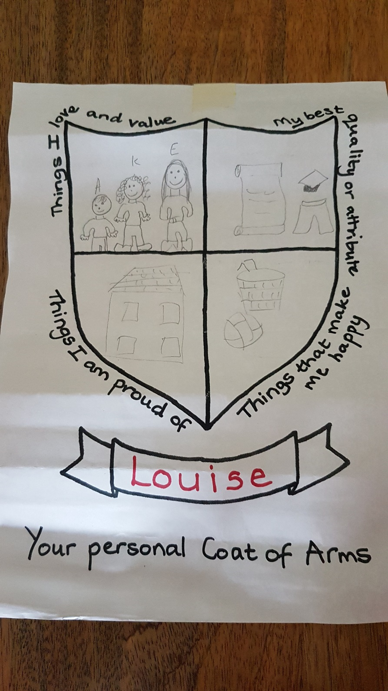

Appendix 2 – Five Ways to Well-being handout


