‘A critical analysis of the relationship between teacher subject knowledge and effective learning and teaching in the primary school.’
Introduction:
In this essay, I will begin by critically analysing literature surrounding teacher subject knowledge and its link to children’s learning. I will then follow this by analysing my own knowledge base of primary teaching, which will be drawn from my Professional Teaching Experience (PTE) within a placement school. I will refer to my placement school as School A to maintain the anonymity of the school, the staff, and the pupils (Bera, 2018).

School A is a small school in a rural village that caters to 68 children aged three to eleven. Most children come from socially and economically disadvantaged area, with 26% of children receiving free school meals (Estyn 2014). The predominant language spoken at home and at school is English. The school is currently focusing on their Welsh Language Development across the whole school. During PTE, I taught in a mixed Nursery and Reception class of 20 pupils, 7 female and 13 male all aged from three to five. The class teacher is assisted by once teaching assistant and a student teaching assistant three days a week on a temporary basis.

Section One: Literature Review

‘Great teaching is defined as that which leads to improved student progress’, and teacher subject knowledge has been a central component to the debate amongst academics regarding effective teaching for decades (Coe, Aloisi, Higgins and Major, 2014 p.2). Shulman was the first academic to talk about teacher subject knowledge as more than what teachers know about the subject that they teach (Shulman, 1987). His work is seminal in inspiring the discussion regarding teacher subject knowledge and its relation to effective teaching. Shulman identifies a number of components that make up teacher subject knowledge, arguing it is more than content knowledge. Other academics have supported similar ideas, such as those ideas by Coe et al. They argue that effective teaching is made up of six important components that contribute to positive student outcome, which outline some of the same ideas as Shulman (Coe et al, 2014, pp.2-4). Other likeminded academics include Rowland et al, who used the framework of ‘The Knowledge Quartet’ to explore teacher subject knowledge (Rowland, Huckstep and Thwaites, 2003). Like Shulman, the framework identifies how teacher subject knowledge is underpinned by a number of components, one of those being a pedagogical skill. That is, having the ability to teach content in ways children can understand (Rowland et al, 2003). Other studies define teacher subject knowledge as all pedagogical knowledge and how knowledge of skill is ‘used and developed into a mastery performance’ (Anderson, 1982, as referenced in Guerriero, 2017, p.103). Although these academics have slightly different perceptions of the definition of teacher subject knowledge and its importance for effective teaching, generally, it can be said that they all support a similar notion. That is, that teacher subject knowledge is fundamental to effective teaching, and is made up of number skills, including content knowledge and pedagogical knowledge.
The debate regarding teacher subject knowledge has always been important, but for teachers now and for myself and other trainee teachers alike, it is extremely prevalent with the development of the new curriculum in Wales based on Graham Donaldson’s ‘Successful Futures Report’ (Donaldson, 2015). Donaldson notes that the new curriculum is based upon the idea that ‘subject knowledge has stood the test of time and remains the best path to a sound and relevant education’ (Donaldson, 2015, p.5). It is unrealistic to expect teachers to have a comprehensive grasp of this whole body of knowledge because in reality, teachers have a range of knowledge and abilities. However, Donaldson acknowledges this and how subject knowledge is not enough on its own. Donaldson argues that a combination of ‘theoretical and practical knowledge and skills with fine judgment about what is required to promote effective learning in particular contexts’ is what lies at the very core of being an excellent teacher (Donaldson, 2015 p.63). We can see how the ideas of Shulman are being echoed and continue to influence education to this very day. In his work, Shulman lists seven important elements he believes are part of a teacher’s ‘knowledge base’, which are outlined in Figure One (Shulman, 1987, p.8). Donaldson emphasises similar elements, suggesting excellent teaching is the product of a number of elements, rather than content knowledge alone.
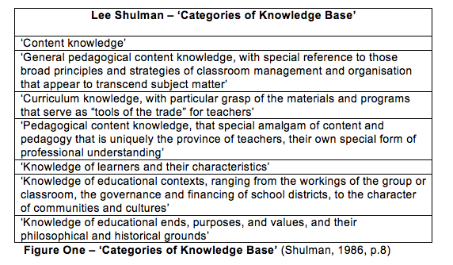

Similarly to Shulman’s ‘Categories of Knowledge Base’, Coe at al. have identified ‘the six components of great teaching’, which includes ‘(pedagogical) content knowledge’, ‘quality of instruction’, ‘classroom climate’, ‘classroom management’, ‘teacher beliefs’, and ‘professional behaviors’. (Coe at al, 2014, pp.2-3) They argue how teachers with a deep understanding of the content that they teach are the most effective in positively impacting student outcomes. Conversely, if teachers’ knowledge falls below certain criteria, it has negative outcomes on student learning by limiting the information they can access (Coe et al., 2014, p.2). They outline how teachers must be skilled in understanding how students think about the information, and have the ability to recognise misconceptions among students (Coe at al, 2014, p.2). They focus on a combination of content knowledge and pedagogy, as do Donaldson and Shulman. If teachers lack the pedagogical skill to teach the lesson content, negative impacts can be seen via the outcomes of the learners. In the case of PGCE student Naomi, Rowland et al highlight how subject knowledge is not the only component needed for effective teaching (Rowland et al, 2003, p.99). Naomi had gained an A* in mathematics at GCSE and gave model answers in an audit of her mathematical subject knowledge. Naomi was teaching mathematics lesson on subtraction and difference to her Year 1 class, but encountered some difficulties when her students struggled to understand the lesson objective and the vocabulary.
To evaluate Naomi’s subject knowledge, Rowland et al. use the framework of ‘The Knowledge Quartet’ (Rowland et al, 2003). The framework was originally developed to analyse Mathematical subject knowledge. However, it has been used to analyse other areas of subject knowledge. There are four categories within the framework. The first category ‘foundation’ is made up of subject knowledge, teacher beliefs, and how children learn best, which in turn inform the pedagogy applied by the teacher in the classroom. There is a clear link here with some of Shulman’s ‘Categories of Knowledge Base’, such as ‘content knowledge’, ‘general pedagogical content knowledge’, and ‘curriculum knowledge’, however, the ideas are simply organised in an alternative manner (Shulman, 1987, p.8). ‘Transformation’ is the second category, in which knowledge is transformed and taught in a way that students are able to understand, using appropriate representations and materials. Shulman’s ideas are also visible here, with links to his categories ‘curriculum knowledge’ and ‘knowledge of learners and their characteristics’ (Shulman, 1987, p.8) ‘Connection’ is the category that analyses how connections are made between ideas and prior learning, and the understanding of progressive steps and when it is appropriate to make these steps. Shulman supports a similar category of ‘knowledge of educational ends, purposes and values’ (Shulman, 1987, p.8). And finally, ‘contingency’ is the category that analyses how teachers are able to react to classroom events and children’s ideas and responses in a contingent way that maximize learning (Rowland et al, 2003, pp.97-98).
The fluid nature of ‘The Knowledge Quartet’ would allow it to be applied to most lessons in primary and secondary settings, not confining it to just mathematics lessons. The framework contains many of the same elements that we see in both Shulman’s work, and in the work of Coe et al. In fact, as Shulman does, this framework emphasises that teacher subject knowledge is more than what you know about what you are teaching. It emphasises how bringing ideas together in a way that children to understand along with how you react to student response is an example of effective teaching. Hattie argues how teachers subject knowledge has little impact on the quality of the students’ outcomes. He argues the most important factors are how teachers understand how to teach the subjects they teach and their teaching beliefs (Hattie, 2012, p.28) This seems to indicate that subject knowledge is irrelevant, and may not give it the weighting it deserves. However, we must be careful we are not ignoring the centrality of point Hattie is attempting to make, which is that subject knowledge is just one element of a wide number of skills needed for excellent teaching.
Using the framework, Rowland et al identify how despite having excellent content knowledge, Naomi’s lack of pedagogical content knowledge meant her student’s struggled to understand the learning objective. The framework highlights how Naomi has a good understanding of the content, but early on she encounters some difficulty when she fails to address the ambiguity surrounding the word ‘difference’, which leaves her students with a lack of understanding (Rowland et al, 2003p.99). Although Naomi understands the context of ‘difference’, she has struggled with pedagogical content knowledge and the ability to make the information accessible to her students. When looking at the ‘contingency’ strand of the framework, Naomi’s lack of pedagogical content knowledge produces some anxiety (Rowland et al, 2003, p.101). We see this anxiety when a student proposes their own solution for the problem Naomi posed. Naomi does not explore this student’s solution, and Brown and Wragg have noted how ‘our capacity to listen diminishes with anxiety’ (Brown and Wragg, 1993, p.20). Rowland et al have argued how such anxiety can be induced by insufficient subject matter knowledge, although there are other causes (Rowland et al, 2003, p.98). In Naomi’s case, her anxiety seems to have stemmed from a lack of pedagogical content knowledge and the ability to make the information accessible to the learners. This emphasises how subject knowledge alone does not make for excellent teaching.
Teaching skills, knowledge and abilities grow over time, as teachers gain experience in different classroom settings with different learners, frequently teach the same or similar content, and receive professional feedback to improve their teaching, to eventually become experts in their role. In Naomi’s case, feedback from her observation will allow her to make progressive changes to her pedagogical approach. Coe et al have pointed out how beneficial feedback from observation is and how it can lead to improved student outcome if action is taken (Coe at al, 2014, p.5 & p.42). By assessing teacher questionnaires, they have argued how teachers in professionally supportive schools continued to improve their teaching standards after three years. This provides huge challenge to the idea that teachers stop improving after 3-5 years (as argued by Rockoff, 2004). Furthermore, teachers in unsupportive schools showed a decline in their effectiveness on student outcome (Coe et al, 2014, p.5 & p. 42).
Hattie has argued how expert teachers and experienced teachers may have the same bank of knowledge, but where they differ is in how they organise this content, use teaching strategies, understand the curriculum, and make links with prior learning (Hattie, 2012, p.28). In Shulman’s work, he uses an example of an English teacher, Nancy, who had been teaching English for twenty-five years. In an observation she was compared to ‘a symphony conductor, posing questions, probing for alternative views, drawing out the shy while tempering the boisterous’ (Shulman, 1986, p.1). Nancy was said to have an extremely in-depth understanding of all of the literary works she was teaching (Shulman, 1986, p.2). The likelihood is, Nancy would have been teaching these texts for years. This suggests she has built up a comprehensive bank of content knowledge and that she has experience teaching this content to various learners of varying abilities. Therefore, it would not be fair to compare her directly to much less experienced student teacher Naomi.
One of Nancy’s observations occurs on a day she was ill, being unable to talk or use her voice. She used notes and whispers to control the classroom, and the children worked independently and were engaged and focused on learning (Shulman, 1986, p.2). This demonstrates how advanced Nancy’s pedagogy is as an expert, and how one cannot rely on excellent content knowledge alone. Her relationship with the children is clearly built on mutual respect, as they were able to continue learning while Nancy maintained in control of the classroom. It is important to consider the fact that this is within a secondary setting, meaning Nancy would have had regular encounters with her students over the years since she would likely have been teaching them from Year Seven to Year Eleven, and how this is not the case in Primary schools. The body of knowledge for Primary school teaching is different in its complications, as it covers all subjects. It is unrealistic to expect teachers to become experts in all areas. However, it is important that primary school teachers have an in-depth understanding of the Foundation Phase seven areas of learning and of the Key Stage Two subject areas. Furthermore, comprehensive content knowledge of literacy, numeracy and digital technology is especially important since these three areas will become cross-curricular responsibilities when the new curriculum is in place (Donaldson, 2015, pp.39-41).
Section Two: Analysis and Evaluation of Teacher Subject Knowledge
In this section of the essay, I will analyse and evaluate my teacher subject knowledge and how this came to play in the classroom during PTE1. I will base the analysis of my subject knowledge upon the framework of ‘The Knowledge Quartet’, discussed in Section One, along with some references to Shulman’s ideas (Rowland et al, 2003; Shulman, 1987). I will use the framework and the academic ideas to discuss my subject knowledge, focusing on specific lessons and incidents during my PTE teaching in the Foundation Phase, as well as for teaching the whole primary age range. I will also explore my areas of strength in relation to teacher subject knowledge, explore the implications of the developing curriculum on my subject knowledge, and explore the areas of content knowledge where I have weaknesses, looking for ways to overcome these weaknesses.
My mentor was extremely supportive during PTE. I was provided with feedback and advice on a daily basis that helped me to reflect upon and improve my teaching, which ultimately boosted my confidence. As previously discussed in Section One, observation feedback can improve teaching standards, which in turn positively impact student outcome if advice is taken and acted upon (Coe et al, 2014, p.5 & p.42). As a student teacher constantly seeking constructive criticism, feedback from my mentor was one of the key ways I was able to become a more effective teacher. I used the advice I was given to improve elements of lessons, or by acting contingently to alter something that was not working, a key element of teacher subject knowledge according to ‘The Knowledge Quartet’ (Rowland et al, 2003). The use of feedback to take action is complicated and does not fall neatly under the category of ‘teacher subject knowledge’. Not all teachers teach within a supportive environment and neither do they undergo regular observations. However, having the ability to reflect and take on board any constructive criticism for the benefit of students has been key for professional development.
As previously discussed, the first element of ‘The Knowledge Quartet’ is ‘Foundation’, which is the knowledge of the teacher and their pedagogical beliefs (Rowland et al, 2003, pp. 97-98). This consists of an understanding of content, knowledge of how children learn best and applying these methods, understanding and identifying learner errors, and the use of accurate vocabulary. Being placed in a mixed Nursery and Reception classroom meant that the content knowledge required was not challenging, since it was basic content that I already understood. When planning, my focus lay largely on my pedagogy, making the learning exciting and accessible to the children, and researching to understand how to best teach different concepts. Much of my planning consisted of play-based and exploratory learning, which entailed giving the children freedom to explore ideas and concepts, opportunities for creative development, creating memorable experiences, opportunities for collaboration and creating a communication friendly environment. Social constructivist and psychologist Lev Vygotsky was a supporter of play-based learning, arguing for its fundamental role in enabling children’s growth (Vygotsky, 1967, p.16).
The prospect of teaching mathematics has always caused me some concern and brought my lack of confidence in my content knowledge to the forefront. Being in a mixed Nursery and Reception classroom, I did not feel concerned about teaching the content, as it was basic information I already had an understanding of. Had I been placed in a Key Stage Two classroom, I would have felt differently. This is a hurdle I need to overcome, as my lack of confidence in the subject could have detrimental impacts on how I teach the content and therefore negatively impact student outcome, as demonstrated in Section One with the example of student teacher Naomi (Rowland et al, 2003, p.99). To overcome this, I have been working to improve my own content knowledge and confidence in my mathematical ability, as well as researching effective methods to teach varying mathematical content. With the developing curriculum’s emphasis on cross-curricular responsibilities and numeracy being one of these three responsibilities, it is fundamental I tackle this area of weakness. I need to provide students with opportunities to ‘use their numeracy skills in different contexts’ in order to support them in all areas of learning (Donaldson, 2015, p.40).
In relation to the other two cross-curricular responsibilities, literacy and DCF (Digital Competence Framework), I feel more confident in my abilities. Throughout PTE, I made sure to include the use of digital technology at all appropriate opportunities and at the appropriate level for the children. During Phonics sessions, for example, the children often used the IPads, sometimes to capture images of sounds around the environment or to use an application called ‘Hairy Letters’. ‘The ability to use digital technology skills creatively is an increasingly common feature of the modern workplace’, so it is essential we prepare children for the future (Donaldson, 2015, p.41). Donaldson has noted how ‘competence in literacy, including competence in the spoken word, syntax and spelling, is essential for learning’ and is why I employed cross-curricular literacy strategies, giving pupils opportunities discuss ideas and use their language skills wherever appropriate (Donaldson, 2015. p.41). I felt it was important to create a communication friendly environment, as by giving children diet of rich spoken language, we give them the tools to communicate, think, and learn and support their lifelong development and learning (Alexander, 2017).
During my second week of PTE, I taught measurement, focusing on height and length using non-standard measurements (See Appendix E for session plan). I will base my analysis of this session to ‘The Knowledge Quartet’ (Rowland et al, 2003).
‘Foundation’: The content knowledge was simple and I was confident in my ability to make the content accessible to the children. I used physical objects to introduce the comparative language to the children. Putting long/tall/short objects on the whiteboard for the children to compare introduces the potential problems of optical illusion, depending on the width of the objects on the board, potentially causing confusion, hence why I avoided this. I decided on using objects of varying size that were of interest to the children, such as magic wands and animals. Shulman has noted how part of teacher subject knowledge is having ‘knowledge of learners and their characteristics’, and I decided to use what I knew about the children’s interests as a motivational component within the lesson (Shulman, 1987, p. 8). The activities addressed the important elements of measurement, including transitivity and conservation, which involved ordering sets of more than two objects based on height and length, using comparative language, and measuring using non-standard measurements (Hansen, 2011, p.100).
‘Transformation’:
The use of physical objects enabled me to model and demonstrate to the children how I would sort the objects, and use the comparative vocabulary correctly. During the end of week plenary, we created a human chain based on the children’s height. This was an excellent assessment for learning opportunity. The children were largely independent ordering the chain and I saw who understood the learning objective and was using the comparative language correctly. Although the lesson went well, upon reflection, I would have used a children’s storybook about height or length as a hook during my input. For some of the children in Nursery, it took a few days to grasp the concepts of comparison and the vocabulary, and I feel a storybook may have helped with this process, acting as a stimulant that may have helped with engagement and understanding.
‘Connection’:
With knowledge of the children’s Mathematical abilities, I made the decision to introduce the concept of transitivity to the Reception children only, that was sorting more than two of the same object from short to long/short to tall and vice versa. I decided to introduce two of the same object but different in length to the Nursery children. I believed that having a ‘middle’ size would overwhelm some of the Nursery children, and I was correct, as it proved challenging for some lower ability Reception children. The higher ability children built on their logical reasoning skills, and with a lot of support, were able to address the idea of how object A was taller than object B, object B was taller than object C, so object A must be taller than object C too, by physically moving and comparing the objects. Studies have demonstrated how children who have been exposed to such logical reasoning have made more progress in mathematics than children who have not, and Piaget noted how logical reasoning is a vital component of a child’s understanding of measurement (Hansen, 2011, p.99). Using comparative language for measurement and engaging with such logical reasoning skills lay good foundations for revisiting measurement, looking at weight or capacity.
‘Contingency’:
When comparing objects, some children would not place the object at the same starting point, giving the illusion that some objects were taller/shorter. This is a common misconception among children (Hansen, 2011, p.101). I did not anticipate that so many of the children would have this misconception, so this took some time to overcome. Using modelling, I demonstrated to the children that in order to fairly compare, the ends of both objects would have to be placed a the same point. Another misconception was that objects change size based on their orientation. As objects move, their length is fixed, which is the Mathematical concept of conservation (Hansen, 2011, p.101). I removed my shoe and told the children it was size four. I turned my shoe a different direction and asked the children if my shoe had gotten longer and pondered the idea it may be a size six now. They found my suggestions hilarious and told me that my shoe would not change size if I moved it around. I then asked, “So, why would this object get longer/taller/shorter if I moved it around?”. This example left me feeling proud, as the children grasped the understanding of conservation based on an example I had come up with on the spot.
When I began teaching science, despite having good content knowledge, I worried having never observed a science lesson in my classroom. Nevertheless, I designed an activity based on Bonfire Night. We made our own edible sparklers and the focus was an observation over time, looking at the process of melting the chocolate (See Appendix F for session plan). My curriculum knowledge, a key element of Shulman’s knowledge base, enabled me to come up with this age-appropriate way of observing change over time (Shulman, 1987, p.8). We looked at the chocolate before it was melted, what we would need to melt the chocolate (heat), how the chocolate would change while cooling, and ways to speed up the cooling process. Eating our edible sparklers, we used our senses vocabulary to explore them. During the plenary, we discussed other things that change when their temperature is altered. One pupil suggested her snowman melting was an example of this. Knowledge of my learners and their characteristics, another key element of Shulman’s knowledge base, allowed me to prompt and question until one child was able to make the link between the sun coming out and the increasing temperature melting the snowman (Shulman, 1987, pp.8-9). This was an excellent discussion point allowing us to relate the process to other real-life situations. A sensory zone was set-up in the classroom, filled with interactive elements to allow children to continue exploring their senses as we did eating the sparklers (See Appendix G).
Conclusion:
This essay has demonstrated how teacher subject knowledge is made up of a number of important components, that when combined and applied, produce excellent teaching that leads to progressive student outcome. Although varying academics list its contents in different ways, overall we see similar ideas portrayed by the likes of seminal academic Shulman and within ‘The Knowledge Quartet’ (Shulman, 1987; Rowland et al, 2003). Both emphasise teacher subject knowledge as being about more than what teachers know about the content they are teaching, and emphasise how integral teacher subject knowledge is for excellent teaching and positive student outcome (Shulman, 1986, p.8; Rowland et al, 2003, pp.97-98). Content knowledge is undoubtedly important and if teachers lack confidence in their content knowledge, the outcomes for their students could be detrimental. However, without pedagogical skill, curriculum knowledge, classroom management skill, knowledge of learners and knowing appropriate teaching methods for varying content, content knowledge alone will not produce excellent teaching or positive student outcome. Moving forward, I will continue to work on building my confidence in mathematics by studying to enhance my content knowledge, as well as researching for the best ways to teach various content in order to improve my pedagogical skill. I wish to enter Key Stage Two with fewer worries over teaching mathematics, as I feel having low confidence will overshadow my lessons. As Donaldson has noted, mathematics ‘provides strong support for the development of wider skills’, and I feel only by improving my own teacher subject knowledge in relation to mathematics, will I be able to support my students in this way (Donaldson, 2015, p.40).

Reference List:
Alexander, R. J. (2017) 5th edition. Towards dialogic teaching: Rethinking classroom talk. York: Dialogos
BERA, (2018) Ethical Guidelines for Educational Research.
Brown, G. and Wragg, E. C. (1993) Questioning. London: Routledge
Coe, R., Aloisi, C., Higgins, S. and Elliot Major, L. (2014), What makes great teaching: Review of underpinning research
Donaldson, G. (2015) Successful Futures: Independent Review of Curriculum and Assessment Arrangements in Wales Crown
Estyn (2014), A report on Rhigos Primary School, Available at: www.Estyn.co.uk (Accessed 12th December, 2018)
Grigg, R. (2015) 2nd edition, Becoming an Outstanding Primary School Teacher. Oxon: Routledge

Guerrerio, S. (2017) Teachers’ pedagogical knowledge: What it is and how it functions in Guerrerio, S. (Ed) Pedagogical Knowledge and the Changing Nature of the Teaching Profession, OECD Publishing
Hansen, A., Drews, D., Dudgeon, J., Lawton, F. and Surtees, L. (2011). Children's Errors in Mathematics. 2nd ed. Learning Matters Ltd

Hattie, J., (2012), Visible Learning for Teachers: Maximizing Impact on Learning, Routledge
Rockoff, J. E. (2004). The impact of individual teachers on student achievement: Evidence from panel data. The American Economic Review, 94(2), pp. 247-252
Roden, J. and Archer, J. (2014) Primary Science for Trainee Teachers. London. Learning Matters
Rowland, T., Huckstep, P., And Thwaites, A. (2003) The Knowledge Quartet in Williams, J. (Ed) Proceedings of the British Society of Research into Learning
Shulman L., S., (1987), Knowledge and Teaching: Foundations of the New Reform, Stanford University
Vygotsky, Lev S., (1967), “Play and Its Role in the Mental Development of the Child.” Soviet Psychology 5:6–18
Welsh Assembly Government (2015), Curriculum for Wales: Foundation Phase Framework, Cardiff: Welsh Assembly Government
Welsh Assembly Government. (2018) Digital Competence Framework guidance, Cardiff: Welsh Assembly Government
Appendix:
A: An activity targeted at the development of fine motor skills and sorting skills. The children used the tweezers to pick up and return the dragon eggs to the nests, sorting based on varying colours and sizes of the pom pom’s. The idea was based on the mid-term theme of “Castle’s and Dragon’s’, and the children’s interest in dragons and dragon eggs, represented here by the pom pom’s.
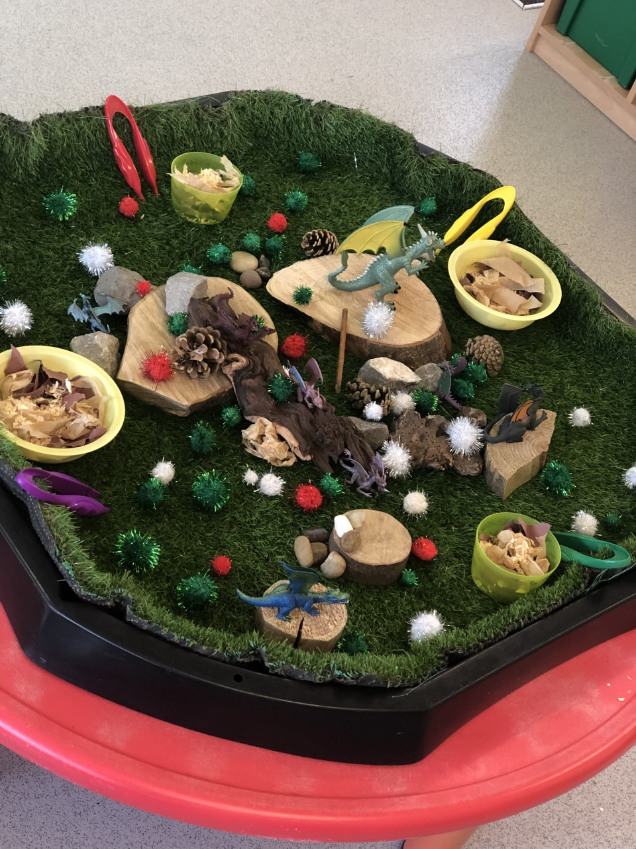

B: ‘Robby the Robot’ was designed and built when I taught 2D and 3D shape. A new 3D body part was added to Robby during each plenary when the children could correctly name all 2D and 3D shapes with confidence. After the robot was built, we decided as a class to give him a name. We added 2D buttons to the main cuboid, and Robby became the Mathematics mascot for the ‘Numeracy Area’ within the classroom. The children loved being part of building Robby and love having a robot in their Numeracy Area.

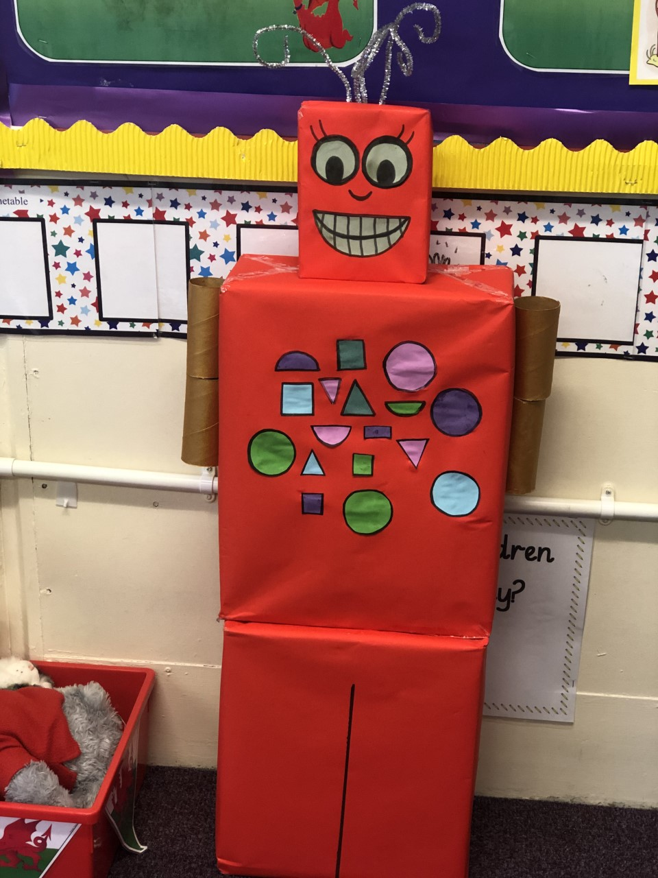

C: This enhanced provision was designed to work on pupils touch-counting skills. The children worked in pairs and they collected the frogs from the water and balanced as many as they could on the lily pads before touch counting them to see how many they had balanced and if they had balanced more than their partner. The inspiration came from a conversation with a group of children who told me how they loved visiting the local lake and had never seen any frogs there. The children thoroughly enjoyed this activity and were often coming back and forth to tell me how many frogs they had managed to balance.
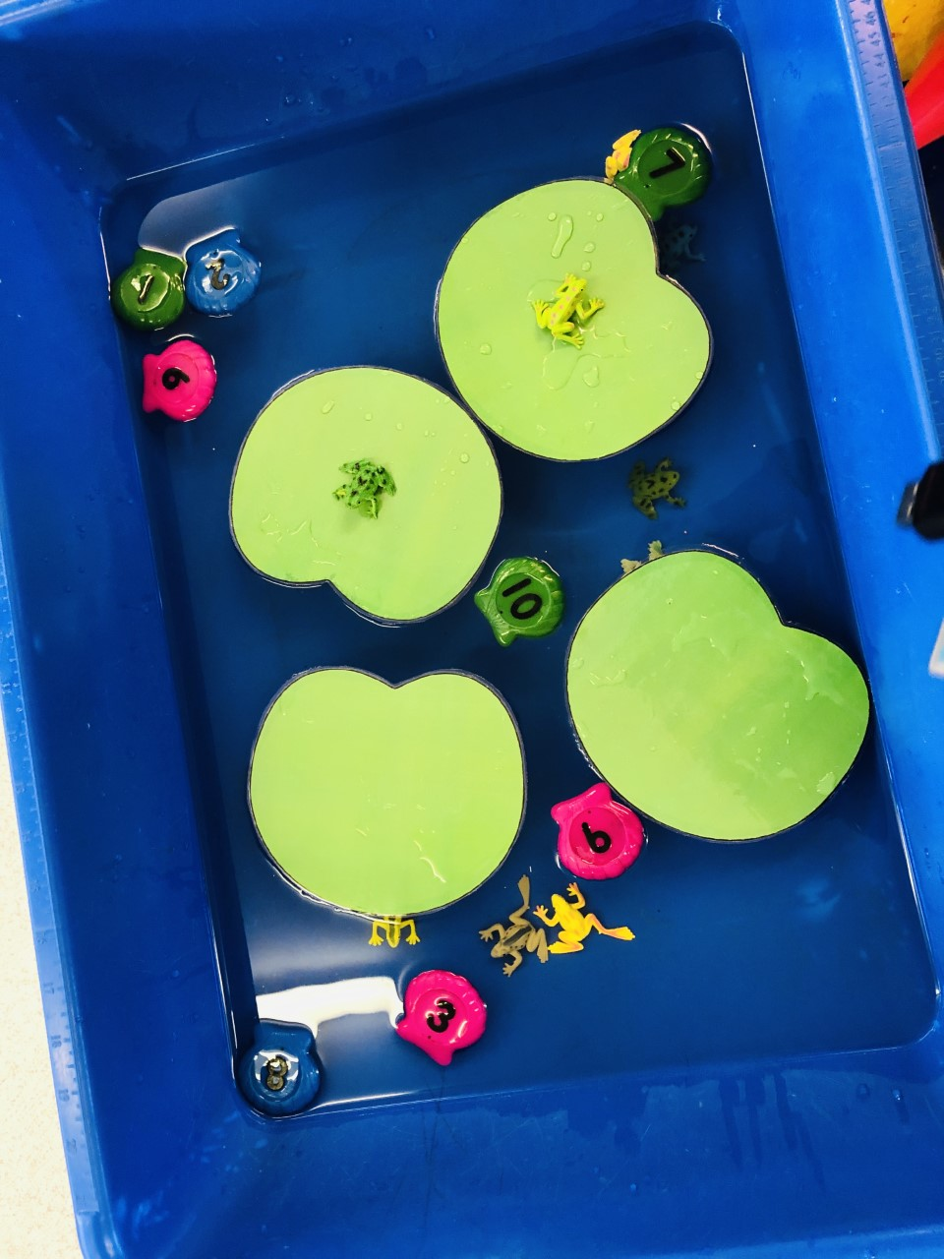

D: This enhanced provision was both a fine-motor activity and an activity based on the idea of sharing equally. This was a concept we were exploring in Mathematics in a problem solving based context, through a teddy bear’s picnic, which involved sharing plates, cups and food equally between the bears. The children love wild animals and were excited to become zookeepers for the week and share out the pasta between the animals equally.
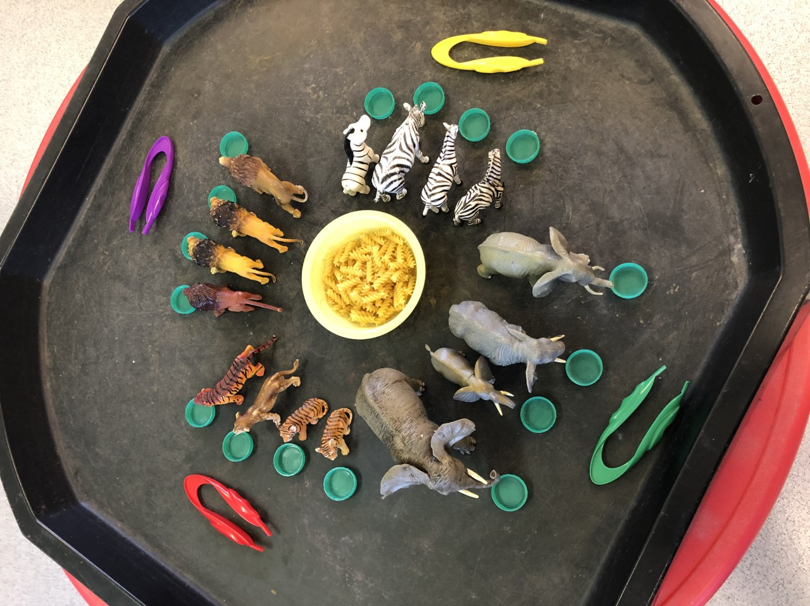

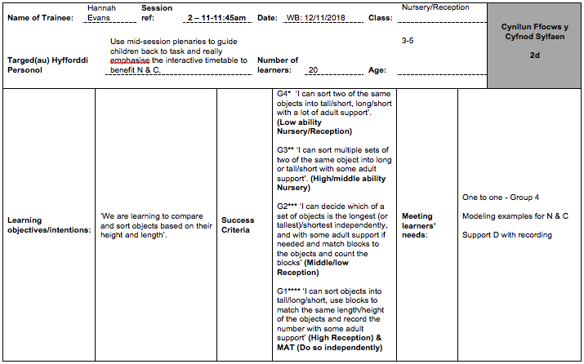
E: Session plan for measurement:

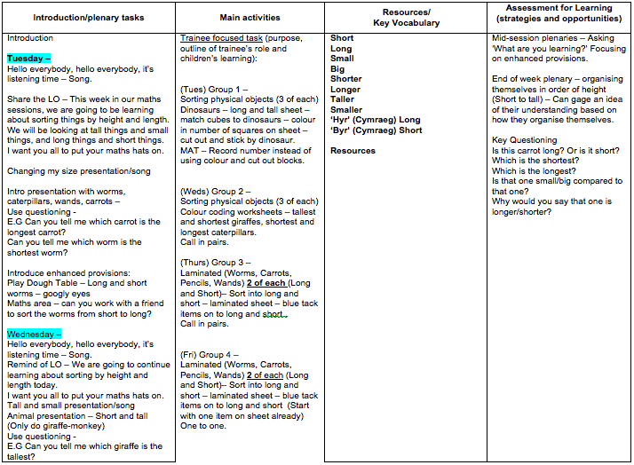

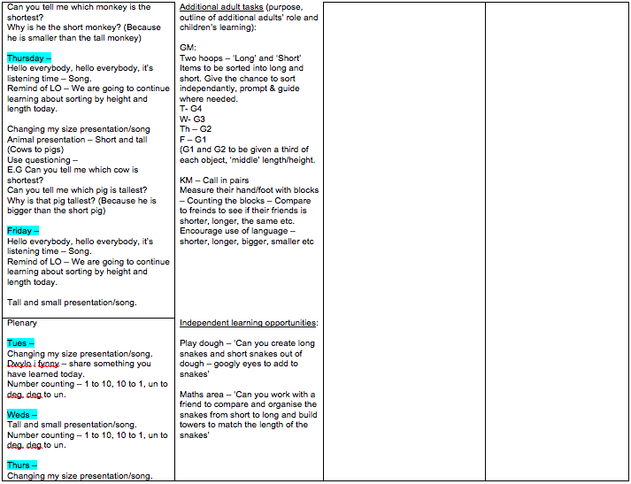

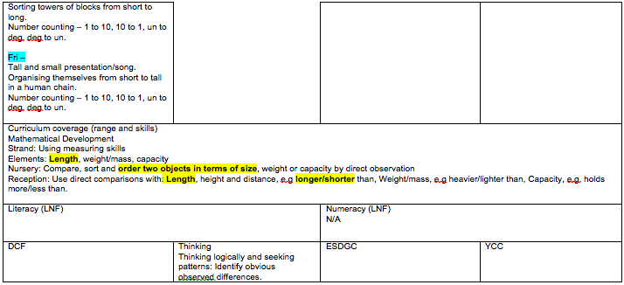

F: Session plan for myself and non-living things:
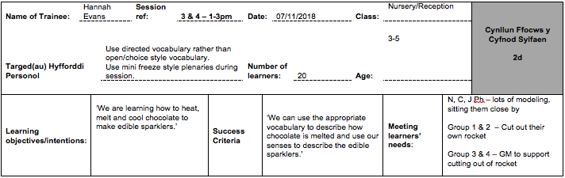

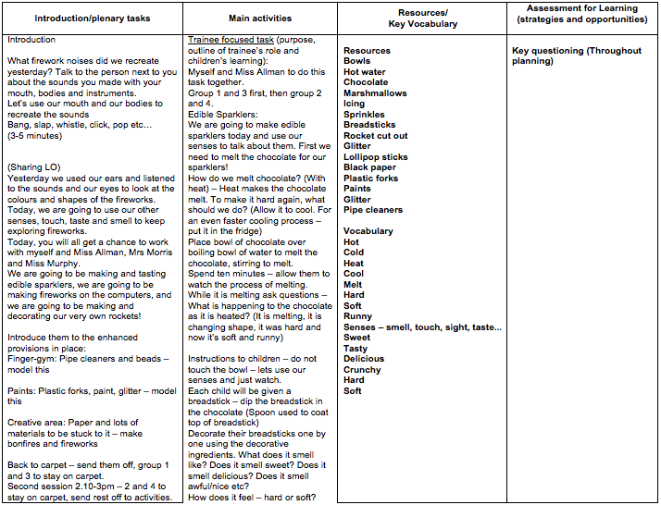

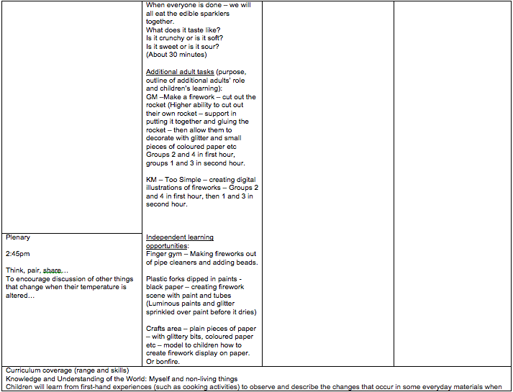

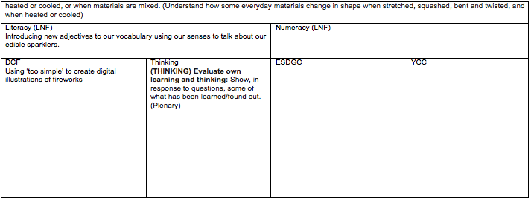

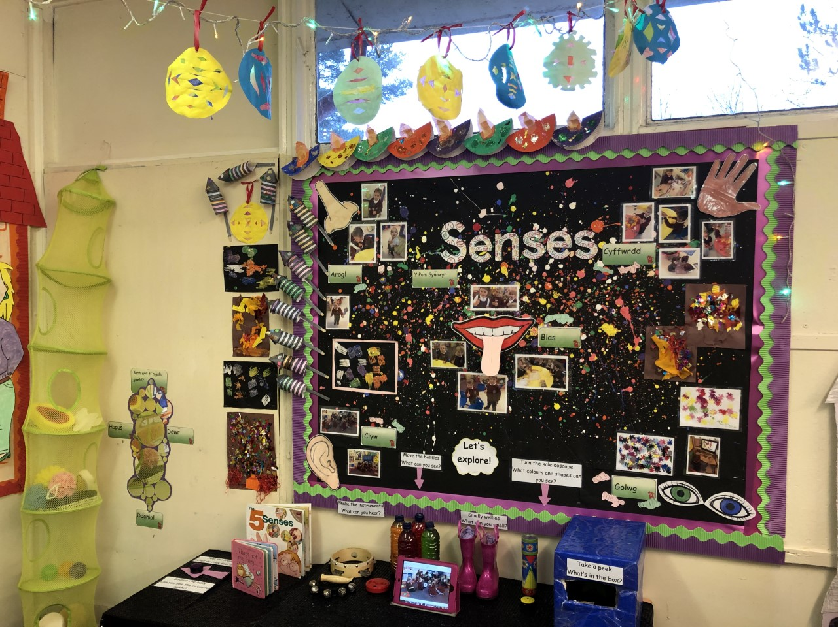
G: This is the interactive sensory area I created with the children as we explored our senses through a variety of topics. After exploring fireworks, we looked at the celebration of Diwali. We created Diwali crafts such as Rangoli patterns and Diva lamps as well as using our senses to taste vegetable Pakoras, a food traditionally eaten during Diwali. After exploring day and night, we added fairy lights to the area and the blue box with glow in the dark stars inside. We also looked at recycling during an ESDGC session, and we recycled plastic water bottles from the school kitchen, adding food colouring, flowers, twigs and biodegradable glitter to create sensory shaker bottles. This area of the environment is well used by the pupils, and provided a safe space for one pupil in particular with Autistic Spectrum Disorder.

