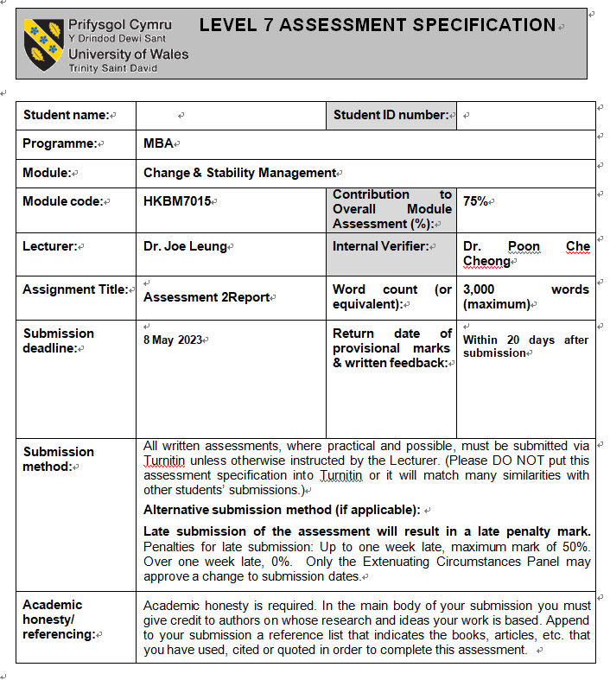



Change & Stability Management – Cathay Pacific

Student Name: Kwok Chun Ho, Leo

Table of Contents
1. Introduction 3
2. Background of Cathay Pacific Airways 3
3. Current situation of the Cathay Pacific and the major drivers for the change 5
3.1 Difficulties faced by the Cathay Pacific 5
3.2 General Environment - Economic Dimension 6
3.3 General Environment - Technological Dimension 7
3.4 Task Environment - Customers 8
3.5 Internal Environment – Employees 9
4. Advantages and disadvantages of organizational change 10
5. Exceptional event in the modern business environment 12
6. Recommendations & Conclusion 15
6.1 Technological Component 15
6.2 Sociocultural Component 17
6.3 Conclusion 17
7. References 18

Introduction

The COVID-19 pandemic brings three challenging years, especially making a big effect on the aviation industry, and airlines worldwide have to deal with problems like never before. Like many other airlines, Cathay Pacific Airways has had to change how it operates to meet changing customer expectations and adhere to COVID-19 restrictions. In addition, Cathay Pacific Airways has been challenged by low-cost carriers, shifting customer expectations, and advancements in technology. The following report will analyze how the Cathay Pacific Group made changes through Kotter's Eight-Step Plan and turned crisis into opportunity.

Background of Cathay Pacific Airways

Cathay Pacific was established in Hong Kong in 1946. Over the past seventy-six years, the Group has always regarded Hong Kong as its home, and is still committed to contributing to Hong Kong, making continuous huge investments in order to develop Hong Kong into a major international aviation hub. Forty-eight new passenger aircraft will join the fleet in the coming years. In 2015, Cathay Pacific took on a new image. The fuselage of the fleet was replaced with a new image, coupled with a brand-new "Wings Up and Wings" logo and a new color level. Cathay Pacific had a fleet of 181 passenger and cargo aircraft as at 31 December 2022. The group's other investments include food service, laundry, ground handling and cargo terminal companies, as well as a corporate headquarters at Hong Kong International Airport.

In addition, the Group provides services to a total of 131 destinations in 21 other countries and regions through code-sharing agreements. Customer-oriented is one of the main areas of work leading Cathay Pacific to realize the Group's strategy. It is based on data to deeply explore the reasons why customers prefer to use Cathay Pacific services, so as to enhance customer loyalty and support. Cathay Pacific will also keep improving to ensure the maintenance of high-efficiency operations; establish a high-performance culture that focuses on creating an ideal employee experience and a diverse and inclusive working environment; maximize productivity and create value, so that Cathay Pacific can work better and better, and make continuous progress. According to the IATA World Air Transport Statistics Report 2019, the Cathay Pacific Group was the world's eighth largest international passenger airline and the third largest international cargo airline before the COVID-19 outbreak ("COVID-19").

Current situation of the Cathay Pacific and the major drivers for the change

Figure 3.1: Cathay Pacific's 4-year total revenue trend chart
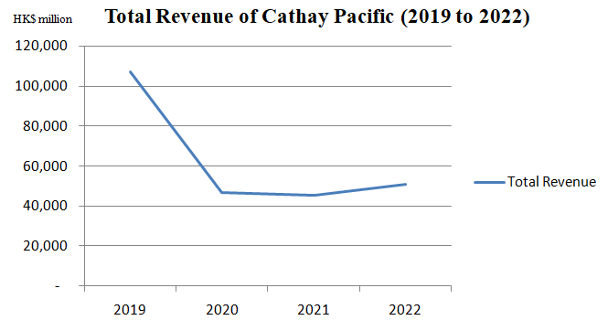
Source: Constructed by the Author

A company needs constant transformation to cater to changing market conditions. Especially the service industry(Hossain, 2017), In the figure 3.1, it can be seen that Cathay Pacific’s total revenue under COVID-19 has fallen by more than 50%, and it has lasted for nearly 3 years. The impact of COVID-19 has been hit hard, but if there is a crisis, there will be opportunities.

Difficulties faced by the Cathay Pacific

During the COVID-19 period, Cathay Pacific posted its worst financial results ever, recording a loss of HK$21.6 billion in 2020. It will save costs as it remains in 'survival' mode after record losses in 2020(Danny, 2021). Cathay Pacific axed 5,300 jobs in Hong Kong and 2,600 unfilled roles were eliminated jobs. Hong Kong-based cabin and cockpit crews are demanding new, cheaper contracts. Restructuring costs were HK$2.2 billion, while a monthly cash burn of HK$2 billion was reduced by HK$500 million through layoffs and airline closures. Cathay Pacific is a company that provides services, so a large reduction in manpower will seriously affect the quality of service(Mehtarizadeh & Pourkiani, 2021), thereby affecting customer experience. The following will use the type of organizational environment to go to Cathay Pacific.
Figure 3.2: Type of organizational environment
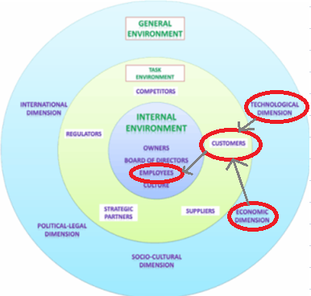
Source: Constructed by the Author

General Environment - Economic Dimension

As a well-known company in Hong Kong, Cathay Pacific plays an important role in tourism and logistics. In order to further boost the economy, the Airport Authority will build Hong Kong International Airport into an "aviation city" in the Greater Bay Area in terms of cargo. As an international center, it can provide unparalleled connection services for people from all over the world. Hong Kong International Airport has won the title of the world's busiest cargo airport for eight consecutive years, and also has an excellent geographical location that can fly to nearly half of the world's population within 5 hours. At the same time, it has achieved the world's first handling of 5 million tons of cargo and airmail airport(AAHK, 2018).
However, entering 2019, the advent of COVID-19 has greatly affected the business models of all walks of life. The aviation industry is the first to bear the brunt. Entry restrictions and isolation measures have been implemented around the world, making everyone lose their desire to travel abroad. It is even regulated by the government to ground certain destinations. In view of this, the company needs to continue to survive, so it must change. Seek more business opportunities(Jackman, 2015).

General Environment - Technological Dimension

Enterprises such as Amazon and Ant Financial are actively researching the technology of "unmanned supermarkets" to human labor with technology so that customers can shop faster, more conveniently, and efficiently(Priporas, Stylos & Fotiadis, 2017). Take the current unmanned store as an example. After the customer has purchased the product and arrives at the payment area, the system will use high-frequency radio frequency identification (RFID) technology to sense the product in the customer's hand, and then automatically deduct the corresponding amount from his electronic wallet(Gillenson & Sherrell, 2002).
At present, Cathay Pacific's automation can only be applied to some relatively low-skilled jobs, such as immigration and boarding procedures. As a result, there is a shortage of manpower, which affects the customer experience. Similarly, airport operations are tedious, and the working hours are long and irregular. So it is difficult to attract young, promising, ambitious people (Fisherl, 1993). In addition to Hong Kong, even world-class airports like Singapore's Changi Airport are facing the problem of lack of fresh blood and young people. The shortage of manpower is becoming more and more serious, resulting in long queues at the counters and affecting the passenger experience. Since jobs related to airport operations are difficult to become interesting and attractive in the short term, measures such as salary increases or improved benefits will increase the financial burden of airports and weaken their competitiveness (Chang & Chen, 2012).

Task Environment - Customers

Many airports around the world are also facing customer congestion. In order to avoid the delay of the plane, many passengers will check in at the airport two hours in advance. If check-in and other procedures are fully automated, the airport will be able to release more manpower to provide passengers with better individual services. This not only improves the operational efficiency of the airport, but also reduces the time required for boarding and security checks. Passengers can have more time to enjoy various services at the airport, and can activate the robot to answer any questions of passengers. Passengers simply scan their boarding pass and the robot guides them to the boarding gate. The robot can also translate multiple languages around the world at any time, eliminating language barriers for customers and further enhancing the passenger experience. Create beautiful memories of your trip. To sum up, "automation" can not only reduce operating costs, improve efficiency, and improve the problem of manpower shortage (Rodríguez, Soria & Campo, 2016), but also make the entire immigration and boarding process smoother and more convenient, bringing passengers different experiences.

Internal Environment – Employees

Employees are one of the most important assets in a company, but they are also the most difficult to use(Das & Baruah, 2013). Because of the underutilization of employees and large-scale layoffs during the epidemic, the company also needs to re-sign with employees in order to operate more effectively. Set a new employee contract, reduce the original salary of the employees in a disguised form and tide over the difficulties together. Therefore, the company needs to re-develop the trust relationship between the employees and the management, and maintain the stability and enthusiasm of the employees(Pattnaik & Jena, 2020). Make the jobs of the remaining employees get better Security and prospects. Also need to provide employees with adequate resources and support can encourage their loyalty to the employer and help to retain valuable people(Chen, Huang, Pak & Hou, 2021).

Advantages and disadvantages of organizational change

The epidemic has brought challenges, but has accelerated the transformation of airlines.
Figure 4.3: Strategic drift of Cathay Pacific Airline
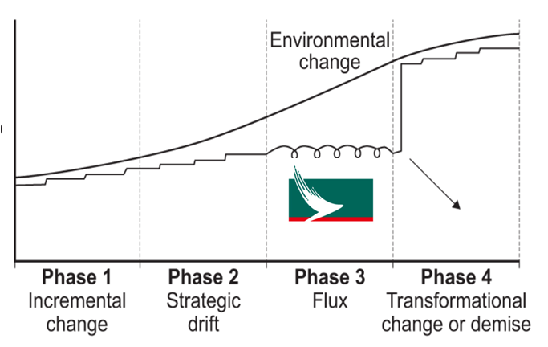
Source: Constructed by the Author

The development of biometric technology will be an important milestone in the aviation industry, especially the "Zero-touch" technology of face, iris and fingerprint. Cathay Pacific will benefit from the changes, such as the addition of a contactless check-in process and digital health passes that reduce the need for manual handling and physical contact, making the check-in and boarding process faster and safer. On the other hand, adding chatbots can provide 24-hour real-time service and airport information updates and support, and there is no problem with language barriers because the robot can switch to different language modes anytime and anywhere, which employees cannot bring the convenience, thereby improving the customer experience(Patel, 2018). Because it enhances customer experience and improves operational efficiency, it can increase customer loyalty and satisfaction, thus bringing higher and more stable income to airlines(Yi & La, 2004). The company will also continue to introduce relevant resources, ranging from seat registration, checked baggage, license inspection, security clearance, VIP room services, face recognition boarding, etc., and the implementation can save 40% of the boarding time. The foundations can be laid first for changing market conditions in the future.
In the check-in process in front of the boarding counter, there are often long queues of people, which seriously affect the happy mood of customers before departure. Therefore, you can use the phone APP to issue a "virtual queue". After obtaining the boarding pass, the App will display when it is the passenger's turn to board the plane, a pop-up notification will help improve the efficiency of providing information to customers. Weather and mechanical failures will affect the flight, and many passengers can understand the force majeure factor, but it is definitely a painful nightmare to spend a lot of waiting time at the airport. On-site human judgment can make preparations for the aftermath of problems before they occur, and can also notify passengers in advance before arriving at the airport, avoiding the dilemma of waiting at the airport and not being sure when the problem will be resolved.
Cathay Pacific is not immune to some shortcomings when it comes to change. Because of the increased reliance on technology, major failures or breaches of digital systems could have significant impacts on operations and customer trust. And every time a company changes, there is usually resistance from employees(Bolognese, 2002). Introducing new technologies and processes can be challenging for employees, especially when they have not received adequate training or feel their job security is threatened. This can lead to resistance and lower morale, ultimately affecting customer service and the overall success of the change program. On the other hand, some older customers may not be comfortable using digital platforms, or may find them confusing or difficult to navigate(Lee & Lee, 2020). This can lead to frustration and a negative perception of the airline, especially if they experience delays or other issues using these platforms.

Exceptional event in the modern business environment

Table 5.1: Exceptional event in the World
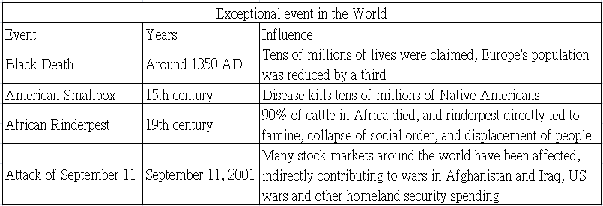
Source: Constructed by the Author

According to the special events happening in the world in the table 5.1, No matter how many excellent talents and risk management personnel a company has, there will inevitably be unexpected emergencies in the world, such as the Russo-Ukrainian War and Covid-19. These two major events in modern times have a great impact on society and the economy it has caused a lot of impacts, especially on the aviation industry. The Russo-Ukraine War has affected individual flight routes, and the airspace in specific areas has become a no-fly zone, and many flights have to be diverted(Mira and Jin, 2022). The impact of Covid-19 is even greater, directly affecting Flights all over the world are facing the threat of being banned from flying, only a small part of the flight is maintained, and the monthly passenger capacity is greatly reduced. In addition, there are also many anti-epidemic measures against the epidemic, and increasing the airline is Day-to-day operating costs has had a huge impact on the aviation industry.
Kickbusch who is the founder and director of the Global Health Center in Geneva, pointed out in an interview that if there is no trade war or other tensions in 2019. In the past, global public health crises have also occurred during times of major geopolitical tensions. She pointed to the example of the acute respiratory syndrome (SARS) outbreak when the global response was still considered a collaboration that led to more transparency. SARS, caused by the corona virus, also first occurred in China and caused chaos around the world in 2002 and 2003. Back then, China admitted it had made mistakes and reorganized the Ministry of Health to create the Chinese Center for Disease Control and Prevention (CDC). Others are choosing to believe it and calling for more cooperation. But before the COVID-19 crisis, geopolitical tensions had undermined the global public health response. Kickbusch said the U.S.-China trade war has morphed into a "geopolitical blame game." The result is that China is fully clamping down, and the United States does whatever it wants, which ultimately "causes the world to suffer together." The most catastrophic outcome of this confrontation.
The whole world has been impacted by the Russia-Ukraine War, the Sino-US trade war and covid-19 in just a few years. All walks of life have made relative changes in order to survive in a turbulent social environment. Under these uncertain factors, Cathay Pacific’s business model needs to be reformed to cater to the general trend of society. In this world, where there is a crisis, there is an opportunity. Affected by the government's anti-epidemic policy, the airport and passenger flow have been greatly reduced, resulting in excess manpower. The system reduces face-to-face contact with customers, and also provides various high-tech applications such as CHATBOT and VR, etc., to make perfect preparations for future digitalization. Although the number of passengers has declined, the anti-epidemic materials produced due to the epidemic have driven air transportation According to the Hong Kong Airport Authority, the cargo volume of Hong Kong International Airport increased by 12.5% year-on-year to 5 million metric tons, surpassing before the epidemic; the number of cargo aircraft movements also hit a record high, jumping 19.8% year-on-year. In the long run, with the rise of surrounding cities, the strengths of Guangzhou and Shenzhen airports should not be underestimated, and cooperation and competition coexist. Studies have pointed out that the overlap between Hong Kong Airport and mainland airports is as high as 60% to 70%. How to effectively allocate resources and integrate development with airports in other cities in the Greater Bay Area is the root cause pointed out by many industry insiders. In view of this, we take advantage of the epidemic to make early changes, upgrade our service quality in the aviation industry, and lay a solid foundation for the digital society in the future.

Recommendations & Conclusion

Some advantages of the change plan implemented by Cathay Pacific Airways will be described from the perspective of technological and sociocultural component.

Technological Component

Figure 6.4: Global Merchandise Trade Volume
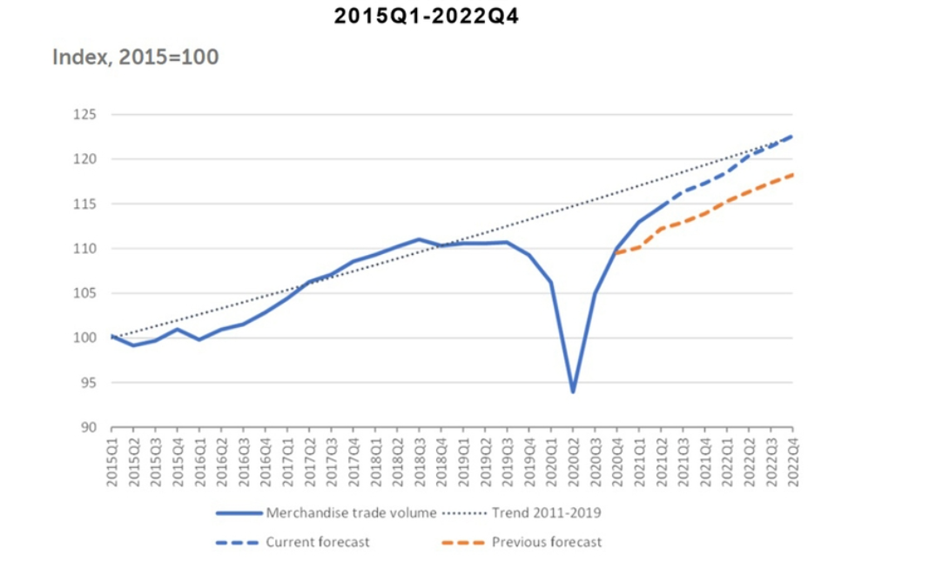
Source: (HKTDC, 2021)
Cathay Pacific’s digital initiatives have streamlined operations, resulting in greater efficiency and lower costs. For example, contactless check-in processes and digital health passes reduce the need for manual handling and physical contact, making the check-in and boarding process faster and safer. The digital initiative also improves the customer experience by providing real-time updates and support through mobile apps and chatbots, reducing the hassle of physical paperwork. Enhanced customer experience and operational efficiency increase customer loyalty and satisfaction, resulting in higher revenue for airlines. Additionally, Cathay Pacific could explore opportunities for innovation in areas such as augmented reality (AR) and virtual reality (VR) to enhance the customer experience, especially on long-haul flights. AR and VR can be used to create immersive and interactive experiences for passengers, with the aim of providing the best flight experience possible.
The volume of global trade continues to increase. Under the catalysis of COVID-19, the Internet consumption of overseas users has increased rapidly, and cross-border e-commerce has become a new growth point for stabilizing foreign trade. The importance of overseas warehouses is even more prominent when the epidemic affects the suspension of a large number of aircraft. From the beginning of 2020 to the present, merchants who keep goods in overseas warehouses have obvious profit benefits. Cross-border e-commerce sellers prepare goods to overseas warehouses and ship directly locally, which greatly shortens the delivery time. Local logistics is used for the last delivery, and the movement of packages can be tracked through digital technology. Cathay Pacific Cargo's digital transformation will allow Cathay Pacific Cargo and customers to monitor in near real time and the data during the transportation of goods from the departure airport to the destination airport will make the transportation process more transparent. It is also possible to remotely monitor the status of the goods on the network. In addition to customers being able to monitor their cargo, Cathay Pacific Cargo's professional cargo team will also monitor it around the clock. The team is not only responsible for monitoring the condition of the cargo, but also instructs the operators on the apron and warehouse to manipulate the cargo and make adjustments as needed. Customers can also chat with the team in the cargo transportation control center in real time. Such a platform can occupy a considerable market share in the international trade market.

Sociocultural Component

The epidemic is gradually subsiding. For business travel, the experience during the epidemic has convinced the company's management that remote meetings are economical and practical, and can even replace face-to-face meetings and events, so business travel may not return to pre-epidemic levels(Mancl & Fraser, 2020). But business travel only accounts for a small part, mainly leisure travel activities and air freight business. Historical experience shows that the Spanish flu broke out at the end of World War I in 1918 and did not subside until 1920. However, people were not shrouded in the shadow of the epidemic, but ushered in the so-called "Roaring 20s". And today's Young people like to live in the present, so there will be a large number of potential customers and a lot of accumulated consumption power will explode. In addition, most of the people's time is now spent using mobile phones, APPS, and various networks Platform. Cathay Pacific has taken the lead in implementing multi-faceted digital services, so it can naturally give priority to attracting customers' choices, thereby increasing revenue.

Conclusion

Cathay Pacific has successfully implemented a change program in response to the external challenges of the COVID-19 pandemic and rapid digitization. The adoption of digital initiatives enables airlines to improve operational efficiency, reduce costs, enhance customer experience and continue to be the leader in the industry.

References

AAHK (2018) Sustainability report. Available at: https://www.hongkongairport.com/iwov-resources/html/sustainability_report/eng/SR1718/our-future-airport/economic-contribution/index.html (Accessed: 12 April 2023).
Bolognese, A. F. (2002). Employee resistance to organizational change. Retrieved November, 14, 2006.
Chen, Q., Huang, R., Pak, K.Y. and Hou, B. (2021), "Internal marketing, employee satisfaction and cultural congruence of Gulf airlines", Tourism Review, Vol. 76 No. 6, pp. 1214-1227.
Chang, Y. C., & Chen, C. F. (2012). Meeting the needs of disabled air passengers: Factors that facilitate help from airlines and airports. Tourism Management, 33(3), 529-536.
Cathay Pacific Airways Limited. (2022) Annual Report 2022. Available at: https://www1.hkexnews.hk/listedco/listconews/sehk/2023/0403/2023040302330.pdf (Accessed: 1 May 2023).
Cathay Pacific Airways Limited. (2021) Annual Report 2021. Available at: https://www1.hkexnews.hk/listedco/listconews/sehk/2022/0309/2022030900463.pdf (Accessed: 1 May 2023).
Cathay Pacific Airways Limited. (2020) Annual Report 2020. Available at: https://www1.hkexnews.hk/listedco/listconews/sehk/2021/0310/2021031000247.pdf (Accessed: 1 May 2023).
Danny, L. (2021) ‘Hong Kong’s Cathay Pacific Airways in survival mode’, The Times, 10th March. Available at: https://www.scmp.com/news/hong-kong/hong-kong-economy/article/3124792/cathay-pacific-airways-posts-record-losses-hk216?module=perpetual_scroll_0&pgtype=article&campaign=3124792 (Accessed: 7 April 2023).
Das, B. L., & Baruah, M. (2013). Employee retention: A review of literature. Journal of business and management, 14(2), 8-16.
Fisherl, C. D. (1993). Boredom at work: A neglected concept. Human relations, 46(3), 395-417.
Gillenson, M. L., & Sherrell, D. L. (2002). Enticing online consumers: an extended technology acceptance perspective. Information & management, 39(8), 705-719.
Hossain, M. (2017). Business model innovation: past research, current debates, and future directions. Journal of Strategy and Management, 10(3), 342-359.
HKTDC (2021) “Post-pandemic Supply Chains: Unlocking Shipping Bottlenecks”. Available at: https://research.hktdc.com/en/article/ODU5MTYxMjQz (Accessed: 29 April 2023).
Jackman, D. (2015). The compliance revolution: how compliance needs to change to survive. John Wiley & Sons.
Lee, S. M., & Lee, D. (2020). “Untact”: a new customer service strategy in the digital age. Service Business, 14(1), 1-22.
Mira, R. and Jin, W. (2022) “Where Russia Is Banned From Flying—And Who It’s Banned in Retaliation” Available at: https://www.bloomberg.com/graphics/2022-russia-ukraine-flight-bans/?leadSource=uverify%20wall (Accessed: 29 April 2023).
Mehtarizadeh, Z., & Pourkiani, M. (2021). A Manpower Productivity Model for Organizational Excellence: Quality and Entrepreneurship. Management Theory and Studies for Rural Business and Infrastructure Development, 43(2), 249-258.
Mancl, D., & Fraser, S. D. (2020). COVID-19’s Influence on the Future of Agile. In Agile Processes in Software Engineering and Extreme Programming–Workshops: XP 2020 Workshops, Copenhagen, Denmark, June 8–12, 2020, Revised Selected Papers (pp. 309-316). Cham: Springer International Publishing.
Priporas, C. V., Stylos, N., & Fotiadis, A. K. (2017). Generation Z consumers' expectations of interactions in smart retailing: A future agenda. Computers in Human Behavior, 77, 374-381.
Pattnaik, L., & Jena, L. K. (2020). Mindfulness, remote engagement and employee morale: Conceptual analysis to address the “new normal”. International Journal of Organizational Analysis, 29(4), 873-890.
Patel, V. (2018). Airport passenger processing technology: a biometric airport journey.
Rodríguez, G., Soria, Á., & Campo, M. (2016). Artificial intelligence in service-oriented software design. Engineering Applications of Artificial Intelligence, 53, 86-104.
Yi, Y., & La, S. (2004). What influences the relationship between customer satisfaction and repurchase intention? Investigating the effects of adjusted expectations and customer loyalty. Psychology & Marketing, 21(5), 351-373.

