Factory Control 1



Module: Control Technology
Module Code: ACMA6001
Lecturer: Dr Gary Jones
Student: Thomas Hughes
Student Number: 1909575
Contents
List of Figures 3
List of Tables 3
Introduction 4
Literature Review 4
Factory Control Report 6
Operational Flow Chart 6
Alarm & Warning Strategy 7
Ladder Logic Program 8
HMI Screens 11
References 14

List of Figures
Figure 1 Operational Flow Chart
Figure 2 Examples or Warnings and Alarms.
Figure 3 Factory stack lights and siren
Figure 4 Bird's eye view of the Factory Layout
Figure 5 Root HMI Screen
Figure 6 Warning HMI Screen
Figure 7 Engineers HMI Screen

List of Tables
Table 1 Pros & Cons of the Fixed PLC
Table 2 Pros & Cons of the Modular PLC
Table 3 Pros & Cons of a Rack Mounted PLC

Introduction
Despite recent technology advancements, Programmable Logic Controllers (PLC) are still employed in many real-world applications (Guedes, 2010) and serve an important part in industrial automation infrastructure.
As the need of automation increases significantly, a control system needs to be easily programmable, flexible, reliable, robust and cost effective (Wiley, 2015). In this paper a review of the types of programmable logic controller (PLC) used in industry, and a description of their strengths and weaknesses.
Secondly, the report will detail a Factory control system that is designed to sort a number of boxes based on their size and weight, the warning and alarm strategy of the system and a description of each network step of the ladder logic PLC programme.

Literature Review
PLCs are computer-based, solid-state, single-processor devices that mimic the behaviour of an electric ladder diagram and can manage a wide range of industrial equipment and full automated systems. PLCs are commonly used in industrial automation systems. In applications involving sequential control and the synchronisation of processes and auxiliary parts in the industrial, chemical, and manufacturing sectors, they are extremely efficient and dependable (Alphonsus & Mohammad, 2016).
The three main types of PLC’s used in industry are Fixed PLC, Modular and Rack PLC, Typically, fixed PLCs are designed to execute simple duties. They are compact and consist of a power supply, a CPU, and I/O devices all contained in one unit (Muthukrishnan, 2020). The smooth operation of all processes is heavily reliant on the faultless execution of each component (Gilbert, 2019).
The modular PLC is a form of PLC that allows for various expansions of the PLC system by the use of modules, hence the name "modular." Modules provide extra functionality to the programmable logic controller, such as an expanded number of I/O units, and they are often easier to operate because each component is independent of the others (Phillips, 2019).
Rack mounted PLCs are comparable to modular PLCs but are implemented differently. A modular PLC links each module directly to the base unit, whereas a rack mounted PLC maintains each module independent. All extra modules are network-connected, and they are stored in orderly racks. Allowing for the construction of bigger systems without becoming unduly crowded and complex. The modules on the rack are properly arranged and may be withdrawn and reinserted as needed (Aries, 2022).

The tables below provide a description of the Pros and cons of the Fixed, Modular and Rack mounted PLC.
Fixed PLC
Pros | Cons
Cost Effective | Cannot be expanded
Small and compact | Extremely simple and basic
Easy to programme | Any failures require the whole unit to be replaced
All parts are housed in one | Low memory
Table 1 Pros & Cons of the Fixed PLC
Modular PLC
Pros | Cons
Expandable | Expensive compared to Fixed
Single modules can be replaced | More complicated than a Fixed PLC
Capability of control
Large Memory
Easier to troubleshoot
Less downtime
Table 2 Pros & Cons of the Modular PLC
Rack Mounted PLC
Pros | Cons
Has all the attributes of a Modular PLC | Most expensive PLC
Highly scalable | High energy consumption
Single modules can be replaced with low cast and ease
Communicates easily with other systems
Works at a higher speed
Capable of controlling the most complexed processes
Table 3 Pros & Cons of a Rack Mounted PLC

Factory Control Report

Operational Flow Chart
Figure 1 delivers an operational flow chart for the designed factory control process.
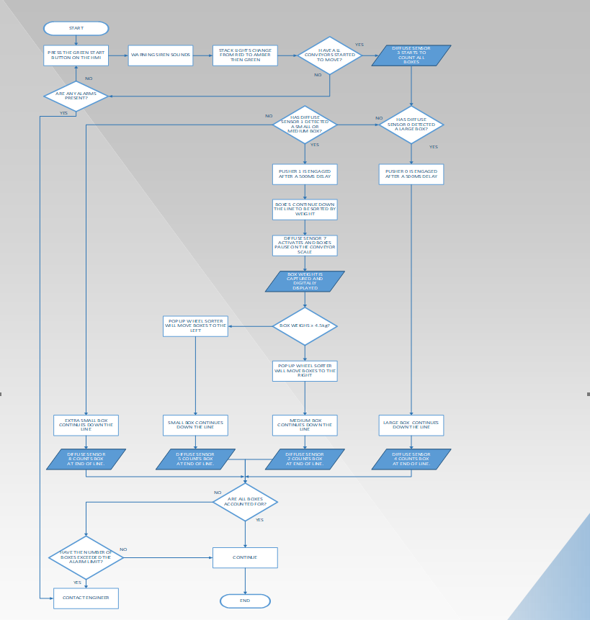
Figure 1 Operational Flow Chart

Alarm & Warning Strategy
To automate and manage a manufacturing line, alarms and warnings are essential. Although a warning won't stop the line, it will give operators enough time to react and make necessary adjustments to save downtime. Whereas an alarm immediately stops the line as soon as the set point has been reached.
The alarm strategy is programmed within the PLC ladder logic, to make the system as user friendly as possible. Figure 2 provides an example of warnings and alarms shown on the Warning HMI, providing the user with adequate information to understand the performance of the line.
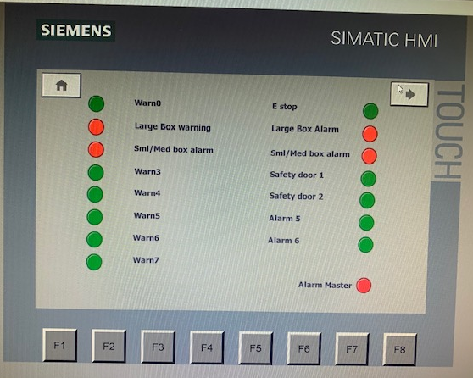
Figure 2 Examples or Warnings and Alarms.
The Operational limits for each set point can be determined by the user and are situated on the Engineering HMI screen, when either of these set points are breached, Warning and Alarm flags are present on each of the HMI’s.
As an engineer, it's imperative that safety come first when a new system or process is implemented, followed by process control. To enhance operator safety, several safety features have been implemented. For example, the Root screen HMI has an emergency stop button that may be used to quickly stop the line. As the line is automated, there is no need for anyone to enter the Zone whilst the line is running, therefore fencing has been installed with two safety gates added, when the interlock is broken on either gate, the line will stop, and the lights will appear red on Safety 1 or 2 & Alarm master on the Warning HMI screen.
Above the Control Panel 1 of 2 stack lights and a siren, the siren warns employees that the line is about to start and the stack lights provides a clear visual that the line is Operational or on stop.
Figure 3 shows how the stack lights look on the factory.
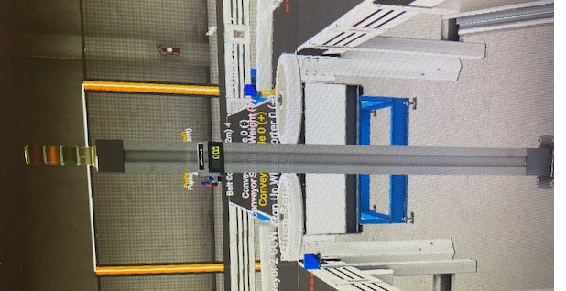
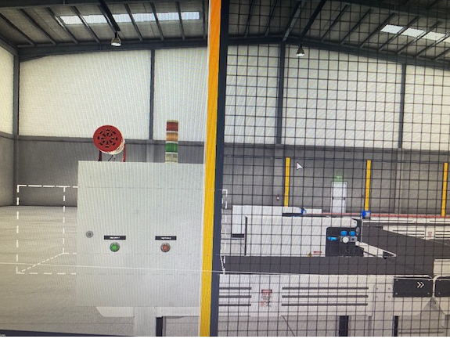

Figure 3 Factory stack lights and siren

Ladder Logic Program
The factory control ladder logic programme consists of a total of 20 networks, each of which contributes to the automation of the factory system. To mimic how the factory would operate in a real-world setting, the PLC was programmed in Siemens TIA and connected to Factory IO. A bird's-eye overview of the factory layout is shown in Figure 4.
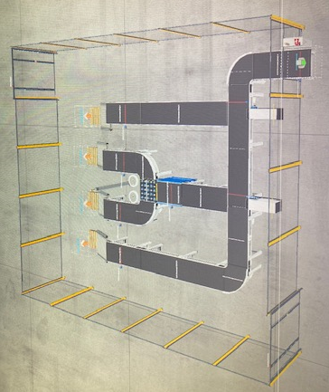
Figure 4 Bird's eye view of the Factory Layout
A description of each step is provided in the below section of work.
Network 1: Initiate PLC
The purpose of network 1 is to initiate the PLC so that the system can be started.

Network 2: Start/Stop the Line
Inputs of network 2 are the start and stop buttons. Once the start button is engaged the Factory will operate, when the stop button is engaged the line will stop and the alarm master (normally closed) will light, once reset the line can restart via the start button.
Network 3: Initiate Conveyors
Network 3 controls all of the factory conveyors, prior to each conveyor starting there is a 2 second time delay to allow a warning siren to sound. Each conveyor can then start, with a time delay, ranging from 500 milliseconds – 3seconds for the starting conveyors and 5seconds for the conveyors furthest away.
Network 4: Initiate Stack Lights
The siren(input) dictates when the stack lights can start to change colour, after the siren has sounded, yellow lights 1&2 will appear on both stack lights.
If 2m belt conveyor (0) is operating, then green lights 1&2 will appear on both stack lights.
If 2m belt conveyor (0) has stopped, red lights 1&2 will appear on both stack lights.
Network 5: Setting Warning Flag
If a Warning (Input) is present and the line is in Operation, a signal (output) is sent for the warning flag to operate, turning the Warning light on the Root screen HMI Red.
Network 6: Setting Alarm Flag
If an Alarm is present (input) a signal is sent for the Alarm master to light on the Warning HMI.
When the Alarm Master has been triggered a signal is sent for the Alarm flag to operate, turning the Alarm light on the Root Screen HMI Red.
Network 7: Activate Large Box Pusher
Diffuse sensor 0 is positioned so that it will only detect large boxes, once Diffuse sensor 0 detects a box, Pusher 0 will engage after a 500milisecond delay.
Network 8: Activate Medium & Small Pusher
Diffuse sensor 1 is positioned so that it will detect medium and small boxes, once Diffuse sensor 1 detects a box, Pusher 1 will engage after a 500milisecond delay.
Network 9: Activate Conveyor Scale & Digital Display.
When diffuse sensor 7 (input) is activated the box will pause for a small delay and the conveyor scale is activated, when the conveyor scale is activated a signal is sent to display the reading on the Digital display.
Network 10: Weighing the Box
The Move is an output instruction in ladder logic using the conveyor scale as the input to output the weight of the box so it can be read by the Pop up wheel sorter and display weight on the Digital display.

Network 11: Pop up Wheel Sorting Medium and Small Box Based on Weight
The network is set via two “in_Range” inputs, both of which determine weight as its value, with the output determining whether the Pop us sorter shifts the boxes left or right.
Firstly, if a box weighs between 3 - 4.25kg, then Pop up sorter 0 will shift the box left.
Secondly, if a box weighs between 4.5 – 5.5kg, then Pop up sorter 0 will shift the box right.
Note: A flaw in the design has been identified, if a box weighs between 4.25 – 4.5kg, then the system will not react. Network to be updated prior to implementation.
Network 12: Total Box Count
Diffuse sensor 3 is located at the start of the line. A Count up (CTU) application is added so that each time the Diffuse sensor 3 is activated, the “Total Count” value will increase, with the total count value being displayed on the root screen HMI.
The CTU counter is reset when the Reset Counter button has been pressed, this is located on the Engineers HMI.
Network 13: Large Box Error and Count
When pusher 0 is activated the CTUD will count up, diffuse sensor 4 is located at the end of the line and when activated will count down, the difference between these values determine how many large boxes have fallen off, this value (CV) is displayed on the Root screen HMI above “Large box errors”.
Diffuse sensor 4 is also used to count the total number of Large boxes, when activated the CTU counts up, the Count value (CV) is displayed on the HMI under “Large Box”.
Both counters are reset when the Reset Counter button has been pressed, this is located on the Engineers HMI.
Network 14: Large Box Warning & Alarm Set
When the Large box errors are ≥ the Large Box Warning set point, Warning 1 (Large Box Warning) will be the output and turn red on the Warning HMI.
When the Large box errors are ≥ the Large Box Alarm set point, Alarm 1 (Large Box Alarm) will be the output and turn red on the Warning HMI.
Network 15: Medium & Small Error Count
When pusher 1 is activated the CTUD will count up, diffuse sensor 7 is located in the middle of the conveyor scale and when activated will count down, the difference between these values determine how many boxes have fallen off, this value (CV) is displayed on the Root screen HMI above “Small & Medium Errors”.
Counters are reset when the Reset Counter button has been pressed, this is located on the Engineers HMI.

Network 16: Medium & Small Warning/Alarm
When the Small & Medium errors are ≥ the Small & Medium Box Warning set point, Warning 2 (Small & Medium Box Warning) will be the output and turn red on the Warning HMI.
When the Small & Medium errors are ≥ the Small & Medium Box Alarm set point, Alarm 2 (Small & Medium Box Alarm) will be the output and turn red on the Warning HMI.
Network 17: Extra Small Box Count
Diffuse sensor 8 (input) is located at the end of the Extra small box line, when activated will count each Extra small box and output the value (CV) on the Extra Small count displayed on the Root Screen HMI.
Network 18: Small Box Count
Diffuse sensor 5 (input) is located at the end of the Small box line, when activated will count each Small box and output the value (CV) on the Small count displayed on the Root Screen HMI.
Network 19: Medium Box Counter
Diffuse sensor 2 (input) is located at the end of the Medium box line, when activated will count each Medium box and output the value (CV) on the Medium count displayed on the Root Screen HMI.
Network 20: Safety Door Interlock Alarm
Both safety doors 1&2(input) are set to normally closed, when opened a signal(output) is sent to Alarms 3&4 respectively which immediately stops the line.
Red lights will appear on the Warning HMI page under Safety door 1 & 2 (whichever has been breached).

HMI Screens
For the aforementioned Factory, 3 HMI screen have been designed. See Figure 1 777
The Root screen has a number of functions and information provided for the user.
- Start & Stop button for Operation of the Factory
- 5 counters, each counting the total number of boxes and each sized Large, Medium, Small & extra small box
- 2 Error boxes to show Large box errors and Small & Medium errors
- Three lights to mirror the stack lights
- Emergency stop button
- A warning and alarm flag light
- Access to the Warning Screen
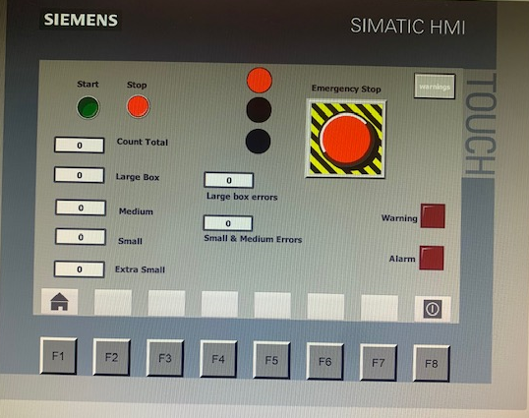
Figure 5 Root HMI Screen
The warning screen provides the user with all the warnings and alarms that are currently showing on the system. See Figure for an example of the Warning HMI screen.
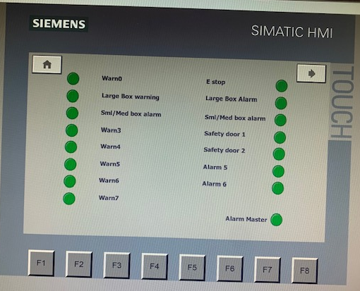
Figure 6 Warning HMI Screen
The engineers screen is where the Operational warning and alarm limits are set. Access to this screen will also allow the user to reset all counters and master reset all warnings & alarms. Figure shows an example of the Engineer HMI screen.
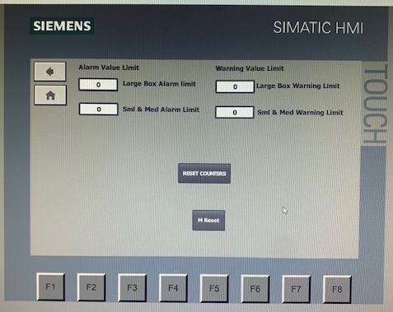
Figure 7 Engineers HMI Screen

References
Alphonsus, E. R. & Mohammad, O. A., 2016. A review of the applications of prgrammable logic controllers (PLCs). Renewable and Sustainable Energy Reviews, Volume 60, pp. 1185-1205.
Aries, B., 2022. Techwalla. [Online]
Available at: https://www.techwalla.com/articles/the-types-of-plcs
[Accessed 31 July 2022].
Direct, A., 2022. Automation Direct.com. [Online]
Available at: https://library.automationdirect.com/history-of-the-plc/
[Accessed 20 July 2022].
Gilbert, C., 2019. Idaho State University. [Online]
Available at: https://blog.cetrain.isu.edu/blog/bid/353287/
[Accessed 26 July 2022].
Guedes, L. A., 2010. Programmable Logic Controller. 10 ed. London: IntechOpen.
Muthukrishnan, V., 2020. electrical4u. [Online]
Available at: https://www.electrical4u.com/programmable-logic-controllers/
[Accessed 25 July 2022].
Phillips, R., 2019. BASICPLC.COM. [Online]
Available at: https://basicplc.com/different-types-of-plc/
[Accessed 30 July 2022].
Wiley, J., 2015. The New Cyber-Physical in Architecture: Computational Construction. Architectural Design, 85(5), pp. 28-33.

