12/4/2025
Aliu Djalo (2117368)

University of wales trinity saint david

Artificial intelligence and Machine Learning (ACCA6011)

ML Model
Table of Contents:
1. Abstract 2
2. Introduction 2
3. Problem Statement and Literature support: 2
3.1. Problem statement: 2
3.2. Literature support 3
4. Methodology 3
4.1. Data Exploration & Pre-processing 3
4.1.1.1. Initial inspection: 3
4.1.1.2. Dropping identifiers: 3
4.1.1.3. Train–test split 4
4.1.1.4. Feature scaling 4
4.2. Exploratory data analysis (EDA) 5
4.3. Supervised models. 5
4.3.1.1. Linear SVM baseline 5
4.3.1.2. Tuned RBF-kernel SVM 6
4.3.1.3. Baseline Decision Tree 7
4.3.1.4. Tuned Decision Tree 9
4.3.1.5. Evaluation metrics and model comparison 9
4.4. Clustering (K-Means) 10
4.4.1.1. Clusters based on Age and PlayTimeHours 10
4.4.1.2. Clusters based on SessionsPerWeek and AchievementsUnlocked 12
5. Experiments and Results 12
5.1. Clustering results 12
5.2. Classification results 13
6. Discussion 13
7. Recommendations: 14
8. Conclusion: 14

Abstract
This project looks at how machine learning be can used to understand and predict how engaged players are in an online game. Using a Kaggle dataset [1] with player demographics and gameplay behaviour, the author built and tuned two models: a Decision Tree and an SVM and used K-Means clustering to find groups of similar players. The tuned Decision Tree performed best, with around 90% accuracy, and the tuned SVM was close behind. Overall, the results show that simple models can give game studios useful insight into which players are highly engaged and which might be at risk of dropping off.

Introduction
Online games generate large amounts of behavioural data as players explore game worlds, interact with features, and respond to rewards. Understanding this behaviour is important because it helps developers improve engagement, keep players active for longer, and increase revenue. Engaged players are more likely to return often, buy in-game items, and recommend the game to others, which strongly supports a game’s success.[2]
Machine learning offers useful tools for analysing these patterns. In this project, the author will use two supervised learning methods, Decision Trees and Support Vector Machines (SVM) to classify players into High, Medium, and Low engagement groups based on factors like playtime, activity frequency, and performance. These models can highlight players who may be losing interest, helping developers plan effective retention strategies.
Also unsupervised learning will be applied through clustering to discover natural groups within the player base. This helps uncover hidden behaviour patterns and supports more personalised content and game design. [3]

Problem Statement and Literature support:

Problem statement:
The main goal of this research is to predict each player’s engagement level, classifying them as High, Medium, or Low from a set of demographic and behavioural features:( Age, Gender, Location, Game Genre, Game Difficulty, Play Time Hours (weekly play time), Sessions Per Week, Average Session Duration Minutes, Player Level, Achievements Unlocked and In Game Purchases).
This is framed as a multiclass classification problem with three roughly balanced classes (Medium = 48%, approximately High 26%, Low 26%, as seen in the Engagement Level value counts).
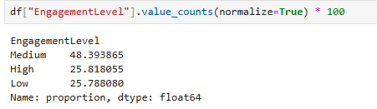
Alongside prediction, the project also aims to discover behavioural clusters of players based on (Age, Play Time Hours, Sessions Per Week, Achievements Unlocked).

Literature support
Supervised learning models like Decision Trees and Support Vector Machines are well suited for this task. Decision Trees are valued for their interpretability and ability to model nonlinear relationships without extensive pre-processing. [4]
SVMs are highly effective classifiers that perform well in high‑dimensional spaces and can separate complex decision boundaries using kernels. [5]
Besides classification, clustering also will be used, (an unsupervised learning approach) to discover natural sub-groups in the players, patterns that do not necessarily match predefined labels. And to perform hyperparameter tuning on the models to boost their ability to generalise well to new data.[6]
In summary: by combining classification (Decision Trees, SVM) with clustering and careful tuning, this project aims to build a straightforward, effective workflow to identify players at risk of disengaging, helping games stay fun and profitable.

Methodology

Data Exploration & Pre-processing
The dataset contains 40,034 rows and 13 original columns, later expanded to 18 engineered feature columns after one-hot encoding. Key preparation steps:

Initial inspection:
- head(), info(), describe() and nunique() were used to understand data types, ranges, and unique values. The nunique() output confirmed that PlayerID is a unique identifier and that EngagementLevel has exactly three classes.

Dropping identifiers:
- PlayerID was dropped because it carries no behavioural information and would only add noise.
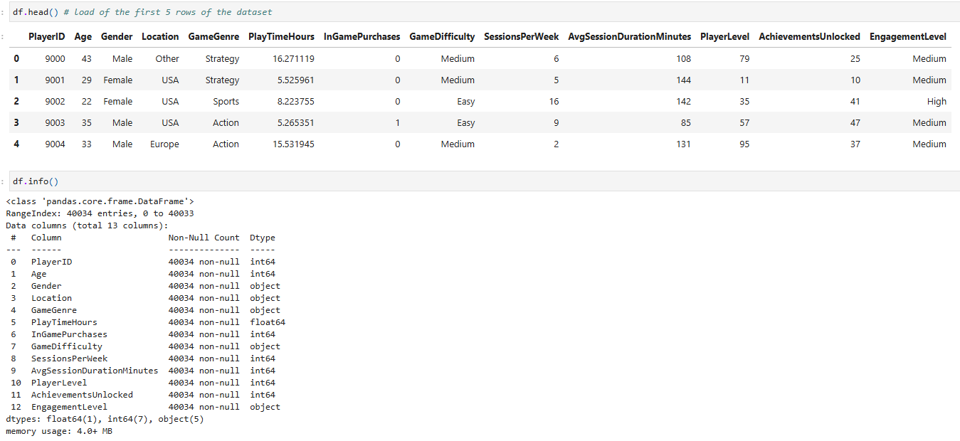

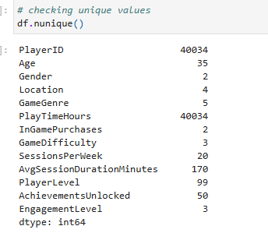
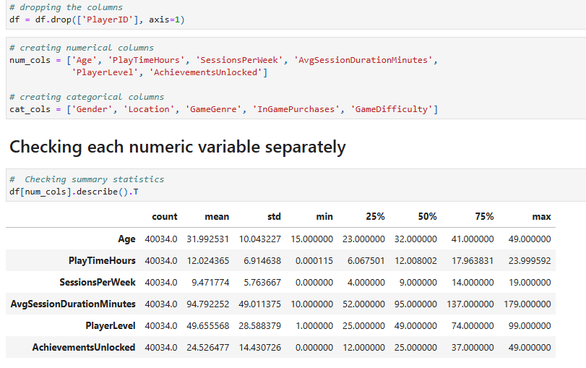

Train–test split
The data was split into 80% training (32,027 rows) and 20% testing (8,007 rows) using train_test_split with stratify=y to preserve class proportions. The printed value counts confirm that the High/Medium/Low distribution is almost identical in train and test.

Feature scaling
Because SVMs are sensitive to the scale of features, numeric columns were standardised using StandardScaler after the train–test split, producing X_train_scaled and X_test_scaled. Decision Trees were trained on the unscaled data, which is appropriate because tree splits are invariant to monotonic transformations.

Exploratory data analysis (EDA)
EDA focused on both categorical distributions and numeric relationships:

Supervised models.
The classification pipeline follows the steps laid out in the “Model Building” section of the notebook.

Linear SVM baseline
A linear SVM (kernel='linear', class_weight='balanced', probability=True) was trained on the scaled training features.
- Train and test accuracies were both around 0.80.
- The classifier generalises reasonably well (no obvious overfitting) but recall for some classes is in the mid-70% range, meaning many High or Low engagement players are misclassified as Medium.

Trained model
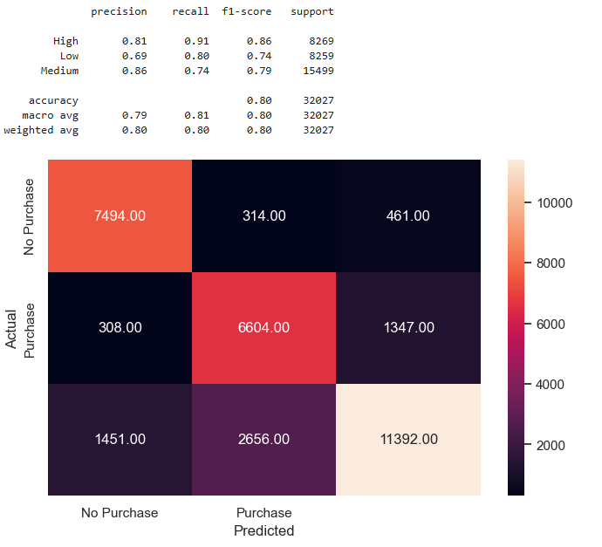

Tested model:
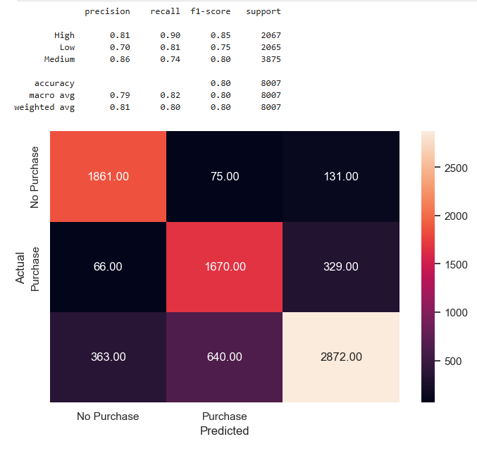

Tuned RBF-kernel SVM
To capture non-linear decision boundaries, an SVM with an RBF kernel was tuned using GridSearchCV.
- The best configuration was:
  - C = 10
  - gamma = 0.01
  - kernel = 'rbf'
  - class_weight = None
- with a cross validated weighted F1 of 0.886. On the test set:
  - Accuracy = 0.89

- Class-level metrics:
  - High: precision 0.92, recall 0.85
  - Low: precision 0.89, recall 0.84
  - Medium: precision 0.87, recall 0.93
The weighted F1 is 0.89, indicating strong and balanced performance.
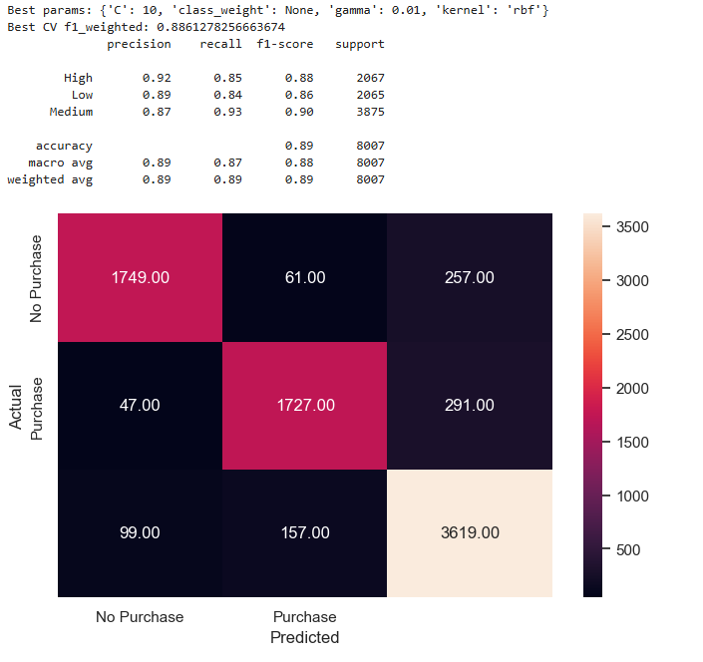

Baseline Decision Tree
- A DecisionTreeClassifier with default hyperparameters and random_state=42 was trained on the unscaled training data (X_train, y_train).
- On the training set, the tree achieved 100% accuracy, with precision, recall and F1 of 1.0 for all classes clear evidence of overfitting.
- On the test set, accuracy dropped to 0.8355, with class-level F1 of 0.82 (High), 0.80 (Low) and 0.86 (Medium).

Train accuracy:
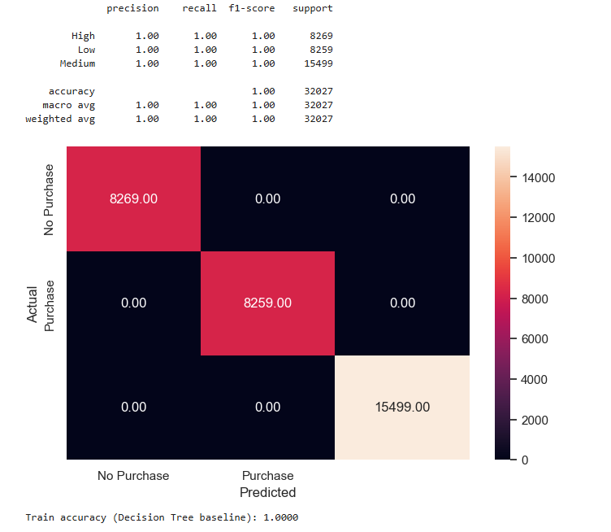

Test accuracy:
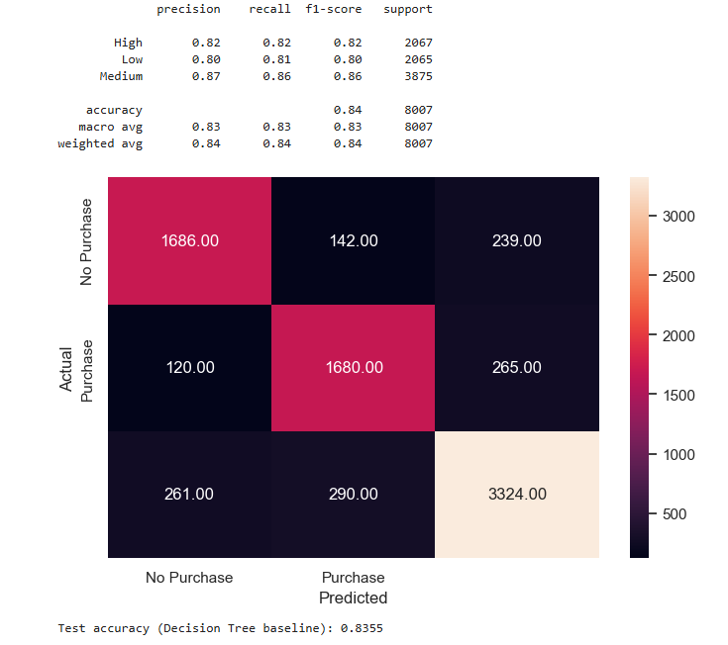

Tuned Decision Tree
The tuned model improved test accuracy to 0.897, with balanced precision, recall and F1 across all three engagement classes. The Medium class, which is the largest, achieved an F1 of about 0.91, indicating strong sensitivity and specificity.
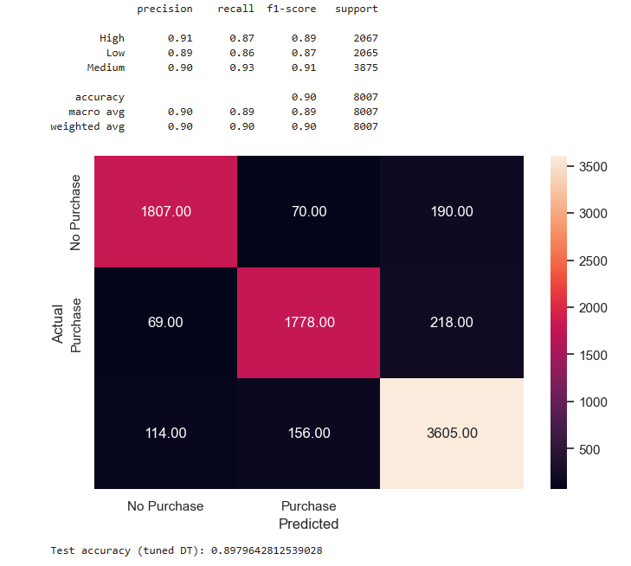

Evaluation metrics and model comparison
All models were evaluated using:
- Overall accuracy.
- Per-class precision, recall and F1-score.
- Weighted F1-score to account for mild class imbalance.
- Confusion matrices
A summary comparison table shows that the tuned Decision Tree slightly outperforms the tuned SVM on all weighted metrics:
- Tuned Decision Tree accuracy = 0.898, weighted precision = 0.898, weighted recall = 0.898, weighted F1 = 0.898
- Tuned RBF SVM: accuracy = 0.886, weighted precision = 0.888, weighted recall = 0.886, weighted F1 = 0.886

See below a screenshot of the output.
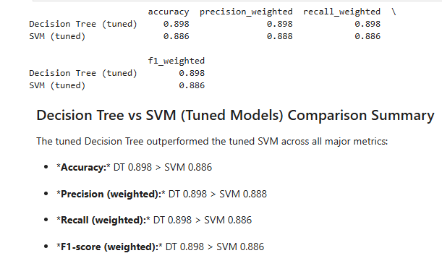

Clustering (K-Means)
Two K-Means experiments were conducted:

Clusters based on Age and PlayTimeHours
- K-Means was run for k = 2–6 and evaluated using both the elbow method and silhouette scores. Silhouette scores peaked around k = 2 around 0.431 but were still reasonable at k = 3, and the elbow plot also suggested k = 3.
Screenshot of elbow method.
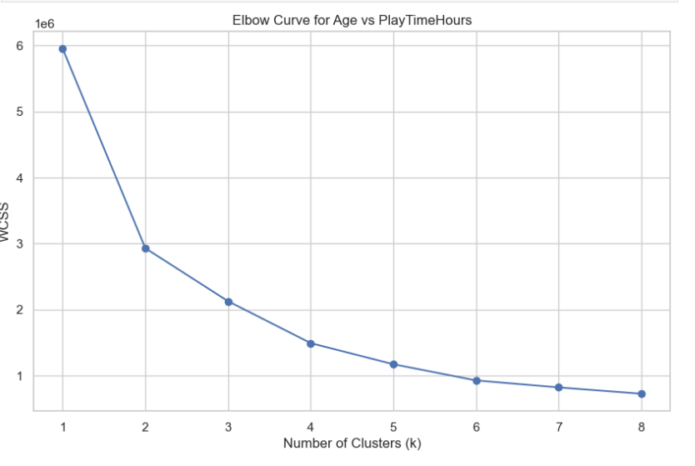
- A final model with k = 3 was chosen to obtain more interpretable behavioural groups. The resulting clusters were visualised on an Age vs PlayTimeHours scatterplot coloured by cluster membership Cluster_AgePlay.
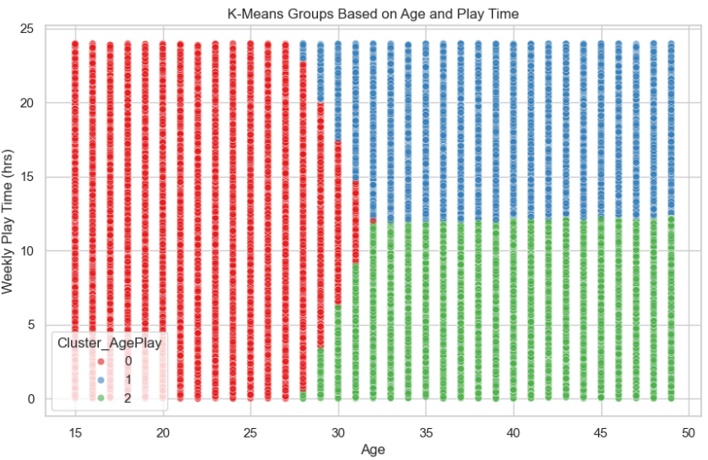

Clusters based on SessionsPerWeek and AchievementsUnlocked
- A second K-Means (k = 3) was applied to gameplay frequency and achievements, producing Cluster_SessAch.
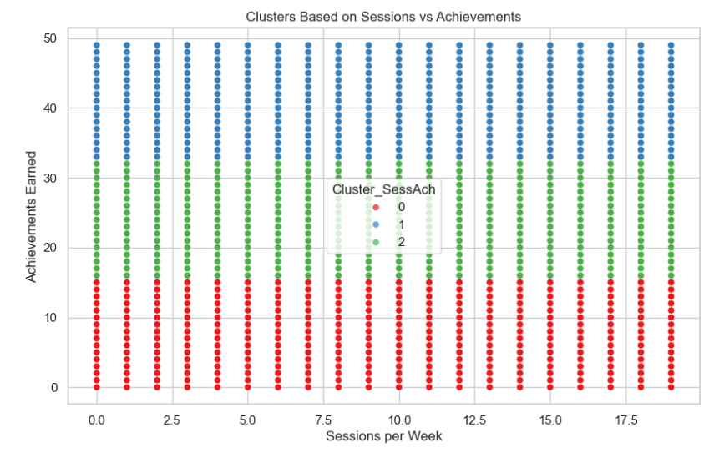
- A crosstab of Cluster_SessAch against EngagementLevel reveals how each cluster maps to High, Medium, and Low engagement. Cluster 0 contains more Low and Medium players (lower-activity group), Cluster 1 has many Medium and High players (stable, active group), and Cluster 2 sits between them with mixed behaviour.
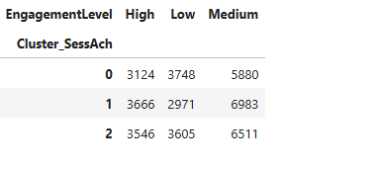

Experiments and Results

Clustering results
The two K-Means experiments demonstrate that player activities can be reduced to few distinct clusters.
- The Cluster_AgePlay analysis groups players into three categories based on age and playtime hours but the silhouette scores indicate only moderate separation between groups.
- The Cluster_SessAch analysis produced clusters that showed better separation between groups.
- The analysis of EngagementLevel against Cluster_SessAch reveals the following patterns:
- The Cluster 0 contains numerous players who fall into Low and Medium engagement levels which indicates they have low activity.
- The Cluster 1 contains mostly Medium and High players who focus on achievements and show active behaviour.
- The Cluster 2 contains players who show moderate activity levels although their distribution is mixed.
The research findings match previous studies which used K-Means clustering to identify three player segments based on engagement levels in online and platform games. [7]

Classification results
The main findings from the classification experiments include:
- The baseline Decision Tree achieved 100% training accuracy, but it failed to generalise well to the test data with only 0.8355 accuracy.
- The optimised Decision Tree model achieved better generalisation than the baseline model while maintaining high test accuracy at 0.898 and balanced F1-scores for all classes with the best results for medium players at 0.91.
- The Linear SVM model achieved 0.80 accuracy on both training and testing data, but it showed weak recall performance for specific classes.
- The RBF SVM model achieved 0.89 accuracy and 0.89 weighted F1 score while demonstrating outstanding recall performance for medium engagement players at 0.93.
- The tuned Decision Tree model outperformed the tuned RBF SVM model on all weighted evaluation metrics although it achieved slightly better results.

Discussion
The experiments demonstrate that model performance improvement requires proper hyperparameter optimisation for tree-based and margin-based models. The Decision Tree model achieved perfect training accuracy, but it failed to predict new data correctly. The model achieved better accuracy and stability through tree depth restriction and split criterion management which follows standard decision-tree regularisation. [8]
Research studies about classification have shown that SVMs and Decision Trees achieve similar results when properly optimised, but trees demonstrate superior performance on datasets containing mixed numerical and categorical data and they provide better interpretability. For this project, the tuned Decision Tree model achieved the highest accuracy and F1 scores while generating simple rule-based splits.
The RBF SVM model maintains its appeal when organisations need to create smooth decision boundaries and maximise their margins. The model demonstrates exceptional ability to predict medium class players because it achieves a high recall rate of 0.93.The model demonstrates strong ability to predict typical player behaviour which makes it suitable for detecting small changes in player engagement at moderate levels. The research on advanced SVM kernels and multi-class classification methods supports this approach. [9]
The clustering experiments introduce new understanding to the research. The K-Means algorithm creates meaningful player groups through its analysis of gameplay activities and achievement records which match the defined engagement categories. The research follows previous studies which used clustering to identify three player types (casual and core and highly engaged) before establishing connections between these segments and player retention and monetisation. [10]
Even though the silhouette scores show that clusters are not perfectly separated (especially for Age and PlayTimeHours), they are still useful for targeting communication or content updates to specific behavioural groups.
Limitations of the current work include:
- The model performance on actual live-ops data with its natural errors and absent data points remains unknown.
- The research depends on basic classification models which recent studies demonstrate that stacked and deep learning models achieve superior results for game churn prediction tasks.[11]

Recommendations:
For a real game studio, the following actions are recommended:
- Deploying the tuned Decision Tree as the primary engagement prediction model, using it to flag Low-engagement players for targeted retention campaigns (e.g. rewards, difficulty adjustments).
- Using the tuned RBF SVM as a secondary model to validate predictions and to identify cases where the two models disagree, such cases may indicate interesting edge-player behaviours.
- Operationalising the K-Means segments (Cluster_SessAch and Cluster_AgePlay) for content design, matchmaking, or marketing for example, tailoring challenges to highly active, achievement-heavy clusters.
- Extending the feature set with temporal and social metrics (e.g. recent playtime streaks, friend interactions) to capture early signs of churn, following recent churn-prediction studies. [12]
- Explore more advanced ensemble methods (e.g. gradient boosting, random forests or stacked models) and compare them with the tuned Decision Tree and SVM, as recent work suggests these can provide further gains in some game datasets.[3]

Conclusion:
This coursework built a full end-to-end pipeline to predict how engaged players are and to group them into meaningful segments using an online gaming dataset. After cleaning the data and exploring it, clustering was applied and then trained and tuned two main types of models: Decision Trees and SVMs.
Overall, the tuned Decision Tree turned out to be the strongest model, with around 90% test accuracy and balanced precision and recall for High, Medium and Low engagement. The tuned RBF SVM performed almost as well, reaching about 89% accuracy, and doing especially well at correctly identifying Medium-engagement players. K-Means clustering added another layer of insight by finding clear behavioural groups based on Age with PlayTimeHours and on SessionsPerWeek with AchievementsUnlocked, which matched well with the engagement labels.
References
[1] Rabie El Kharoua. Predict Online Gaming Behavior Dataset. Available: https://www.kaggle.com/datasets/rabieelkharoua/predict-online-gaming-behavior-dataset?resource=download.
[2] Anonymous Anonymous Game data
science. Game data
science. Available: https://global.oup.com/booksites/content/9780192897879/Pages_from_9780192652713_WEB.pdf.
[3] R. Guo, W. Xiong, Y. Zhang and Y. Hu. R. Guo, W. Xiong, Y. Zhang and Y. Hu. Enhancing game customer churn prediction with a stacked ensemble learning model. Enhancing game customer churn prediction with a stacked ensemble learning model. J Supercomput J Supercomput 8181(1), pp. 178. pp. 178. 2024. Available: https://doi.org/10.1007/s11227-024-06675-9. DOI: 10.1007/s11227-024-06675-9.
[4] Anonymous (30 Jun). Decision Tree. Available: https://www.geeksforgeeks.org/machine-learning/decision-tree/.
[5] G. L. E. Team. G. L. E. Team. Support vector machine (SVM) algorithm. Support vector machine (SVM) algorithm. 2025. Available: https://www.mygreatlearning.com/blog/introduction-to-support-vector-machine/.
[6] By Jaishree Tomar. By Jaishree Tomar. What is clustering in machine learning? A beginner's guide. What is clustering in machine learning? A beginner's guide. 2025. Available: https://www.guvi.in/blog/what-is-clustering-in-machine-learning/.
[7] V. Klézl and S. Kelly. V. Klézl and S. Kelly. Negativists, enthusiasts and others: A typology of players in free-to-play games. Negativists, enthusiasts and others: A typology of players in free-to-play games. Multimed Tools Appl Multimed Tools Appl 8282(5), pp. 7939–7960. pp. 7939–7960. 2022. Available: https://doi.org/10.1007/s11042-022-13647-9. DOI: 10.1007/s11042-022-13647-9.
[8] Anonymous Anonymous International journal of data and network science. International journal of data and network science. Available: https://www.growingscience.com/ijds/Vol8/ijdns_2024_106.pdf.
[9] R. Guido, S. Ferrisi, D. Lofaro and D. Conforti. R. Guido, S. Ferrisi, D. Lofaro and D. Conforti. An overview on the advancements of support vector machine models in healthcare applications: A review. An overview on the advancements of support vector machine models in healthcare applications: A review. Information Information 1515(4), pp. 235. pp. 235. 2024. Available: https://www.mdpi.com/2078-2489/15/4/235. DOI: 10.3390/info15040235.
[10] V. Klézl and S. Kelly. V. Klézl and S. Kelly. Negativists, enthusiasts and others: A typology of players in free-to-play games. Negativists, enthusiasts and others: A typology of players in free-to-play games. Multimed Tools Appl Multimed Tools Appl 8282(5), pp. 7939–7960. pp. 7939–7960. 2023. Available: https://doi.org/10.1007/s11042-022-13647-9. DOI: 10.1007/s11042-022-13647-9.
[11] R. Guo, W. Xiong, Y. Zhang and Y. Hu. R. Guo, W. Xiong, Y. Zhang and Y. Hu. Enhancing game customer churn prediction with a stacked ensemble learning model. Enhancing game customer churn prediction with a stacked ensemble learning model. J Supercomput J Supercomput 8181(1), pp. 178. pp. 178. 2024. Available: https://doi.org/10.1007/s11227-024-06675-9. DOI: 10.1007/s11227-024-06675-9.
[12] I. Weiss and D. Vilenchik. I. Weiss and D. Vilenchik. Predicting churn in online games by quantifying diversity of engagement. Predicting churn in online games by quantifying diversity of engagement. Big Data Big Data 1111(4), pp. 282–295. pp. 282–295. 2023. Available: https://pubmed.ncbi.nlm.nih.gov/36940288/. DOI: 10.1089/big.2022.0109.

