Name: Aimee Rayner

Student Number: 2204919

Course: Surface Pattern and Textiles

Lecturer: Dr Julia Lockheart

Word count: 2749

Key words: Reflective Practice, Outsider Art and Art Therapy.

Introduction:
Using a wide variety of research on each keyword, I have come up with my own definition that captures the synthesis of all three words together. Looking at thinkers such as, Tim Ingold, who focuses on thinking through making, Picasso, who broke free of artist rules by creating playfully, and Jean Dubuffet who defined Outsider Art as ‘works executed by those unscathed by artistic culture’ (Dubuffet in Boyce, 2012), as well as Edward Adamson who pioneered Art Therapy in psychiatry, I have begun to dissect what makes up Art Therapy.
Reflective practice:
Reflective practice in the context of art and design can be defined as the unconscious and conscious thinking about art practice whilst making, as well as the pause taken after making, and the changing making or process, based from self-analysis. The Oxford Dictionary medical definition of reflective practice is “the process of retrospectively examining one's own professional performance…and to learn from them” (Ireland, 2010). However, thinker Tim Ingold suggests that thinking whilst making is a better way to reflect on your art process. Ingold speaks of ‘thinking through making’ like living through the making process and reflecting along the way. He said that “feeling your way through the material, tools and making process is improvising. The creativity happens in the improvisation. And to find one’s way, is to think through making’’ (Ingold, 2013). In this context, the term improvisation could refer to the freedom that comes from creating when the reflective practice is so subconscious that the artist doesn’t realise they are doing it. “Much of the reflective awareness of each artist is bound within the act of making as reflection and can’t be separated out as words or text” (Grushka, 2005). This further suggests that the best way for an artist to reflect on their practice is to be actively making, or engaging with their practice.
Although it could be argued that learning comes from pausing the making process and taking time to think about what you’ve done, it’s important to notice the unconscious reflection which happens for artists when they are making, for “artists are (natural) reflective self‐learners” (Grushka, 2005). The making process itself becomes the start of a journey of constant reflection. When comparing designers and psychiatrists work, D. Schön (2017) sees a cyclical element to reflective practice within both Art and Design practice as well as psychiatry practice. By reframing the problem, “the unique and uncertain situation comes to be understood through the attempt to change it and changed through the attempt to understand it” (Schön, 2017). Although solving different problems, practitioners, including artists, cycle through different stages of reflective practice.
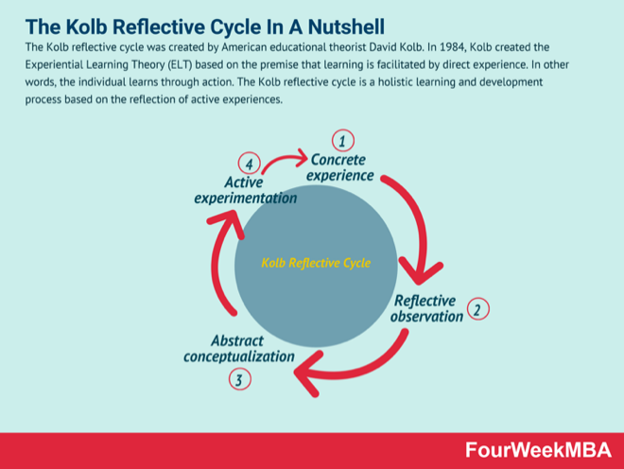
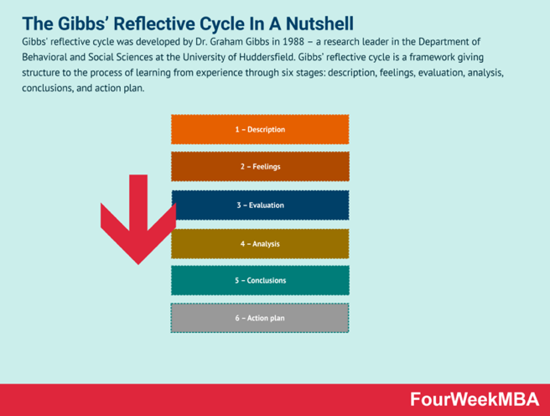
Artists are more likely to go through a natural reflection process while making and creating than going through a purposeful reflective account after each project. Reflective theories such as Gibbs’ Reflective Cycle (Cuofano, 2021a) is popular in disciplines such as education, business, and science, but the art disciplines require a more fluid and intrinsic approach. Kolb’s Reflective cycle (Cuofano, 2021b) is more suitable for artists, but again, it is not a purposeful exercise where the artist pauses
Figure 1: Gibbs and Kolb's Reflective Cycles by Cuofano, G. (2021)
from their work to make a reflection. For instance, when a ceramicist throws clay on a wheel, they use their hands to get feedback from the material, making adjustments as needed without stopping to think about it. In this way, the hands and mind are going through the reflective process without labelling it as reflection. This is achieved through practice and repetition. It doesn’t become natural until the artist has the knowledge and experience to make these instinctive adjustments, but reflective practice can help build this knowledge. A beginner ceramicist would pause to reflect on what went wrong, consider what they should have done and learn from that experience and thought process until it becomes second nature.
The example in figure 2 shows clear changes in approach in order to get to a desired outcome. This creativity to be able to take complexity and turn it into simplicity is a new way of thinking. This suggests that, whether Picasso was aware of it or not, he was practicing reflectively in order to come up with something new.
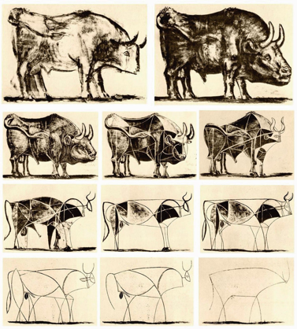
Figure 2: The Bull (Le Taureau) by Pablo Picasso (1945)

By contrast, Grushka, (2005), mentions that ‘to reflect on the experience(s) requires a grasp of all appropriate meanings embedded in the experience’. This suggests that there is a deeper level of knowledge needed for an artist to fully be able to reflect on the work. This deeper understanding mentally as well as physically, through the use of the artists hands, tools, and into materials, enables an artist to become one with the process of their practice. The skill of using this internal reflective monologue, and turning it into successful actions takes practice, deep understanding of the making process and a conscious realisation of the reflective journey. Sometimes, consciously realising your reflective journey “required a suspension or pause and the development of a more contemplative position. To attain this required one to remove oneself from making” (Grushka, 2005). This idea is in direct contrast to Ingold. This leads me to question if reflective practice for artists needs to be taught for it to be most effective or is it an innate skill?

Outsider Art:
Reflective practice can be seen as a mixture of child-like inquisitiveness to learning and growth enabling freedom to create and try new things. Pablo Picasso states that “every child is an artist. The problem is how to remain an artist once he grows up” (Picasso cited in Martelle, 2022). What Picasso meant by this was that we all start with an ability to be creative and not be afraid to fail, but this can get lost as people age. Reflective practice enables this creativity to live on. In this way it seems everyone has the ability to not only be artistic but also use reflective practice in their lives. This leads to Outsider Art, as I see it as a childlike form of art which although the artists have no training on reflective practice, they seem to have an irresistible urge to create that has come from within, with the added ability to reflect on their practice to create art.
The definition of Outsider Art is; “works that were created by individuals outside established society such as inmates in mental institutions and prisoners”. Furthermore, these artists are not trained in art theory. Instead they “simply responded to a creative drive, may not have even felt they were producing art” (Pearlman, 1998).
Characteristics of outsider art might go amiss to the untrained eye but elements such as the odd colour choices which do not match normal colour theory patterns, or the lack of proportions are tell-tale signs of outsider art. Often there is a mixed media approach, or low-quality materials used suggesting ordinary people using what they could get to rather than a master who invests a lot into one or a select few mediums. Jean Dubuffet, a famous Outsider Artist and art collector, thought that Outsider Art had a ‘naïve quality’ and considered to be ‘free from societal constraints’ (Dubuffet cited in Tate, 2024). “His idealistic approach to aesthetics embraced so-called ‘low art’ and eschewed traditional standards of beauty in favour of what he believed to be a more authentic and humanistic approach to image-making” (Tate, 2024). In this way Dubuffet starts to see the aesthetic benefits to art making compared to the normal high standard artwork. Details in outsider artwork enables viewers to see the underlying human effort and time it has taken to create the piece such as fingerprints, scratches, smudges, mistakes covered and such. David Hockney makes this connection that ‘paintings come alive’ with the visual marks that show the time taken to create them as well as a great deal of inferred information about the artist (Hockney, 2016).
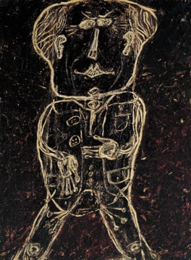
Figure 3: Monsieur Plume with creases in his trouser (Portrait of Heni Michaux), 1947, Jean Dubuffet.
Although Dubuffet did have some professional training, he was drawn towards the more alternative non-conformist styles, unlearning any previously taught skills. This enabled him to release his inner childish creative impulses. “His paintings from the early forties in brightly coloured oils were soon followed by works in which he employed such unorthodox materials as cement, plaster, tar, and asphalt-scraped, carved and cut and drawn upon with a rudimentary, spontaneous line” (PACE, 2024). These materials helped take his work outside the established artist norms and in doing so “Dubuffet made it a point to underline the blurry border between normal and abnormal, and he proclaimed that an artistic process is itself something out of the ordinary” (Asplund, 2021). Artists that fall into the Outsider Art category often do not realise they are creating art of any worth but find the simplistic pleasure and therapeutic benefits that the process of art making can bring. The lines he has used in Figure 3 show a story of time through texture by scraping the outline of a figure into thick paint like a child would draw pictures in wet sand.
Art therapy:
The Outsider Artist is often someone who struggles with their mental health; where taking up art is a way to find comfort and distraction from their physical or mental situation. Artists like Alfred Wallis and Gwyneth Rowlands participated in art related activities to improve their mental health. Alfred Wallis participated in solo therapeutic art processes to support him through grief and depression, whereas Gwenyth Rowlands was part of an early Art Therapy programme led by psychiatrist Edward Adamson.
“There are various definitions of art therapy as different schools of thought in psychology attribute different definitions and sometimes different psychotherapeutic goals to it” (Walter, 2019). There are also different definitions of art-making as a therapeutic process (often referred to as Art As Therapy). Walter’s (2019) overall definition of Art Therapy is; “a triangular psychotherapeutic relationship between therapist, client, and artwork”. The addition of the therapist or psychiatrist makes Art Therapy different from ‘Art As Therapy’ even though most theorist agree on the “inherent healing power of the creative process of art making” (Farokhi, 2011) as the central spine to what makes up both Art Therapy and Art As Therapy. Therefore, referring to Art As Therapy, is referring to the naturally therapeutic process of art making. “Art making is seen as an opportunity to express one's self imaginatively, authentically, and spontaneously, an experience that, over time, can lead to personal fulfilment, emotional reparation, and recovery” (Farokhi, 2011). This can be done in a more low-key way, individually, without a trained professional or just in a group of friends or artists.
Another element to Art Therapy is the interpretation of symbols within the artist or clients work. Adamson speaks of two levels to understanding a client’s paintings. The first is the immediate visual understanding and the process of the art making as described before. The second level of understanding comes with a “deeper level of symbolism, where the selection of subject, the objects chosen to be represented, the colour choice, the placing on the paper - everything, in fact, where choice has been exercised - has a much deeper significance” (Adamson et al., 2014). Interpreting the reasons why an artist or client has made those choices in the context of psychoanalysis of the unconscious thoughts is a sensitive topic and needs to be touched upon with a trained art therapist or psychiatrist. Thinkers like Freud started to make the connection between the unconscious impulse and art making as a process but did not join up that art could help to communicate the internal negativity.
Below is a comparison between two artists, one using structured Art Therapy and one individually using Art As Therapy:
Gwyneth Rowlands was one of the first patients to work with Adamson in Netherne Hospital during her 20-year stay. During studio sessions with Adamson, then titled ‘hospital artist’, she painted people and animals onto flint transforming them into a “treasure trove of objects which showed brilliantly observed detail. Some were poignant and tender, while occasionally others would show the darker side of life” (Adamson et al., 2014). Adamson noted in his book that her artist journey had “finally let the outside world in, which I felt resonated with the progress in her inner state”. This is a clear example of the slow but sure success in the use of art therapy.
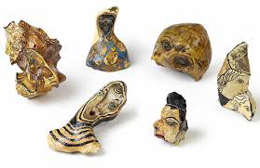
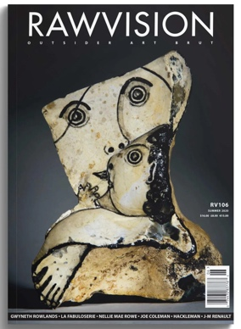
Figure 4: Rowlands, G. Untitled (Woman and Child), [Paint on Flint] (1978)
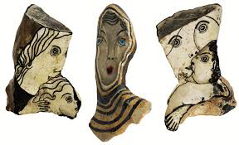
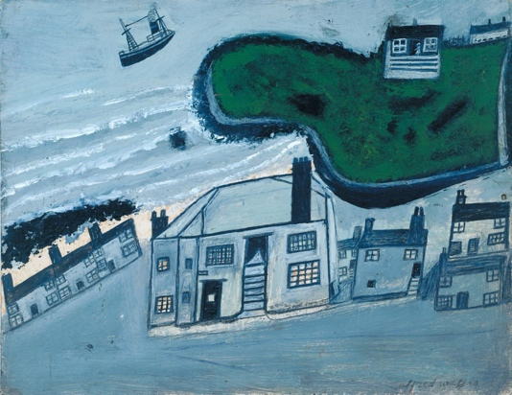
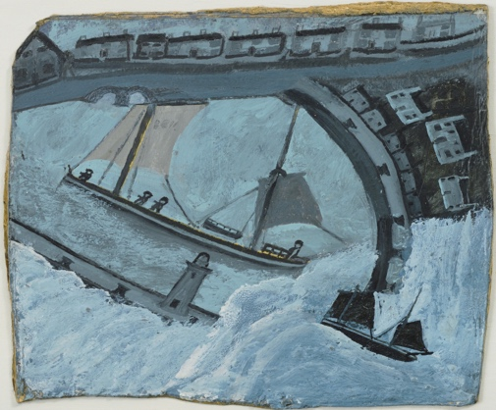
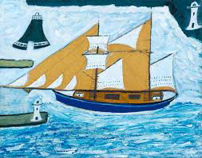
Cornish sailor Alfred Wallis is known as an Outsider Artist but never thought himself as an artist at all. He used boat paints to create artwork on the side of crates and old window shutters (Chilvers, 2015). His work lacks structure and is confusing to the eye. As an isolated man, he used art to fill his time and escape his grief and
Figure 5: Wallis, A. Various ship paintings [Oil Paint on Board on Wood] (1932-34)

depression. Although he continued to paint, his mental state continued to deteriorate and eventually was unable to live independently. Art As Therapy helped Wallis up until a point but I think that without the guidance or safety of a therapist or psychiatrist, his art making made him worse because he relived negative experiences through the process of drawing or painting and could not separate this fiction from reality.

“Art therapy supports the belief that all individuals have the capacity to express themselves creatively and that the product is less important than the therapeutic process involved” (Malchiodi, 2011). Everyone has the ability to communicate creatively and often people do not realise that they are making beautiful art. Outsider Artists often do not value the end outcome of their work, hence they give it to collectors like Adamson or Dubuffet. Their artwork often shows troubled scenes indicating inner turmoil which Art Therapy could have helped them work through. Outsider Artists are often seen as people who would benefit from Art Therapy or Art As Therapy but I question why some Outsider Artists did not turn to Art Therapy. Most likely because of the lack of funding or knowledge to know what it even is. However, perhaps people do not need Art Therapy because they have found it themselves in their art and have been able to reflectively practice art making simply by doing and not thinking. If Outsider Artwork is a communication of unconscious troubles and this is what defines them as ‘Outsider Artists’ then have they reached a personal inner peace by simply creating for personal pleasure and release? Or is there more that an Art Therapist could do for them to understand what their art is telling them? Does this process need a therapist or is it a personal journey of self-discovery through the creative process of self-reflective practice?

Art Therapy links to reflective practice because a lot of the work done between the client, therapist and artwork is working together to reflect on the client’s work in order to ‘sort through’ their unconscious thoughts, or troubles, and come up with solutions or just to help improve outlook. I question if the taught element of reflective practice of the therapist and the lack of ability to reflect from the client is what creates a need for one another. A pairing. Does participating in art making with or without a therapist encourage reflective practice and in turn inner healing?
Synthesis
Reflective Practice has many benefits. Outsider Art is evidence that Reflective Practice is powerful and works to help process trauma or internal darkness. However, as we have seen, Reflective Practice can sometimes lead to needing therapy to stop things from unravelling in a harmful way. Facilitators of Reflective Practice therefore need to be aware of when it may be better to signpost to Art Therapy with a professional that can help the client or artist through their emotional struggles. However, this should never take away from the benefits of the process of doing untrained art, especially amongst children and those who struggle to otherwise express emotions. Letting people free to create art and express themselves is a powerful thing especially in a society that so often struggles to express emotion. Regardless of the definition of Outsider Art this should be encouraged and recognised and where necessary when combined with Art Therapy this can be truly transformational.
Through this synthesis of keywords, Reflective Practice is the link between all three. This could lead to further research and discussion by the use of Reflective Practice in different ways; firstly an individual who uses art to explore and express themselves with no external influence from either a Therapist, a trained Artist or a workshop facilitator (the Outsider Artist), secondly an environment that is facilitated or run by an artist who provides the space and materials for individuals to use art to express their thoughts and feelings both positive and negative (Art As Therapy) and finally, a formal Art Therapy session run by a trained Art Therapist.
This leads to the research question,

‘Which of these points listed above (defined loosely as, Outsider Art-making, Art As Therapy or Art Therapy) proves the best/ most effective/ most beneficial use of reflective practice that leads to inner healing, contentment, pleasure, creativity and positive mental health?’

Bibliography
Adamson, E., Timlin, J. and Stevens, A. (2014). Art as Healing. [online] Wellcome Collection. London: Coventure Ltd. Available at: https://wellcomecollection.org/works/sxy727f5 [Accessed 1 Jun. 2024].
Asplund, E.L. (2021). Exhibiting the Outsider Exhibition practice, Art Brut and Outsider Art. [online] Available at: https://www.duo.uio.no/bitstream/handle/10852/88386/Masteroppgave---Erik-Lind-e-Asplund-1.pdf?sequence=1&isAllowed=y [Accessed 2 Jun. 2024].
Boyce, N. (2012). The Art of Medicine: Outsider Art. The Lancet, 379(9825), pp.1480–1481.
Chilvers, I. (2015). Alfred Wallis. In: The Oxford Dictionary of Art and Artists. London: Oxford University Press.
Farokhi, M. (2011). Art Therapy in Humanistic Psychiatry. Procedia - Social and Behavioral Sciences, 30(30), pp.2088–2092.
Grushka, K. (2005). Artists as Reflective Self‐learners and Cultural communicators: an Exploration of the Qualitative Aesthetic Dimension of Knowing Self through Reflective Practice in Art‐making. Reflective Practice, [online] 6(3), pp.353–366.
Hockney, D. (2016). What David Hockney’s Brilliant Collages Reveal about Photos. Youtube. Available at: https://www.youtube.com/watch?v=rz5vWgKy2Sc [Accessed 31 May 2024].
Ingold, T. (2013). Ingold -- Thinking through Making. YouTube. Available at: https://www.youtube.com/watch?v=Ygne72-4zyo [Accessed 14 Mar. 2024].
Ireland, R. (2010). Reflective Practice. In: A dictionary of Dentistry. [online] Oxford University Press. Available at: https://www.oxfordreference.com/view/10.1093/oi/authority.20110803100410468 [Accessed 29 May 2024].
Malchiodi, C.A. (2011). Handbook of Art Therapy. [online] Google Books. Guilford Press. Available at: https://books.google.co.uk/books?hl=en&lr=&id=y6PY4hv47I0C&oi=fnd&pg=PR3&dq=the+art+therapy+sourcebook&ots=-joen5BSpm&sig=LbKBLul_jx2818teNThwFkE6gXQ&redir_esc=y#v=onepage&q&f=false [Accessed 1 Jun. 2024].
Martelle​, A. (2022). Picasso and the Art of Children - Stedelijk Studies. [online] stedelijkstudies.com. Available at: https://stedelijkstudies.com/picasso-and-the-art-of-children/#:~:text=Pablo%2520Picasso%2520famously%2520said%253A [Accessed 1 Jun. 2024].
PACE (2024). Pace Gallery | Jean Dubuffet. [online] www.pacegallery.com. Available at: https://www.pacegallery.com/artists/jean-dubuffet/ [Accessed 2 Jun. 2024].
Pearlman, J. (1998). Outsider Art. In: M. Kelly, ed., Encyclopedia of Aesthetics. [online] London: Oxford University Press. Available at: https://www.oxfordreference.com/display/10.1093/acref/9780195113075.001.0001/acref-9780195113075-e-0386 [Accessed 31 May 2024].
Schön, D.A. (2017). The Reflective Practitioner: How Professionals Think in Action. 1st ed. [online] London: Routledge.
Tate (2024). Jean Dubuffet 1901–1985. [online] Tate. Available at: https://www.tate.org.uk/art/artists/jean-dubuffet-1035 [Accessed 31 May 2024].
Walters, D.A. (2019). Art as therapy; museums and galleries as places for psychodynamic art therapy. Asia Pacific Journal of Counselling and Psychotherapy, [online] 11(1), pp.3–22.

List of Figures:
Figure 1 - Cuofano, G. (2021a). What Is Gibbs’ Reflective Cycle? the Gibbs’ Reflective Cycle in a Nutshell. FourWeekMBA. Available at: https://fourweekmba.com/gibbs-reflective-cycle/ [Accessed 30 May 2024].
Figure 1 - Cuofano, G. (2021b). What Is the Kolb Reflective Cycle? the Kolb Reflective Cycle in a Nutshell. FourWeekMBA. Available at: https://fourweekmba.com/kolb-reflective-cycle/ [Accessed 29 May 2024].
Figure 2 - Picasso, P. (1945). The Bull (Le Taureau). [11 Lithographs] Available at: https://www.dailyartmagazine.com/pablo-picassos-bulls-road-simplicity [Accessed 1 Jun. 2024].
Figure 3 - Dubuffet, J. (1947). Monsieur Plume with Creases in His Trousers (Portrait of Henri Michaux) . [Oil and Grit on Canvas] artuk.org. Available at: https://artuk.org/discover/artists/dubuffet-jean-19011985 [Accessed 2 Jun. 2024].
Figure 4 - Rowlands, G. (2020). Our Lady of the Flints. [Paint on Flint Stones] RAW VISION. Available at: https://rawvision.com/blogs/articles/articles-our-lady-flints?_pos=1&_sid=43de76c92&_ss=r [Accessed 31 May 2024].
Figure 4 - Rowlands, G. (1978). Untitled (Woman and Child), 4.5 x 5.5 x 4 in. / 11.5 x 14 x 10.8 cm . [Paint on Flint].
Figure 5 - Wallis, A. (1934). The Blue Ship. [Oil Paint on Board on Wood] Tate. Available at: https://www.tate.org.uk/art/artworks/wallis-the-blue-ship-t00291 [Accessed 31 May 2024].
Figure 5 - Wallis, A. (1932). The Hold House Port Mear Square Island Port Mear Beach. [Oil Paint on Board] Available at: https://www.tate.org.uk/art/artworks/wallis-the-hold-house-port-mear-square-island-port-mear-beach-t01087 [Accessed 31 May 2024].
Figure 5 - Wallis, A. (1933). St. Ives Harbor. [Oil on Board] Available at: https://www.moma.org/collection/works/38737 [Accessed 31 May 2014].

