
How the learning in this module has helped me to develop a range of employability skills
TASK 2
ACADEMIC AND EMPLOYABILITY SKILLS

December 6, 2021
university of wales trinity st david
LECTURER: GIRIDHAR KATTI

MAGDALENA SIEMIATKOWSKA, ID:2110059
MODULE NUMBER: BMSW 4001
Table of Contents
INTRODUCTION 2
TIME MANAGEMENT 3
4D strategy of Time Management 5
How is time management vital for me and others? 6
Gathering information…………………………………………………………………………………………………………………………….7
What is the best way to find content?..........................................................................................................8
RESEARCH/FINDING INFORMATION 9
Materials 9
TEAMWORK 10
Gibb's reflective cycle 11
Conclusions 13
References 15
Appendices……………………………………………………………………………………………………………………………………………17

INTRODUCTION
The ability to do a task well is known as a skill (Oxford Dictionary, 2020).
This study examines how multitasking, collaboration and obtaining data skills influence students' success at university.
Reflection is a kind of thought, an ability that we utilize to attain a goal and perhaps an expected consequence. It is used to solve problems that are complex, unorganized and relies heavily on prior information, comprehension, or sometimes feelings. (Moon, 2005)
In this report, I will be using Gibb's Reflective Cycle, 4D's, and CRAPP Test to reflect critically on using each expertise and its significance for students in each current dispensation. It will be offering a perspective into the challenges that effective teaching carries affiliated with having to work responsibilities and private affairs.
As students in Higher Education need to be able to manage their time well, do research, find relevant material, as well as work well in groups; in my report, I have focused on: Time management, Research/Finding Information & Teamworking.

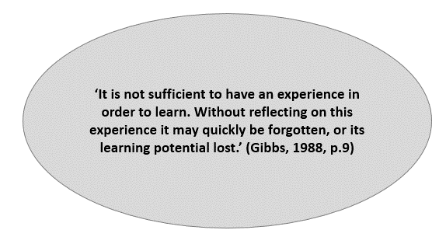

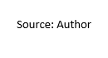

ACADEMIC SKILLS

TIME MANAGEMENT

Following Lakein, various phrases have been used to characterize time-management skills, such as serendipity, harmony, adaptability, and maintaining control over the situation (Lakein, 1973).

Time management is an ability that focuses on teaching how to manage, control, and regulate the schedule to execute everyday tasks effectively and efficiently. It is an ability utilized by learners, experts, individuals in their personal affairs (Macan, 1990,1994,2000).
Britton reports that we can even say that time management is a valuable tool. Becoming planned, able to handle schedules is especially important for students since it allows them to complete tasks that involve a lot of thought and investigation in a small space of time. Britton also stated that the inability to control time could lead to anxiety, stress, a lack of academic accomplishment (Britton, 1991). In many instances, students will discover how challenging it’s to strike the right balance among their social and academic lives, becoming disappointed, disturbed when they do not reach their aims. However, for everyone else, it might be able to discover time to complete anything, those are referred to as extraordinary time users for their potential to reduce mental anguish and keep it consistent (Lay, 1993).
Similarly, time management may be described as "the process by which a person achieves duties and targets more successfully" / "it’s a process in which a person acquires domination above the schedule and material during her or his activities" (Schuler, 1979), (Hellsten, 2012).

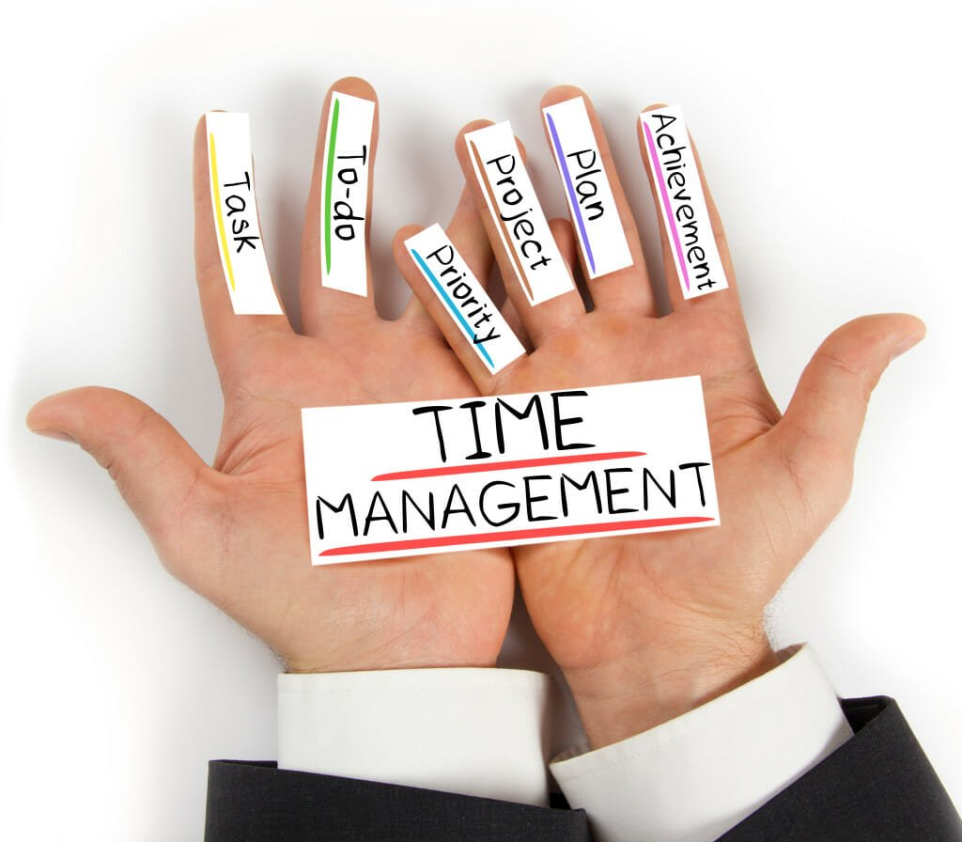

4D strategy Time Management

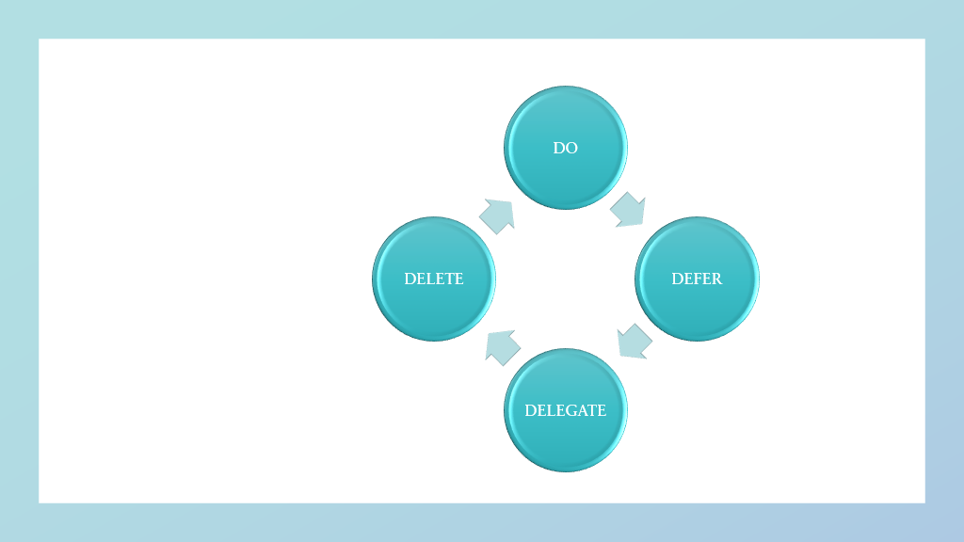

• Do: Complete all chores that need the least amount of time first to free up time for the more time-consuming jobs.

• Defer: Put off or postpone some duties that are superfluous or non-essential.

• Delegate: Partially complete the process, distribute a portion of the task with colleagues.

• Delete: reschedule encounters with friends / relatives, which will not help you advance in your career (McCain, 2007).

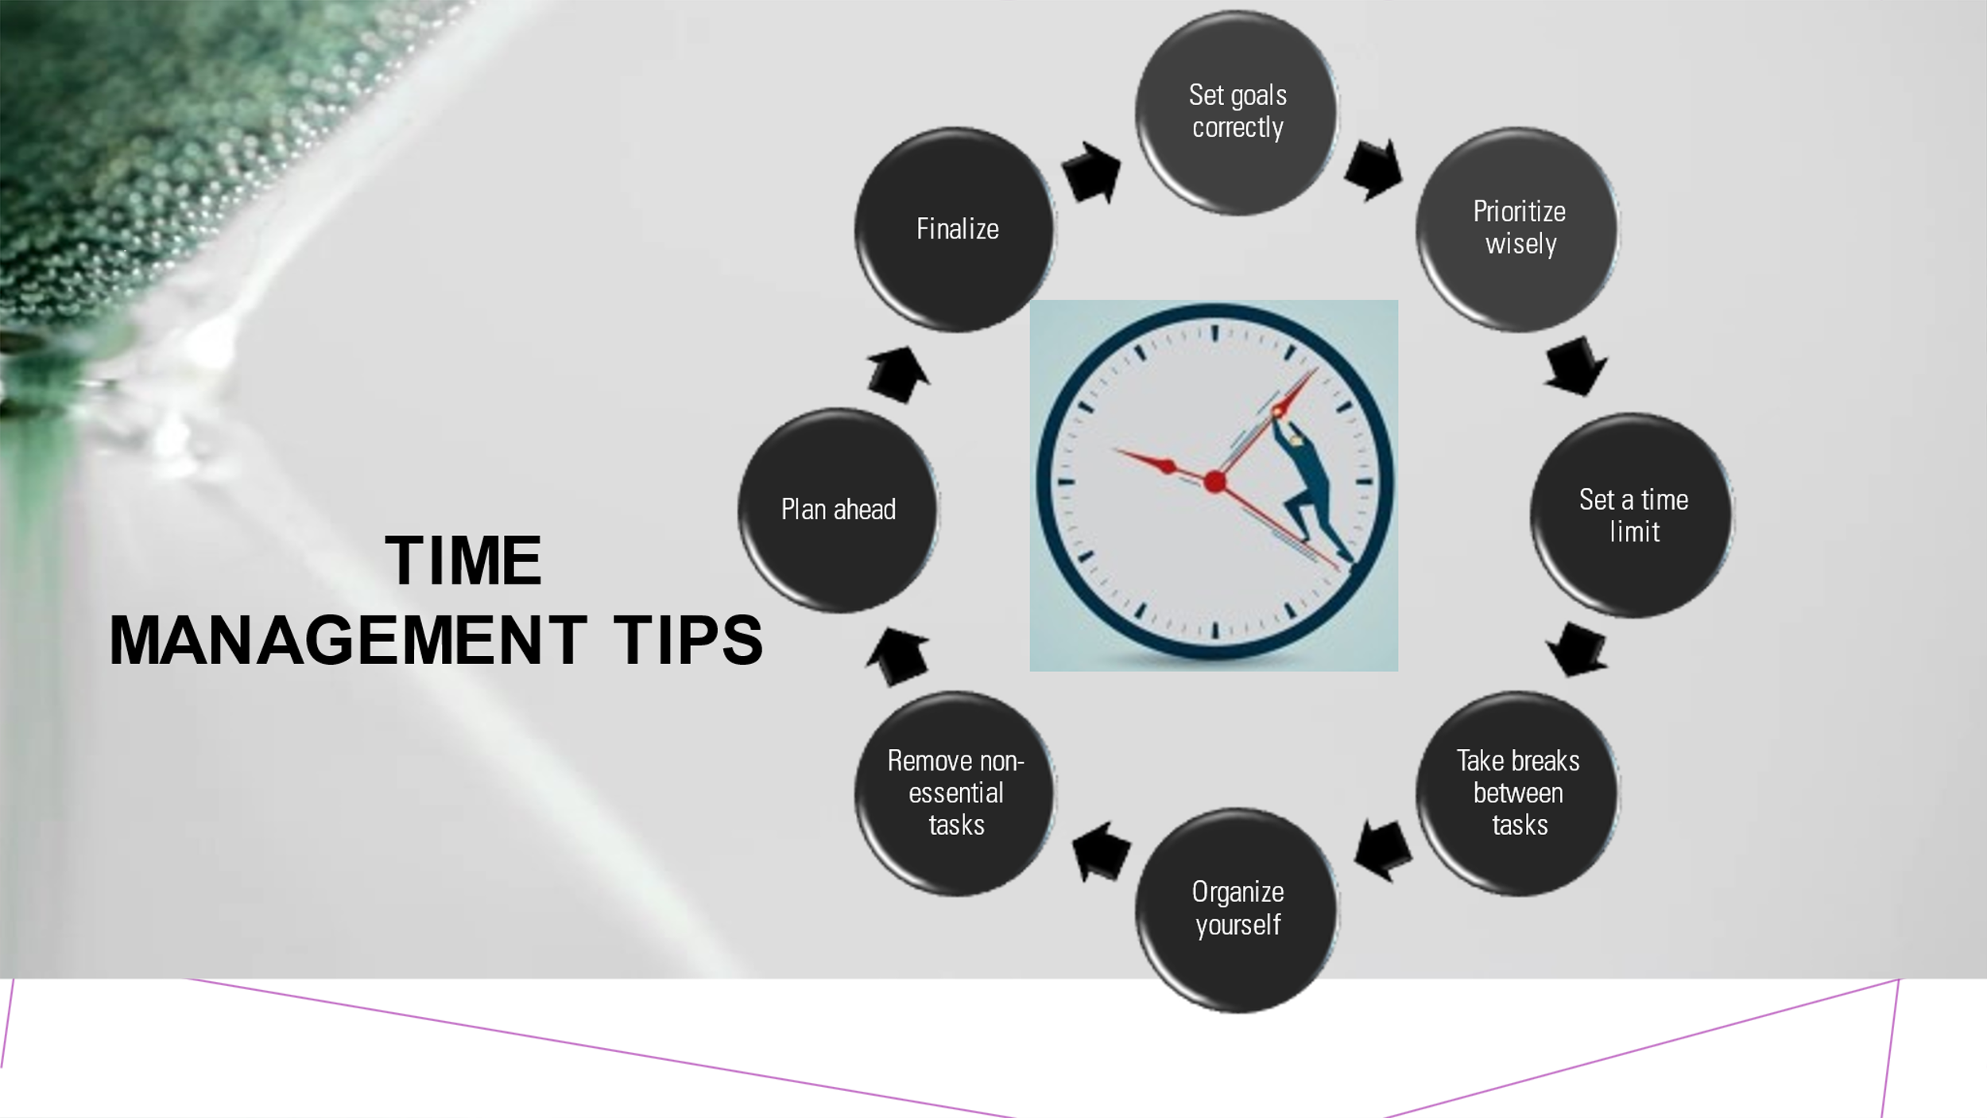

How is time management vital for me and others?

The most valuable resource is time. It’s also the most precious asset we possess. It’s precious, valuable, tough to save. All humans have the same time available. When time is up, it is up - so it has lost forever.
Realizing how important time management is might help see things in a new light. We could, for example, play computer games all day. Nonetheless, that time might have been spent better on researching, planning, or organizing.
Stress may cause health problems, affect intelligence, diminish general resistance, leading to worry, sadness. Nevertheless, there are many good techniques to unwind that we may use at work. Achieving objectives will make one feel more at ease, confident. We are ready to meet deadlines, avoid unpleasant surprises, become productive, ready to face anything the world throws at us. Taking complete control of our schedules. Our focus should be on one task at a time, disregarding distractions like social media, phone notifications.Time management standards encourage to work better appropriately and make better decisions. This does not guarantee perfection. Since we neglected to include it on our to-do list and will no longer skip critical details or make serious mistakes.We must create targets to achieve prosperity with due time. There are always small phases that lead to better achievements.
Thanks to my well-planned time management objective, I was able to finish most of my tasks before the deadline. On Sundays, I examine each week's curriculum and prepare the tasks required. The weekly planner also helped me keep track of tasks. After confirming the due dates, I would split the responsibility across the week depending on the assignment's complexity.
Time management is vital in my life as a student, wife, mother. I have everyday tasks and choices to make, assisting youngsters with schoolwork, teach my native language. These were the most astounding methods I learned to spend my time between study and home. Planning my schedule properly enabled me to prioritize, reduce stress, arrange my studies, and get positive feedback from my tutors.
As deadlines loomed, I fought hard to keep my anxiety under control and do everything on time. I sought help from tutors when I needed it. I delegated unimportant tasks to free up time for more important ones.

Gathering information

To complete assignments successfully, students must get safe material, real, accurate, from a reliable sources. The information should be basic, supported by respectable organizations or professionals, comprise text, resources, and images. The basic analysis must be thorough, with a clear purpose and topic.
Throughout term one, I found myself doubting the legitimacy, validity of published articles due to conflicting publications and figures. This prompted me to investigate the phenomenon of prejudice, which has been extensively established in recent years. Despite the use of a rigorous critical appraisal procedure by respectable publications, manuscripts with serious problems are nonetheless printed.
I needed to choose suitable publishing materials with greater attention. Following these results, I decided to employ frequent assessments to evaluate research and noticed that using published research saved time and energy, and that the University Library was a great digital data repository.

What is the best way to find content?

As a student, I had to follow my tutor's instructions to build a solid foundation. My investigation started in the University Library. It expanded to the rest of the web, where I searched and picked credible information for my job. That's when I started paraphrasing, developing content using own ideas. Using the CRAAP Test ensured me that the data is correct.

CRAAP TEST


Research/Finding information
It takes time for a student to perform research.
Students require research to solve difficulties and get intellectual gratification from having evidence and gain from researchers collecting information. It’s vital to investigate since it equips learners with information and problem-solving abilities.
We are all investigators, and discovering information requires locating, organizing, showing its relevance. It must be precise, with a clear objective and task relationship.
To succeed as a student, I had to consistently follow my lecturer's instructions. I began my investigation in the University Library, then moved to the internet. References provided relevant material for my work. I paraphrased and produced content using my language after choosing materials.
It’s important, according to Kurpiel (2021), to utilize the CRAAP test, which states that the data must be relatively current, verified to determine whether the document requires, or historical data suffices. The material must be relevant to the study's subject, the intended audience, the degree of involvement required to interact with the work. Multiple sources must be evaluated, the origin must be stated.
If the institution that made the material available is associated with any authorized organizations and the journalist has the requisite credentials to comment on the problem, and so on, it should be explored. We must use only precise, dependable, genuine stuff. The information's availability must be justified (Kurpiel, 2021).

Materials

- Books and e-books- In its published form, it's possible to be characterized as a written document that can be printed or electronically and has a hard copy which is usually composed of numerous pages attached to the front and rear cover (Thesaurus, 2020)
- Newspapers: A newspaper is a printed form of publication usually detailed with photographs, information, various topics. Newspapers are typically published daily, weekly, or monthly (DICTIONARY, 2012).
- Scholarly Articles: A scholarly article is written by students, teachers, or universities to study specific literature. The volume of material in a scholarly article varies depending on the requirement, it's frequently reviewed by other trainees, researchers, academic staff, and related groups (University, 2021).

Teamwork


Teams can express a variety of aspects, with emphasis on variables such as authority, responsibility partnerships, groups can achieve more by continuing to work together rather than alone, gatherings are beneficial because of the diverse culture of information they carry together, purely whose productive inputs are closely linked.
In this concept, university teams are roughly defined as groups of two or more academic staff collaborating to "create" the university's diverse range of products.
Universities have plethora of unofficial groups, ranging from individual faculty cooperation inside and between courses, university cooperation. Institutional and public community collaboration are all examples of partnership: collaborative research projects, publications, teamwork.
Conforming to Burgess (1994), individualized instruction is prevalent. Also, there are practical service tasks, a variety of external initiatives necessitate collaboration. There is already much collaboration going on. Compact academic teams can benefit from strong partnerships (Burgess, 1994).
Essentially, teamwork is an intriguing topic for any leader, anyone who works with teams. It's been difficult for me since I was exposed to the corporate world at a young age and needed to show teamwork and communication skills. It’s challenging to persuade somebody twice your age to understand the tasks, have a solid grasp of the topic, and are competent of part of the success if they implement your directions. This may happen to students, especially while working in groups.
Last semester I built and used the interpersonal skills required to sustain connections with other students. Gibbs (1988) uses the reflective cycle to effectively reflect. This model it's a well-known platform for reflecting that has six steps to follow, which allows to continually enhance my own talents while studying the best practices for the upcoming. As the Gibbs cycle progresses, its first stage outlines the setting in which teammates collaborate; second stage examines crew members' sentiments about their work, as well the third phase, entails an examination of group members' perceptions. Step four is an assessment, the fifth stage is the collaboration result, and the last stage is the exit strategy. This kind of introspection resulted in practical knowledge that aided me in working with my teammates and adapting to new situations. The partnership resulted in a feeling of accomplishment and the development of positive skills.

Gibb's reflective cycle
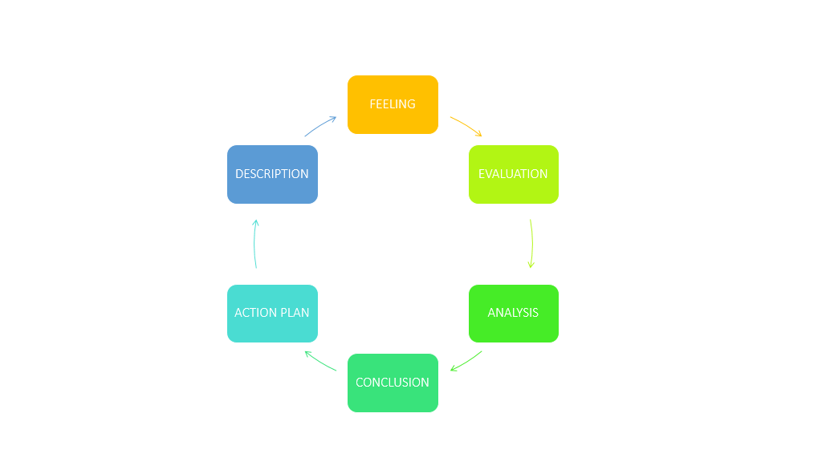

Description
As a leader in my employment and academic work, I experienced progressively development in my knowledge.
Handling team conflicts may be challenging, especially when the entire group's success is dependent on everyone performing as required to reach targets. It is much more sensitive at the academic level when we consider that everyone in the group is ostensibly there to study along. However, there is not always a supervisor present, and convincing everyone else that you are cut out for it and can get over it can be extremely difficult.

Feeling
I have had to take a leadership role and do all the tasks to ensure my results were productive, sometimes recognizing that others in the group would most surely be interested in it with minimal effort, which was harsh at the time.
The concept of carrying everybody makes the process feel heavier than it ought to be, and sometimes you must make judgments within your own, which causes to question yourself.
Evaluation
This made me stronger to take on more duties. It made me develop and appreciate my coworkers in various settings. I received a positive reaction. On the flip side, I would say that a bit of assistance mixed with a different point of view would quite certainly ensure a better outcome. Essentially the reaction to the work was positive, with members recognizing the excellent work done with the University.
Analysis
Things went well in my perspective, maintained my spirits, trusted my ability to accomplish work with a restricted timeframe, learnt how to communicate with people, completely appreciate their skills and limitations. Found a method to get my team's admiration. The task taught me never to lose confidence in my abilities and that being a leader sometimes means doing things independently, even if the goal is to improve as a team member.

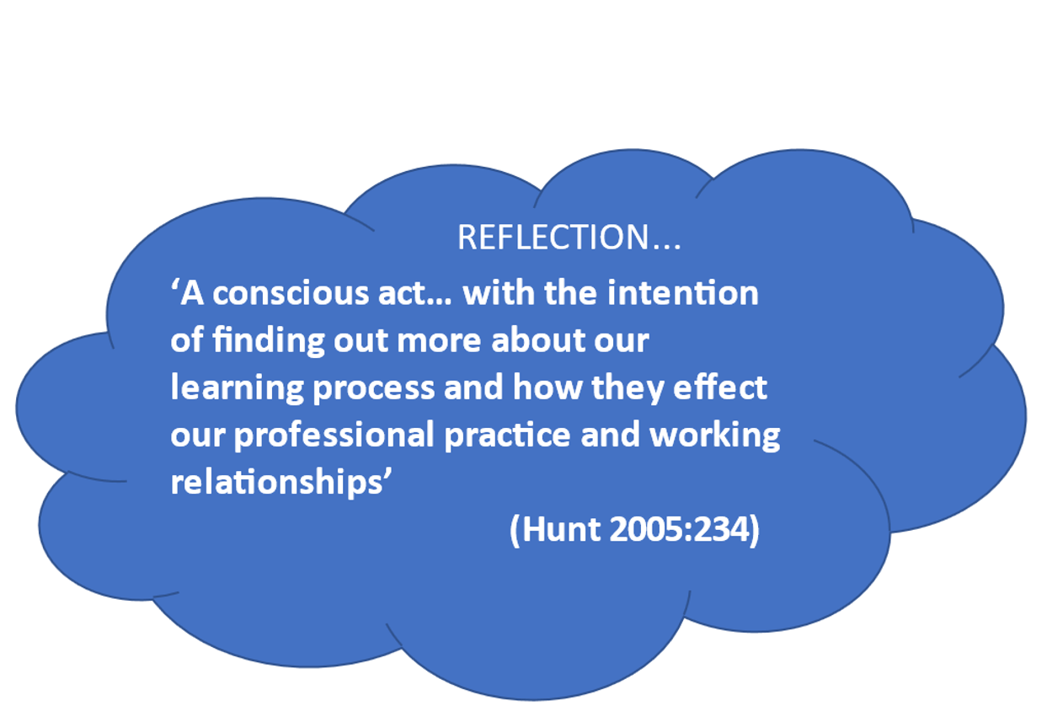

Conclusions
Organizing your job and making group choices will enrich the task and lead to greater results. It gave me the motivation to finish projects even when members of the team refused to participate. It also taught me how important it is to respect others' views, perspectives to grow personally and professionally.
Assuming the same situation at university, I would start by developing specialized group skills to distribute tasks. I'd also want to get to know my team better to foster ties and participation. It's also important to plan of time, outlining objectives, allowing members to alter anything that the group disagrees on. I think that everyone should testify when they disagree, but only if they don't cause a problem or delay the decision.
After several years away from education, I concluded that abilities are critical for growth, achievements, professionalism and that it makes such a difference when you establish the grit and self-belief for goals achieved in a short amount of time with the instruction of excellent academic staff determined to make you wider for professional life. Students will master additional skills and better comprehend what they are studying at university, preparing them for prospective reflective practice; they will have to practice improving these vital abilities as they proceed in their studies.
I am better positioned for the academic assignments now, understanding and experience I have gained over the last two months. The 4D Strategy, Gibb's Reflective Cycle and CRAAP Test were some of the instruments that helped me design my strategy.
I am also convinced that my ability to grasp and complete tasks has increased and will continue to grow with training and perseverance.

References

Britton, A. T., 1991. Effects of Time-Management Practices on College Grades. Journal of educational psychology, 83(3), pp. 405-410.
Burgess, P. L., 1994. Teamwork in Higher Education: Why Don't We Have More of It?. Metropolitan Universities: An International Forum, 5(1047-8485), pp. 45-53.
DICTIONARY, C., 2012. Dictionary.com. [Online] .
Available at: https://www.dictionary.com/browse/newspaper
[Accessed November 16 2021].
Gibbs, G., 1998. Learning by Doing: A guide to teaching and learning methods. Paperback, Further Education Unit, s.l.:s.n.
Hellsten, L.-A. M., 2012. Time Management. In: P. T. Stoilov, ed. What Do We Know About Time Management? A Review of the Literature and a Psychometric Critique of Instruments Assessing Time Management. Saskatchewan: In-Tech, pp. 4-6.
Kurpiel, S., 2021. Benedictine University. [Online]
Available at: https://researchguides.ben.edu/source-evaluation
[Accessed October 17 2021].
Lakein, A., 1973. In: How To Get Control Of Your Time And Your Life. New York: Wyden.
Lay, C. &. S. H., 1993. Trait procrastination, time management, and academic behaviour. Journal of Social Behavior and Personality, Volume 8, pp. 647-662.
Macan, T. H., 1990,1994,2000. College Students' Time Management: Correlations With Academic Performance and Stress. Journal of educational psychology, 82(4), pp. 760-768,
McCain, T.D.E. (2005) Teaching for tomorrow: teaching content and problem-solving skills. Thousand Oaks, Calif: Corwin.
Moon, J (2005) Learning Through Reflection, A guide to busy academics, No 4, The Higher Educations Academy, University of Exeter.
Thesaurus, C. A. L. D., 2020. Cambridge Dictionary. [Online]
Available at: https://dictionary.cambridge.org/dictionary/english/book
Accessed November 19 2021]
University, W., 2021. Webster University Library. [Online]
Available at: http://library.webster.edu/guides/quickscholart.html
[Accessed October 18 2021].
W.P.How, 2015. Master 4d Time Management: Delete, Delegate, Defer, Do. s.l.: CreateSpace Independent Publishing Platform.

Britton, A. T., 1991. Effects of Time-Management Practices on College Grades. Journal of educational psychology, 83(3), pp. 405-410.
Burgess, P. L., 1994. Teamwork in Higher Education: Why Don't We Have More of It?. Metropolitan Universities: An International Forum, 5(1047-8485), pp. 45-53.
DICTIONARY, C., 2012. Dictionary.com. [Online] .
Available at: https://www.dictionary.com/browse/newspaper
[Accessed November 16 2021].
Gibbs, G., 1998. Learning by Doing: A guide to teaching and learning methods. Paperback, Further Education Unit, s.l.:s.n.
Hellsten, L.-A. M., 2012. Time Management. In: P. T. Stoilov, ed. What Do We Know About Time Management? A Review of the Literature and a Psychometric Critique of Instruments Assessing Time Management. Saskatchewan: In-Tech, pp. 4-6.
Kurpiel, S., 2021. Benedictine University. [Online]
Available at: https://researchguides.ben.edu/source-evaluation
[Accessed October 17 2021].
Lakein, A., 1973. In: How To Get Control Of Your Time And Your Life. New York: Wyden.
Lay, C. &. S. H., 1993. Trait procrastination, time management, and academic behaviour. Journal of Social Behavior and Personality, Volume 8, pp. 647-662.
Macan, T. H., 1990,1994,2000. College Students' Time Management: Correlations With Academic Performance and Stress. Journal of educational psychology, 82(4), pp. 760-768,
McCain, T.D.E. (2005) Teaching for tomorrow: teaching content and problem-solving skills. Thousand Oaks, Calif: Corwin.
Moon, J (2005) Learning Through Reflection, A guide to busy academics, No 4, The Higher Educations Academy, University of Exeter.
Thesaurus, C. A. L. D., 2020. Cambridge Dictionary. [Online]
Available at: https://dictionary.cambridge.org/dictionary/english/book
Accessed November 19 2021]
University, W., 2021. Webster University Library. [Online]
Available at: http://library.webster.edu/guides/quickscholart.html
[Accessed October 18 2021].
W.P.How, 2015. Master 4d Time Management: Delete, Delegate, Defer, Do. s.l.: CreateSpace Independent Publishing Platform.

APPENDICES:
Appendix 1- My Personal Development Plan
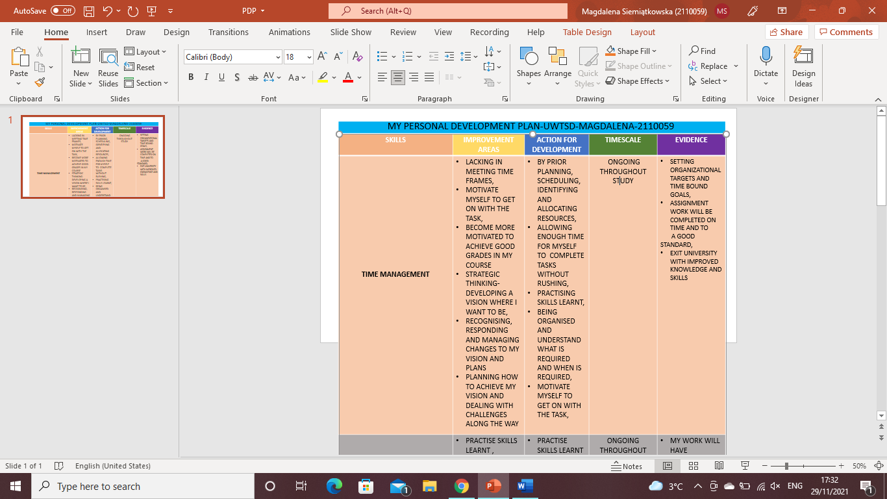
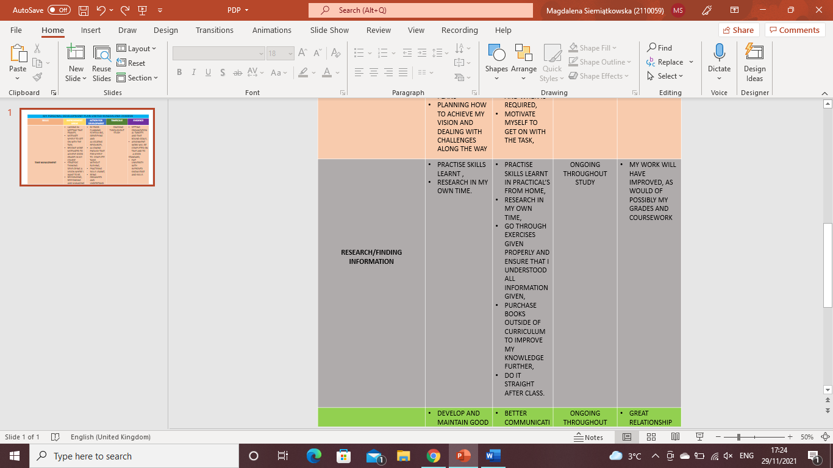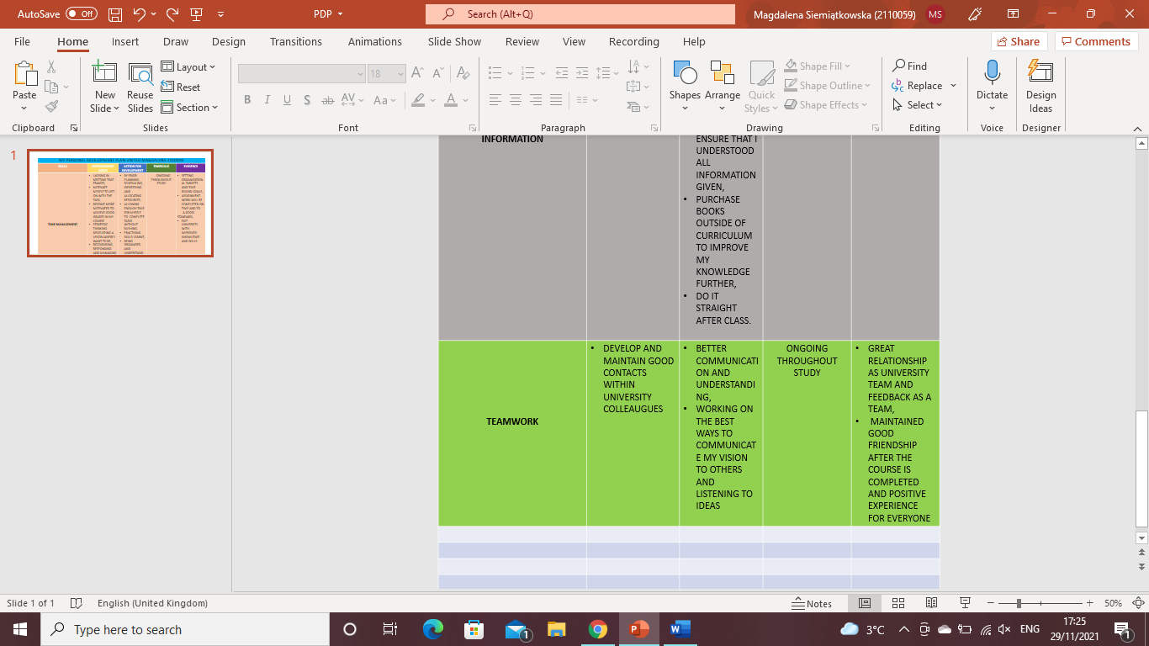

Appendix 2- Presentation Skills Form

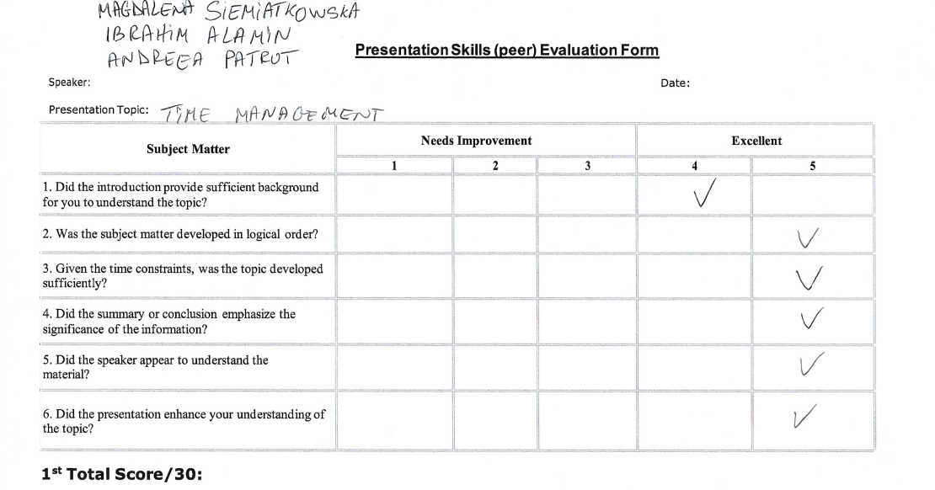
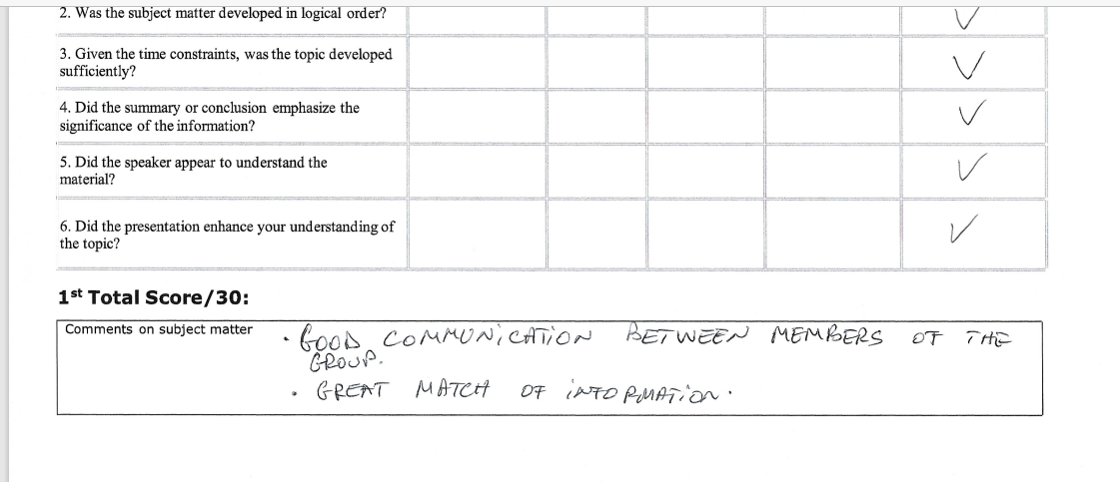
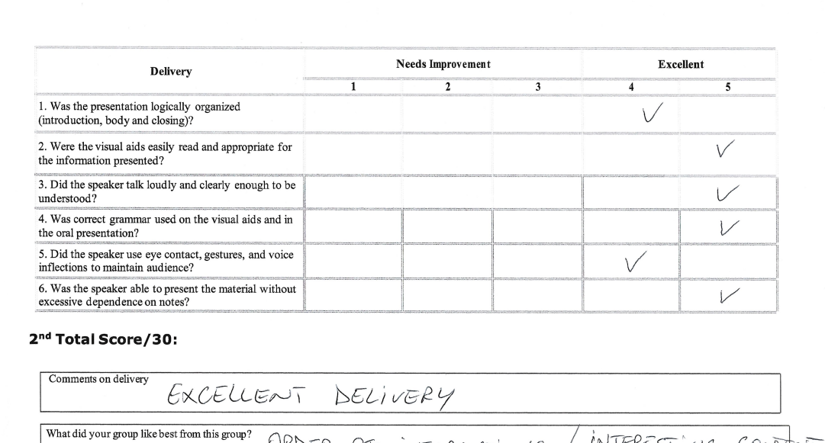
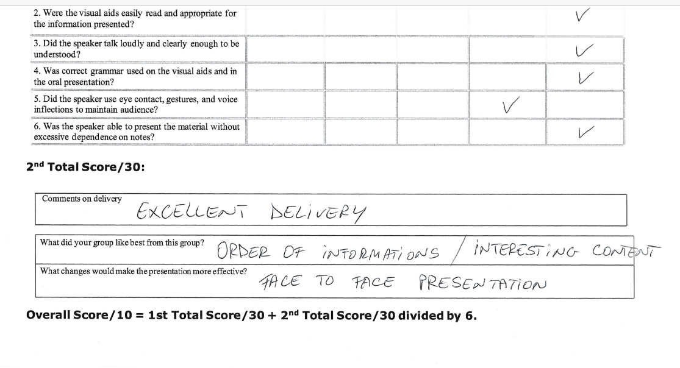

Appendix 3- feedback from my Tutor on TASK 1

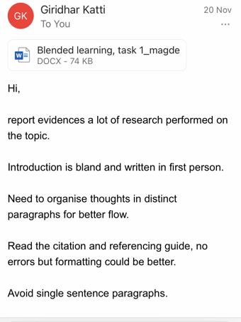

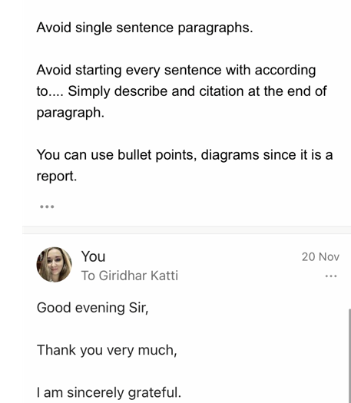

Appendix 4- Feedback from my Tutor on TASK 2

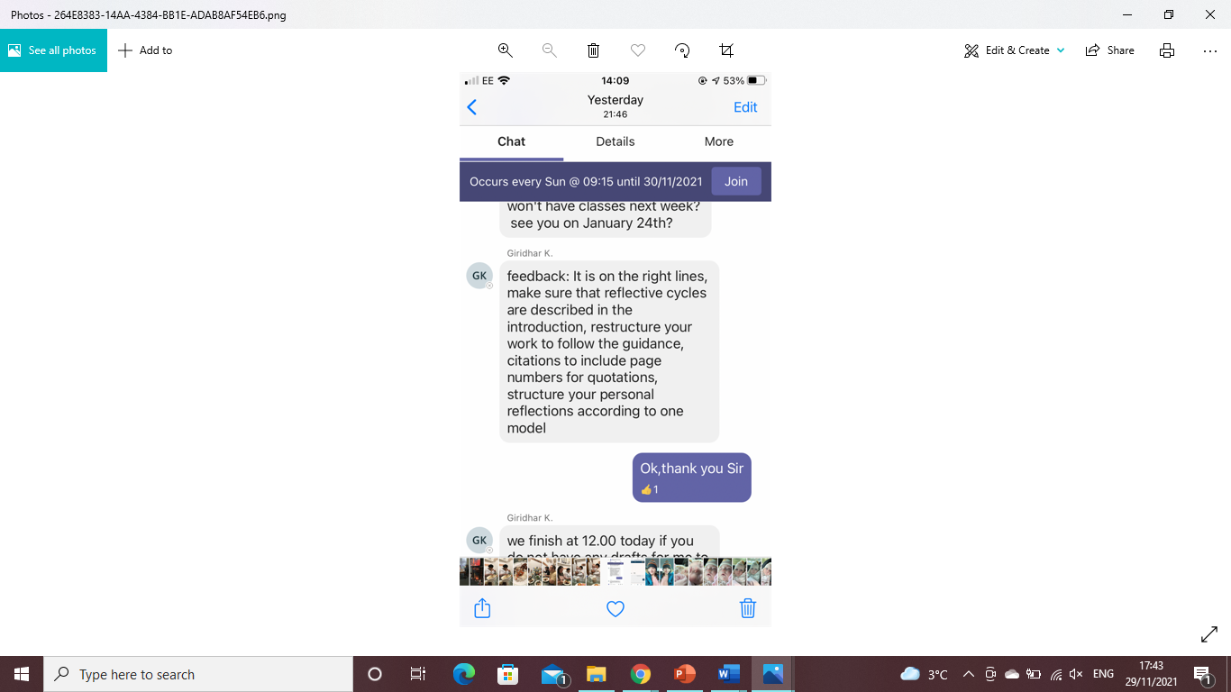

Appendix 5- written, short feedback on the group presentation "CASE STUDY OF DONNA".

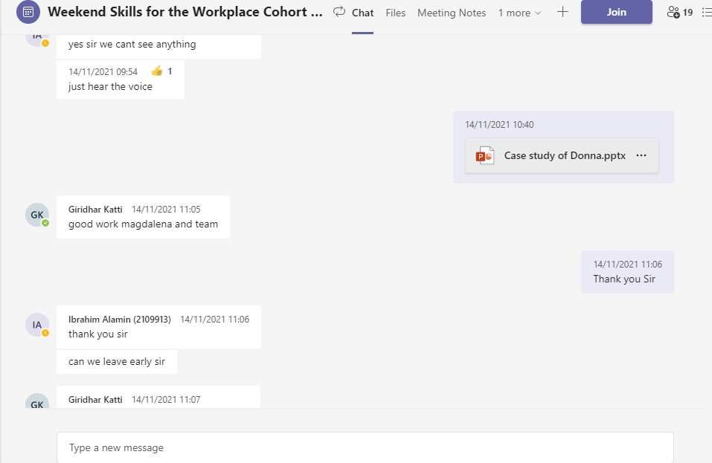

Appendix 6- Student feedback form


