Florina Loredana Lupulescu 1922055

07/08/2020

University of London Trinity Saint david
Lecturer: Saqib Shamim

Effective Team Working and Communication BMSW4002
Models of Communication

Table of Contents
Introduction 2
Models of Communication 2
Communication Skills 7
Examples of Poor Communication in the Workplace 9
Conclusion 10
References 11

- Introduction
One of the most important things in human interaction is communication and the way we communicate effectively between each other so we can make ourselves understood.
The Oxford dictionary defines communication as “the activity or process of expressing ideas and feelings or of giving people information”. (Press, 2006)
Communication is essential in our daily lives and workplaces because it brings people and places closer to each other and this way we can share ideas, feelings, and information more considerately. In the workplace, all the efficiency and productivity of the organisation starts from how well communication is shared between employees or employer and employees. For a leader in an organisation creating good working relationship, not only brings results for the company but it sends trust between employees, increasing their morale and performance.
There is more on communication, it involves not only the transfer of the message from a person to another but also how you receive and transmit the information, and the skills you need to do it. All these will be covered in more detail below with examples of case studies.

- Models of Communication
Communication is the exchange of thoughts, information, or ideas that results in mutual understanding between two or more people. No less than two persons, a sender and a receiver are involved in the action. The sender encodes the idea then choses a way to send it, might be through media, in writing, vocally or non-verbally, to the receiver. The receiver then needs to decode the message and understand it correctly otherwise it can cause issues. (Maund A, 2017)
More on how effective communication is developed between sender and receiver is explained by three models of communication:
  - Shannon and Weaver
Was created in 1948 by a mathematician and a scientist and is the “mother of all models” and its aim at the start was to aid the technical communication. It was improved later to help all types of communication.

The sender encodes a message and transmits it to the receiver through a channel. There is physical noise through the channel which can interfere with the reception of the message. And after the message passed through the channel, the receiver decodes it so he can understand it and gives feedback to clarify if the message was clear. (Communication, 2018)
Case study example: ‘Maria and Pedro’s telephone conversation’
One day Maria phoned Pedro, who works in construction, and told him to buy a chicken on his way home. When he got home, he went into the kitchen because that is why he thought Maria said on the phone. When he was supposed to buy a chicken. According to Shannon and Weaver’s model of communication, noise from Pedro’s work interfered and he misunderstood the actual message. And the feedback was missing too because he did not confirm back if it was clear. So, this could have been avoided if feedback were provided.
Various problems and criticism here are the fact that the communication is not a one way process, is more effective in person to person than group communication, the sender is more important than the receiver and the feedback is less important to, but understanding the noise will help solve the problems in communication. (Richard, 2013)

  - Schramm
Is very common and was suggested by Wilbur Schramm in 1954. It is a circular way of communication and involves two persons sending and receiving a message with the message travelling in between them.
The message must be clear before being understood. At the same time, a lot of significance can be lost during the process because of the semantic barriers like noise, ideals, attitudes, and cultural differences as they influence how the message is being sent and received.
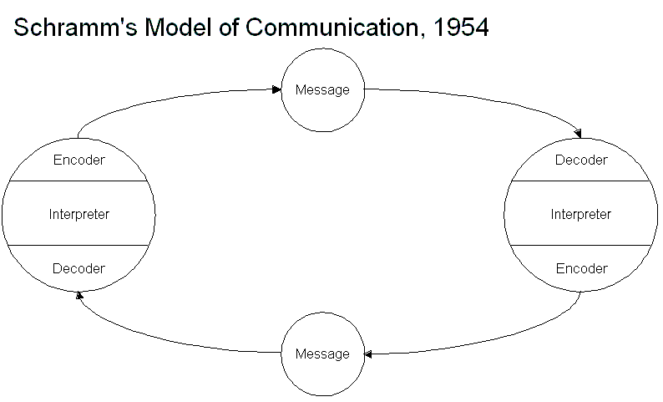

Both the sender and the receiver must send a clear message (encode it), use their skills to decode the message so it makes sense otherwise is of no use and then must be interpreted, finding the meaning of it, and feedback must also be given to the sender so the communication can be finished and effective. (Drew, 2020)
Case study example: Billy to Servant - “Please bring something hot for me to drink as I am suffering from sore throat.”
The servant brought him a glass of lukewarm water, but Billy wanted a cup of hot chocolate coffee. The servant misunderstood the message because of his different culture where is normal to have lukewarm water for sore throat. So, the cause here it attributes to their cultural backgrounds. (Juneja, n.d.)

  - David Berlo
Was set up by David Berlo in 1960 and describes the SMCR (Source, Message, Channel, and Receiver) as being essentials in the communication process.
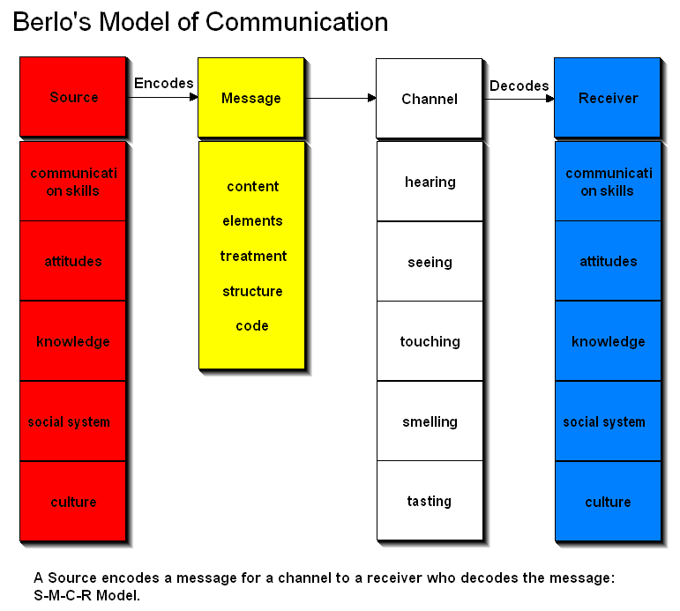
The message (what needs to be communicated), comes from a source that is the sender and goes through a channel before it gets to the receiver (audience).
The channel is the dimension by which the message travels and it can be auditory or visual, face to face, radio, TV, internet.
The message also needs to be encoded, put into words, pictures, music to go through the channel. The receiver then decodes it into meaning.
The source (sender) is influenced by different aspects like communication skills including reading, speaking listening and if these are good, then the message will be communicated effectively; the attitude of the sender and receiver can have an impact on the message; knowledge on the subject to send a clear message; the social system like the faith, beliefs, values can control how the sender conveys the message; the culture of an individual can send a message with a different meaning.
The message can be affected by the content; the nonverbal things like gesture, facial expression, body movements, signs; the way the message is conveyed; the way the message is arranged; and by the form a message is being sent.
The receiver is affected by the same things as the sender, communication skills, attitudes, knowledge, social system and culture, so they need to be very much alike. (Janse, 2019)

- Communication Skills
Communication is the process of sending and receiving a message through verbal (oral or written) or nonverbal (tone of voice, gestures, body language) means.
  - Verbal communication – is the use of words to share information through speaking or writing.
The words we say are important when we communicate that is why we need certain language skills to send clear messages across and to understand what others are saying to us. (A. Maund, 2017)
In the workplace we communicate vocally by giving and receiving instruction and information, phone calls, group discussions or presenting reports. So in order to communicate effectively you need to have clarity in the language used, show empathy and be friendly, show sincerity by not pretending to be someone you are not, relax as being tense makes talking hard, make eye contact and make sure you sit appropriately as it can send a different message.
To write effectively is to understand who you are writing for, is it formal or informal writing, for your boss or a friend or a report. You need to know the needs of your readers and the subject you are writing about. The structure is also important as writing long sentences makes reading harder so keep them short. The grammar needs to be checked for errors. The last thing to do is to read the whole text again to check for mistakes. (teams, n.d.)
  - Nonverbal communication – is all the ways we communicate but without the words. (A. Maund, 2017)
We communicate using our entire body through gestures, signs, signals, eye contact, and emotions, tone of voice even the way we look and what we wear and move. The body language communicates differently, it can: repeat the message that was said vocally, contradict the message, be a substitution for the vocal message or add to the definition of the message. (Guzman, 2016)
Nonverbal communication is the primary way we communicate our feelings and attitudes and has a big impact on what someone gets from what we are communicating.
  - Listening
Most of us do not listen because of the diversity and the environment in the place we work. Being an effective listener and communicator is very important in any business and to achieve that we need to work on our listening skills.
The reasons we do not listen are because of certain barriers like: (a)The external noise of a phone ringing, talking in the background, language differences, level of technology communication; (b) Internal noise – you should not listen to others around you when doing something; (c) Failing to focus and to listen actively; (d) Our attitudes – excuses or refusal of things (“I do not need to hear that, I already know; I’m getting confused, you’re taking too long”
To be an active listener you need to make an effort to hear what a person is saying to you and the complete message they communicate, pay attention carefully and do not become distracted by any noise or getting bored and lose focus.
Listening is always confused with hearing, but they are very different as hearing is the physical ability to detect sounds and listening is the way we interpret the verbal and nonverbal messages. Reason why listening has an impact on our productivity at work and our success in life.
Types of listening: (a) Informational - listening to acquire knowledge; (b) Critical – listening to decide; (c) Empathetic – being able to understand how someone else feels and put yourself in their place. You must listen patiently even if you disagree with what they are saying paying attention to what they say and how they feel.
You need to motivate yourself to listen not only for your motivation but for the motivation of the speaker, giving attention to the speaker and getting involved in communication by avoiding interrupting him or yourself. (A. Maund, 2017).

Examples of Poor Communication in the Workplace
- In my workplace, normally communication tends to be well distributed between staff and managers with different means of transmitting information to staff, like emails, weekly newsletters, weekly staff meetings. But sometimes communication might be misunderstood. For example, during a normal school day, a child happens to be sick, so the teacher had to phone the parents to come and take the child home. She decided to make the call from class even though there was noise because another child had behaviour. Mum answered the phone and the teacher explained what happened in a kindly manner. Mum did not show up and only at the end of day when she normally picks her child, we find out that she taught her child is a little bit unwell and nothing else.
The reason for mum misunderstanding the message was the noise in the background. The noise had an impact on mum getting the right message, so the model of Shannon and Weaver is applied here. This could have been avoided if the teacher would have asked for feedback from mum.

- Cultural differences involved at times are another reason for poor communication even in my workplace. There were things that our class teacher, who is Polish had to share with the staff in class, but she failed to do it right. The model of communication that explains this situation is Schramm’s because of the cultural background that is interfering, and attitude used by the teacher to approach us. All this is creating confusion and misunderstanding in the way she interprets a message and transferring it further to her staff and affects how we do our work as well. So, to repair this she can check for confirmation of any message received and improve the communication and decoding skills that apply in school because in an organisation like this communication is really important for the benefit of the school and the safety of the children.

- Conclusion
In the pages above we have seen that communication is a more complex process that needs to be well understood and perfected by any individual that wants to be a better communicator in his/her workplace or personal life.
If a message is not interpreted in a manner that has meaning, it will bring problems to the receiver’s attitudes that affect relationships at work and outside to.
Oral and written communication, presentation skills, getting the grammar right, making sure the academic work is well structured, listening wisely, they are communication skills that one can not be without in a workplace as they are vital for your performance and the company’s progress.
If these are considered, there is no means of errors in communication between people in their lives or workplaces but unfortunately there are barriers to communication to. They interfere with the message sent or received and is confusing for your understanding and can create conflict between people. Some of these barriers may be language or cultural differences, physical disabilities, lack of interest or emotional barriers and attitudes.
The models of communication explored are used in everyday situations and show how the communication process works and what it involves. And we have seen that a message needs to be clearly understood to communicate effectively and perform well in our job roles.

References
A. Maund, M. S. a. P. K. T., 2017. Certificate in Higher Education Skills for The Workplace Student Yearbook. s.l.:Sage Publications.
A. Maund, M. S. a. P. T., 2017. Certificate in Higher Education: Skills for The Workplace, Student Yearbook. s.l.:s.n.
Communication, b. i., 2018. Shannon and Weaver model of communication, s.l.: s.n.
Drew, C., 2020. helpfulprofessor.com. [Online]
Available at: https://helpfulprofessor.com/osgood-schramm/
[Accessed august 2020].
Goins, J., n.d. Communication Changes the World. [Online]
Available at: http://goinswriter.com
[Accessed July 2020].
Guzman, A., 2016. https://youtu.be/SKhsavlvuao. [Online]
Available at: https://youtu.be/SKhsavlvuao
[Accessed August 2020].
Janse, B., 2019. [Online]
Available at: https://www.toolshero.com
[Accessed August 2020].
Juneja, P., n.d. https://www.managementstudyguide.com/schramm-model-of-communication.htm. [Online]
Available at: https://www.managementstudyguide.com/schramm-model-of-communication.htm
[Accessed August 2020].
Maund A, S. M. a. T. P., 2017. Certificate in Higher Education: Skills for the workplace. Student yearbook. s.l.:Sage Publications.
Press, O. U., 2006. Oxford Advanced Learner's Dictionary. 7th ed. Oxford: s.n.
Richard, G., 2013. Shannon Weaver model of communication. [Online]
Available at: https://communicationinlibraries.wordpress.com/2013/12/07/shannon-weaver-model-of-communication/
[Accessed July 2020].
teams, M. t. c., n.d. [Online]
Available at: https://www.mindtools.com/CommSkll/WritingSkills.htm?route=article/WritingSkills.htm
[Accessed August 2020].

