University of Wales Trinity Saint David
Wales Institute of Science and Art


Electronic Circuits Testing and Applications

Electrical Control Systems
ACHA 4010

Benjamin Hilton
2220555
02/04/23
Contents
1 Task 1 1
1.1 A 1
1.2 B 1
1.3 c (i) 1
1.4 c (ii) 1
1.5 c (iii) 1
1.6 c (iv) 1
1.7 d 1
1.8 e 1
1.9 f 1
1.10 g 1
2 Task 2 2
2.1 Scope Time Division Calculations 2
2.2 Function Generator output sine wave 2
2.3 Unsmoothed Rectifier Wave 2
2.4 Smoothed Rectifier Wave 2
2.5 Drop in Voltage Question 2
2.6 Rectifiers use in Automotive applications Question. 2
2.7 Probing Question 2
3 Task 3 3
3.1 Scope Time Division Calculations 3
3.2 Function Generator output sine wave 3
3.3 Capacitor charge and discharge wave marked at correct points. 3
3.4 Basic Capacitor Calculations 3
3.5 Capacitor discharge table 3
3.6 Gradient Plot and calculations 3
3.7 Inaccuracies Question 3
4 References 4

Task 1

A
Resistance = voltage / current
R = 0.6/0.5
R = 1.2 ohms

B

A=0.3 amps
B=?
C?
0.5 – 0.3 = 0.2
0.2 / 2 = 0.1
B= 0.1 C= 0.1

c (i)
0.9J/s = 0.9 watt
power = current x voltage
0.9 = 0.3 x voltage
Voltage = 0.9 / 0.3
Voltage = 3 V

Resistance = voltage / current
Resistance = 3 / 0.3
Resistance = 10 Ohms

c (ii)
B current = C current = 0.1 Amps
Resistance = (9 / 0.2) / 2
Resistance = 22.5 ohms

c (iii)
potential difference of
A = 3v
B = 4.5V
C = 4.5V

c (iv)
resistance = voltage / current
r = 5v / 0.5amps
r= 10 ohms

d

e
0.6v
0.5 amps
6 ohms

Resistance = voltage / current
Voltage= Resistance x current
Voltage = 6 x 0.5
Voltage = 3v

f

g

Task 2

Scope Time Division Calculations

Time division = (1/Frequency) x (number of horizontal divisions on screens)

Time division = (1/10) x 8

Time division = 0.8 seconds or 800 milliseconds

Function Generator output sine wave

Use the given subheadings to submit your scope wave graphs with markers in the relevant places from the PC oscilloscope:1. Function generator output (4)2.Rectifier without Capacitor before the resistor (4)3.Rectifier with Capacitor before the resistor (4)

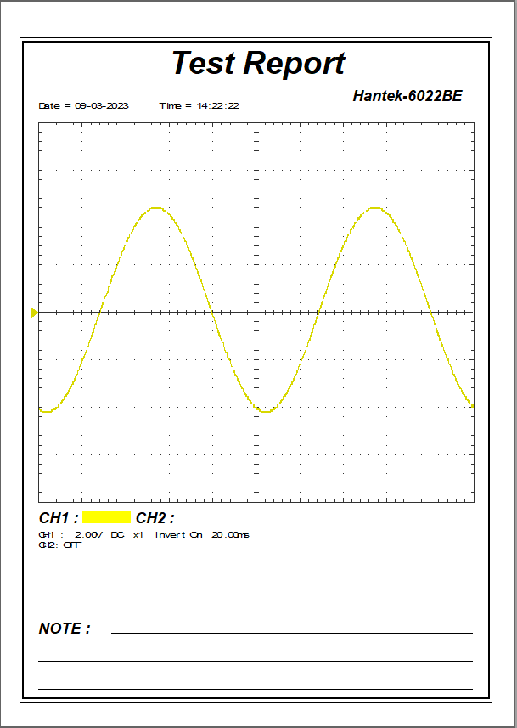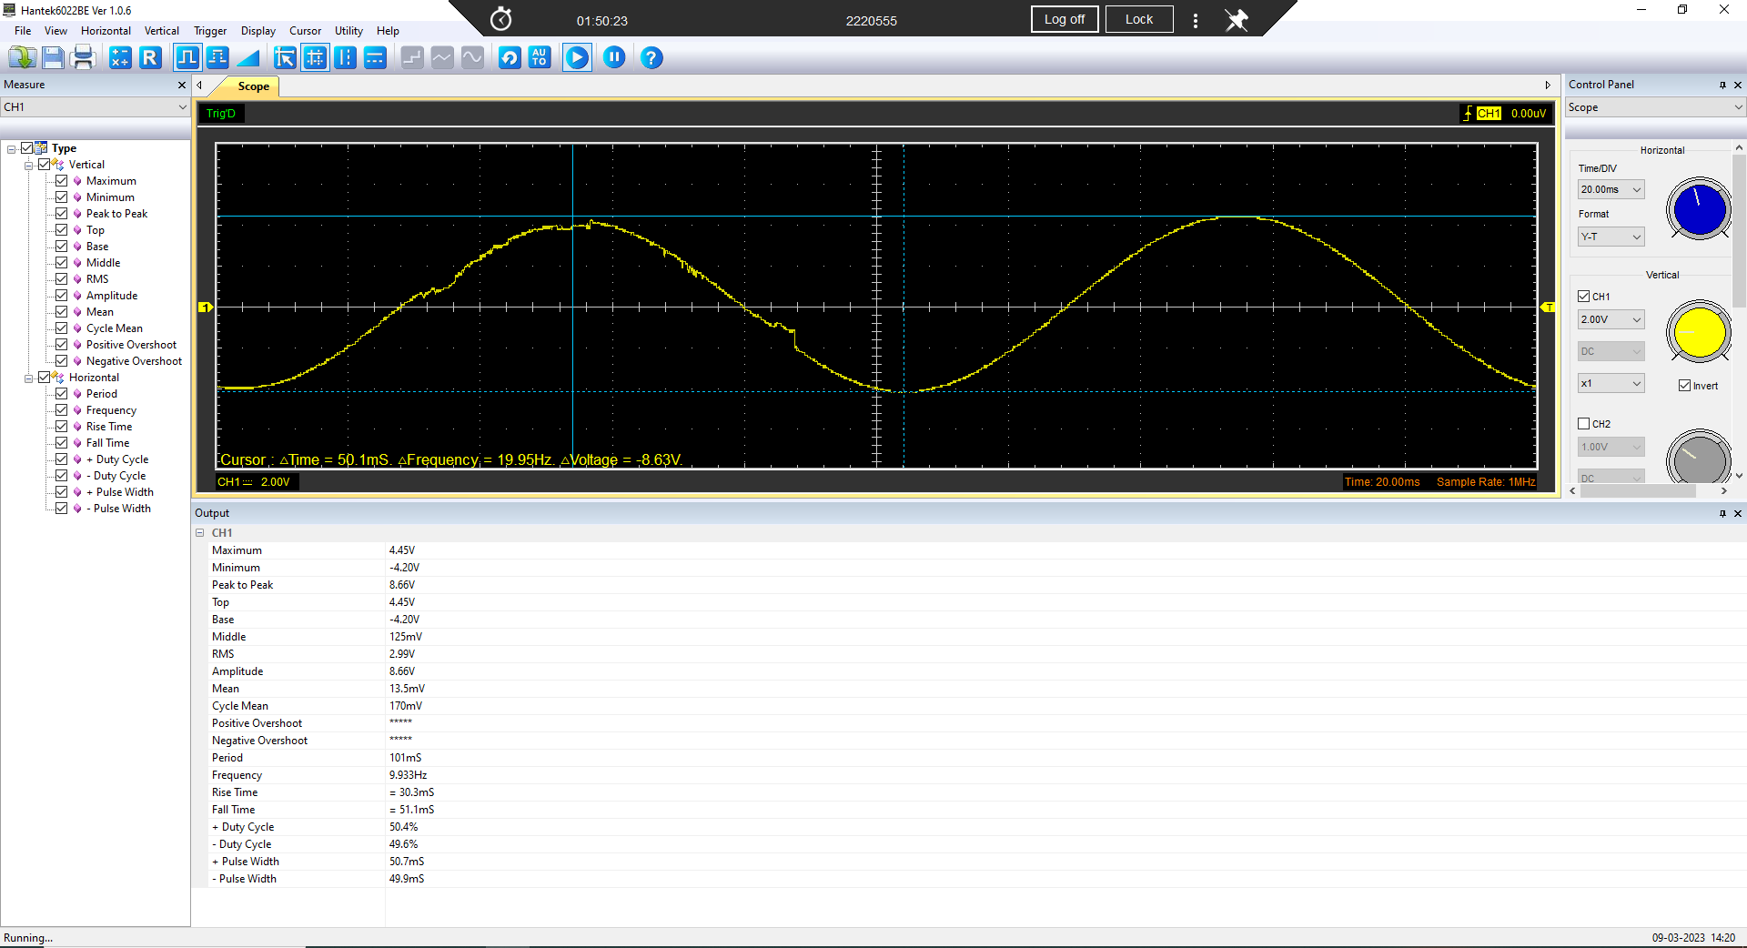

Unsmoothed Rectifier Wave
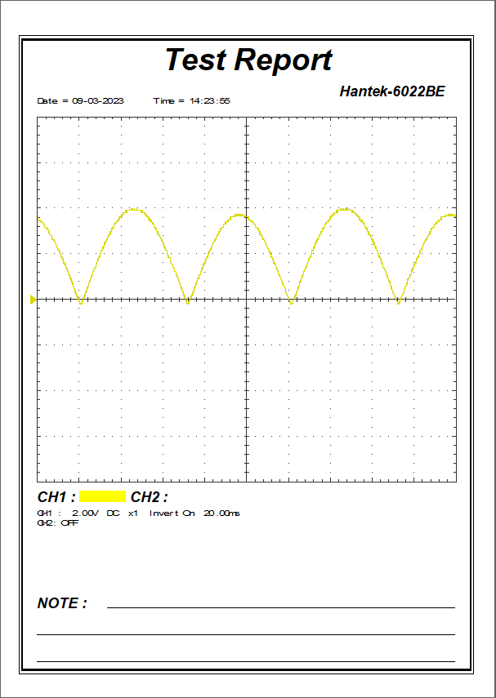
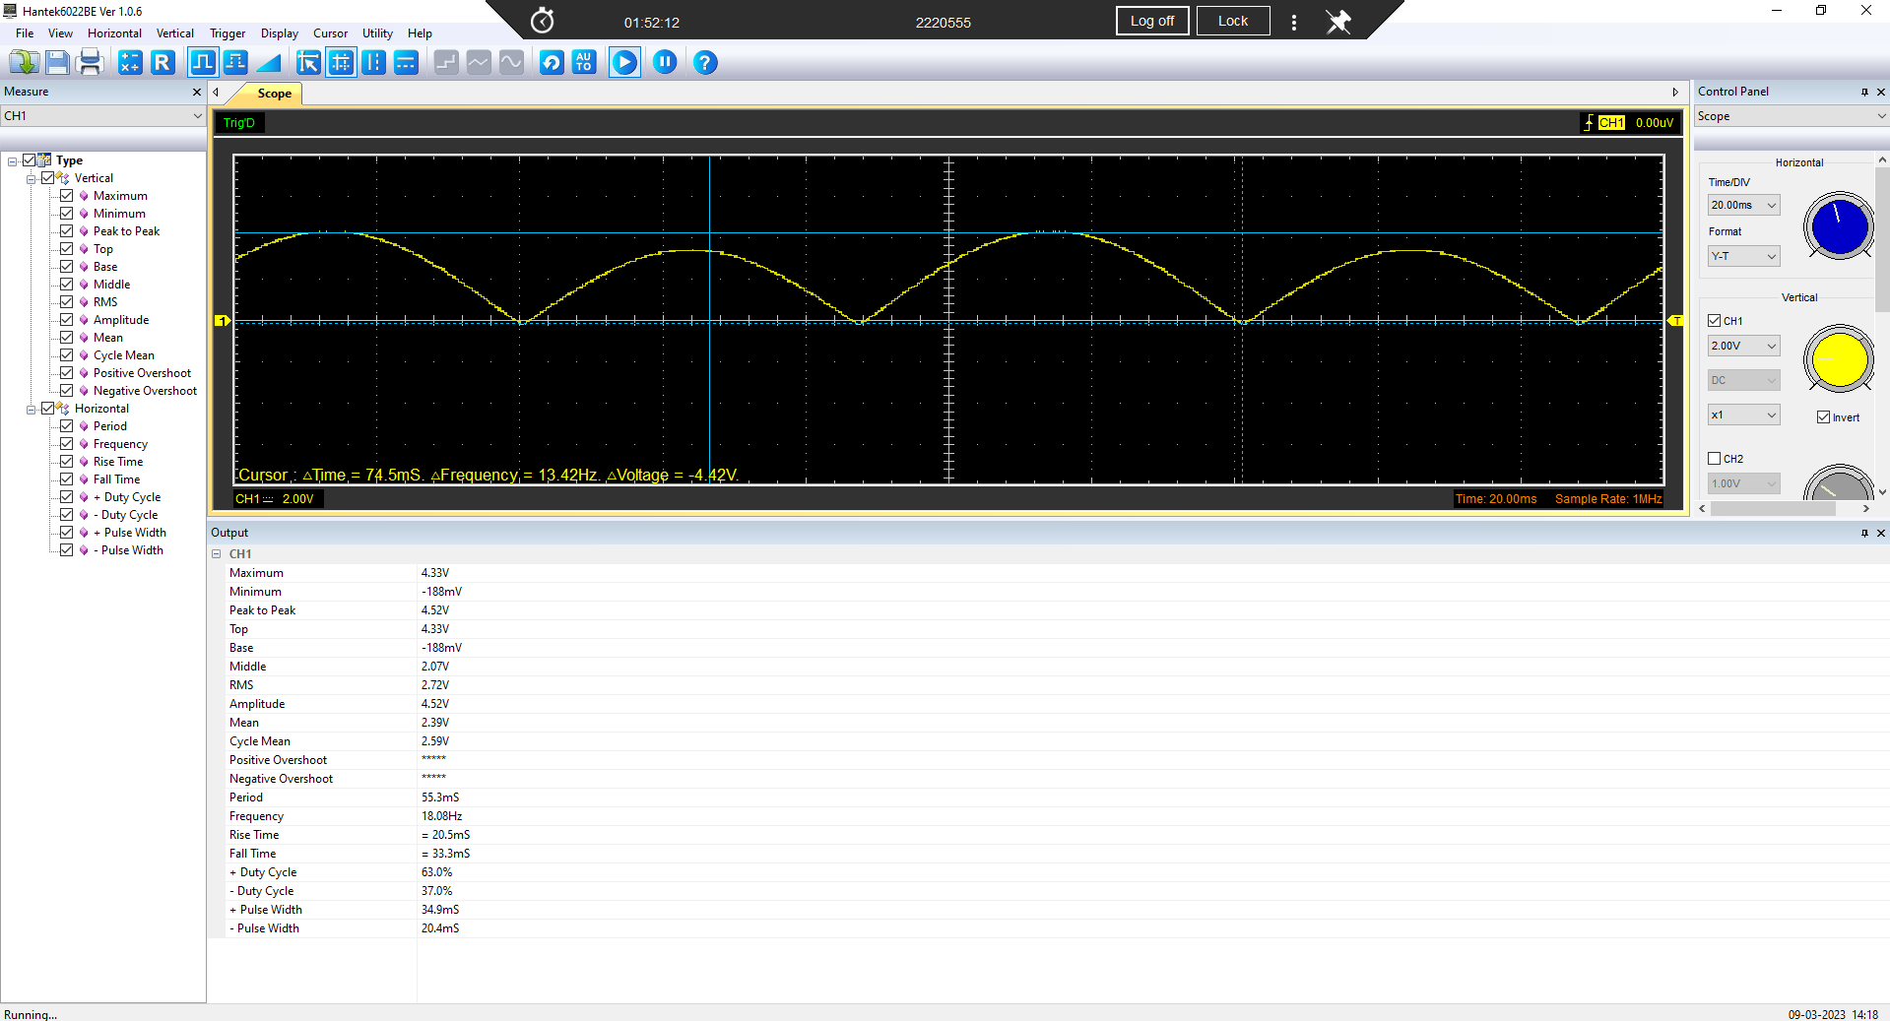

Smoothed Rectifier Wave
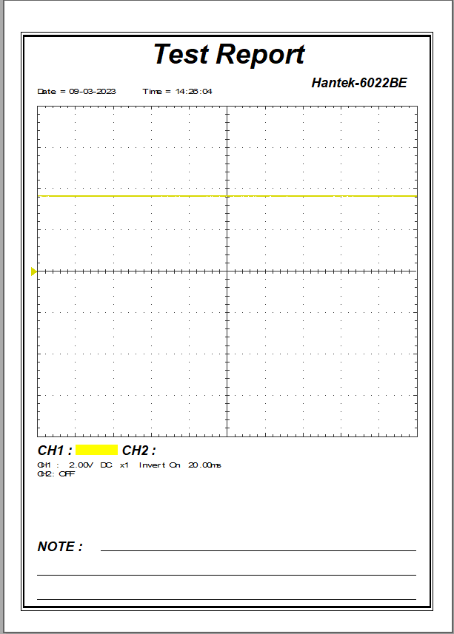

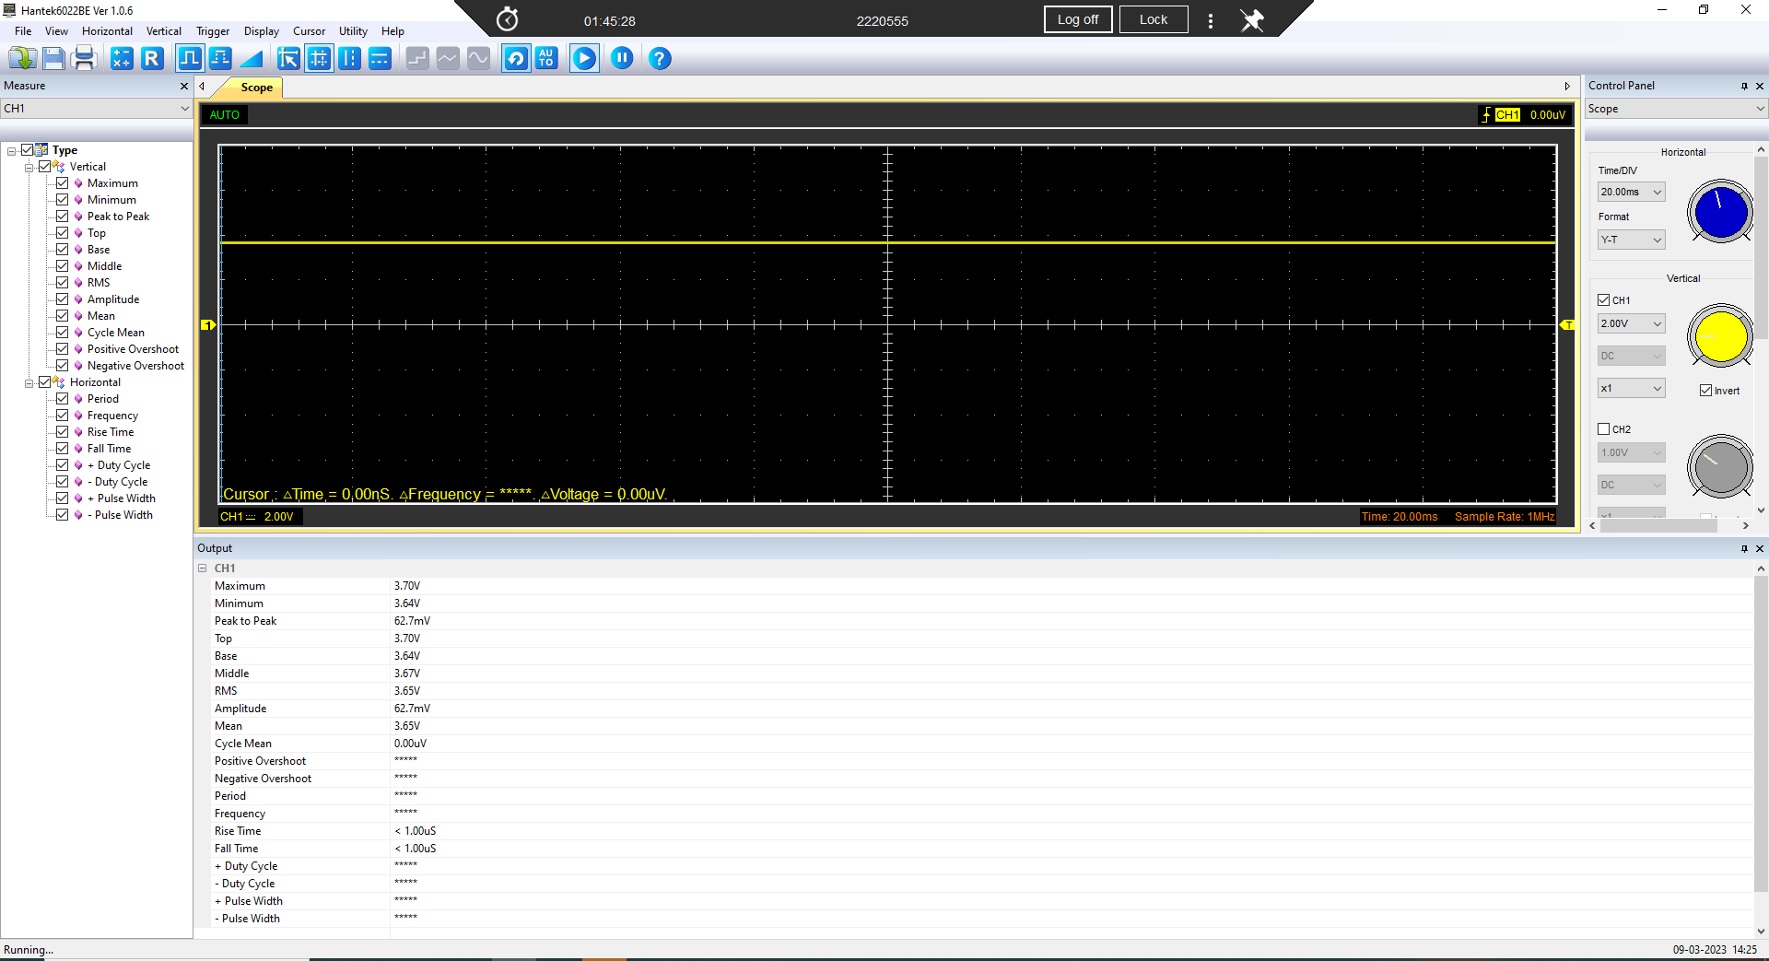

Drop in Voltage Question

We are using a full wave rectifier circuit instead of a half wave rectifier so both halves of the input AC voltage into DC voltage causing us to get a closer Peak voltage to the input sin wave as seen by the results (4.45V to 4.33V). some of the other factors that can effect this voltage is the temperature of the components as high temperatures causes a loss in efficiently leading to a lower voltage, total resistance in the rectifier as any resistance in the circuit will cause the voltage to drop, diodes can also effect the voltage drop as a cheap inefficient diode will cause a loss in DC voltage and more.

Rectifiers use in Automotive applications Question.

Rectification is a crucial process used in several types of vehicles to convert AC to DC power. The main usage of rectification in motor vehicles is to convert the AC output from the alternator to DC output to be feed directly into the battery and allow the vehicles to keep charged and stop them from running out of battery on long journeys.

With electric vehicles becoming more relevant in modern times battery capacity and charging times are becoming a limitation when it comes to EV and PEV vehicles. To charge one of these vehicles you need a powerful DC charger what uses rectification to change the AC power from the mains to DC power to charge your battery so making the most efficient rectifier can allow you to charge your vehicles in less time. Another system used is regenerative braking what uses the AC motors on a vehicle to slow the car doesn’t as well as output AC power what can be sent to a rectifier to help charge the battery, allowing the vehicle to charge the battery without a alternator based system.
(collins, 2020)
(Learn all you need to know about the motor of an electric car, 2021)
(Vishal A. Dhotre)

Probing Question

With the Scopes in class, you are not able to probe the input of the function generator on one channel whilst simultaneously probing the rectifiers out put on another. Explain why this is and through research what you can use to allow simultaneous probing.
The reason why we cant simultaneously probe the input of the function genitor alongside the output of the rectifier on separate channels of the oscilloscope is because the scopes both share a ground meaning when they are connected to the circuit it creates a ground loop what will distort are measurement.
A way to avoid this is by using a oscilloscope with isolated channels that will have independent grounds allowing simultaneous probing.
Another option is to use a isolated probe to allow you to measure the voltage between two points in a circuit, without creating a ground loop but on a down side these probes do come at a high cost.

(catewell, 2022)

(OWON HDS-I Handheld DSO With Channel Isolation, n.d.)

(Isolated probes manual, n.d.)

Task 3

Scope Time Division Calculations

Function Generator output sine wave

Use the given subheadings to submit your scope wave graphs with markers in the relevant places from the PC oscilloscope:1.Function generator output (4)2.Scope Wave across the capacitor output with markings at the relevant points stipulated on the lab sheet during the charge and discharge.(4)

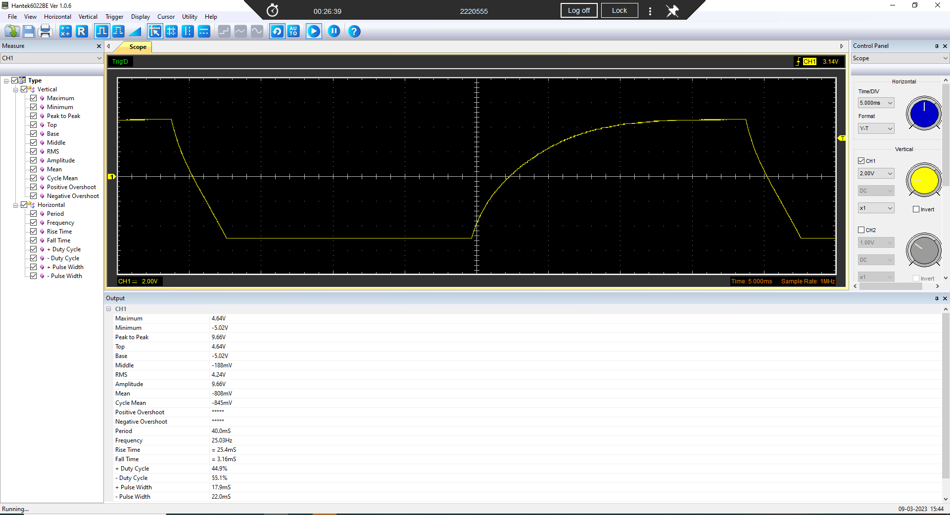

Capacitor charge and discharge wave marked at correct points.

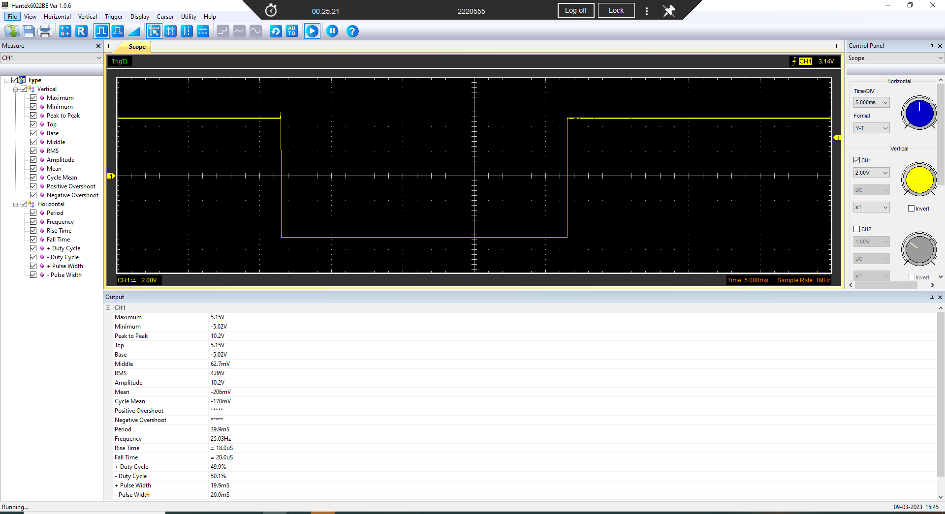

Basic Capacitor Calculations

Using t=RC and the relevant points explained in the lab sheet calculate the capacitance of the capacitor.(3)

T = R x c
T= 10 x10x10^-6
T=10x10^-5 seconds
2ot = 20 x 10x10^-5
=200x10^-5
=0.002 seconds
= 2 Ms
1/200x10^-5 = 500hz

Capacitor discharge table

Discretise the discharge curve into 10 different points and complete the table noting the voltage and time then taking the log of the voltage.(4)

Gradient Plot and calculations

Complete the calculations using the log(v) and time to calculate the capacitance. Compare this with the previous result and work out the percentage and delta difference between the two calculations. (6)

Inaccuracies Question

Due to the quality of the oscilloscopes I was unable to use the calculations for 3.4 as the oscilloscope wouldn’t accurately read the signal there for I ran my test at 25hz instead of 500hz like calculated, this also caused my wave to drop suddenly unlike figure 1 what is another students test what showed a better graph to see the discharge from the capacitor.

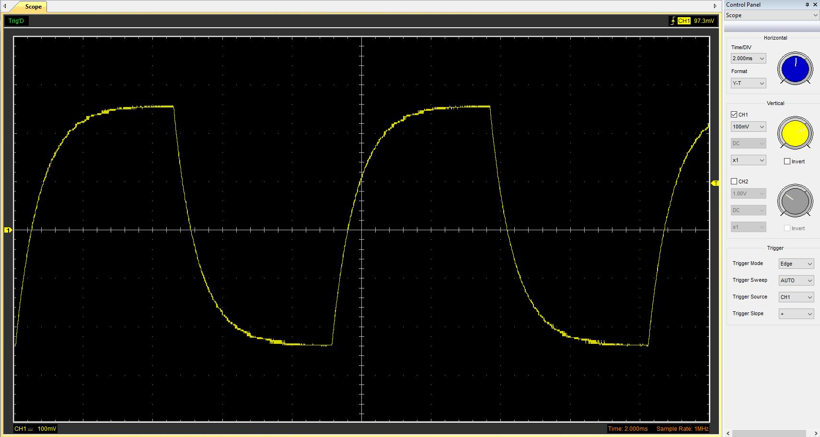
Figure 1
(sanders)

To improve are test results and test accuracy we can use probes with a smaller input capacitance as it will cause less disturbance and loading what will massively improve are results consistency and accuracy.

(TestEquity)

4References
catewell. (2022). Secrets of Ground Loops explained!
collins, D. (2020). What’s the difference between dynamic braking and regenerative braking?
Isolated probes manual. (n.d.). Retrieved from Tektronix: https://www.tek.com/en/support/product-support?series=IsoVu%20Isolated%20Probes&type=manual
Learn all you need to know about the motor of an electric car. (2021). Retrieved from Renault Group: https://www.renaultgroup.com/en/news-on-air/news/learn-all-you-need-to-know-about-the-motor-of-an-electric-car/#:~:text=While%20your%20electric%20car%20motor,the%20grid%20is%20always%20AC
OWON HDS-I Handheld DSO With Channel Isolation. (n.d.). Retrieved from OWON: https://www.owon.com.hk/products_owon_hds-i_handheld_dso_with_channel_isolation
sanders, n. (n.d.).
TestEquity. (n.d.). How Oscilloscope Probes Affect Your. Retrieved from https://assets.testequity.com/te1/Documents/pdf/probes-affect-measurement-an.pdf
Vishal A. Dhotre, A. N. (n.d.). Rectifier based Electric Vehicle Charger with.

