

Programme: MSc Public Health and Social Care in Practice
Module: Community Care and Management of Longer-term Conditions
Project Title: Living with Dementia: Evidence-Based Information Booklet for UK Health and Social Care Practice

Student Name: Kashish Sunilbhai Ardeshna
Student Number: 2539014

Table of Contents
1. Introduction and Aim 2
2. What Dementia is and why it Matters 2
2.1 Definition of Dementia 2
2.2 Global and UK Burden 2
2.3 Why Dementia Matters 3
3. Risk Factors and Aetiology 4
3.1 Non-Modifiable Risk Factors 4
3.2 Modifiable Risk Factors 4
3.3 Aetiology and Disease Mechanisms 5
4. Impact of Individuals 6
4.1 Physical Impact 6
4.2 Psychological Impact 6
4.3 Social Impact 6
4.4 Critical Integration with Long-Term Condition Care 7
5. Impact of Family and Carers 7
5.1 Carers as an Informal Workforce 7
5.2 Emotional, Financial and Social Burden 7
5.3 Critical View: From Self-Management to Shared Management 7
6. NHS Evidence-Based Management 8
6.1 Diagnosis and Assessment 8
6.2 Pharmacological Treatment 2
6.3 Non-Pharmacological Interventions 2
6.4 NICE NG97 and Person-Centred Care 2
6.5 Critical Pharmaceutical Debate 2
7. Models (UK + INTERNATIONAL) 2
7.1 UK Model: House of Care 2
7.2 International Model: WHO Innovative Care for Chronic Conditions 3
7.3 Critical Comparison 4
8. Policy Context 4
8.1 National Policy and Legal Frameworks 4
8.2 Integrated Care and Implementation Gaps 4
9. Self Management 5
10. Conclusion 5
References 1

1. Introduction and Aim
Dementia is a syndrome that combines numerous underlying pathological processes with the most common ones being Alzheimer disease and vascular dementia (Cleveland Clinic, 2024). Dementia is an issue of emerging public health concern in the UK as the ageing population and rising multimorbidity are causing certain dilemmas. The progressive impairment of cognitive functions and long-term dependency requirements in dementia necessitate a multi-level and multi-agency approach in health, social care and informal carers.

2. What Dementia is and why it Matters

2.1 Definition of Dementia
Dementia is a term used to refer to a collection of progressive neurocognitive disorders, which impair memory, thinking, language, behaviour, and doing everyday activities (WHO, 2025). For example, Alzheimer disease represents around 60% to 70% of all the cases and it is characterised by neuro-degeneration of memory and cognitive processing progressively (Tryphena et al., 2024).

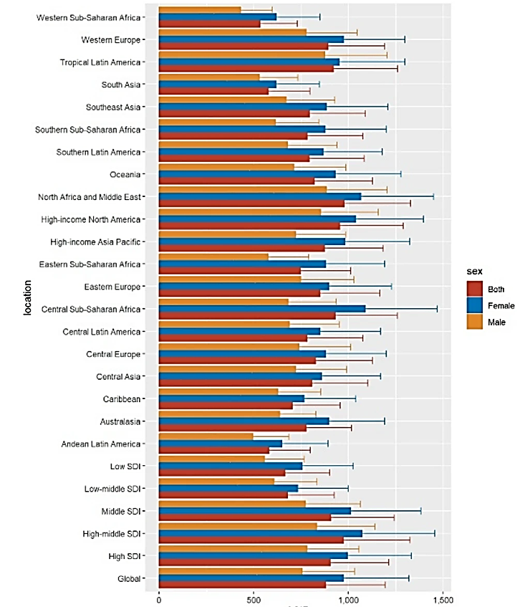
2.2 Global and UK Burden

Figure 1: Age-standardised incidence rate of dementia across the globe
(Source: Yu et al., 2025)
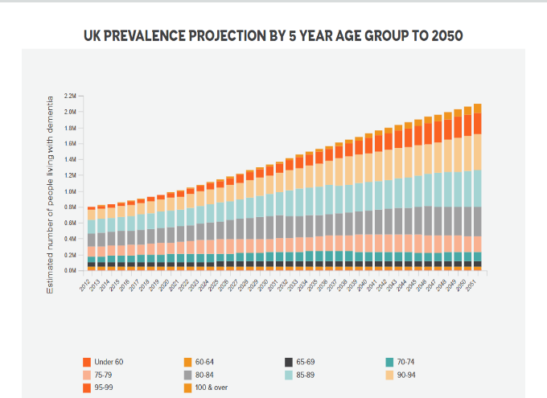
Dementia is a major and enhancing health challenge across the globe. The figure shows dementia incidence rate in different global locations per 100,000 populations. It is notable that Western Europe has a high emergence rate reaching nearly 1000 per 100,000 populations (Yu et al., 2025).

Figure 2: Prevalence of Dementia in the UK
(Source: Dementia Statistics Hub, 2024)
In the UK, almost 1 million individuals are living with dementia. It is estimated to exceed 1 million by 2030 and 1.4 million by 2040 which is mainly because of the demographic ageing of the UK (Alzheimer's Society, 2024). As shown in the above figure, the prevalence can even reach 2 million in the UK by 2050 (Dementia Statistics Hub, 2024). The most widespread subtype is Alzheimer’s disease, which is in line with international trends.

2.3 Why Dementia Matters
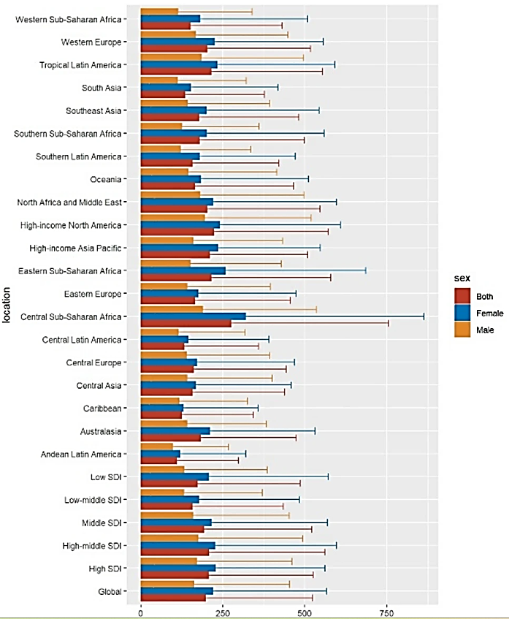
Figure 3: Death rates from Dementia for people above 60 years
(Source: Yu et al., 2025)
Dementia is is progressive and irreversible in the sense that it is one of the leading causes of death as shown in the figure. Western Europe including the UK experiences nearly 250 deaths per 100,000 populations (Yu et al., 2025).
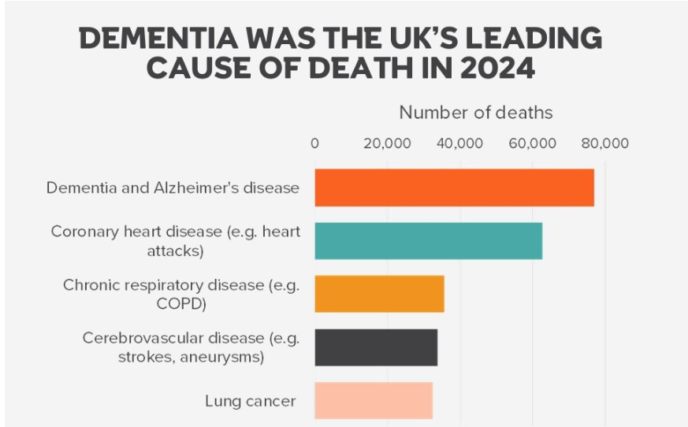
Figure 4: Number of deaths from dementia in the UK
(Source: Cooper, 2025)
As per the above figure, dementia and Alzheimer's disease contributed the highest mortality rate in the UK in 2024. The number of deaths reached 76000 (Cooper, 2025). The condition imposes a significant burden to both the NHS and the social care systems through the frequent hospitalisation, long-term care requirements, and rising residential and home care support services demands (Islam et al., 2024). However, one of the critical problems in the modern delivery of services is underdiagnoses and delayed diagnosis which is not all people are diagnosed at early and even at moderate stages.

3. Risk Factors and Aetiology

3.1 Non-Modifiable Risk Factors
The strongest risk factor is age because dementia becomes major after 65 years due to the accumulating neurodegeneration, vascular concerns, and related weakness of the brain (Ahmad et al., 2022). Genetics possess a risk factor especially the APOE-e4 allele which is linked to a potential risk of Alzheimer disease do not necessarily lead to the development of the disease. Furthermore, sex differences come in since women are generally the most affected by Alzheimer disease (Mielke, 2018).

3.2 Modifiable Risk Factors
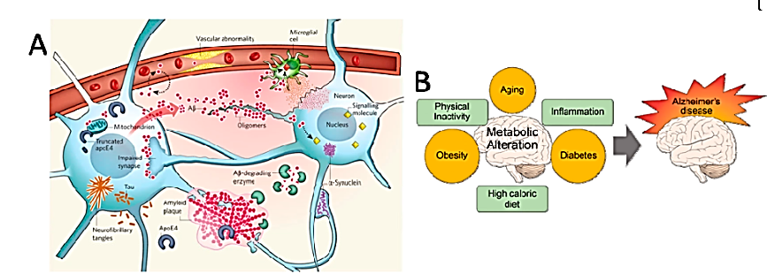
Figure 5: Risk factors of Alzheimer disease
(Source: Passeri et al., 2022)
The Lancet Commission states that approximately 45% of the incidences of dementia can be possibly avoided or postponed by targeting 14 adjustable risk factors throughout life (Livingston et al., 2024). The research stated a low education, hearing impairment, high blood pressure, smoking, obesity, depression, physical inactivity, diabetes, social isolation, and air pollution, high levels of alcohol consumption, traumatic brain damage, elevated LDL cholesterol levels and unimpeded loss of vision. For example, the above figure identified obesity, diabetes, high-caloric diet, physical inactivity, aging and inflammation as modified risk factors of Alzheimer disease (Passeri et al., 2022).
Risk factor | Example of dementia relevance
Hypertension and diabetes | Damaging blood vessels and increasing vascular dementia risk (Chang Wong and Chang Chui, 2022).
Obesity and physical inactivity | Increasing inflammation, insulin resistance and cardiovascular risk (Małkowska, 2024).
Smoking and alcohol | Increasing oxidative stress and neurovascular damage (Thangameeran et al., 2024).
Hearing loss and social isolation | Reducing cognitive stimulation and increasing loneliness.
Low education | Reducing cognitive reserve across the life course.
Air pollution | May increase neuroinflammation and vascular injury.
Table 1: Modifiable Risk Factors
(Source: Self-Created)

3.3 Aetiology and Disease Mechanisms
Dementia is a variety of biological processes. In Alzheimer disease, the uncontrolled deposit of beta-amyloid plaques and tau tangles causes impairment of neuronal communication and subsequent atrophy of the brain (Abdulkhaliq et al., 2026). In vascular dementia brain tissue hazards are caused by a decrease in blood flow to the brain due to stroke, small vessel disease or chronic hypertension (NIH, 2021). In various forms of dementia, neuroinflammation, oxidative stress and compromised clearance of proteins drive neuronal damage and cognitive impairment.
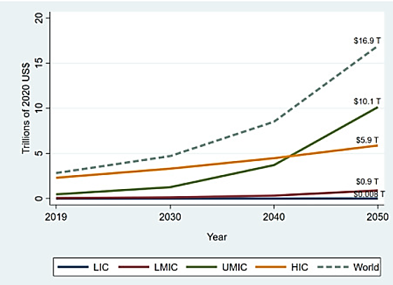
Figure 6: Economic burden of dementia
(Source: Nandi et al., 2022)
Comprehensively, the development of dementia is a result of interaction of biological susceptibility and exposure to risk in life-course. There is solid evidence of prevention, but poor scores of implementation at a population level are attributed to behavioural, economic and structural obstacles. For example, the above graph shows dementia can cause economic burden up to $16.9 Trillion that restricts proper implementation of prevention (Nandi et al., 2022).

4. Impact of Individuals

4.1 Physical Impact
The effect of dementia is progressive physical since cognitive impairment deteriorates the ability of the individual to carry out activities of daily living (ADLs) (Barros et al., 2024). The major risks are falls and frailty due to impaired balance, frailty in decision-making, attention and environmental awareness, all affected by dementia. For example, an individual can forget about using a walking support, misunderstand steps or become lost at night.
Nourishment and dehydration can take place as people forget whether to eat, people lose appetite, lead to issues with becoming incapable of cooking safely (Beck et al., 2023).

4.2 Psychological Impact
Depression and anxiety can be experienced by various people especially during the initial phases during recognition of their memory loss and lessening independence. Cognitive and psychological manifestations of dementia (BPSD) like agitation, aggression, hallucinations, delusions, wandering and sleep disturbance can occur (Umesh et al., 2022). These symptoms are caused by brain changes and might be aggravated by pain, infection, innovative surroundings, deficient communication or unfulfilled emotional requirements.
Identity and self-esteem can be affected by dementia due to patients’ dependence on others (Abbeyfieldengland, 2021)). The Alzheimer Research UK Dementia Statistics Hub lists dementia as a major UK public health problem, and it will be the most economically costly health challenge by 2050. In 2021, the amounts spent on dementia in the UK amounted to £25 billion, which is expected to almost grow to about £47 billion by 2050 (Abbeyfieldengland, 2021). With unfamiliar faces and surroundings, routines, and hospital or care home settings, distress is exacerbated. This demonstrates the need for person-centred care.

4.3 Social Impact
Severe and terrible social effects can be caused by dementia. Stigma can lead to use of disguise by those affected, procrastination of treatment or backlash against life in society (Huang, 2022). Protection against risk is incapable since victims can be susceptible to financial exploitation, neglect, exploitation or unhealthy living conditions. For instance, an individual staying alone can forget to switch off the appliances, leave doors unlocked or become a victim of fraud. Such risks demonstrate that dementia is a medical and a social care and the protection of the population matters.

4.4 Critical Integration with Long-Term Condition Care
Long-term conditions underlines that individuals desire integrated services, whole-person care, participation in decisions, information, self-management support and integration of care. In dementia self-management has to be a supporting management that incorporates care assistants, professionals, memory supports, care planning and consistent review (Cornelius et al., 2025).
Although the focus on person-centred care has become a policy priority, the services regarding dementia are still fragmented and result in uneven outcomes in terms of psychological and social support. A powerful dementia road has to be in place linking primary care with memory services, social care, protecting teams, voluntary organisations and family carers using a single coordinated plan of care.

5. Impact of Family and Carers

5.1 Carers as an Informal Workforce
Dementia affects not only an individual who has been diagnosed with it, but also the family members and informal carers. In the practical sense, carers and the healthcare assistants are made part of an informal, unpaid workforce to the broader health and social care system. Its duties in most cases involve medication prompting, scheduling appointments, overseeing safety, personal care, preparing meals and offering emotional comfort (Kagonya et al., 2023).

5.2 Emotional, Financial and Social Burden
Dementia is unpredictable, progressive and emotional demands which often causes care assistants to undergo a lot of stress. Depression and anxiety are widespread as the carers might be mourning the gradual absence of the former identity of the person being attended to, but who, still, feel the need to offer practical care (Whaley et al., 2024). Economic pressures arise as carers work, leave employment, or pay to receive extra support.

5.3 Critical View: From Self-Management to Shared Management
The traditional long-term condition models tend to focus on self-management, in which patients are assisted in handling symptoms, medication and lifestyle decisions (Alessa, 2025). However, this is not entirely true in the case of dementia since the maintenance of cognitive decline over time impairs memory, judgement and decision-making skills. Thus, dementia demands a cohesive management model with the individual, carers, GPs, memory services, social care teams and voluntary organisations. Carer support, respite care, shared care planning and professional coordination are now fundamental to safe and person-centred dementia management.

6. NHS Evidence-Based Management

6.1 Diagnosis and Assessment
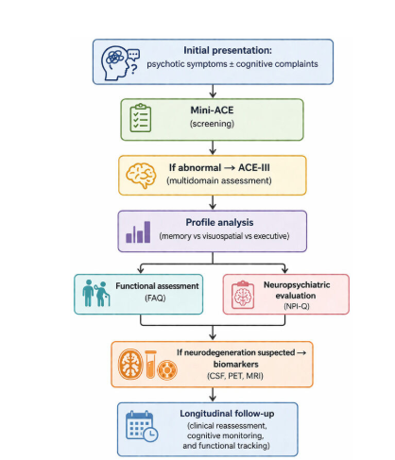 Figure 7: Methods of cognitive assessment (Source: Barczak, 2026)
The above figure shows that Cognitive assessment instruments commonly used in memory clinics include the Mini-Mental State Examination (MMSE), Addenbrookes Cognitive Examination III (ACE-III), functional history and collateral information about carers and, in certain cases, brain scan (Barczak, 2026). A cognitive score alone should not be used as a basis to diagnose since education, language, culture, sensory impairment and comorbidity shall influence the test performance.

6.2 Pharmacological Treatment
Treatment Type | Examples | Purpose
Cognitive medicines | Donepezil, rivastigmine, galantamine, memantine | Improving cognitive symptoms such as memory, thinking and daily functioning in suitable dementia types (Malík and Tlustoš, 2022).
Psychological and social support | Cognitive stimulation therapy (CST), reminiscence therapy, social prescribing | Enhancing cognitive function, psychological wellbeing, social engagement and quality of life (World Health Organization, 2022).
Functional support | Occupational therapy, falls prevention programmes, home adaptations and assistive devices | Promoting independence, improving safety, reducing falls risk and supporting activities of daily living (Zhong, Meng and Su, 2024).
Carer support | Carer education, respite care, personalised care planning and support groups | Reducing caregiver burden, improving care coordination, strengthening coping skills and enhancing continuity of care.
Table 2: Pharmacological Treatment
(Source: Self-Created)

6.3 Non-Pharmacological Interventions
Dementia care focuses on the non-pharmacological interventions since one cannot respond to the functional, psychological, and social needs of the dementia patients using medication. Cognitive stimulation therapy (CST) is suggested to patients with mild to moderate levels of dementia to assist in cognition and socialising (Fisher et al., 2025).
Occupational therapy includes home safety assessment, routines, equipment and environmental adaptations (DYNSEO, 2026). Preventable deterioration avoided with the assistance of falls prevention, nutrition monitoring, continence care, social prescribing and community dementia groups.

6.4 NICE NG97 and Person-Centred Care
NICE NG97 advances person-centred evaluation, care planning and help in people with dementia living with their healthcare assistants. It prioritises personal preferences, adjustments in equality, involvement of carers and decisions based on capacity (NICE, 2018). This is in line with the concentration on whole-person care, combined decision-making and combined assistance among the primary, secondary, community and social care services.

6.5 Critical Pharmaceutical Debate
Recent disease-modifying Alzheimer treatment drugs like lecanemab (brand name Laqembi) and donanemab (brand name Kisunla) are scientifically significant in that they are designed to treat amyloid pathology and not symptoms (U.S. Food and Drug Administration, 2024). It expresses some concerns related to engage eligibility, monitoring load, delivering infusions, adverse effects and cost-effectiveness. NICE has not suggested routine NHS application in which judges benefits are too little to warrant extra NHS expenses. Although scientific innovations in the field of disease-managing therapies have been made, the adoption of the NHS is still minimal as it is closely linked to the cost-effectiveness criteria and unpredictable long-term prospects.

7. Models (UK + INTERNATIONAL)

7.1 UK Model: House of Care
One useful model applicable in dementia in the UK is the “House of Care model”, where the model is coordinated around long-term management of conditions instead of clinical intervention alone. The model consists of four interconnected components which consists of informed and engaged individuals, healthcare professionals dedicated to being partners working, organisational systems that facilitate care planning, and commissioning that facilitates integrated services (Health and Social Care Alliance Scotland, 2018). House of Care is a model of long-term conditions in the UK, which facilitates personalised care and support planning. It is applicable to dementia as dementia cannot be treated using medicine only. The individual requires constant support by primary care, memory services, social care, family carers, voluntary organisations and community services.
In the case of dementia, the House of Care would be helpful to use since the strategies facilitate the transition to planned care instead of reactive crisis care (Allam and Chan, 2025). To illustrate, rather than waiting till someone falls, is admitted to hospital or his carer cracks, professionals can make an early care plan, which includes a medication review, home safety check, advance care planning and crater support. However, the model relies on effective local coordination. Without effective communication in NHS, social care and voluntary services, the model can be more theoretical, but not practical.

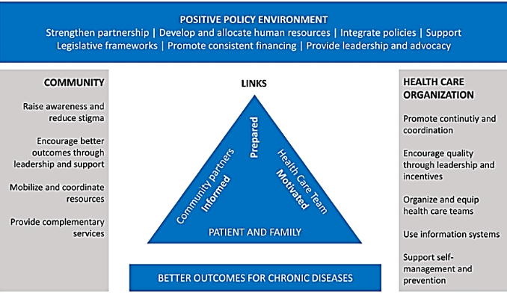
7.2 International Model: WHO Innovative Care for Chronic Conditions

Figure 8: WHO ICCC Model
(Source: Salvador et al., 2018)
The International model of WHO Innovative Care Chronic Conditions (ICCC) model offers a significant framework. As shown in the figure, it extends past the clinical visit focusing on the chronicle care that connects the patient and family, to the community resources, healthcare organisations and policy environment (Salvador et al., 2018). This is useful in the case of dementia, as successful treatment relies upon medication, memory clinic diagnosis, dementia-friendly localities, carer services, social security, community health prevention, and leadership by national policy.
The WHO ICCC model is applicable to dementia since the care of dementia people requires more than clinical services. At the individual level, the person with dementia and their family need information, shared planning and emotional support. On the other hand at the healthcare level, services should be structured around multidisciplinary working and long-term follow-up and continuity (WHO, 2026). In the community, dementia-friendly communities, voluntary organisations, social support networks can alleviate feelings of isolation and enhance quality of life. Governments need to respond on policy issues such as funding, training of workforce, access and inequalities in social care, and diagnosis disparities (WHO, 2026).
The ICCC model is more powerful than the House of Care in demonstrating the ways policy and community action and health systems should collaborate (Coulter et al., 2016). Hence, it is noteworthy since social determinants of dementia include poverty, education, housing, ethnicity and access to care. Due to its broadness, the ICCC might not be as practical in day-to-day NHS care planning, except when it is converted into local pathways.

7.3 Critical Comparison
Model | Main focus | Strength in dementia care | Limitation
House of Care | UK personalised care planning for long-term conditions | Practical for NHS care planning, carer involvement and coordinated reviews | Depends on local service availability and integration
WHO ICCC | International system-wide chronic care model | Stronger focus on community, policy, prevention and system reform | Broad model, less specific for frontline dementia practice
Table 3: Comparison between House of Care and WHO ICCC Model
(Source: WHO, 2026)
The House of Care model is viable to NHS implementation since it directly assists with personalised care planning and local service coordination (Health and Social Care Alliance Scotland, 2018). On the contrary, WHO ICCC model is more robust since it is a macro-level population health framework, such that it encompasses community and policy layers (Salvador et al., 2018).
The two models presuppose effective cross-service integration. NHS care of dementia is still impaired by the disintegration between primary care, memory services, hospitals and social care and voluntary support.

8. Policy Context

8.1 National Policy and Legal Frameworks
The NICE NG97 offers evidence-based advice on assessment, diagnosis, support and management of dementia with a focus on person-centred care, carer and equality of access consideration. There is significance in the “Care Act 2014” which imposes a responsibility on the local authorities to assess care requirements, promote wellbeing and understand the needs of carers (Care Act, 2014). “The Mental Capacity Act 2005” regulates the decision-making when the person is unable to make the decision because they require the best-interest decision and the least restrictive approach (Shickle, 2006). Likewise, “The Equality Act 2010” plays a significant role as dementia can present disability-related needs that demand reasonable adjustments in services (GOV.UK, 2022).

8.2 Integrated Care and Implementation Gaps
Long Term Plan and Integrated Care Systems (ICS) of the NHS suited towards enhancing the co-ordination of NHS organisations with local authorities and community services. This is applicable, since dementia is associated with medical, psychological, social and protective requirements (van der Feltz-Cornelis et al., 2023). Though ICSs seek to enhance integration, the implementation is skewed as social care funding drives the lack of workforce and local provision of services continue to influence accessibility, continuity and quality.

9. Self-Management
Early Diagnosis and Supported Self-Management Planning: The innovative dementia care model has to be supported self-management instead of crisis care, which is reactive (Nair et al., 2026). Early GP detection, prompt referral to memory clinics and definite diagnostic routes would make people and their families aware of the condition, create care plans and make informed choices before the symptoms can escalate.
Self-Management Education and Care Coordination: Individuals with dementia and their caregivers ought to be provided with effective details regarding medication, routines, safety, nutrition, falls prevention and community assistance in place. The primary care, hospital, community and social care staff should have dementia-specific training to ensure that self-management support in GP services, memory clinics, hospitals, social care and voluntary organisations is uniform.
Carer-Supported Self-Management: Self-management is shared management between the individual, family carers and professionals as dementia advances. Healthcare assistants ought to be regularly assessed, have respite care, emotional support and education to enable them to assist safely with medication, appointments, behaviour change and daily living needs. This would minimise burnout, and enhance continuity of care.
Person-Centred and Inclusive Self-Management: Self-management plans must be culturally aware, personalised and updated frequently (Cipta et al., 2024). Services ought to accommodate the person and the inclusion of preferences, communication needs, daily habits and identity minimising inappropriate antipsychotic taking and encouraging dementia friendly communities.

10. Conclusion
Overall research depicts that dementia is a chronic and progressive disorder of the long term that involves cognitive, physical, psychological and social activities and interactions within society. The main effective dementia care is an integrated model which traverses primary care, memory, hospital, social care, voluntary organisations and community support. The care system and NHS have to transform the pie meal service delivery to coordinated, anticipatory and person-centred care. Integration of clinical, social and community systems is the key to future dementia care based on early intervention and continuity of providing healthcare assistant’s support.

References

Abbeyfieldengland (2021). The significance of independence for people living with dementia. Information and Advice Available at: https://www.abbeyfieldengland.com/where-to-begin/living-with-dementia/the-significance-of-independence-for-people-living-with-dementia/.
Abdulkhaliq, A.A., Kim, B., Almoghrabi, Y.M., Khan, J., Ajoolabady, A., Ren, J., Bahijri, S., Tuomilehto, J., Borai, A. and Pratico, D. (2026). Amyloid-β and Tau in Alzheimer’s disease: pathogenesis, mechanisms, and interplay. Cell Death & Disease, 17(1). https://doi.org/10.1038/s41419-025-08186-8.
Ahmad, M.A., Kareem, O., Khushtar, M., Akbar, M., Haque, M.R., Iqubal, A., Haider, M.F., Pottoo, F.H., Abdulla, F.S., Al-Haidar, M.B. and Alhajri, N., 2022. Neuroinflammation: a potential risk for dementia. International journal of molecular sciences, 23(2), p.616. https://www.mdpi.com/1422-0067/23/2/616
Alessa, T. (2025). Anticipations and Requirements of Individuals with Long-Term Health Conditions Regarding Self-Management and Digital Health Support Tools. Patient Preference and Adherence, Volume 19, pp.2901–2918. https://doi.org/10.2147/ppa.s545496.
Allam, S. and Chan, H. (2025). Healthcare Continuity in Crisis: Addressing Gaps in Longitudinal Care Through Inferential Statistics. Cureus. https://pmc.ncbi.nlm.nih.gov/articles/PMC12289353/
Alzheimer's Society (2024). Facts for the media about dementia. https://www.alzheimers.org.uk/what-we-do/news-and-media/facts-media.
Barczak, A. (2026, May). The Utility of Addenbrooke’s Cognitive Examination III (ACE-III) in Differentiating Neurodegenerative Disorders with Psychotic Symptoms: A Narrative Review. In Healthcare (Vol. 14, No. 10, p. 1313). MDPI. https://doi.org/10.3390/healthcare14101313
Barros, D., Borges-Machado, F., Silva-Fernandes, A., Ribeiro, O. and Carvalho, J., (2024). Do physical fitness and cognitive function mediate the relationship between basic activities of daily living and quality of life in older adults with dementia?. Quality of Life Research, 33(4), pp.917-926. https://link.springer.com/content/pdf/10.1007/s11136-023-03570-3.pdf
Beck, A, M., Bech, C, B., Knudsen, A, W., and Munk, T. (2023). Malnutrition and dehydration in older adults – how are the overlaps between the two conditions? Clinical nutrition open science, 51, pp.72–79. https://doi.org/10.1016/j.nutos.2023.09.001.
Care Act (2014). Care Act [online] Legislation.gov.uk. https://www.legislation.gov.uk/ukpga/2014/23/contents.
Chang Wong, E. and Chang Chui, H., (2022). Vascular cognitive impairment and dementia. Continuum, 28(3), pp.750-780. https://pmc.ncbi.nlm.nih.gov/articles/PMC9833847/pdf/nihms-1830237.pdf
Cipta, D.A., Andoko, D., Theja, A., Utama, A.V.E., Hendrik, H., William, D.G., Reina, N., Handoko, M.T. and Lumbuun, N. (2024). Culturally sensitive patient-centered healthcare: A focus on health behavior modification in low and middle-income nations—insights from Indonesia. Frontiers in Medicine, 11(1353037), pp.1–7. https://doi.org/10.3389/fmed.2024.1353037.
Cleveland Clinic (2024). What Is Dementia (Forgetfulness) & The Types Of Dementia | Cleveland Clinic. [online] Cleveland Clinic. https://my.clevelandclinic.org/health/diseases/9170-dementia.
Cooper, E. (2025). Dementia is still the UK's biggest killer – where do we go from here? - Alzheimer’s Research UK. [online] Alzheimer’s Research UK. Available at: https://www.alzheimersresearchuk.org/news/dementia-is-still-uks-biggest-killer-where-do-we-go-from-here/ [Accessed 9 July 2026].
Cornelius, G., Hodgson, W., Maguire, R. and Egan, K., (2025). Wearable technology, smart home systems, and mobile apps for the self‑management of patient outcomes in dementia care: systematic review. Journal of Medical Internet Research, 27, p.e65385. https://www.jmir.org/2025/1/e65385/
Coulter, A., Kramer, G., Warren, T. and Salisbury, C. (2016). Building the House of Care for People with long-term conditions: The Foundation of the House of Care Framework. British Journal of General Practice, 66(645), pp.288–290. https://pmc.ncbi.nlm.nih.gov/articles/PMC4809714/
Dementia Statistics Hub (2024). Prevalence and Incidence. [online] Available at: https://dementiastatistics.org/about-dementia/prevalence-and-incidence/ [Accessed 9 July 2026].
DYNSEO (2026). Home Arrangement: Occupational Therapy Recommendations | Guide. [online] DYNSEO - Educational apps & brain training apps for all. https://www.dynseo.com/en/home-arrangement-occupational-therapy-recommendations-guide/
Fisher, E., Mkenda, S., Walker, J., Ssenku Safic, Stoner, C.R., Dotchin, C., Stella-Maria Paddick, Godrule Lyimo, Rogathi, J., Jelen, M., Breckons, M., Fossey, J., Walker, R. and Spector, A. (2025). Implementing Cognitive Stimulation Therapy (CST) for Dementia in a Low-Resource Setting: A Case Study in Tanzania Exploring Barriers, Facilitators, and Recommendations for Practice. Global Implementation Research and Applications. https://doi.org/10.1007/s43477-024-00142-6.
GOV.UK. (2022). Government Equalities Office. Disability: Equality Act 2010 - Guidance on matters to be taken into account in determining questions relating to the definition of disability (HTML). [online] Available at: https://www.gov.uk/government/publications/equality-act-guidance/disability-equality-act-2010-guidance-on-matters-to-be-taken-into-account-in-determining-questions-relating-to-the-definition-of-disability-html.
Health and Social Care Alliance Scotland (2018). The House of Care Model. [online] Health and Social Care Alliance Scotland. https://www.alliance-scotland.org.uk/past-work-and-projects/scotlands-house-of-care/the-house-of-care-model/.
Huang, S.-S. (2022). Depression among caregivers of patients with dementia: Associative factors and management approaches. World Journal of Psychiatry, 12(1), pp.59–76. https://pmc.ncbi.nlm.nih.gov/articles/PMC8783169/pdf/WJP-12-59.pdf
Islam, N., Shabnam, S., Khan, N., Gillies, C., Zaccardi, F., Banerjee, A., Nafilyan, V., Khunti, K. and Dambha-Miller, H. (2024). Combinations of multiple long term conditions and risk of hospital admission or death during winter 2021-22 in England: population based cohort study. BMJ Medicine, 3(1), p.e001016. https://doi.org/10.1136/bmjmed-2024-001016.
Kagonya, V.A., Onyango, O.O., Maina, M., Gathara, D., English, M. and Imam, A., (2023). Characterising support and care assistants in formal hospital settings: a scoping review. Human resources for health, 21(1), p.90. https://link.springer.com/content/pdf/10.1186/s12960-023-00877-7.pdf
Livingston, G., Huntley, J., Liu, K.Y., Costafreda, S.G., Selbæk, G., Alladi, S., Ames, D., Banerjee, S., Burns, A., Brayne, C. and Fox, N.C., (2024). Dementia prevention, intervention, and care: 2024 report of the Lancet standing Commission. The lancet, 404(10452), pp.572-628. https://www.repository.cam.ac.uk/bitstreams/28a9c76f-ca43-4ebf-ba4b-eddfe99c9442/download
Malík, M. and Tlustoš, P. (2022). Nootropics as Cognitive Enhancers: Types, Dosage and Side Effects of Smart Drugs. Nutrients, [online] 14(16), p.3367. https://doi.org/10.3390/nu14163367.
Małkowska, P., (2024). Positive effects of physical activity on insulin signaling. Current issues in molecular biology, 46(6), pp.5467-5487. https://www.mdpi.com/1467-3045/46/6/327
Mielke, M.M. (2018). Sex and Gender Differences in Alzheimer’s Disease Dementia. The Psychiatric times, 35(11), p.14. https://pmc.ncbi.nlm.nih.gov/articles/PMC6390276/.
Nair, P., Junghans, C., Kay, M., Harris, M., Majeed, A. and Hayhoe, B. (2026). Transforming dementia care pathway: why shifting to a universal, comprehensive, proactive, local, and integrated model is imperative to improve outcomes. Frontiers in Dementia, 4. https://doi.org/10.3389/frdem.2025.1719630.
Nandi, A., Counts, N., Chen, S., Seligman, B., Tortorice, D., Vigo, D., and Bloom, D. E. (2022). Global and regional projections of the economic burden of Alzheimer's disease and related dementias from 2019 to 2050: a value of statistical life approach. EClinicalMedicine, 51. https://www.thelancet.com/pdfs/journals/eclinm/PIIS2589-5370(22)00310-8.pdf
NICE (2018). Dementia: Assessment, Management and Support for People Living with Dementia and Their Carers | Guidance | NICE. [online] Nice.org.uk. Available at: https://www.nice.org.uk/guidance/ng97.
NIH (2021). Vascular Dementia: Causes, Symptoms, and Treatments. [online] National Institute on Aging. Available at: https://www.nia.nih.gov/health/vascular-dementia/vascular-dementia-causes-symptoms-and-treatments.
Passeri, E., Elkhoury, K., Morsink, M., Broersen, K., Linder, M., Tamayol, A., Malaplate, C., Yen, F.T. and Arab-Tehrany, E., (2022). Alzheimer’s disease: treatment strategies and their limitations. International journal of molecular sciences, 23(22), p.13954. https://doi.org/10.3390/ijms232213954
Salvador, J. C., Uceda, J. M. R., Muiños, V. C., Lopez, J. R., and de Castro, C. (2018). Ubiquitous computing and its applications in the disease management in a ubiquitous city. J. Comput. Commun, 6, 03-19. https://www.researchgate.net/profile/Carlos-De-Castro-Lozano/publication/323873757_Ubiquitous_Computing_and_Its_Applications_in_the_Disease_Management_in_a_Ubiquitous_City/links/5b9c115545851574f7cb4abf/Ubiquitous-Computing-and-Its-Applications-in-the-Disease-Management-in-a-Ubiquitous-City.pdf
Shickle, D. (2006). The Mental Capacity Act 2005. Clinical Medicine, 6(2), pp.169–173. https://doi.org/10.7861/clinmedicine.6-2-169.
Thangameeran, S.I.M., Wang, P.K., Liew, H.K. and Pang, C.Y., (2024). Influence of alcohol on intracerebral hemorrhage: from oxidative stress to glial cell activation. Life, 14(3), p.311. https://www.mdpi.com/2075-1729/14/3/311
Tryphena, K.P., Shukla, R., Khatri, D.K. and Vora, L.K. (2024). Pathogenesis, Diagnostics, and Therapeutics for Alzheimer’s Disease: Breaking the Memory Barrier. Ageing Research Reviews, 101, pp.102481–102481. ttps://doi.org/10.1016/j.arr.2024.102481.
U.S. Food and Drug Administration (2024). FDA Approves Treatment for Adults with Alzheimer’s Disease. U.S. Food and Drug Administration. [online] https://www.fda.gov/drugs/news-events-human-drugs/fda-approves-treatment-adults-alzheimers-disease.
Umesh, S., Goyal, N., Grover, S., Bhattacharyya, R., Menon, V., Mohapatra, D., Mehra, A. and Bakhla, A.K., (2022). A multicentric exploratory study of behavioral and psychological symptom characteristics of dementia. Indian Journal of Psychiatry, 64(4), pp.370-376. https://journals.lww.com/indianjpsychiatry/_layouts/15/oaks.journals/downloadpdf.aspx?an=01363795-202264080-00008
van der Feltz-Cornelis, C., Attree, E., Heightman, M., Gabbay, M. and Allsopp, G. (2023). Integrated Care Pathways: A New Approach for Integrated Care Systems. The British Journal of General Practice, 73(734), p.422. https://doi.org/10.3399/bjgp23X734925.
Whaley, P., Elloyse Fitzgeraldson, Fitzpatrick, S. and Hanstock, T. (2024). Constructions of carer identity for people supporting someone with depressive or anxiety symptoms: a qualitative study. Advances in Mental Health, pp.1–19. https://doi.org/10.1080/18387357.2024.2386262.
WHO (2025). Dementia. [online] World Health Organization. Available at: https://www.who.int/news-room/fact-sheets/detail/dementia.
WHO (2026). Innovative Care for Chronic Conditions. DSpace. [online] Available at: https://iris.who.int/bitstreams/4aea436e-9fc6-4e1f-a0c5-9d57a9213b21/download [Accessed 9 July 2026].
World Health Organization (2022). Mental health. [online] World Health Organization. https://www.who.int/news-room/fact-sheets/detail/mental-health-strengthening-our-response.
Yu, D. T., Li, R. X., Sun, J. R., Rong, X. W., Guo, X. G., and Zhu, G. D. (2025). Global mortality, prevalence and disability-adjusted life years of Alzheimer’s disease and other dementias in adults aged 60 years or older, and the impact of the COVID-19 pandemic: a comprehensive analysis for the global burden of disease 2021. BMC psychiatry, 25(1), 503. https://link.springer.com/content/pdf/10.1186/s12888-025-06661-2.pdf
Zhong, Y.-J., Meng, Q. and Su, C.-H. (202s4). Mechanism-Driven Strategies for Reducing Fall Risk in the Elderly: A Multidisciplinary Review of Exercise Interventions. Healthcare, [online] 12(23), pp.2394–2394. https://doi.org/10.3390/healthcare12232394.

