DS 1 Template

My Screenshots/Photos
- Please add 4–6 screenshots or photos of your digital life.
- You can use your phone or laptop.
- For each screenshot, write one or two sentences explaining what it shows.

Screenshot/Photo 1
 Sum up is a financial platform used by small business and sole traders to manage finances and take card payments. It can be used with in person contactless, chip and pin and mobile wallet payments.

Screenshot/Photo 2

WhatsApp is my messaging app that I use to send friend and family pictures, videos- video calls. This allows us to keep in touch with loved ones and some professionals.

Screenshot/Photo 3
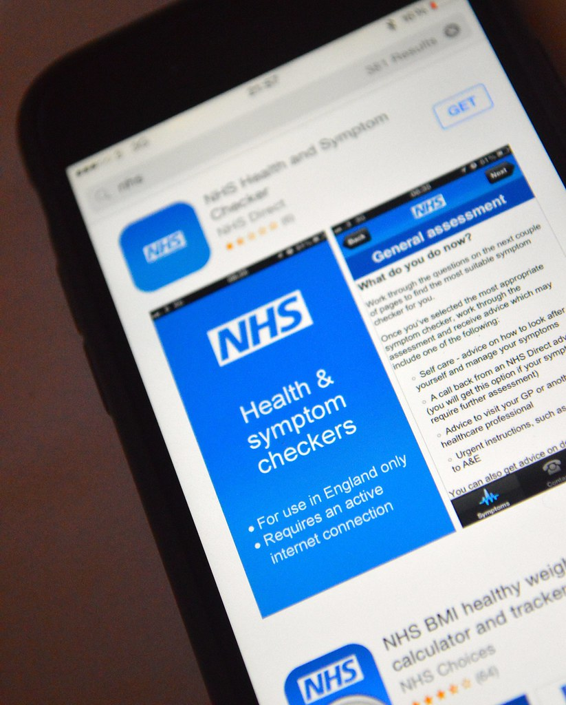 NHS APP
More efficient way to stay up to date with my health record, this app keeps the cost of sending out letters down and up to date with correspondence with health professionals.

Screenshot/Photo 4
[Insert Photo/Screenshot below]

JD sports is an app that people can browse or shop online, this is where I purchase most items for my children footwear and clothing.

Screenshot/Photo 5
 A more convenient way for me to shop I e food shopping, clothing at my own leisure. Tesco online is where I do our weekly food shop to be delivered directly to my home.

Screenshot/Photo 6
[Insert Photo/Screenshot below]

[Write what this shows of your digital life]

My Short Reflection
- Write 5–8 simple sentences about your digital life.
- You can use the sentence starters below if helpful.

Sentence starters
- I use digital tools to …
- I feel confident when I …
- I want to improve …
- I often use these tools: …
- I sometimes feel nervous about …
- I hope this module will help me …
- Digital skills are important for me because …
You can write more if you want.

Submission Checklist
Before you submit, please check:
​​​ ☐ I added 4–6 screenshots
☐ I wrote short sentences for each screenshot
☐ I wrote my short reflection
☐ My work is my own
☐ My file opens correctly
​​☐ My file opens correctly

