Name: Scott Thomas
Student number: 2015683

Module: Electronic Systems Design
Module code: ACDA6002

Assignment title: 14 Day Weather and Air Quality Measurement and Logging System

Table of Figures
Figure 1 – Davis Vantage Pro2
Figure 2 – ACCUR8 DWS7100 7-in1 Complete Solar-Powered Wi-Fi Weather station
Figure 3 – Bresser 5 in 1 Complete Weather Station
Figure 4 – Spectrum WatchDog 3250 weather station
Figure 5 – Microcontroller PIC18F24K50
Figure 6 – Peli 1200 Waterproof Plastic Equipment case
Figure 7 – ATP 16 GB industrial SD card
Figure 8 – RS PRO cable mount connector (3 pin)
Figure 9 – Figure 9 - RS PRO Cable Mount Connector (4 pin)
Figure 10 - Full proteus design
Figure 11 – Microcontroller PIC18F24K50 connections
Figure 12 - Full circuit built in Easy-PC

Table of Tables
Table 1 – Comparison of Portable Weather Stations
Table 2 - Non – volatile Memory Storage
Table 3 - Temperature/humidity sensor comparison
Table 4 – Wind speed and direction sensor comparison
Table 5 – Airbourne particle count sensor comparison
Table 6 – Sunlight brightness sensor comparison
Table 7 – UV sensor comparison
Table 8 – VOC sensor comparison
Table 9 – GPS position sensor comparison
Table 10 - Total costs

Abstract
Detailed in this report is the design of a microcontroller based weather and air quality measurement and logging system which is required to record data over a 14 day period. This data acquisition system is intended to be used by amateur weather forecasters to aid in their weather predictions. The system will be portable and adaptable for a variety of monitoring sites.
The data that the weather and air quality measurement and logging system will be required to measure the following data over a 14-day period:
- Temperature
- Humidity
- Wind speed
- Wind direction
- Airborne particle count
- Sunlight brightness
- UV levels
- GPS position
- VOC level

Introduction
There are a variety of portable weather and air quality measurement and logging systems available to buy on the market that can record a variety of different weather parameters to aid amateur weather forecasters and to record air particles in different environments to record possible pollution issues and harmful particles in a certain environment. Below are a few examples of portable weather and air quality measurement and logging systems that are available on the market.
Davis Vantage Pro2 Wireless Weather Station & WeatherLink Live Bundle 6122UK
Figure 1 – Davis Vantage Pro2
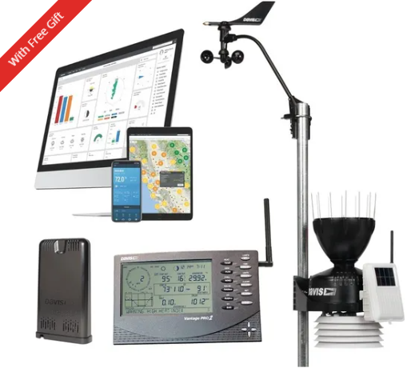
The Davis Vantage Pro2 weather station has a rugged design which is designed to offer years of service. The Integrated sensor suite is solar powered. All electronic components are protected in a weather resistant case. All the outdoor electronic components are designed to resist the effects of the environmental conditions. This system is designed so that the user can live stream any data that is being collected.
The Davis Vantage Pro2 weather station is capable of measuring:
- Air quality
- Barometric pressure
- Dew point
- Humidity
- Leaf wetness
- Rainfall
- Soil moisture
- Soil temperature
- Temperature
- Water temperature
- Wind direction
- Wind speed [1]
The Davis Vantage Pro2 is capable of measuring a large variety of weather parameters as shown above. This system would be ideal for an amateur weather forecaster, but it does not measure some parameters required in the specification such as airborne particle count.
The cost of this weather system is £989.99

Figure 2 - ACCUR8 DWS7100 7-in1 Complete Solar-Powered Wi-Fi Weather station
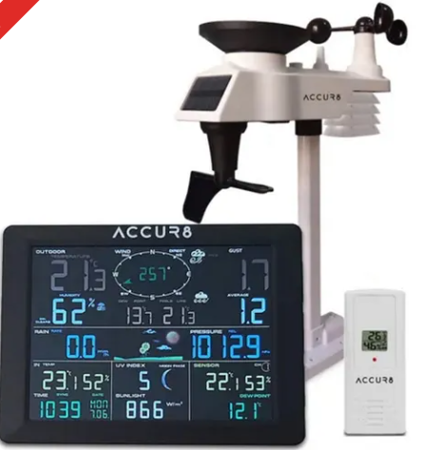

The solar-powered 7 in 1 outdoor sensor suite reliably transmits a variety of different weather parameters to the display console seen in the above image.
This weather station is capable of measuring:
- Wind speed
- Wind direction
- Humidity
- Temperature
- Rainfall
- UV level
- Light intensity [2]
This weather system would be a great tool for amateur weather forecasters but is incapable of measuring some parameters required such as airborne particle count.
This weather system costs £179.95

Figure 3 - Bresser 5 in 1 Complete Weather Station

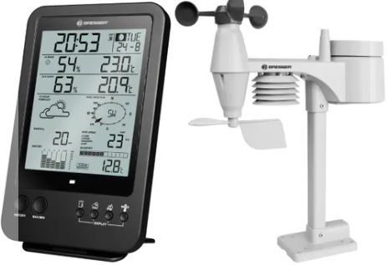

The Bresser 5 in 1 wireless weather station combines a compact design with in depth information about the weather. This weather system is powered by 3 AA batteries for the outdoor sensor suite and the display console and there is no capability for solar power.
The Bresser 5 in 1 wireless weather station is capable of measuring:
- Wind speed
- Wind direction
- Humidity
- Temperature
- Precipitation [3]
This is a more basic weather system which is not capable of measuring several required weather parameters such as sunlight brightness, UV levels and Airborne particle count.
The cost of this weather system is £109.99

Figure 4 - Spectrum WatchDog 3250 weather station
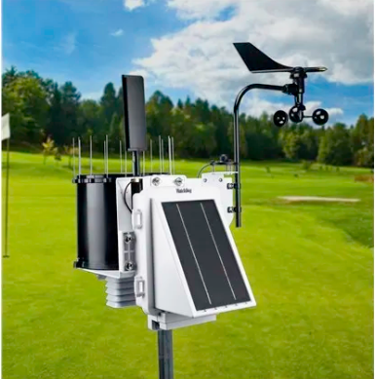
The Spectrum WatchDog 3250 weather station is a more professional weather station than the previous models. This model boasts integrated solar power and a variety of connectivity methods including USB, Bluetooth and RS232 communications. This weather station has an internal data logger that holds 18 months of data and can be used in a variety of environmental conditions with an operating temperature range of -30°C to 55 °C
The Spectrum WatchDog 3250 weather station is capable of measuring the following:
- Evapotranspiration
- Humidity
- Leaf Wetness
- Quantum Light
- Rainfall
- Soil moisture
- Solar radiation
- Temperature
- UV
- Wind direction
- Wind speed [4]
The cost of this weather system is £2945.83

Table 1 – Comparison of Portable Weather Stations
 | Davis Vantage Pro2 | ACCUR8 DWS7100 | Bresser 7002510 | Spectrum WatchDog 3250
Cost | £989.99 | £179.95 | £109.99 | £2945.83
Temperature | 
Humidity
Wind speed
Wind direction
Sunlight brightness |  | 
UV levels
VOC level
GPS position

After comparing all relevant parameters, the ACCUR8 DWS7100 is the best choice portable weather system for an amateur weather forecaster. This weather system is capable of measuring temperature, humidity, wind speed, wind direction, sunlight brightness and UV levels. The only parameters that this system does not factor is the VOC level and it does not track GPS position. This weather system is very reasonably priced at £179.95 and therefore would be ideal for an amateur weather forecaster.

Equipment
Microcontroller Selection
Before selecting an appropriate Microcontroller that is capable of processing the incoming signals from the sensors required to build the portable weather system a list was first compiled to choose which functions were required on the microcontroller.
The Microcontroller selected was the PIC18F24K50. This microcontroller has all the pins required for the 14 day weather and air quality measurement and logging system.
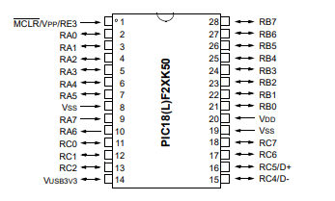
Figure 5 – Microcontroller PIC18F24K50

[28]

Casing selection
An appropriate case is required to house the electronic components and to protect against all environmental conditions. The portable weather system will be used outside in poor weather conditions so the case must be rated to at least IP66. The case must also be of sturdy design so that it can survive impact damage and protect the delicate electronic components inside.
The case that has been selected for this portable weather system is the Peli 1200 Waterproof Plastic Equipment case as seen below:
Figure 6 - Peli 1200 Waterproof Plastic Equipment case
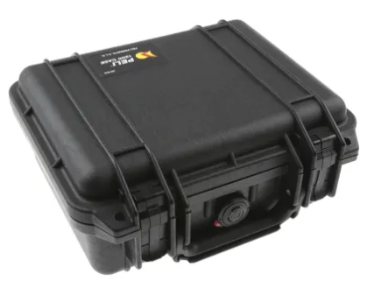[29]
The Peli watertight equipment case is designed to protect materials inside and is supplied with internal foam support to keep articles safe and secure. The case is rated to IP67 so it will keep internal components dry and protected. Cost = £109.07
Table 2 - Non – volatile Memory Storage
 | Logging rate | Bytes | Bytes/s
Temperature | 60 min | 2 | 2000 bytes/s
Humidity | 60 min | 2 | 2000 bytes/s
Wind speed | 60 min | 2 | 2000 bytes/s
Wind direction | 60 min | 1 | 1 byte/s
Airborne particle count | 12 hours | 1 | 1 byte/s
Sunlight brightness | 60 min | 2 | 2000 bytes/s
VOC levels | 12 hours | 1 | 1 byte/s
UV levels |  | 1 | 2000 bytes/s
GPS position | 60 mins | 2 | 1 byte/s

It can be seen in the above table that the system is required to record 10004 bytes per second.
To calculate the total bytes per minute = 10004 x 60 = 600,240 bytes
Number of bytes per hour = 600,240 x 60 = 36,014,400 bytes
Number of bytes per day = 36,014,400 x 24 = 864,345,600 bytes
Number of bytes per week (7 days) = 6,050,419,200 bytes
Number of bytes of the required 14 period = 6,050,419,200 x 2 = 12,100,838,400 (12.1 GB)
Using these calculations, a 16GB SD card is required for the non-volatile storage. The SD card selected is the ATP 16 GB industrial SD card as shown below and costs £65.05.
Figure 7 - ATP 16 GB industrial SD card
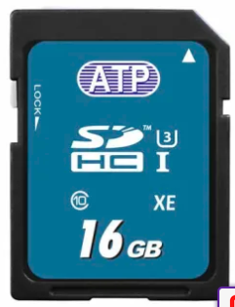 [30]
Sensor Selection

Temperature/humidity sensor
The portable weather system is required to measure a number of environmental conditions such as temperature and humidity. There are several sensors on the market that can measure both temperature and humidity. A comparison of some examples are shown below:
Table 3 – Temperature/humidity sensor comparison
 | HygroVUE10 [5] | EE181-L [6] | Amphenol Advanced Sensors Temperature and Humidity sensor [7] | TE Connectivity Temperature & Humidity Sensor [8]
Image of sensor | 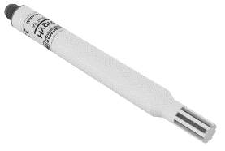 | 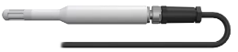 | 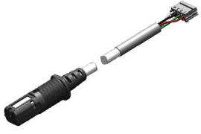 | 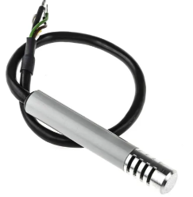
Power supply | 7 – 28 Vdc | 7-30 Vdc | 5 Vdc | 3-10 Vdc
Temperature range | -40˚C - +70˚C | -40˚C - +60˚C | -20˚C - 70˚C | -40˚C - 85˚C
Temperature accuracy | +/- 0.2˚C | +/- 0.2˚C | +/-0.5˚C | N/A
Relative humidity range | 0 – 100% RH | 0 – 100% RH | 0 – 95% RH | 1 – 99% RH
Relative humidity range | +/-1% RH | +/-2.3% RH | +/-2% RH | +/-3 RH
Number of pins | 4 | 5 | 4 | 4
Environment protection | IP67 | IP65 | IP67 | N/A
Cost | Unknown | Unknown | £43.97 | £128.95

The sensor selected to measure the temperature and humidity is the Amphenol Advanced. This sensor is the most appropriate for the application required. It runs off low voltage, is accurate enough for the requirements of an amateur weather forecaster and is very reasonably priced at £43.97.

Wind speed/direction sensor
The portable weather measurement system is required to measure both wind speed and direction. Below is a comparison table of sensors that measure both wind speed and direction.

Table 4 – Wind speed and direction sensor comparison
 | WSD-V Wind speed and direction sensor [9] | WindSonic solid state wind speed and direction sensor | Meteorological sensor wind speed and direction [11] | 05103-L Wind Monitor [12]
Image of sensor | 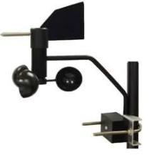 | 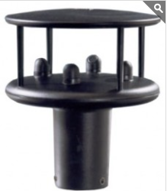 | 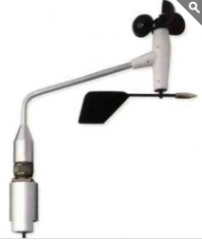 | 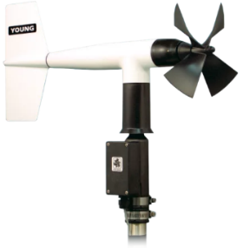
Power supply | 12V AC/DC | 5 – 30Vdc | 9Vdc – 26Vdc | Voltage supplied by data logger
Output | 0-5Vdc | RS232 | 4 – 20 mA | AC voltage (3 pulses per revolution)
Wind speed Accuracy | 5% or 1.5 m/s | +/- 2% | +/- 0.3 m/s | +/- 0.3 m/s
Maximum wind speed | Unknown | 60 m/s | 60 m/s | 100 m/s
Wind direction accuracy | +/- 5˚ | +/- 2% | +/- 1% | +/- 3°
Number of pins | 4 | RS232 connection | 6 | 6
Cost | £552 | £812 | £1393.93 | Unknown

The wind direction and speed sensor selected for the weather measurement sensor is the WSD-V wind speed and direction sensor. This is the most appropriate for the application required. The selected sensor is accurate and costs £552 which is the cheapest out of the sensors compared.

Airborne particle count
The portable weather measurement system is required to measure the amount of airborne particles in the environment. Below is a comparison of sensors that measure airborne particles.
Table 5 – Airbourne particle count sensor comparison
 | Airnet ll channel air particle sensor [13] | TERA sensor Next-PM [14] | Sensirion SEN50-SDN-T [15]
Image of sensor | 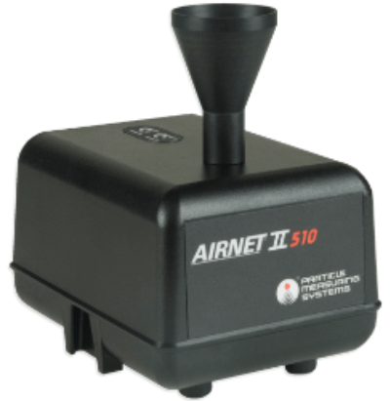 | 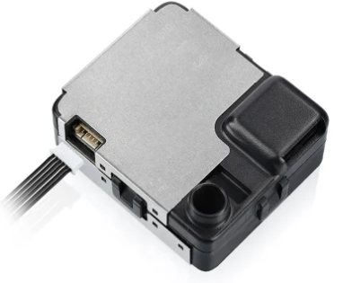 | 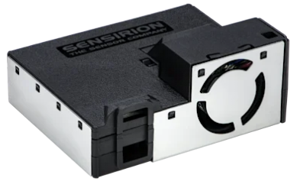
Power supply | 24Vdc | 5Vdc | 5Vdc
Size range | 0.3 - 0.5 µm | 0.3-10 µm | 0.3 – 1 µm
Output | 24Vdv, 4-20mA | 5Vdv | 3.3V
Number of pins | 6 | 3 | 6
Cost | Unknown | £93.16 | £21.44

The airborne particle sensor selected for the weather measurement system is the TERA sensor Next-PM. Through comparison, this sensor is the most appropriate for the required application. It has the largest size range and costs £93.16

Sunlight brightness sensor
The portable weather measurement system is required to measure sunlight brightness. Below is a comparison table for sensors that measure sunlight brightness/lux.
Table 6 – Sunlight brightness sensor comparison

 | External light level sensor[16] | ML-020S-0 Lux sensor [17] | ML-020S-I Lux sensor[18]
Image of sensor | 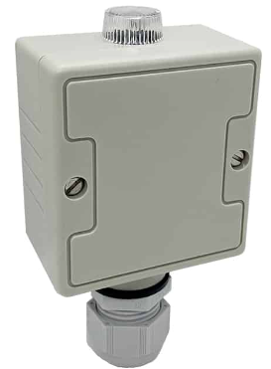 | 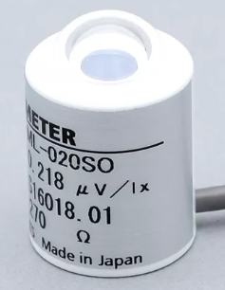 | 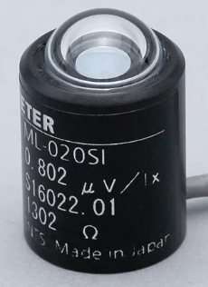
Supply voltage | 12V AC/DC | 0-30mV | 0-30mV
Output | 0-10V / 4-20mA | 0-20mV | 0-30mV
Range | 0 – 20000 Lux | 0-150Klux | 0-30Klux
Number of pins | 3 | 2 | 2
Cost | £40 | Unknown | Unknown

The sunlight brightness sensor selected for the weather measurement system is the External Light Level Sensor. This sensor has the most robust design which will hold up to the environmental conditions and costs £40.

UV sensor
The portable weather measurement system is required to measure UV levels in the environment. Below is a comparison table of sensors capable of measuring UV levels.
Table 7 – UV sensor comparison
 | Davis UV sensor[19] | Renke UV sensor (wall mounted) [20] | Renke UV sensor (aluminum shell)[21]
Image of sensor | 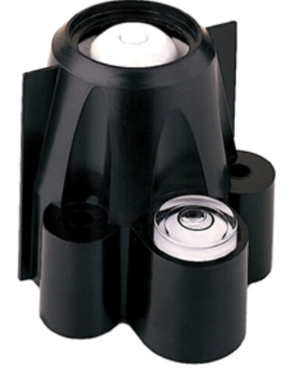 | 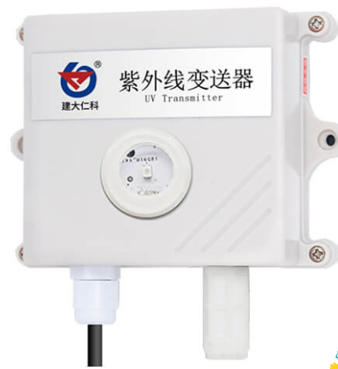 | 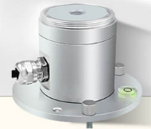
Power supply | 3V +/-10% | 0-30Vdc | 0-30Vdc
Output | 0-2.5V | 0-5V | 0-5V
Range | 300 – 1100 nm | 240-370nm | 290-390nm
Number of pins | 4 | 3 | 3
Cost | £530.58 | £51 | £67

The UV sensor selected for the portable weather system is the Renke UV sensor (aluminum shell) This sensor is designed to be used outdoors so it is appropriate for the portable weather system. The cost of this sensor is £67.

VOC level sensor
The next sensor to be selected is the VOC sensor. VOC stands for Volatile Organic Compound. Volatile Organic Compounds are often components of hydraulic fluids or petroleum products and are common ground water contaminants.
Table 8 – VOC sensor comparison
 | AQDTF Duct Air Quality VOC Sensor [22] | Titon VOC sensor [23] | BAPI voc Duct and Harsh Environment Sensor [24]
Image of sensor | 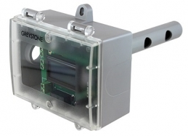 | 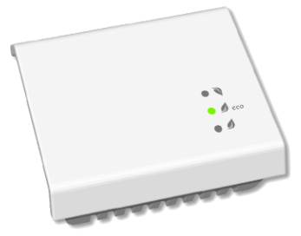 | 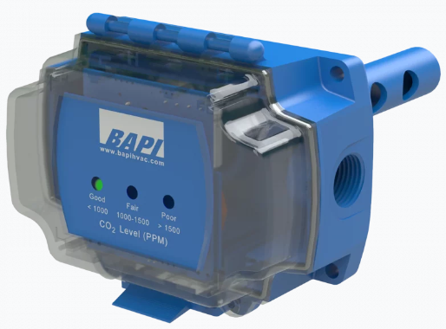
Power supply | 20-28V AC/DC | 12-35Vdc | 12Vdc
Output | 0-5V | 0-10V | 0-5V
Range | 450-2000 ppm | 400-2000ppm | 0-2000ppm
Number of pins | 3 | 3 | 3
Cost | £310 | Unknown | £284.61

The VOC level sensor selected for the portable weather system is the BAPI VOC Duct and Harsh Environment sensor. This sensor has the widest range and runs off a 12Vdc supply. The cost of this sensor is £284.61.

GPS Position sensor
The portable weather measurement system is required to track the position of the weather system using GPS. Below is a comparison table of appropriate GPS sensors.
Table 9 – GPS position sensor comparison
 | GPS 16Xlvs [25] | GPS160 NMEA 0183 [26] | GPS 34xd GPS receiver [27]
Image of sensor | 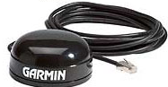 | 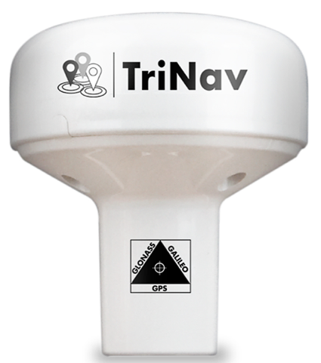 | 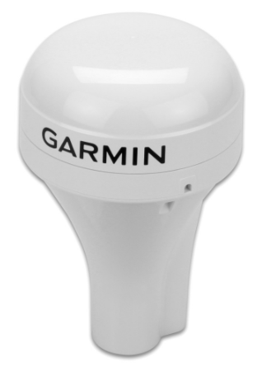
Power supply | 3.3 – 6Vdc | 12Vdc | 9-16Vdc
Accuracy | 10 metres | 1 metre | Precise
Number of pins | Cat5 | 3 | 3
Cost | $81.47 | £156 | £249.95

The GPS sensor to be used in this portable weather system is the GPS160 NMEA 0183. This sensor is very accurate and has an accuracy of 1 metre which will be more than sufficient for the portable weather system. The cost of this sensor is £156.
Connector Selection
The sensors selected require both 3 pin and 4 pin connectors.
The selected connectors must have good protection from environmental conditions and the material of the pins must be gold. The pins of the connectors must be gold as the material gives improved electrical connectivity as gold plating provides a smooth finish which allows consistent circuit connection and gold has very good conductive properties which ensures a strong electrical connection. Gold connectors also increase durability and provide improves corrosion protection which is especially important in this weather monitoring system as it will be outdoors for long periods.

3 pin plug/socket
The connector selected for the 3 pin connectors is the ‘RS PRO cable mount connector’ as seen in the image below:
Figure 8 - RS PRO cable mount connector (3 pin)
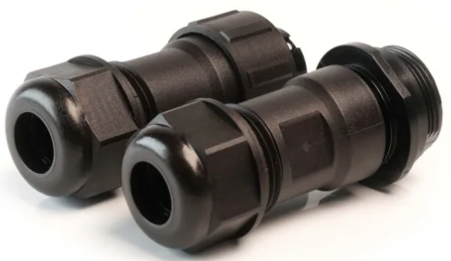[31]
These connectors are gold plated which will ensure quality electrical connection. They are rated to IP68 so they are designed to be used in very harsh environmental conditions and have a current rating of 10 amps which is more than enough. The cost of this plug/socket is £26.53 and 5 of them are required.

4 pin plug/socket
The connector selected for the 4 pin connector is also the ‘RS PRO Cable Mount Connector’ except this one has 4 pins instead of 3 and can be seen below:
Figure 9 - RS PRO Cable Mount Connector (4 pin)
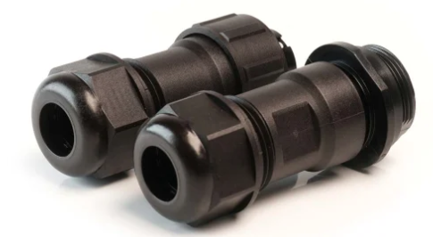[32]
These connectors are also gold plated and rated to IP68 so they will be appropriate for use in the weather measurement system. The cost of this plug/socket is £24.67 and 2 of them are required.

Circuit Design
The full circuit design was first produced using Proteus circuit design software and is displayed below in figure 19. The sensor included in this circuit design are: A temperature/humidity sensor; a wind speed/wind direction sensor; an airborne particle count sensor; a UV level sensor; a sunlight brightness sensor; a GPS sensor and a VOC level sensor.
The Circuit design also has a battery with a voltage regulator; an SD card reader; a USB connector; a button to start the system and an LED to show that the system is on.
As the Microcontroller PIC 18F24K50 runs on a voltage of 5 Volts, it is essential that a maximum of 5 Volts is input to the Microcontroller to prevent damage occurring. As the temperature/humidity sensor; wind speed/direction sensor; sunlight brightness sensor and VOC sensor run on a voltage of 12V, a voltage divider must be used to reduce the voltage from 12V to 5V. It can be seen in figure 10, that a 14KΩ and a 10KΩ resistor are connected in series and the output is connected to the centre point of these two resistors. The output is then ‘clamped’ to a maximum of 5 volts using a capacitor and Zener diode connected in parallel as can be seen in figure 10. The capacitor and Zener diode are used to ‘clamp’ the voltage to a maximum of 5 volts to prevent damage occurring to the Microcontroller.
The voltage regulator is an essential component of this circuit design. A 12 volt battery is used which then supplies a 7805 voltage regulator. This voltage regulator produces a 5 volts output. This is an essential component of the circuit design as the Microcontroller and some of the sensors operate on a voltage of 5 volts. The other sensors in the design operate on 12 volts so the other sensors will be supplied straight from the battery.
Figure 10 - Full proteus design
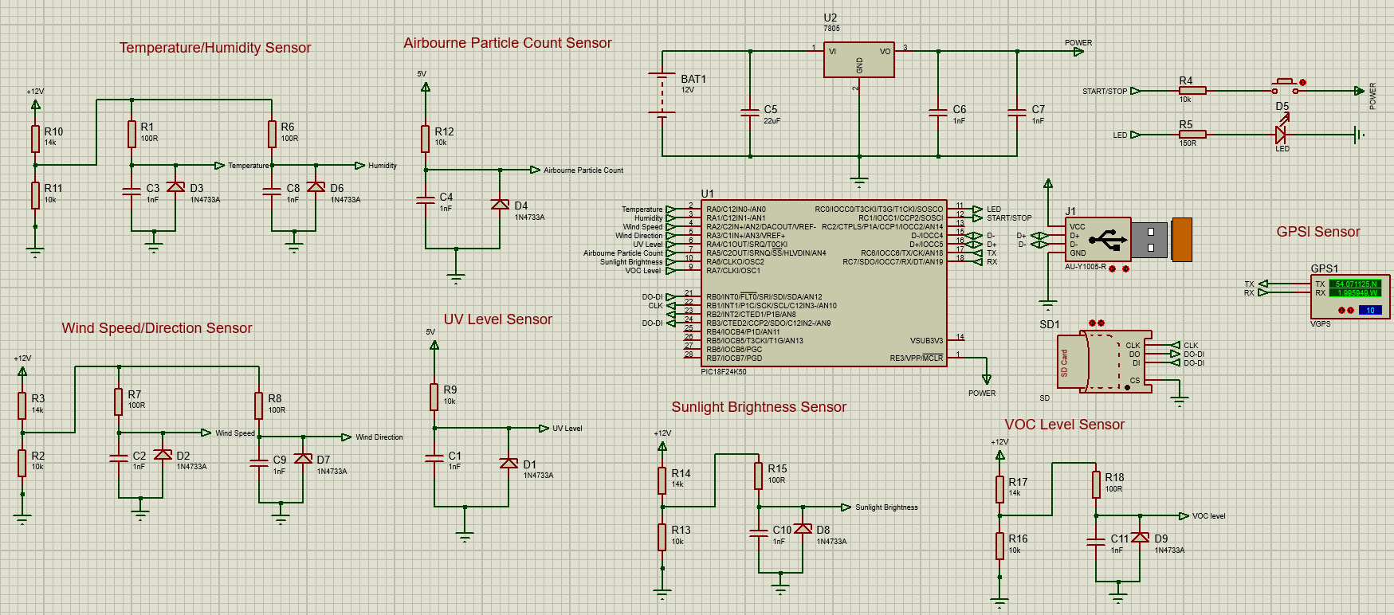
Shown below in figure 11 are all the connections used on the Microcontroller PIC18F24K50 and what each pin is used for.

Figure 11 – Microcontroller PIC18F24K50 connections
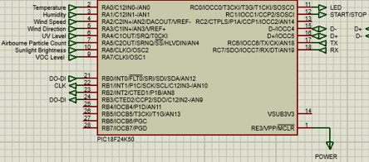

Shown in figure 12 is the full circuit designed in Easy-PC.
Figure 12 - Full circuit built in Easy-PC

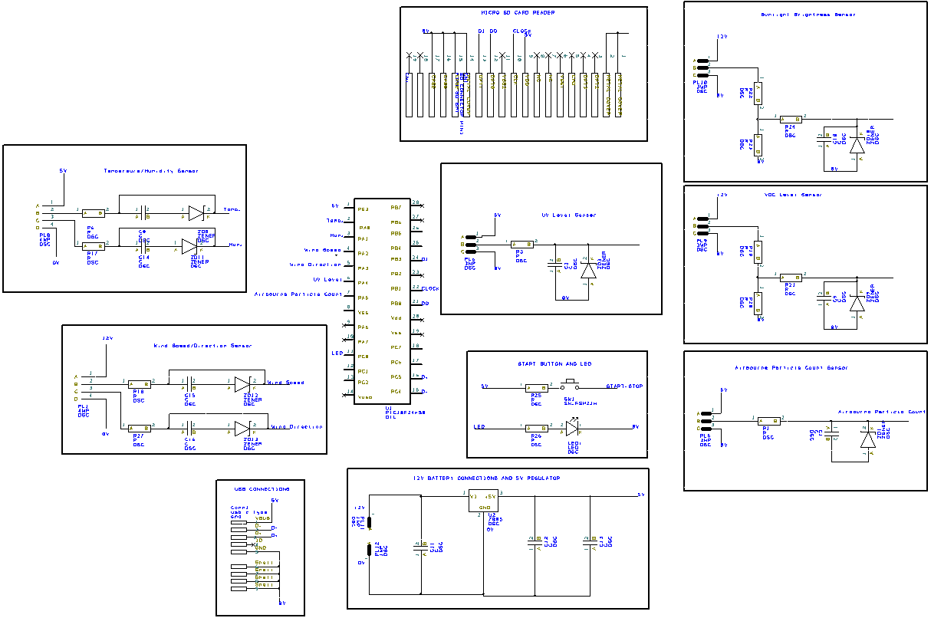

Table 10 - Total costs
Product | Cost | Number of | Total Cost
Temperature/humidity sensor | £43.97 | 1 | £43.97
Wind speed/direction sensor | £552 | 1 | £552
Airbourne particle sensor | £93.16 | 1 | £93.16
Sunlight brightness sensor | £40 | 1 | £40
UV sensor | £67 | 1 | £67
VOC level sensor | £284.61 | 1 | £284.61
GPS position sensor | £156 | 1 | £156
RS PRO cable mount connector (3 pin) | £26.53 | 5 | £132.65
RS PRO cable mount connector (4 pin) | £24.67 | 2 | £49.34
Peli 1200 Waterproof Plastic Equipment case | £109.07 | 1 | £109.07
ATP 16 GB industrial SD card | £65.05 | 1 | £65.05

Total cost of the prototypes designs = £1592.85

Shown below is figure 13 is the structure diagram. The sensors on the left of the structure diagram are supplied with 12 volts and the sensors on the right are supplied with 5 volts through a 7805 voltage regulator.
Figure 13 – Structure diagram
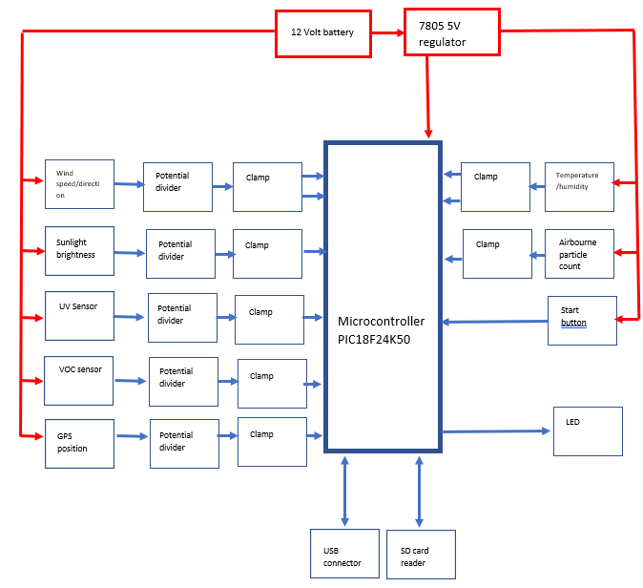

Proposed Improvements
After researching several different types of weather monitoring and recording systems, some improvements could be made to the prototype system that has been designed. These include:
- Renewable energy charging capability. This would be a major improvement to the prototype design. It would allow the system to be used for longer periods as the batteries would recharge. Solar panels and a wind turbine would allow the weather measurement system to recharge in most weather conditions.
- More variety of measurements. A more professional weather analyst would like more weather parameters to measure as seen in figure 4, the Spectrum WatchDog 3250 weather station. This weather station allows the measurement of evapotranspiration, leaf wetness, quantum light, rainfall, soil moisture and solar radiation.
- Electronic screen. The installation of an electronic screen in the prototype weather station would allow the user to monitor weather conditions in real time which would be useful.
- Bluetooth capability. Installing Bluetooth technology to the prototype weather station would be useful to the analyst as they could connect to their mobile device to monitor current weather and analyse weather trends

References
[1] Davis Vantage Pro2 Wireless Weather Station & WeatherLink Live Bundle 6122 UK | Weather Shop ® UK
[2] ACCUR8 DWS7100 7-in-1 Complete WiFi Weather Station With Light Intensity, UV Monitoring & Weather Alerts | Weather Shop ® UK
[3] Bresser 7002510 5-in-1 Complete Weather Station with Hi/Low Alerts | Weather Shop ® UK
[4] Spectrum WatchDog 3250 WiFi/Cellular Evapotranspiration (ET) Weather Station | Weather Shop ® UK
[5] HygroVUE10: Digital Temperature and Relative Humidity Sensor with... (campbellsci.com)
[6] EE181-L: Air Temperature and Relative Humidity Sensor (campbellsci.com)
[7] T9602-3-D-1 | Amphenol Advanced Sensors Temperature and Humidity Sensor, Analogue, Digital Output, Cable Mount, I2C, ±2% | RS (rs-online.com)
[8] HPP809A031 | TE Connectivity Temperature & Humidity Sensor, Voltage Output, Through Hole Mount, Analogue, ±5%RH | RS (rs-online.com)
[9] WSD-V Wind Speed & Direction Sensor - Voltage Output (measurementsystems.co.uk)
[10] WindSonic Solid State Wind Speed and Direction Sensor (omniinstruments.co.uk)
[11] Meteorological Sensor for Wind Speed and Direction (omniinstruments.co.uk)
[12] 05103-L: Wind Monitor (campbellsci.com)
[13] Airnet II Aerosol Particle Counter | EMS (emsparticlesolutions.co.uk)
[14] TERA Sensor Next-PM, Particle Matter / Dust Air Quality Sensor | RS (rs-online.com)
[15] Sensirion SEN50-SDN-T, Particle Matter / Dust Environment Sensor for Air Quality Monitors | RS (rs-online.com)
[16] Buy External Light Level Sensors (TPVLLO & TPLLO) | Titan Products
[17] ML-020S-O Lux Sensor (eko-instruments.com)
[18]ML-020S-I Lux Sensor (eko-instruments.com)
[19] UV Sensor by Davis Instruments
[20] uv sensor, ultraviolet rays sensor - Renke (renkeer.com)
[21] uv sensor, ultraviolet rays sensor - Renke (renkeer.com)
[22] AQDTF Duct Air Quality VOC Sensor (measurementsystems.co.uk)
[23] VOC Sensor - Titon UK
[24] BAPI VOC Duct and Harsh Environment Sensor - Tyrrell Products
[25] GPS 16xLVS | 010-00258-62 (starlite-intl.com)
[26] GPS160 - Positioning Sensor with NMEA 0183 Interface - Digital Yacht
[27] Garmin GPS 24xd GPS Receiver and Heading Sensor (force4.co.uk)
[28] PIC18(L)F2X/45K50 Product Brief (microchip.com)
[29] 1200-000-110E | Peli 1200 Waterproof Plastic Equipment case, 124 x 270 x 246mm | RS (rs-online.com)
[30] AF16GSD3A-WAAXM | ATP 16 GB Industrial SDHC SD Card, Class 10, UHS-1 U1 | RS (rs-online.com)
[31] RS PRO Cable Mount Connector, 3 Contacts, Plug and Socket | RS (rs-online.com)
[32] RS PRO Cable Mount Connector, 4 Contacts, Plug and Socket | RS (rs-online.com)

