Exam HRM in Context

Name: Denise Fitzsimmons
Student Number: 2007361
Word Count: 2,696
List of Abbreviations
HDUHB – Hywel Dda University Health board

Section 1
Question 1
When reviewing the value of long-term planning in organisations, it is essential to acknowledge that operating in an unstable environment, which was showcased in the case study, makes it necessary to consider having agile strategies to support organisational needs.
If the linear sequential view is considered with regards to long term planning, it emphasises the rational scientific nature that the strategic process needs to take (Farnham, 2015, p.135). However, a fixed strategy like this may not be capable of encompassing the long-term features of organisations (Mintzberg, 1994). According to Lynch (2012), emergent approaches consider people issues and analyse systems. When planning and setting a strategy, like in the case study, a 5-year cycle needs to have a certain level of malleability to operate in a VUCA environment (VUCA World, 2022). Using the emergent approach allows plans to develop the more that is learned about the strategic situation. This was shown in the case study with the development of the blogs and bulletins to help bolster and ‘pivot’ communication strategy.
Certain aspects of long-term planning can be beneficial; organisations will need to take on board techniques such as forecasting to predict the organisation’s needs and future workforce (Trapero, Kourentzes and Fildes, 2012). The value of long-term planning in organisations such as the NHS includes the ability to workforce plan, based on social needs, for example, ageing populations (ONS, 2019). HDUHB’s, a public sector NHS Healthcare provider, current workforce strategy is a ten-year plan based on a best practice model and Welsh Government strategy. There are limitations with people strategies based on best practice rather than best fit; they work on assuming that employers can take a long-term perspective of their businesses and continued market growth, which sometimes doesn’t encompass the required agility (Farnham, 2015, p.184).
External environments today require leaders that weren’t previously anticipated and being able to expose this potential is vital in the organisation’s long-term planning, and HR strategy has an integral part to play in this (Harvard Business Review , 2015b) , therefore, long term planning can be a good thing, but organisations need to showcase agility in long term strategy if they want to remain competitive.
Question 2
PESTLE analysis can help identify risks in the external environment and help create a future-focused organisational strategy (Engage365 , 2022). A PESTLE analysis may show the risks of political restrictions, like those seen in the case study, impacting delivery (CIPD, 2021b). However, as seen in the case study, unexpected change needs to be considered, for example, the changing needs of the workforce during lockdown restrictions. Therefore, in the circumstances like this, although it can be used to predict some risk and define strategy, it can lack agility and be oversimplified (PESTLE Analysis, 2022) . It is also challenging to use PESTLE in isolation as it does make assumptions about external trends, and at times, an evidence-based knowledge approach would be beneficial. In HDUHB, PESTLE is essential for establishing strategy; for example, social factors such as an ageing population would directly impact HR and organisational strategy in terms of labour market trends, policy and organisational design.
SWOT can also be beneficial when looking at organisational ad HR Strategies; for example, it can help understand business needs and address weaknesses to help capitalise on opportunities. This can be beneficial when looking at the internal factors and potential constraints like HR’s relationship with employees alongside the organisation’s finances, marketing and operations. For example, in Figure 1 below, the external SWOT factors can impact the organisation's policy and strategy.
Figure 1: HDUHB SWOT Analysis
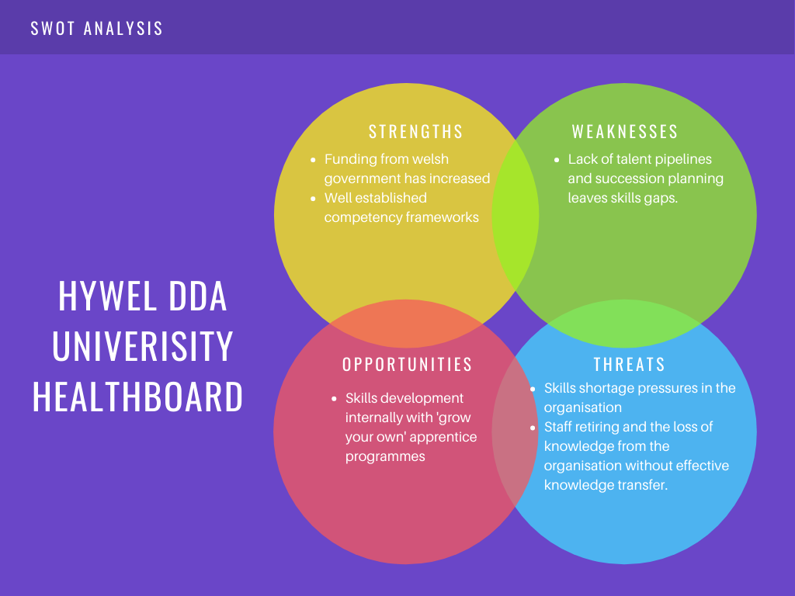
However, a SWOT analysis does not prioritise issues, and it can generate so many ideas that may vary in urgency or need. These methods must be considered when understanding the complexities of future trends and evaluating critical factors that may limit success. For example, if the case study is taken into consideration, internal communication and engagement may be considered a weakness that needs to be addressed. However, a SWOT analysis would not estimate the impact of not addressing this need or its overall importance. Organisations must react to present environments (Farnham, 2015, p.139 ). However, these methods help set organisation strategy. The Covid pandemic shows that these analyses must be updated regularly to ensure that they are agile enough to meet the organisation’s future needs.

Question 3
Some of the key points raised in the case study allude to how HR can become involved in an organisational support strategy during change, engage employees, communicate, and support diversity.
Skills such as a focus on performance a vital in the organisation when it comes to change. This could be seen in HDUHB during the start of the pandemic. HR strategy in the organisation had to mobilise so that it was at the forefront of communicating changes in government policy and organising deployment opportunities to ensure that the organisation could continue to perform.
Skills such as influencing and consulting with senior stakeholders and evaluating the power of interventions are essential, and being a true strategic partner is vital to supporting organisational change. As an employee advocate and a change agent, the below Ulrich model (see Figure 2) is critical for the HRM function (Farnham, 2015, p112). However, criticisms of this model suggest some issues with uptake in organisations as it is too rigid and doesn’t take onboard individual organisation needs (Reilly, P., 2006).
Figure 2: Ulrich Model (Manchester University , 2018)
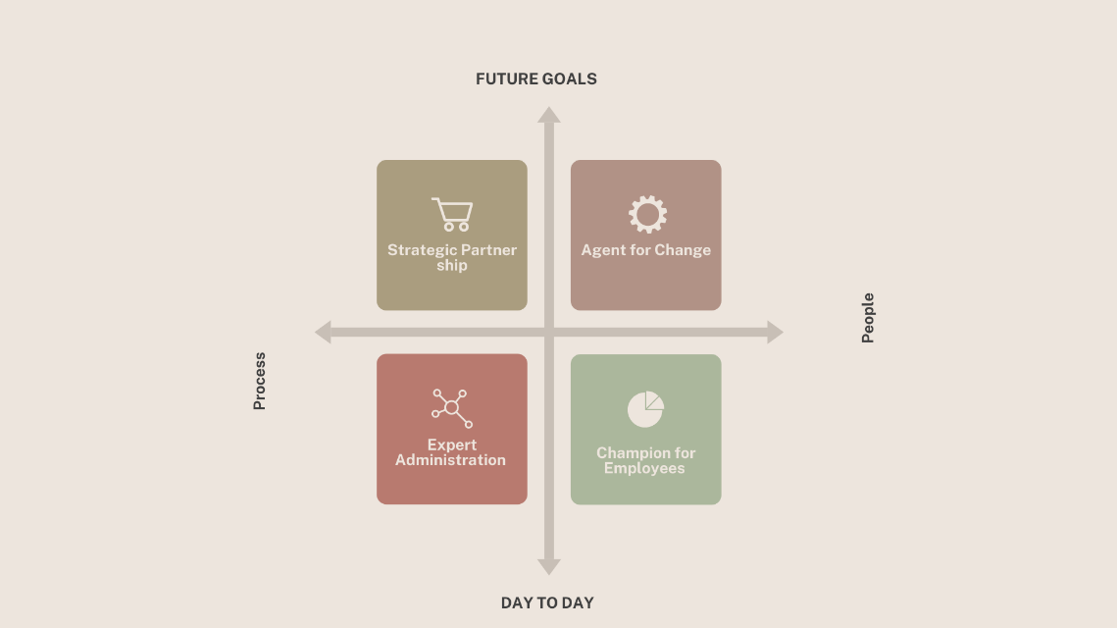

HR skills should include being positioned to give the organisation a competitive advantage, effecting change and ensuring agile practices. HR should also be able to offer cohesive solutions and make evidence-based decisions to ensure business success (CIPD, 2015).
Alternatively, if Mackinzes 7’s are taken into consideration, as seen in Figure 3, HR needs to position itself where it can influence the less tangible ‘soft skills’, which are usually influenced by culture. According to the CIPD (2015), HR should be organised to have an outside-in perspective; focusing on talent and practice is vital, aligning with the organisational structure model. HR is best positioned to support business strategy when it is partnered effectively (CIPD, 2021a)

Figure 3: McKinsey 7S Model (McKinsey and Company, 2008)
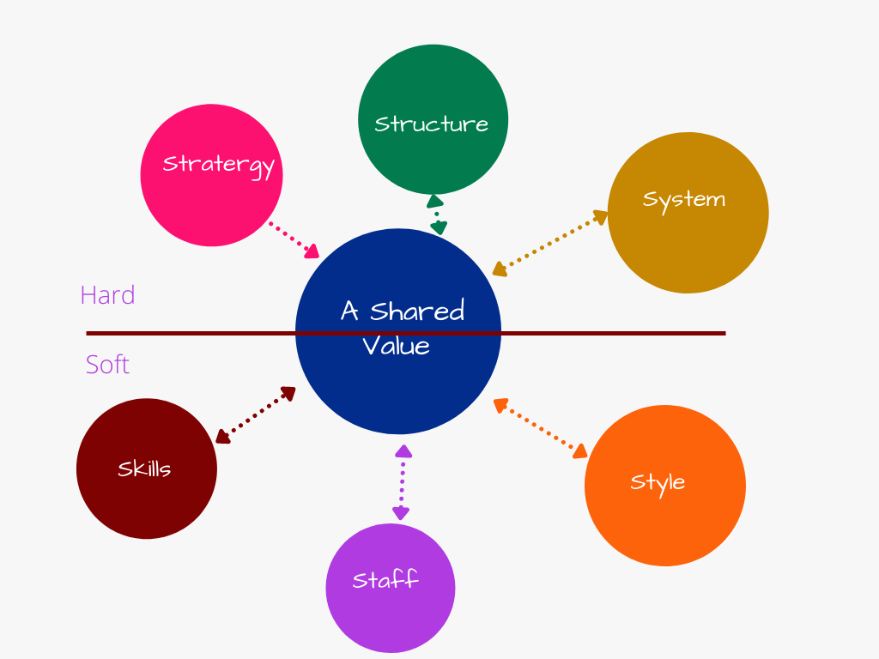
However, Lucy Adams suggests the EACH approach, which means that HR needs skills to treat employees as adults, consumers and human beings (Adams, 2017) to ensure that employees are engaged and motivated. In HDUHB, there has been a move away from the Ulrich model favouring Lucy Adam’s approach by introducing Relationship Managers rather than HR Business Partners. The inclusivity viewpoint in the case study also showcases the importance of diversity and inclusion in the workplace to support the idea that treating employees as individuals is vital for engagement.
At times of uncertainty, HR having vertical alignment and being positioned where they have access to the business strategy can help the organisation realise its potential and be better prepared to innovate (The HRD Masterclass Podcast, 2021). However, the horizontal approach is concerned with bundles of HR offerings. This can be beneficial, but HR needs to focus on how the initiatives and bundles could yield specific positives, such as an innovative approach to talent pools (Harvard Business Review, 2015a). Talent is an ongoing concern in organisations such as HDUHB due to talent shortages.
According to Young-Sam and Yonduk (2021), having a sustainable HR strategy helps create a competitive advantage by rejuvenating and evolving human resources. As shown in the case study, HR can be the most influential factor in employee satisfaction, and internal communication is vital in supporting strategy delivery during times of change. For example, improved communication through turbulent times helped raise engagement scores in Severn Trent to high levels, leading it to become an award-winning organisation.

Section 2
Question 2.1
b)
When looking at the external context, it is essential to consider Porter’s five forces analytical framework. These forces show the constraints that organisations face and the opportunities for responding to change, as seen below in Figure 4;
Figure 4: Porter 5 Forces Model (Harvard Business School, 2016)
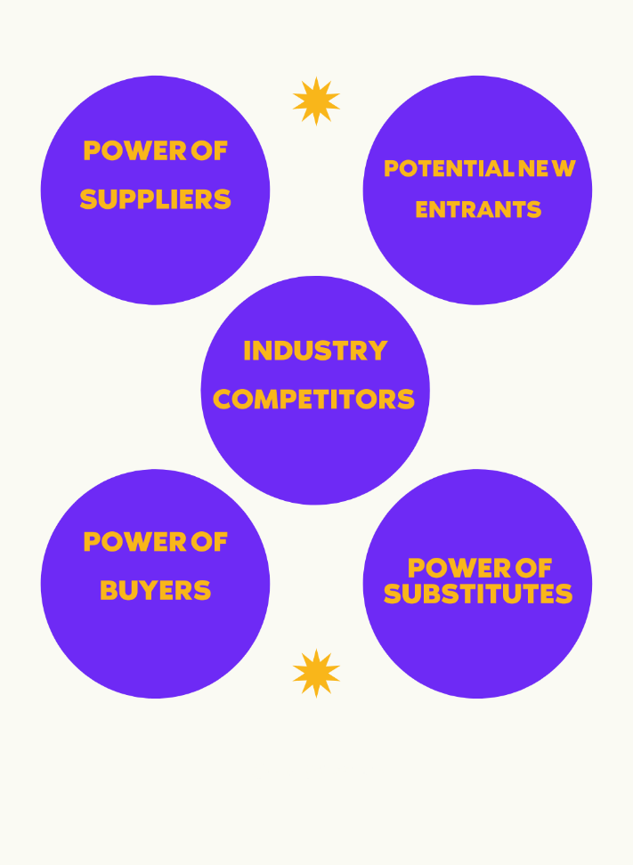
Regarding how this impacts recruitment and retention, new challenges in terms of rivalry between existing firms showcase the issues with recruiting in narrow talent pools. For example, the introduction of home and remote working has removed some restrictions around geography, creating more competition between companies that can offer remote working. In industries such as Healthcare, the elasticity of labour markets has impacted the need for retention; there is little elasticity in the doctors’ labour market, which has been reflected in HDUHB (The HRD Podcast, 2021). Although this model does illustrate the impact that external forces have, it does not consider the impact that government policy, for example, minimum wage requirements and law, including visa restrictions around immigration, can have on resourcing and talent planning in organisations (Goyal, 2020). For example, in 2019, 5,000 nurses left the NHS due to Brexit (The Guardian, 2019), these external factors have a substantial impact on recruitment and retention. A STEEPLE analysis may be a better way to reflect on external influences in these circumstances.
Other external factors, such as the hourglass model, should also be reviewed, as seen below in Figure 5.
Figure 5: Hourglass Model (HR Magazine, 2015)
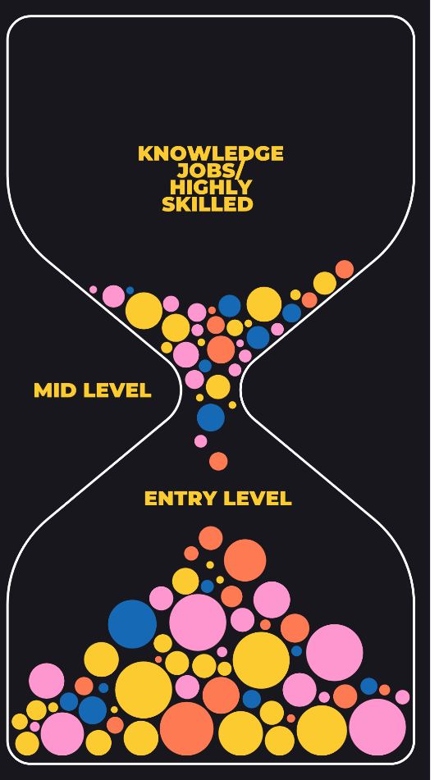

As we see this model increase, it is essential that HR influences organisations on what they can do in a cost of living crisis. External factors such as living wage need to be considered; going over and above government policy relating to flexible working and agile working can help resist the great resignation (BBC, 2021) and can help to alleviate some of the financial pressure being felt by those at the entry-level and support retention in HDUHB.
However, it is essential to consider that whilst these external forces and competitive markets for talent have a high impact, how organisations manage culture and engagement from within the organisation is vital.
With this argument in mind, taking account of the external markets can be as crucial as looking inwards at the organisation's internal resources. Taking the Resource-Based View of the Firm (Strategic Management Insight, 2021), developing talent at different leadership levels is essential for workforce planning and increases awareness of human capital risk. However, RBVF can have its limitations. Even the most thought out HR policies do not always equate to positive recruitment and performance. Other factors such as poor culture and behaviour in the organisation can erode the competitive advantage.
In summary, taking different approaches to how organisations assess external factors is essential. However, it is also necessary to consider the culture and the internal factors in the organisation and the risk of attrition and high turnover.

Question 2.2
b)
The broad definition of culture is the concepts, practices, and behaviour of a group or society (CIPD, 2020). Inclusivity is defined as including all individuals and ideas and supporting them fairly and equitably (ACC, 2022). Supporting diversity and equality in an organisation is a significant factor when considering inclusion.
Inclusive, strong cultural identity ensures that all employees understand their value. Conversely, weaker cultures can cause an increase in turnover, impact employee engagement and lead to poor performance (Forbes , 2019)
According to research, inclusive cultures are not just morally right; organisations that prioritise inclusion are twice as likely to exceed financial targets and more likely to exceed performance targets, have increased agility and have better innovation (Forbes, 2020) . Therefore, inclusive culture is vital for employee engagement, performance and financial success.
For example, organisations such as L’Oreal, an MNC, are present in 130 countries. They invest heavily in diversity and inclusion and offer training around this subject for its employees across the globe (L'Oreal, 2022). Investment such as this could help the organisation become an employer of choice. In times of turbulence, negative publicity or discrimination claims can negatively impact (Farnham, 2015, p318). The risk of not supporting diversity and inclusion can be high, but some organisations still fail to prioritise inclusive cultures. For example, studies show that in 350 FTSE companies surveyed, only 15 of the directors are people of colour (The Parker Review Committee, 2020), which illustrates the work that needs to be done regarding diversity and inclusion in the workplace.
It can also be argued that without inclusion, which requires commitment, changing processes, and enabling people to do things differently, diversity on its own, with no inclusion, will be unlikely to work. Recruitment without an inclusive environment will lead to high levels of turnover.
Organisations can make themselves more open and inclusive by focusing on equal opportunities in the workplace and ensuring that, as a minimum, the organisation adheres to the Equality Act (2010).
Recommendations could include staff training on inclusion and diversity. Organisations need to consider flexible working policies that include the potential of job shares or homeworking, to be inclusive of working parents or those with caring responsibilities. The CIPD (2018) endorses recommendations such as reviewing recruitment processes to ensure that hiring managers encompass reasonable adjustments and gathering employee data on inclusivity to see how individuals perceive the organisation’s culture.

Question 2.3
b)
When reviewing the business case relating to going above and beyond regarding environmental legislation, it is impossible not to examine the impact of globalisation and global markets. The current government legislation around the Environment Act (2021) suggests that there are fines for organisations that do not adhere; however, there are targets and restrictions relating to waste and resource use which are likely to become scarcer in the future.
For example, the war in Ukraine has created issues with market supply that have caused a rise in cost factors. Relying on renewable energies or electric cars would help support this in these circumstances. In HDUHB, pool cars and fleet vehicles are fuelled with fossil fuels, and an increase in these costs can impact finances. Research estimates that the NHS spends £500 million per year on energy costs (Energy Management LLP, 2019), which is only set to increase with shortages and cost of production; for this reason, switching to renewable energies such as solar is not only environmentally friendly, it’s a cost-saving measure.
The organisation is also at risk of the adverse effects of market failure because of market instability and the problems that arise from hyper-competition due to uncertain market changes and price wars over scarce fuel reserves. Looking at greener, renewable methods of energy generation alleviates some of the pressures and assists with business continuity (Farnham, 2015, p.245).
Some theories also suggest that markets are beginning to turn inwards, and countries like China are not exporting in the volumes they once were. This may also indicate the end of hyper globalisation (Exchanges at Goldman Sachs, 2022). Focusing on switching to renewable or less wasteful manufacturing decreases the need to look to other countries for energy supply. There is also a movement toward a circular rather than a linear economy where products and resources are reused (The World Economic Forum , 2022). There is an argument that due to global instability, the break up of globalisation, finite resources and issues with material value chains, organisations will need to consider changes to how they source materials to ensure that they are future proof. For example, more environmentally friendly PPE or biodegradable PPE would help with waste management costs, support the environment, and reduce reliance on external overseas markets in HDUHB.
It is also essential to consider that to remain competitive in markets; organisations will need to go above and beyond when it comes to their environmental impact; consumers and employees are more conscious of environmental factors. For example, negative press around the pollution relating to the fashion industry may dissuade consumers from purchasing ‘unethical, fast fashion’ (The Ethical Consumer, 2021). This can also be seen in HDUHB, where employees may not consider the organisation an employer of choice due to ineffective and environmentally wasteful practices. Encouraging homeworking, for example, can help cut costs and pollution. According to the CIPD, green practices can make the organisation an employer of choice (2021c).
Despite the initial implementation costs, this can be viewed as a long term solution for organisations such as HDUHB; along with increasing pressures from external markets, employees and consumers are more aware of environmental issues and that it is not just a moral obligation but it can have a substantial cost-saving impact.

References
- ACC (2022) Equity, Diversity, and Inclusion: What is Inclusion?
Available at: https://researchguides.austincc.edu/c.php?g=522627&p=7624731
(Accessed 18 May 2022)
- Adams, L. (2017) HR Disrupted. 1st edn. Practical Inspiration Publishing.
- BBC (2021) The Great Resignation: How employers drove workers to quit.
Available at: https://www.bbc.com/worklife/article/20210629-the-great-resignation-how-employers-drove-workers-to-quit
(Accessed 18 May 2022)
- Younsam, C. and Yongduk, C. (2021) 'When and How Does Sustainable HRM Improve Customer Orientation of Frontline Employees? Satisfaction, Empowerment, and Communication'. Sustainability, Volume 13, pp. 1-14.
- CIPD (2015) Changing HR operating models.
Available at: https://www.cipd.co.uk/knowledge/strategy/hr/operating-models
(Accessed 18 May 2022)
- CIPD (2018) Diversity and Inclusion in the Workplace.
Available at: https://www.cipd.co.uk/Images/diversity-and-inclusion-at-work_2018-summary_tcm18-44150.pdf
(Accessed 18 May 2022)
- CIPD (2020) Organisational culture and cultural change.
Available at: https://www.cipd.co.uk/knowledge/culture/working-environment/organisation-culture-change-factsheet
(Accessed 18 May 2022)
- CIPD (2021a) Strategic human resource management.
Available at: https://www.cipd.co.uk/knowledge/strategy/hr/strategic-hrm-factsheet
(Accessed 18 May 2022)
- CIPD (2021b) PESTLE analysis.
Available at: https://www.cipd.co.uk/knowledge/strategy/organisational-development/pestle-analysis-factsheet
(Accessed 11 January 2022)
- CIPD (2021c) Embedding Environmental Sustainability in your Organisation: A Guide for HR Professionals. [Online]
Available at: https://www.cipd.co.uk/Images/sustainability-guide_tcm18-98576.pdf
[Accessed 18 May 2022].
- Energy Management LLP (2019) NHS energy spends estimated to be £500m.
Available at: https://www.energymanagementltd.com/news/nhs-energy-spend-estimated-to-be-500m/
(Accessed 18 May 2022)
- Engage365 (2022) SWOT Analysis: Internal and External Environment.
Available at: https://engage365.org/swot-analysis-internal-and-external-environment/
(Accessed 12 January 2022)
- Equality Act 2010 Available at: https://www.gov.uk/guidance/equality-act-2010-guidance. (Accessed 18 May 2022)
- Exchanges at Goldman Sachs (2022) Is (De)Globalisation Ahead? [Podcast] Available at: htt ps://www.goldmansachs.com/insights/podcasts/episodes/05-10-22-posen-rodrik-oneill.html (Accessed 17 May 2022)
- Farnham, D. (2012) Developing Corporate Strategies. In: Human Resource Management in Context. 5 ed. London: Kogan Page,
- Forbes (2019) Four Steps To Create A Truly Inclusive Culture.
Available at: https://www.forbes.com/sites/shereeatcheson/2019/06/06/four-steps-to-create-a-truly-inclusive-culture/?sh=77d4e1201173
(Accessed 18 May 2022)
- Forbes (2020) Five Major Benefits Of Increasing Diversity & Inclusion In Your Organization.
Available at: https://www.forbes.com/sites/forbescoachescouncil/2020/10/12/five-major-benefits-of-increasing-diversity--inclusion-in-your-organization/?sh=376aeb656f71
(Accessed 18 May 2022)
- Goyal, A (2020) A Critical Analysis of Porter's 5 Forces Model of Competitive Advantage. Journal of Emerging Technologies and Innovative Research 7(7), 149-152.
- Harvard Business Review (2015a) Bright, Shiny Objects and the Future of HR
Available at: https://hbr.org/2015/07/bright-shiny-objects-and-the-future-of-hr
(Accessed 18 May 2022)
- Harvard Business Review (2015b) People Before Strategy: A New Role for the CHRO.
Available at: https://hbr.org/2015/07/people-before-strategy-a-new-role-for-the-chro?registration=success
(Accessed 16 May 2022)
- Harvard Business School (2016) The Five Forces.
Available at: https://www.isc.hbs.edu/strategy/business-strategy/Pages/the-five-forces.aspx
(Accessed 18 May 2022)
- HR Magazine (2015) Job quality in an hourglass labour market.
Available at: https://www.hrmagazine.co.uk/content/features/job-quality-in-an-hourglass-labour-market
(Accessed 18 May 2022)
- Trapero,J.R, Kourentzes, N. and Fildes, R. (2012) 'Impact of information exchange on supplier forecasting performance' Omega, 40(6), pp. 738-747.
- L'Oreal (2022) Promoting Diversity, Equity & Inclusion.
Available at: https://www.loreal.com/en/commitments-and-responsibilities/for-the-people/promoting-diversity-and-inclusion/
(Accessed 18 May 2022)
- Lynch, R. (2012) Strategic Management. 6 edn. Harlow Pearson.
- Manchester University (2018) Ulrich Model.
Available at: http://blog.gdi.manchester.ac.uk/3918-2/ulrich-model/
(Accessed 18 May 2022)
- McKinsey and Company (2008) Enduring Ideas: The 7-S Framework.
Available at: https://www.mckinsey.com/business-functions/strategy-and-corporate-finance/our-insights/enduring-ideas-the-7-s-framework#
(Accessed 18 May 2022)
- Mintzberg, H. (1994) The Rise and Fall of Strategic Planning. London: Prentice-Hall.
- ONS (2019)Old age structure variant - UK population in age groups.
Available at: https://www.ons.gov.uk/peoplepopulationandcommunity/birthsdeathsandmarriages/ageing
(Accessed 18 May 2022)
- PESTLE Analysis (2022) 6 Frustrating Disadvantages of PESTLE Analysis.
Available at: https://pestleanalysis.com/disadvantages-of-pestle-analysis/
(Accessed 24 March 2022)
- Short, D. (2021) 'Strategic HRD' The HRD Masterclass. [Podcast]. Available at: https://open.spotify.com/show/17FNutoiq4iQ2WcmO6KuGT.
(Accessed 17 May 2022)
- Reilly, P. (2006) 'HR Transformation - Pitfalls of the Ulrich model' People Management, p. 36.
- Strategic Management Insight (2021) Resource-Based View.
Available at: https://strategicmanagementinsight.com/tools/resource-based-view/
(Accessed 18 May 2022)
- The Environment Act 2021 Available at: https://www.legislation.gov.uk/ukpga/2021/30/contents/enacted. (Accessed 17 May 2022)
- The Ethical Consumer (2021) What is fast fashion, and why is it a problem?
Available at: https://www.ethicalconsumer.org/fashion-clothing/what-fast-fashion-why-it-problem
[Accessed 18 May 2022].
- The Guardian (2019) NHS nursing crisis worsened by Brexit exodus.
Available at: https://www.theguardian.com/society/2019/may/08/nhs-nursing-crisis-worsened-by-brexit-exodus
(Accessed 18 May 2022)
- The Parker Review Committee (2020) Ethnic Diversity Enriching Business Leadership, Available at: h ttps://assets.ey.com/content/dam/ey-sites/ey-com/en_uk/topics/diversity/ey-what-the-parker-review-tells-us-about-boardroom-diversity.pdf (Accessed 18 May 2022)
- The World Economic Forum (2022) Circular Economy and Material Value Chains.
Available at: https://www.weforum.org/projects/circular-economy
(Accessed 18 May 2022)
- VUCA World (2022) Leadership Skills and Strategies: VUCA World.
Available at: https://www.vuca-world.org/
(Accessed 11 January 2022)

