BMIH5003 Cultural awareness

Hotel Handbook for Intercultural Competence

Student name- Mihaela Buzdugan 2121942
Tutor: Rodrigo Fernandes Aguilera

Executive Summary
This report, produced for the St. Martin's Lane Hotel in London, emphasized the need for cultural knowledge as well as the problems of international communication. The study's major emphasis has been the variations in communication and cultural behaviour discovered between Japanese hosts and their overseas visitors. The report also lists the hotel department that responded to the visitor's needs.
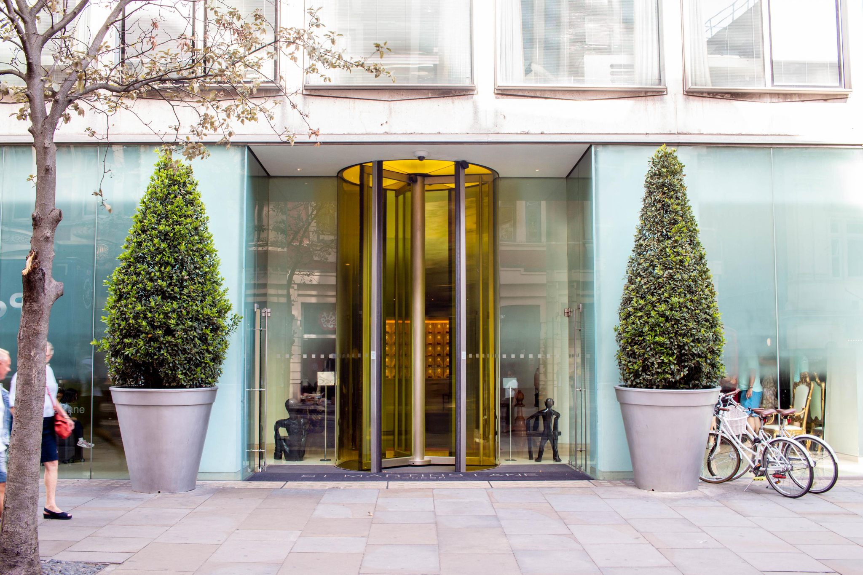
Source: https://book.ennismore.com/hotels/originals/st-martins-lane

Table of Contents
Executive Summary 2
Introduction 4
Cultural Intelligence and Sensitivity 5
Importance of Cultural Intelligence & Sensitivity 5
Guests' Experience with the Service 5
Theory of cultural aspects by Hofstede 6
DO’s and DON'Ts for hotel workers 7
Prioritizing the preferences of guests from Japan 7
Summary 8
Recommendations 8
Conclusion 9
References 10

Introduction
On a global scale, the hotel sector is growing increasingly competitive, and one of the challenges that operators confront is effectively communicating with consumers who speak languages other than their own. The study will provide material that will throw light on the importance of cultural knowledge and sensitivity. Moreover, we will illustrate how Hofstede's theory's cultural hurdles and dos and don'ts might affect a visitor's experience while staying in a hotel. The research will explain how to prioritize the criteria of Japanese visitors in significance.

Cultural Intelligence and Sensitivity

Importance of Cultural Intelligence & Sensitivity
To maintain a competitive edge in today's hotel industry, managers might shift their attention to boosting visitor happiness and expanding offerings. When hotel staff members prioritize cultural knowledge, they boost the property's standing in the community. At the same time, technology may help strengthen ties between nations and facilitate better communication between people. With the help of cultural awareness, hotel staff and guests may better understand one another and tailor their interactions to each guest's needs (Sonawane, 2020).

Guests' Experience with the Service
The personnel at the hotel have been given training in cultural sensitivity and are aware of the special expectations that are put on them by the hotel's Japanese clientele. This ensures that customers will receive the greatest service possible from hotel staff members who appreciate the significance of respect and decency in Japanese culture (Oriade et al., 2021).
It is essential to have a Japanese-speaking staff as well as a variety of amenities traditionally associated with Japan, such as tea sets and menus written in Japanese. Moreover, the hotel is required to make a determined effort to meet the needs of its Japanese customers. Finally, the hotel should focus the bulk of its marketing and promotion efforts on the Japanese market, since this will improve the possibility that Japanese guests will choose to stay there (Nazarian et al., 2022).
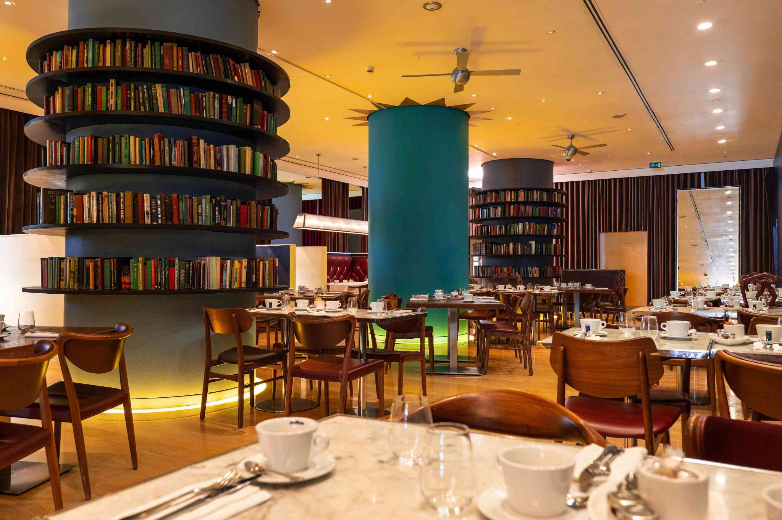
Source: https://book.ennismore.com/hotels/originals/st-martins-lane

Theory of cultural aspects by Hofstede

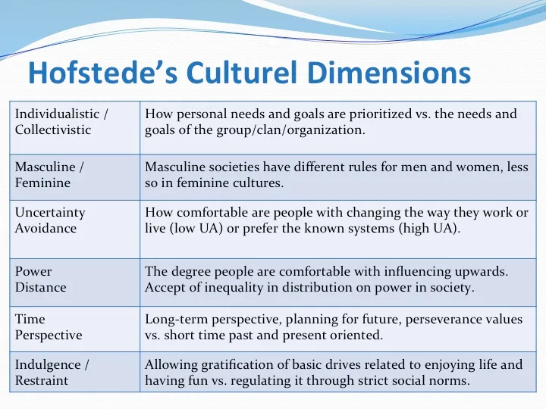
Source: https://eslkevin.wordpress.com/tag/hofstedes-cultural-dimensions-theory-from-wikipedia/

DO’s and DON'Ts for hotel workers
- Individuals are required to carry out their tasks following the hotel's rules and regulations.
- While dealing with employees or customers, always maintain a professional and pleasant demeanour (Ndiuini and Baum, 2021).
- Please respond to their guest's query in the quickest time possible.
- Act quickly when paged and continue in a logical way to meet the client's expectations.
- Both visitors and staff members should be treated with respect and courtesy at all times.
- Depending on the time of day, hotel staff should welcome their guest with "Good Morning," "Good Afternoon," "Good Evening," or "Sir/Madam" (if possible by using the name).
- Please come 15 minutes before the start of their next shift.
- They ask that they always have a neat and organized appearance while working at the hotel and wearing their uniform.
- Do not stand in a slouched stance or lean against walls or corners when aiding customers (Escandon-Barbosa et al., 2022).
- Hotel staff should not be afraid to disclose any concerns, disputed activity, or discrepancies they discover to their Supervisor or Assistant Manager. Before they begin cleaning the guest room, turn off the radio and television.
- Note that they may only use their phone in public places. They should never make personal phone calls when staying in a hotel room.
- It is critical to organize and file any old newspapers, magazines, and visitor supplies (Afsar et al., 2019).

Prioritizing the preferences of guests from Japan
A typical Japanese handshake involves minimal to no eye contact between the participants. Some Japanese people will bow even when shaking hands with another person. The Japanese bow is a well-known and often-used display of respect (Hossain et al., 2022). The general populations of five prefectures were chosen at random and asked to offer input on their different healthcare systems' health, health inequality, responsiveness, responsiveness inequality, and fair funding objectives. The goal of this study was to look at the relationships between various demographic parameters and respondents' perceptions of the healthcare system's goals using multinomial logistic regression analysis (Marinakou and Giousmpasoglou, 2019). Omotenashi, meaning "the method of hospitality," is an important component of Japanese culture. Being hospitable entails paying great attention to the needs of their guests or customers so that may alter their service to meet their needs (Huang and Crotts, 2019).

Summary
The St. Martin's Lane Hotel in London highlighted the need of being attentive to the cultures of others, as well as the difficulty in creating effective channels of communication across national boundaries. Visitors' Points of Perspective Concerning the Service Visitors from Japan may be certain that the London St. Martin's Lane Hotel will provide a warm and inviting atmosphere during their stay (Chou et al., 2019).

Recommendations
- Keep order in both their room and their workstation. Maintain a clean and organized workspace, and always utilize sanitized devices.
- Let them have a half-hour break between meals. Let them eat all of their meals in the employer-provided cafeteria (Abo-Murad et al., 2019).
- Workers must sign in and out on the attendance sheet when they enter and depart the premises. Even if they are permitted to take food breaks, they must still complete the attendance sheet. Unless otherwise directed by the Supervisor, perform all responsibilities entirely within the assigned area (Hultman et al., 2021).

Conclusion
This was concluded from the above report that during a survey of Japanese visitors staying at the St. Martin's Lane Hotel, it was determined that the vast majority of hotel guests were satisfied with the quality of service they received. Nonetheless, a better degree of cultural understanding on the side of the employees would have enhanced the Japanese guests' experience. The most major difficulty was the language barrier, which made it difficult for Japanese visitors to converse with the employees. Moreover, the study's results revealed that the front desk employees, concierge, and housekeeping staff were the most helpful components of the hotel. This research emphasized the need of training employees about the numerous cultural variations that exist and how to utilize that knowledge to give greater service to customers from other countries.

References
- Abo-Murad, M., Abdullah, A.K. and Jamil, R., (2019). Effect of the organisational culture on crisis management in the hotel industry: A qualitative exploration. International Journal of Entrepreneurship, 23(2), pp.1-18.
- Afsar, B., Shahjehan, A., Shah, S.I. and Wajid, A., (2019). The mediating role of transformational leadership in the relationship between cultural intelligence and employee voice behaviour: A case of hotel employees. International Journal of Intercultural Relations, 69, pp.66-75.
- Chou, T.Y. and Liu, A.C., (2019). ANALYZING THE CUSTOMER-PERCEIVED VALUE OF CULTURAL AND CREATIVE HOTELS. International Journal of Organizational Innovation, 11(4).
- Escandon-Barbosa, D., Ramirez, A. and Salas-Paramo, J., (2022). The Effect of Cultural Orientations on Country Innovation Performance: Hofstede Cultural Dimensions Revisited?. Sustainability, 14(10), p.5851.
- Hossain, M.S., Hussain, K., Kannan, S. and Kunju Raman Nair, S.K., (2022). Determinants of sustainable competitive advantage from resource-based view: implications for the hotel industry. Journal of Hospitality and Tourism Insights, 5(1), pp.79-98.
- Huang, S.S. and Crotts, J., (2019). Relationships between Hofstede's cultural dimensions and tourist satisfaction: A cross-country cross-sample examination. Tourism management, 72, pp.232-241.
- Hultman, M., Papadopoulou, C., Oghazi, P. and Opoku, R., (2021). Branding the hotel industry: The effect of step-up versus step-down brand extensions. Journal of business research, 124, pp.560-570.
- Marinakou, E. and Giousmpasoglou, C., (2019). Talent management and retention strategies in luxury hotels: evidence from four countries. International Journal of Contemporary Hospitality Management.
- Nazarian, A., Zaeri, E., Foroudi, P., Afrouzi, A.R. and Atkinson, P., (2022). Cultural perceptions of ethical leadership and its effect on the intention to leave in the independent hotel industry. International Journal of Contemporary Hospitality Management, 34(1), pp.430-455.
- Ndiuini, A. and Baum, T., (2021). Underemployment and lived experiences of migrant workers in the hotel industry: policy and industry implications. Journal of Policy Research in Tourism, Leisure and Events, 13(1), pp.36-58.
- Oriade, A., Osinaike, A., Aduhene, K. and Wang, Y., (2021). Sustainability awareness, management practices, and organizational culture in hotels: Evidence from developing countries. International Journal of Hospitality Management, 92, p.102699.
- Sonawane, U., (2020). The Impact of Customers' Expectations on Cross-cultural Marketing in the Hotel Hospitality Industry: A Comparative Study of the UK and India (Doctoral dissertation, Cardiff Metropolitan University).

