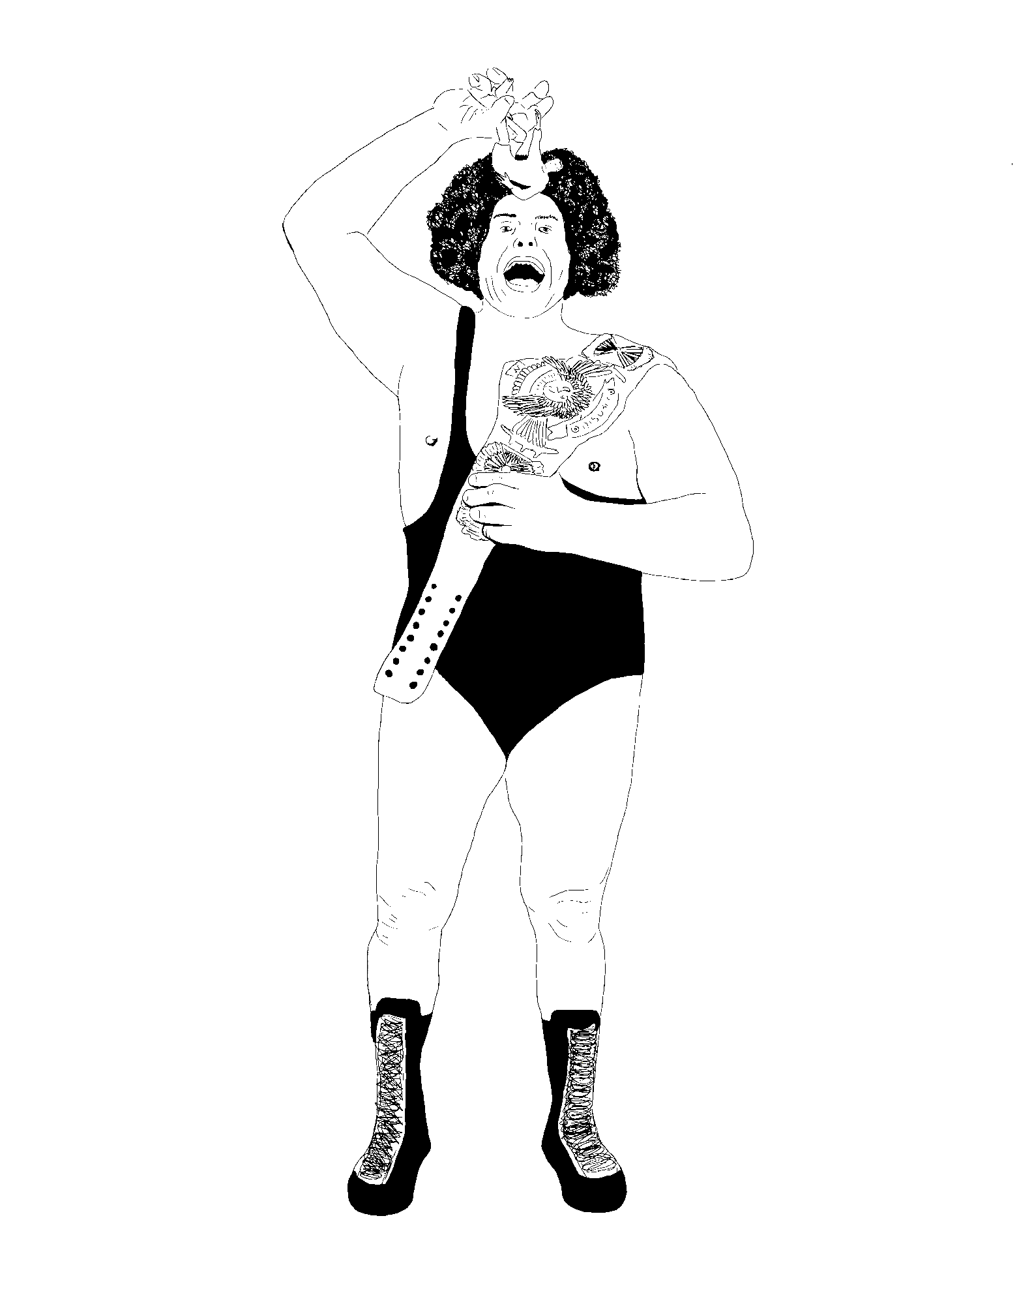
Can Professional Wrestling transfer itself from one social confine to another and become universally accepted as an art form?

Name: Andrew Bowen
Student No. - P127506
Course – Fine Art: Studio, Site and Context
Word Count: 6,457
Tutor: Alex Duncan
Acknowledgements
To Gabby, for your overwhelming support, financially and emotionally through my artistic endeavour. I love you.
To Mum and Dad, for the constant love you give when at times I don’t deserve it, and for the role models you provide me, driven to the point of frustration.
To my artistic peer group, for sharing the pain of a large written assignment on a course dominated (preferably so) by practical work. Well done guys, we did it!
To my lecturers, for challenging me at every turn, forcing me to explore facets of practice outside my comfort zone, it is artists like yourselves that I hope to become.
To my dudes, for consistently explaining to me that I’m going to ‘smash it’ in regards to my independent enquiry (and occasionally providing me with coffee).
To Alex, for having faith in my ability and allowing me to develop my enquiry as I deemed fit, while simultaneously providing me with invaluable nuggets of information.
To professional wrestlers worldwide, who sacrifice so much, putting their bodies on the line for my entertainment.
Abstract
This independent enquiry is a study of professional wrestling within the parameters of an artistic pursuit. Specifically looked at are the differentiations between high and low culture and where this pseudo-sport lies in relation to these perceived differences.
A brief but detailed exploration of gender, nationality, race and sexuality within the world of pro-wrestling is evident, alongside an inquiry of the perceived ideal body image in correlation with sculptural artistic practice.
Wrestling’s portrayal within the visual arts spectrum is researched through the works of contemporary and traditional practitioners, and used to draw comparisons between both fields of study.
Lastly, the fields of performative based artistic endeavour are examined and contextualised in association with professional wrestling and a conclusion is brought justifying the phrase: professional wrestling is art.

Contents
- Introduction (p.5 – p.9)
- High and Low (p.10 - p.11)
- Differentiating Between High and Low Art (p.12 - p.14)
- Sculpture (p.15 - p.16)
- Adonis Complex (p.17 – p.18)
- Wrestling Culture (p.19 – p.22)
- Switching Between art Cultures (p.23 – p.26)
- Pop Art (p.27 – p.30)
- Wrestling’s Representation in Visual Art (p.31 – p.34)
- Performance art (p.35 – p.38)
- Art in Action (p.39 – p.44)
- Conclusion (p.45 – p.47)
- Reference list (p.48 – p.52)
- Appendix (p.53 – p.67)
- List of Illustrations (p.68 – p.72)
- Further Reading, Listening and Watching (p.73 – p.74)

Introduction

There is no more a problem of truth in wrestling than in theatre. In both, what is expected is the ineligible representation of moral situations which are usually private. This emptying out of interiority to the benefit of exterior signs, this exhaustion of the content by the form, is the very principle of triumphant classical art.
(Barthes, 1972)

Professional Wrestling is experiencing a global renaissance which is evident through the recent addition of four new televised hours of weekly wrestling content commissioned by media powerhouses. This resurgence is largely due to a cross pollination of different styles; Mexican Lucha-Libre, Japanese Puroresu, American sports entertainment and British catch-as-catch-can. They come together to create a global dialect that breaks the boundaries of language. In a world in which the President of the U.S.A. is featured in a professional wrestling hall of fame, it is impossible to ignore wrestling's place in our society and the platform it has, that reaches billions of homes worldwide through television and internet streams, reflecting on the struggles of its audience through nationality, race, sexuality, gender and class. It is a platform that creates an escape from a current state of fear- mongering global politics by offering storylines of good vs evil that, over the course of a story arc, will always result in the ‘face’ (good guy) over-coming insurmountable odds and prevailing over his/her evil ‘heel’ (bad guy), thus giving us heroes to root for and villains to distain, distrust and dislike (Wrestlers, 2019). These storylines are played out on a weekly basis, consistently and constantly, like a soap opera. Indeed, the longest running episodic television show in recorded history is run by the largest wrestling promotion in the world, World Wrestling Entertainment (WWE).

Professional wrestling is a hotbed of mismatched influences; it is considered by some to be neither theatre nor sport, yet also both at the same time; meaning that it has had a tendency of being prejudged and placed in a category of its own. It must be stated that the similarities with art are evident (see personal creative writing in appendix i). Over generations cultures from around the world have developed their own individual style, the ring in which the story arc is performed is called a canvas, the plot is rehearsed, adapted, rehearsed again until the dance battle is perfected, the wrestlers suit up in costumes and make-up to evoke emotions ranging from hope to despair, creating a narrative as heart-stirring as any other artistic movement or discipline.

The best kind of professional wrestling aspires to take you on an emotional journey, to thrill you when an underdog triumphs. To resonate with you deeply when one tag team partner betrays another. It engages you in the chance for glory and drags you through the valley of defeat. It even grants you access to that most intimate of moments, when someone’s life-long dream is fulfilled.
(Quackenbush, 2015)

Wrestler's bodies are so muscularly sculpted and the ring positioned at eye level, that comparisons can be made between Michelangelo's marble masterpieces set upon plinths; both project an unobtainable body image that could suggest that the performers themselves might suffer from an Adonis complex.

This Independent Inquiry will build a case that professional wrestling should be classed as art - mentioned in the same breath as ballet, figure skating and graphic novels. The study will argue that the performer is the wrestler who tells stories, the canvas is the stage in which these stories are played out. And that if Shakespeare’s ‘Hamlet’ was Michelangelo’s ‘David’, then New Japan Pro-Wrestling’s ‘Omega vs Okada’ is one of Jeff Coon’s metallic balloons (see comparisons in appendix ii).

The study will reflect on the works of renown visual artists of exemplary standing that have created works of art regarding the hard-hitting subject of professional wrestling, while researching live performance art to explore the potential similarities and differences.

A brief look at the notion that professional wrestling should be classed as a sport will be undertaken, while also covering the age-old stereotype of the in-ring action sequences being ‘fake’. Gender and racial inequality, along with national stereotyping and body dysmorphia will also be viewed through the lens of the professional wrestling industry.

This study is not an argument that professional wrestling should be displayed in the Louvre or Tate, but that it should be given similar standing to artistic styles such as graffiti, advertising and pop-art; forms of art that are depicted by critics to be deemed as ‘low’ culture. The discussion begins, not with professional wrestling at all but rather with modern art and popular culture - a place in which I believe professional wrestling belongs. To understand this, we must first discuss the perceived differences between both high-art and low-art, or rather, high-culture and low-culture and its fluidity in the modern day.

High and Low

“Culture is one of the two or three most complicated words in the English language” (Williams, 1976, p.87). What is it that differentiates ‘high’ and ‘low’ culture and art? High art is traditionally reserved for the upper-class societies, who tend to be well educated and financially well off. It is the type of art that, without formal education, many may find difficult to comprehend. Low art is perceived as the opposite - made for the many and not for the elite; easily comprehendible to the lower, traditionally less educated classes.

As we advance in time, separation of knowledge between classes is diminishing due to social and technological advancement and more accessible further and higher education. In doing so, the lines between high and low have blurred. When speaking of ‘high’ and ‘low’ art, we must also speak of ‘high’ and ‘low’ culture as both stand side by side in meaning and definition. Just as time and social advancement is changing the education accessibility of the masses, it is also mutating the definition of the complex word ‘culture’ (The refined understanding of the arts and other human intellectual achievement. (Oxford Popular English Dictionary, 1998)).
Originally a synonym of civilisation, over time its uses and definition have changed, developing the word to become what we currently know. Herder, one of the many historians to have manipulated the words usage, argued that culture should be spoken of in the plural: “the specific and variable cultures of different nations and periods, but also the specific and variable cultures of social and economic groups within a nation” (Williams, 1976, p.89). It was this argument, among others, that helped remove the term culture from the term civilisation.

More recently, and through modern abstraction, this noun has become a description of intellectual and artistic works and practices. To add further complexity to the word's meaning, it now includes artistic activity referring to a plethora of art forms. These modern developments have allowed for the noun ‘culture’ to be used as a way of creating distinctions between high art and low art and used as a means in which superior knowledge is claimed, allowing for usage of the phrase to create hostility. (Williams, 1976).
Differentiating Between High and Low Art

An example of low art would be the Marvel Universe - an extremely popular series of comic books/ graphic novels created by renown illustrators and writers such as Jack Kirby and Stan Lee and include characters such as Spiderman, Ironman and Captain America. It is easily accessible to all regardless of class, income, gender or academic ability. These pages of super-heroes and villains, good overcoming evil, are not dissimilar in content to the stories portrayed within the worlds of professional wrestling. In fact, there have been numerous occasions in which the world of graphic novels and pro-wrestling have merged together to create content of wrestlers and matches on the graphic page (see example in Appendix iii). Stories of pro-wrestling that take place on the pages of graphic novels are undoubtedly classed as low art, but when these same stories are played out on stage in a live theatrical production (roles of production staff are elaborated upon in Appendix iv) that is projected into the living rooms of millions, it is not classed as art at all.

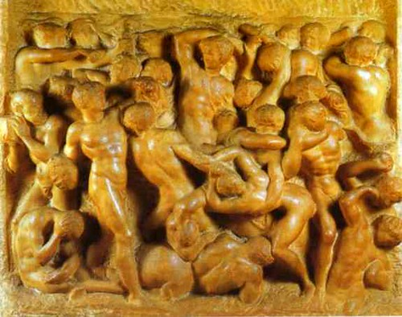
On the opposing side of the spectrum, what is high art? To find an example of this we need look no further than to one of the most famous artisans the world has ever seen, Michelangelo, specifically his sculptural works. Battle of Hercules with the Centaurs (1491-92), is a marble made image and considered to be one of his earliest sculptural works.

Fig. 1: Battle of Hercules with the Centaurs

The relief piece represents a group of males enclosed in a small space amidst a violent altercation. Figures are throwing punches and grappling with one another in what looks like as a free-for-all wrestling match, akin to WWE’s Royal Rumble - an over-the-top rope Battle Royale of thirty combatants. It was with this sculptural carving, the male nude in movement began to dominate Michelangelo’s work throughout his career “Michelangelo has depicted all the figures as human, despite the centurion subject of the relief, focusing mainly upon the muscular torsos of the men” (Bradbury, 2001, p.18.). Michelangelo’s mastery in sculpting the muscular male nude led to a number of commissions from the Catholic church over the course of his life, including the figure titled ‘Moses’ (1513-16) (see Appendix v), that was built as decor for the tomb of Pope Julius II.

These sculptural masterpieces are considered high art due to the time during which they would have been made, the context in why they were built and the method in which they were constructed. Michelangelo was commissioned to form these male nudes by an extremely wealthy and powerful client, the Catholic church, during a time in which a large, sophisticated, and wealthy urban-based society provided a coherent and conscious aesthetic framework and large-scale training for the visual arts (Dormer, 1997). These benefactors would source materials and finance projects. Such an environment would have enabled an artist like Michelangelo to realise and fulfil his creative potential, with few technical or practical constraints.
Sculpture

The word sculpture originates ‘from the Latin sculptura, from sculpere.’ (Allen, 2011, p.1088). Artisans have been forming shapes and three-dimensional imagery from materials found in nature since the dawn of humanity e.g. Stone Age totems. The dictionary’s definition of sculpture is: The art of making two- or three-dimensional representative or abstract forms, especially by carving stone or wood or by casting metal or plaster (12th Edition of the Concise Oxford English Dictionary). In the 1970’s, conceptual art began its trajectory towards art practice dominance. During this period, sculpture began to be used to describe a wide variety of art. “To explain sculpture is an almost impossible task because any attempt inevitably becomes an academic discussion of idiom and materials” (Mills, 1976, p.9)

With modern development, the term it is now used as a verb as well as a noun; for example, “When the British artist Richard Long made one of his planned walks across the country, and recorded what he had done on a map, this action was labelled ‘sculpture’” (Lucie-Smith, 1994, p.168).

In contemporary culture, just as man sculpted ‘God-like’ physiques from stone, people have begun to sculpt their own bodies. Breaking down muscles through use of strenuous weightlifting, resulting in them growing larger and stronger. Using flesh and muscle as a canvas for sculpting, moulding and forming desired shapes and proportions. It is plausible that Michelangelo’s fascination and passion in obtaining a physical representation of the perfect muscular male form within his sculptural practice, contributed to the birth of the ‘Adonis Complex’. He presented the human populous with imagery of huge, muscular men atop plinths, and in doing so, quite literally placed this body ideal on a pedestal.

The Adonis Complex

The Adonis complex is named after the Greek god Adonis whose body represented an exquisite standard of masculinity. It is “...a collection of male body image problems that can include compulsive weightlifting and exercising, steroid abuse, eating disorders, and full-blown body dysmorphic disorder...” (Bryson, 2003, p.255).

During his academic research, J. Kevin Thompson wrote a book (The muscular ideal: psychological, social, and medical perspectives) to help those suffering with this complex. It uses the image of Michelangelo’s ‘David’ (1501-04) (see Appendix ii) as its cover photo, further solidifying the theory that Michelangelo’s marble sculptures represent an unattainable and unrealistic body image ideal. This ideal is sweeping across current society; evident through more gyms/ fitness studios which are opening as modern-day men and women swap the artisan studio for the bench press, the chisel and hammer for the dumbbell, and the marble and granite for muscle tissue. Spurred on by consistent social media presence of pop-culture icons, including professional athletes and actors - like former WWE wrestler Dwayne ‘The Rock’ Johnson - they slowly chisel away at their imagined imperfections, with the hope that they will obtain a body akin to the marble masterpieces ‘Moses’, and ‘David’ by Michelangelo (see appendix ii and v).

This Adonis complex rears its ugly head throughout professional wrestling history. From the mid-1980s to the early-1990s, a performer named Hulk Hogan headlined the WWE’s (see appendix vi for a brief history of WWE) largest show, 'Wrestlemania', seven times in its first eight years. According to Strum, Hogan was an imposing blond, tanned, over-muscled 'hulk' figure who would refer to his biceps as 'pythons' (Strum, D. 2018), he projected a body image that is unobtainable without the abuse of steroids (see appendix vii).

Wrestling Culture

The wrestling community is vast and worldwide; while it considers Mexico the spiritual centre of wrestling, where luchadors perform acrobatic feats of athleticism hidden behind super-heroesque masks. It is due to decades of consistently pushing performer’s boundaries from a physical and creative perspective, that Japan has become to be recognised as the burning heart of the professional wrestling world. This is exemplified in the match between Kota Ibushi and Yoshihiko (a blow up doll) (DDT, 2015), where the choreography of movement and manoeuvres composed and acted out by a single performer produces a realistic, entertaining wrestling bout between two.

Current events have always inspired storyline direction within pro-wrestling because they engage audiences. Unfortunately, it is evident that groups based on ethnicity, race, sexual orientation, gender and nationality are represented in a negative light, being cast as heels (villains). This sends the message that people who do not conform the 'norm' are allowed to be ostracised (Friedrichs, 2014). This racial stereotyping and perception of one ethnicity being portrayed as superior in morality and strength over another, is challenged in an oil painting by William Etty titled ‘The Wrestlers, 1940’ (see Appendix viii). It depicts a wrestling match between a black man and a white man and was created during a time in which it was common belief that black people were physically weaker than whites (Smith, 2001). Knowing this, Etty has made a conscience effort to place both competitors on an equal footing, illustrating a culturally relevant moral lesson within the painting. This seems to have been overlooked by the professional wrestling promoters of the early 1990’s who depicted black people as heels that would have to cheat in order to win matches.

Sasha Banks, a female wrestler has changed the role of women on the canvas. The so-called 'Diva's Revolution' has altered the perception of women fighters being sex-symbols to high quality performances, positive characterisations and serious competitors (Harkulich, 2018).

Earlier in WWE’s history, before ‘Hulkamania’ swept over the industry, there existed a performer by the name of Adrian Adonis, a performer that presented himself as a hyper-masculine, arrogant playboy from New York. By the late 1980’s, he had begun to gain weight and fall out of shape. Not fitting into McMahon’s ideal ‘Adonis” image, the wrestler was forced to change his name and gimmick. Being re-dubbed ‘Adorable’, he would enter the ring wearing pink tights and eye make-up to the tune of “Coming Out the Closet”. He was the definition of a gay stereotype, during a time in which homophobia was rife throughout America due to the AID’s crisis. Due to McMahon’s monopoly (see appendix vi) performers had severely limited opportunities to find work.

If a wrestler wanted to earn a pay-check, their persona had to conform to Vince McMahon’s worldview… one that idolises traditional hegemonic masculinity and aggressive heterosexuality.
(Catte and Howard, 2018, p.141)

The actions of the WWE during this period, has led aspiring wrestlers to abuse their bodies, through illegal drug use (see appendix vii), to create the perceived ‘Adonis’ physique, in order be successful at the world’s largest, and most well paid, professional wrestling organisation.

Switching Between Art Cultures

In the past, many artists switch between both high and low. A good example of this being be the works of American artist Jean-Michel Basquiat. ‘Untitled (1982)’ (see Appendix ix) a work created during the later stages of his life before his tragic death at the age of 27. It has received critical acclaim due to its message regarding white on black racial violence (The Guardian, 2018), and was recently bought by Japanese entrepreneur Yasaku Maezawa for over $100,000,000.

It is classed as high art for several reasons. These include but are not limited to; its uniqueness and its inability to be mass produced, the traditional means of its production, being paint on a canvas, and the educated social commentary that the artwork depicts. I chose Jean-Michel Basquiat as an example of an artist that works within both sides of this spectrum due to his original roots. His earlier art form of choice was illustrative and text-based graffiti (see Appendix x), a style synonymous with low art and historically frowned upon by upper class society. As Kirk Varnedoe wrote in Modern Art and Popular Culture, graffiti was “stigmatized as the un-evolved, regressive behaviour of the social difunctional” (Gopnik and Varnedoe, 1991, p.74). Can professional wrestling, just like Basquiat, transfer itself from one social confine to another, and be universally accepted as an art form?

In modern history, there have been times when lines drawn between high and low have become blurred. An example of such blur would be the work of the pop artist, Roy Litchenstein. In response to American arts popularity of Abstract Expressionism, he drew inspiration from war comics and penny-book romances, as shown in an example of Lichtenstein’s work titled Whaam! (1963). He said of this decision that;

It was hard to get a painting that was despicable enough so that no one would hang it. Everyone was hanging everything. It was almost acceptable to hang a dripping paint rag… the one thing everyone hated was commercial art.
(King, 2010, p.490)

The now iconic visual artist would use large bold outlines and the benady dot system to depict imagery usually found in comic books and animation, forms of art that were deemed low culture. “Almost without exception, Lichtenstein’s comics paintings from the early 1960’s were adapted from the work of a small handful of ambitious comic-book artists.” (Gopnik and Varnedoe, 1991, p.199). He would simplify the design, reduce the colour pallet, incorporate his trade mark dot system, edit the text to remove narrative and eliminate any line work he felt was unnecessary. This simplification, stylisation and appropriation can be seen to a great extent in ‘Whaam!’ (1963), in comparison to the comic it was lifted from ‘Star Jocky’ (1962), illustrated by Lichtenstein’s friend, Irv Novick.
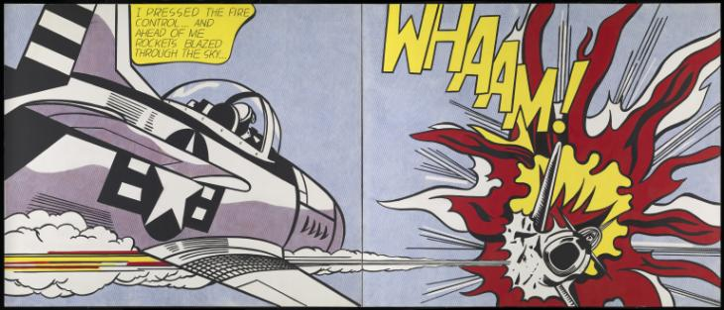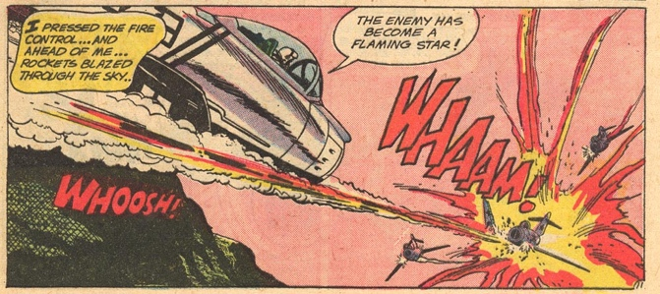
Fig 2: Whaam! Fig 3: Star Jocky
Inspired and influenced by Lichtenstein’s rejection of realism, detail and use of bold, curvaceous line work, Marvel Comic’s editor and chief, Stan Lee, appropriated these appropriations for his company – changing the stylisation of Marvel’s graphic illustrations resulting in a comic book boom for the previously struggling industry.

“High art on the way down to the bottom met, without knowing it, low art struggling to find its way back up” (Gopnik and Varnedoe, 1991, p.199) and as a result, Liechtenstein’s reworking of comic book illustrations produced in a chain of borrowings that traverse from low art, to high art, to low art again; blurring the predetermined lines of what each category is supposed to be. In this case, high art had saved a low art form from extinction. Many years later, resulting in a box office phenomenon that collectively grossed over twenty billion dollars at the global box office, another example of low art, Marvel’s Cinematic Universe.

Pop Art

It is within Lichtenstein’s realm of pop art, a style of art that sits on the line between high and low, that we find artworks being created on the subject of professional wrestling.

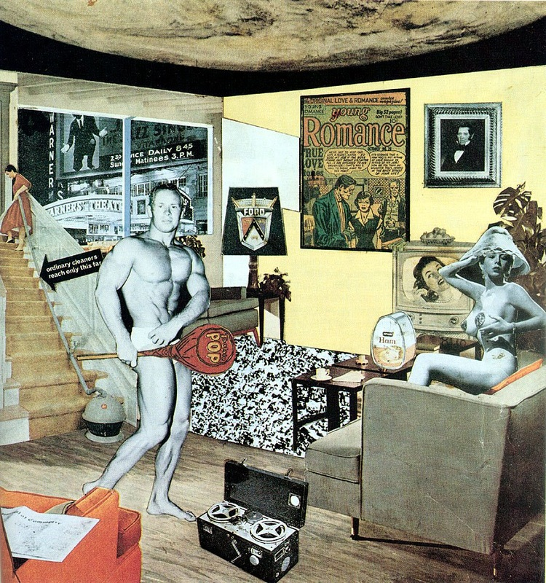
Fig 4: Just what makes todays homes so different, so appealing?

In this collage titled, ‘Just what makes todays homes so different, so appealing?’, by Richard Hamilton (1956), there is a half nude Adonis-like body builder holding a lollypop, that covers up the general vicinity of his genitalia, and placed upon this oversized sweet is text adorning the ‘package’ that reads ‘Pop’. Pop being the abbreviation of the word ‘popular’. While this artistic movement may have been born in 1956 with Hamilton’s collage, but it wasn’t until 1958 that the term ‘Pop Art’ was officially coined. Writing for Architectural Design in an essay titled ‘The Arts and the Mass Media’, British art critic Lawrence Alloway wrote that: “The popular arts of our industrial civilisation are geared to technical changes which occur, not gradually, but violently and experimentally” (Alloway, 1958). Within this statement, is the first recorded time the term ‘popular arts’ was used in an academical context. He continues his argument by discussing that modern technological development played a large role in the rise of popular art.

Technical change as dramatised novelty (usually spurred by economic necessity) is characteristic not only of the cinema but of all the mass arts. Colour TV, the improvements in colour printing (particularly in American magazines), the new range of paperback books; all are part of the constant technical improvements in the channels of mass communication
(Alloway, 1958)

These technological advancements played a major role in the rise of a mass-media phenomenon, with artists beginning to question the apparent distinction between the previously discussed high and low art forms.

Most of the artists were in revolt, not against consumer society itself but the artificial distinction between ‘high’ and ‘low’ culture made by critics and the elitist refinement of traditional ‘good taste’
(Grant, 2010, p.486)

Andy Warhol’s work space was akin to a commercial production line, creating art works in a way not dissimilar to the means of which almost every consumer product is produced. Aptly naming his studio ‘The Factory’ he had learned ‘to see commercial art as real art and real art as commercial art’ (Horne and Frith, 1987). Produced in a similar manner is a famous Peter Bake collage, a renowned visual artist, Blake lent his unique visual language to the Beatles for their iconic album cover for ‘Sgt. Pepper’s Lonely Hearts Club Band’ (1967) (see Appendix xi).

Wrestling’s Representation in Visual Art

Both the aforementioned pop artists, Warhol and Blake, have gone on record to discuss professional wrestling. Sir Peter Blake, when producing a painting (Nagasaki,1992) (see Appendix xii) for the BBC Documentary series ‘Masters of The Canvas’ has confessed that his fantasy was to be the mysterious masked wrestler Kendo Nagasaki. Andy Warhol frequented wrestling shows at Madison Square Garden during the 1970s, appearing on camera at 'The War to Settle the Score', a WWF event aired on MTV in 1985. When asked his thoughts on the show he simply replied “I'm speechless… it’s just so exiting I don’t know what to say” (Warhol, 1985).

Kendo Nagasaki wasn’t the only wrestler Sir Peter Blake has painted throughout his illustrious career. In 1961 he created a series of sculptural paintings regarding this escapist entertainment that depicted various wrestlers appropriated by himself. With the exception of ‘Masked Zebra Kid’, whose real autograph appears as a trophy item in the centre of collaged photographs. He seemed to have fun with the preposterous names he generated, such as ‘The Da Vinci Brothers’, presumed Italian Mafiosi named in honour of the painter of the Mona Lisa. Marco Livingstone elaborates on this in the book ‘Peter Blake - A Retrospective’:

Their often brutish appearance, like their hilariously over-the-top stage names redolent of power, evil and outlaw status - Baron Adolf Kaiser, Doktor K. Tortur, or Franck and Jesse, the James Brothers - masks the suspicion that they are really just big softies underneath, acting out an assumed identity just as they choreograph their acts of combat in the ring for the entertainment of us mortals.
(Livingstone, 2007)

What Livingstone provides is interesting facets of information, but nothing is more fascinating than the quote taken from the book which reads; “...these larger than life figures are all inventions of the artist. In flaunting their toughness and masculinity to the point of self-parody, they play of boyhood fantasies, of super-heroes and super-villains.” (Livingstone, 2007). The first sentence of which is entirely untruthful. Not a single wrestler Blake painted was of his invention; each depicted a famous wrestler in his instantly recognisable pose of choice, what Blake did was simply change each name. For example, Doktor K. Tortur (see appendix xii) is really a painting of Bruno Sammartino, an Italian-born American pro-wrestler, who held the WWF World Heavyweight Championship for more than eleven years (see appendix xiii).

What can be agreed with is when Livingstone furthers his point by insisting that, “In spite of their masks, their muscles and their threatening demeanour, there is nothing very frightening about any of these men. It is more tempting to smile at their posturing than find them intimidating” (Livingstone, 2007).

Thanks to Blake’s choice of colour pallet, delicate brush marks and hilarious renaming one can’t help but smile upon viewing these sculptural paintings. As Richard Avedon, an artistic photographer, has been quoted as saying “all portraiture is performance” (Goldberg , 2004), he goes on to state that the sitters are all performing, even Rembrandt in his self-portraits, as they pull faces to manipulate facial expressions, select clothes or costumes to wear and decide which pose to hold.
Ed Paschke challenged masculinity in wrestling through his vibrant and erotic oil paintings; depicting muscular men dressed costumes and masks with man-ginas instead of penis’ (see appendix xii). Steve McQueen raised issues about race, homo-eroticism and violence in his short film ’Bear’ (see appendix xiv), where two black men, one of which is the artist, grapple and wrestle each other naked. Of the film he says about his audience “You are very much involved in what is going on. You are a participant not a passive viewer.” (Bickers, 1997).

Performance Art

Performance and live art are areas of art that had been overlooked and underexamined. The very nature of the live performance means that it cannot be re-seen, only described by the watchers (Goldberg, 2004). Performance art and performance as art are two separate subjects entirely. For the sake of this discussion when referencing theatre, dance etc. the term ‘performance art’ will be used and when referencing performance as art, we will use the term ‘live art’.

Prior to the 1980s wrestling was still considered by many as a real sport, akin to rugby, football or boxing. Indeed, amateur wrestling is still classed as a highly respected sport across the world; sumo-wrestlers are heroes in Japan, many American universities give scholarships based on wrestling prowess, and let’s not forget that wrestling was included in the gladiator arenas and is still an Olympic event. Pro-wrestling has always had a complicated relationship with the truth, for decades bookers tried to maintain that matches were not fixed. It wasn’t until the 1980s, after a slew of negative reports, that it became wildly known that the winners/ losers of each match were predetermined. For non-fans it has proven difficult for wrestling to shake the moniker of ‘fake’, but to dismiss wrestling as ‘fake’ is to misread it entirely, despite its founder of WWE, Vincent McMahon telling a state senate that professional wresting is “an activity in which participants struggle hand in hand primarily for the purpose of providing entertainment to spectators rather than conducting a bona fide athletic contest” (New York Times, 1989). On the fringes of wrestling is ‘death match’, where performers battling with barbed wire, razor blades and broken glass challenge this very notion. Xavier Woods, a doctor of psychology and current professional wrestler employed by the world’s most renown and global recognised brand, WWE, wrote in response to this notion of ‘fake’:

Wrestling is one of the last forms of Shakespeare in the world, the crowd is watching men and women tell stories through physicality with an audience at a 360-degree setting. Artist[s] use paint to create art on a canvas, and we use our fists and feet to create art on a canvas, its art. We get one take, not 40, in front of a live audience that appreciates us putting our bodies on the line for their entertainment, It’s fine if you don’t like it, but there’s no need to disrespect us or the people who watch it by calling it ‘fake.’ … the pain we feel is very real. We suffer from real injuries doing what we love to do.
(Woods, 2016)

This immortalisation of the professional wrestler as a subject matter for renown visual artists such as Blake cements the industries place in popular culture. But, to argue the case for professional Wrestling to be classed as an art in itself, the similarities between performance art, live art and the grappling contest between spandex clad men and women must be studied. Initially performance and live art such as photography, monologues, music and dance were performed in galleries and museums but due to growing popularity and appreciation from the public these performances moved to mainstream media such as theatre.

“In wrestling, you can’t kick a guy’s ass without the help of the guy whose ass you’re kicking.” (Diaz, 2009). A line from the Pulitzer Prize-nominated play by Kristoffer Diaz, 'The Elaborate Entrance of Chad Deity', perfectly sums up the central contradiction of professional wrestling; an intensely physical and dangerous performance by two (or more) performers battling for supremacy, which is entirely reliant on the theatrical effort and co-operation between the two (or more) participants.
This performance of pro-wrestling could also be deemed site-specific as each individual event can be inspired by and responsive to the location in which the event takes place (Pearson, 2010), for example, a heel may berate a local crowd to garner a negative response.

Art in Action

While at centre stage, in the middle of the ‘squared-circle’ (a term used to describe the ring in which bouts take place) are the wrestlers, at the core of each event lies the connection between the audience and performers. This form of entertainment would not exist if it weren’t for the live audience, who become active participants; chanting, cheering and booing the combatants though each match as the pre-determined pantomime plays out. Goldberg describes this as art in action, when the audience is confronted by an artist’s physical presence in real time (Goldberg 2004). A strong reliance on storytelling and character conflicts is used to drive forward a narrative, projected to a live crowd that respond to every clinch, grapple and back-drop with sounds of “ooooh” and “aahhggg”. All the while being simultaneously broadcast to millions of viewers, not only through the medium of television but also more current online streaming platforms. And while pro-wrestling is indeed a television show, it can be seen as first and foremost a live theatrical performance that is intensely physical and requires a sense of acting from its participants to invoke an emotional response from the live crowd. If the crowd doesn’t find interest in a character, the character will be changed. As Barthes writes in his 1972 semiotic research anthology, ‘Mythologies’;

The function of the wrestler is not to win; it is to go exactly through the motions which are expected of him. […] wrestling […] offers excessive gestures, exploited to the limit of their meaning. […] In wrestling, a man who is down is exaggeratedly so, and completely fills the eyes of the spectators with the intolerable spectacle of his powerlessness. This function of grandiloquence is indeed the same as that of ancient theatre [and] in wrestling, as on the stage in antiquity, one is not ashamed of one’s suffering, one knows how to cry, one has a liking for tears
(Barthes, 1972)

This emphasises that professional wrestling is indeed a live theatrical art form akin to the Shakespearian play, Hamlet. But, as so eloquently put in 'Performance and Professional Wrestling' “Hamlet doesn’t blade” (Chow et all, 2017). The term ‘blading’ is used in professional wrestling to describe the act of a performer cutting themselves with a razor blade while hidden from the audience. This is used to draw blood and adds a larger sense of drama to a match. Usually partaken by the ‘face’ of the bout after an aggressive blow to the head, this act of ‘drawing colour’ is now banned, as is the use of shots to the head by ‘foreign objects’ (chairs, ladders and steel stairs) due to research involving concussions. Yet this ‘ban’ is only relevant within the world of WWE, not the larger wrestling scene; it is this element of the ‘real’ that forces professional wrestling away from traditional theatre of performance art and towards the ‘real’ of live art.

“In Performance art the “distance” between the really real (socially, personal, with the audience, with the performers) is much less than in drama theatre where just about everything is pretend - where even the real (a coffee cup, a chair) becomes pretend.”
(Gómez-Peńa, 2005)

In terms of professional wrestling Gomez-Pena’s chair moves from being “really-real” to pretend back to “really-real” again. A chair is used as a prop to sit upon but also as a means of violence, to make a ‘feud’ seem more personal, removing the sportsman etiquette and portraying that the performers involved truly hate one another. There is absolutely nothing pretend in receiving a chair, swung by an athletic, strong person, across the spine. The renown live artist Marina Abramović further complicates things by explaining to the Guardian in 2010 that;

“To be a performance artist, you have to hate theatre […] Theatre is fake … The knife is not real, the blood is not real, and the emotions are not real. Performance is just the opposite: the knife is real, the blood is real, and the emotions are real.”
(The Guardian, 2010)

Live art first become popular in the 1950’s; artists, taking the form of the ‘performer’ had begun creating ‘happenings’, challenging many of the accepted rules of current and historical theatre. It is due to the radical works of artists such as the aforementioned Marina Abramović that has allowed live art to become an art form distinct from the likes of drama, dance, sculpture and painting. But due to its relatively new conception there has been very little documentation to describe, discuss and elaborate upon action art. It wasn’t until 1999, when Anthony Howell wrote a book titled ‘The Analysis of Performance Art’, in which, similarly to colour theory, he writes that live art can be made up of three primary elements, these primary actions are stillness, repetition and inconsistency. Concluding that;

“Each new piece of work must demonstrate as much inconsistency with that which has gone before as it entails some repetitive reflection on it. This requires that while a grammar of performance may help to lay out possibilities, each new work must invent its own rules.”
(Howell, 1999)

In doing so he contradicts his own set of primary rules used to describe live art, alluring to the fact that each piece performed must, within itself, be comprised of its very own set of grammatically correct wordings. Acknowledging that within the analysis of live art, the words used in discourse are entirely dependent on the performance in question. Another viewpoint to take into consideration is, “… performance [live] art actually defies precise or easy definition beyond the simple declaration that is live art by artists…” (Goldberg R, 2004 p.12). adding further weight to the idea of performance art being un-contextual as a broad style of artistic projection. It is individual works that can be dissected by art critiques, rather than the subject itself, as each variation of live art is unique and requires its own parameters of reflection and comprehension.

Conclusion

Does a notion of ‘real’ and ‘fake’ determine what category of art professional wrestling falls in? Is it theatre or is it a form of performance art or live art? Possibly a combination of all. Alternatively, is it a “Kafkaesque [nightmarish yet relatable] blend of Jerry Springer and Jackass” (Smith, 2014).

I agree with Goldberg (2004) that live art rarely aims to seduce but it is fast paced and aims to provoke the spectator, that it is sometimes ridiculous, ludicrous but also frightening; and believe that this study has shown that professional wrestling falls firmly into these categories.

In the realm of wrestling, the performance is undoubtedly theatrical and the result predetermined, yet the blood is real, the knife used to’ blade’ and the pain of the performers are real. The emotion felt by the audience which are active and adept at reading the theatrical performance, albeit manipulated by the performers is undeniably real. As Chow explains, wrestling can be seen as both performance and theatre as the wrestlers are actually doing the things we are seeing, motivated by theatre. It is also scripted, similar to plays, improvised and real which is categorised as performance art (Chow et al, 2017).
Like the professional performers in opera and theatre, wrestlers hone their craft through dedication and rehearsal. They are supported by directors, costume designers, script writers and managers. If live art represents the spirit of its own times, as the gladiators performed in the vast arenas for the spectators of Rome, “We go to the arena as we go to the theatre, to be amused and also to be acculturated…” (Mazer, 2017). It can be therefore argued that wrestlers perform on the small canvas arenas for the spectators of today.

Goldberg (2004) states that the followers of today’s art world remains the most willing to be repeatedly overwhelmed, constantly provoked and challenged, to have their preconceptions expanded and redefined. Maybe professional wrestling falls into its own category of sport-art, a combination of athletic prowess, theatrical pantomime and audience participation.
Whether professional wrestling falls under bracket of performance art, live art or sport art, it has undeniably transformed from the low culture social confines of its origins to a universally acceptable, recognisable art form.

Referencing
- Allen, R (2011) The Concise Oxford dictionary. BCA
- Alloway, L. (1958) The Arts and the mass media. Architectural Design Magazine
- Arena: Masters Of The Canvas (1992) BBC Television, 31 January. Available at: https://www.bbc.co.uk/iplayer/episode/p0370w28/arena-masters-of-the-canvas (Accessed: 27 October 2019)
- Barthes, R. (1957) Mythologies. LLN
- Bickes, P. (1996) ‘Let’s Get Physical’, Art Monthly 202, pp. 1-5.
- Bradbury, K. (2001) Michelangelo. Parragon
- Bryson, S. (2003) Body Image and modification: New Problem or Ancient Preoccupation? PS
- Catte, E. And Howard, J. (2018) A Secret Fascination. McFarland
- Chow, B. et al. (2017) Performance and Professional Wrestling. Routledge
- DDT Wrestlng (2015) Kota Ibushi vs Yoshihiko [Video] Accessible at: https://www.youtube.com/watch?v=_LApVz53Spw (Accessed on: 12 November 2019)
- Friedrichs, J. (2014) Good Versus Evil in the Squared Circle. MTSU
- Goldberg, R. (2004) Performance: Live Art Since the 60’s. Thames and Hudson
- Gómez-Peña, G. (2005) Ethno-Techno: Writings on Performance, Activism and Pedagogy. Routledge
- Gopnik, A. And Varnedoe, K. (1991) Modern Art and Poplar Culture. Thames and Hudson.
- Grant, R. And King, C. And Zaczek, I. (2010) Art the Whole Story. Thames and Hudson
- Grunberg, C. And Livingstone, M. (2007) Peter Blake a Retrospective. Tate
- Harkulich, C (2018) Sasha Banks, the Boss of NXT. McFarland
- Horne, H. And Firth, S. (1987) Art into Pop. Methuen Young Books
- Howell, A. (1999) The Analysis of Performance Art. Routledge
- Jones, J. (2017) ‘Is this Basquiat worth $110m?’, The Guardian, 19th May. Available at: https://www.theguardian.com/artanddesign/2017/may/19/jean-michel-basquiat-110m-sothebys (Accessed: 15th November 2019)
- Kerr, P. (1989) ‘Now It Can Be Told: Those Pro Wrestlers Are Just Having Fun’, New York Times, 10th February. Available at http://www.nytimes.com/1989/02/10/nyregion/now-it-can-be-told-those-pro-wrestlers-are-just-having-fun.html (Accessed: 3 December 2019)
- Lucie-Smith, E. (1994) Elisabeth Frink: Sculpture Since 1984. ABI
- Mazer, S. (2015) The Game of Life. Routledge
- Mills, J. (1976) The Technique of Sculpture. B T Batsford
- O’Hagan, S. (2010) ‘Interview: Marina Abramović’, The Guardian, 3rd October. Available at: http://www.theguadrian.com/artanddesign/2010/oct/03/interview-marina-abramovic-performace-artist (Accessed: 20th November 2019)
- Pearson, M. (2010) Site-Specific Performance. Palgrave Macmillan
- Quackenbush, M. (2015) Ignite Philly 16: The Art of Pro Wrestling [video]. Available at: https://www.youtube.com/watch?v=4A1VpPXy4ws (Accessed: 2 November 2019).
- Smith, A (2001) Exposed: the Victorian Nude. Tate
- Strum, D (2018) Macho Madness and the Mania. McFarland
- The Elaborate Entrance of Chad Deity by Kristoffer Diaz (2019) Directed by Edward Torres [Biograph Theater, Chicago. 25 September 2009]
- The Wrestlers (2019) Channel 4, 18 October. Available at: https://www.channel4.com/programmes/the-wrestlers (Accessed: 19 October 2019)
- Thompson, K. (2007) The muscular ideal: psychological, social, and medical perspectives. APA
- Warhol, A. (1985) Mean Gene Okerlund Interviews Andy Warhol [video]. Available at: https://www.youtube.com/watch?v=fI3Oh1ELmBI (Accessed: 14 November 2019)
- Williams, R. (1976) Keywords, Harper Collins
- Woods, X. (2016) [Twitter] 21 April. Available at: https://twitter.com/XavierWoodsPhD/status/723347216836997120 (Accessed: 23 November 2019)

Appendix i
I begin by stretching, the canvas is framed by lengths of solid wood. I limber up, preforming small exercises in preparation for the task at hand. A gargantuan undertaking, copious amounts of time has been spent practising and failing. I must remember that every moment must count for something, every gesture, every mark must have meaning. I pay homage to those that came before me, those that struggled and sacrificed. Excited, anxious and intimidated, I remember the people that helped my get here; tutors, family and friends. I have mapped it out on paper, going over every pain-staking detail. This is the one, I know it, the piece of work that will propel me to the higher echelons of my chosen discipline - my chosen art form. I am painting a picture, a picture of my interior thoughts as I enter a wrestling ring for the very first time.
Appendix ii
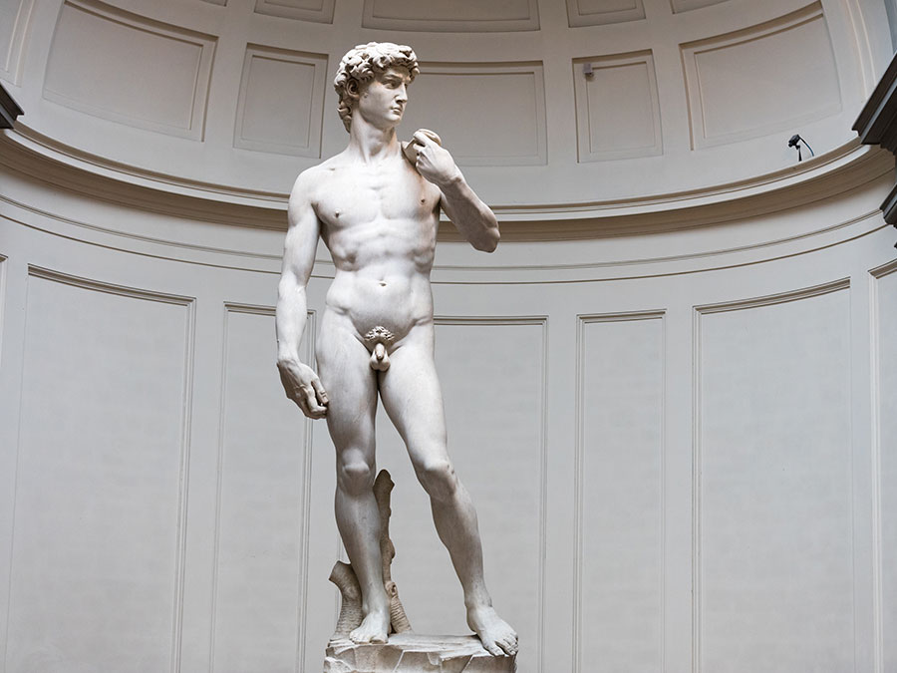
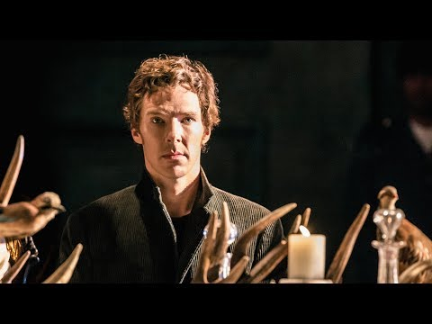

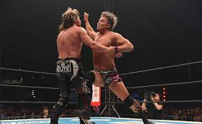
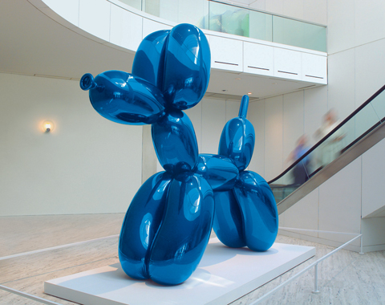
Fig 6: David
Fig 5: Hamlet
Fig 8: Okada vs Omega
Fig 7: Balloon Dog
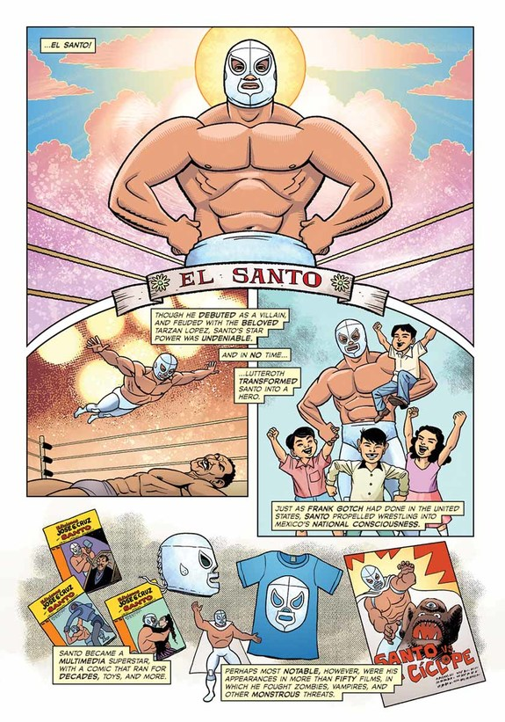
Appendix iii

Fig 9: The Comic Book Story of Professional Wrestling

Appendix iv
Artistic director - Assistance Stage Manager - Audio engineer – Backstage - Call boy – Carpenter - Charge artist – Choreographer - Company manager – Composer - Costume designer - Costume director - Crew chief – Dancer – Director - Director of audience services - Director of development - Director of production - Director of public relations - Director of special events – Dramaturg – Dramaturge – Dresser – Electrician - Fly crew - Front of house manager – Grips - House manager – Janitor - Light board operator - Lighting designer - Lighting technician - Literary manager - Marketing director - Master electrician - Movement director - Music director – Musician - Paint crew – Performer - Playbill writer – Playwright – Producer - Production manager - Property master – Publicist - Scenic artist - Scenic designer – Scenographer - Set designer - Sound designer - Spotlight operator - Stage crew - Stage manager – Stagehands - Technical director - Technical director - Theatre manager - Theatrical technician - Ticketing agent – Usher - Wardrobe supervisor

Appendix v
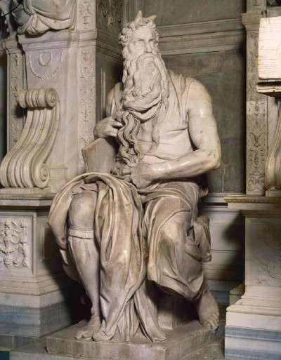
Fig 10: Moses
Appendix vi
The history of WWE dates back to the early 1950s when it was founded by Jess McMahon and Toots Mondt in 1952 as Capitol Wrestling Corporation (CWC). It underwent several name changes throughout the years, from World Wide Wrestling Federation (WWWF) under Vine McMahon Sr. to World Wrestling Federation (WWF) under Vincent Kennedy McMahon Jr. In 2002 the WWF was forced to change its name to WWE (World Wrestling Entertainment) due to legal issues with the World Wildlife Fund.
In the early 1980’s Vince Jr poached the top talent from around the established American territories and taking advantage of the new mediums of entertainment, including cable television and pay-per-view, quickly drove all competition out of business, creating a monopoly for himself and his company.
Today WWE is the largest professional wrestling company in the world. It has promoted some of the most successful wrestlers and storylines, and featured some of the most iconic and significant matches and moments in the history of the sport. WWE currently airs several high-profile programs such as Raw, SmackDown and more recently NXT, in more than 150 countries, hosts 12 pay-per-view events a year including WrestleMania, and holds approximately 320 live events a year throughout the world. In 2014, WWE launched the first ever 24/7 streaming network which would eventually showcase the entire WWE video library and boast a subscription rate of around two million viewers, each paying a monthly subscription cost of £9.99/ $9.99.

Appendix vii
George Zahorian is an osteopath and urologist from Pennsylvania who served as a doctor for the Pennsylvania State Athletic Commission. One of wrestling's worst kept secrets was that he was dealing anabolic steroids and a to wrestlers and was convicted of this in 1991. Hulk Hogan was originally scheduled to be called as a witness, but his layer provided the argument that Zahorian and Hogan had a legitimate doctor-patient relationship and became exempt. McDevitt claimed that the medical issue Hogan sought treatment for would cause embarrassment to him if revealed publicly.
Hogan was scheduled to appear on a late-night Arsenio Hall's. The plan was for him to be contrite and admit to using anabolic steroids. Instead, he claimed to have only used anabolic steroids three times in the past and only "for the treatment of injuries" (something that anabolic steroids aren't legitimately used for).
Not only did the media rain down blow after blow on WWE, The Justice Department began investigating the company, leading to a 1994 trial in which Vince McMahon and Titan Sports (the parent company of the WWF) were found not guilty of putting performers lives at risk.
On Nov. 13th, 2005, Eddy Guerrero died of heart disease on the day he was going to become WWE's World Heavyweight Championship. On his death certificate, anabolic steroid abuse was listed as a contributing cause.
While it's no longer available. WWE.com had posted a video of Vince McMahon explaining to talent that random and consistent drug testing would be taking place. It seemed as if the talent least likely to have any worries were stationed opposite the camera but this trick didn't prevent the meeting from feeling awkward. Kurt Angle was the only wrestler to ask any questions. Sounding extremely nervous, he asked if the testing would show exactly how much medication the wrestlers were taking.
The program officially launched on Feb. 27th, 2006. It started with "baseline testing" that didn't count, instead allowing anyone who was on anything to slowly and safely taper off while getting an idea of where their levels needed to come down from while new hires would also take baseline tests when they signed.
According to a document supplied to U.S. Congress:
  - 186 baseline tests were administered in the first year of the program.
  - 75 people tested positive.
  - There were 115 positives among the 75 people, as some tested positive for more than one class of drug: 68 for anabolic steroids, 34 for "prescription drugs," two for "illicit drugs," and 11 for Ephedrine/Pseudoephedrine.
Almost a year later, on the last weekend of June, Chris Benoit killed his wife Nancy, their son Daniel and then committed suicide. Large quantities of anabolic steroids (testosterone cypionate) were found in the home, with Benoit getting what would last the average patient on testosterone replacement therapy ten months every four weeks from his "personal physician" Dr Phil Astin Jr.

Appendix viii
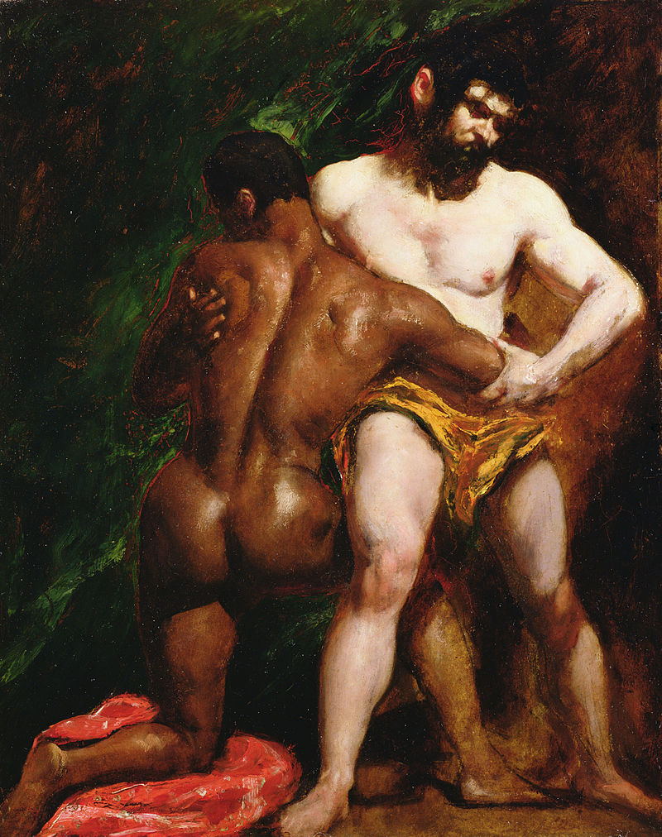
Fig 11: The Wrestlers
Appendix ix

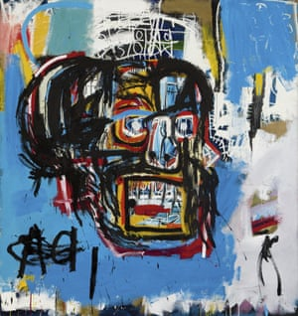
Fig 12: Untitled

Appendix x
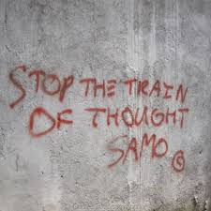

Fig 13: SAMO

Appendix xi
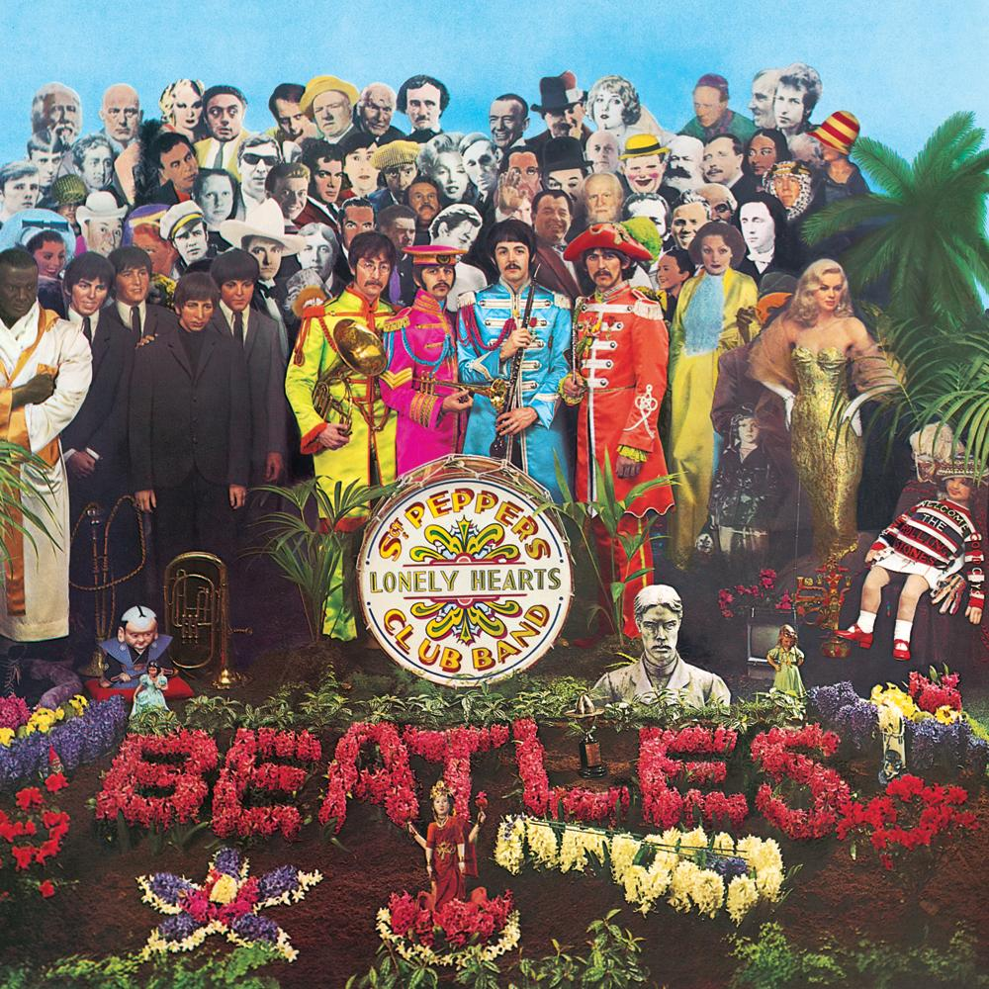
Fig 14: Sgt Pepper’s lonely hearts club band

Appendix xii
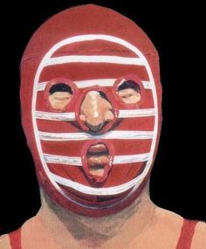
Fig 15: Kendo Nagasaki

Appendix xii
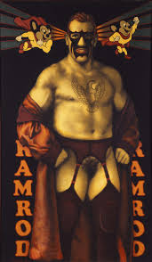

Fig 16: Ramrod, Ramrod

Appendix xiv

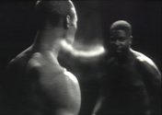
Fig 17: Bear

List of Illustrations
  - Michelangelo. (1492) Battle of the Centaurs [Marble] Available at: https://upload.wikimedia.org/wikipedia/commons/3/39/Michelangelo%2C_centauromachia%2C_1492_ca._01.JPG (Accessed: 15 November 2019)
  - Lichtenstein, R. (1963) Whaam! [Acrylic and oil on canvas] Available at: https://www.tate.org.uk/art/artworks/lichtenstein-whaam-t00897 (Accessed: 20 November 2019)
  - Novick, I. (1962) Star Jockey [Pen and Ink] Available at: https://2000adhallofhomage.wordpress.com/2017/12/18/no-156-whaam/irv-novicks-1916-2004-star-jockey-panel-from-all-american-men-of-war-89-dc-comics-1962/ (Accessed 20 November 2019)
  - Hamilton, R (1956) Just what makes today’s home so different, so appealing? [Collage] Available at: http://www.bbc.co.uk/culture/story/20150824-richard-hamilton-and-the-work-that-created-pop-art (Accessed: 3 December 2019)
  - Unknown (2017) Hamlet [Photograph] Available at: http://ntlive.nationaltheatre.org.uk/productions/ntlout27-hamlet (accessed: 2 December 2019)
  - Michelangelo. (1464) David [Marble] Available at: https://www.britannica.com/story/how-a-rejected-block-of-marble-became-the-worlds-most-famous-statue (Accessed; 27 November 2019)
  - Koons, J. (1994) Balloon Dog [Polished stainless steel] available at: http://www.jeffkoons.com/artwork/celebration/balloon-dog-0 (Accessed: 17 November 2019)
  - NJPW (2018) Okada vs Omega [Photograph] Available at: https://aminoapps.com/c/wrestling/page/blog/okada-vs-omega-a-six-star-rivalry/nbHL_unR74kjM6dDQZweXLdBgJ6VXj (Accessed: 10 November 2019)
  - Moreno, C. (2018) The Comic Book Story of Professional Wrestling [Illustration] Available at: https://www.newsarama.com/39908-the-comic-book-story-of-professional-wrestling-preview.html (Accessed: 23 October 2019)
  - Michelangelo. (1513) Moses [Marble] Available at: https://entertainment.howstuffworks.com/arts/artwork/michelangelo-sculptures10.htm (Accessed: 15 November 2019)
  - Etty, W. (1840) The Wrestlers [Oil on Canvas] Available at: https://www.yorkmuseumstrust.org.uk/collections/ (Accessed: 28 November 2019)
  - Basquiat, J. (1982) Untitled [Mixed media on canvas] Available at: https://www.theguardian.com/artanddesign/2017/may/19/jean-michel-basquiat-110m-sothebys (Accessed: 11 October 2019)
  - Basquiat, J. (1976) Samo [Marker pen on brick wall] Available at: https://streetartnyc.org/blog/2013/06/12/speaking-with-al-diaz-on-graffiti-samo-word-play-and-his-upcoming-workshop-for-writing-on-it-all-on-governors-island/ (Accessed: 12 October 2019)
  - Blake, P. (1967) Sgt. Pepper’s Lonely Hearts Club Band [Collage] Available at: https://www.thebeatles.com/album/sgt-peppers-lonely-hearts-club-band (Accessed:1 December 2019)
  - Blake, P. (1972) Kendo Nagasaki [Oil on canvas] Available at: http://www.youtube.com/watch?v=KRDTeULZKOs (Accessed:1 December 2019)
  - Pasche, E. (1969) Ramrod, Ramrod [Oil Paint on linen] Available at: https://www.thecompmagazine.com/ed-pascke-an-analysis-of-two-paintings/ (Accessed: 4 December 2019)
  - McQueen, S. (1993) Bear [Video projection] Available at: https://www.tate.org.uk/art/artworks/mcqueen-bear-t07073 (Accessed: 26 December 2019)

Further Reading, Listening and Watching
- Atkins, R. (1990) Art Speak. Abbeville Press
- Best, D. (1974) Expression in Movement and the Arts. Lepus
- Colt Cabana. (2013). The Art of Wrestling. [podcast] transmitted: 2013-present
- Dixon, J. (2012) All or nothing. Self-published
- Dixon, J. (2014) Titan Sinking. Lulu
- Fairey, S. (2006). Obey:Supply and demand. Gingko Press
- Glow. (2017). [web series]. USA: Netflix
- Hendrickson, J. (2000) Lichtenstein. Taschen
- Holt, M. (1988) Stage Design and Properties. Phaidon
- Lambert, G (2017) Ropes and Glory, the emotional rise of British professional wrestling. Self-published
- Lippard, L. (1966) Pop Art. Thames and Hudson
- Sedgwick, M. (2017) Development Hell. Whatculture
- The Mountain Goats. (2015). Beat the champ:The wrestling concept album. [CD Recording] Merge Records
- The Wrestler. (2008). [film]. USA: Fox
- Warr, T. And Jones, A. (2000) The Artist’s Body. Phaidon
- What Culture. (2015). Wrestling. [podcast] transmitted: 2015-present
- Williams, G. (2014) How to Write about contemporary Art. Thames and Hudson

