University of Wales Trinity Saint David

EFFECTIVE TEAMWORKING FOR TEAM SUCCESS

Student name: Vasilka Sarandalieva
Student number:2113113
Module: Effective Teamworking and Communication
Modul code: BMSW4002
Lecture name: Richmond Lamptey

Contents
Contents 2
Introduction 3
Overview of Teamworking 4
1. What defines a team 4
2. Factors contributes to effective teamworking 4
Models of team development 5
Tuckman’s model 5
Gersick model 7
What are the types of roles needed to create an Effective Team? 8
Discussion 10
What type of impact can effective teamworking have on team success? 10
What are the barriers to effective teamworking identified in this scenario? 11
Conclusion and Recommendations 12
References 13

Introduction

According to Griffith, BA and Durham (2014) it is common for people to work together to achieve collective goals and solve problems. In addition to achieving exceptional results, teams can also deteriorate into dysfunctional groups of frustrated individuals. In the context of every combined activity, individuals exchange views, concepts, intentions and feelings. Communication is the exchange of realities, concepts, ideas or feelings between individuals. Conveyance takes position by precise indications and symbols to define some information. In this case, communication could take part just if a specific situation exists. Successful team in the workplace is necessary for effective business functioning. It is a central aspect of professional growth and professional growth (Pabini, 2017). Based on the mentioned case study, Abdul is assigned to a new project for Vodafone UK, where he need to manage 18 employees to deliver a community event. It is imperative that a number of issues be addressed immediately. This report explains how Abdul can develop an effective team and what theoretical model can be used. The document also defines the types of roles needed to create an effective team and explain the kind of impact effective team working can have on team success. Finally, this report presents the barriers to effective teamwork identified in this scenario.

Overview of Teamworking

1. What defines a team

Organizing groups of people to accomplish a specific task isn't always indicative of what it means to work as a "team." If a group is to be considered a team rather than a work group, it must meet five basic conditions. Hackman (2009) identifies these five basic conditions:
1.1.“Teams must be real.” An effective team is made up of members who work collaboratively towards the same goals.
1.2. “The direction of the team must be compelling.” To be successful and have the right direction, the team need to recognize and adopt a common objective.
1.3. “Teams need enabling structures.” To do this, you are going to need the right kind of people to perform the right kind of tasks in the right manner, and then you are going to need to govern them according to the right values and norms.
1.4. “Everything in the organization must be supportive” From the structures of the people, systems, and processes of the team to the behaviours and outcomes that are most prized or rewarded.
1.5. “Teams need expert coaching.” Any group's evolution should be guided by an expert third party at critical points. Rather than focusing on individuals, coaching should focus on teamwork and team processes.
Participance with diversity in a teams is important for the success of organizations.

2. Factors contributes to effective teamworking

Developing a high-performing team engages more than simply bringing combined a group of skilled individuals. Its associates should share a motivating and stimulating work vision (Reynolds, 2018). They should have apparent aims and be dedicated to performing their responsibilities to the best of their capability to obtain overall business success. There are particular approaches to developing a successful team with the best outcomes.
It is essential to explain the team's aim, comprising the purposes to be acquired. What does Abdul wish to make, enhance or change? What is the objective of every individual in the group? Sharing a proper and motivating vision is the key to effective teamwork.
High-performing teams are established of individuals who effectively embrace the motive of their work, consider that each participant is appropriate, and are stimulated to present their best performance. A team should also share norms of trust, regard and assistance. Thus, it is essential to select individual abilities to give the group-specific concepts and views (Scott and Eduardo, 2020). In addition, Abdul should attempt to balance personality styles, so the group will be motivated and perform pleasantly.
Once the team is formed and combined based on a shared aim, the next phase is to break the policies down into more minor, more practical purposes. First, Abdul must determine what role every team member will perform. Then, he should focus all essential resources regarding time, space, assistance and money.
To make sure Abdul recognises the team's prediction, he must establish a standard of conduct. Establishing proper standards by the beginning assures that the team action is as suitable as probable. Abdul must commonly assess group performance through team meetings and personal feedback to ensure progress against goals. Reflect on how the group is working, what has been achieved so far, what has been learned, what is not working and where there is room for improvement. Monitoring progress allows the team to evolve along the way.

Models of team development

Tuckman’s model

To acknowledge group dynamics, different theorists attempted to assess them, and the most recognised and applied models are the Tuckman Team Model, Gersick Punctuated Equilibrium Model (PEM), GRIP Model and the Lencioni Model.
For identifying the condition of Abdul, the Tuckman model will be applied. According to the theory, the group or the team has several stages in its development, which differ according to the degree of maturity of the group. With the help of the leadership, team can increase its maturity and to develop forward to different stages. The wisdom of a team has two dimensions.
- Relationship between team members.
- Attitude of the participants to the team task and the progress of implementation
Whit Tuckman’s theory the leaderships/managers can easily understand what is happening in their teams, what and how to do as their leaders. Also explains why the leader of one team should be flexible and conform to the behaviour and attitude of the people in the team according to the situation, which differs depending on the stage of development of the team. Tuckman’s stages of group growth define that teams must pass by forming, storming, norming, performing and adjourning to become effective (Drew and Greg, 2019).
- Forming stage refers to understanding every team member, making trust and making expectations. There is a high dependence on the leader for directions.
- Storming stage is complicated, where predictions and limits are challenged, the strengths and weaknesses of every member are identified. Cliques can be formed. To avoid getting distracted by relationships and emotional concerns, the team needs to focus on its goals.
- Norming stage is where most of the team responds well to a leader's facilitation, which helps them reach agreement and consensus. Responsibility and roles are clearly defined.
- The performing degree is obtained through that the team members make most decisions based on criteria agreed with the leader and are focused on achieving goals.
- Adjourning phase (if need) is where the group separates, and everyone is going in different manners (Amy, 2012).

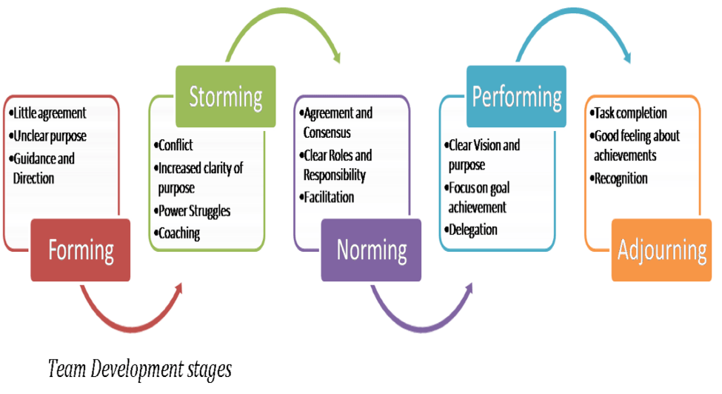
Team Development Stages (Tuckman,1965)

From an organizational point of view, it is important to keep in mind that the members of the team can be sensitive to the topic of disintegration of the group, because of the work they have together created a close relationship. With the disintegration of the team, it is possible to increase the feeling of insecurity or intimidation
Team working is a combined work with a group of individuals to obtain an aim, usually a particular area of any company, with staff applying their abilities and presenting positive responses. Drew and Greg (2019) mentioned that 97% of individuals by a business consider that a project result is directly impacted through insufficient team alignment. Coordination is explained as getting a common aim by functioning combined with other individuals, the most effective and successful teams being small with three to six associates. For the individuals to coordinate effectively and have the option to understand each other, the group for the presentation must have a maximum of six associates.

Gersick model

The Punctuated-Equilibrium Model (PEM), developed by Connie Gersick (1988; 1989), outlines two phases that group’s progress through as they work towards the completion of a project. The distinctive feature of Gersick's model is that it is based on the theory of punctuated equilibrium in natural sciences. The PEM theory hypothesized that the development of the group would be punctuated by periods of equilibrium. A group will exhibit long periods of inertia as it intermingles with short revolutionary shifts as it moves toward completion. Model implies that these periods of inertia are triggered primarily by group members’ awareness of time and task deadlines. An example of Gersick model can be seen in diagram 1 (Hurt and Trombley,2007).

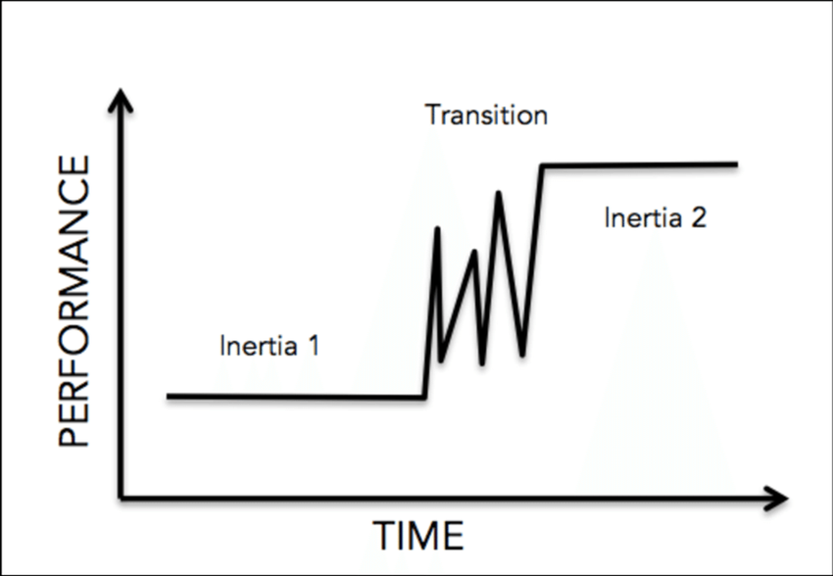
Punctuated-Equilibrium Model (Gersick, 1988; 1989)
Gersick model can not be applied in this case study, because the team is working over than two months and never meet as a team due to Covid-19 restriction. According to the model, the framework of behavioural models and proposals, through which the group approaches the godfather of the project, is based on its purity and remains so through the first half of its life. Also there is limited time for Abdul and his project.

What are the types of roles needed to create an Effective Team?

To create a cohesive and effective team, Abdul need to apply Belbin’s Team Roles. That roles of behavioural attributes are identified by Dr Meredith Belbin’s research at Henley as being effective in order to facilitate team progress.
The types of behaviour in which people engage are infinite. But the range of useful behaviour which make an effective contribution to team performance, is finite. This behaviours are grouped into a set number of related clusters , to which the term “Team Role” is applied.
(Belbin,2010,p.115)
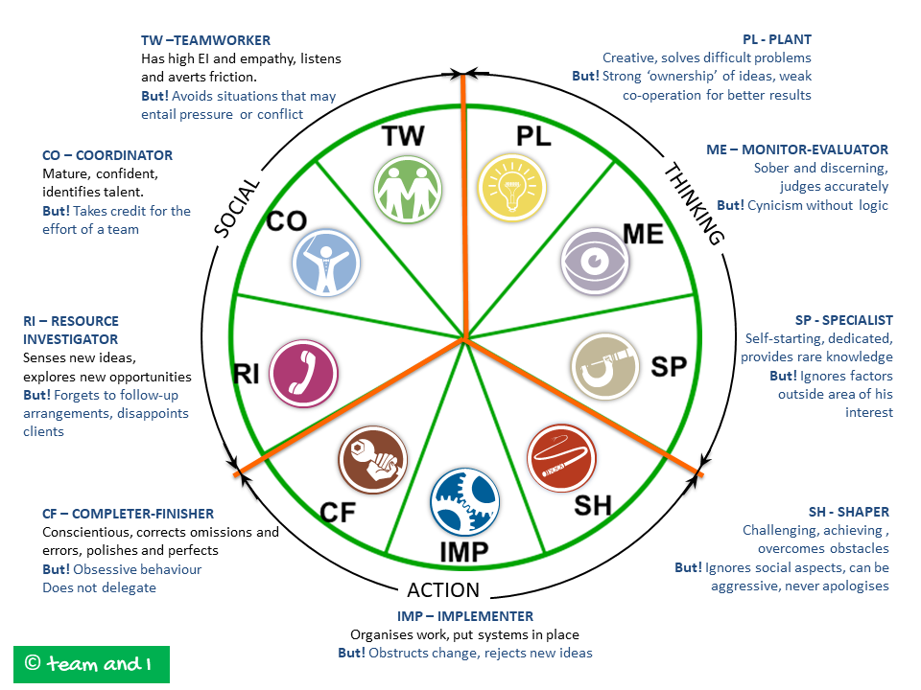
According to Belbin (2010), research estimates that many teams are made up of people with similar mindsets. This is not surprising, because we are usually attracted to or like people who are like us. However, such teams are seldom as effective as teams made up of different talents and personalities. Gather several individualistic people of ideas in one place and be sure that conflict will be inevitable. To achieve synergy, you need a balance in which the strengths and abilities of each individual complement each other and the total energy of the team is greater than the sum of individual efforts. Individual weaknesses can be tolerated and compensated, as long as there is someone else in the team who has the appropriate strength. Team roles are crucial for successfully completing the task. They support the clear achievement and achievement of team goals. Team roles bring balance and help structure people working together. Every role in the team is vital for the successful achievement of goals. In order to properly differentiate the team roles in a team, it is necessary to study its weakness and needs. We need to identify potential areas of conflict that may arise in the team and resolve them. For example, if a team has too many coordinators, they can weaken it by pulling each team to achieve their idea or goal. That is why it is important to know the team roles well and to consider which of them are suitable for building the team and the work that needs to be done.
It’s very important to consider a team role when we hire new employees. First we need to be sure what we want and why we hire. Expanding the business or position where need improvements? When hiring employees, one of the most obvious recruitment criteria is identifying the candidates' qualifications, not only for the position on offer, but also those that will help them thrive in your company. In addition can be applied Belbin test for defining a role and join a team where is a room for improvements, current team with the missing role, or creating a new effective team.

Discussion

What type of impact can effective teamworking have on team success?

To make effective teams, it is essential to keep multiple contexts that support the business capability to innovate, assure roles that match the staff’s abilities, enhance work satisfaction, and make suitable and tangible aims for professional development. Successful teams, be they marketing, sales, or any other business area, are prepared of skilled people and exemplary leaders: high workability relates to the professional's technical qualifications and a pleasant business environment, tools appropriate and stimulated individuals. Personal growth chances are necessary to assure the development of the team. But performance should occur sustainably and be supported through good leadership exercises (Susan, 2015).
Teams focus on being further competitive and innovative when they make multidisciplinary teams that comprise particular profiles. Such multiplicity supports brainstorming and coordination. In addition, every individual has a specific context, supported by their life knowledge and experiences. When such concepts are added combined, the context and chances improve: creative ideas and responses to particular issues appear (Scott and Eduardo, 2020).
Collaboration supports the deliveries agility, meeting deadlines, quality of outcomes, and overall performance. When a group member has issues, the other experts can help and even change them, as they recognise the work and understand how to make it. Teamwork also makes a feeling of belonging that support expert to identify their part of responsibility in the search for effective outcomes. When one realises that his work is appreciated and focuses on something more significant—and same to what other team associates do, every element of the whole feels further stimulated to perform better (Pabini, 2017).
Successful teams have revealed the dynamics of effective relationships. It begins with the theory that it is essential to regard variations and improve personal abilities, but with a concentration on the cohesion necessary to get the aims (Scott and Eduardo, 2020).
Using formulating excellent and effective communication, the possible impacts are the following.
Proper delegation of tasks after the formulation of good and effective communication. Abdul may easily delegate the task to each personnel. He can easily explain their job description by utilising the communication model. As a result, the team will have a better understanding of the deliverables and how each procedure will be implemented for the success of the event project (Scott and Eduardo, 2020).
An exemplary implementation of procedures and accurate execution of the project. Since the delegation of tasks has been clearly defined and the roles, the impact will most likely be positive. Furthermore, the implementation of the project can run smoothly; the procedures will be implemented without difficulties with the help of personnel assigned in specific areas with the assistance of an extended team (Susan, 2015).

What are the barriers to effective teamworking identified in this scenario?

The common barriers recognised for proper coordination comprise insufficient respect and faith, particular mind-sets, poor listening ability, knowledge lack, imperfect alignment around aims, knowledge hoarding, business silos and physical separation, which refers that another essential aspect for the group to perform a suitable presentation is to get combined physically and recognise strengths and weaknesses of every member (Drew and Greg, 2019). Other barriers to effective teamwork may include people presenting priority to their intentions despite the work, not considering the aim effectively, their responsibilities, not being skilled on the subject, poor communication, insufficient discipline and punctuality, and even their loss of intention completely.
As presented in the case study above, the problem occurred due to the existence of the current pandemic. Team working physically are limited. Thus, the workforce failed to develop a high level of concern for each other, resulting in production delays and failure to comply with the deadlines.
The success of the project relies on the effective communication of the team. The presented scenario above requires teamwork and effective communication, but the team failed to do so since the team seems to be unconcerned when someone asks for help. As a result of this barrier, the workforce could not meet the objectives (Drew and Greg, 2019).

Conclusion and Recommendations

In conclusion, a group by a diverse context can perform very well combined if they go through a couple of phases and begin by understanding each other. Abdul and his team must have a minimum of one session to understand each other through different games and communication to perform successfully. The essential abilities recognised for effectively functioning within a diverse group comprise teamwork, communication, patience and consideration. However, there are different issues, the advantages and working rewards in a diverse, creative and innovative group are worth it. Moreover, it is a suitable exercise for the future profession that have a critical working chance in a job with individuals by particular contexts and cultures. Abdul can establish a successful team using the theory explained earlier if they manage to cross the barriers that may guide an ineffective team working if they recognise the correct responsibilities for every member and understand how effective team working can affect the team success. Based on the scenario, Abdul received complaints about a poor level of communication. Thus, it is recommended for this project to develop sound and effective communication for the team's better performance. Abdul may formulate a communication model that will accurately address the lack of communication.
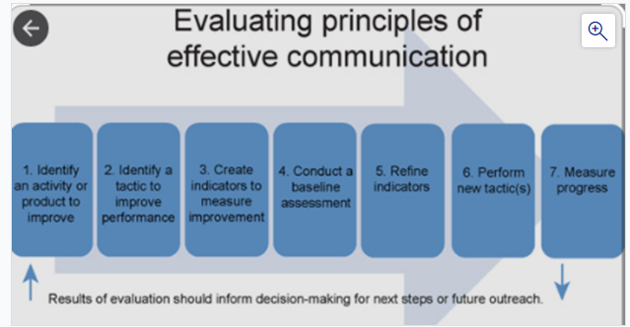
Measures an activity or tactic to indicators to baseline indicators new tactic(s) progress product to improve measure assessment improve performance improvement Results of evaluation should inform decision-making for next steps or future outreach (Susan, 2015). Another recommendation can be made by splitting the hole team to sub teams (3 teams by 6 persons ). This will allowed Abdul to apply easily Belbin’s roles and help each person to engage with the task. However, this will lead to successfully accomplished common goal, in this case study – project for Vodafone UK- community event.

References

Amy C. Edmondson, 2012, Teaming: How Organisations Learn, Innovate, and Compete in the Knowledge Economy, Publisher John Wiley & Sons
Andrew C. Hurt and Sarah M. Trombley,2007, The Punctuated-Tuckman: Towards a New Group Development Model, Texas A&M University
Created from trinity on 2021-09-18 13:29:19.
Drew D'Agostino, Greg Skloot, 2019, Predicting Personality: Using AI to Understand People and Win More Business, Publisher John Wiley & Sons
Griffith, BA, & Dunham, EB 2014, Working in Teams : Moving From High Potential to High Performance, SAGE Publications, Thousand Oaks. Available from:
J. Richard Hackman, 2002, Leading Teams: Setting the Stage for Great Performances, Publisher Harvard Business Press
Meredith Belbin, Team Roles at Work (Routledge – Taylor & Francis, 2nd ed., 2010.) ISBN 978‐1‐85617‐800‐6 (Originally published, 1993)
Pabini, G.P. 2017, Overcoming common barriers to collaboration, available at: https://www.uxmatters.com/mt/archives/2017/10/overcoming-common-barriers-to- collaboration-part-1.php (Accessed at 15 Oct 2021)
ProQuest Ebook Central. [18 September 2021].
Reynolds, K. 2018, 13 Benefits and challenges of cultural diversity in the workplace, available at: https://www.hult.edu/blog/benefits-challenges-cultural-diversity-workplace/ (Accessed at 8 Oct 2021)
Scott Tannenbaum, Eduardo Salas, 2020, Teams That Work: The Seven Drivers of Team Effectiveness, Publisher Oxford University Press
Susan McCahan, 2015, Designing Engineers: An Introductory Text, Publisher John Wiley and Sons
Sven Rosenhauer, 2008, Teams and Teamwork as the Basis of Effectiveness, Publisher diplom.de R.

