

Task 1 – Reading Task Template
Upload your photo of your A3 in-class notes here:
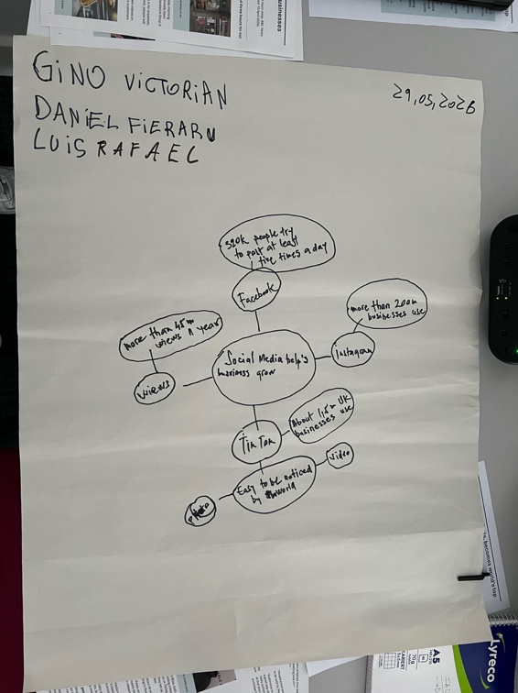
Gino Victorian Tinca 2539736
1. Answer these questions using the sentence starters below
a. What is the main idea of the text?
Social media helps businesses to grow
b. What are two key points?
One key point is that social media platforms like TikTok and instagram made it easier for businesses to become seen by the world and become a viral trend, on a 09:00 Tuesday morning , a bunch of customers have already been at the Honywood Sandwich shop in Basildon due to their viral videos witch made customers from far away to come and check their viral sandwiches.
Another key point is that Honywood Sandwich shop does post videos about their sandwich, but their customers post their sandwich too because the hype trend that made their sandwiches be all over the social media , which has helped them to make their sandwiches even more viral over the social media witch has helped them to bring new customers from everywhere.
c. What part of the text did you find most important? Why?
The most important part is to be constant and active in the social media promoting your business and services , by doing this your business is always over the social media and if you have inventive ideas of promoting your business you will have constant new customers checking out your business and your services, of course this will only work out if you provide excellent customer service and products.
d. Was anything unclear or difficult to understand?
I was not sure about what I had to do at the start for this task and where to find all the key information, but by reading more I started to understand what the key information is, and useful data to take notes and formed a diagram with all the key information.
e. How did your group help you understand the text better?
My group helped me by reading the text with me and analysed all the data, facts, and key information together , by having a conversation about this key information we came to an agrement, and we started to write the notes that we founded more important in the texts provided to us in class on a a3 sheet , this is provided above as a picture.
3. One sentence reflection
Question: What did you find challenging about this task?
The hardest part was at the start of the task to find some pieces of important information that are useful to take notes , but once I started to read the whole text I started to comprehend more about the task, what the key information is, the main idea and the data, in class I felt like I didn’t have enough time to understand the whole task and I didn’t catch all the information, but once I started to read it again in my own time I feel now that I understand what the information and data is.

