Event Plan Document

1. Executive Summary

This document serves as the event plan for the chosen live event. It outlines the planning, organisation, and delivery of the event, covering key elements such as the event overview, programme, aims and objectives, project planning techniques using the EMBOK framework, market research, marketing strategy, budget and financial planning, risk management, contingency planning, evaluation methods, and sustainability considerations. The plan is designed to ensure the event is delivered efficiently, safely, and to professional event management standards.
Events are temporary occurrences with a finite duration, and for planned events this is usually fixed and publicised (Getz, 1997, p. 4). Getz (1997) further notes that “events are transient, and every event is a unique blending of its duration, setting, management, and people.” The UK events industry in 2026 is shaped by key trends including artificial intelligence, sustainability, and high-impact, smaller-scale, experience-led gatherings (Brookes, 2026).

2. Event Management Plan

For the Live Events module, “The Feel-Good Health & Wellness Fayre” will be hosted at the University of Wales Trinity Saint David (UWTSD), taking place at the Innovation Matrix Building and Y Fforwm on the SA1 Campus. The event will be delivered by a team of five students, including myself, who will collaboratively plan, organise, and manage all aspects of the Fayre to ensure its successful delivery.
The event is designed to promote engagement with physical, mental, and emotional wellbeing among the target audience, which includes university students, staff, and members of the wider community. The Fayre will encourage participation through a variety of interactive and informative activities, structured around key attendee motivations such as social connection, learning, and personal growth (Meeting Hand, 2026). Attendees will have the opportunity to participate in group activities, expert-led sessions, and immersive wellness experiences, as well as network with health and wellbeing vendors, explore or purchase wellbeing products, or simply enjoy a relaxed conversation over coffee. Through these experiences, the event aims to support individuals in enhancing their wellbeing while fostering a strong sense of community. As health and wellbeing continues to grow as a prominent social focus, the theme of the Fayre is both timely and relevant for the university and the wider public.

The event will be open to the public from 10:00am to 4:30pm, with vendors arriving from 8:00am to allow sufficient time for set-up. From 10:00am to 4:00pm, vendors will be located within the Innovation Matrix Building, where attendees can explore stalls and engage with a range of health and wellbeing services and organisations.

A raffle draw will take place at 12:30pm in the Innovation Matrix Building, providing an opportunity for attendees to participate and win prizes. From 1:00pm onwards, a programme of wellbeing activities will take place in the immersive room at Y Fforwm, offering attendees the opportunity to take part in interactive sessions designed to promote relaxation, learning, and personal wellbeing.

3. Aim and Objectives

Aim:
The aim of this project is to plan and deliver a successful Health and Wellbeing Fayre that promotes physical, mental, and emotional wellbeing while generating revenue through ticket sales.

Objectives:
- Plan, organise, and deliver a Health and Wellbeing Fayre to professional standards.
- Attract lecturers, students, and the public through marketing, promotion, and ticket sales.
- Provide engaging health and wellbeing activities that educate and inspire attendees.
- Facilitate networking between health professionals, wellbeing practitioners, and the local community.
- Ensure a positive and enjoyable experience for all participants.

The objectives were developed using the SMART framework. They are specific in clearly defining the event goals, measurable through attendance figures and participant feedback, achievable within the available resources, relevant to promoting community wellbeing, and time-bound with clear deadlines for planning, delivery, and evaluation (Chartered Management Institute, 2014).

4. Project Planning Techniques

An event process refers to the series of structured steps and activities involved in planning, organising, and delivering an event. Each event is unique, which means that planning is not a one-off task but a continuous process that extends from the initial concept or bid all the way through to post-event evaluation and feedback (Catherwood & Van Kirk, 1992, p. 5). As emphasised by Catherwood and Van Kirk, “Without planning it is possible that the finished product will disappoint not only the intended audience, but also the organising bodies themselves.” This underscores the critical importance of thorough preparation to meet both stakeholder expectations and event objectives.

The project group will examine, analyse, and evaluate each aspect of event management using the event project life cycle as a guiding framework. This life cycle typically consists of five sequential stages: initiation, planning, execution, monitoring and control, and project closure. Each stage plays a distinct role in ensuring the event progresses effectively from initial concept through to completion (See Figure A; Brown, 2026).

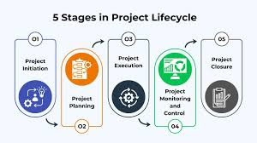
Figure A. Project Management Life Cycle
Source: Brown (2026)

The event planning process can be further broken down into practical stages such as concept development, logistics coordination, marketing, operational planning, and post-event evaluation (see Figure B; Faster Capital, 2026).

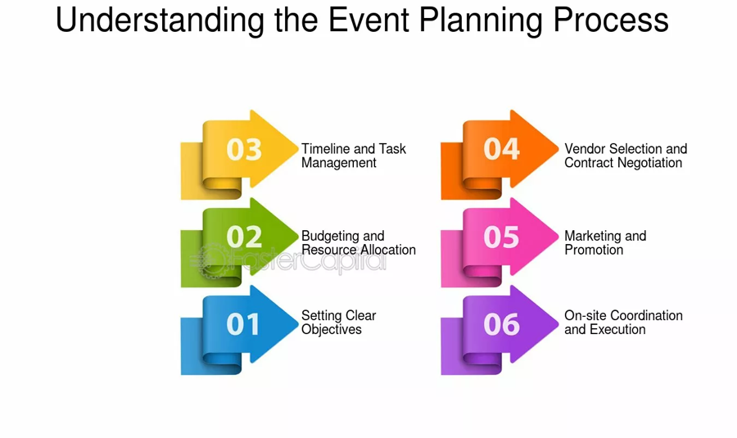
Figure B. Event Planning Process Stages
Source: Faster Capital (2026)

To successfully organise the Health and Wellbeing Fayre, a range of project planning techniques will be employed. These techniques structure the planning process, clarify responsibilities, and ensure that every aspect of the event is carefully managed. A combination of project management tools and the EMBOK (Event Management Body of Knowledge) framework will guide planning, execution, and post-event evaluation.

The EMBOK (Event Management Body of Knowledge) Framework provides a structured approach to managing the event, ensuring that all critical aspects of the event are addressed systematically. Within this framework, administration oversees planning, coordination, scheduling, budgeting, and logistics to ensure resources are used efficiently. Design shapes the event concept, theme, decorations, branding, and attendee experience, creating an engaging and welcoming environment. Marketing promotes the Fayre, attracts participants, and secures sponsorships, while operations manages venue setup, equipment, staffing, health and safety, and the smooth execution of on-the-day activities.
Risk management is integrated throughout the planning process, identifying potential hazards such as technical failures, safety incidents, or weather disruptions and developing contingency plans to mitigate them. By applying the EMBOK framework, the Health and Wellbeing Fayre can be delivered professionally, providing a safe, enjoyable, and informative experience for all participants (Silvers, 2003).

A Work Breakdown Structure (WBS) will be applied to the Health and Wellbeing Fayre to divide the event into manageable tasks, including concept development, marketing, venue booking, workshop coordination, and event logistics. Responsibilities will be allocated to specific team members to ensure accountability and maintain a smooth workflow, supporting the successful delivery of this small-scale Fayre. This structured approach helps ensure that all critical aspects of the event are addressed. Using a WBS increases the likelihood that tasks are clearly defined, guides task allocation, provides clarity on which tasks should be handled in-house or outsourced and presents a detailed understanding of time, budget, and resources This ensures that the Fayre can be delivered efficiently while providing a professional and enjoyable experience for attendees (See Figure C).
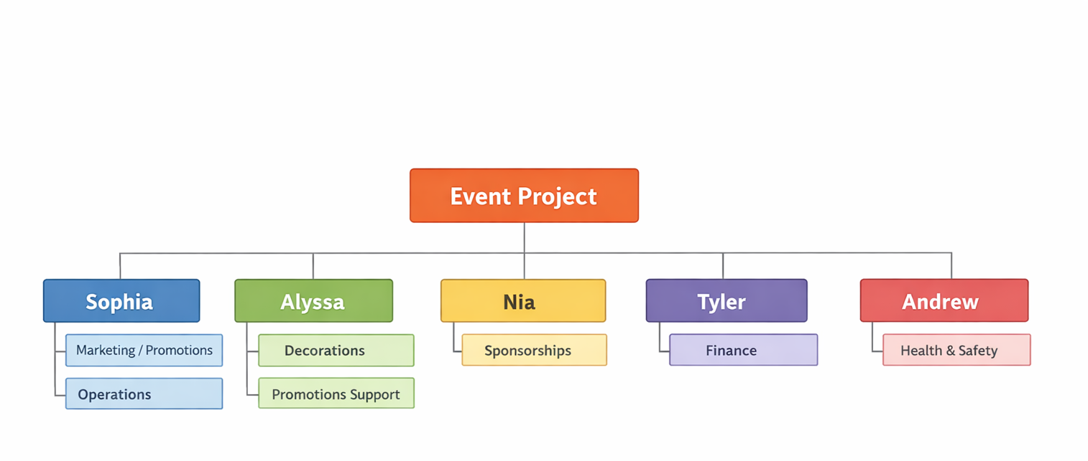
Figure C. A Work Breakdown Structure (WBS)

A Critical Path Analysis (CPA) is a planning and scheduling tool that can help streamline all the processes to be undertaken (Getz, 1997). CPA examines the relationship between all resources and activities required to deliver the event.

A Gantt chart provides a visual timeline of all planning activities for the Health and Wellbeing Fayre, displaying tasks, durations, start and end dates, and dependencies along a horizontal timeline. This allows the team to understand task sequencing and monitor progress throughout the project.
Using a Gantt chart has helped to visually summarise the overall event schedule, serve as an effective communication and control tool, identify potential problem areas or scheduling conflicts, and adapt readily to all aspects of the event. It also provides a summary of the event’s history and clearly defines everyone’s responsibilities while showing how tasks relate to one another (Team Gantt, 2026), (See Figure D).

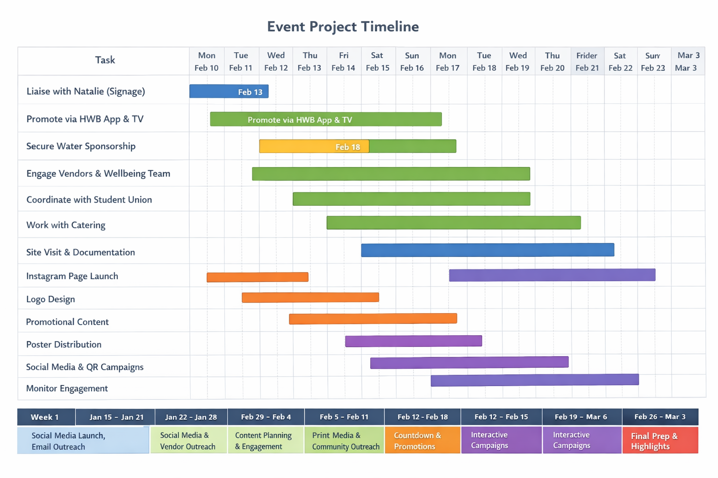
Figure D. A Gantt Chart for Marketing Roles and Responsibilities

A detailed running order will be developed for the Health and Wellbeing Fayre, outlining the full schedule of activities, including registration, workshops, keynote sessions, networking breaks, and closing remarks. This ensures that the event runs smoothly and that all staff and volunteers are fully aware of their responsibilities and timings. By providing a clear structure for the day, the running order supports efficient coordination, reduces the risk of delays, and enhances the overall attendee experience (See Figure E).

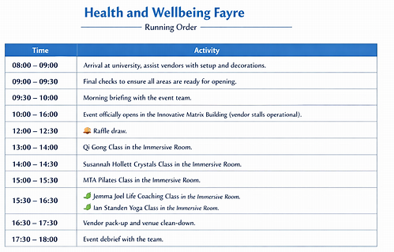
Figure E. Running Order

The event process and planning techniques outlined above form the foundation of this document, which serves as the Event Plan for the Health and Wellbeing Fayre. By combining structured project management tools with the EMBOK framework, this plan ensures that all stages of planning, organisation, delivery, and evaluation are carried out systematically and in accordance with professional event management standards.
5. Market Research & Target Audience
A comprehensive market analysis was conducted to identify key consumer groups and evaluate local health and wellbeing events in Swansea and surrounding areas. The research identified three primary target audiences: students seeking personal development, stress relief, and engagement in wellbeing activities; UWTSD staff interested in health and wellbeing; and members of the general public interested in wellbeing practices. As Alastair M. Morrison (2013) highlights, audience segmentation enables marketers to tailor campaigns to meet specific consumer needs and increase engagement. Developing a structured approach to market research was therefore essential. This process drew on detailed knowledge of the target market, including demographics, age groups, psychographic traits, and previous event participation, helping to identify the most likely attendees.

Competitor analysis revealed a strong local market. Regular events organised by Cariad
Events, The Wellbeing Health Centre Swansea, and Lush attract significant participation through specialised wellness offerings (Event Brite, 2026). This analysis demonstrated clear demand for health and wellbeing events in the area, with many events frequently reaching high attendance levels and several Eventbrite listings nearing sell-out. These findings indicate that the proposed Feel-Good Health and Wellbeing Fayre has strong potential for success within the Swansea events market.

The fayre aims to differentiate itself by providing an affordable and inclusive wellbeing experience. Insights from competitor events helped shape a clear unique selling proposition (USP), ensuring the fayre stands out in the local market. The event will feature interactive workshops, educational sessions, practical activities, and an immersive room experience, creating a unique and engaging environment. Further research into consumer preferences highlighted a strong demand for experiential and interactive events that promote relaxation, mental health, and self-care. Affordability, accessibility, and a welcoming atmosphere were identified as key factors influencing engagement. These insights informed the event design, ensuring it meets audience expectations while maintaining competitive positioning. Additionally, careful scheduling was essential to avoid clashes with similar events, protecting attendance and overall success.

Market research for the fayre will also focus on observing consumer experience, attendee motivation, and marketing effectiveness. This includes evaluating registration processes, engagement in sessions and activities, participant satisfaction, and opportunities for social interaction. Understanding how attendees engage with both physical and digital aspects of the event is increasingly important, as technology shapes participant experience (Chen, Jung & Cai, 2025). By systematically collecting this data, event managers can gain insights into participant needs and preferences, refine marketing strategies, and enhance the overall event experience for future initiatives.

6. Event Marketing Plan
Social media platforms were used as key marketing channels, including Instagram, Facebook, and LinkedIn. Instagram served as the primary platform, as analytics indicated it generated the highest level of engagement and audience reach. In addition, emails were sent to vendors to inform them about the event and encourage participation. Eventbrite was also utilised to advertise and sell tickets. Furthermore, flyers were distributed across local businesses to increase awareness and promote the event within the local community.
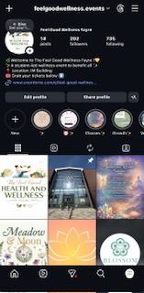
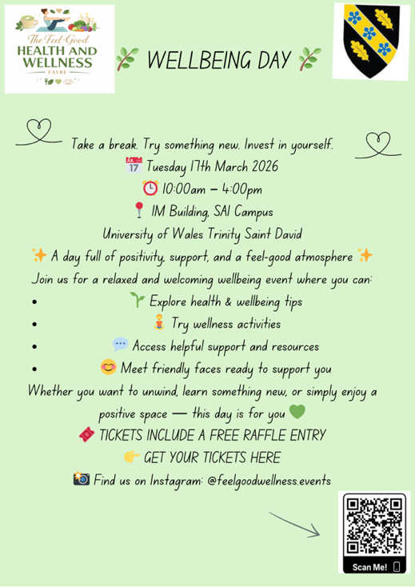
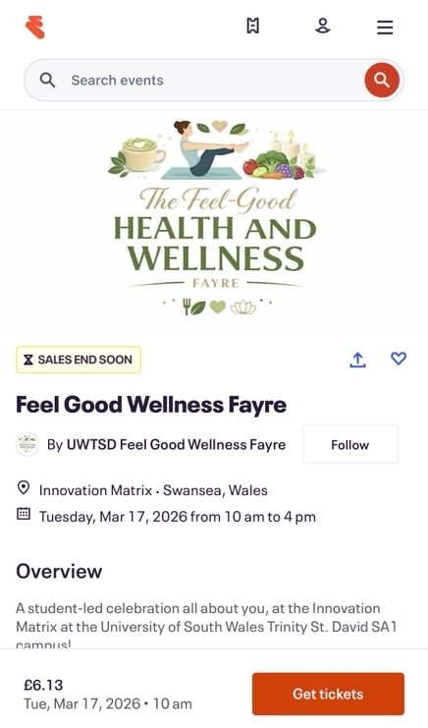

Figure. F- Promotional Materials
A comprehensive marketing plan was implemented to ensure the Health and Wellbeing Fayre reached its target audience, generated ticket sales, and built awareness of the event. This included a combination of digital marketing approaches, such as social media campaigns, and traditional marketing methods, including posters, local promotions, and partnerships. The SOSTAC model provides a structured framework for marketing planning, consisting of six stages: situation analysis, objectives, strategy, tactics, action, and control (Chaffey, 2023). This framework guided the marketing planning process for the Health and Wellbeing Fayre, ensuring that market research, promotional activities, and post-event evaluation were carried out systematically (See Figure G; Mishra, 2023).
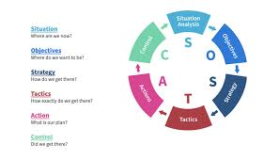
Figure G. SOSTAC Marketing Planning Model
Source: Mishra (2023)
The marketing plan incorporated both the traditional marketing mix—product, price, place, and promotion and Getz’s four additional Ps: Programming, which included workshops, immersive experiences, and educational sessions; People, such as the audience, hosts, facilitators, and guest speakers; Partnerships, involving stakeholders like the university’s Wellbeing Team; and Packaging, covering ticket distribution and accessibility. Market segmentation considered geographic, demographic, psychographic, and behavioural factors, defining the target audience as students, UWTSD staff, and the general public with an interest in health, wellbeing, and personal development, following the principles of the marketing mix outlined by Salesforce (no date).
The Health and Wellbeing Fayre was designed as a comprehensive event promoting holistic wellbeing, encompassing physical health, mental health, lifestyle improvement, and personal development. Attendees have the opportunity to participate in interactive workshops, access educational sessions, meet expert facilitators and guest speakers, and engage with both university and community wellbeing initiatives. The marketing plan ensured that the event effectively reached its intended audience, maximised engagement, encouraged participation, and raised awareness of available wellbeing services and activities, following the principles outlined by Getz in 1997.

Promotional Timeline
The following timeline provides a structured overview of the Health and Wellbeing Fayre’s promotional and operational activities, outlining the week-by-week initiatives across social media, vendor engagement, community outreach, email marketing, and event preparation that I have prepared.
Week | Dates | Key Activities
1 |  | Social Media: Launch on Instagram, teaser posts; Email Outreach: Invite vendors/partners, share stall/workshop info
  15th–21st January 2026
2 | 22nd –28th January 2026 | Social Media: Instagram + Facebook/LinkedIn posts; share tips, teaser images/videos; Engagement Monitoring; Vendor Follow-Up
3 | 29th January – 4th February 2026 | Social Media: Highlight workshops & community features; share vendor quotes; Vendor/Partner Engagement: Confirm participation; Content Planning: Draft visuals & online ads
4 | 5th –11th February 2026 | Social Media: BTS content & vendor highlights; Flyers/Print Media: Finalise design & distribution; Community/Vendor Outreach: Invite local gyms/orgs; Content Scheduling: Plan online ads & email updates
5 | 12th –18th February 2026 | Social Media: Countdown & highlight confirmed vendors; Flyer Distribution: Campus & local businesses; Community Engagement: Encourage local participation; Vendor Follow-Up & Email Marketing
6 | 19^{th-} 25th February 2026 | Social Media: Interactive content & vendor spotlights; Targeted Ads: Instagram, Facebook, LinkedIn; Community Engagement: Promote collaborations; Vendor Follow-Up & Email Marketing
7 | 26th February – 3rd March 2026 | Social Media: Event highlights & countdowns; Vendor Coordination: Final logistics; Content Prep: Final visuals; Community Outreach: Promote attendance
8 |  | Social Media: Final push, countdowns & teasers; Email Marketing: Reminders with event info; Vendor Coordination: Confirm setup & materials; Community Outreach & Event Prep
  4th –10th March 2026
Final | 11th March- 17th March 2026 | Social Media & Email: Last-minute reminders; Vendor/Partner Check-ins: Confirm logistics; Community Engagement; Event Day (17 Mar): Setup, staff coordination, on-site promotions, post-event follow-up
Key messages and branding positioned the Health and Wellbeing Fayre as an inclusive, interactive, and educational wellbeing experience, emphasising positivity, accessibility, and community engagement. Sponsorship and partnership strategies focused on collaboration with local gyms, wellness centres, health brands, and the university’s Wellbeing Team, providing opportunities for stalls, workshops, and branded sessions to enhance visibility. This integrated marketing approach ensured the fayre effectively reached its target audience, maximised engagement, and strengthened its presence within both the university and the wider community.
7. Budget & Financial Plan
A comprehensive financial and operational plan was essential to ensure the Health and Wellbeing Fayre was delivered successfully, efficiently, and in a financially sustainable manner. While no direct costs were incurred for the venue, equipment, marketing, staffing, or catering, careful planning, sponsorship, and collaboration were key to maximising resources and delivering a high-quality event.

Projected Income
- Ticket sales via Eventbrite
- Sponsorship contributions from local businesses, wellness centres, and community organisations
- Optional donations from attendees and supporters

Expenditure and Resource Management
- Venue & Equipment: Use of the Innovation Matrix, including tables and chairs, was coordinated with the university’s operations team at no cost
- Marketing & Promotion: Branded items, decorations, and promotional materials were funded through sponsorship and collaboration with the Health and Wellbeing Team
- Staffing & Security: Volunteers and university support provided staffing and event management at no additional cost
- Catering & Logistics: Instead of providing refreshments, attendees were directed to the building’s café, reducing overheads while maintaining a positive attendee experience
- Contingency: Minimal, as all major resources were covered through sponsorship or university support

Budget Management & Personal Contribution
In my role overseeing the marketing budget, I secured additional sponsorship funding to cover decoration costs, branded hoodies, and promotional materials. In my operational role, I collaborated with the university’s operations and catering teams to arrange venue use, coordinate setup, and optimise logistics. These efforts maximised event impact while ensuring financial sustainability.

Budget Reporting & Financial Tracking
A detailed budget report was maintained throughout planning and delivery to track sponsorship contributions, resource allocation, and logistical arrangements. This ensured transparency, accountability, and informed decision-making, providing a clear framework for successful event delivery.
8.Risk Management & Health & Safety
The Health and Wellbeing Fayre will be managed to ensure the safety, wellbeing, and protection of all attendees, staff, and volunteers through a comprehensive risk management approach. Key health and safety risks including slips, trips, medical emergencies, fire hazards, and crowd control—will be mitigated through clear signage, unobstructed walkways, trained first aid staff, fire safety protocols, and controlled attendee movement.

In my operations role, I collaborated closely with the university’s operations and catering teams to implement these measures, coordinating venue layout, emergency access, and safe traffic flow to minimise hazards. I also ensured that logistical decisions, such as table and chair placement and directing attendees to the café for refreshments, contributed to a safe and organised environment.
In my marketing role, I contributed to managing risks related to privacy, data, and communications. Attendee photos were handled responsibly by obtaining consent, blurring faces when necessary, or using stock images, and all social media and marketing messaging was carefully monitored for accuracy to prevent misinformation. Additionally, sponsorship and budgeting risks were mitigated through proactive financial planning, reporting, and contingency strategies, ensuring resources were allocated effectively without compromising safety or quality.

Environmental risks, such as adverse weather or sustainability challenges, were addressed through contingency arrangements and responsible practices. By linking operational logistics and marketing oversight to risk management, the event maintained continuity, protected its reputation, and created a secure, professional, and welcoming environment for all participants (Getz, 2007).

9. Contingency Planning

Contingency planning was integral to ensuring the Health and Wellbeing Fayre ran smoothly despite unexpected disruptions. In my operations role, a backup venue at the Dylan Thomas Centre was arranged to provide an alternative location if required. In my marketing role, a crisis communication plan ensured timely and accurate updates to attendees, staff, and stakeholders via email, social media, and on-site announcements, addressing potential misinformation or unforeseen incidents. Together, these measures created a resilient and adaptable framework, enabling a safe, professional, and engaging event under all circumstances.

10. Evaluation Strategy

A structured evaluation strategy will be implemented to assess the success of the Health and Wellbeing Fayre and provide actionable insights for future events. In my role as a marketing professional, I will oversee the post-event phase to maximise learning and value. Attendee feedback will be collected through online surveys using Google Forms to understand satisfaction, engagement, and suggestions for improvement. Key performance indicators (KPIs) such as attendance figures, ticket sales, social media engagement, and participant satisfaction will be measured to evaluate overall success, with attendance tracked exclusively through digital ticketing on Eventbrite. Additionally, post-event questionnaires will be distributed to both attendees and vendors to gather further insights. This systematic evaluation ensures continuous improvement, optimises audience experience, and strengthens marketing effectiveness, in line with Bowdin et al. (2011), who emphasise that post-event analysis enhances planning for future events. A post-event debrief meeting will be conducted by the group to review the event’s performance, assess what worked well, and identify areas for improvement (See Figure H).

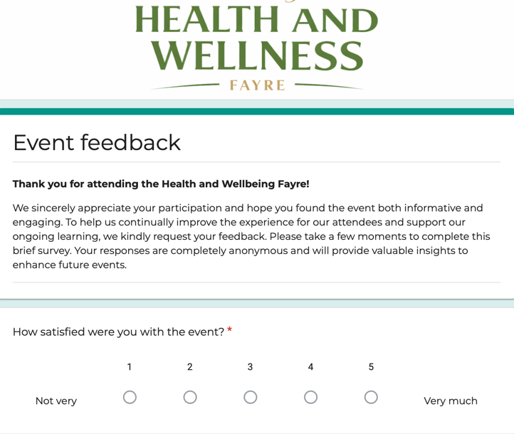

Figure H – Post-Event Evaluation Questionnaire

11. Sustainability & Event Legacy

According to Ashwin (2023), sustainability and legacy are fundamental in event planning, focusing on reducing environmental impact and creating lasting social and economic benefits. Sustainability was a priority when selecting both the venue and vendors, although the limited availability of sustainable options posed challenges. Eco-friendly measures included minimising single-use plastics, promoting digital alternatives in marketing, and reducing waste by donating decorations for reuse at other events. Clearly labelled recycling bins were provided in the venue to encourage proper waste disposal, and eco-friendly transport was promoted through social media campaigns highlighting public transport routes. Digital ticketing via Eventbrite further reduced paper use, and promotional materials were planned with sustainability in mind. While we aimed to use eco-friendly decorations, budget constraints as students made it difficult to fully implement all sustainable alternatives. Incorporating these practices not only minimises environmental damage but also enhances the event’s appeal to environmentally conscious attendees (Mair & Jago, 2010).

12. Key Areas of Managing Event Operations

Accruent (2025) identifies seven key steps involved in planning and managing an event: organising a team, defining event goals and objectives, setting a budget, selecting an appropriate date and venue, planning event details, marketing and promoting the event, and executing and managing the event. These stages will be applied to the proposed health and wellbeing event to ensure it is effectively organised and achieves its intended outcomes. The event will aim to promote both mental and physical wellbeing through activities such as mindfulness sessions, light fitness activities, and information on healthy lifestyle choices. Careful selection of the venue and the use of appropriate promotional channels will help maximise attendance and participant engagement. Following these structured planning stages will support the successful delivery of the event and contribute to a positive wellbeing experience for attendees.

A detailed staff rota was developed to ensure the efficient allocation of roles, responsibilities, and working hours for all event staff and volunteers. This strategic scheduling guarantees that all operational areas of the event including setup, vendor coordination, guest management, health and safety, and marketing are managed effectively. Assigning clear responsibilities ensures accountability, promotes smooth workflow, and minimises the risk of operational issues during the event (See Figure I).

Staff Member | Roles & Responsibilities | Scheduled Hours
Sophia Rabaiotti | Responsible for event setup and decoration to create an engaging environment; managing marketing and promotions, including photography to document the event; supporting vendors as required to ensure timely setup. | Monday 16th March: 5:00pm–7pm (setup in Innovation Matrix Building)  Tuesday 17th March: 8:00 am–5:00 pm
Andrew Jones | Assisting with event setup and decoration; overseeing health and safety protocols to ensure compliance with regulations and minimise risk to participants. | Monday 16th March: 5:00pm–7pm (setup in Innovation Matrix Building)  Tuesday 17th March: 8:00 am–5:00 pm
Nia Mugford | Assisting with setup and decoration; managing the immersive room experience to enhance participant engagement and ensure smooth operation. | Monday 16th March: 5:00pm–7pm (setup in Innovation Matrix Building)  Tuesday 17th March: 8:00 am–5:00 pm
Tyler Condon | Supporting event setup and decoration; managing guest check-in and registration to provide a welcoming and organised start for attendees. | Monday 16th March: 5:00pm–7pm (setup in Innovation Matrix Building)  Tuesday 17th March: 8:00 am–5:00 pm
Alyssa Stoneman | Assisting with event setup and decoration; coordinating vendor setup to ensure all exhibitors and suppliers are ready before the event begins | Monday 16th March: 5:00pm–7pm (setup in Innovation Matrix Building)  Tuesday 17th March: 8:00 am–5:00 pm
Riley Tippett | Supporting decoration and vendor setup to maintain event aesthetics and operational efficiency. | Monday 16th March: 5:00pm–7pm (setup in Innovation Matrix Building)  Tuesday 17th March: 8:00 am–5:00 pm
Poppy | Supporting decoration and vendor setup to maintain event aesthetics and operational efficiency. | Tuesday 17th March: 8:00 am–5:00 pm
Ethan | Supporting decoration and vendor setup to maintain event aesthetics and operational efficiency | Tuesday 17th March: 8:00 am–5:00 pm
Lily Lewis | Supporting decoration and vendor setup to maintain event aesthetics and operational efficiency. | Tuesday 17th March: 8:00 am–5:00 pm
Figure I. Staff Schedule and Responsibilities for Event Management

This rota ensures that every aspect of the event is covered, from aesthetics and immersive experiences to safety and logistics. By clearly defining roles and allocating appropriate timings, the event team can operate efficiently, respond to unforeseen challenges, and provide attendees with a seamless and professionally delivered experience.

Logistics and on-site management are critical for the health and wellbeing fayre, encompassing essential functions such as transportation of equipment and materials, crowd control to maintain a safe environment, technical setup for workshops or interactive demonstrations, and equipment handling to ensure smooth delivery of activities. Equally important is stakeholder coordination, which involves liaising with health organisations, community partners, vendors, and local authorities to align objectives, allocate resources effectively, and address any issues promptly. Together, these operational functions provide the foundation for a well-organised and impactful event, ensuring that attendees can fully engage with wellbeing activities such as mindfulness sessions, fitness demonstrations, nutrition workshops, and health advisory stalls, thereby maximising the event’s benefit to the community.

To meet the requirements of effective stakeholder coordination, engagement with partners, vendors, and authorities is essential to ensure all aspects of the health and wellbeing fayre run smoothly. This involves aligning objectives with local health organisations, wellness practitioners, vendors, and authorities, clarifying responsibilities, allocating resources efficiently, and resolving issues promptly. Effective coordination ensures a safe, well-organised, and engaging experience for all attendees.

13. Division of Work & Responsibilities

Records of all planning meetings were maintained through detailed meeting minutes, which captured discussions, decisions, and agreed actions. These minutes served as a reference for task allocation, deadlines, and follow-up actions, ensuring accountability and continuity throughout the event planning process. Key email correspondence with team members, stakeholders, and external partners was also documented to facilitate effective coordination, confirm agreements, and provide an auditable trail of decisions and approvals, supporting transparency and clear communication. I took responsibility for engaging with potential local vendors, including internal university teams such as the Wellbeing Team and the Student Union. A dedicated event email account was created to manage all vendor communications professionally, ensuring messages were consistent, traceable, and easy to monitor. Meetings with vendors were conducted via email, Microsoft Teams, and in person.

This section outlines the allocation of tasks, responsibilities, and communication strategies used to coordinate internal teams and external vendors during the event planning process. Emphasis was placed on clear documentation, accountability, and efficient collaboration.
I was responsible for engaging with potential local vendors, as well as internal university teams such as the Wellbeing Team and the Student Union. A dedicated event email account was created to manage all vendor communications professionally, ensuring messages were consistent, traceable, and easy to monitor.
Vendor meetings were conducted through multiple channels: email, Microsoft Teams, and in-person consultations (See figure J).

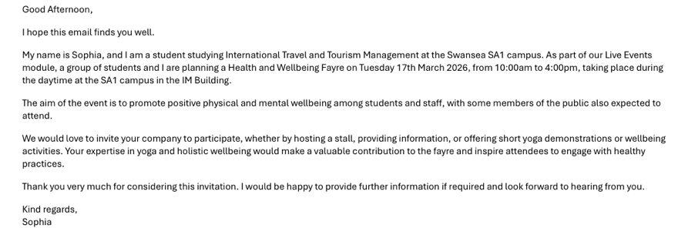

Figure J. Email to potential vendors demonstrating documentation of decisions

An Excel spreadsheet was used to track all vendor responses, monitor pending replies, and ensure timely follow-ups. This enabled efficient management of external partnerships and event resources (See figure K).

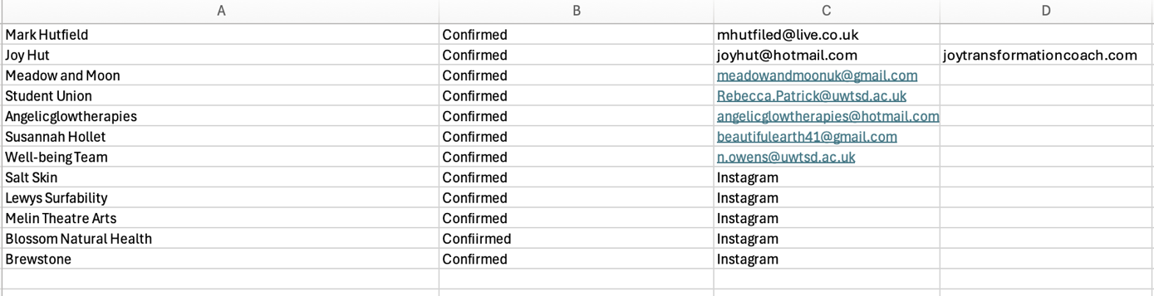
Figure K. Excel spreadsheet with confirmed vendors

Alongside my responsibilities in marketing, I also took on the role of Operations Manager, overseeing all operational aspects of the event. This included coordinating with catering and operations teams via email, Microsoft Teams, and in-person meetings, as well as completing all relevant documentation when required. I collaborated closely with the University’s Operations Manager to plan the event layout for the day, ensuring smooth logistics and a well-organised setup (See figure L)

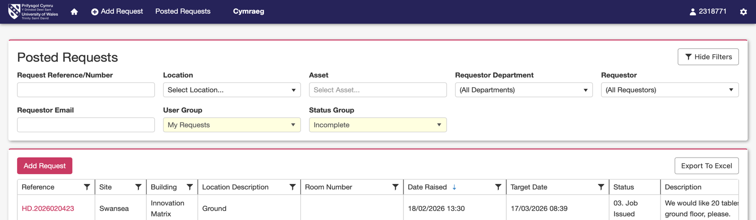

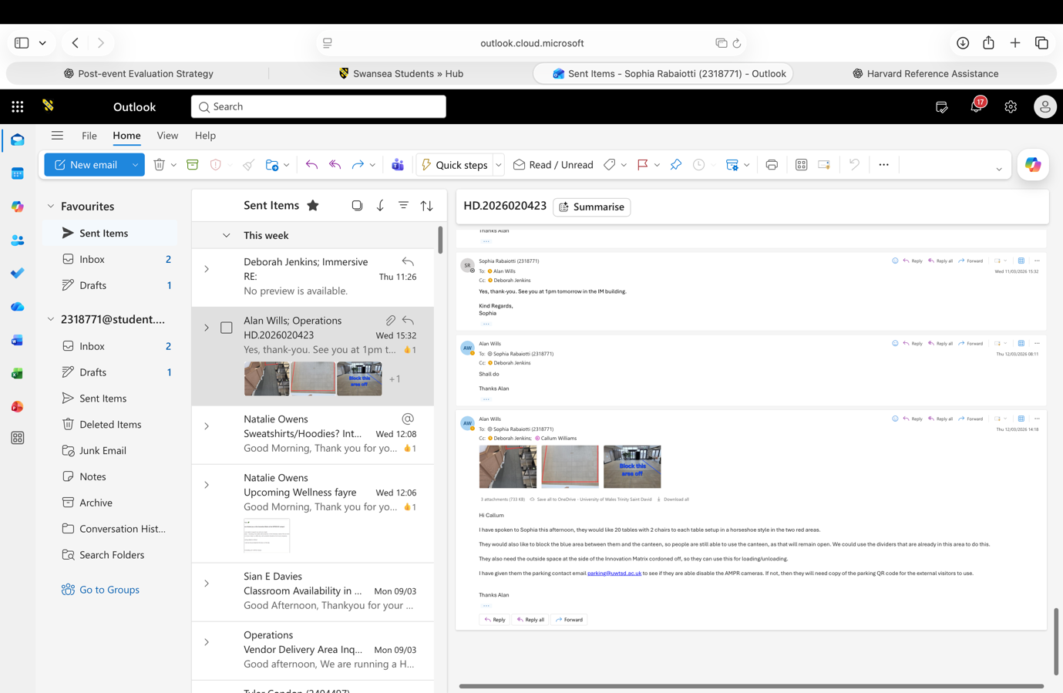
Figure L. Communications with operations

I created an Excel spreadsheet was used to track all vendor responses, monitor pending replies, and ensure timely follow-ups, enabling efficient management of external partnerships and event resources (See Figure M).
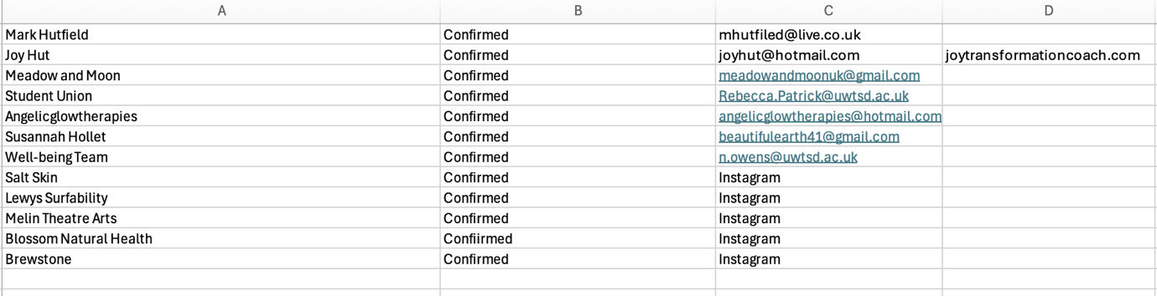
Figure M. Excel spreadsheet with confirmed vendors

I secured sponsorship from the University’s Wellbeing Department, which covered marketing and decoration costs, ensuring the event’s promotional materials and venue enhancements were fully funded without impacting the overall budget (See Figure N).

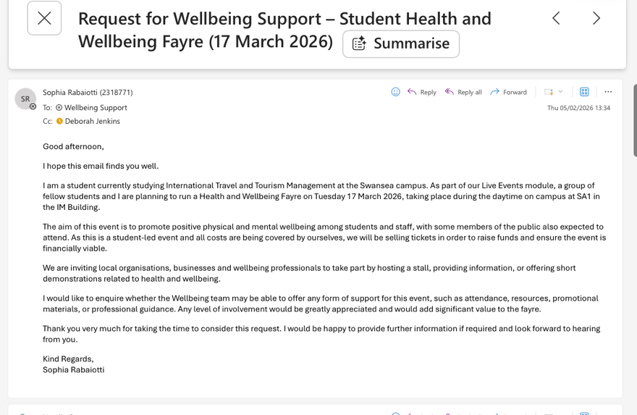
Figure N. Sponsorship email with well-being

I collaborated with the Health and Wellbeing (HWB) Team to promote the event through the HWB app and campus TV screens (Figure O).
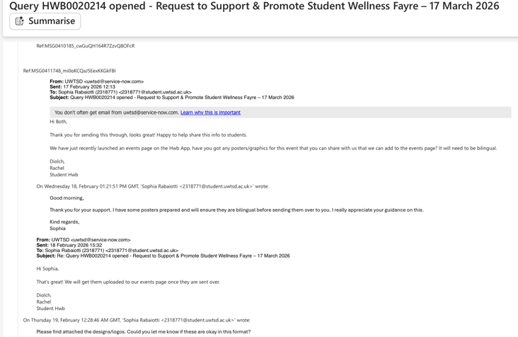
Figure O. Marketing communications

Task assignments were developed to clearly define each team member’s roles and responsibilities, aligning tasks with individual strengths and Belbin Team Roles to maximise efficiency and ensure all operational aspects of the event were effectively managed. Detailed meeting minutes, email correspondence, and clearly defined task allocations supported this process. The Belbin Team Roles questionnaire was used to identify behavioural strengths and weaknesses, enabling leaders to allocate tasks effectively, address skill gaps, improve self-awareness, foster mutual trust, and guide team selection and team building (Indeed Editorial Team, 2025). The event development team followed the standard stages of team formation: forming, storming, norming, performing, and adjourning.

Task Assignments:
- Alyssa: Decorations/ Promotions
- Tyler: Finance/Promotions
- Andrew: Health and Safety
- Sophia: Marketing, /Promotions & Operations
- Nia: Promotions & Immersive Room Leader

Belbin Team Roles:
- Coordinator: Alyssa, Tyler, Sophia – Overall project leadership
- Shaper: Alyssa, Nia, Tyler, Sophia – Driving progress and maintaining team focus
- Plant: Alyssa – Generating creative ideas
- Monitor Evaluator: Tyler, Sophia, Nia – Critically assessing ideas and ensuring quality
- Implementer: Alyssa, Nia, Tyler, Sophia, Andrew – Translating plans into actionable steps
- Completer Finisher: Alyssa – Ensuring all details are perfected
- Supporting Roles:
- Resource Investigator: Alyssa, Sophia, Nia, Tyler – Seeking external opportunities and partnerships
- Teamworker: Sophia, Nia – Promoting collaboration and team harmony
- Specialist: Sophia, Nia – Providing in-depth knowledge in key areas

This structured approach, supported by the EMBOK framework, ensured the team delivered a well-organised, engaging, and strategically marketed event while mitigating risk and maximising collaboration.

This document acts as a framework to guide the planning and execution of the event, ensuring adherence to best practices in event project management. It incorporates the EMBOK framework to support structured planning and effective risk management, while also applying Belbin Team Roles to enhance team collaboration and ensure efficient task allocation.

Reference List

Accruent (2025) Hybrid event management: software solutions & strategies. Available at: https://www.accruent.com/resources/knowledge-hub/event-management-process (Accessed: 10th March 2026).

Ashwin, K. (2023) The importance of sustainability in event planning. Available at: https://www.theeventcompany.com/news/the-importance-of-sustainability-in-event-planning (Accessed: 10th March 2026).

Brookes, C. (2026) 15+ event industry trends for 2026: The ultimate guide. EMS Events. Available at: https://www.ems-events.co.uk/event-industry-trends-for-2026 (Accessed: 13 March 2026).

Brown, L. (2026) 5 phases of project management life cycle. Invensis Learning. Available at: https://www.invensislearning.com/blog/5-phases-project-management-lifecycle/ (Accessed: 5th March 2026).

Catherwood, D.W. and Van Kirk, R.L. (1992) The complete guide to special event management: Business insights, financial advice, and successful strategies from Ernst & Young, advisors to the Olympics, the Emmy Awards and the PGA Tour. New York: John Wiley & Sons.

Chaffey, D. (2023) SOSTAC marketing planning model guide. Available at: https://www.smartinsights.com/digital-marketing-strategy/sostac-model/ (Accessed: 3rd March 2026).

Chartered Management Institute (2014) Setting SMART objectives: Checklist 231. Available at: https://www.managers.org.uk/wp-content/uploads/2020/03/CHK-231-Setting_Smart_Objectives.pdf (Accessed: 6th March 2026).

Chen, J., Jung, S. and Cai, L.A. (2025) ‘A critical review of technology facilitated event engagement: current landscape and pathway forward’, International Journal of Contemporary Hospitality Management, 37(13), pp.169–189.

Eventbrite (no date) Events in Swansea: “The Swansea Wellbeing Centre”. Available at: https://www.eventbrite.co.uk/d/united-kingdom--swansea/%22the-swansea-wellbeing-centre%22/ (Accessed: 10th March 2026).

Faster Capital (2026) Understanding the event planning process. Available at: https://fastercapital.com (Accessed: 14 March 2026).
GanttChart.com (no date) Gantt charts. Available at: http://www.ganttchart.com/ (Accessed: 12th March 2026).

Indeed Editorial Team (2025) The 9 Belbin team roles (with definitions and examples). Indeed. Available at: https://www.indeed.com/career-advice/career-development/belbin-team-roles (Accessed: 4th March 2026).

Meeting Hand (2026) A guide to successful event management strategies driven by attendee motivations. Available at: https://meetinghand.com/blog/a-guide-to-successful-event-management-strategies-driven-by-attendee-motivations(Accessed: 10th March 2026).

Mishra, S. (2023) SOSTAC – How we do it at Joules. LinkedIn, 18 April. Available at: https://www.linkedin.com/pulse/sostac-how-we-do-joules-siddharth-mishra/ (Accessed: 10th March 2026).

Salesforce (no date) The marketing mix: A guide to the 4 Ps of marketing. Available at: https://www.salesforce.com/marketing/mix/ (Accessed: 9th March 2026).
Shone, A. and Parry, B. (2004) Successful event management: A practical handbook. London: Thomson.

Silvers, J.R. (2003) Event Management Body of Knowledge Project. Available at: https://www.embok.org/juliasilvers/embok.html (Accessed: 8th March 2026).

TeamGantt (2026) What is a Gantt chart? Available at: https://www.teamgantt.com/what-is-a-gantt-chart (Accessed: 10th March 2026).

