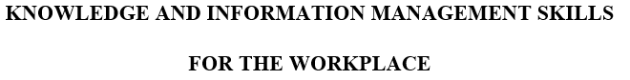
Student Name: Marin-Adrian Mirancea
ID: 1811973
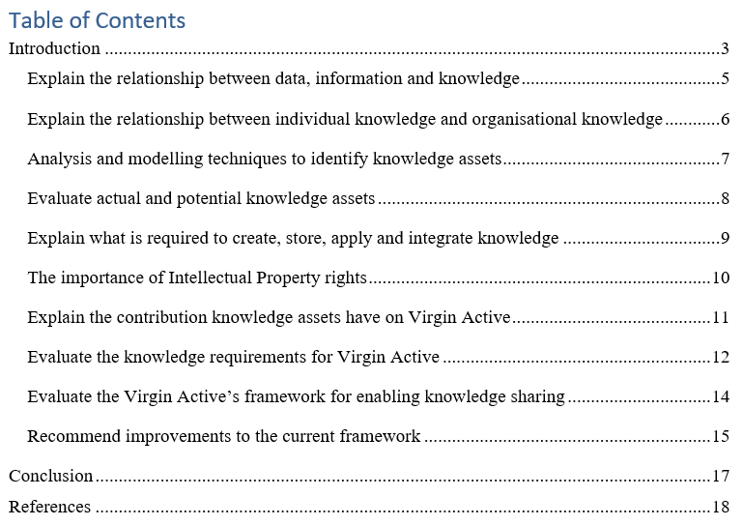

Introduction
Handling the organisational resources and information is considered to be an important job through which the business runs in the right direction and achieves its goals and objectives properly. In order to ensure the maintenance of organisational resources and information, knowledge management should be utilised properly otherwise it would be difficult for the business to achieve its goals and objectives. This report will critically evaluate how the selected company Virgin Active has initiated an applied knowledge management process to ensure organisational efficiency and compete with its competitors properly. In order to handle the knowledge properly, the management needs to understand the difference between individual knowledge and organisational knowledge and the techniques used by the business to identify the knowledge assets. Although it takes little time for the business to acquire the capital assets, it requires lots of time and energy from the management to acquire the knowledge assets without which the business will not be able to achieve its goals and objectives or run in accordance with the strategic direction properly. This report will also cover what are the actual and potential knowledge assets available to virgin active and the importance of intellectual property rights that the business might consider for sustaining its operational activities properly. Each and every business has some framework for managing the knowledge assets. However, it may need to improve those knowledge management frameworks based on the changing situation of the external environment. This report will also analyse how the knowledge sharing framework provides benefits to the business and the later part of the report will cover what are the recommended actions that virgin active might consider for improving the knowledge sharing framework in its business.
Company overview - Virgin Active:
Virgin Active is a chain of health clubs that operates its business in the UK and also in different parts of the world. The business was founded by Sir Richard Branson and headquartered in London. The business has its operational branches in 43 locations in the UK. The business serves those customers who are concerned with fitness and health related issues. The business uses cutting-edge exercise equipment because of which it has strong brand recognition in the health club industry. The registered members of the club are served by the most qualified trainers. Currently the business has 1.4 million members across different locations. The business has been offering different types of experiences from Yoga to Boxing, Cycling to Grid Training, From Pilates to Swimming etc.

Data | Information | Knowledge
Data refers to any objects or things which have not any specific meaning or which cannot be used without further information (Caruso, 2017). | Information refers to any structural or symbolic thing which has specific meaning or which makes it easier for the user to visualise or analyse those things for specific purposes. | Knowledge refers to collected information which is more relevant to the user that can be utilised for achieving specific goals and objectives.

Data: Data is a collection of unprocessed facts and figures that might require further processing and can be considered as an input for analysis. For example, in the context of Virgin Active, several raw data are collected when the new members are joined in the club to get their desired services. Moreover, the CEO of virgin active Matthew Bucknall has to collect lots of facts and figures to research for opening a new branch in a new location. By using those raw data, the management could not undertake a proper decision without further analysis.
Information: Information refers to those facts and figures which have specific purpose and relevance for the business to undertake an important decision (Newell, et al. 2009). For example, in Virgin Active the management team could identify the pattern of revenue at different times of the year by collecting the revenue data and classify them according to their requirements. Moreover, virgin active collects raw data from different branches to analyse the demographic characteristics of the club members to identify a trend and undertake any strategic activities.
Knowledge: Knowledge refers to those relevant facts of figures that might be helpful to achieve the goals and objectives of the organisation. For example, Virgin active might have lots of information regarding the market competitiveness and the internal financial condition of the business. But that information should be categorised in such a way that it provides specific direction to the business so that it could implement a perfect strategy to achieve organisational goals and objectives properly.
The stakeholders of Virgin Active need to assess the financial information of the business to understand the current situation and the strategic direction of the company. The following two examples shows that financial data of Virgin Active:
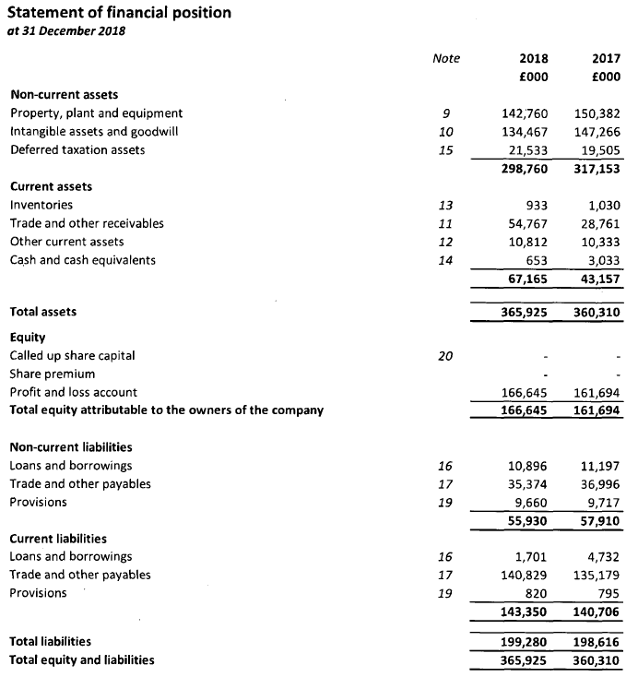
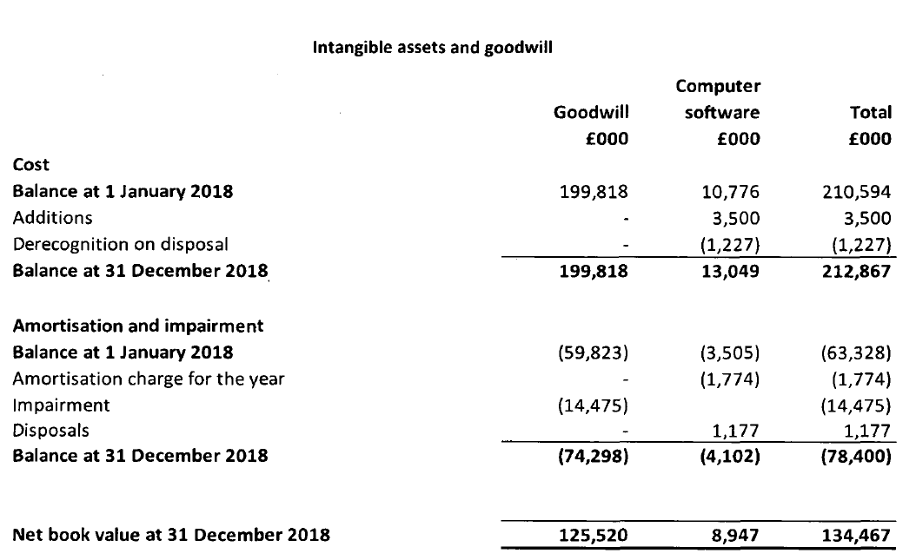
Since the data, information and knowledge are interrelated the business needs to collect the data from various sources to extract relevant information and use that information for increasing the knowledge base of the business to attain organisational efficiency (Trantopoulos et al., 2017). the organisation must maintain a proper mechanism for extracting the information from numerous data and analyse that information for creating organisational knowledge for achieving competitiveness in the market.
For maintaining the knowledge management endeavour in any organisation, the individual knowledge and the organisational knowledge should be monitored on a regular basis. Individual knowledge streams from information available to the individuals and it ultimately formulates the organisational knowledge. When the organisational knowledge is properly externalized by undertaking several tactics or events then the individual knowledge can be improved.
Individual Knowledge: Individual knowledge refers to the reflection, experience and expertise in a certain area that is achieved by the individuals. it is a professional or functional knowledge that is used for dealing with the organisational issues on a regular basis (Trantopoulos et al., 2017). For example, virgin active hires professional trainers who have experiential knowledge to provide training to the club members. These professionals are experienced in some particular fields and they are applying their knowledge to achieve the organisational goals and objectives.
Organisational knowledge: organisational knowledge refers to the collection of individual knowledge that provides competitive advantage to the business over the others (Caruso, 2017). The organisational knowledge is formed by the collective experience of the individuals working in the organisation. For example, in virgin active the trained professionals provide training to the other employees of the organisation to improve their skill level. Organisational knowledge is considered to be an asset for Virgin active because it provides efficiencies and it adds value to the business significantly.
Virgin active needs to focus on both individual knowledge and organisational knowledge to improve the knowledge base or increase the knowledge assets as they are interrelated. Although the business recruits the employees with certain individual knowledge, they should be involved with the organisational knowledge properly to improve their productivity and performance which will ultimately improve their individual knowledge that could be used in their own professional setting.
Since the business scenario and the way of doing business is always changing, the management needs to identify the knowledge assets as well as the knowledge gap to bring efficiency in the business and improve the current level of expertise of the individuals in the organisation. The following analysis could be undertaken to identify the knowledge assets in virgin active:
Strategic Mapping: By conducting the knowledge mapping, the management of virgin active could easily identify what are the most essential knowledge assets to improve its performance (Caruso, 2017). Moreover, the business could easily identify those knowledge assets that are providing competitive advantage to the business over the others. By conducting the strategic mapping, the business could easily identify the knowledge assets from two distinctive dimensions one is structure of knowledge and the other is diffusion of knowledge. It also enables the business to identify whether people in the organisation are getting their required knowledge or not.
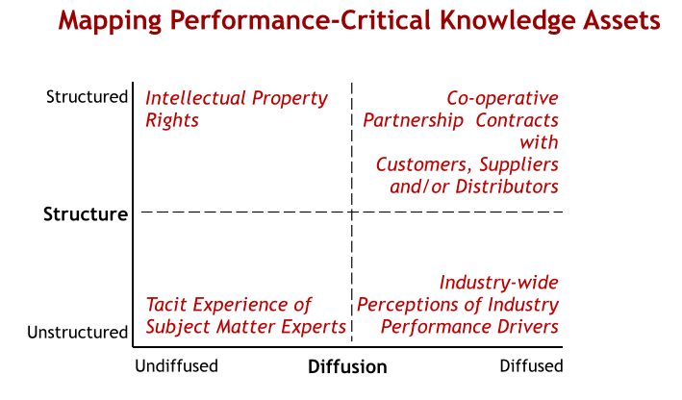
Figure 1: Strategic Mapping of Knowledge Assets (Trantopoulos et al., 2017)
Focus Group: When dealing with a particular problem, the management of virgin active arranges a focus group which includes a diverse group of people who share their experiences and knowledge through an open discussion method to bring new ideas for change (Trantopoulos et al., 2017). In this way, the management could easily identify the knowledge assets and transfer those knowledge assets to other stakeholders of the business to improve the performance.
Applying Information and Technology: By applying the information and technology, virgin active could identify the lack of knowledge assets in its business and identify the areas in which knowledge assets are gathered. Information on technology paves the way for sharing the organisational knowledge assets among several groups of people to improve their efficiency and performance in the business.
There should be a proper mechanism for identifying the knowledge assets because it will provide efficiency and productivity to the business which cannot be imitated by the competitors easily.

Knowledge assets are those intellectual resources that provide strategic directions to the business that provides competitive advantage over the others. Virgin active should focus on both actual and potential knowledge assets to bring new ideas and innovation in the business and achieve organisational objectives.
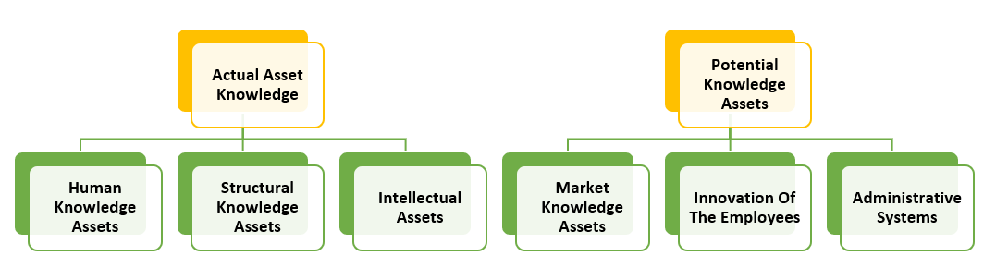
Figure 2: Actual and Potential Knowledge (Newell, et al. 2009)
Actual Knowledge Assets: Actual knowledge assets are those assets that already existed in the business and that can be used for creating value in the organisation. For example, in virgin active the actual knowledge assets are the human knowledge such as knowledge of the professionals and the executives of the business (Jones, 2009). Moreover, some intellectual assets such as brand names, company logos and the domain names of business are considered as actual assets of the business.
Potential Knowledge Assets: Potential knowledge assets are those assets that are dynamic in nature and that can be changed over the time. For example, in virgin active the potential assets are the market information available in the external environment that can be utilised as an opportunity for increasing the growth of the business. Virgin Active focuses on the potential knowledge assets of its employees through innovation that will provide extra competitive advantage to the business over the others as they will ensure the efficiency and performance of the employees in a business.
Although the business has accumulated actual knowledge assets due to the long tenure of its activities, the business needs to focus on potential knowledge assets to improve its efficiency and increase the growth of the business by using those potential knowledge assets as an opportunity.
Knowledge management is a multidisciplinary approach in which the organisational knowledge is properly handled to achieve organisational goals and objectives. The factors used in the knowledge management process are interrelated and they are handled by the senior executives of the business.
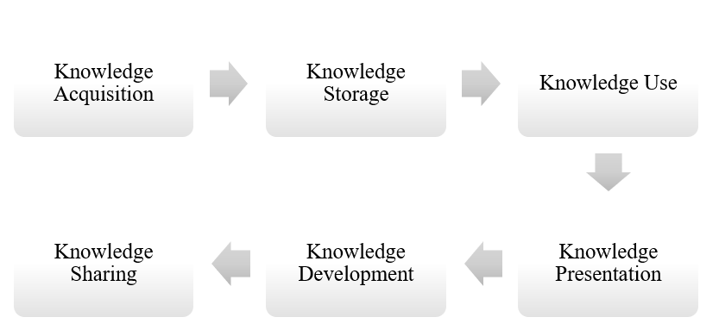
Figure 3:KM Process (Trantopoulos et al., 2017)
Knowledge acquisition refers to the accumulation of organisational resources by utilising the human experts and following systematic procedures. For example, in virgin active, both the traditional methods and technologies are used for extracting and organising knowledge from various sources. Knowledge storage refers to the preservation of knowledge assets by undertaking internal strategies so that it can be utilised for a sustainable period of time (Jones, 2009). For example, in virgin active the knowledge storage is ensured by embedding the organisational knowledge in various structures of the business so that the employees are properly following that knowledge regularly. Knowledge use is a common phenomenon in a business through which the management undertakes strategic actions to improve the organizational efficiency. For example, in Virgin Active, the management organizes various types of events and offers different packages for the club members through which they could generate revenue by charging a fee. The decision-making process becomes easier when the management uses its knowledge to identify the right strategic movement for the organisation. Knowledge presentation refers to the reflection of organisational knowledge to all the related parties or stakeholders of the organisation. For example, in Virgin Active, the top management share their ideas with its subordinates to convince them to perform their job accordingly. It has been discussed already that knowledge development is achieved by performing some unique activities such as focus group discussion, knowledge mapping and using the technologies to accumulate the potential knowledge assets from diverse groups of people and apply those knowledges to improve organisational efficiency. Knowledge sharing is a continuous process through which the knowledge is transferred from the one who has sufficient knowledge to those people who lack the proper knowledge. For example, in virgin active the knowledge sharing is achieved by exchanging information through meetings, conversations, learning sessions and workshops.

Intellectual property rights are considered to be an intangible asset for a business through which the business gets some competitive advantages or privilege over the other businesses. intellectual property Rights might be achieved in different forms among which the most common forms are patents trademarks and copyrights. Intellectual property Rights is important for virgin active because it will enable the business to keep its innovation and ideas for a sustainable period of time and get some benefits from those intellectual property rights (Newell, et al. 2009). Intellectual property rights provide some ways for innovation for the business as the management are properly compensated from the intellectual property rights and for this reason they are motivated to work for some new ideas and techniques for improving organisational efficiency. Without protecting the innovative ideas, the management might not be able to get the full benefits from their innovation and the competitors might reap the benefits which will reduce the organisational performance and competitiveness in the industry. Without the intellectual property rights the culture of innovation in the business might be hampered due to which the customers might not get the desired services from the business (Jones, 2009). intellectual property Rights motivate the management to focus on research and development to get some new ideas for improving the performance and service level of the business. For example, in Virgin Active there is a dedicated research and development team that focuses on improving the organisational efficiency such as improving the payment system, importing the machinery which are essential for the exercises of the club members etc.
The business might need to incur some costs for achieving the intellectual property rights, but it provides long-term benefits to the business which is comparatively higher than the cost involved in achieving the intellectual property rights. So, there should be strong dedication and determination from the management to achieve the intellectual property rights. all the intellectual property Rights might not provide the same benefits to the business but they are equally necessary for continuing the operational activities of the business.

Without the proper application of knowledge assets, Virgin active might not be able to perform its organisational activities and co-ordinate the functional units of the business properly. The senior executives of Virgin Active share their experiential knowledge to the newly recruited so that they could get the proper direction and that will improve their performance and competencies in the business properly. Proper Knowledge assets reduce the stress level of the employees in the organisation and it also improves the motivation level of the employees (Jones, 2009). The business needs to introduce new concepts to attract the customers and identify opportunities for expanding the business operations in new areas. Since Virgin Active is providing service for its customers, both the capital assets and knowledge assets are equally important for the business for serving the customers and maintaining proper organisational efficiency. The skills and performance of the employees are equally important for the business to achieve its objectives and the senior management always try to make sure that its subordinates get the proper strategic directions by transferring the knowledge assets to several units of the business. In the physical asset or capital asset area, the business might not be able to beat its competitors because all of them have equal competitiveness; but in case of knowledge assets only those firms we'll beat the industry who have experienced management teams and skilled and professional employees in its work setting.
Directing the business to a specific goal is not an easy task because there are lots of complex issues involved in the process. The knowledge assets actually make it easier for directing the business to a specific goal although there are lots of complex issues involved in the process. If the business properly accumulates the knowledge assets by engaging the people in different areas of the business, sharing the knowledge to all other units of the business then it will be easier for the business to handle the capital assets and the organisational resources effectively.
The knowledge gap of virgin active can be evaluated by using the knowledge gap analysis and considering the strategic gap of the business (Jones, 2009). Virgin active has professional trainers who could provide better training to the club members. But they are needed to be equipped with modern technologies and training facilities to improve their skill levels. The club members will be eager to get the services from the business only when they find that the business is recruiting the best professional or having top qualification in their area of service. In Virgin active, the club members could ask any kinds of training related questions to the personal trainers. So, the personal trainers need to know the health-related issues properly and they need to communicate with the club members on a regular basis.
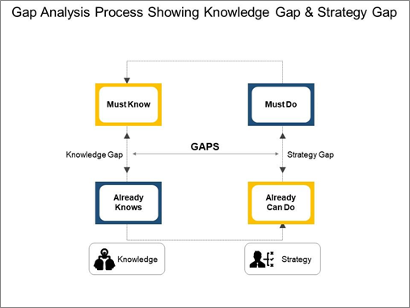
Figure 4: Newell, et al. (2009)
Virgin active must know what kind of services the club members are preferring and the way of communication they want to get from the professional trainers. If they properly grasped the customer's demands and preferences properly then they will be able to equip themselves with those skills and knowledge and deliver those knowledges to their regular customers. The application of knowledge is necessary in different strategic activities and it needs to be improved to compete with the competitors in the industry. To understand the current trend of health issues, the personal trainers need to join in seminars and study new articles and research papers. Moreover, as the current activities of businesses are always changed by the external environment, the business needs to know the performance level of its competitors and identify their strategic movements to improve their own strategic actions. For example, virgin active always evaluates the strategic actions of its competitors such as examining the packages offered by the competitors and its profitability. If the packages offered by the competitors seem beneficial for the business in that case the business will offer the similar packages to its customers to retain them and increase the profitability of the business. The requirements for knowledge have never faded away rather it always increases as there is increased competition in the industry.
From the above discussion it has been understood that Virgin Active is focusing on sharing the knowledge among the individuals to improve the organisational performance and efficiency. And, this is quite logical for Virgin Active because it is a service provider and it needs to have professional individuals to offer the best services to its customers.
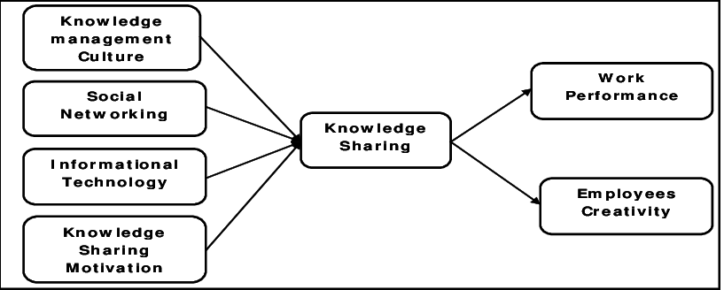
Figure 5: Newell, et al. (2009)
From the above diagram it can be understood that knowledge sharing could increase work performance and employee creativity and it can be achieved by incorporating a knowledge management culture, involving the stakeholder of the business with the social networking sites, introducing information technology in the workplace and improving the motivation level of the employees. Virgin Active initiates different types of events and strategies to produce a knowledge management culture that facilitates sharing of knowledge to the employee as well as the customers of the business. Virgin active may face some barriers while conducting the activities and those barriers should be removed to ensure proper knowledge sharing among the people. Virgin active also ensures proper communication among the people and maintains the flow of information and knowledge among individuals in the organisation. The modern information technology has made it easier to communicate among the employees or share any new information about them in no time (Trantopoulos et al., 2017). Virgin active should ensure proper rewards for the people who share their innovative ideas with others and this reward system will increase the knowledge sharing motivation level in the business.
However, the business needs to consider the quality and quantity of information shared among the individuals to increase the competency and performance of the business in the industry.

Figure 6: Newell, et al. (2009)
However, sometimes it might not be possible for the business to ensure equal flow of knowledge sharing as there are ups and downs of business activities. so, when there are chances or opportunities for sharing the knowledge among the individuals, the business should grasp those opportunities actively to increase the flow of information and knowledge among the individuals in the organisation.

From the above analysis it can be understood that virgin active has undertaken several strategies to maintain the knowledge management process in its business. However, there are some other approaches that Virgin Active might consider for improving the knowledge sharing activities of the business properly which will ultimately ensure organisational competitiveness. The more the business will ensure increasing its knowledge sharing framework the more it will be able to create competitiveness and bring sustainable solutions in its operating areas. The recommendation for virgin active for improving its current knowledge sharing framework is given below:
- There should be an open and transparent communication method among the people working in the organisation so that they could share their thoughts and knowledge with others and get some solutions for any problems if they find themselves while conducting the business activities.
- there should be an independent team who will oversee the overall knowledge management process of the business to identify any gap in the knowledge management and sharing process and recommend effective solutions to resolve that problem.
- The organisation should develop the culture in such a way that the employees feel comfortable to share their ideas with other departments or seniors and recommend any strategy tactics if they find it reasonable.
- Virgin active should initiate more events to connect the the employees in the organisation and there should be a proper incentive for those who are sharing their views with others for increasing organisational efficiency.

Conclusion
Knowledge management is an integrated system through which the business stores, captures and transfers the knowledge assets to several business units which paves the way for handling the other resources of the business properly. The organisations focus on knowledge management to improve the organisational effectiveness by creating value and improving the strategic directions of the business for competing with the competitors properly. In order to ensure the maintenance of organisational resources and information, knowledge management should be utilised properly otherwise it would be difficult for the business to achieve its goals and objectives. This report has covered how the selected company Virgin Active has initiated and applied knowledge management process to ensure organisational efficiency and why the knowledge management process is important for generating the values of the business properly. Here, we have covered the difference between individual knowledge and organisational knowledge and the techniques used by the business to identify the knowledge assets. This report has covered what are the actual and potential knowledge assets available to virgin active and the importance of intellectual property rights that the business might consider for sustaining its operational activities properly. It also analysed how the knowledge sharing framework provides benefits to the business and what are the recommended actions that virgin active might consider for improving the knowledge sharing framework in its business.

References
2020. [online] Available at: <https://www-dawsonera- com.ezproxy.uwtsd.ac.uk/abstract/9780273790327> [Accessed 12 August 2020].
Abell, A. and Oxbrow, N., 2006. Competing with knowledge: the information professional in the knowledge management age. Facet Publishing.
Al-Hawamdeh, S., 2002. Knowledge management: re-thinking information management and facing the challenge of managing tacit knowledge. Information research, 8(1), pp.8-1.
Blumentritt, R. and Johnston, R., 1999. Towards a strategy for knowledge management. Technology Analysis & Strategic Management, 11(3), pp.287-300.
Bouthillier, F. and Shearer, K., 2002. Understanding knowledge management and information management: the need for an empirical perspective. Information research, 8(1), pp.8-1.
Choo, C.W., 2000. Working with knowledge: how information professionals help organisations manage what they know. Library management.
Collinson, C and Parcell, G (2004) Learning to Fly:Practical Knowledge Management from Leading and Learning Organizations, Capstone, England.
Duffy, J., 2000. Knowledge management: What every information professional should know. Information Management Journal, 34(3), pp.10-10.
Easterby-Smith, M. and Lyles, M. A. (2003). The Blackwell Handbook of Organizational Learning and Knowledge Management.
Griseri, P. (2002). Management Knowledge: A Critical View. Houndmills, Basingstoke, Hampshire: Palgrave.
Hislop, D., 2002. Mission impossible? Communicating and sharing knowledge via information technology. Journal of information Technology, 17(3), pp.165-177.
Hislop, D., 2002. Mission impossible? Communicating and sharing knowledge via information technology. Journal of information Technology, 17(3), pp.165-177.
Jones, B. (2009). Knowledge Capitalism. Oxford: Oxford University Press Pl.
Kebede, G., 2010. Knowledge management: An information science perspective. International Journal of Information Management, 30(5), pp.416-424.
Laudon, K., & Laudon, J. P. (2014). Management Information systems: Managing the digital firm. Thirteenth edition
Lilley, S. Lightfoot, G and Amaral, P. (2004) Representing organization: knowledge, management and the information age.
Lips, M. (2014). Transforming Government—by Default? In Society and the Internet (p. Society and the Internet, Chapter 12). Oxford University Press
Marshall, S.K., Tilton-Weaver, L.C. and Bosdet, L., 2005. Information management: Considering adolescents’ regulation of parental knowledge. Journal of adolescence, 28(5), pp.633-647.
n.d. Virgin Active | Gyms, Personal Trainers, Swimming, Spas .... [online] Available at: <https://www.virginactive.co.uk/> [Accessed 2020].
Newell, S. et al. (2009). Managing Knowledge Work and Innovation. 2nd ed. Basingstoke: Palgrave Macmillan.
Okike, E., & Mbero, Z. (2015). Information Technology (IT) Knowledge Management system stage model: A proposal for today's workplace.
Sanchez, R. (2003) Knowledge management and organizational competence. (Online) Oxford University Press: New York
Schlögl, C., 2005. Information and knowledge management: dimensions and approaches. Information Research: An International Electronic Journal, 10(4), p.n4.
Trantopoulos, K., von Krogh, G., Wallin, M.W. and Woerter, M., 2017. External knowledge and information technology: Implications for process innovation performance. MIS quarterly, 41(1), pp.287-300.
Volker, M.S.A.V.P., 2003. Sharing expertise: Beyond knowledge management. MIT press.

