

Title: Business Development Proposal
Programme: Master of Business Administration
Module code: LCMB7037
Name: Nedyalko Radev
Student ID: 2128093

Introduction
The laundry and ironing service continue to be important household service, but the sector is changing as time shortage, urbanisation trends, and customer demands are shifting towards convenience and value-added services (Mintel, 2022; Statista, 2023). Busy families, college students in residential accommodation and small hospitality services are increasingly outsourcing linen services by doing so to gain time and quality. Meanwhile, environmental and regulatory factors (using water, effluent discharge) demand professional operators to show the level of compliance and efficiency, which impedes informal providers and opens opportunities to competent local companies (GOV.UK, 2022). This proposal analyses Fresh and Pressed Ltd, which is a proposed private limited company (LTD), with family-owned washing, ironing, scheduled pickup/delivery and subscription services that are to be located in Stoke-on-trent.
The main research question: Does a viable market and working concept of family run subscriptions laundry service exist in Stoke-on-Trent on the basis of secondary evidence? Secondary questions examine likely pricing brands, important customer groups and legal limitations of a small processing depot.
Mission: To deliver high quality, on demand, and environmentally conscious laundry services at a high level by employing family run services and quick delivery. The enterprise will meet applicable UK business regulations from day one onwards

Methodology - secondary research
The business development proposal is based on secondary research, governmental statistics, local government publications, market reports on industries, trade and industry guidelines and commercial directories and company websites.
Data selection criteria:
The sources selected or will be selected based on, firstly credibility (authoritative agencies, reputable market research companies and recognised trade associations), secondly currency (needs to be published within the last five years) and thirdly topicality to domestic and small scale commercial laundry services (market size, household composition, local demand drivers, regulatory requirements). Key sources include Office for National Statistics with demographic data, Stoke-on-Trent City Council with local economic background and industry reports (IBISWorld, Mintel, Statista) with market trends.
Search strategy and Inclusion rules:
Structured database queries (where available) were used with searches of specific web sites (local council, Severn Trent Water, GOV.UK, Google Maps business listings). Key claims, e.g. market sizing, household laundry behaviour, etc.
Limitations and Mitigation:
The micro behavioural information (actual household willingness to pay) is not possible using secondary only research and can have a report bias. These shortcomings are addressed through cross referencing between numerous sources, with emphasis on official datasets to make demographic claims and check assumptions about pricing and operations and scale them beforehand (Saunders et al., 2019).

Market overview & industry context
The laundry and dry cleaning market of the UK is a developed yet developing market. According to market intelligence (IBISWorld, Mintel), the demand is small yet stable due to urbanisation, more people joining the labour force and higher enrollment in the student and care industries, which ensure a constant supply of laundry requirements (IBISWorld, 2023; Mintel, 2022). Among other demand drivers, there are time scarcity amongst the working houses, growth in student accommodations and the outsourcing by small hospitality operators of compliance and reliability. Agrile local operators have lowered the unit operating costs due to the advancements in technology (energy efficient machines, route optimisation software) (Statista, 2023).
Industry structure:
The industry contains coin-operated laundrettes, independent family laundries, contract/commercial laundries (providing to care homes and hospitality) and national/tech platforms which provide pickup and delivery. The bottom of the price competition is intense (self service), although there can be an opportunity to differentiated, subscription based or SLA-backed B2B services that are more focused on reliability and compliance (IBISWorld, 2023).
Local context:
Stoke-on-Trent has a population and household structure that is favourable to a neighbourhood laundry business, a combination of families, privately rented or privately studying students (ONS census data). According to the local council business information, the commercial rents and industrial units are less than in metropolitan centres of the region, which favour positive startup economics.
Regulatory Environment:
Small laundries have to think about trade effluent consent when discharging the detergents and process wastewater into the sewer, manufacturer warranties and environmental needs also carry considerable impact on the choice of machines. According to the advice given by Severn Trent Water and government environmental pages (GOV.UK), prior cheques with the water company about pre-application and written waste management processes are necessary to prevent enforcement and expensive remediation. Such restrictions lead to compliance costs as well as barriers to entry to favour those operators who make regulatory compliance part of the model.

Market segmentation
Five priority segments based on secondary sources, which include Students, Families, Professionals/Commuters, Elderly / Care recipients, and B2B clients (care homes, student halls, small hospitality operators).
Students: Student focused on campus/university and rental of a particular hall (Universities UK data) and are very convenience oriented. They are cost elastic and elastic to term time offers and making reservations; volume is seasonal (term cycles) (Universities UK, 2022).
Families: The volumes of laundry are high in larger households (ONS household size data). Families appreciate the ability to schedule in advance, the ability to resell in large quantities and value-based subscriptions that lower the cost of administration per load (Kotler and Keller, 2016).
Professionals/Commuters: Time-starved households would be ready to pay extra to have express or guaranteed pickup windows. Such a segment has average price elasticity but is focused on reliability and quality of services (Mintel, 2022).
Elderly / Care recipients: The elderly, and residential houses require trust, hygiene and assisted collection services. The documented hygiene protocols and constant SLAs are needed by care providers, and price elasticity can help them to find reliable suppliers (Skills for Care, 2023).
B2B clients: Contract pricing, consolidated invoicing and predictability in linen hygiene and operational operations are favoured with institutional customers (care homes, student accommodation, boutique B&Bs) as it brings them predictable operations. Reduced volumes minimise the churn and support cashflow.
STP recommendation: To launch with a minimum viable, focus on Families and one B2B vertical (student halls or a local care home). Families offer volume recurrence and increased traction through subscriptions, B2B agreements offer revenue stability and credibility. A second phase would be to target students with custom term-time offers when operational SLAs are demonstrated to be effective.

Competitive landscape
Local competitive environment at Stoke-on-Trent is the combination of traditional laundries, self service sites, family owned laundries, dry cleaners and local commercial operators. According to the listings in Google Maps and the local directories, there are five direct competitors: Posh Wash Laundertte (London Road), Cottage Laundry (Hartshill Road), The Laundertte (Bucknall New Road), Fenton Laundertte (Victoria Road), and The Washtub (Stone, regional proximity). These companies mostly sell walk-in wash and dry services and little has been documented of any structured subscriptions or published price per kilo (Google Maps listings; Yell, 2026).
There are five indirect competitors (self-service chains Revolution Laundry / Wash.ME sites in Longton and Festival Park, specialist dry cleaners (e.g. Johnsons), regional contract laundries (e.g. Sunrise Laundry Services (Crewe)) and inhouse laundry within student halls), and the household self washing. Self service competitors are low cost bulk washing, which does not include any collection or ironing, whereas contract laundries focus on high volume and low local flexibility.
There is an apparent positioning gap of the transparent prices, subscription-based services and formal service level agreements (SLAs). Online reviews are often glorifying of cleanliness and convenience (e.g. good value and quick turnaround), and not often glorify reliability guarantees or pickup services. There are not many local rivals with considerable prices or bundled subscriptions, which opens an opportunity to Fresh and Pressed Ltd to differentiate with the door to door delivery, predictable prices and B2B agreements.
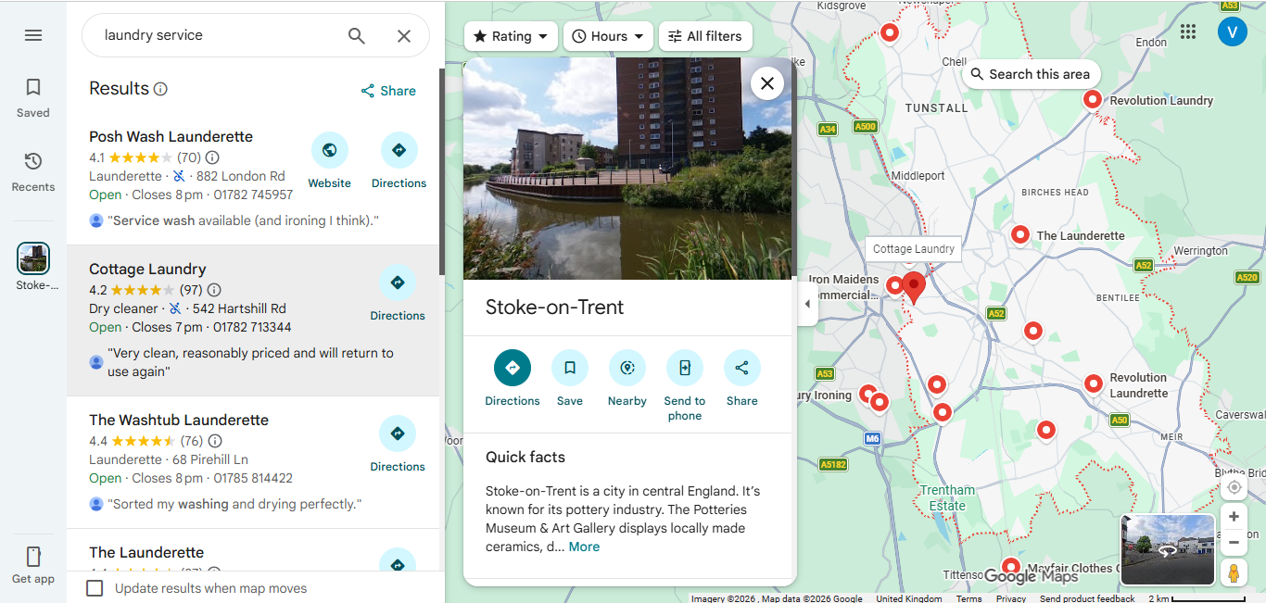
Figure 1: Stoke-on-Trent local 3-5 miles of the suggested location map and competitors
Competitor Matrix table in appendices as Appendix 1

Business model & operations
Fresh & Pressed Ltd will be a private limited company (LTD) that will be providing domestic and small-scale commercial laundry services in hybrid forms, per-kg washing, per item ironing, monthly subscription plans and fixed price B2B deals. This structure saves the balance between having transactional demand and predictable recurrent income that enhances the stability of the cashflow (Osterwalder and Pigneur, 2010).
In operational terms the business will need a small light industrial space in an area of three to five miles of service with commercial washers, dryers and press units. The staffing needs are two functional staff and one delivery driver at the start up phase and increasing with the volumes. We will have one branded van that will aid in scheduled pick up and deliver routes via postcode grouping.
Critical operational compliance means that drainage capacity is checked and any trade effluent consent needed is obtained before installation as advised by Severn Trent Water. The choice of equipment will be based on the preference of energy and water efficient equipment to control the operating expenses and impact on the environment.
Business Model Canvas:
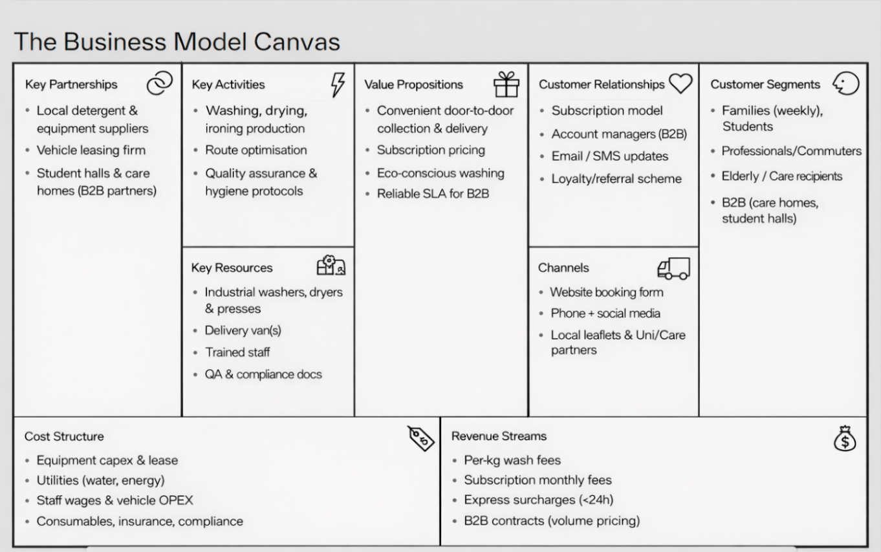
Figure 2: Business Model Canvas for Fresh & Pressed Ltd

Financial snapshot & viability indicators
The secondary benchmarks show that a small professional laundry business has moderate startup capital requirements. According to industry sources, commercial washers and dryers usually range in price between £6,000 -15,000 each unit, depending on capacity and specification (Statista, 2023). Utility fees (water and electricity) are one of the key variable costs, whereas labour fees are predetermined by the UK standards of the National Living Wage (GOV.UK, 2024). Independent laundry local prices normally vary between £1.75 and 2.50 per kg, according to the directory and competition reveals.
To evaluate viability, a simplified break even is shown. Taking the constant monthly expenditure to be around 6,000 pounds (rent, labour, utilities, vehicle, insurance), and the average subscription fee is 40 pounds per month, the number of subscribers that are required to break even is:
Breakeven subscribers = Fixed costs / Subscription price.
= £6,000 / £40 = 150 subscribers per month
This amount does not include extra income on ironing, express charges and business to business agreements which would lower the breakeven point.
The source of potential funds can be the equity of the founder, small business loan, and local enterprise/ start-up grant managed by Stoke-on-Trent City Council. The financial analysis indicates that the business could become operationally viable in the first year provided that there is enough early subscription taking and one B2B contract.

Risks, feasibility conclusion & recommendations
Operational risks: include (1) inability to obtain the right trade effluent consent, which is mitigated by consulting Severn Trent Water early; and (2) equipment downtime, which is mitigated by the means of maintenance contracts and the availability of leased equipment on reserve.
Market risks: Include (3) intense price competition by self-service laundrettes and household substitutes to which the differentiation of pickup, subscriptions and ironing services will be applied; (4) slower than projected customer acquisition, which will be counteracted by gradual marketing and initial offers of subscription.
Financial risks: involve (5) a cashflow strain in the start-up phase, which the company addressed with restrictive cost assumptions and reserve funding; and (6) overdependence on a single customer segment, which the company has addressed by focusing on household and B2B clients.
Fresh and Pressed Ltd, to negotiate premises and obtain documentary confirmation of drainage/consent options, get formal supplier quotes and maintenance contracts, emulate the financial model using sensitivity and scenario analysis using secondary benchmarks, compile competitor financials with the Companies House and trade directories, prepare the entire Business Model Canvas and implementation chapters on basis of secondary evidence. The approved methodology does not involve primary customer surveys or pilot field trials and these will not be subjected to. To enact risk monitoring, it will be formalised by board reviews monthly and quarterly financial reporting to ascertain adaptive governance and stakeholder update meetings.

Gantt Chart:
Task /Month | Feb 2026 |  |  | Mar 2026 |  |  | April 2026
Finalise Proposal
Superviosr Review and feedback
Refine project scope & structure (15,000 words)
Update methodology (secondary research) Data Collection
Industry & market analysis chapters
Business model & operations chapters
Financial plan & risk analysis chapters
Implementation plan & Gantt refinement
Full draft completed

Proofreading & academic editing with final supervisor check with amendments

References

- GOV.UK, 2024. National Living Wage and National Minimum Wage rates. Available at: https://www.gov.uk/national-minimum-wage-rates
- GOV.UK, 2022. Waste duty of care and hazardous waste guidance. Available at: https://www.gov.uk/guidance/waste-duty-of-care-how-to-comply
- Google Maps, 2026. Laundry services in Stoke-on-Trent. Available at: https://www.google.com/maps
- IBISWorld, 2023. Laundry & Dry-Cleaning Services in the UK (industry report). IBISWorld. Available at: https://www.ibisworld.com
- Kotler, P. and Keller, K.L., 2016. Marketing Management. 15th edn. Harlow: Pearson. ISBN: 9781292092628.
- Mintel, 2022. Laundry and Fabric Care — UK. Mintel Group Ltd. Available at: https://www.mintel.com
- Office for National Statistics, 2021. Census 2021: population and household data. Available at: https://www.ons.gov.uk/census
- Osterwalder, A. and Pigneur, Y., 2010. Business Model Generation: A Handbook for Visionaries, Game Changers, and Challengers. Hoboken: Wiley. ISBN: 9780470876411.
- Saunders, M., Lewis, P. and Thornhill, A., 2019. Research Methods for Business Students. 8th edn. Harlow: Pearson. ISBN: 9781292208780.
- Severn Trent Water, 2025. Trade effluent guidance for businesses. Available at: https://www.stwater.co.uk/businesses-and-retailers/trade-effluent
- Skills for Care, 2023. The adult social care workforce in England. Available at: https://www.skillsforcare.org.uk
- Statista, 2023. Commercial laundry equipment and service cost benchmarks / Household and consumer statistics — UK. Statista. Available at: https://www.statista.com
- Stoke-on-Trent City Council, 2025. Business support and local enterprise funding / Local economic profile & business support. Available at: https://www.stoke.gov.uk
- Universities UK, 2022. Higher education student statistics and accommodation trends. Available at: https://www.universitiesuk.ac.uk
- Yell, 2026. Laundry and dry-cleaning services — Stoke-on-Trent. Available at: https://www.yell.com

Appendices:
Appendix 1: Competitor matrix (Researched through secondary sources mentioned)
Competitor | Indicative price | Services (wash / iron / pickup) | Typical location (area) | Typical hours
Posh Wash Launderette. Address listed: 882 London Rd, Stoke.  (Posh Wash Launderette) | (1.8 - £2.5/kg) | Wash, dry, reported ironing service, walk-in + possible local pickup. | London Road / ST4 area (eastern Stoke). | 07:00–19:00
Cottage Laundry — 542 Hartshill Rd. (directory listings). (Stoke Sentinel Business Directory) | (2.0 - £2.5/kg); local directories list as commercial/domestic laundry | Laundry & dry-clean category (likely wash & some ironing). | Hartshill Road (north-east Stoke). | 07:00–19:00
The Launderette (Hanley) — 103 Bucknall New Rd (Hanley). (Yell) | Per-load pricing (coin / machine) for self-service; per-kg for service not always published | Coin-operated self-service and drop-off/collection service; some offer wash & fold. | Hanley (central Stoke). | 07:00–19:30
Fenton Launderette — 37 Victoria Rd (Fenton). (West Wickham Launderette) | (1.8 - £2.5/kg) | Self-service launderette; on-site machines; no clear collection service listed. (West Wickham Launderette) | Fenton area (ST4). | 07:00–19:00
The Washtub (Stone) — 68 Pirehill Ln (Stone). (nearby town). (Yell) | Example listing shows per-load pricing for larger loads (1.6 - £2.5/kg) | Full launderette services (wash/dry); walk-in; some report quick turnaround. | Stone (north of Stoke) — within regional competitive set. | 07:00–20:00
Wash.ME / Revolution (Wash.ME sites) — Longton / Morrisons Festival Park / other sites. (Revolution Laundry) | Example: 20 kg wash ~£13.50 (example for Revolution machine) — note self-service fixed price per machine. | 24/7 self-service, contactless, large drum machines; limited/no pickup; sometimes app booking. | Multiple sites across Stoke (Longton, Festival Park etc.). | 24/7 for some locations (contactless kiosks), others have shop hours.
Sunrise Laundry Services — (regional commercial laundry; listed in Crewe with domestic enquiries). (Sunrise Laundry) | Commercial/contract pricing (listed as linen/contract); domestic service possible | Contract laundry, linen hire; commercial clients; may accept domestic drop-off in some sites. | Crewe base (regional competitor for B2B contracts). | 08:00–19:00
Local dry-cleaners & specialist services (various) — e.g., Johnsons & independent dry-cleaners. (Johnson Cleaners) | Per-item pricing; higher than per-kg laundry of (1.8 - £2.5/kg) | Specialist dry-clean, stain removal, pressing; push customers wanting specialist care. | Town centre and shopping districts. | 07:00–19:00
DIY / home washing (substitute) | £ (home cost depends) | In-home washing/drying — closest substitute for price-sensitive users | Everywhere | 24/7

