BMDS7009-CW1

FITT assessment of the antenatal module of the Diabetes Consultation Note

Introduction
The Welsh Information Solution for Diabetes Management (WISDM) aims to “provide real time access to all diabetes care information on a single platform” (DHCW, 2023a). It includes a specific module for the management of pregnant patients with diabetes (DHCW, 2025), designed to meet the needs of clinicians to manage the treatment of patients and submit the National Pregnancy in Diabetes Audit (NPID).
Data shows approximately 5% of pregnant patients have diabetes, and 87.5% of those have gestational diabetes (All Wales Maternity and Neonatal Network, 2023).
The antenatal module is used in four Welsh health boards, across which there are approximately 1,000 antenatal appointments each month, equating to over 300 patients each month (Fig. 1). This corresponds to about 10% of all diabetes appointments recorded via WISDM.

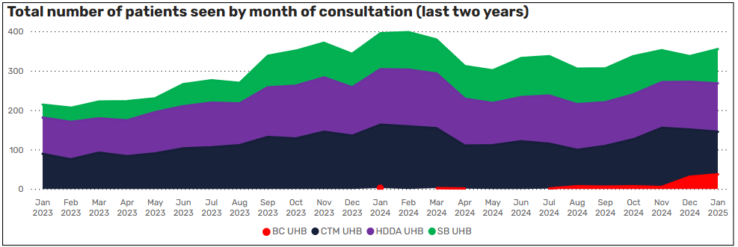
Figure 1: total number of antenatal patients see by month of consultation (DHCW PowerBI, 03/02/2025).

WISDM aims to collect data needed for the National Pregnancy in Diabetes Audit (NPID), which tracks outcomes of pregnant women with diabetes (NHS England Digital, no date). NPID is made up of three sections:
- Participant and pre-pregnancy.
- Pregnancy details.
- Pregnancy outcome.

WISDM collects data relevant to the first two (Fig. 2 shows extract of WISDM system test environment); the third is collected in the clinical record of the child.

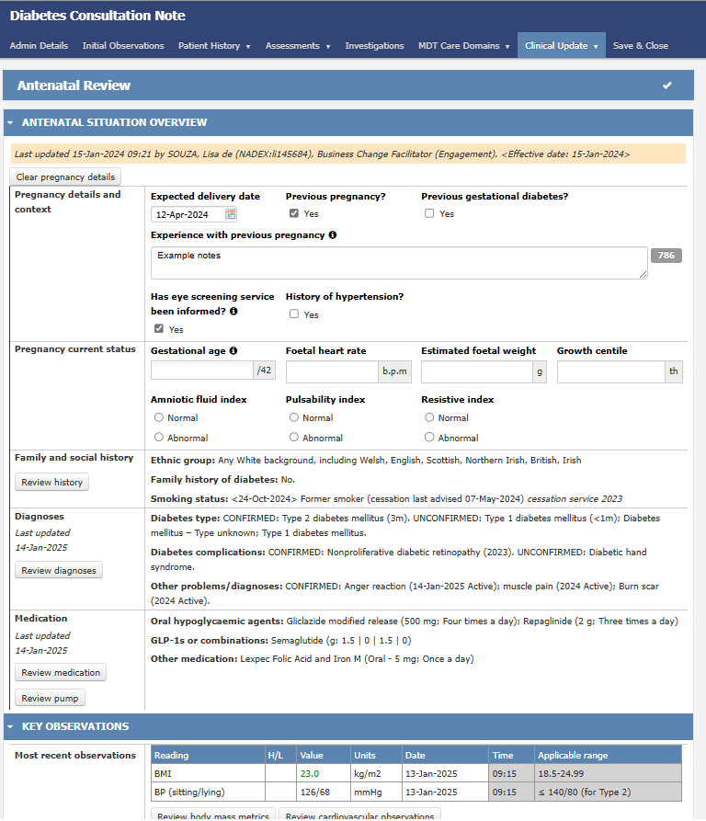
Figure 2: screenshot of the antenatal module from WISDM test patient environment, 03/02/2025.

This paper will assess the fit between the antenatal module, user need and their tasks using the FITT framework: the technology being assessed is the WISDM antenatal module; the user group is predominantly Diabetes Specialist Nurses, as they are the main care providers for antenatal diabetes patients; the task is the management of antenatal patient care and completion of NPID.

Methods

Framework
In this study, the FITT framework is used to analyse the fit between the antenatal module, its users and its functional tasks. FITT is a framework to help assess the fit between individuals, technology and tasks (Ammenwerth, Iller and Mahler, 2006). It expands on previous frameworks such as the Technology Acceptance Model and Task-Technology Fit, which exclude the role and experience of the user (Tsiknakis and Kouroubali, 2009).
FITT is used to support the implementation of digital projects in healthcare by assessing the fit between the individual (user) and technology, technology and task, and task and individual (Fig. 3). It facilitates the identification of interventions that may enhance the success of a project or product. De Leeuw, Woltjer and Kool (2020) note, "a poor fit might lead to frustration and, in the end, a boycott of ICT use."

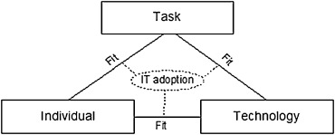
Figure 3: FITT framework, (Ammenwerth, Iller and Mahler, 2006).

FITT is not a static or one-off evaluation process, as the fit between the three axis varies over time (Tsiknakis and Kouroubali, 2009). Interventions could be applied to any of the axis, such as user training, reorganisation of working processes, or system redesign (Ammenwerth, Iller and Mahler, 2006).

Sample group
In summer 2023, Betsi Cadwaladr University Health Board (BCUHB) instigated the adoption of WISDM across three regions in phases: West went live in December 2023 and Central went live in December 2024 (East go live is outstanding at the time of writing) (DHCW, 2025).
The sample group for this study was DSNs and service management leads working across West and Central BCUHB. DSNs are registered nursing professionals, supported in the management of clinics by service managers. Table 1 shows the breakdown of users by roll and site.

 | Ysbyty Bangor | Ysbyty Glan Clwyd
DSN | 4 | 4
Service manager | 1 | 0
Table 1: sample group
Usage management data shows most care for antenatal diabetes patients is provided by Diabetes Specialist Nurses (DSNs) – looking at the 31,000 antenatal appointments recorded in WISDM, 13,916 were undertaken by DSNs. Therefore, they are an appropriate user group to engage with regarding the FITT of the antenatal module.

Methodology
Qualitative data was gathered through user feedback and observations via face-to-face engagement, go live briefings and email during the go live period for WISDM in BCUHB, from December 2023 to January 2025.
Observation requires the researcher to “undertake detailed description and provide an ‘ethnography’ of their interpretation of events” (Draper, 2015). One limitation of observations is the data is subject to the observers understanding and assumptions (Wästerfors, 2018), so informal meetings and conversations were used to encourage an open dialogue (Swain and King, 2022), corroborate data collected and enable users to validate assumptions and understanding (Pugsley, no date). Triangulation of multiple methods provides assurance and context for the data collected (Bowling, 2023). A multi-pronged qualitative approach was deemed appropriate for this use of the FITT framework as it enables data to be captured directly from the users to better understand their relationship with the task and technology.

Results
Data collected from observations and feedback were categorised into five themes (Table 2):

Theme | User comments
Using WISDM | Usability and workflow  45 minute limit  Does not autosave  User training
Availability of data | Availability of patient information  Reduced paper and physical storage  Saves time  Integration
Workload | Volume of patients  Clinic times
Requests for change | Move gestational diabetes diagnosis to primary diagnosis list  Capture OGTT result  Calculate gestational age from estimated delivery date  Change Investigations heading to Test Results
Audit | Digital audit submissions  Capture pregnancy outcomes
Table 2: themes and descriptions

Feedback was generally positive about WISDM making data more widely available. WISDM captures a substantial and useful volume of data needed for managing antenatal patient care and aligned well with existing work processes including capture of audit data.
Prior to using WISDM, West staff used paper and Central used Diamond, a third party digital application with limited licenses. Since WISDM is accessed through Welsh Clinical Portal (WCP), it’s accessible to clinical staff across Wales, so saved time handling queries or sharing information with teams across BCUHB and other health boards. One user noted: "WISDM has made our working life much more flexible as we can access patient consultations from anywhere without having to carry paper forms everywhere.”
However, frustration was noted because WCP times out after a set period to protect and secure patient data. Furthermore, WISDM does not autosave, as there is a risk it would save incomplete data that could later be clinically acted upon; therefore, each save requires the user to enter their password as clinical authorisation that the data is accurate. These points are addressed in user training, but it was observed that some users lost work and had to re-enter information into the form. This was time-consuming for the impacted users.
Users praised the training and on-site support during go live: “Having the team on site during the first 2 weeks was most reassuring and certainly alleviated some of the anxiety that new systems always bring.” Furthermore, some users nominated themselves as implementation champions, leading and supporting their colleagues with using WISDM.
In Central, the antenatal team delayed adoption of WISDM due to the high volume of patients in clinics. For non-antenatal clinics, there was capacity to extend each appointment and reduce the number of appointments per clinic to give users time to complete WISDM, which takes longer in the early period as users are getting used to the new technology. However, the antenatal team explained that there are three antenatal clinics per month, 50 patients per clinic, and the care of each patient is time sensitive due to the nature of pregnancy timelines; thus, there is not sufficient capacity to reorganise the clinics to allow extra time for the completion of WISDM in the initial adoption period.
WISDM enables staff to capture data for audit. This data is shared to the health board data warehouse for business intelligence teams to extract and submit via the NHS Digital data entry system (NHS England Digital, no date). However, DSNs are not sighted on the work business intelligence undertake, so there were concerns about the responsibility for audit submissions. Furthermore, DSNs questioned the inability to capture the pregnancy outcome in WISDM, which is required for NPID.
Users were also keen to share WISDM data with other systems. The Digital Maternity Cymru (DMC) programme is supporting health boards to adopt digital maternity software (DHCW, 2023b), and WISDM users were keen to see integration between systems to further enhance information sharing, including providing information back to the patient.
A few requests for change were suggested by users, including moving the gestational diabetes diagnosis from a secondary list to the primary diagnosis list and capturing the oral glucose tolerance test (OGTT) result in the Investigations tab (rather than in the wider WCP test result section). There was some confusion about the difference between the Investigations tab, containing a read only view of test history, and Latest Observations tab, where a more concise and recent summary is recorded and extracted into the clinic letter. In general, the usability of WISDM received positive feedback, for example: "It’s made my job a lot easier going forward in a time poor environment because my focus is clinical".

Discussion
As demonstrated by previous FITT assessments, it can be challenging to “make clear distinctions between the fit dimensions, since they are not mutually exclusive” (De Leeuw, Woltjer and Kool, 2020). This essay attempts to align the results into the axis to analyse the fit of the antenatal module, before identifying potential interventions and future phases of study.

Individual and technology
The fit between the individual and technology was generally positive, with users reporting WISDM was accessible and usable. The user centred approach to designing the form meant that terminology and process flows were easily understood. There were some minor changes requested and some confusion between the Investigations and Latest Obs tabs.

Individual and task
Regarding the fit between the individual and the task, most staff were open to adoption of a new digital system to support their work and noted WISDM aligns with existing ways of working. The assessment highlighted a gap regarding clear responsibility for audit submissions. Furthermore, new systems require some additional time to get used to, and there were concerns highlighted about resource capacity to complete the tasks during the allotted appointment time.

Technology and task
Though WISDM makes the data more widely accessible to clinical colleagues, the fit between the technology and the task highlighted some key changes needed. WISDM enables the recording of relevant information needed to manage antenatal patients’ care. However, the absence of the pregnancy outcome in WISDM impacted the ability to complete NPID. The location of gestational diagnosis and OGTT result extended the time taken to find or record key information. Limitations on WCP log in times interrupted task completion and sometimes resulted in duplication of work. Furthermore, consideration is needed in future to integrate WISDM with other antenatal digital systems to ensure information is reusable and sharable.

Strengths and weaknesses
Table 3 shows the strengths and weaknesses of the fit of the antenatal module with each axis of the framework:

ITT | Strengths | Weaknesses
Individual | Open to change  User champions  User training and skills
Task | Defined and standardised processes | Resource capacity  Responsibility for audit submissions
Technology | Form usability  Information sharing  Audit: pre-natal and pregnancy information | Log in limitations  Requests for change  Audit: pregnancy outcome
Table 3: strengths and weaknesses

The main strength lies with the users, who were open to change and engaged with the training and support offered, as demonstrated through the appointment of “champions”. Regarding the tasks, the implementation was supported by clearly defined working processes and national standardisation, which have fed the form design, resulting in positive feedback about usability.
However, there lacked a clear responsibility and governance process around the health board audit submission – this issue pre-existed the introduction of the technology but should be addressed.
Also, DSNs had limited capacity to complete the form within the appointment time when first adopting WISDM and sometimes had to duplicate work if ejected from the system by WCP log out limits.
Generally, the form was usable and captured all the information needed for patient care and audit, but some requests for change were raised, demonstrating the need for enhancements to the product design.

Implications and interventions
This study identifies some important lessons for future adoption of the antenatal module or WISDM:
- Training and onsite support is key to engaging the individuals in the technology.
- Digital champions can help lead the team and create a positive environment for change.
- Users value information sharing as a key benefit of technology.
- Involving stakeholders in the design of systems ensures technology aligns with workflows and processes.

This study also highlights key interventions for consideration, which can be categories using the FITT framework (Table 4):

ITT | Interventions
Individual | Enhanced training and awareness of WCP log in limits
Task | Review or establish governance and processes for audit submission  Additional resource to pre-populate WISDM for antenatal clinics
Technology | Move gestational diabetes diagnosis to primary diagnosis list  Capture OGTT result  Calculate gestational age from estimated delivery date  Capture pregnancy outcome  Integration with other digital clinical systems
Table 4: interventions

Enhancements to training to help users better understand the impact of WCP log in limits is a simple intervention. Existing training covers this, but future training and on-site support should further emphasise the information governance justification and potential impact on WISDM user experience.
It is recommended to establish the process for audit submissions, including the role of the business intelligence team. This would ensure that digital submissions are completed and would provide assurance to the clinical staff.
To support DSNs in the clinics, it’s suggested that admin resource could pre-populate WISDM with a minimal data set including appointment and referral details, patient diagnosis and treatment. This would only be needed for an initial period while staff got used to the new system. There would be a cost to the health board of approximately 0.2 full time equivalent (FTE) staff but would bring significant benefits to DSNs completing tasks during the appointment.
Most of the technology interventions are simple changes to the product design but would require all-Wales clinical agreement and prioritisation as WISDM is a national product. For example, the form does not currently capture the pregnancy outcome as existing subject matter expert guidance suggests this should be documented in the record of the child.

Limitations and future studies
It must be noted this study does not address environmental factors impacting the adoption of the antenatal module, such as wider organisational and financial strategy.
FITT considers environmental factors to be part of the “individual” axis, but Prgomet et al. (2019) reimagined the framework to place the environment as the overarching structure impacting the three other axis. As Fig. 4 indicates, the environment in which the individual, task, and technology operate can ultimately impact the success of adopting technology in healthcare.
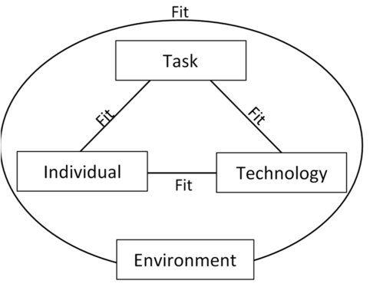
Figure 4: FITTE framework, (Prgomet et al., 2019).

Environmental factors may include operational support, managerial commitment, variations in physical space, infection control, or device availability (Prgomet et al., 2019; De Leeuw, Woltjer and Kool, 2020).
This study extracted no information about wider organisational support, including justification for the decision to go live or possible resource capacity to support the challenges. It does not fully explore the potential impact of changes to organisational priorities or strategy, for example, if a health board were to prioritise another piece of work meaning there was limited training resource available. Questions remain about whether the fit of the antenatal module would vary in another health board or with different organisational priorities.
Furthermore, the FITT framework tends to focus on a specific piece of technology, rather than exploring a system within broader technical architecture. In this case, users highlighted the need for WISDM to share data with other digital clinical systems such as DMC. It is unclear from this study whether WISDM and DMC have compatible data collection processes and standards to enable information sharing, such as Fast Healthcare Interoperability Resources (FHIR). This paper recommends further study into the interoperability of WISDM with other digital clinical systems.
In summary, the overall fit of the antenatal module was deemed good, with this study highlighting lessons that could be repeated for future digital projects, and concise product design change to enhance the system. Future research could explore the fit within the organisational environment to help identify factors to explain why implementation works differently in different settings; or investigate the interoperability of WISDM with other systems to better understand the fit of WISDM within NHS Wales technical architecture.

References
All Wales Maternity and Neonatal Network (2023) ‘All Wales Strategy for Screening and Management of Gestational Diabetes’. Available at: https://wisdom.nhs.wales/all-wales-guidelines/all-wales-guidelines/all-wales-gdm-guideline/ (Accessed: 18 January 2025).
Ammenwerth, E., Iller, C. and Mahler, C. (2006) ‘IT-adoption and the interaction of task, technology and individuals: A fit framework and a case study’, BMC Medical Informatics and Decision Making, 6(1), pp. 1–13. Available at: https://doi.org/10.1186/1472-6947-6-3/FIGURES/10.
Bowling, A. (2023) Research methods in health : investigating health and health services. 5th edn. Maidenhead : Open University Press. Available at: https://nhswaleslibrarysearch.cardiff.ac.uk/discovery/fulldisplay?vid=44WHELF_CAR:44WHELF_NHS_VU1&search_scope=NHS_eBook&tab=LSCOP_NHSWALES&docid=alma9912325674302420&lang=en&context=L&adaptor=Local%20Search%20Engine&isFrbr=true&query=any,contains,research%20design&offset=0 (Accessed: 20 January 2025).
DHCW (2023a) Diabetes consultation note changing landscape for diabetes patients. Available at: https://dhcw.nhs.wales/news/latest-news/diabetes-consultation-note-changing-landscape-for-diabetes-patients/ (Accessed: 3 February 2025).
DHCW (2023b) Women in Wales to benefit from new digital maternity system. Available at: https://dhcw.nhs.wales/news/latest-news/women-in-wales-to-benefit-from-new-digital-maternity-system/ (Accessed: 19 January 2025).
DHCW (2025) Diabetes management system launched in North Wales. Available at: Diabetes management system launched in North Wales (Accessed: 3 February 2025).
Draper, J. (2015) ‘Ethnography: principles, practice and potential’, Nursing standard, 29(36), pp. 36–41. Available at: https://oro.open.ac.uk/44007/1/NS_p36-41_v1_w36_0652.pdf (Accessed: 19 January 2025).
De Leeuw, J.A., Woltjer, H. and Kool, R.B. (2020) ‘Identification of factors influencing the adoption of health information technology by nurses who are digitally lagging: In-depth interview study’, Journal of Medical Internet Research, 22(8). Available at: https://doi.org/10.2196/15630.
NHS England Digital (no date) National Pregnancy in Diabetes Audit. Available at: https://digital.nhs.uk/data-and-information/clinical-audits-and-registries/national-pregnancy-in-diabetes-audit (Accessed: 18 January 2025).
Prgomet, M. et al. (2019) ‘Fit Between Individuals, Tasks, Technology, and Environment (FITTE) Framework: A Proposed Extension of FITT to Evaluate and Optimise Health Information Technology Use’, Studies in Health Technology and Informatics, 264, pp. 744–748. Available at: https://doi.org/10.3233/SHTI190322.
Pugsley, L. (no date) ‘How to : get the most from qualitative research’, Wales Deanery [Preprint]. Cardiff. Available at: https://www.cardiff.ac.uk/__data/assets/pdf_file/0006/1164966/How_to_Get_the_Most_from_Qualitative_Research.pdf (Accessed: 20 January 2025).
Swain, J. and King, B. (2022) ‘Using Informal Conversations in Qualitative Research’, https://doi.org/10.1177/16094069221085056, 21. Available at: https://doi.org/10.1177/16094069221085056.
Tsiknakis, M. and Kouroubali, A. (2009) ‘Organizational factors affecting successful adoption of innovative eHealth services: A case study employing the FITT framework’, International Journal of Medical Informatics, 78(1), pp. 39–52. Available at: https://doi.org/10.1016/J.IJMEDINF.2008.07.001.
Wästerfors, D. (2018) ‘Observations’, The SAGE Handbook of Qualitative Data Collection, pp. 314–326. Available at: https://doi.org/10.4135/9781526416070.

Glossary
Acronym | Meaning
BCUHB | Betsi Cadwaladr University Health Board
DMC | Digital Maternity Cymru
DSN | Diabetes Specialist Nurse
FHIR | Fast Healthcare Interoperability Resources
FITT | Fit between Individual, Technology and Task
FITTE | Fit between Individual, Technology, Task and Environment
FTE | Full time equivalent
NPID | National Pregnancy in Diabetes Audit
OGTT | Oral glucose tolerance test
WCP | Welsh Clinical Portal

Other information
I confirm this essay is my own original work and does not include text created by a generative artificial intelligence tool.

