University of Wales Trinity Saint David

School of Engineering

Passive RC Filter Network Technical Report

Electrical & Electronic Principles ACDB4002

Joshua Axon

2218372

14th April 2023

Table of Contents
1 Introduction 3
1.1 Abstract 3
1.2 Introduction 3
1.2.1 Circuit Descriptions 5
1.3 Results 6
7
8
1.4 Discussion 9
1.5 Conclusion 9
2 References 9

Introduction

Abstract
This technical report aims to document the findings of a series of laboratory exercises analysing specific circuits and networks, performing electrical measurements then recording and analysing data gained from these measurements to derive what the cut-off frequency is for the attenuation of -3dB and provide some background on filter circuits what they are why they do what they do and ultimately provide a statement of findings for the lab exercises. Both high and low-pass passive filters were built to accept input from a function generator using 5v pk to pk using a sine wave input signal, that signal was then filtered through the circuits to remove any unwanted frequencies and then picked up on the receiving end by an oscilloscope with any unwanted frequencies filtered out. A capacitor was used in both circuits to act as the filter for the circuits a 15 nano-farads capacitor for the high pass and a 560 pico farads capacitor for the low pass. Then from frequencies from 10Hz to 3Khz, the output voltage amplitude on the oscilloscope was recorded for both circuits with around 30-40 measurements taken between the two frequency boundaries, with the data now collected the next stage was to input the data in an Excel datasheet and calculate using a formula in excel the attenuation in dB’s this data was then used to make a scatter plot graph for attenuation. Excel was also used to generate a theoretical attenuation data set once collated it was also plotted on a scatter plot graph in Excel.

Introduction
The function of high and low-pass filter circuits is to as the name suggests allow certain frequency ranges to pass through the circuits and block / attenuate any signals that do not fall within the desired frequency ranges. A high pass filter is designed to have a higher cut-off frequency to allow the higher end of the frequency band to pass through the circuit while attenuating all those that fall below the cut-off frequency. A low pass filter works in the reverse, designed to have a lower cut-off frequency, and allow lower-end frequencies to pass through the circuit and attenuate all those that fall above. 1st order filters as those just described above work based on the use of the capacitor's changing opposition, the opposition they provide is inversely related to the frequency of the source this changing opposition is more commonly known as capacitive reactance. (Rawlins, 2000).
This is because in an AC circuit, the voltage applied to the capacitor is constantly changing in the case of sine wave signals it changes from positive to negative polarity in practice this means the capacitor is always charging and discharging at a rate determined by the supply frequency this is the ‘changing opposition’ mentioned above for this reasons capacitors can be thought of as frequency dependant resistor as the frequency changes the capacitor’s capacitive reactance changes either raising with frequency or lowering and depending on the value of the capacitor. As mentioned, is known as capacitive reactance and is the internal impedance of the capacitor this is given the symbol XC and is measured in Ohms (Kuphaldt, 2007). Equation 1 below shows how this is calculated π is 3.142, f is the frequency in hertz and C is the value of the capacitor measured in farads.
Equation 1 – Capacitive Reactance
XC = 1/(2πfC) (Storr, 2014)
This was used to calculate the theoretical capacitor complex impedance which is then used to calculate the Vout of the theoretical filter circuit using the ac potential divider equation shown in ‘Equation 2’ in the figure below.
Equation 2 – Voltage out
Vout = Vin * XC /sqrt{R² +XC² } (Storr, 2014)
Where Vin and Vout are measured in Volts once the Vout has been calculated the attenuation can then be calculated via the formula shown in ‘Equation 3’ this formula was be used to calculate the attenuation (attenuation measured in dB decibels) for both the theoretical and experimental circuits using both sets of data.
Equation 3 - Attenuation
( dB = –20log*VOUT/IN ) (Storr, 2014)
Once all of this has been calculated scatter plot graphs can be made using the calculated data for both the theoretical and experimental circuits to map the attenuation for both the high and low-pass filter circuits this is what will be presented later in the report and what the results of those graphs demonstrate. It should also be noted that when the attenuation of a signal is measured it is often measured in negative decibels and a lower attenuation amount in decibels means that the attenuation has gotten greater and that the signal strength has gotten weaker for example -10dB is a greater level of attenuation than -3dB and an indication of that the signal strength has gotten weaker (Nelken, 2023). This will be more relevant when looking at the attenuation scatter plot presented later in the report.
The High and low pass filters mentioned in this report are used in many different sectors such as telecommunications, consumer electronics & signal processing. You can if them in many products for example they are present in microphones, amplifiers and Wi-Fi routers they will often be found in electronic that require the use of limited/narrow bandwidth of signals to avoid interference from things such as noise vibration wind etc simple passive filter circuits such as those highlighted in this report are often used as they have a low cost, are simple to mass produce and implement into electronics.

Circuit Descriptions

As previously stated, there are two types of circuits that this report will look at they are High and Low 1st order AC passive filter circuits. Note that the control variables in these circuits will be firstly the input voltage of 5v and the resistor of 10kΩ which will stay the same across circuits. Our independent variable in these circuits will be the capacitor, the low-pass circuit will use a 10 nanofarads capacitor whereas the high-pass will use a higher value capacitor of 560 pico farads. The dependent variable in these circuits will be the output voltage measured on the oscilloscope. The low-pass circuit will be first tested at 10Hz results recorded and then tested all the way up to 300Khz with results taken at different increments. ‘Figure 1’ below shows a diagram of a low-pass filter circuit where the capacitor has been placed in parallel with the input source placed to create a voltage divider this ensures that any voltage has a path to travel across the capacitor and allow the capacitor to discharge and ‘smooth out the signal’ / filter out the high-end frequencies (Rawlins, 2000).

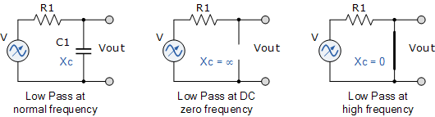

Figure 1 – Low Pass 1st order passive filter circuit diagram. (Storr, 2014)

‘Figure 2’ below shows a diagram of a high-pass filter circuit however this circuit differs as the resistor is in parallel with the input source and the capacitor is now in series with the input source this configuration allows the input signal to pass through the capacitor when high frequencies pass through a capacitor it creates a voltage drop off this drop off paired with the resistor in parallel means providing a path for high-frequency signals to pass through the resistor, in turn, attenuating the signal and creating a voltage drop across this then causes a high-pass filtering effect to be made (Rawlins, 2000).
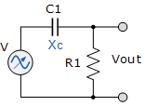

Figure 2 – High Pass 1st Order passive filter circuit diagram. (Storr, 2014)

Results
Once the lab exercise was complete and all was collected the raw data set of the V_{OUT} for the high and low pass filter circuits from the lab work and calculated theorical data set using the mentioned equations those calculations were then used to plot scatter plot graphs in excel with a log 10 base where the frequency was plotted along the X axis and the attenuation in dB was plotted along the Y axis. Four separate graphs were produced two for the High pass and two for the Low pass.
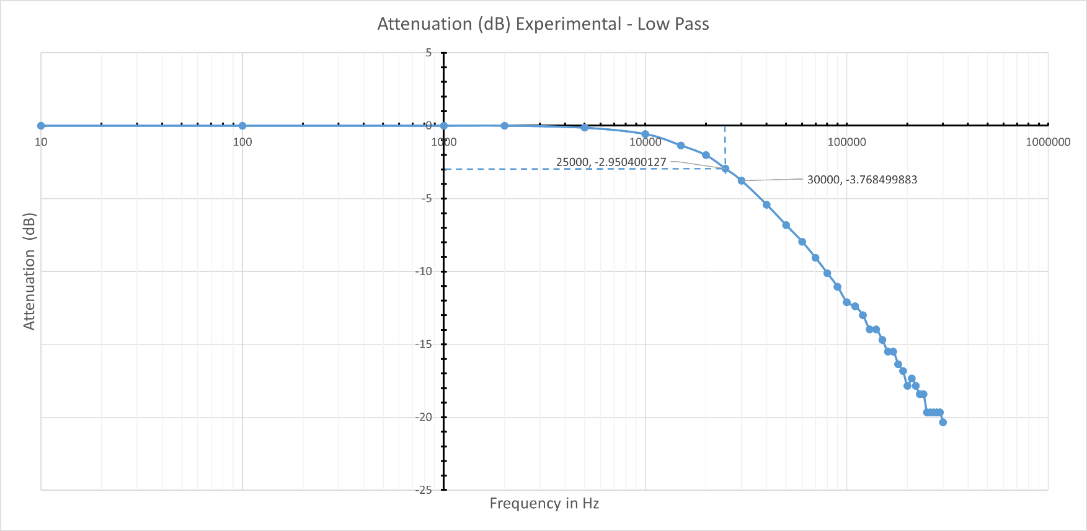
Figure 3 Attenuation Low Pass (Experimental)

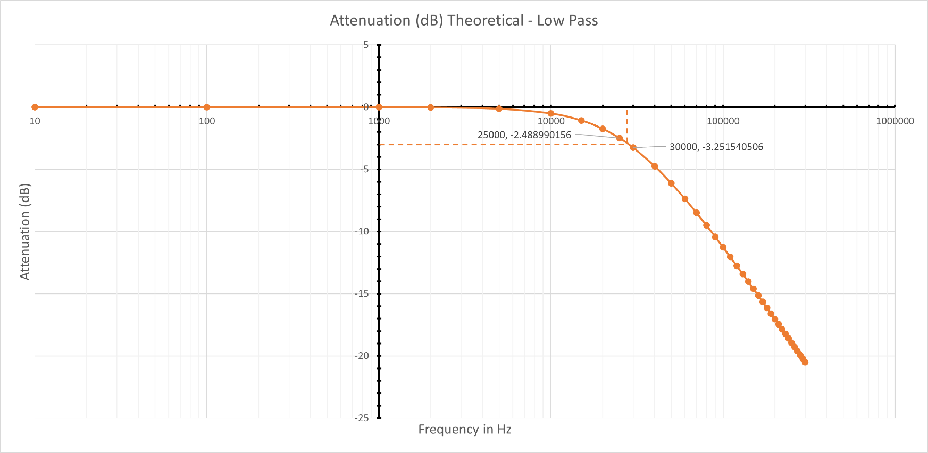
Figures 3 & 4 are the graphs for the Low pass attenuation for both experimental and theoretical data sets they can be identified as such by the fact that there is a level of attenuation that starts to increase as the frequency increases there is also small differences between the graphs especially on the higher end of the frequency band.
Figure 4 - Attenuation Low Pass (Theoretical)
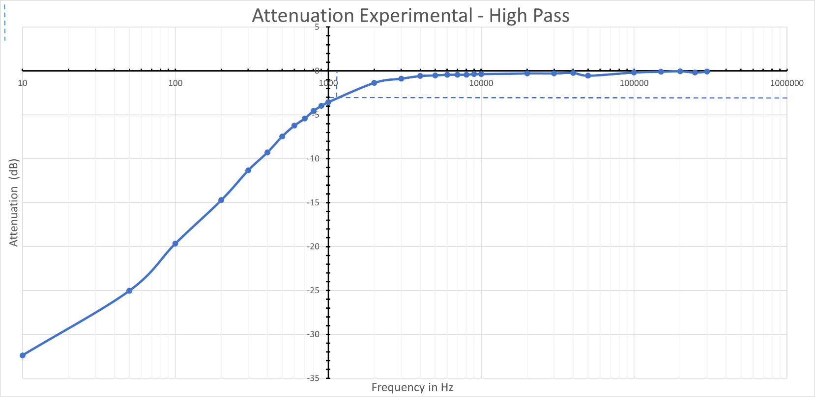
Figure 5- Attenuation High Pass (Experimental)
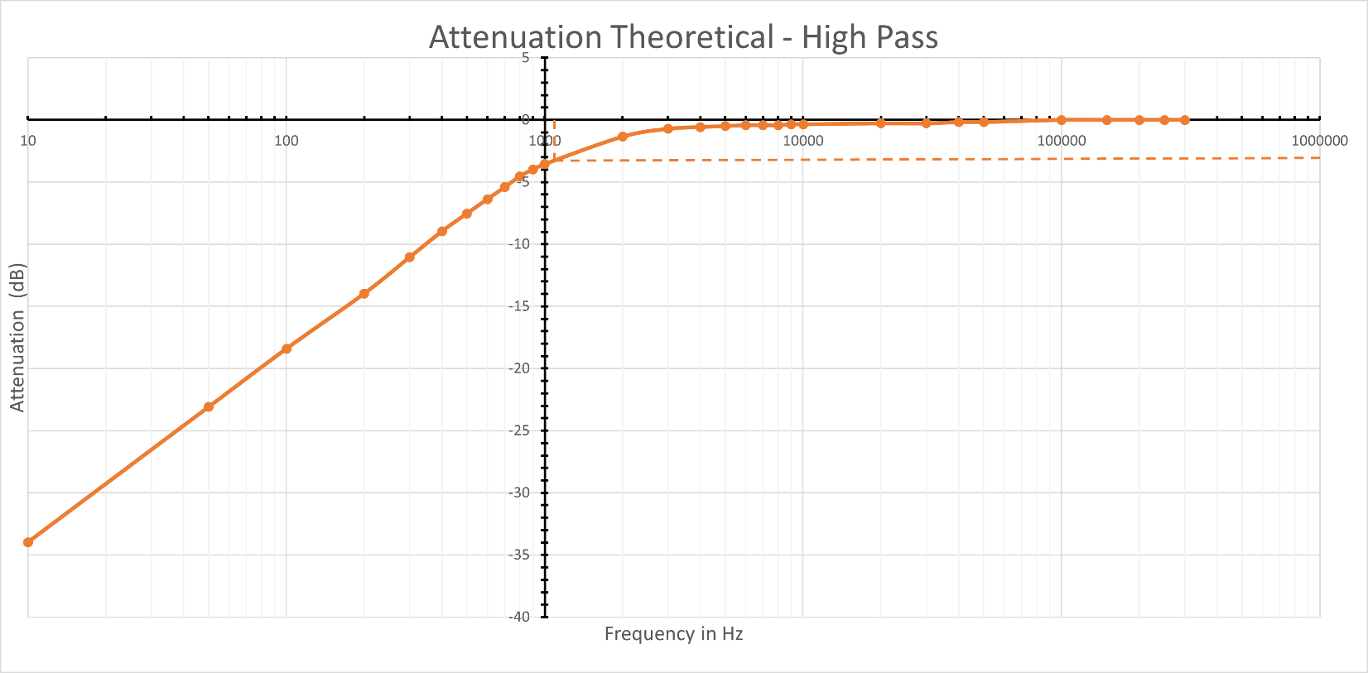
Figure 6 - Attenuation High Pass (Theoretical)
Figures 5 & 6 are for the High Pass Filters both using experimental and theoretical data sets the distinguishing feature of the high pass filter graphs is the fact unlike the low pass there is a high level of attenuation straight away and it bleeds off as the frequency increases this like the low pass also has some slight differences on however these are more round the lower end of the frequency band.

Discussion
In both of the experimental attenuation graphs for the high and low pass as mentioned in the results section the on the far end of the scale of results for both filter circuits e.g. higher band of frequencies in the low pass circuit and lower band of frequencies for the high pass it can be seen that there are a number of anomalies in the result that do not line up with the results for the theoretical graphs it can be theorised that these anomalies are due in part to interference as when there is a high level of attenuation in the circuit this means that there would be a very weak signal or a low VOUT circuit, a signal is small or weak it means the signal is more susceptible to interference this believed to be was experienced when taking the readings as the voltage out as it was observed on the oscilloscope that when the voltage out was under 2 volts would fluctuate randomly to a higher or lower voltage and then settle at either that high or lower voltage this would worsen the lower output voltage got. Examples of interference that might be experienced in a lab environment where the experiment was conducted in such as environmental interference noise generated from a student talking or walking around during the experiment. Interference can also generate from thermal noise as the equipment increases in temperature so would the level of interference this is believed to be the reason why in the high pass there is a greater level of anomalies in the results than in the low pass and not just when the VOUT was very low but when it higher as well the high pass readings were some of the last after all the low pass readings were taken it can be presumed that the equipment would be it hottest when they were taken thus the level of thermal noise experience greatest.
The -3dB cut-off for the experimental graphs differs slightly from theoretical attenuation graphs with the cut-off in the experimental graphs occurring slightly earlier in both graphs these minor differences to can be attributed to inaccuracies with equipment as no one piece of equipment whether it be resistor, capacitor or oscilloscope are 100% accurate and although for example a resistor is given a value of 10000 Ω and they are built to a tolerance and means there will still have some variation and could end up providing slightly more or slightly less resistance and the theoretical calculations as well as the attenuation graphs are plotted form that data are calculated with idea that all components are 100% accurate and does not factor in any level of inaccuracy which would be experienced when conducting the real experiments.

Conclusion
In this experiment, it has been determined that attenuation in 1st order Low Pass Passive Capacitor filter circuits is inversely proportional to frequency as the experimental graph shows, when the frequency increases on the graph so too does the level of attenuation demonstrating a reduction in signal strength in essence that the circuit is able to filter out higher-end frequency signals.
It can also be determined that in 1st order High Pass Passive Capacitor filter circuits frequency is also inversely proportional to attenuation as the experimental graph demonstrates with a high level of attenuation on a lower frequency band and as the frequency increases the level of attenuation decreases this showing that the circuit is able to filter/attenuate lower end frequency signals.
If the experiment was to be repeated measure should be taken to reduce the potential for interference such as avoiding conducting all the experiment in a loud busy environment to reduce the impact environmental interference could play a role, taking the readings for the high and low pass in two separate session’s two avoid the having interference from thermal noise. Create more than one theoretical data set with different tolerance built in for example run the calculations with a resistor that is 5% over and under the value this should allow the results to be more relevant to the lab-derived results.

References
ANALOG DEVICES, 2008. MT-078 Tutorial High Frequency Log Amps. s.l.:s.n.
Kuphaldt, T. R., 2007. Lessons In Electric Circuits, – AC Volume II. In: s.l.:Michael Stuz, pp. 189 - 216.
Nelken, A. d. C. &. I., 2023. Filters: When, Why, and How (Not) to Use Them. Neuron, pp. 280 - 293.
Rawlins, J. C., 2000. Basic AC Circuits Second Edition. s.l.:Sams Publishing.
Storr, W., 2014. Electronic Tutorials. [Online]
Available at: https://www.electronics-tutorials.ws/filter/filter_1.html

Equation 1 – Capacitive Reactance 4
Equation 2 – Voltage out 4
Equation 3 - Attenuation 4

Figure 1 – Low Pass 1st order passive filter circuit diagram. (Storr, 2014) 5
Figure 2 – High Pass 1st Order passive filter circuit diagram. (Storr, 2014) 5
Figure 3 Attenuation Low Pass (Experimental) 6
Figure 4 - Attenuation Low Pass (Theoretical) 6
Figure 5- Attenuation High Pass (Experimental) 7
Figure 6 - Attenuation High Pass (Theoretical) 7

