

Sustainable Hospitality & Tourism Management
BMIH5006

Student: Jaber Hossin Ruman
Student ID: 1812666
Lecturer: Kathryn Roberts

Contents
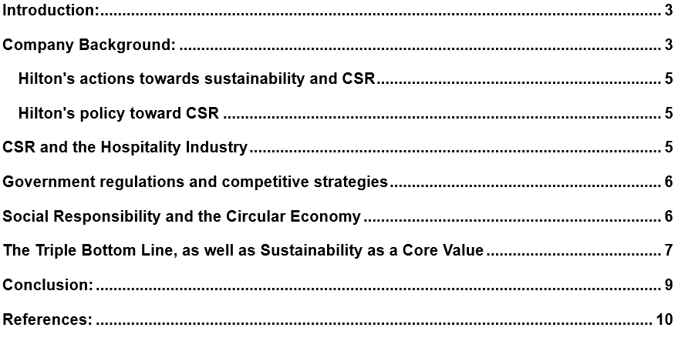

Introduction
The hotel business in particular has a checkered past when it comes to its impact on the natural world. Excessive use of consumables and utilities is a major contributor to these effects. However, the tide is turning as the idea of sustainability becomes increasingly central in the corporate world. In this article, we will investigate and assess Hilton Hotels' CSR policy, paying special attention to the company's commitment to protecting the natural world. Corporate social responsibility (CSR) has emerged as a critical success element for businesses in the 21st century (Hilton, 2023). We will conduct an in-depth analysis of the causes, such as demands from the government and actions taken by competitors, that have compelled hoteliers to make environmental responsibility a major component of their overall business strategy. In addition to going through the Triple Bottom Line and the several tenets of sustainability, this conversation will also go into the idea of corporate social responsibility (CSR) and its relationship to the circular economy.

Company Background

Figure 1: “Hilton Hotels and Resorts; Source: (Ziakas, 2021)
The Hilton Hotels and Resorts brand is the flagship of the American international hotel chain Hilton, originally known as Hilton Hotels. Luxury hotels and resorts from all around the world make up this group. Founder Conrad Hilton built the company from the ground up. Hilton Hotels and Resorts, as of the end of 2018, operates 584 hotels and resorts throughout six continents, providing a total of 216,379 guest rooms. There are a total of 219,264 rooms over 61 hotels that are either owned or leased (251 hotels with 77,451 rooms and 272 hotels with 119,612 rooms) (Inkson and Minnaert, 2018). Fortune magazine has named Hilton Hotels and Resorts the greatest place to work in 2020 based on results from a company-wide survey.
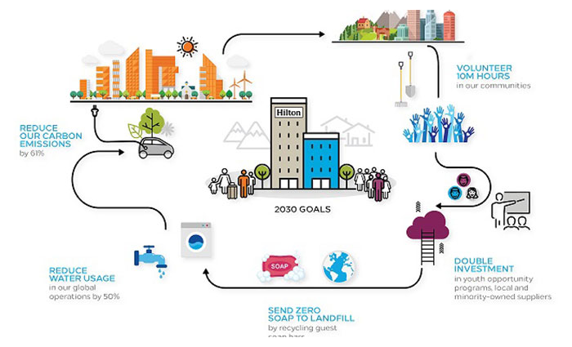
Figure 2: Hilton taking steps towards sustainable environment, Source: (Matteucci, 2020)
Hilton is committed to the principles of the circular economy and waste minimization. Waste management, recycling, and reusing and donating food are all vital parts of making the hotel industry more sustainable. Thanks to this approach, Hilton has reduced its global carbon footprint by 36%, its food waste by 44%, and its water consumption by 25% (Qian, Shen, Law, 2018). A global company like Hilton's actions, no matter how little, have far-reaching consequences (Inkson and Minnaert, 2018). Hilton's plan to promote sustainable tourism on a global scale is called "Travel with Purpose." Environmental, Social, and Governance (ESG) is an element of the company's overall programe (Hilton, 2023). Their goal, via the use of Travel with Purpose, is to improve our company's operations, supply chain, and local communities in a way that is both environmentally and socially responsible.

Hilton's actions towards sustainability and CSR
The elimination of waste and the promotion of a circular economy are two of Hilton's top priorities (Inkson and Minnaert, 2018). Waste reduction, material recycling, and creative food reuse, donation, and upcycling are all crucial steps in making the hospitality industry greener. Our goal is to cut waste production in half by 2030.

Hilton's policy toward CSR
They are dedicated to halving their negative effects on the environment and doubling their investment in positive social impact by the year 2030 (Ziakas, 2021). Our overall Travel with Purpose 2030 Goals are supported by a set of sub-targets that closely align with the global Sustainable Development Goals (also known as "SDGs") approved by the United Nations in 2015.

CSR and the Hospitality Industry
The idea of corporations accepting responsibility for their activities as well as the effect those actions have on society and the environment is at the heart of the Corporate Social Responsibility (CSR) movement, which is a notion that has garnered an incredible amount of attention in recent years (Ziakas, 2021). In the context of the hotel business, corporate social responsibility (CSR) plays an important part in mitigating the negative social and environmental repercussions that have historically been associated with the sector (Pérez and De Los, 2023). As tourists grow increasingly aware of the impact they have on the environment, hotels will need to adjust their operations and embrace sustainability in order to maintain a competitive edge. Hilton Hotels is a leader in the movement towards eco-friendlier corporate policies (Korstanje, George, and Nedelea, 2020). According to the company's CSR policy (Font, Lynes, 2018), Hilton is committed to "Travel with Purpose," an effort that highlights the company's intention to improve both the community and the environment via its operations. In keeping with this guiding principle, Hilton has set a variety of lofty sustainability goals, some of which include reducing the company's negative effects on the natural world, increasing the prosperity of the areas in which it works, and improving the quality of life for its employees.

Government regulations and competitive strategies
Increasing government pressure is being felt by the hotel industry to implement eco-friendly policies and procedures. Through environmental laws and tax incentives, hotels are prompted to lessen their impact on the natural world (Cooper, 2020). Hotels located in areas where there is a worry about a lack of available water are often mandated to employ water-saving measures and adopt environmentally friendly construction designs (Hilton, 2023). Certifications granted by the government, such as those granted by the Leadership in Energy and Environmental Design (LEED) program, are now required for hotels that want to show that they are committed to being environmentally responsible (Cooper, 2020). For example, Hilton Hotels has taken a proactive position by getting LEED certifications for several of its locations. This demonstrates its commitment to environmental sustainability. The hotel business is also being driven towards sustainability by the acts of competitors. Hotels that fail to adopt environmentally friendly practices run the danger of losing market share as the number of eco-conscious travelers increases (Cooper, 2020). When there is a lot of competition in a market, sustainability becomes an important difference that can attract customers who are environmentally conscious and are looking for eco-friendly lodgings (Pérez and De Los, 2023). The dedication of Hilton to environmental protection not only brings in new consumers, but it also helps the company build a good image and inspires brand loyalty among those whose ideals are congruent with Hilton's.

Social Responsibility and the Circular Economy
The idea of corporate social responsibility (CSR) in the hospitality industry has strong ties to the circular economy. An economic model that encourages the ethical consumption of goods and services as well as the effective use of available resources is known as a circular economy (Legrand, Sloan, Chen, 2016). This means decreasing waste as much as possible, cutting down on the amount of energy and water used, and purchasing goods and services from local vendors wherever possible (Pérez,and De Los, 2023). The corporate social responsibility (CSR) program of Hilton involves attempts to decrease waste and increase resource efficiency. For instance, the firm has made a commitment to preventing all soap from ending up in landfills and is working hard to cut the amount of water used in its hotels (Legrand, Sloan and Chen, 2016). Through the implementation of these steps, Hilton not only lessens its impact on the environment but also makes a contribution to a circular economy through the efficient reuse of its resources.

The Triple Bottom Line, as well as Sustainability as a Core Value
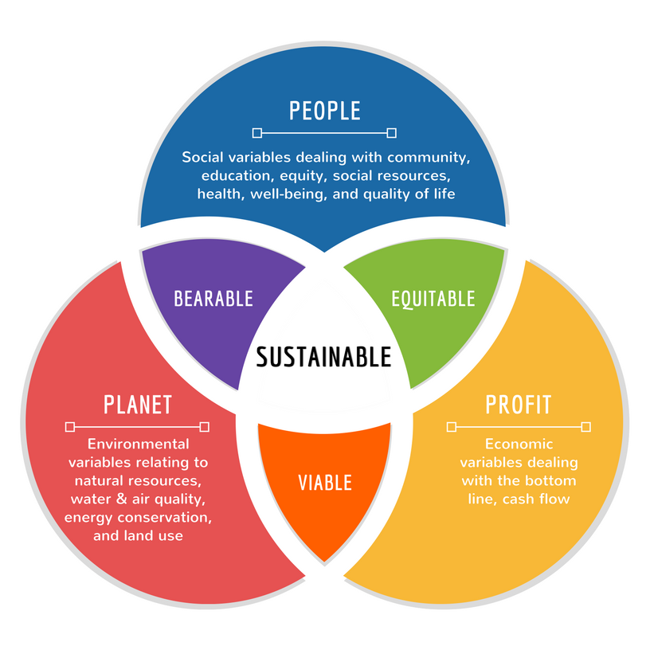
Figure 3: Triple Bottom Line; Source (Stephanclassen, 2022)
Relationship between Triple bottom line and CSR: By Emphasising people, the environment, and profits in equal measure, Hilton's CSR approach demonstrates the company's dedication to the Triple Bottom Line model. Based on this paradigm, Hilton's "people" strategy prioritises increasing employees' access to opportunities that will improve their lives and advance their careers (Korstanje, George, and Nedelea, 2020). Hilton, in the sense of "planet," displays an unshakable dedication to lessening the environmental effect of its activities. This includes cutting back on water and power use and recycling as much as possible (Pérez, and De Los,2023) Hilton is cognizant that cost savings and increased income can emerge from sustainability initiatives, and therefore the corporation continues to prioritize the "profit" aspect of its business.
Three Components: The economic, social, and environmental facets of a company are typically considered the "three pillars" of sustainability. The Corporate Social Responsibility (CSR) strategy of Hilton successfully encompasses each of these pillars, assuring a holistic approach to sustainability (Font and Lynes, 2018). Economically speaking, Hilton makes active investments in the communities surrounding its properties, which helps to stimulate economic growth in the areas in which such assets are located. Not only does this help the areas in which Hilton Hotels operates, but it also demonstrates the company's dedication to being a responsible member of society.
- In the "social" realm, Hilton lays a substantial emphasis on the company's workers' overall well-being as well as their professional growth and advancement (Korstanje, George and Nedelea, 2020). Hilton transcends its status as merely a hotel chain into that of an employer that demonstrates real concern for the well-being of its staff by creating a positive work environment that encourages professional development in addition to general well-being (Qian, Shen, and Law, 2018). This social pillar of sustainability isn't just about keeping worker morale up; it also increases employee loyalty and happiness, which, in turn, has a beneficial influence on both the customer experience and the reputation of the organization.
- It is possible that the "environmental" component of Hilton's CSR strategy is the most apparent and well-recognized facet of the company's commitment to sustainability (Mooscaner et al., 2020). Hilton aggressively lessens its toll on the environment by embracing a diverse range of environmentally friendly business practices. These initiatives include energy-efficient building designs that minimize energy use, reduced water usage to battle worries about water shortages, and a strong focus on waste reduction (Qian, Shen, Law, 2018). These designs can help reduce the amount of energy that is consumed. Not only do Hilton's efforts in this respect serve to reduce the company's overall carbon footprint, but they also strike a chord with environmentally concerned travellers, who increasingly base their decisions on a company's level of ecological responsibility.
In summary, Hilton's corporate social responsibility strategy is well-aligned with the Triple Bottom Line approach, which addresses the critical aspects of people, the environment, and profits (Mooscaner et al., 2020). In addition, Hilton has positioned itself as a frontrunner in the sustainability movement-taking place within the hotel industry by adopting the three pillars of sustainability, which are economic, social, and environmental responsibility (Hilton, 2023). The economic aspect helps to improve the local community, the social aspect promotes the health and growth of the workforce, and the environmental aspect works to reduce the ecological impact that the firm leaves behind. The comprehensive approach to sustainability that Hilton takes not only serves as an admirable model but also strikes a chord with a wider audience of environmentally conscious travelers. As a result, the firm is in a better position to enjoy a more sustainable and prosperous future in the highly competitive world of hospitality.

Conclusion:
Finally, sustainability is no longer a nice-to-have, but rather an absolute must-have, in the hotel industry. Hilton Hotels' "Travel with Purpose"-inspired CSR approach is illustrative of the hospitality sector's commitment to environmental responsibility. As a result of rising government regulations, the actions of their rivals, and the changing preferences of their clientele, hotels have been compelled to make sustainability a core part of their business strategy. This shift towards CSR is consistent with the principles of sustainable development, the Triple Bottom Line, and the circular economy. Hilton's initiatives are good for the environment, the local community, and the company's bottom line. Going forward, sustainability will remain a motivating factor, guaranteeing that the hotel industry evolves to suit the needs of a planet that is growing increasingly environmentally conscious.

References
Cooper, C. (2020) Essentials of tourism. Sage Publications Limited.
Font, X. and Lynes, J., 2018. Corporate social responsibility in tourism and hospitality. Journal of Sustainable Tourism, 26(7), pp.127-142.
Guix, M., Bonilla-Priego, M.J. and Font, X., 2018. The process of sustainability reporting in international hotel groups: An analysis of stakeholder inclusiveness, materiality and responsiveness. Journal of Sustainable Tourism, 26(7), pp.103-184.
Hilton, H. (2023) Hilton taking steps towards sustainable environment, BW Hotelier. Available at: https://bwhotelier.businessworld.in/article/Hilton-Taking-Steps-Towards-Sustainable-Environment/05-06-2018-151164/. (Accessed: 11 Oct. 2023)
Inkson, C. and Minnaert, L. (2018) Tourism Management: An Introduction. SAGE.
Khatter, A., McGrath, M., Pyke, J., White, L. and Lockstone-Binney, L., 2019. Analysis of hotels’ environmentally sustainable policies and practices: Sustainability and corporate social responsibility in hospitality and tourism. International Journal of Contemporary Hospitality Management, 31(6), pp.2394-2410.
Korstanje, M.E., George, B. and Nedelea, A.-M. (2020) Strategies for promoting sustainable hospitality and tourism services. IGI Global.
Legrand, W., Sloan, P. and Chen, J.S. (2016) Sustainability in the hospitality industry: Principles of Sustainable Operations.
Matteucci, V., 2020. How can the hospitality industry increase corporate value aligned with sustainable development goals? Case examples from Hilton, Meliá and Sun. Worldwide Hospitality and Tourism Themes, 12(5), pp.509-523.
Molina-Collado, A., Santos-Vijande, M.L., Gómez-Rico, M. and Madera, J.M., 2022. Sustainability in hospitality and tourism: a review of key research topics from 1994 to 2020. International Journal of Contemporary Hospitality Management, 34(8), pp.3029-3064.
Mooscaner, D.C., Laasch, O., Parkes, C. and Brown, K.G. (2020) The SAGE Handbook of Responsible Management Learning and Education. SAGE.
Pérez, A. and De Los, M.D.M.G., 2023. CSR communication and media channel choice in the hospitality and tourism industry. Tourism Management Perspectives, 45, p.101066.
Qian, J., Shen, H. and Law, R., 2018. Research in sustainable tourism: A longitudinal study of articles between 2008 and 2017. Sustainability, 10(3), p.590.
Resources, M.A.I. (2018) Sustainable tourism: Breakthroughs in research and practice: Breakthroughs in Research and Practice. IGI Global.
Ziakas, V. (2021) Strategic Event leveraging: Models, Practices and Prospects. CABI.

