The Global Business Environment LCCB4005
Assessment 2 Environmental Analysis of an industry

Student:Valentina-Elena Cojocariu
Student ID:2022564
Date: 7/5/2021

H&M (Hennes & Mauritz)

H&M is a fashion retailer which has its headquarter in Sweden (Stockholm). Person S. is its chairman and his son Karl-Johan is the CEO of the company.
Although at first sight, the fast-fashion sector is shaping up as an extremely crowded market, in reality the Romanian fashion industry is not "very developed". If we compare it to other European markets, we can state that the brand diversity is "fake", in the sense that the same brands are present in all malls. In other words, in Romania we cannot speak of a “brand war” or of a “fierce” competition between the Swedish retailer (H&M) and other retailers such as Inditex. Their marketing and promotion strategies are very different. What makes H&M’s business model different from the rest of retailers is the price level and the types of collections.
The well-known company started to be more concerned about the impact of its business on the environment and consequently focuses more on “green” practices. The brand is trying to expand its business while maintaining the same standards of quality, improving its sustainable practices. H&M’s current business model relies on the fact that the company does not own the stores, but prefers to rent them or work in a franchise system.
It might be surprising for some of us, but the fast-fashion retailer does not have any factory. The business model gathers about 800 suppliers, especially from Europe or Asia. All H&M's collections and garments are planned by the procurement department, The contact with the suppliers is permanently maintained to ensure all the company’s standards.
In addition, the production department is responsible for placing orders and making sure that all the garments are manufactured according to the company’s standards, and of course at the right price. All the garments are manufactured in a couple of weeks up to 6 months. However, the intended clothes are produced in smaller volumes and with considerably shorter execution times. Generally, garments which have to be delivered in a shorter delay are manufactured in Europe, while the rest of items are produced in Asia. Like Zara, this strategy will allow H&M to react more quickly to new trends. The size of a store, the country in which it is located and the type (larger or smaller) are other factors that are taken into account when ordering clothing items (high-fashion ones will be sold mainly in big cities).
We have conducted a research and consulted various reports and articles in order to have a better understanding of the changes and amendments taken by H&M over the years in order to self-regulate its business model and improve its sustainability performance.
First, compared to other fast-fashion chains (e.g. Zara), H&M’s individual stores do not have spare stocks; they are resupplied according to the requirements of the central warehouses. As soon as a product is sold out, a resupply request is submitted. In line with H&M's sustainability policy, the “greenest” means of transport are used, with the lowest possible fuel consumption. As a result, the volume of air transport has halved in just a few years. H&M also monitors the consumption of logistics service providers, such as shipping lines or road carriers.
Goods sent by Asian producers are transported almost exclusively by sea. Within Europe, H&M's ambition is to increase rail transport to the detriment of road transport. More than 90% of transport is by sea, rail or road. Air transport is used only in exceptional cases, when urgent deliveries are required. The stores are located in the best shopping areas around the world. This has been a clear principle since the opening of the first H&M store in 1974. In addition, H&M does not own stores, preferring to rent the necessary premises.
The table below provides us with valuable data on the Key Performance Indicators regarding the circular and climate approach from 2017 to 2020. The company’s biggest achievement is that the cotton used is 100% certified organic or recycled or it is part of the Better Cotton Initiative.
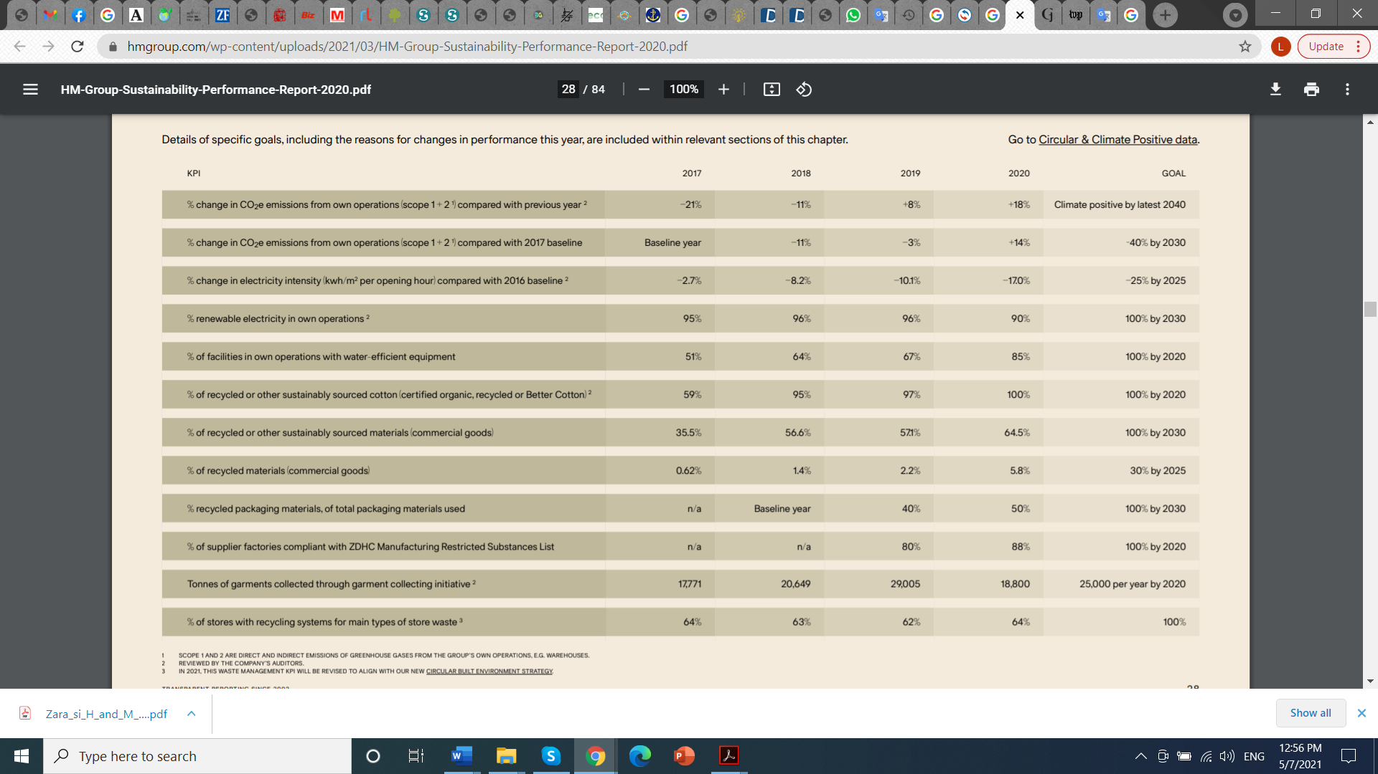
Since 2013 H&M has made efforts to reduce its impact on the environment and got involved in several sustainable actions and projects.
Last year, the company launched a service in Stockholm through which customers can bring their old products and with the help of a new innovative machine “Loop” they can see how their items go through a whole process and they are given a second life, becoming a new product. The process lasts five hours, and guests can choose between a sweater, a baby blanket or a scarf.
The clothes brought by customers will be washed and placed in this machine called Looop, which will disassemble and chop them into fibers which will then be used to create a new garment. The whole process takes about five hours and can be seen by customers, behind some windows. The company said that this recycling process does not use water or chemicals, but that sometimes it may need new materials added, but they will be from sustainable sources. Customers will be able to choose, in exchange for old clothes, a sweater, a baby blanket or a scarf, for which they will pay a small amount of money.
The Swedish clothing retailer H&M also launched in 2013 a campaign to recycle old clothes in all its stores from the 48 countries. Customers are able to bring used clothes to H&M stores, and in exchange for their gesture they receive a voucher to buy new clothes. Thus, buyers can support the saving of natural resources, while also helping to reduce the impact on the environment by avoiding textile waste. As we can notice from the above table, H&M has collected in 2019 am impressive amount of more than 29 005 tons of garments. In 2020, this figure fell by more than 10 000 tons, probably because of the outbreak of coronavirus and the decision of the governments to close the shops temporary in order to reduce the spread of coronavirus.
Based on the information presented above, the only theory that can explain H&M's business model is, as in the case of Inditex, that of resource heterogeneity, again emphasizing their complementarity (i.e. the complementarity of strategic capabilities that form a responsible mix for economic success).
The year 2021 have brought big changes in the business model of the company. As the demand for vegan accessories and clothing increases, as well as for ethically and environmentally-friendly garments, big fashion brands around the world are happily preparing to meet the demands of a changing market. This is the case with H&M. With the help of its designers, the company prepared a surprise: a completely fruity, vegan and eco-sustainable line launched in the Conscious Exclusive 2021 collection. Several materials were used in the production of these garments and boots such as: pineapple leather and orange fiber silk. Carmen Hijosa, a designer and expert in leather goods, managed to create this ecological and sustainable material from fibers of pineapple leaves. This type of vegan leather was used in the production of boots and jackets
In addition, it is also worth mentioning another durable material which is made from orange peel, Orange Fiber®, which has earned the nickname of vegan silk and is made in Italy (Salvatore Ferragamo used it in his fashion lines).
In conclusion, H&M has brought a number of changes related to the shipment of garments around the world, trying to use green means of transport (maritime and rail transport), and has succeeded in replacing the old non-renewable materials with ecological and even vegan ones (such as the leather made out of pineapple leaves).
2. Recommendations and competitive advantage position
Consumerism has become a disturbing factor for the environment. The fast-changing trends in the fashion industry are becoming worrying. With about 24 collection a year, H&M encourages its customers to go shopping spending spree on clothes. What was “in” yesterday it is no longer in fashion today. First, let's better understand the concept of fast-fashion: we can compare it with the fast food industry. Cheap, poor quality food, prepared quickly and has serious consequences on the customer’s health. The same happens with the fast-fashion trend: cheap fashion, produced quickly and of poor or average quality, minimum costs, minimum investments and cheap labor and most of the time exploited. Therefore, it has serious consequences on the environment and on humanity in general.
In the first part of our research, we noticed that the company holds a competitive advantage position as it outsources its production. Its business model allows in-house designers have the ability to create new clothing items in a fast rhythm, transforming design into a core competency of the company. Also, its corporate culture that promotes flexibility and adaptability is another advantage. In terms of multinational presence, H&M enjoys the advantage of using suppliers from various economic backgrounds (e.g. Turkey in Europe and Bangladesh in Asia) where it is better positioned to take advantage of diverse market conditions and country-specific endowments.
Apart from to investments in publicity, H&M's strategy also relies on the signing of contract with famous designers. For more than 20 years, the company worked with famous fashion designer. However, although they are designed for different age groups, the commercials and promotional materials has the same vision, as unified as possible. H&M has high skilled designers with a strong know-how on eco-friendly products and materials who have succeeded in bringing a competitive advantage to the company by replacing the materials, such as leather, cotton with more environmentally friendly ones. As we mentioned in the first part of our presentation, designers came up with innovative ideas: such as leather made up of pineapple leaves.
Although H&M demonstrates that it has control of the entire production chain, its situation cannot be compared to that of other fast-fashion industries such as Inditex. Preferring to reduce costs, H&M outsourced production and focused internally on functions such as procurement, design or IT infrastructure.
We are aware of the fact that the company wishes to keep the prices low, this is the reason why people who are manufacturing the clothes are not well paid or not even enough paid. For instance, Romania has become an expensive "tailor" for H&M. At the moment, only 6,700 more people are working for H&M compared to 11,500 employees who worked for the big brand two years ago.
In April 2021, some of the H&M stores in China were closed by more owners where they operated, and the official store of the retailer on the online platform Tmall, belonging to the Alibaba company, was not accessible for several days. The Chinese are still boycotting the Swedish retailer following H&M comments about the abuses and forced labor of workers in the Xinjiang region and the decision of the Swedish retailer to stop buying cotton from the region of Xinjiang. China has launched a media offensive on several Western brands, of which H&M was the worst hit.
Labor in the fashion industry is a delicate topic as we all know that most of the time the wage is low and people work long hours to produce tons of garments. From a commercial point of view, for the companies in the field, the boycott of Xinjiang cotton is not a good decision. At present, Xinjiang cotton products account for about 20% of the global and an important part of the international supply chain, with Xinjiang cotton being difficult to replace.
Improving working conditions in the textile industry implies a harmonious communication between the labor market and the representatives of the factories in this field. The H&M Group continues to improve relationships with suppliers and their pay programs, offering support through extensive training programs. H&M collaborates globally with organizations such as IndustriALL or IF Metall.

In the future, our recommendation for H&M is to focus more its efforts on awareness and on making the public better understand the harmful effects of consuming fast-fashion products not only on the environment but also on humanity. This is the first step towards alleviating the impact on the environment. The brand should produce in limited or at least less series, so that it does not contribute to flooding the planet with waste.
In the end, we know that it is a personal choice. Customer can choose to follow the path of consumerism, to have a closet full of clothes and nothing to wear, or to choose with their soul, some wonderful items from all points of view, which they can wear with pleasure for a long time.

References
Boicotarea bumbacului din Xinjiang nu aduce beneficii companiilor străine, [online] http://romanian.cri.cn/informatii/comentarii/3361/20210402/644419.html
Marinescu, Cosmin, (2008) Economia costurilor de tranzacţie şi dezvoltarea economică – de la
metodologie la preliminarii empirice
Safia Minney (2017), Slave to Fashion
Dana Thomas (2019), Fashionopolis: The Price of Fast Fashion and the Future of Clothes
Osterwalder, A. (2021) Business Model Trend Report,
Alina Sorescu, Ruud T. Frambach, Journal of Retailing, Vol. 87S, Nr. 1 (2012): S3-S16 (accessed on 6th May 2021 http://ssrn.com/abstract=1997189)
Williamson, Oliver, (1985) The Economic Institutions of Capitalism, New York, Free Press Oana Racheleanu,Clienții H&M din Stockholm pot vedea cum sunt transformate hainele vechi într-un produs nou [online] https://www.green-report.ro/hm-transforma-haine-vechi/
Rashmila Maiti, (2020) Fast Fashion: Its Detrimental Effect on the Environment, [online] https://earth.org/fast-fashions-detrimental-effect-on-the-environment/
H&M Group, Sustainability Performance Report 2020, https://hmgroup.com/wp-content/uploads/2021/03/HM-Group-Sustainability-Performance-Report-2020.pdf

