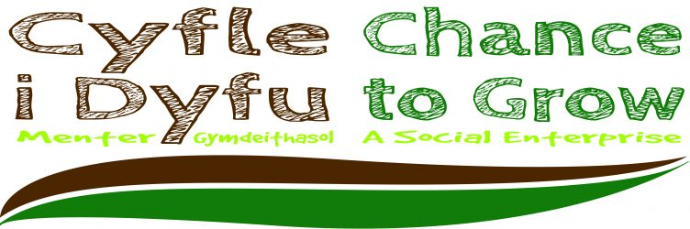
Reflection of project
-+

Name - Cameron Borkett
Student number – 1702706
Module name: academic skills
Project name: cyfle I dyfu

Contents
Executive summary 4
Report remit 5
Background of project 5
Models of reflection 6
Masterclasses and their influence on me 12
Influence on the project 15
Conclusion 17
References 18

List of figures

Figure 1:form for driscolls reflective model nhs (NHS, 2018) 6
Figure 2: driscolls model of reflection (driscoll, 2007) 7
Figure 3:diagram of Gibbs reflective cycle (gibbs, 1988) 9

Executive summary

report remit
this report will talk about the project and what impact the masterclasses have had on the project and include a reflection on how the project has gone.

background of project
cyfle I dyfu is a not for profit social firm that helps get marginalised people get back to work by providing them with qualifications in carpentry and word work so that they find it easier to get work and lose the perception of these individuals as not fitting into society.
The masterclasses
They provided us with insight into how to promote run and maintain a business and share stories p how we could also be successful with dedication and taking future opportunities that arise. Some also help develop skills for us to take on through life with us.
Influence on project
They were a great help to the project in giving us ideas on how to achieve our goal in spreading awareness of cyfle I dyfu and they also gave us the skills needed to be able to achieve what we did.
Models of reflection
The models used were by Borton and developed by Driscoll that included three steps what so what and now what which is a brief reflection. Another model used was Gibbs’ reflective cycle which allowed a more in-depth discussion on what could be done next time if the situation arose and gave a good idea of where things may have gone wrong.

Report remit
This report will concern how I believe that the project has gone and how the master classes have influenced and affected my decisions when working with the group and cyfle I dyfu.

Background of project
In the project we had to help spread awareness of cyfle I dyfu a social firm which are:
“committed to creating employment and training opportunities for people who are furthest from the labour market.” (socialfirmswales, 2014)
This helps
“To enable and empower marginalised people” (cyfleidyfu, 2018)
They achieve this by getting marginalised individuals back into working environments by teaching them new skills and experiences through woodworking and carpentry and giving the, a qualification. And getting them to sell the products to increase social skills so that they can fit in and do away with the perception of them being “different”.

Models of reflection

Three-stage model
Driscoll’s three-stage model that he developed from Borton’s model of reflection is a cycle of what? So, what? And now what? Meaning what has been done what effect has it had and what next basically saying what happened? What did I notice? what did I feel? This reflection when I looked in to is is widely used in cases of accidents and nursing and other medical practices where you must revisit a recent event.
So much so that there is a form for the NHS Isle of Wight for people to fill in after an incident has occurred.
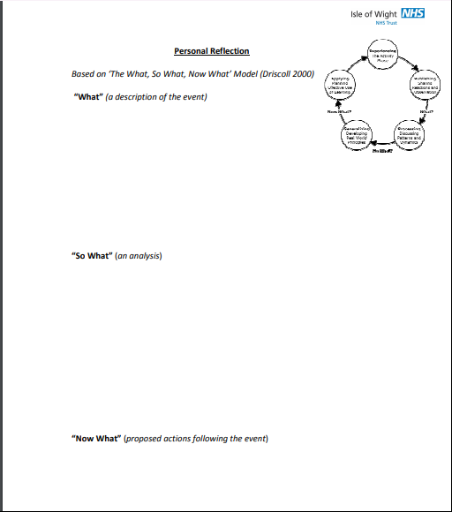
Figure 1: form for Driscoll's reflective model NHS (NHS, 2018)

“it provides an organized way of increasing awareness (What), evaluating intention (So What), and experimenting with new behaviour (Now What).” (borton, 1970)

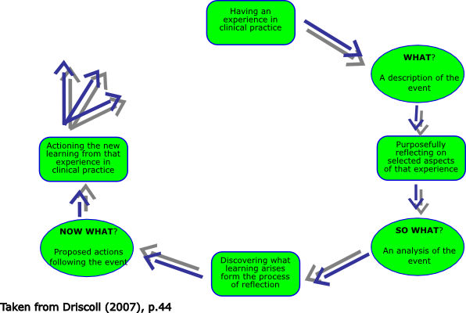
Figure 2: Driscoll's model of reflection (driscoll, 2007)

What?
While working with the group I helped with the presenting of ideas and the creating of presentations and formatting of documents and what our goal was to spread awareness of cyfle I dyfu which is what we did through blogs, Facebook and an event at unit 19. what I noticed is that I was putting a lot of effort in with team leader and myself and not getting much input from other members although it was hard to reach them due to the communication issues within the group anyway. What I felt during the group was that some were pulling their weight more than others although I feel we could have been more organised in how we conducted work and meetings there was still more issues with getting work complete than there should have been.

So, what?
At the time where this was going on I felt really frustrated as I took on the job of formatting the documents I had to go through all the work before submission which took a long time so when I received the work at last minute it became harder for me to do as there is more pressure but I found as the time went on mine and the groups communication got better relieving a bit of the stress that was put on allowing me to spend more time checking through assuring the presentation of documents were of a professional manner which I think I did well in achieving.

Now what?
In this time working within a group on a project that was assigned I found out that working in groups requires a lot of communication, teamwork and trust that people are going to fulfil their roles but in this scenario, I feel that not enough was done within the group to really have an impact on cyfle I dyfu and its business. if I was to do this over again I would make sure to be more insistent in conducting more meetings and working more closely with others in the group instead of just communicating at whatever time we wanted but to have a more organised plan to achieve the goals this could help to potentially boost the moral and work ethic on others in the group for better results in the future.
The next reflective model I will go through is Gibbs reflective cycle some steps are like Driscolls three-stage model, but Gibbs seems to go into more detail with the extra added steps
Gibbs reflective cycle
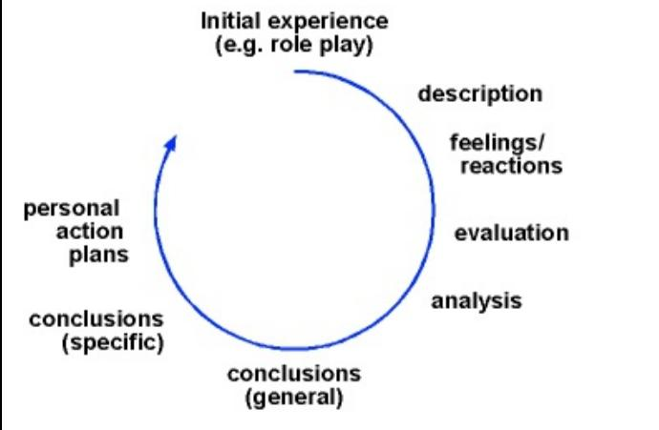
Figure 3:diagram of Gibbs reflective cycle (gibbs, 1988)
First step to Gibbs’ reflective cycle as Gibbs says in his book to “simply describe” (gibbs, 1988) what happened
so, in my case with cyfle I dyfu we conducted meetings whenever possible we participated in an event in unit 19 where we had a stall, we did blog posts online and shared them with friends to attempt to spread more awareness about cyfle I dyfu.
The following step what you felt so this as explained by Gibbs was the reactions and feelings about what happened without going into too much detail.
At first, I felt awkward as I knew no one in my group making it hard to get work done and get ideas across, but when we started to talk more things get easier over time and we were able to get ideas in such as posters, Facebook advertising and word of mouth through sharing with friends. Working with the group on occasions made me feel stressed a lot of the time as there was little communication after the initial conversation we had. Coming up to the event in unit 19 I was nervous about things going wrong with members not turning up or not getting the equipment we needed for the stall we were planning to set up.
Next step is the evaluation which is good and the bad of what happened and how they happened. The things that went well was that we got all the assignments in on time and looking well presented with equal participation from the group by assigning each group member topic to talk about when the group work was needed. The major problem with the group, however, was the attendance and communication due to the distance it was hard to meet up and hard to get group members to come in meaning that we had to keep catching up all the time which slowed down our progress and made it hard for everyone in the group to get involved as much another issue was getting in contact with Andrew the man who runs cyfle I dyfu we found it rather difficult as he was working with someone from another university making it difficult to also get him involved and run our plans by him.
In an analysis, I can see that the difficulties in the group made an impact on the project and made it hard for the group to coordinate and produce work making things very last minute and harder to put together thankfully we were able to pull everything together on time. I think that we all had different ways of working that may have conflicted with each other whereas I panic when a deadline is coming up others may be more relaxed about it making me feel stressed whether the work would get done
I think we could have achieved a lot more if we had more communication and we were able to meet more and get more ideas flowing and maybe be able to act more on our ideas and get things done quicker and more efficiently.
If I was ever to do a project like this again I would be more assertive within the group and make more of an effort to involve people and get encourage people to come in more and do work as the approach that some of the members took was very lazy and last minute and maybe we should have been more strict with deadlines and get things done sooner to potentially have produced better and more detailed work within the group.

Masterclasses and their influence on me
During the year our class has sat in on some masterclasses that have taught us a few things for extroverts and introverts alike teaching us about the things that they did to become successful and how they run their businesses and ways in which to get yourself out there through advertising.
An example is Andy Rodgers networking for introverts which gave us an insight into what introvert and extrovert means and give us ideas on how well they may work in different environments. This talk was very important for me, as an introvert, I find it hard to network and get myself out there but with Andy tells us about the comfort zone thresh holds and how every so often we should step out of them for a brief amount of time until the comfort zone gets a little bit wider. This has allowed me to be able to enhance my social skills and has allowed me to come out of my shell a bit and work in busier environments work better in certain situations. for example how to stand when talking in a group and you should stand in a way in which more people are able to join the conversation and how body language can make a difference when presenting and talking to people.
“Experts have determined that people respond to body language 55 percent of the time; tone of voice 38 percent of the time; and actual words a mere 7 percent.” (arthur, 1995)
This shows that no matter how much information we get out there if we may not have the response we want due to the lack of attention.
Another of the talks that stood out for me was Ben Rooms presentation on becoming entrepreneurial he had created BRD sport mountain and terrain boarding which is a centre where people can go to learn mountain sports and the disciplines for the sports (brdsports, 2008) which showed us how we can take something that we like and bring it to the local area with a twist if the environment is not exactly apt for the task. He then showed ways to become more innovative and creative and gave us a task to reinvent the sport bowls to appeal to younger generations this also helps to develop skills to identify a target and capitalise on their interests and create a product or service based around that market this is essential as knowing your market is essential when pitching an idea or providing products and services.
“because he understands his market and caters to it shamelessly. "Because we have a greying population, I've cut down a lot on cosmetics and am doing more in the area of braces and walkers and home health care. We must have a hundred different kinds of canes in the store.” (cassell, 1998)
This shows the importance of how knowing what market your working with can help you compete better.
Kate from Gower cottage brownies winner of the observer food monthly award (jenkins, 2016) and according to BBC good food magazine they were the best brownies they ever tasted (bbc, 2008)
This masterclass showed the class that as long as there is a market for it you can be successful and the importance of advertising and how we can use the technological age to our advantage as she started as a local store in Gower but now she ships her brownies across the UK to paying customers showing how the growing world of technology can help businesses. Which is also said by doctor kyeong Kang of the University of technology In Sydney
“E-commerce provides immense capability for connectivity through buying and selling activities all over the world.” (Kang, 2010)

The mark Powell masterclass at smoke hous was very interesting as it told us about the start-up and origins of smoke house and the trial and error it takes to get it right and how to make your business stand out in the crowd and to provide a service that differs from others. when referring to service their website says
“We also wanted to capture the atmosphere, warmth and genuine hospitality that great barbecue is served up with” (smokehaus, 2018)
This conveys how that it is not only about the product but the service and the location itself that can have an impact. In the masterclass, mark mentions the work it takes to expand and manage new stores that can be a considerable distance away from the first.
Ben Reynolds is a founder and director of urban foundry rebranded from trying to make it more descriptive of the brand and easier to say and recognise. This showed me how you can take a space that was not in use and turn it into something that is able to host events which shows that you can make something out of nothing with the right opportunities and dedications

Influence on the project
The masterclasses did have some impact on our project group as Andy Rodgers class helped with my confidence allowing me to run the stall with my group feeling confident. While running the stall in unit 19 Andy’s talk gave me the push I needed to get me out of my comfort zone and allowed me to have coping mechanisms so that I felt better while running the stall. thanks to the talk additionally, when I talked in groups I assured to apply the methods taught to invite people in to conversation this allowed for more people in a space so that my group could explain the project better to an audience and all at one time which helped in the goal we were given to spread awareness within the community about our project group cyfle I dyfu.
Kates brownies also helped us with our objective as it gave us an idea on another way to advertise online and to reach a wider audience unfortunately we did not get many people to see us online due to the little organisation we had and the lack of time we had to advertise was limited due to this factor but all the same what we did do and the ideas we got from it still applied.
Mark Powell’s helped the group as it showed us that we had to be different and stand out and to stand out so for us to stand out from the others and had a sign and leaflets to hand out. we also arranged for Andrew the manager of cyfle I dyfu to join us in the unit 19 event and set up a well-presented stall so that we stood out from others to do that we got Andrew to bring in a variety of his products e.g benches plaques and tables as samples of products so that we can show off the hard work of the individuals this also allowed Andrew to potentially take orders for items while he was there providing him with more potential business.
Ben Reynolds master class was a big help as he showed us unit 19 which meant that we were able to have a look at what space we were using for the event so that we could plan more efficiently he also helped in giving us example of what has happened in there before allowing us to get some ideas on how to present our selves while we were at the event.
“Ben has also led a range of feasibility studies, community engagement/ consultation exercises, business and marketing planning for social enterprises” (urban foundry, 2018)
this shows that ben Reynolds has experience with projects such as ours making him a great person for us to learn from as we were going through the group project.

Conclusion
In conclusion I think that despite the ups and downs of the group the result was fitting, and I believe that I fulfilled my role within the group well and produced work that was up to par with what was expected considering the communication issues and hope that I can continue to do so throughout the year with potential other projects. I am also glad to come out with a new experience in which I can learn from and apply within the future. Using the reflective models prove to be very useful to see where the things went well and where things went bad, so I may look back and improve. I also believe that the masterclasses will stick with me and be very helpful if I choose to run a business one day could be very useful skills that they helped me develop through the masterclasses.

References

arthur, d., 1995. the importance of body language. HR focus, 72(6), p. 22.
BBC, 2008. BBC good food. s.l.:BBC.
Borton, t., 1970. reach touch teach. washington: Vail-Ballou Press.
brdsports, 2008. BRD sports. [Online]
Available at: http://www.brdsports.co.uk/about-us
[Accessed 11 03 2018].
cassell, d., 1998. knowing your market helps. Drug Topics; North Olmsted, 142(20), p. 54.
cyfleidyfu, 2018. cyfle I dyfu. [Online]
Available at: http://cyfle-i-dyfu.co.uk/about-us
[Accessed 11 03 2018].
driscoll, j., 2007. Practising Clinical Supervision: A Reflective Approach for Healthcare Professionals.. 2nd ed. Edinburgh: Bailliere Tindall Elsevier.
gibbs, g., 1988. learning by doing. 1st ed. Oxford: s.n.
jenkins, k., 2016. gower cottage brownies. [Online]
Available at: http://www.gowercottagebrownies.co.uk/about-gower-cottage-brownies/
[Accessed 12 03 2018].
Kang, K., 2010. E-commerce. s.l.:in tech.
smokehaus, 2018. smoke hous. [Online]
Available at: https://thesmokehaus.co.uk/about/
[Accessed 12 03 2018].
socialfirmswales, 2014. social firms wales. [Online]
Available at: http://www.socialfirmswales.co.uk/about-us
[Accessed 04 03 2018].
urban foundry, 2018. Dr ben reynolds. [Online]
Available at: http://www.urbanfoundry.co.uk/?team=dr-ben-reynolds
[Accessed 12 03 2018].
NHS (2018). NHS form driscoll three stage model. [image] Available at: http://www.iow.nhs.uk/Downloads/Education%20Centre/Development%20and%20Training/Learning%20Environment/Preceptorship/Personal%20Reflection%20template.pdf [Accessed 12 03. 2018].

