

Postgraduate/Distance Learning
Assignment coversheet & feedback form
TO BE USED FOR ALL ESSAY SUBMISSIONS FROM APRIL 2026
THIS COVER SHEET REPLACES ALL PREVIOUS VERSIONS.
YOU MUST SIGN THE AI DECLARATION BEFORE YOU SUBMIT THE ESSAY.

THIS SHEET MUST BE THE FIRST PAGE OF THE ASSIGNMENT YOU ARE SUBMITTING (DO NOT SEND AS A SEPARATE FILE)

For completion by the student:
Student Name: HATSUKO NAGASAKI

Student University Email: 2511100@student.uwtsd.ac.uk
Module code:  HPCA7028  Module title:  Sacred Skies | Student ID number:  2511100 |  |  | Educational support needs:  N/A
Assignment title: Measurement based on a physical site
Assignment due date: 30 April 2026
This assignment is for the 1st 2nd 3rd 4th 5th 6th module of the degree
Plagiarism declaration
I confirm that this is my original work and that I have adhered to the University policy on plagiarism.

Artificial Intelligence (AI) declaration

I confirm that I have not used any AI tools in the research and creation of this assignment. I confirm that I have not presented any AI generated materials as my own work. I confirm I have copies of my drafts, notes, and other resources I used, which I may be asked to provide in evidence.

Signed: Hatsuko Nagasaki
Date: 23 April 2026

Assignment Mark
1st Marker’s Provisional mark
2nd Marker’s/Moderator’s provisional mark
External Examiner’s mark (if relevant)
Final Mark

NB. All marks are provisional until confirmed by the Final Examination Board.

For completion by Marker 1 :
Comments:

Marker’s signature: |  |  | Date:
For completion by Marker 2/Moderator:

Comments:

Marker’s Signature: |  | Date:
External Examiner’s comments (if relevant)

External Examiner’s Signature: |  | Date:

Measurement based on a physical site

According to the Agency for Cultural Affairs of Japan, there are currently over 80,000 Shinto shrines in Japan registered as religious corporations. The number is assumed to be higher if it includes shrines that such organisations do not systematically manage. Shinto shrines are part of the country's daily landscape, while their historical backgrounds, the divinities they worship, sizes, and positions of importance vary. Shinto shrines worship a variety of divinities, including but not limited to figures depicted in Japanese mythology. Shinto is believed to have been established and evolved under the influence of other philosophies and religions, such as Daoism and Buddhism, which were brought to Japan from China. There has also been a political decision to merge Shinto shrines with Buddhist temples until the Meiji era. Such Chinese influence is also believed to have shaped the location and layout of Shinto shrines. There have been academic discussions about the existence of a ‘sacred axis’ based on the sun’s movement, along which important buildings and imperial tombs were built in ancient Japan, before a new axis, based on Chinese cosmology, became a solid part of Japanese culture from 300 B.C. to the 7th century. This essay explores the sacred axis in Japan through a literature review and an analysis of existing shrines. A sample of five shrines that worship the Sun Goddess Amaterasu was examined to determine whether they are aligned with a specific axis and whether the buildings’ orientations were designed with key dates in the Sun’s movement in mind, such as the vernal equinoxes and the solstices. This work involved on-site measurements at two shrines and virtual measurements at the remaining three shrines. Possible historical and social factors that may have influenced the observed orientation among these five shrines were also investigated. The study of five shrines highlighted mixed results regarding alignment with possible sacred axes, and a lack of evidence that offers clear explanations for these buildings, mainly due to the shrines' antiquity and their links to Japanese myths. It also highlighted that the alignment is not necessarily designed around the key buildings that constitute the shrines, and can take the form of alignments with objects of worship in nature, such as mountains, and with areas of political importance in ancient Japan.

Literature review
The tradition of Shinto is centred around the concept of Kami as the subject of worship. Helen Hardacre explained that Kami could arise from different beings. It could be the spirits of a particular place, natural forces like rivers and mountains, figures from myth, or holy beings not appearing in myth but believed to have grown out of communal customs and to have no textual basis. The spirits of human beings who earned the respect of locals for various reasons could also be worshipped as Kami. There have been academic debates over whether to call Shinto a religion or a philosophy, and whether it is appropriate to call it ‘indigenous.’ Sakyo Ono, a Japanese scholar of Shinto writing in 1962, explained that:
Shinto is more than a religious faith. It is an amalgam of attitudes, ideas, and ways of doing things that through two millenniums and more have become an integral part of the way of the Japanese people.
Helen Hardacre criticised this view by pointing out the influence from ‘so many other places and traditions, including Buddhism, Daoism, and Confucianism.’ Hardacre also pointed out the different attitudes Japanese scholars have shown in their writings on Shinto, targeted at audiences outside Japan and at academic circles within Japan: ‘romanticising and idealising’ in the former and ‘sober, balanced and authoritative’ in the latter. She explained that the historical influences on the study of Shinto history, including its association with the rise of nationalism in the pre-World War II period and its link to imperial ancestry, created taboos, especially for academics who were also Shinto theologians.
The study of Japanese mythology, which is linked to numerous Shinto shrines as well as the imperial ancestry, is centred on several literary works, including Kojiki and Nihonshoki. Mark C. Funke explained that the compilation of these two national chronicles was designed by the court to ‘verify that its rule was sanctioned by the deities themselves’ amid the increasing introduction of Chinese ways into Japan. Both documents the myths and history of Japan from the creation to the time of writing. There are other historical documents, such as Fudoki, reports of events and traditions from certain regions presented to the monarchy of Japan, as well as compilations of poems, such as Manyoshu compiled in the 8th century, from which observations of celestial bodies and movements made by the poets could be found.
Regarding what is considered a ‘sacred axis’ in Japan, Edwina Palmer, a Japanologist from New Zealand, pointed out that the east-west axis was predominant in the spatial organisation of ancient Japan, as evidenced by archaeological sites and mythological literature, before the north-south axis gradually replaced it under Chinese influence. Palmer cites various findings from related literature as indirect evidence of east-west axis orientation. For example:
- In the two key works of Japanese mythology, namely Kojiki and Nihon Shoki, she contrasts the high frequency of east and west in the writing, while south is mentioned only once, and there is no mention of north at all.
- Implicit references to east-west by the expression of sunrise rays and evening suns indicate auspiciousness attached to the axis.
- Indication of marching towards the Sun is considered disrespectful to the Sun Goddess, Amaterasu

Another subject of study that influences the discussion on such a sacred axis is the existence of the sun cult in Japan. Palmer explains a possible political background that can be read in the myths, giving superiority to the east-west axis that includes the Ise Grand Shrine worshipping Amaterasu and inferiority to the north-south axis, placing the land of the dead (Underworld) not under the ground but beyond the sea in the north from then the capital of Yamato Dynasty (currently Nara prefecture), the direction of sunset on the summer solstice. Palmer concluded that ‘The most important direction was that of sunrise on the winter solstice, so important that it was probably even considered sacred’ and that ‘This predominant axis of orientation was almost certainly associated with the cult of sun-worship’. There has also been an argument about when and why Amaterasu was installed as the sun goddess in the myths. Takeshi Matsumae explained the existence of numerous sun deities in Japanese folklore and myths, not limited to Amaterasu, and argued that Amaterasu was not the deity of imperial ancestry; Takamusubi (one of the three gods who created the universe at the beginning of Japanese mythology) was. Mark Teewen, a Dutch Japanologist, also studies a theory by Yoshino and Okada on the influence of Chinese cosmology on the Ise Jingu, a grand shrine considered one of Japan's most important and closely linked to imperial ancestry. He highlights various evidence of possible sun worship by the local Watarai clan and the original Gaigu (outer palace) of the Ise Jingu being on the east-west axis, before the Sujin Emperor established the Ise Jingu on the north-south axis. Fabio Rambelli argued that the Ise Jingu has changed its significance and the meanings attached to it through history and served as a useful device that bridges different beliefs in Shinto, political vision, and ritual systems:
…in many cases Ise has been taken as an empty signifier that could be filled with any kind of meaning (Buddhist, Confucian, Daoist, internationalist and nativist, local and universal). At times, Ise could even work as a code or semiotic shifter, joining and mediating between different sets of representations - as, for instance, by connecting a different snrine (Omiwa or Hie, say) to the emperor through the use of relations with the goddess Amaterasu, or by transforming the Ise region into the center of the universe by associating the Outer shrines central pillar (shin no mihashira) with Mount Sumeru.
Allan Grapard studied the official registration of over 2,800 shrines by the government in the 8th century, discussing around three working hypotheses: 1) location of shrines carrying strategic importance in the political and military campaigns; 2) social and economic competition among the leading sacerdotal houses at the time; 3) Buddhism being a part of the equiation. He also pointed out the fact that ‘the central government took control of these shrines and their cults in a strategy of territorial and social control’, and their ‘appropriation of these shrines and cults’ must have led to significant changes in their practices and ideas.
Such a wide variety of discussion around Shinto, Japanese mythology, sacred axes and the Ise Jingu leads to a question of whether the Shinto shrines that worship Amaterasu show consistency in terms of their orientation to the Sun’s movements and if there are factors such as historical, political and social reasons that could explain the current orientation of the shrines measured for this essay.

Methodology
The research consisted of measuring key buildings of the Shrine, conducting a literature review, and investigating factors that might explain questions about their orientation to certain axes. Since some of the shrines date back thousands of years, primary documents or evidence explaining the reason for such orientation are limited; therefore, the literature review is conducted mainly through secondary sources.

Criteria for the selection of the shrines for measurement
Different types of Shinto shrines worship different gods and goddesses from Japanese mythology or imperial ancestors. In this research, five Shinto shrines in Japan that worship the Sun Goddess Amaterasu were examined to determine which axis their key buildings align with and whether they are designed to align with certain celestial events, such as the vernal equinoxes and solstices. The details of the five shrines are summarised in Table 1. Their locations on the map of Japan are shown in Figure 1.
Table 1: Shrines selected for measurement
 | Name | Location | Date established
1 | Oji Jinja | Tokyo | Unknown. Believed to have been built in the 14th century.
2 | Shiba Daijingu | Tokyo | 21 October 1005
3 | Ise Jingu (Naigu) | Mie | Unknown. Believed to have been built in 4 BC.
4 | Moto Ise Kodai Jingu | Kyoto | Unknown. Believed to be 2600 years old. Temporary location for Ise Jingu, based on the Sutoku Emperor's order in BC 59.
5 | Oomi Jinja | Miyazaki | Unknown. The shrine’s own record states that the shrine dates back to Ninigi's descent in the myth.

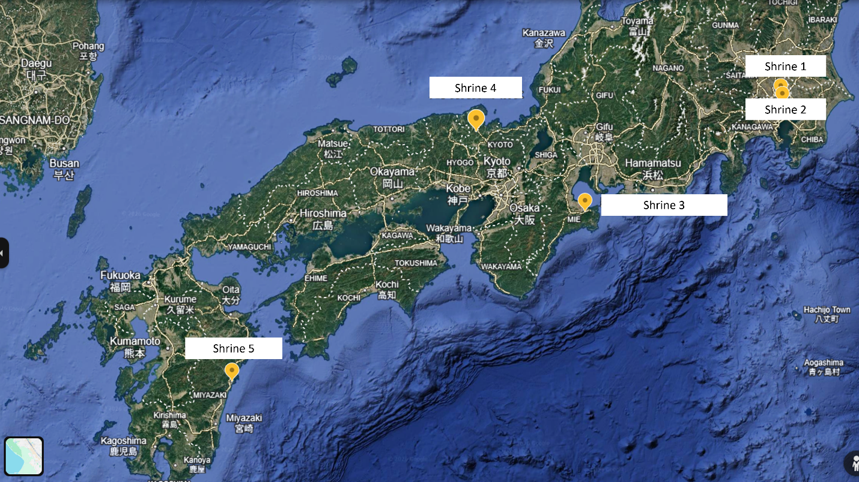Figure 1: Locations of the shrines (based on Google Earth)

Two shrines in Tokyo were chosen for onsite measurement. Shrine 1 is relatively small and was selected as a representative of a small neighbourhood shrine. Shrine 2 is also relatively small, located in the middle of an office district surrounded by high-rise buildings, but differs from Shrine 1 as it worships the same two goddesses worshipped at the Ise Jingu (Shrine 3), and has been called ‘Kanto-no-Oise-sama (Shrine of Ise in the Kanto region). Kanto includes Tokyo and the six prefectures surrounding Tokyo. The other three shrines (Shrine 3, 4 & 5) were selected with consideration for their varying importance to the Shinto community and their historical ties to Japanese mythology. For Shrine 3, there are two separate locations: Naigu (Inner Palace) and Gaigu (Outer Palace). For this measurement, the Naigu, which worships Amaterasu, was selected.
Differences in the surrounding environment were also taken into account in the selection. For example, Shrine 2 is in a busy city area of Tokyo, Shrine 4 is in a relatively mountainous area, and Shrine 5 is located close to the sea. Locations such as Mie and Miyazaki also have a strong link to Japanese mythology, suggesting they lie along what Palmer considered the sacred east-west axis in ancient Japan.

Method and subject of measurement
On-site measurements were taken using a compass and the iPhone compass app. For virtual measurement, Google Maps and Google Earth were used to measure azimuth. A website, ‘heywhatsthat.com’ was used to measure the altitude of the Sun when it becomes visible from the site. Declination was calculated using a tool provided by the University of Wales Trinity Saint David, based on the data for azimuth, altitude, and latitude obtained through the tools mentioned above.
The orientation of the shrines’ main buildings, namely Haiden (the prayer hall) and/or Honden (the main hall), was measured. In cases where the object of worship has historically been a natural entity, such as a mountain, alignments between the shrine and that object were also checked.

Findings and Discussion
Mixed results for the orientation of the main buildings
The results of the measurement are summarised in Table 2. The measurement highlighted mixed results on the orientation of the main buildings. There is no consistency observed by location or by the era in which the shrines are believed to have been established.

Table 2: Summary of measurement results
 | Name | Location | Axis | Measurement data | The timing of the sunrise is expected to beam into the main building
1 | Oji Jinja | Tokyo | Northeast - Southwest  (Building facing southwest) | Azimuth: 246.01  Latitude: 35.753278  Longitude: 139.735917  Altitude: 0.35  Declination: -19.05 | 25-26 January,  18 November
2 | Shiba Daijingu | Tokyo | East-west  (Building facing east) | Azimuth: 88.75  Latitude: 35.657639  Longitude: 139.753056  Altitude: 0.59  Declination: 0.34 | 22-23 March,  22 September
3 | Ise Jingu  - Naigu | Mie | North-south  (Building facing south) | Azimuth: 179.71  Latitude: 34.45561079393287  Longitude: 136.72635785435497  Altitude: 9.28  Declination: -46.26 | N/A
4 | Moto Ise Kodai Jingu | Kyoto | North-south  (Building facing south) | Azimuth: 169.68  Latitude: 35.430139  Longitude: 135.1545  Altitude: 4.12  Declination: -49.28 | N/A
5 | Oomi Jinja | Miyazaki | Northwest – Southeast  (Building facing northwest) | Azimuth: 132.86 (towards the direction of sunrise)  Latitude: 32.411  Longitude: 131.649417  Altitude: 0.07  Declination: -33.59 | N/A

The measurements show that one out of five shrines is on the east-west axis, two on the north-south axis, and the other two on neither axis.
At Shrine 1, the main building and entrance face southwest. The calculation shows that the timing of the sun's beam entering the main building does not coincide with the equinoxes or solstices. The current building was burnt down during World War II air raid and was rebuilt in 1964. There is no publicly available literary document stating that the building's orientation was originally different. At this shrine, Amaterasu is worshipped as one of the five deities. The shrine has its roots in the Kumano Shrines in Wakayama. The establishment of the oldest shrine, Kumano Motomiya Jinja, is unknown, but several documents record it as 33 BC. Virtual measurement showed that Kumano Motomiya Jinja is located at an azimuth of 241.24, in the southwest direction from Shrine 1, suggesting a possible conscious choice in determining the shrine's direction.
[Figure 2: View of Oji Jinja from the entrance (Shrine 1)]

Shrine 2 is the only shrine in the sample group that stands on the east-west axis, with the main building facing the east. The Sun is expected to beam into the main building around the dates of equinoxes. This shrine has its roots in the Ise Jingu, and therefore, Amaterasu is the primary subject of worship. The place has been known as the ‘O-Ise of Kanto’ (Kanto is a region that includes Tokyo and its six surrounding prefectures). The shrine has been rebuilt several times due to fire, earthquakes, and war, and the current building was completed in 1964. From the shrine, the Ise Jingu is located at an azimuth of 244.99, i.e. no special alignment seems to exist between the two shrines. No official explanation of its orientation was found at the shrine or in the literature.

[Figure 3: View of Shiba Dai Jingu]

The Naigu building for the worship of Amaterasu at the Ise Jingu (Shrine 3) faces south, which confirms various theories advanced by other scholars. It is believed that Ise Jingu originally worshipped Asakuma Yama, the mountain east of the shrine. There is another theory by Tween, who pointed out that the Watarai clan, located closer to the other Ise Jingu site Gaigu (lit. outer palace), where Toyouke-no-oomikami (the Goddess responsible for divine foods) is currently located, was east-west, indicating the place had an older history than the current Naigu. The current buildings in Gaigu, however, all face south, and the Tsuchinomiya is the only building facing the east, also confirmed by the Ise Jingu itself. The building is built for Ootsuchi-no-mioya-no-kami, a guardian divinity who had protected the area of Yamadagahara and was later added to the line of Gods worshipped at the Ise Shrine. There is no official documentation explaining the reason behind the eastward orientation of this particular building. One theory is that the God worshipped in this particular building has been responsible for protecting the locals from floods from the Miyagawa River, which runs east of the building. Within the grounds of the Naigu, there do not seem to be buildings facing east. However, the official website of the Ise Jingu explains that the Sun rises in alignment with the Torii gate at the Ujibashi Bridge around the winter solstice. The virtual measurement showed the Torii is located at the azimuth of 125. The calculated declination (-24.21) did not confirm its alignment at the winter solstice.

[Figure 4: Map of Ise Naigu]

[Figure 5: Ise Naigu Ujibashi Torii at the winter solstice]

Regarding the connection between the Ise Jingu and the Sun’s movement, Hardacre pointed out a different alignment, not of the particular building of worship in the Ise Jingu, but the location of the shrine itself.
Mt. Miwa had been the original Yamato ritual site, but for reasons that remain unclear, they disengaged from the Miwa deity in favor of a cult of a solar deity at Ise. The shift created a sacred site in the direction of the sun’s rising.
If this is true, the general location of the Ise Jingu site was east of the centre of Japanese politics. The Makimuku ruins are believed to be the site of the Yamato dynasty's capital. Google Earth measurements show that the Ise Jingu (Inner Shrine) is at an azimuth of 96.72° from the ruins, confirming the east-west axis alignment explained by Hardacre. The calculated declination, however, indicates that the Sun does not rise from the direction of Ise Jingu on a date coinciding with equinoxes or solstices. Hardacre’s explanation suggests that the axis on which the shrine is built is not determined solely by the movements of the Sun but may also be affected by geopolitical considerations.

[Figure 7: Location of Makimuku ruins and Ise Jingu]

Shrine 4 has a history of serving as a temporary residence for Amaterasu during her relocation from Miwa in Nara Prefecture to the current site in Ise (the Ise Jingu, Shrine 3). The measurement showed that its hall of worship for Amaterasu is facing southward. Like Ise Jingu, this shrine has historically worshipped a mountain, Himuro-ga-dake (also known as Iwato-yama), surrounded by untouched forest. At the summit of the mountain is what is believed to be a Hanza, a sacred rock on which a God/Goddess is said to descend in Shinto, and the Shrine’s official website presents a theory that the shrine might originally have been located there. The eastern side of the mountain has been preserved as the ‘Forbidden Area’ where humans are not allowed to enter. The current shrine is located east of the mountain, at an azimuth of 101.31, suggesting that there might originally have been respect for the east-west axis. Calculated declination from the mountain did not indicate an alignment with sunrise at the equinoxes/solstices. A virtual measurement was taken between Shrine 4 and Shrine 3 to assess whether there is a special alignment between the two shrines, given their history. The measurement showed that Shrine 3 is located at an azimuth of 126.78 from Shrine 4, i.e. in the direction of south-east. Declination is calculated as -27.37, indicating that the relationship between the two shrines is not linked to equinoxes/solstices.
Shrine 5, which is located in an area referred to as 日向 (Hinata; lit. facing the sun), where important events occurred in the Japanese myth, including the birth of Amaterasu from the left eye of Izanagi and the descent of her grandson Ninigi to rule the land. It is also referred to as ‘Hinata-no-Oise-sama’ (Ise shrine of Hinata), just as Shrine 2 was called the Ise of Kanto. The shrine’s record states that its origin dates back to the day of Ninigi’s descent. The shrine has been built close to the sea, and the current main building was rebuilt in the 1930s. The virtual measurement showed that the hall of worship faces north-west, with its back to the sea, and is not intentionally aligned with the equinoxes or solstices. However, the shrine's official website states that the sunrise from the east enters another shrine located in the cave on the shrine’s grounds (Figure 8) around the winter solstice. Virtual measurement could not confirm the direction of the cave’s entrance where the sun is expected to enter. This case again confirms that the shrine's current main building is not necessarily designed for a specific alignment with the Sun. Still, there could be other objects or locations within the shrine's current premises or in areas that used to be part of the shrine’s grounds, with which such alignment is designed. Having said that, unlike the case of Shrines 3 and 4, it is doubtful whether such alignment between the cave entrance (which looks like a natural crack) and the winter solstice can be arranged artificially, and leaves a possibility that the sacredness assigned to the cave might have come from its alignment with the winter solstice, and not the other way round.
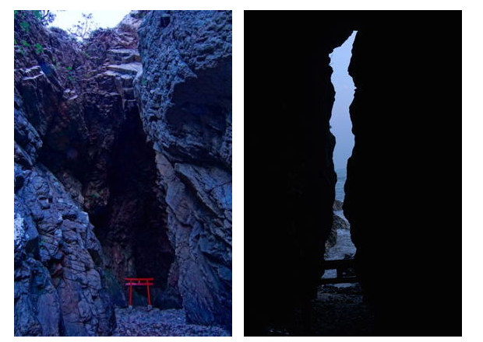
Figure 8: View of the cave from outside and inside (copyright: Oomi Jinja)

Measurements of five shrines showed that axes align with certain movements of the Sun. However, such axes are not necessarily linked to the era of the shrines’ establishment or to the deities worshipped there. Although there are many academic studies on the Ise Jingu (Shrine 3), such discussions on the other shrines were difficult to find.

Findings from additional online research
Since measurements of shrines that worship Amaterasu yielded mixed results, a quick online search was conducted to examine shrines known for their eastward orientation and possible explanations for that orientation.
Kashima Jingu is one of the 24 grand shrines in Japan, with roots in Japanese mythology, and its oldest records date back to the 8th century (Nara period). It is located at the eastern end of the main island. The shrine is unique in that its hall of worship faces north, while the Kamikura inside the hall (where the God dwells) is explained by its past chief priest to face east. Such a case demonstrates that alignment with celestial movements is not limited to the exterior of the building but also to an object placed within a building. During fieldwork, this alignment was not confirmed at Shrine 1, where the object of worship was visible to visitors and facing southwest. For the remaining four shrines, it could not be confirmed whether any objects face east. At Kashima Jingu, the hall’s orientation towards the north is attributed to geopolitical factors, reflecting the site's strategic importance in relation to local tribes that refused to follow the Yamato dynasty. This is in line with Grapard’s discussion of the government's strategic shrines in the northern campaign, which led to their registration in the 8th century.
Hinokuma Jingu, a shrine located in Wakayama, also faces east. The shrines worship a mirror made to free Amaterasu from the cave where she hid. It is one of the grand shrines mentioned in the Nihon Shoki, and its roots are closely linked to Japanese mythology. It was located on the western side of the peninsula, where Yamato used to be, while Ise was at the eastern end of the same peninsula. There is no official explanation for the shrine's orientation, yet its position relative to the Yamato dynasty and Ise Jingu suggests a conscious alignment along the east-west axis. Virtual measurement on Google Earth, however, shows that this shrine is located at an azimuth of 239 from the Makimuku ruins (believed to be the remains of the capital of the Yamato dynasty), denying such intentional alignment among the three locations (Figure xx).
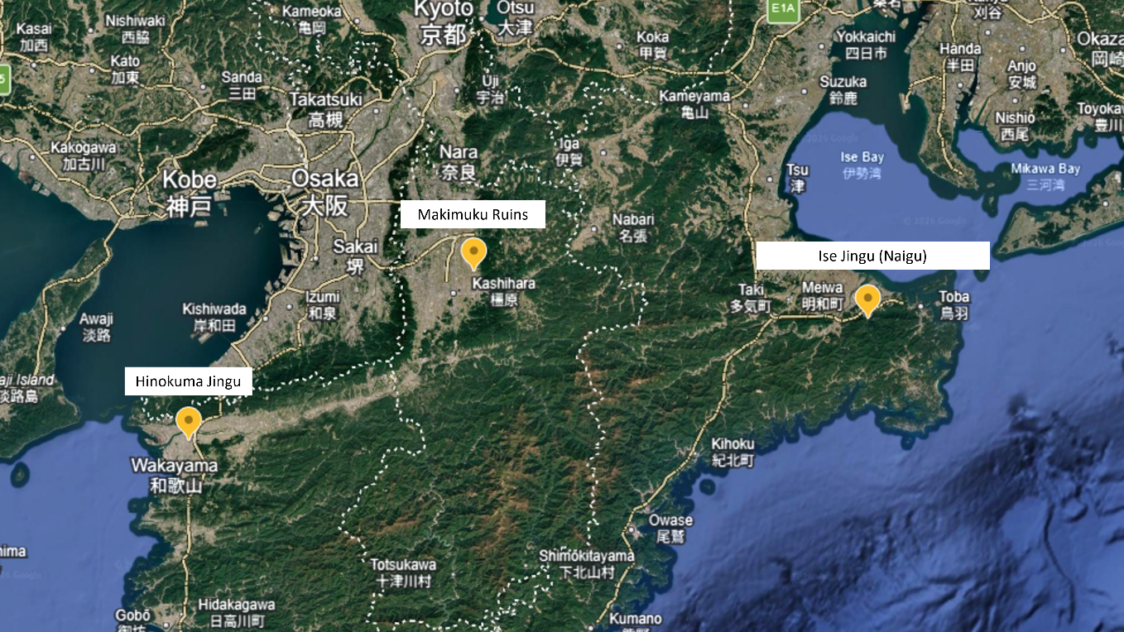
Figure xx: Location of Hinokuma Jingu, the Makimuku ruins and the Ise Jingu Naigu (adapted from Google Earth)

Kamosu Jinja, another shrine with its hall of worship facing east, is located in the area known as Izumo, the north-west area of Japan. Izumo is another important area in Japanese mythology and is believed to have established its own dynasty before falling under the rule of the Yamato dynasty. This particular shrine highlights that shrines are built in different architectural styles, which can affect the alignment between the exterior and interior. Depending on the line of worship (associated with the Gods/Goddesses the shrine is built to worship), shrine architecture can take different styles. Kamosu Jinja worships Izanami, the wife of Izanagi. The couple is known for creating the islands that make up the Japanese archipelago and for giving birth to important gods/goddesses in the myth. The shrine dates back to the myth, and the current building dates to the 16th century, making it the oldest Taisha-zukuri-style building in Japan today. Taisha-zukuri is considered the oldest of shrine architectural styles. Its hall of worship faces east at an azimuth of 94.57. However, for Taisha-zukuri-style buildings, there are two types of interior setting: O-zukuri (Male) and Me-zukuri (Female). In the O-zukuri style, the Kamikura (the place of the God/Goddess’s dwelling within the hall) faces left. In Me-zukuri, it faces right. Kamosu Jinja worships a Goddess; therefore, the interior is designed in the Me-zukuri style, i.e., the building faces east, while the Goddess faces north. This example again shows a complex method for determining what constitutes a ‘sacred direction’ around a Shinto shrine, one that is not limited to alignment with the Sun’s movements.
In summary, the findings from measurements of five Shinto shrines that worship Amaterasu, the Sun Goddess, and additional online research indicate that there is no clear rule or timing for the transition of the sacred axes. Various factors can influence the direction in which Shinto shrines should be built, including respect for the east-west axis Palmer suggested, the north-south axis based on Chinese cosmology, and other historical and geopolitical influences. One common finding is the lack of clear evidence to confirm the original intentions, given the long history of Shinto and Japanese mythology.

Conclusion
This essay explored the existence of a sacred axis in Japan through a literature review and measurements of the existing shrines. A sample of five shrines that worship the Sun Goddess Amaterasu was examined to determine whether they are aligned with an axis and whether the buildings’ orientations were designed taking into consideration the key dates in the Sun’s movement, namely equinoxes and the solstices. This work involved on-site measurements at two shrines and virtual measurements at the remaining three shrines. The study of five shrines highlighted mixed results regarding alignment with possible sacred axes, and a lack of evidence that offers clear explanations for these buildings, mainly due to the shrines' antiquity and their links to Japanese mythology. It also highlighted the influence of geopolitical factors and the possible alignment with the east-west axis suggested by Palmer, not within a shrine but between the shrine and the object of worship in nature, such as mountains. A quick online research on the east-facing shrines not included in the sample group provided additional insights to be considered, including the possibility that an object of worship within a shrine building can be on the east-west axis and not the building itself, which cannot be confirmed by the virtual measurement method taken for this essay. The different Shinto shrine architectural styles can also present the building and the place of dwelling for the deity, prepared within the building, facing different directions. Although the scope of the research conducted for this essay was limited, it confirmed various aspects of the research required to identify the possible sacred axis in ancient Japan, which has produced a wide range of academic studies on these subjects by scholars in and outside Japan, reflecting the long history of their existence and transformation.

Bibliography
Agency of Culture Affairs, Shukyo Nenkan (Religious Yearbook) FY2024
https://www.bunka.go.jp/tokei_hakusho_shuppan/hakusho_nenjihokokusho/shukyo_nenkan/pdf/r06nenkan.pdf [accessed 23 April 2026]

Funke, Mark C., ‘Hitachi no Kuni Fudoki’, Monumenta Nipponica, 49.1 (Spring, 1994), pp. 1-29.

Grapard, Allan G., 'Shrines Registered in Ancient Japanese Law: Shinto or Not?', Japanese Journal of Religious Studies, 29.3-4 (2002), pp.209-232.

Hardacre, Helen, 'Introduction', Shinto (New York, 2017; online edn, Oxford Academic, 22 Dec. 2016)
https://academic.oup.com/book/6981/chapter/151269530?login=true [accessed on 26 April 2026]

Hinokuma Jingu
https://hinokuma-jingu.com/

Ise Jingu official website (English page)
https://www.isejingu.or.jp/en/ [accessed on 28 April 2026]

Izumo Kanko Navi (on Kamosu Jinja)
https://www.kankou-shimane.com/destination/20261 [accessed on 28 April 2026]

Kashima Jingu official website
https://kashimajingu.jp/ [accessed on 26 April 2026]

Matsumae, Takeshi, ‘Origin and Growth of the Worship of Amaterasu’, Asian Folklore Studies, 37.1 (1978), pp. 1–11.

Motoise Naiku Kodai Jingu official website
https://www.motoisenaiku.com/shrine-information [accessed on 26 April 2026]

Oji jinja official website
http://ojijinja.tokyo.jp/index.html [accessed on 26 April 2026]

Oomi jinja official website
https://oomijinja.com/ [accessed on 26 April 2026]

Palmer, Edwina, ‘Land of the Rising Sun. The Predominant East-West Axis Among the Early Japanese’, Monumenta Nipponica, 46.1 (1991), pp. 69–90.

Rambelli, Fabio, ‘Floating Signifiers: The Plural Significance of the Grand Shrine of Ise and the Incessant Re-signification of Shinto’, Japan Review, No. 27 (2014), pp. 221-242.

Shiba Daijingu official website
https://www.shibadaijingu.com/

Teeuwen, Mark, ‘The Imperial Shrines of Ise: An Ancient Star Cult?’, Culture and Cosmos, 10.1 and 2, Spring/Summer and Autumn/Winter (2006), pp.79-98.

