
UWTSD Logo, copyright of University of Wales Trinity Saint David.

3D Modelling Production Diary – Academic and Professional Development (ACCA4039)

Student Number: 2400846
Word Count: 1276

Introduction
For this author’s final project for the 3D modelling module, they were required to produce five detailed 3D models of the following items: Cup and Saucer, Lamppost, House, Dumpster, Soda Can. For this modelling, the author used Autodesk Maya1 to create each of the 3D modelling. The following diary follows the author’s creative process for creating two of the five models, the Cup and saucer, and Lamppost.

Cup and Saucer
The first model this author attempted was the Cup and saucer, as this is traditionally seen as a good starting point for most early 3D modelling careers. Auto Desk Maya includes many tools which one may find useful in the creation of a 3D model.
At the beginning of the creation, one used the simple polygon feature of Autodesk Maya to create two simple cylinders. One was to be kept for the saucer, the other for the Cup. The author began by creating the saucer first, as they believed this was the less complex of the two, and could be used to scale the rest of the project appropriately. To create the saucer the author took the simple polygon cylinder, and using the resize tool, shortened the cylinder considerable, and stretched it out evenly as shown in the screenshots below.

Screen shots of a before and after of using the resize tool²
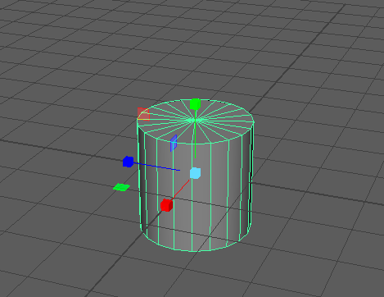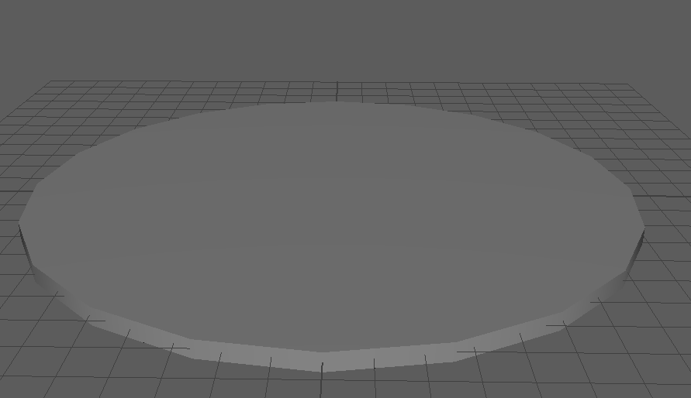

After the cylinder had been reshaped, the author increased the subdivision Axis and Height, giving the shape more mouldable faces. This then allowed the author, to select all of the faces on the inner most, and third inner-most ring of faces, to then extrude and move the faces upwards, creating a smooth curve on the shape. This process was then repeated for each ring of faces, being sure to be slow and careful with each adjustment as any overadjustment would have led to the shape being un-uniform in proportion. The screenshot below shows the final product of the saucer section of this model.
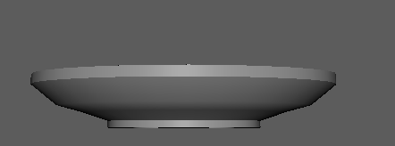

Screen shot of the finished saucer³

To create the saucer, certain tools, such as the subdivision axis and height, were found with the aid of online YouTube tutorials4 (see bibliography for more information).
The next step in the creation was the cup section of the model. The first few steps of creation were very similar to the previous section, with creating a cylinder, reshaping and sizing it. However, instead of wanting to create a short, wider plane, for the cup section the author created a taller plane, to outline the external shape of a cup. The same subdivision axis manipulation was used here as in the previous section, in order to create a more mouldable shape to sculpt.
To create the base of the cup, the author used the Vertices mode of the software, to select the individual edges of faces, and resize them inwards, creating a smooth inwards curve, and a solid base for the mug. Then, the author hollowed out the mug, by selecting and deleting each of the faces on the top of the mug, other than the outermost faces. To make the cup less thin, and more realistic, the author then selected the entire object, and used the extract function, and used the thickness slider to increase the thickness of the whole object at once.
The handle was the most difficult part of this process. The author used the same YouTube tutorial mentioned above to create the handle and followed the process along with the tutorial. The author cut out some of the faces of the model, on the side, where he wanted the joins of the handle to connect with the rest of the model. Using the Bridge Tool, the author then connected the two faces, and set the bridge to curve, in order to create a smooth, curved handle for the cup. Below are screenshots of both the finished cup section, and the finished complete model.
For this model, the author found learning how the subdivision axis, and more in-depth uses of the extrude tool to be more complicated than they had believed. This would put more of a time constraint on the entire project, however, these skills were necessary to learn in order to create not only this model, but the models overall. So, the author believes that this was a necessary challenge, that was eventually overcome and aided in their future work.

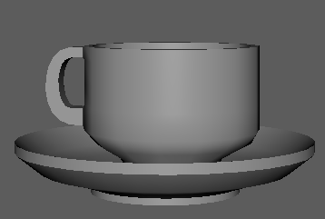
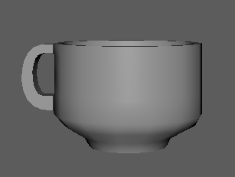

Screenshots of the author’s completed cup section and completed overall model.5

Lamppost
The next model the author decided to take on was the Lamppost. In the initial stages, they decided not to create a traditional lamppost, but wanted to use this model as a way to test their own creativity within the 3D modelling software. This led them to deciding upon an oil-lantern esc design, with a small lantern and a larger wooden frame holding it up.
The first step the author decided to take, was to create the lantern part of the design, as they knew this would be the most time-consuming part. Once again, the lantern began with the simple polygon cylinder. Using a series of extrusions, and resizing of faces and vertices, the author managed to add more texture and depth to the model, ensuring the overall lantern was more than just a smooth surface. Using the isolation tool, the author then too other simple cylinders, to create different aspects of the lantern. One of these was the top and bottom of the lantern, and the other was the loop which would later have a hook connecting it to the main body of the lamppost. Below is a screenshot of the finished lantern section of the model.
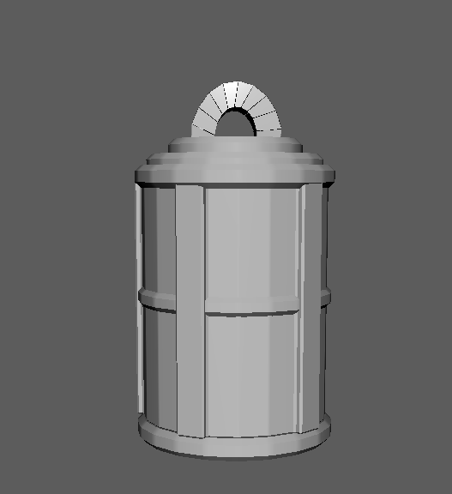

A screenshot of the Lantern section of the model.6
After completing the lantern section of the model, the author then created the main body of the lamppost. This was the simplest part of the model. This consisted of creating three simple polygon cubes, reshaping them to scale, and spending a while trying to decide what layout the author wanted the lamppost to take. Below is a screenshot of the main body of the lamppost.

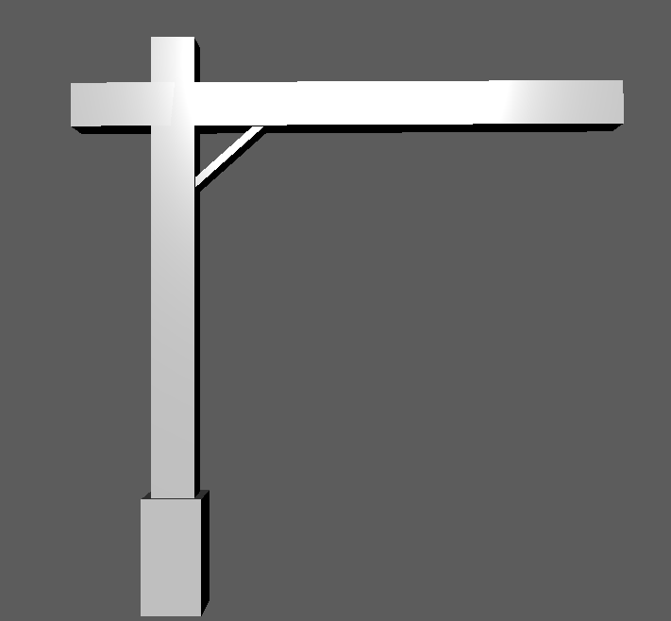
A screenshot of the main body of the Lamppost model.7
The next section was the longest and most tedious section of the entire process. The author wanted to create a hook, to attach the lantern to the body of the lantern. For this, they consulted a YouTube tutorial.8 This section consisted of the most complex reshaping, extraction, and face manipulation the author has done to date. This was the most time-consuming section of the entire process, as it required minute details, and perfect precision otherwise the model would not look correct. For example, with the first attempt, the hook was not fitting through the hole in the model, and the lantern looked to be floating, as the hook did not fit properly. After a few different iterations, the below result was achieved.

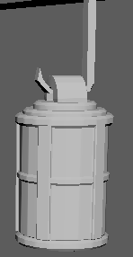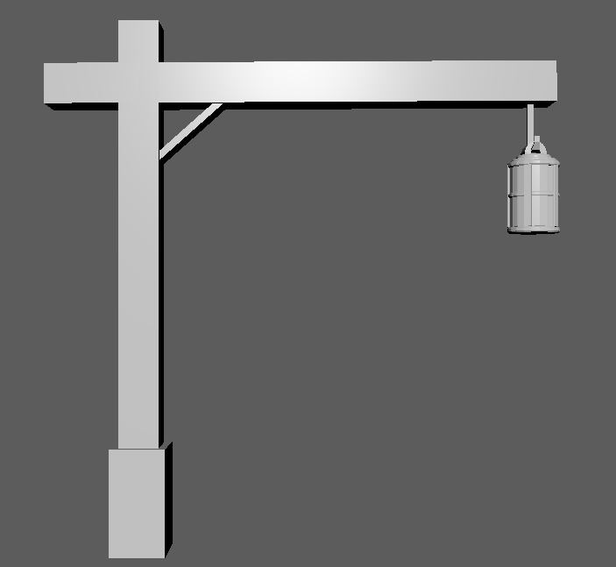
Screenshots of the hook section, and finished Lamppost model9
Overall, the author found the process of creating the above-mentioned models an interesting and engaging challenge. Having to use the tools they learned in their classes in different ways to create the style of model they wanted. The largest challenge the author faced through this process, was the writing of the production diary itself, not being used to writing in an academic tone in this way and having to adjust their own writing style to fit the brief led to a few challenges. The word count also added an additional challenge, attempting to explain and evaluate each step in less than 1500 words was certainly difficult, and in order to accomplish that the author decided to only include two models, and cover them both in depth.

Bibliography.
- Autodesk, 2026, Maya (2026.3)
- E. Clee, 12th November 2025, Screenshot of own work (Cup and saucer model)
- E. Clee, 12th November 2025, Screenshot of own work (Cup and saucer model)
- MH. Tutorials, 1st June 2015, Maya tutorial: How to model a Cup and Saucer, YouTube https://www.youtube.com/watch?v=VRcGsMYEtQ4&t=131s
- E. Clee, 12th November 2025, Screenshot of own work (Cup and saucer completed model)
- E. Clee, 24th November 2025, Screenshot of own work (Lamppost model, Lantern section)
- E. Clee, 24th November 2025, Screenshot of own work (Lamppost model, Lamppost body section)
- Art MZ, 9th November 2022, Lamp Post 3D Modelling (Autodesk Maya tutorial) YouTube https://www.youtube.com/watch?v=mOSsfGC-YRc
- E. Clee, 24th November 2025, Screenshot of own work (Lamppost model, Complete Model)

