5HR03
Reward for Performance and Contribution Presentation
by Daniel Parvin

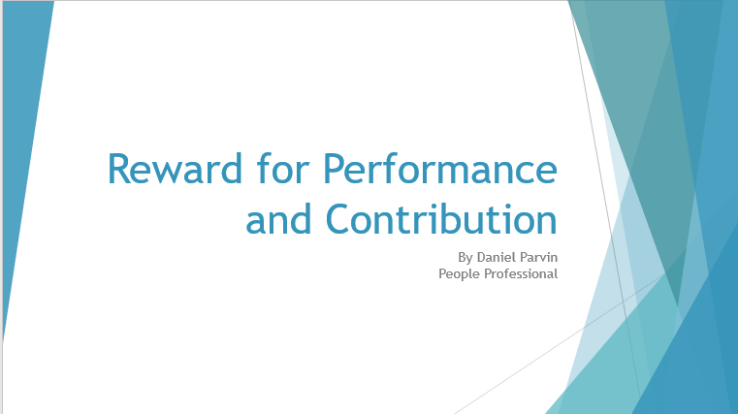

Introduction.
(A.C 1.1)

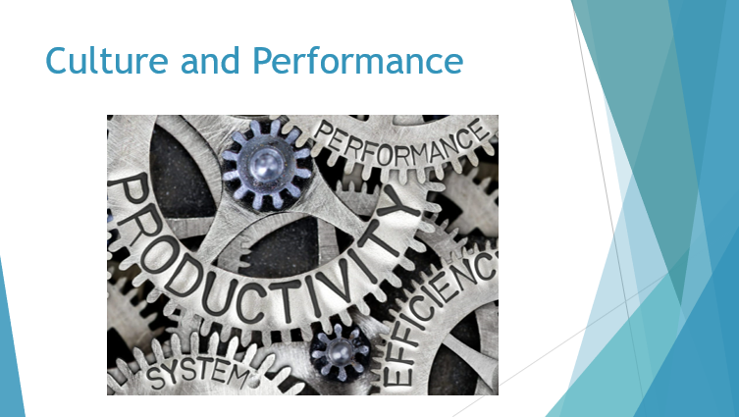
In order to best help our company we must first understand what is meant by reward and how this hold an important place in the organisations culture and performance. There are a number of ways in which an organisation can control its performance and culture. Some examples consist of clear expectation (how is the role measured), or employee engagement (communicating to staff), is there training and development (where staff can see a progression pathway), diversity (do we offer an inclusive work space), and many others. These play an important factor in employee lifecycle, and effective people practices help an organisation to boost the employee lifecycle and its employee engagement.
(Oxford Review, 2016-2021). However we are focusing on one important contributing area and that is reward or even as ‘Total Reward’. Which is believed to be the ‘whole package’ of financial and non-financial rewards (Armstrong, 2019).

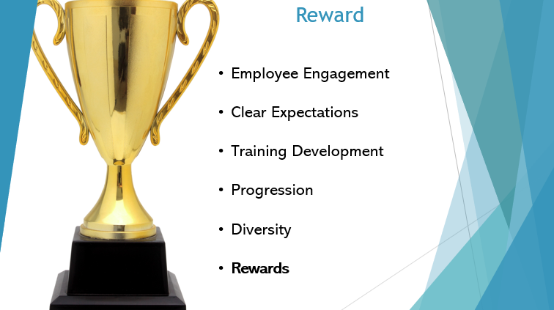
So, reward – what are we offering besides pay? In short some known examples include annual leave, pension, discounts, career development, flexibility, or even just recognising good work. The CIPD (2022) refers to these as “benefits”, the ‘non-cash provisions’. Now, don’t get me wrong, there will be cost implications – and that is on us, the employer – but the attraction, recruitment and retention of great employees will aim to outweigh these costings.
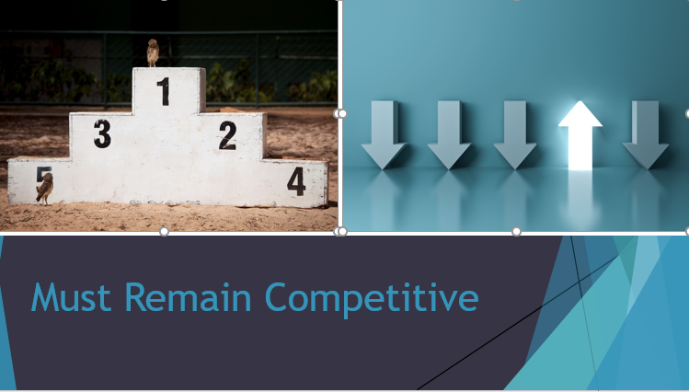
Our employees spend a lot of their time creating and following workplace norms, values, behaviours, etc. all of which amounts to Organisational Culture. Other big organisations such as Lloyds Banking Group supporting personal needs with its benefits, it is important to remain competitive with what we offer – driving good working practices and high performance.

(A.C 1.2)

So how do we implement reward into our policies and practices? Let us look at one of the world largest employers – the NHS and their strategy for this. For the NHS implementing reward is the final phase (phase 3) of their strategy toolkit. It states that there are four key areas to consider;
Testing your approach
Developing your implementation plan
Managing the change
Developing a communications strategy – our communications guide for reward will help with this.
(NHS Employers, 2017).

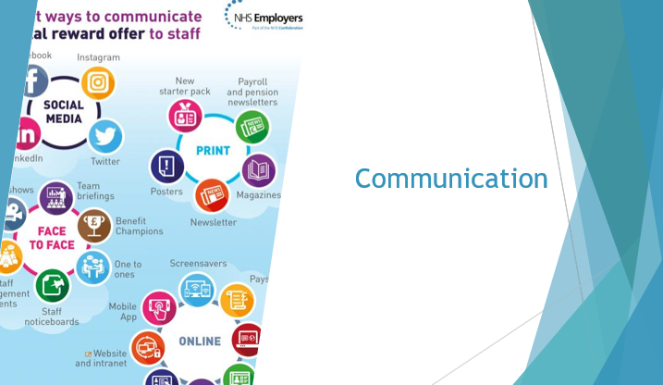
The implementation starts with basic discussions – such as pros and cons, when to launch, accessibility, and current procedures. The main theme throughout its implementation is communication. The role of senior management should be visible to staff, and is fundamental to the success of a new reward strategy. Management will need to engagement with staff, marketing, HR, and throughout to effectively develop a clear implementation pathway (and also gaining valuable insight to its ‘need’ and ‘want’).

Communication will continue to be important to best help employees understand the knowledge, skill and mindsets that will be needed to bring them aligned with the organisations values and behaviours – which should reflect our organisations goals.
(A.C 1.3)

But what is it that amounts to the reaching these organisation goals… How do we measure individual performance and its effectiveness? Well according to Ryan and Deci, 2000) “A motivated person is moved to do something whereas an unmotivated person lacks the drive or will to act”. It is commonly known that there are two types of reward and motivation – extrinsic and intrinsic. Extrinsic motivation is the prospect of reward or punishment and is external to the individual (something done by another person to the individual). This differs to intrinsic which is to pursue something due to your own desires or for ‘your own sake’ (Wait et al, 2021).
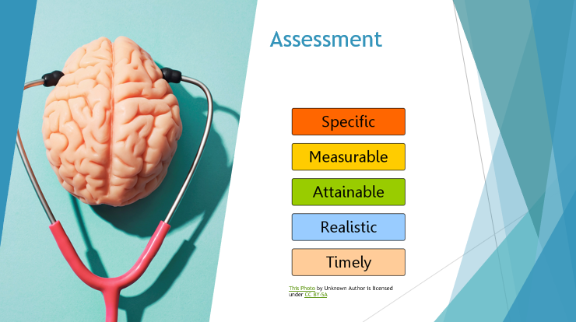
While an employee might be motivated to complete work tasks, the quality of that work will depend significantly on their capability (skills and knowledge) (Wait et al, 2021). The way in which we measure this is via their performance and/or ‘performance management’. This is the notion that performance can be identified as some form of objectives which direct performance and provide a basis for performance to be planned and assessed. There are a number of ways of assessing this, such as, appraisals, targets, objectives, etc. There are advantages and disadvantages to this. As advantage being that we can use SMART targets to effectively support staff better achieve in their roles – with clear links to organisational goals, however, a disadvantage being that for some organisations they can become controlling and heavy on monitoring (micro managing), which is something we will strive to stay clear of.

(A.C 1.4 & 2.1)

When considering how to create a reward package it is important for employers to find out what attracts, keeps and encourages its current employees (CIPD, 2022). So what are the benefits that could be offered?


Let us firstly consider pay, as a benefit under the National Minimum Wage Act 1998, workers have the right to receive the minimum hourly rate of pay (based on age) and due to the Equality Act 2010 me and women are to be paid ‘equally’ for ‘broadly similar’ work and work of equal value. These are both contractual terms and therefore pay as a benefit must be carefully considered. It would be beneficial to remember your PESTLE factors here when thinking about the competitiveness of rates of pay.
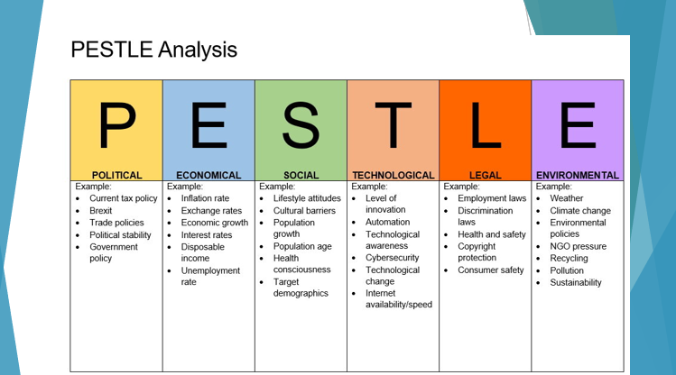
According to CIPD (2020) PESTLE makes up the Political, Economic, Sociological, Technological, Legal and Environmental external factors, that can help shape the decisions made within the organisation.


The benefit additional to rates of pay would be classified as ‘financial reward’. An example of a financial reward may be bonuses. This scheme would reward individuals, teams, or the whole team for their success. This is often followed by a lump sum of money that is dependent of achieving a target. According to CIPD (2019) “bonus schemes are widely used, with 62 percent of organisation including them as a reward”.

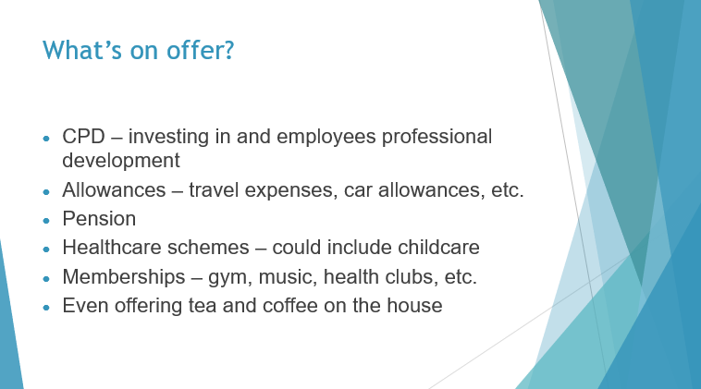

Furthermore, financial gain and pay, or OTE earnings are not the only benefit we can offer. It is vital to ensure the provision and administration of each benefit is worth the cost, which would still come from us, the employer. However, there are a number of different ways we can increase the desired package, other examples include;

- CPD – investing in and employees professional development
- Allowances – travel expenses, car allowances, etc.
- Pension
- Healthcare schemes – could include childcare
- Memberships – gym, music, health clubs, etc.
- Even offering tea and coffee on the house
It would be near impossible to offer every additional benefit to everyone that walks through the door, however, these benefits alongside non-financial benefits, will help manifest a good working culture, and push the organisation become more desirable.

(A.C 2.1)

When assessing reward in business it is important to consider its economic outlook, trends, and what is happening across the board when setting your benefits. As we have discussed PESTLE already it is important to think about how these factors measure on a corporate, national and international scale . An example of two different outlooks of reward is that of set benefits and flexible benefits.
According to the CIPD (2018) flexible benefits are used by 24% of companies. This is where employees are given a range of benefits to enable them to create their own personalised package. This is often something associated with the private sector, where the public sector often adopts a set benefits approach. This is simply what has already been discussed and what I feel would be the most effective way for us to move forward.

With the use of market rate analysis and PESTLE analysis as an organisation we can scour the labour market for its trends and currently cultural drivers, and implement a set strategy in place. This way likely provides the stability and certainty over benefits that will encourage and retain staff.

(A.C 2.2)

We have talked a lot about data and sourcing information for the trends of benefits. As people professional it is part of my job to source intelligence to be comparative and therefore competitive in our organisations earnings, workings hours, recruitment, etc. There are a number of places this can be done.
I have been using the Government data, Office of National Statistics, CIPD, etc. For example as we come out of the global pandemic and according to ONS (2021) “employees furloughed with reduced pay fell from 12% in 2020 to 6% in 2021” which would suggest that the labour market has started to benefit from individuals being back in work and achieving full pay. Which could suggest that the market is back to being competitive when considering it’s ‘pay package’.
(A.C 2.3)

When developing a pay package it is important to understand the different types of pay structures and the incentive for employees to work towards pay progression. A method I have always believed in adopting is that of ‘pay structures’.
This is where there is a predetermined salary range based upon the level of skill in your role. This is widely recognised and adopted across virtually all the public sector, and across some of the private sector. There are a number of different structures that can be adopted, most of which have two common key characteristics. Firstly the name of grades within a structure and secondly the span of each band.
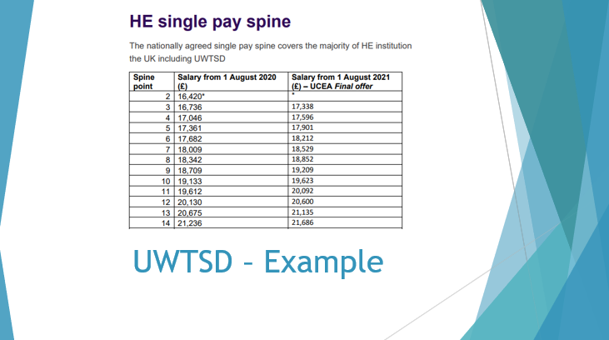
An example of this is used across Higher Education. Where Universities adopt and implement an analytical job evaluation for all staff nationally agreed via a single pay spine (UWTSD, 2020). This is where your increment is not based on the ‘work done’ but more so the ‘time spent’. For example we offer an increment yearly (usually August). I believe this to be a beneficial method as it ensured security and consistency. One thing I really like about working in this sector is that the variety of opportunities is vast, and your band or grade doesn’t have to define you, or your role. Again, this is something that is culturally nurtured.
(A.C 2.4)

It would be important to note at this point that organisations cannot just implement whatever they want and whenever they want. We must strive to follow the legislative requirement that impact our decision making process.
Earlier I briefly mentioned two important Acts, National Minimum Wage Act 1998 (the legal minimum amount of pay per hour) and Equality Act 2010 (which covers gender pay gap and right to equal pay for equal work). However, there is more to be considered as senior management such as both the CEO pay reporting. This comes under the Companies Regulations 2018 which requires that businesses with more than 250 UK employees must publicly list the total renumeration of their CEOs in order to comply with pay ratio data regulations (CIPD, 2021). This is necessary to help raise the necessary questions around fairness in the workforce.
(A.C 1.5)

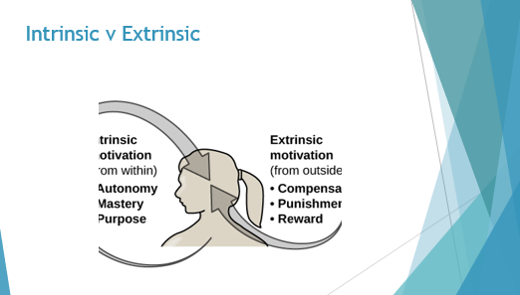
Let us look at the contribution of intrinsic and extrinsic rewards. According to People Management (2017) “extrinsic rewards have dominated rewards schemes for generations, but there has been a cultural shift in focus, money alone is no longer a motivator”. The main extrinsic factor that will always come up – is pay. However, we have taken a look at a number of benefits that aren’t just financial, and maximising a reward package would be useless if the focus was always solely financial. The focus has shifts. People are looking at how the business treats them on a whole.

People are even looking at contracts that involve more working from home, because they are starting to look deeper into the wellbeing and work-life balance. What motivates individuals can be unique, however pay will always be a big factor… Just not the only factor.

(A.C 3.1)

One thing that we keep coming back to is that of performance. What is performance management and how can this be introduced?

Performance managing will vary from company to company and person to person, however generically it at least refers to an annual appraisal for employees. An appraisal if often used to host a meeting between two employees (often and employee and their line manager), in which the employees performance is reviewed and news objectives and goals are set (Wait et al, 2021).


Is this enough? The answer should be no. I believe that an appraisal should be the absolute minimum that good performance managers oversee. There needs to be clear objective-setting that I would propose is assessed numerous times before a formal evaluation – e.g. Performance Reviews. Which are more informal and tend to take place more frequently. The disadvantage of an appraisal is that organisations tend to just tick the box once or twice a year and not evaluate with many other measures.

Ultimately there are a lot of factors to consider here. Such as flexibility, what if an individual’s role and responsibilities change? Also what happens if an employee does not fulfil their objectives? Were they SMART (specific, measurable, achievable, relevant and time bound)? And also will these objective be a direct correlation towards rewards and benefits?
I believe there are both advantages and disadvantages to this. Of course is can motivate individuals to increase their performance, however (for example) 50 out of 100 employees meet their objectives and are in celebration, that means another 50 are bitter, and this can possibly create a domino effect in the culture of the organisation.
Again the point to note here is that, performance management is great – if it is done correctly and most of all fairly.
(A.C 3.3)



One thing I believe line managers and senior management should consider when assessing their workforce is, what is reasonable? In an article by Employee Benefits (2021) it was discovered by Glassdoor, who surveyed 2,017 full time UK employees, that 52% of staff did not have good work life balance. This is often down to the individual, however, as an employer we are responsible for the pressures put onto staff. There are a number of non-financial rewards (like work-life balance) that can help an employee.

This can all begin with conversation, having one-to-one meetings where you are ensuring your employees are heard.



Another example is flexibility. According to Forbes (2022) Apple employees have recently started a petition to keep them working from home. They state that the work produced for the company has been ‘exceptional’ and their argument is why not work from home if it has absolutely no effect to job performance. Organisations must be able to adapt and provide flexible solutions to its staff. As managers the decisions and judgements made has a lasting effect on its workforce.

(A.C 3.2)

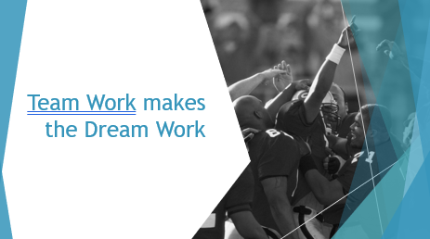

The roles played by us, the people professionals, and yourselves the managers are essential to ensuring there is appropriate action and decisions made moving forward. According to the CIPD (2022) and research carried by a team at Bath University, managers take part in a pivotal role in executing and enacting people professional policies and practices. They state that “where employees feel positive about their relationship with their line managers, they’re more likely to have higher levels of job satisfaction, commitment and loyalty – which are in turn associated with higher levels of performance or ‘discretionary’ behaviour (behaviour that goes beyond the requirements of the job).”

Line managers are often dealt a tricky hand, and have a number of duties that goes beyond that of a normal role. I believe that people professionals should help build the framework that organisations should follow to support its managers. This framework is to be based on the organisational goals and will consist of, recruitment and selection procedures, compliance with workplace legislations, intrinsic and extrinsic rewards, well-being and mental health support, and many other points that a line manager should be able to effectively support on. Not to forget that this relationship is two-way.

(A.C 2.3)



My final recommendation of improving this organisations approach to rewards is to focus more heavily on the non-financial rewards to staff. I am aware that this comes with costs. As the University already has a robust pay spine in place, there is very little ‘incentive’ to encourage performance. Employee know the maximum they can earn, per month, and that is widely recognised across the University and vastly all education establishments. Although bonuses and commissions don’t fit the business place, there needs to be more incentive for staff to excel.

As the role is to engage with Apprenticeship learners, I propose that in order to firstly improve culture, the line managers all offer to take their team out for food if they manage to bring x amount of new companies and x amount of learners into the University before the start of the academic year. This gives some sort of incentive. Although it is ‘expected’, this will help encourage staff to work more closely to achieve the overall collective. This also will help improve culture as this reward directly effects the team – and the roles are WFH which offers little working together.



(Notes word count 2773)

Bibliography

Armstrong, M. (2019). Armstrong’s handbook of reward management practice. 6th edition. Kogan Page, London
Oxford Review. (2016-2021). Human Resources Cycle: Comparison of models. [online]. Available at https://oxford-review.com/oxford-review-encyclopaedia-terms/human-resources-cycle/ (Accessed 16/11/2021)

CIPD (2020) PESTLE analysis. Available at https://www.cipd.co.uk/knowledge/strategy/organisational-development/pestle-analysis-factsheet and https://www.cipd.co.uk/Images/7583-PESTLE-template-2020_tcm18-27107.pdf (Accessed: 23/08/2022)
CIPD. (2019). Reward managements: focusing on pay. [online]. Available at https://www.cipd.co.uk/knowledge/fundamentals/people/pay/reward-factsheet#gref (Accessed 18/08/2022)

CIPD. (2021). Pay fairness and pay reporting. [online]. Available at https://www.cipd.co.uk/knowledge/strategy/reward/pay-fairness-reporting-factsheet (Accessed 20/08/2022)

CIPD. (2022). Employee benefits: an introduction. [online]. Available at https://www.cipd.co.uk/knowledge/fundamentals/people/benefits/factsheet (Accessed 14/08/2022)

CIPD. (2022). Line managers’ role in supporting the people profession. [online]. Available at https://www.cipd.co.uk/knowledge/fundamentals/people/hr/line-managers-factsheet (Accessed 22/08/2022)

Employee Benefits. (2021). Work life balance. [online]. Available at https://employeebenefits.co.uk/52-uk-staff-do-not-have-good-work-life-balance/ (Accessed 20/08/2022)

Forbes. (2022). Apple can’t turn back from flexible work-from home options. Available at https://www.forbes.com/sites/retailwire/2022/08/30/apple-cant-turn-back-from-flexible-work-from-home-options/?sh=c520cd7152de (Accessed 30/08/2022)

NHS Employers. (2017). Phase 3 – reward strategy toolkit. [online]. Available at https://www.nhsemployers.org/sites/default/files/2021-06/RST-Phase-3-Checklist.pdf (Accessed 16/08/2022)

Taylor, S. and Woodhams, C. (2016) Studying Human Resource Management. 2nd edition. London: the Chartered Institute of Personnel and Development

UWTSD. (2020). Pay policy statement 2019/20. [online]. Available at https://www.uwtsd.ac.uk/media/uwtsd-website/content-assets/documents/strategies-policies/annual-pay-policy-statement-201920-final-june-2021.pdf (Accessed 18/08/2022)
Wait, K. Beevers, K. Nicky, S. Tomlinson, K. and Hussain, S. (2021). People Practice. London. Kogan Page

