
managing project in the organisation (bmsk5004)
LECTURER: ERNEST OVIA
student name: mohammed kamal hussain
Student ID: 1711129


Contents
Introduction 2
Describe the organisation 2
Provide a critical assessment of the risks associated with the project. 3
Describe the project management tools and techniques being used in the case study. 4
MoSco Chevron 5
Iron Triangle 6
Roberts Method 7
Delphi Technique 7
Gantt chart (Tool) 8
Show how the project plans will be communicated to the stakeholders 8
Provide a personal reflection of your own ability of managing the project with future recommendation and self-development plan to improve own performance. 9
Conclusion 10
Reference 11-12

Introduction
This report seeks to describe the approach taken to complete the planning stage of the Vintners Project. The report will look at the techniques used to identify and mitigate issues and seeks to offer clarity over the following five areas:

• Describe the organisation for which the project is being developed.
• Provide a critical assessment of the risks associated with the project.
• Describe the project management tools and techniques being used in the case study.
• Show how the project plans will be communicated to the stakeholders
• Provide a personal reflection of your own ability of managing the project with future recommendation and self-development plan to improve own performance.

Describe the organisation

Vintners antiques consist of five people who have an antique shop. They have received an offer from TESCO express for their property and they are thinking of moving to another property in Spark Hill in Birmingham which they own and is used for stocking goods. Vintners want to become similar to ‘Salvage Hunters’ (as seen on TV) who are very successful in antique dealings. Their aim is to achieve a similar business model in order to be successful. They want the warehouse to be renovated within a reasonable and affordable price. The ideal set-up will consist of a showroom, collection point, repairs centre, storage facilities, and give customer experience when they visit Vintners antiques.

The Vintners corporate structure is as follows:
- Dennis Vintner (Project sponsor)-Dennis is the person who makes decisions from an early stage of the project. He is the chair-person of the steering group, he is a stakeholder and will oversee the risk involved in the project and manage problem and give support to the business so that the objectives and vision are achieved, he is also an expert in locating and buying old antiques.
- Doreen Vintner- (commercial) she is financer, she works in accounting and is qualified in this field. She will be distributing money to the appropriate places and budget the project.
- Omar King (specialist) has many talents one of the talents is he can repair and restore old artefacts which can be sold at its original price. His job will be in the warehouse where he is familiar where everything is.
- Suha Madani (User) is expert in customer service she will make sure the customer has a tangible experience when visiting Vintners antique. She will be in the sale department and provide a customer perspective for the project.
- Paul Ranson (Representative)- A friend of Vintners antiques, who will communicate between the project management team and Vintners Management, provide advice and help with any internal or external problems.

Provide a critical assessment of the risks associated with the project.

Risk can be explained in different forms of details for example high level risk in a company who has not a good record in using technology, identifying the risk early can help to understand the riskiness of projects (Roberts, 20110). Where possible all risks need to be anticipated, identified and mitigated. Some of the anticipated risks with the Vintners project are listed below

- Travel disruption and bad weather
Travel disruption may cause goods and material delivery to be delayed. Bad weather such as heavy rain or snow could cause external work such as construction to stop until the weather improves (When winter weather disrupts work, 2015). Due to the increasing frequency of adverse weather, project managers should adopt policies which consider such issues. Most professionals strive to work in any climate, but it is simply not always possible.

- Absent workers/contractors.
There could be many reasons why employees do not show up for work, ranging from illnesses to personal emergencies. Absence of key employees, contractors and tradesmen can cause disruption of project coordination, delay projects and increase expenditure (Cruikshank, 1976).

- Shortage of materials, supplies & equipment on site.
Shortage of materials and delaying supply is considered one of the most essential factors that could lead to delay projects (Rahman et al,. 2017). It will cost more money for Vintners if work was to come to a hold on site as the workers will demand payment even if they are doing nothing it will put a strain to Vintners project and the budget will increase leaving them to an unprecedented outcome.

- Accidents and injuries at work.
Sometimes despite all the safety protocols, accident still happen. It is essential to carry out a risk assessment prior to project commencement and do whatever is necessary to safeguard the health and safety of employees and visitors. This includes deciding how many helpers are needed and what types of first aid kits and facilities should be provided (Indirect, 2020).

Describe the project management tools and techniques being used in the case study.

User Stories (Method)
User stories is a method where the needs and wants of the user is identified by asking them what they want. When designing or building something specific it has to be user friendly. The Gantt chart was based on the user story given by Vintners antique. The user stories are very short, very simple descriptions of the work being told from the point of view of the person who wants to access new opportunities, usually the user or client of the system. They follow a simple formula (Thamrongchote and Vatanawood, 2016). Vintners wanted us to Complete renovation of building work and make the property they want to go to be organised and prepared for trading. They have given us insight on how they want to become more like the successful antique dealer Salvage Hunters. It was our job to specifically give them the time frame it will take on completion of the project and the budget. Specifying how much it will cost on each material used and underling the scoop of the project. Scoop of the project listed below.
- To draw up a plan and layout for the proposed building and structural work using an architect
- Acquire planning permission from the local council via architect.
- Build office space, storage area, warehouse, shelves, reception area and driveaway
- Build a toilet and kitchen area for staffs
- Full drainage for kitchen and toilets
- Fitting pipework's for kitchen and toilets
- Fitting toilets and sinks
- Fitting kitchen sinks

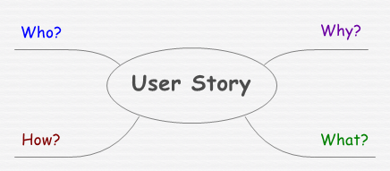
Figure 1 : User Story

MoSco Chevron.

MoSco Chevron is a tool utilised for prioritising tasks on a need basis. The three categories of the chevron are:
(MUST) Must have to complete the task, vital.
(WANT) Useful but not vitally important.
(NICE) Would be nice to have if there is sufficient fund available (Ahmad et al., 2017).
This tool was used to identify what exactly was needed to complete the renovation of the warehouse in order for Vintner antique to operate in an affordable manner. Based on this Chevron, individual tasks were assessed, prioritised, included or discarded in the project on a MUST, WANT and NEED basis.

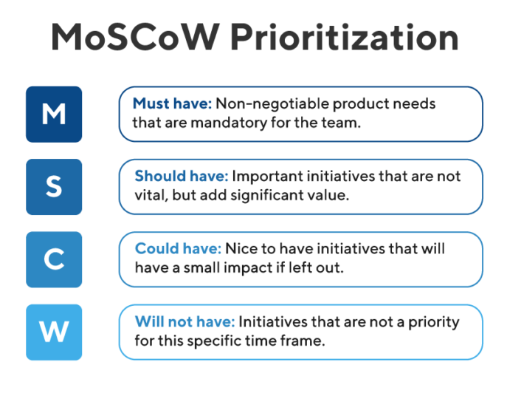
Figure 2 : MoSCo Chevron (Atlassian Software Development and Collaboration Tools, 2020).

Iron Triangle

Iron triangle is used to balance three factors, SCOPE, COST and TIME. If you want to prioritize the quality of the project, concentrating on the Scope will lengthen the project timeline but increase the Cost. Reducing the Cost will reduce the scope thereby giving you more time to do the project, as less work will be needed for you to do (Blaich and Wise, (2018).
The Iron Triangle technique was used balance out all three factors and make the project workable.
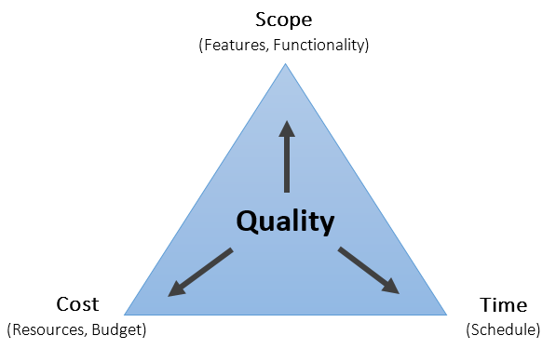
Figure 3 : iron triangle- (Dhillon, 2020).

Roberts Method

This method was used to determine the complexity of the project and the size. When renovating the warehouse for Vintners antique we looked at how large to how small the project was, and difficult from low to high this helped to understand the complexity and size of the project.
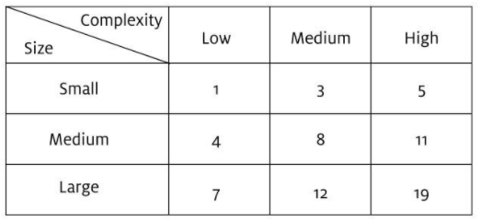
Figure 4 : Roberts Method

Delphi Technique
Delphi techniques is used for forecasting the likelihood or outcome of future scenario, this method is commonly used for determining the range of opinion in consensus matters (Hahn et al., 2020). Delphi technique was used for Vintners antique for all estimate projection, as the Gantt chart gave time frame on project, the Delphi method came very close to what we anticipated the estimation it will take to complete the project for Vintners antique. We asked all member of our project on how much it will cost for the completion of the project. Each member gave an estimate, we then divided the sum that was given by the number of people in relation to the project, and we got our answer. By using the technique usually known Wisdom of the Crowd (Surowiecki, 2005). We came to a consensus that the actual price was very similar to what we spent on the project.

Gantt chart (Tool)

A Gantt chart is a very important tool when it comes to project management. Gantt chart outline the project lifeline from start to finish and include such information as the start and end of specific tasks and measure the duration. Each task duration is based on its complexity and its reliance on (where needed) another job finishing before the current task can start. Gantt chart can display at a glance the order of the tasks as well as the duration (Doyle, 2011).
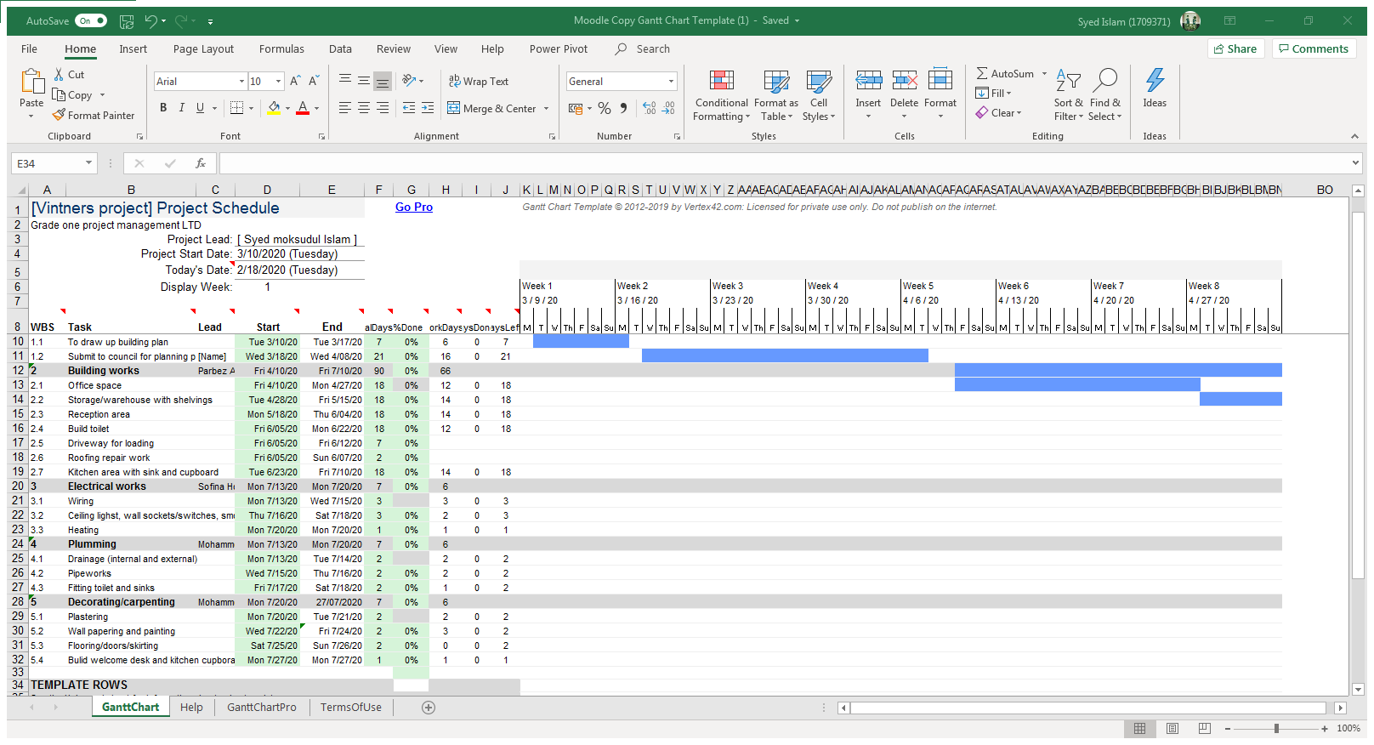 Figure 5 : Gantt Chart

Show how the project plans will be communicated to the stakeholders

When projects are managed with understanding of end user wants and needs, this can deliver a satisfactory outcome. Achieving this is most vital for communication (Leedschildcare, 2020). Organisation informs stakeholders of the current or the future activities. They inform the Values, Beliefs, Strategic formation, intention and other information that may influence their strong relationship to a establish manner (Alexandru, 2020).
Project plan will be communicated in these formations.
Give access to Gantt chart for schedule- giving full access to the Gantt Chart, this will show how long the project will take to complete
Use emails to communicate with stakeholder’s- using email to give update on what is happing in the project
Use video calls to give visual progression of work- showing work that has been done so far
Give detail accounts on budget and spending- showing what has been acquired so far for the project and how much for completion
Stand up communication- This type of communication will determine you are not lazy, and you are up to the job given description on what needs to be done on that day (Atlassian, 2020).

Provide a personal reflection of your own ability of managing the project with future recommendation and self-development plan to improve own performance.

Using all the tools and technics has helped me to understand how less confusing decision making can be. On starting the project mistakes was made for example without complete planning we decided just estimate on how long it will take to complete the project and how much it will cost for fixture and fitting. Without using any of the tools and techniques it was very difficult to understand the full complexity of the project. We did not consider any risk associated with the project.
Using the tools and techniques has helped us to deliver the project plan in timely manner as well as understanding the full nature of these tools and techniques. Having been exposed to these tools I will definitely use these tools for future endeavours for prosperous results. For my own performance, having used these tools has made me realize that for continuous outstanding result, one must adhere to all the rules, methods and tools for self-improvement and better results.

Conclusion

Vintners antique wanted to relocate to new premises. The new premises used to be a warehouse and was not built for the purposes they wanted, hence the warehouse needed to be converted to a fully functioning all in one antique centre, similar to the ‘Salvage Hunters’ operations.
The project needed to be done in a professional manner, so they decided to employ the services of a Project management team. The project management team was tasked with the planning and execution of the project.
The project planning was done using industry standard techniques and tools. The plan was submitted to Paul Ranson (Vintners Representative) in the form of a Power Point presentation.
The presentation was followed up with a Skype call to Paul Ranson the following week, to provide clarity over project elements and answer any questions Vintners may have had.
The project provided the Project Management team to work in unison with Vintners and each other, to come up with a reasonable and workable solution to a real-life situation.

Reference

- Alexandru, B. (2020).Annals of the University of Oradea: Economic Science COMMUNICATION STRATEGY ABOUT BUSINESS MODELS: STAKEHOLDERS PERSPECTIVE. 1222-569X (Print); 1582-5450 (Online) : University of Oradea
- Atlassian. (2020). Atlassian | Software Development And Collaboration Tools. [online] Available at: <https://www.atlassian.com/> [Accessed 26 March 2020].
- Blaich, C. and Wise, K. (2018) ‘Scope, Cost, or Speed: Choose Two—The Iron Triangle of Assessment’, Change, 50(3/4), pp. 73–77. doi: 10.1080/00091383.2018.1509606.
- CRUIKSHANK, G.E., 1976. No-Shows at Work: High-Priced Headache. Nation's Business (pre-1986), 64(9), pp. 37.
- Dhillon, h., (2020). Medium – Get Smarter About What Matters To You.. [online] Medium. Available at: <https://medium.com/> [Accessed 25 March 2020].
- Doyle, C. (2011). GANTT chart. In A Dictionary of Marketing. : Oxford University Press. Retrieved 22 Mar. 2020, from https://www-oxfordreference-com.ezproxy.uwtsd.ac.uk/view/10.1093/acref/9780199590230.001.0001/acref-9780199590230-e-0753.
- Hahn, U., Chater, N., Lagnado, D., Osman, M. and Raihani, N., 2020. Home | The Psychologist. [online] Thepsychologist.bps.org.uk. Available at: <https://thepsychologist.bps.org.uk/> [Accessed 25 March 2020].
- K. S. Ahmad, N. Ahmad, H. Tahir and S. Khan, "Fuzzy_MoSCoW: A fuzzy based MoSCoW method for the prioritization of software requirements," 2017 International Conference on Intelligent Computing, Instrumentation and Control Technologies (ICICICT), Kannur, 2017, pp. 433-437.
- Leedschildcare.proceduresonline.com. 2020. Leeds Children's Social Work Services. [online] Available at: <https://leedschildcare.proceduresonline.com/> [Accessed 24 March 2020].
- Nidirect. (2020). Home. [online] Available at: <https://www.nidirect.gov.uk/> [Accessed 24 March 2020].
- Rahman, M. Motiar & Yap, Yok Hoe & Ramli, N & Dullah, M & Shamsuddin, M. (2017). Causes of shortage and delay in material supply: a preliminary study. IOP Conference Series: Materials Science and Engineering. 271. 012037. 10.1088/1757-899X/271/1/012037.
- Roberts, P. (2012). Effective Project Management. London. UK: Kogan
- Surowiecki, J (2005). Surowiecki The wisdom of crowds Anchor Books, New York (2005)
- Thamrongchote, C. and W. Vatanawood, (2016). "Business process ontology for defining user story," IEEE/ACIS 15th International Conference on Computer and Information Science (ICIS), Okayama, 2016, pp. 1-4.
- When winter weather disrupts work. (2015). The Veterinary record, 176(1), pp. 26.

